Access all the tables created in Assignment 1 and run those queries through the python API.

Table Stock:

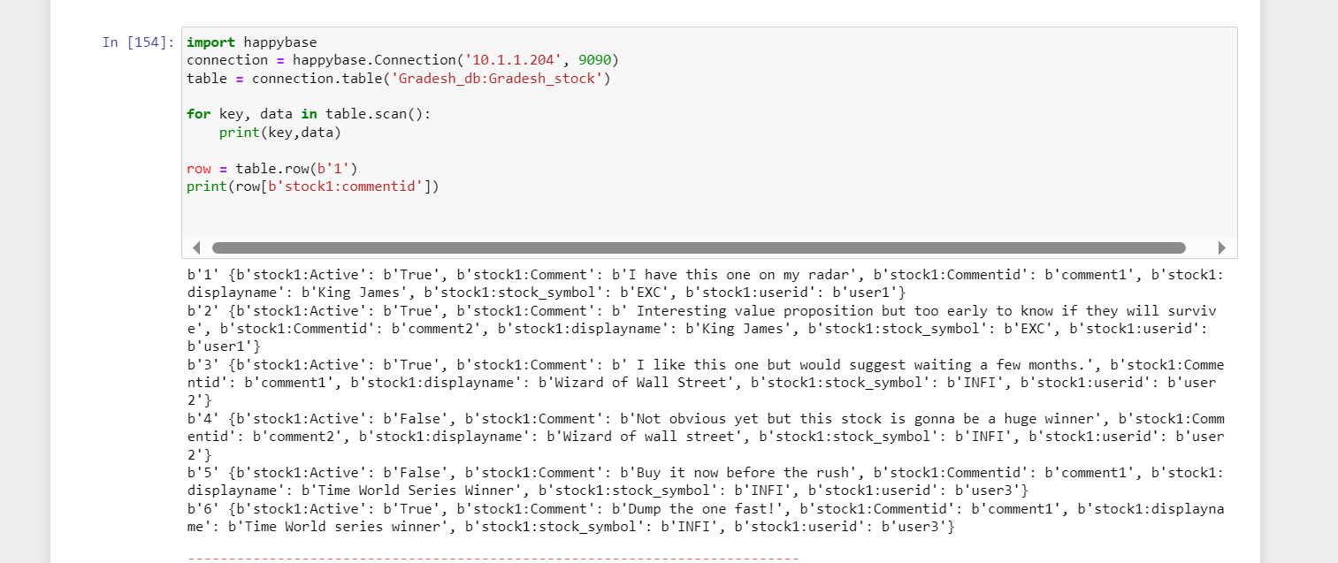

Song:

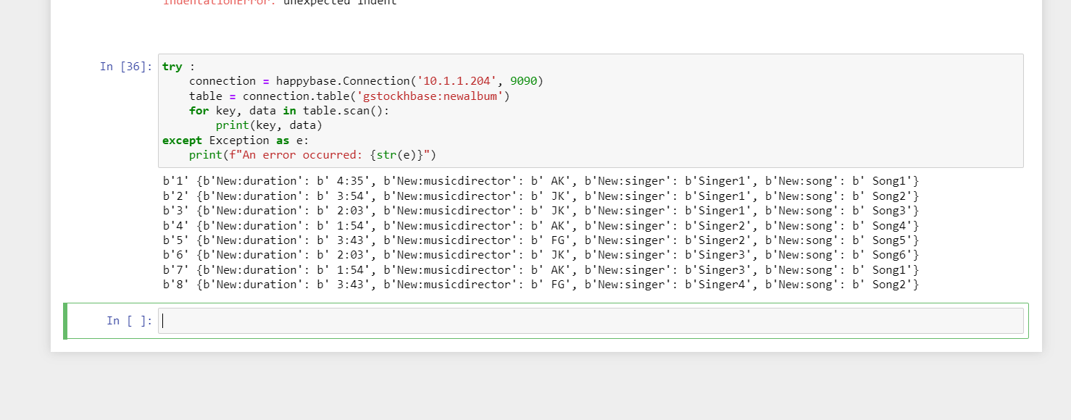

Also Create new tables from python and insert some data in to those tables

