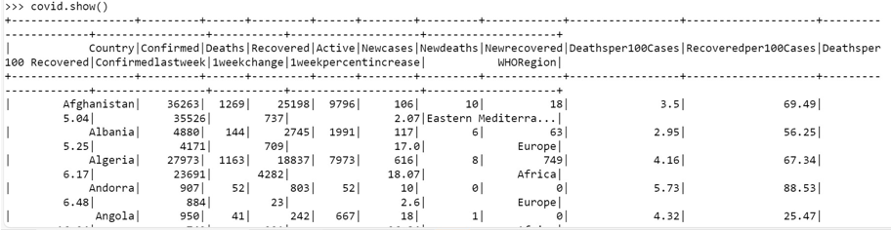



covid.createOrReplaceTempView("covid1")

covi.withColumnRenamed("Deathsper100 Recovered","Deathsper100_Recovered").show(truncate=False)

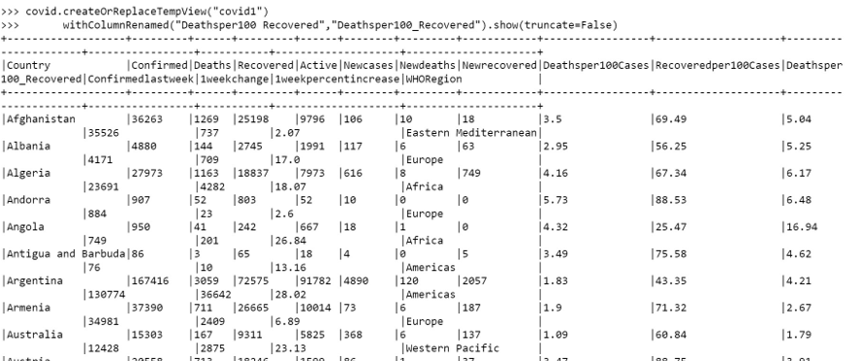



import pyspark.sql.functions as F

covid_agg = covid.agg(*[F.count(F.when(F.isnull(c), c)).alias(c) for c in covid.columns])

covid_agg.show()



spark.sql( "SELECT Country,WHORegion,sum(Confirmed) FROM covid1 GROUP BY Country, WHORegion order by 3 desc").show(10)



spark.sql( "SELECT Country,WHORegion,sum(Confirmed) FROM covid1 GROUP BY Country, WHORegion order by 3 asc").show(10)



spark.sql("SELECT count(distinct Country), count(distinct WHORegion),WHORegion from covid1 group by WHORegion").show()

