hdfs dfs -put crime_incidents_2013.csv

hdfs dfs -ls

crime=spark.read.option("header",True).option("inferschema",True).csv("crime_incidents_2013.csv")

crime.createOrReplaceTempView("crime1")

crime.printSchema()

crime.show()

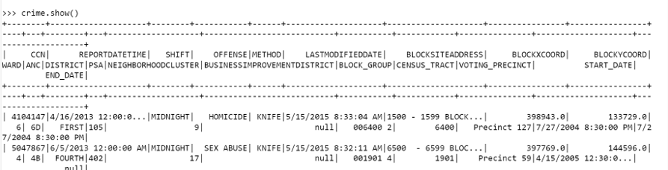

spark.sql("SELECT count(distinct OFFENSE) from crime1").show()

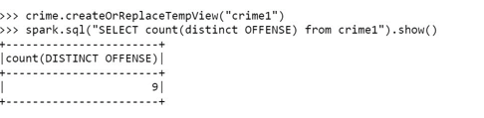



spark.sql("SELECT OFFENSE ,count(CCN) from crime1 group by OFFENSE").show()



spark.sql("SELECT METHOD ,count(METHOD) from crime1 where OFFENSE = 'HOMICIDE' group by METHOD ").show()

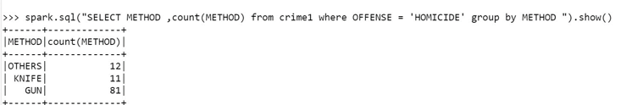



spark.sql("SELECT SHIFT ,max(CCN) from crime1 group by SHIFT order by 2 desc").show()

