orders=spark.read.option("header",True).option("inferschema",True).csv("orders.csv")

orders.createOrReplaceTempView("order")

orders.show()

order_items=spark.read.option("header",True).option("inferschema",True).csv("order_items.csv")

order_items.createOrReplaceTempView("order1")

order_items.show()

products=spark.read.option("header",True).option("inferschema",True).csv("products.csv")

products.createOrReplaceTempView("product1")

products.show()

1. spark.sql("SELECT order_status, count(order_id) from order group by order_status").show()



spark.sql("SELECT order_status, order_id,order_date, order_customer_id from order where order_status = 'CLOSED' or order_status = '

COMPLETE'").show()



spark.sql("SELECT o.order_date, p.product_name ,sum(ot.order_item_subtotal) as revenue from order o join order1 ot on o.order_id =

ot.order_item_order_id join product1 p on p.product_id = ot.order_item_product_id where o.order_status in ('CLOSED','COMPLETE') group b

y o.order_date, p.product_name").show()



spark.sql("SELECT o.order_date, p.product_name ,sum(ot.order_item_subtotal) as revenue from order o join order1 ot on o.order_id =

ot.order_item_order_id join product1 p on p.product_id = ot.order_item_product_id group by o.order_date, p.product_name").show()



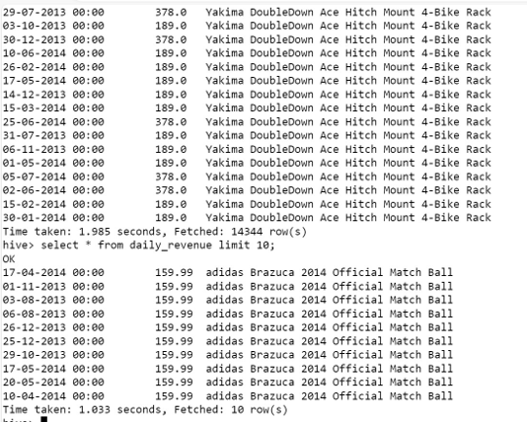

spark=SparkSession.builder.appName("Spark Hive").enableHiveSupport().config("spark.sql.warehouse.dir","/user/hive/warehouse").getOr

Create()

spark.sparkContext.setLogLevel("ERROR")

df = spark.sql("SELECT o.order_date, p.product_name ,sum(ot.order_item_subtotal) as revenue from order o join order1 ot on o.order_

id = ot.order_item_order_id join product1 p on p.product_id = ot.order_item_product_id group by o.order_date, p.product_name")

df.show()

df.write.partitionBy("product_name").mode("overwrite").saveAsTable("airline_db.daily_revenue")