**TP 7**

**Pour la leçon 5**

Code source:

ImportsSystem

ImportsSystem.Collections.Generic

ImportsSystem.Text

namespace SynchronizedBalls

public class Forks

bool[] fork = new bool[5]

// initially false, i.e. not used

// Try to pick up the forks with the designated numbers

public sub Get(int left, int right)

lock (this)

while (fork[left] || fork[right])

Monitor.Wait(this)

//

BallMov bl = new BallMov(pbox)

fork[left] = true

fork[right] = true

Next

End sub

// Lay down the forks with the designated numbers

public sub Put(int left, int right)

lock (this)

fork[left] = false

fork[right] = false

Monitor.PulseAll(this)

End sub

End class

Capture



b. Leçon 6

Solution

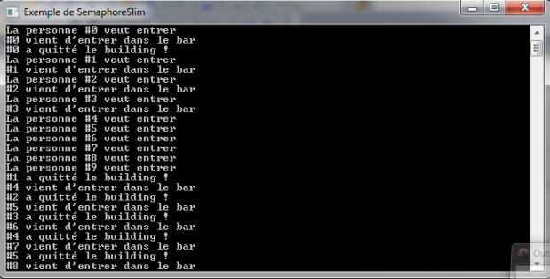

Code sources

public class semaphore

//Déclaration du SemaphoreSlim qui prendra en paramètre le nombre de places disponibles.

static SemaphoreSlim doorman = new SemaphoreSlim(3)

public sub semaph()

Console.Title = "Exemple de SemaphoreSlim"

//Création des threads.

For K As Int = 0 to 9

new Thread(Entrer).Start(i)

Next

Console.ReadKey()

static sub Entrer(object n)

Console.WriteLine("La personne #{0} veut entrer", n)

//Le doorman attendra qu'il y ait de la place.

doorman.Wait()

Console.WriteLine("#{0} vient d'entrer dans le bar", n)

Thread.Sleep((int)n * 1000)

Console.WriteLine("#{0} a quitté le building !", n)

//Le doorman peut maintenant faire entrer quelqu'un d'autre.

doorman.Release()

public sub rt()

End sub

c. La solution « philosophe » n’utilise pas des locks, mais uniquement la classe Monitor

ImportsSystem

ImportsSystem.Collections.Generic

ImportsSystem.Text

namespace SynchronizedBalls

public class Forks

bool[] fork = new bool[5]

// initially false, i.e. not used

// Try to pick up the forks with the designated numbers

public sub Get(int left, int right)

lock (this)

while (fork[left] || fork[right]) Monitor.Wait(this)

//BallMov bl = new BallMov(pbox)

fork[left] = true

fork[right] = true

End sub

// Lay down the forks with the designated numbers

public sub Put(int left, int right)

lock (this)

fork[left] = false;

fork[right] = false

Monitor.PulseAll(this)

End sub

End class

d. La solution « philosophe » doit respecter les règles concernant l'objet synchronization qui ont été énoncées dans les diapositives PowerPoint (diapositive 7).

Solution

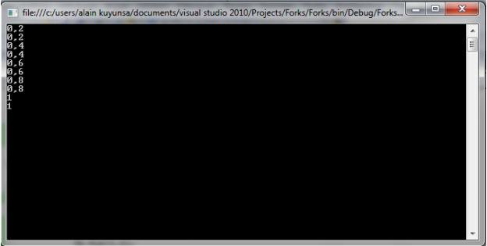

Code source

public class Forkss

bool[] fork = new bool[5]

// initially false, i.e. not used

public STEPS = 5 As Double

public PercentageTakenLeft As Double

public PercentageTakenRight As Double

// Try to pick up the forks with the designated numbers

public sub Get(int left, int right)

lock (this)

while (fork[left] || fork[right])

Monitor.Wait(this)

ReturnBothSticks()

Put(2,2)

fork[left] = true

fork[right] = true

End sub

// Lay down the forks with the designated numbers

public void Put(int left, int right)

lock (this)

fork[left] = false

TakeBothSticks()

fork[right] = false

ReturnBothSticks()

Monitor.PulseAll(this)

End sub

public sub TakeBothSticks()

For K As Int = 0 to STEPS

PercentageTakenLeft += 1.0 / STEPS

PercentageTakenRight += 1.0 / STEPS

Thread.Sleep(100)

Next

Console.WriteLine(PercentageTakenLeft)

Thread.Sleep(100)

Console.WriteLine(PercentageTakenRight)

End sub

public sub ReturnBothSticks()

For K As Int = 0 to STEPS

Thread.Sleep(100)

PercentageTakenLeft -= 1.0 / STEPS

Thread.Sleep(100);

PercentageTakenRight -= 1.0 / STEPS

Next

End sub

End class

class Program

static sub Main(string[] args)

Forkss fk = new Forkss()

fk.Put(1,2)

Thread.Sleep(150)

Thread.CurrentThread.Interrupt()

fk.Get(2,2)

Console.ReadKey()

End sub

End class