Brain Microstructure Modeling Toolkit

A Blender Geometry Nodes tool for generating meshes of axon fibre bundles, neurons and glial cells in human white matter for diffusion weighted MRI simulation.

**1. Overview**

**Purpose**:  
Generate realistic 3D meshes of human white matter microstructures (axons, neurons, glia) with customizable morphology parameters for diffusion-weighted MRI (dwMRI) simulation.

**Core Features**:

* **Procedural Modeling**: Uses Blender’s **Geometry Nodes** for dynamic, non-destructive adjustments.
* **Adjustable Parameters**:
  + Axon radius, angular dispersion, branch generation, tortuosity, density, and cell morphology.
* **Export Compatibility**: Save models as .ply files for use in **MCMR simulator**.

**2. Installation**

**Requirements**:

* **Blender 3.6+** ([Download](https://www.blender.org/download/)).
* *No additional Python packages required.*

**Setup**:

1. **Download Files**:
   * Obtain .blend files for your target structure (e.g., Axon.blend, Confinement_box.blend, Microglial_cell.blend).
   * Store them in an organized project folder.
2. **Launch Blender**:
   * Open files via **File > Open** or by double-clicking (if associated with Blender).

**3. Quick Start Guide**

**3.1 Axon Bundles**

**3.1.1 Setup**

1. Open Axon.blend in Blender.
2. **Locate the Axon Bundle**:
   * In the **Outliner** (top-right), expand the Collection and select Fibre unit.
   * Click the **Modifiers tab** (wrench icon 🛠️) in the **Properties panel** (bottom-right).

**3.1.2 Adjust Parameters**

* **Key Parameters**:
  + Radius, Angular Dispersion, Branch Position (see Section 4 for full parameters/defaults/ranges).
* **Edit Values**:
  + Drag sliders or type directly into parameter boxes. Press Enter to apply.
* **Bundle-Level Adjustments**:
  + Select Fibre bundle in the Outliner to modify global settings (e.g., density, alignment).

**3.1.3 Export Unconfined Mesh**

1. Go to **File > Export > Stanford PLY (.ply)**.
2. **Settings**:
   * Enable **Triangulated Mesh**.
   * Set **Vertex Colors** to None.
3. Save and name your file (e.g., Axon_Unconfined.ply).

**3.1.4 Apply Confinement Box**

1. Open Confinement_box.blend.
2. **Import Your Mesh**:
   * **File > Import > PLY** and select Axon_Unconfined.ply.
3. **Copy Geometry Nodes**:
   * In the **Geometry Nodes Editor** (bottom panel):
     + Select all nodes under Cube, press Ctrl+C to copy.
     + Select your axon mesh, create a new Geometry Nodes group (+ New), delete default nodes, and paste (Ctrl+V).
4. Delete the original Cube object.
5. Adjust confinement properties (size, rotation) via the **Modifiers tab**.

**3.1.5 Export Final Mesh**

* Repeat **Section 3.1.3** to save the confined axon bundle.

**3.2 Individual Cells (Neurons, Astrocytes, Microglia)**

**3.2.1 Setup**

1. Open the desired .blend file (e.g., Neuron_cellbody.blend).
2. In the **Outliner**, locate the cell object (e.g., Neuron) and expand its Collection.
3. Access parameters via the **Modifiers tab** (wrench icon).

**3.2.2 Adjust Parameters**

* Modify morphology settings (e.g., dendritic branching, soma size).
* See Section 4 for parameter ranges and descriptions.

**3.2.3 Export**

* Follow **Section 3.1.3** to save as .ply.

**3.3 Build Complex Cell Collections**

1. **Create a New Scene**:
   * **File > New > General**, then delete default objects (Cube, Light, Camera).
2. **Import Models**:
   * Use **File > Import** to add cells or axons.
3. **Duplicate and Arrange**:
   * *Before duplicating*: **Apply modifiers** (click ▼ next to the modifier > Apply).
   * Right-click objects > **Duplicate** and place them freely.
4. **Export**: Save the entire collection as .ply (see **Section 3.1.3**).

**4. Troubleshooting**

* **Missing Modifiers Tab**:
  + Ensure the correct object is selected in the Outliner.
  + Press N to toggle the sidebar if panels are hidden.
* **Export Errors**:
  + Verify **Triangulated Mesh** is enabled in the PLY export settings.
  + Ensure no non-manifold geometry exists (use **Mesh > Clean Up** tools).
* **Geometry Nodes Issues**:
  + Re-copy nodes if connections break after pasting.

## **Parameter reference**

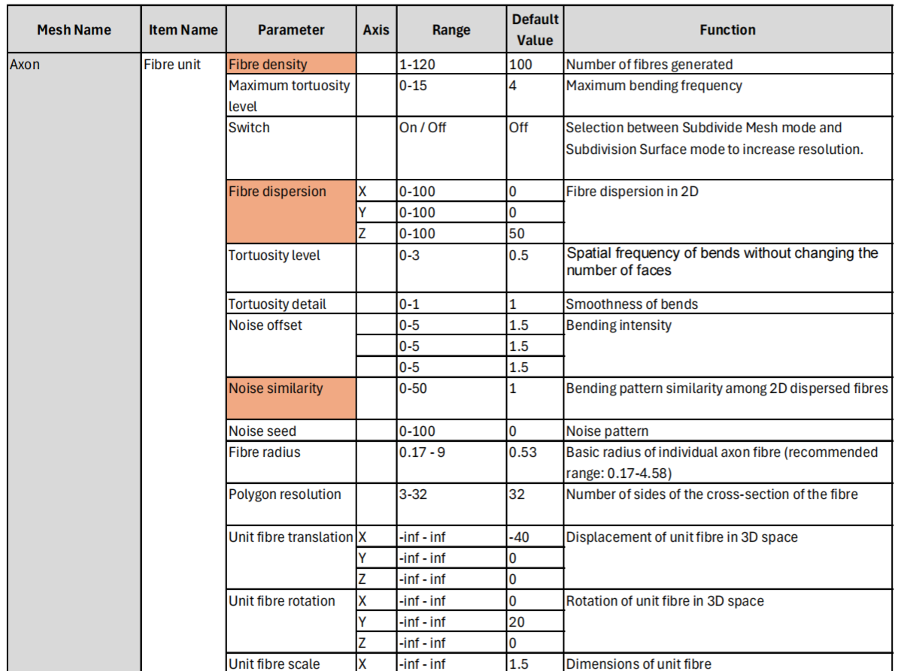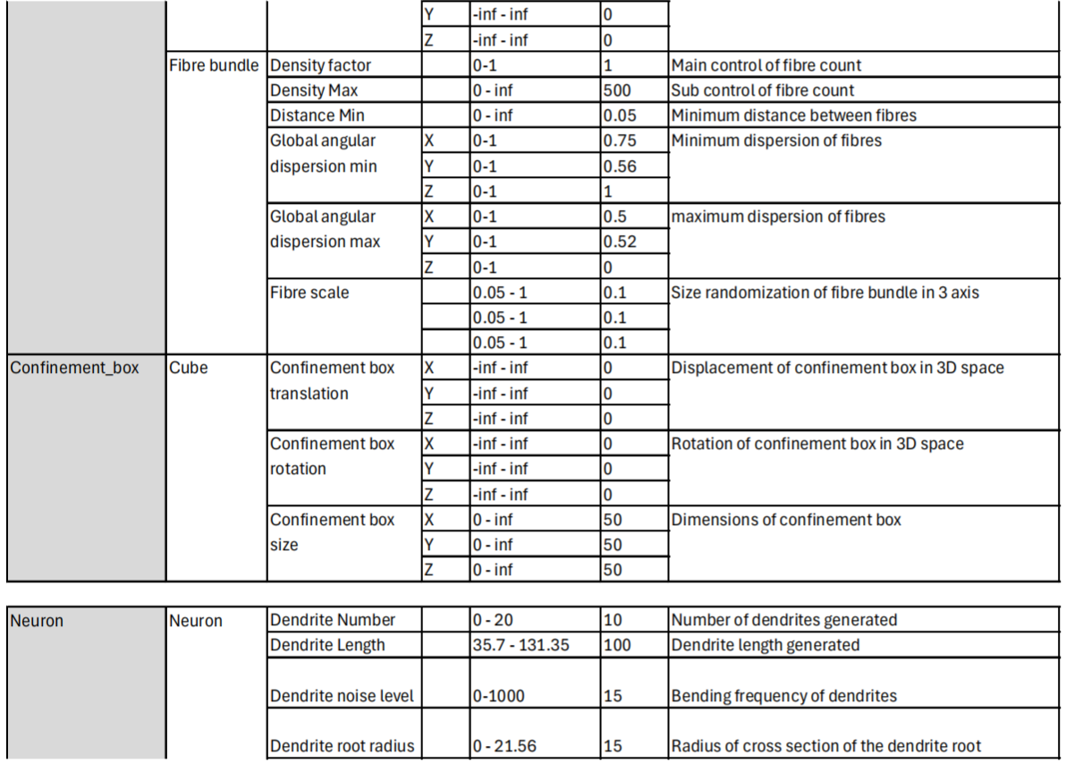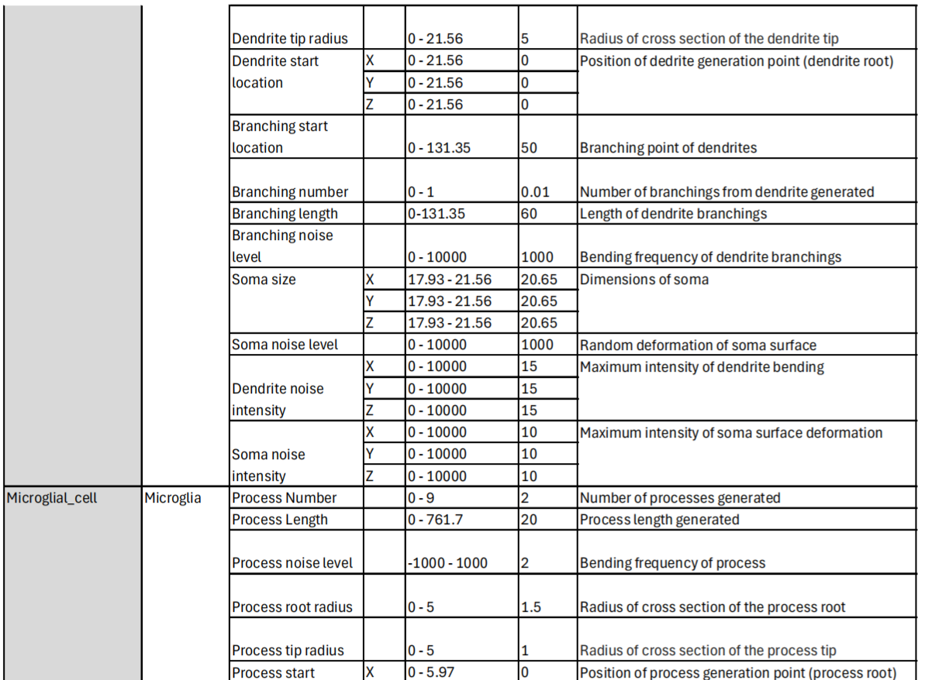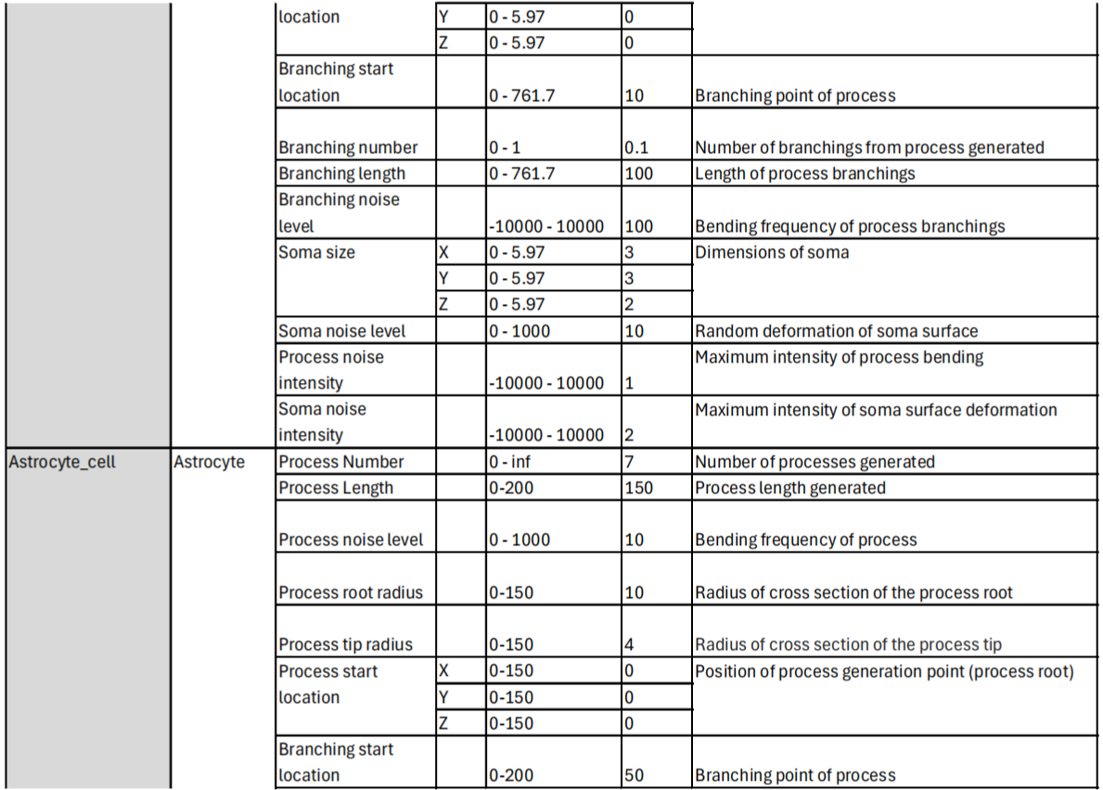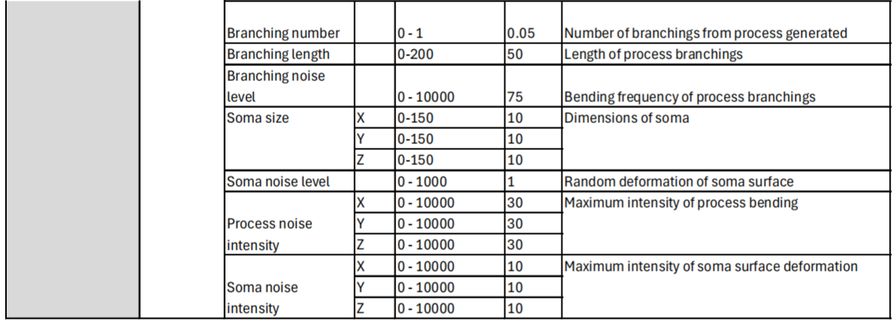 

**5. FAQs & Troubleshooting**

**Q: Why can’t I see changes to axon tortuosity after adjusting parameters like *Noise Offset* or *Tortuosity Level*?**

* **A**: Ensure the **Geometry Nodes** modifier is applied (*Modifier tab > Down Arrow > Apply*). Blender’s viewport preview may lag for complex meshes—toggle **Viewport Rendering** (solid/wireframe mode) or reduce **Preview Resolution** under *Geometry Nodes Settings*.

**Q: How do I avoid artifacts when using the confinement box?**

* **A**: Artifacts arise from residual geometry after clipping. To resolve:
  1. In the confinement box’s **Geometry Nodes**, enable the **Delete Geometry** node.
  2. Adjust the **Selection Threshold** to remove floating vertices/edges.
  3. Run **Mesh > Clean Up > Merge By Distance** (merge threshold: 0.001 mm).

**Q: The *Distribute Points on Faces* node creates overlapping axons. How do I fix this?**

* **A**: Adjust the **Minimum Distance** parameter (default: 2 µm) to enforce spacing between fibers. Increase this value for lower density/higher volume fractions.

**Q: What’s the purpose of the *Noise Texture* node in tortuosity modeling?**

* **A**: The **Noise Texture** node generates Perlin noise to drive naturalistic bends. Pair it with **Math nodes** (e.g., *Multiply, Scale*) to control bend frequency (*Tortuosity Level*) and smoothness (*Tortuosity Detail*).

**Q: How do I ensure reproducibility for research?**

* **A**:
  1. Document **Noise Seeds** and **Random Value** inputs.
  2. Export **.blend** files with applied modifiers.