==TEMPLATE ==

#include <iostream>
#include <vector>
#include <set>
#include <string>
#include <algorithm>
#include <unordered_map>
#include <map>
#include <stack>
#include <climits>
#include <functional>
#include <numeric>
#include <math.h>
#include <queue>
#include <random>
#include <bitset>
#include <array>
#include <iomanip>
#include <cfloat>
#include <chrono>
#include <cstring>
#include <assert.h>

using namespace std;
#define ll long long
#define pll pair<ll,ll>
#define all(v) v.begin(), v.end()
#define sz(v) (ll)v.size()
#define pb push_back
#define eb emplace_back
#define bpc __builtin_popcount
#define bpcll __builtin_popcountll
#define S second
#define F first
#define vec vector
#define show(x) cout<<#x<<"="<<x
#define double double

#define rep(i,a,b) for(ll i = (a); i <= (b); i++)
#define per(i,a,b) for(ll i = (a); i >= (b); i--)
#define fr(i,n) for(ll i = 0; i < n; i++)
#define rf(i,n) for(ll i = n-1; i>=0; i--)
#define prend(x) {cout<<(x)<<"\n"; return;}

#define PR cout<<
#define NDL <<"\n"<<
#define ND <<"\n"
#define SPS <<" "<<
#define SP <<" "

mt19937_64 gen(chrono::steady_clock::now().time_since_epoch().count());
uniform_int_distribution<ll> rnd(0,LLONG_MAX);
// ll randint = rnd(gen);

int inf = 1e9;
ll linf = 1e18;
const ll N = 200000;
const ll M = 998244353;
double pi = acos(-1);
bool multiCase = 0;
const double eps = 1e-6;

void solve(){}

void preprocess(){}

int main() {
#ifdef LOCAL
freopen("in.txt", "r", stdin);
freopen("out.txt", "w", stdout);
#endif
ios_base::sync_with_stdio(false);
cin.tie(NULL); cout.tie(NULL);
cout<<fixed<<setprecision(15);
ll tt = 1;
if(multiCase) cin >> tt;
preprocess();
while (tt--){
solve();
}
}
"-fdiagnostics-color=always",
"-g",
"-Wall",
"-Wextra",
"-Wshadow",
"-Wconversion",
"-Wformat=2",
"-Wnull-dereference",
"-Wduplicated-cond",
"-Wlogical-op",
"-Wuseless-cast",
"-D_GLIBCXX_DEBUG",
"-D_FORTIFY_SOURCE=2",
"${file}",
"-o",
"${fileDirname}\\${fileBasenameNoExtension}.exe"

==ALGEBRA==
[BOSTAN MORI]
using poly = vector<ll>;
poly operator*(const poly &a, const poly &b){
poly res(sz(a)+sz(b)-1);
for(int i = 0; i < sz(a); i++)
for(int j = 0; j < sz(b); j++)
res[i+j]+=a[i]*b[j];
return res;
}
ll bostan_mori(ll k, poly P, poly Q){
if(k == 0) return P[0];
poly Q1 = Q;
for(int i = 0; i < sz(Q); i++) if(i%2) Q1[i] = -Q1[i];
poly PQ1 = P*Q1; //new top but we only care about half of it
poly QQ1 = Q*Q1; //new bottom but half only even degrees are left
poly NP,NQ; // actual new polynomials
for(int i = 0; i < sz(PQ1); i++) if(i%2 == k%2) NP.pb(PQ1[i]);
for(int i = 0; i < sz(QQ1); i+=2) NQ.pb(QQ1[i]);
return bostan_mori(k/2, NP, NQ);
}

[EXT GCD]
int gcd(int a, int b, int& x, int& y) {
if (b == 0) {
x = 1;
y = 0;
return a;
}
int x1, y1;
int d = gcd(b, a % b, x1, y1);
x = y1;
y = x1 - y1 * (a / b);
return d;
}

[FFT]
//2^ceil(log2(x)) where x = Maximum size of Polynomial
const int MAX = 131100;
//Complex class: Quite faster than in-built C++ library as it uses only functions required
template<typename T> class cmplx {
private:
T x, y;
public:
cmplx () : x(0.0), y(0.0) {}
cmplx (T a) : x(a), y(0.0) {}
cmplx (T a, T b) : x(a), y(b) {}
T get_real() { return this->x; }
T get_img() { return this->y; }
cmplx conj() { return cmplx(this->x, -(this->y)); }
cmplx operator = (const cmplx& a) { this->x = a.x; this->y = a.y; return *this; }
cmplx operator + (const cmplx& b) { return cmplx(this->x + b.x, this->y + b.y); }
cmplx operator - (const cmplx& b) { return cmplx(this->x - b.x, this->y - b.y); }
cmplx operator * (const T& num) { return cmplx(this->x * num, this->y * num); }
cmplx operator / (const T& num) { return cmplx(this->x / num, this->y / num); }
cmplx operator * (const cmplx& b) {
return cmplx(this->x * b.x - this->y * b.y, this->y * b.x + this->x * b.y);
}
cmplx operator / (const cmplx& b) {
cmplx temp(b.x, -b.y); cmplx n = (*this) * temp;
return n / (b.x * b.x + b.y * b.y);
}
};
//T = int/long long as per polynomial coefficients
//S = double/long double as per precision required
template<typename T, typename S> struct FFT {
S PI;
int n, L, *rev, last;
cmplx<S> ONE, ZERO;
cmplx<S> *omega_powers;
FFT() {
PI = acos(-1.0);
ONE = cmplx<S>(1.0, 0.0);
ZERO = cmplx<S>(0.0, 0.0);
last = -1;
int req = 1 << (32 - __builtin_clz(MAX));
rev = new int[req];
omega_powers = new cmplx<S>[req];
}
~FFT() {
delete rev;
delete omega_powers;
}
void ReverseBits() {
if (n != last) {
for (int i = 1, j = 0; i < n; ++i) {
int bit = n >> 1;
for (; j >= bit; bit >>= 1) j -= bit;
j += bit;
rev[i] = j;
}
}
}
void DFT(vector<cmplx<S>> &A, bool inverse = false) {
for(int i = 0; i < n; ++i)
if (rev[i] > i) swap(A[i], A[rev[i]]);
for (int s = 1; s <= L; s++) {
int m = 1 << s, half = m / 2;
cmplx<S> wm(cosl(2.0 * PI / m), sinl(2.0 * PI / m));
if (inverse) wm = ONE / wm;
omega_powers[0] = ONE;
for(int k = 1; k < half; ++k) {
omega_powers[k] = omega_powers[k-1] * wm;
}
for (int k = 0; k < n; k += m) {
for (int j = 0; j < half; j++) {
cmplx<S> t = omega_powers[j] * A[k + j + half];
cmplx<S> u = A[k + j];
A[k + j] = u + t;
A[k + j + half] = u - t;
}
}
}
if (inverse) {
for (int i = 0; i < n; i++) A[i] = A[i] / n;
}
}
// c[k] = sum_{i=0}^k a[i] b[k-i]
vector<T> multiply(const vector<T> &a, const vector<T> &b) {
L = 0;
int sa = a.size(), sb = b.size(), sc = sa + sb - 1;
while ((1 << L) < sc) L++;
n = 1 << L;
ReverseBits();
last = n;
vector<cmplx<S>> aa(n, ZERO), bb(n, ZERO), cc;
for (int i = 0; i < sa; ++i) aa[i] = cmplx<S>(a[i], 0);
for (int i = 0; i < sb; ++i) bb[i] = cmplx<S>(b[i], 0);
DFT(aa, false); DFT(bb, false);
for (int i = 0; i < n; ++i) cc.push_back(aa[i] * bb[i]);
DFT(cc, true);
vector<T> ans(sc);
for (int i = 0; i < sc; ++i) ans[i] = cc[i].get_real() + 0.5;
return ans;
}
// c[k] = sum_{i=0}^k a[i] a[k-i], saves one FFT call
vector<T> multiply(const vector<T> &a) {
L = 0;
int sa = a.size(), sc = sa + sa - 1;
while ((1 << L) < sc) L++;
n = 1 << L;
ReverseBits();
last = n;
vector<cmplx<S>> aa(n, ZERO), cc;
for (int i = 0; i < sa; ++i) aa[i] = cmplx<S>(a[i], 0);
DFT(aa, false);
for (int i = 0; i < n; ++i) cc.push_back(aa[i] * aa[i]);
DFT(cc, true);
vector<T> ans(sc);
for (int i = 0; i < sc; ++i) ans[i] = cc[i].get_real() + 0.5;
return ans;
}
};

[GAUSS-ELIMINATION]
const double EPS = 1e-9;
const int INF = 2; // it doesn't actually have to be infinity or a big number
// O(min(n,m) * nm) || n=equation count m = variable count || answer is in ans if any solution exists
int gauss (vector < vector<double> > a, vector<double> & ans) {
int n = (int) a.size();
int m = (int) a[0].size() - 1;

vector<int> where (m, -1);
for (int col=0, row=0; col<m && row<n; ++col) {
int sel = row;
for (int i=row; i<n; ++i)
if (abs (a[i][col]) > abs (a[sel][col]))
sel = i;
if (abs (a[sel][col]) < EPS)
continue;
for (int i=col; i<=m; ++i)
swap (a[sel][i], a[row][i]);
where[col] = row;

for (int i=0; i<n; ++i)
if (i != row) {
double c = a[i][col] / a[row][col];
for (int j=col; j<=m; ++j)
a[i][j] -= a[row][j] * c;
}
++row;
}

ans.assign (m, 0);
for (int i=0; i<m; ++i)
if (where[i] != -1)
ans[i] = a[where[i]][m] / a[where[i]][i];
for (int i=0; i<n; ++i) {
double sum = 0;
for (int j=0; j<m; ++j)
sum += ans[j] * a[i][j];
if (abs (sum - a[i][m]) > EPS)
return 0;
}

for (int i=0; i<m; ++i)
if (where[i] == -1)
return INF;
return 1;
}

[GAUSS-MOD2]
const int MAXB = 500;
struct gauss {
vector<bitset<MAXB>> basis;
gauss() : basis(MAXB) {}
void add(bitset<MAXB> v) {
for (int i = MAXB - 1; i >= 0; i--) {
if (!v[i]) continue;
if (!basis[i].any()) {basis[i] = v;break;}
v ^= basis[i];
}
}
bool canRepresent(bitset<MAXB> x) const {
for (int i = MAXB - 1; i >= 0; i--) {
if (!x[i]) continue;
if (!basis[i].any()) return false;
x ^= basis[i];
}
return true;
}
};

[LINEAR-SIEVE]
const int N = 10000000;
vector<int> lp(N+1);
vector<int> pr;
int main(){
for (int i=2; i <= N; ++i) {
if (lp[i] == 0) {
lp[i] = i;
pr.push_back(i);
}
for (int j = 0; i * pr[j] <= N; ++j) {
lp[i * pr[j]] = pr[j];
if (pr[j] == lp[i])break;
}
}
}

[RANGE-SIEVE]
// O( (R-L+1)*loglog(R)+sqrt(R)loglog(sqrt(R)) )
vector<char> segmentedSieve(long long L, long long R) {
// generate all primes up to sqrt(R)
long long lim = sqrt(R);
vector<char> mark(lim + 1, false);
vector<long long> primes;
for (long long i = 2; i <= lim; ++i) {
if (!mark[i]) {
primes.emplace_back(i);
for (long long j = i * i; j <= lim; j += i)
mark[j] = true;
}
}

vector<char> isPrime(R - L + 1, true);
for (long long i : primes)
for (long long j = max(i * i, (L + i - 1) / i * i); j <= R; j += i)
isPrime[j - L] = false;
if (L == 1)
isPrime[0] = false;
return isPrime;
}

==COMBINATORICS==

[MODINT+FACTORIAL+C(n,k)]
#define ll long long
#define rep(i,a,b) for(ll i = (a); i <= (b); i++)
#define per(i,a,b) for(ll i = (a); i >= (b); i--)
const ll N = 2e5;
const ll M = 1e9+7;
// uses M outside
struct mint {
int v = 0;
mint(ll x=0){v=(x%M+M)%M;}
mint pow(ll e)const{
mint r = 1,a = *this;
for(;e;e>>=1,a=a*a) if(e&1)r=r*a;
return r;
}
mint inv()const{return pow(M-2);}
mint operator*(const mint& o)const{return mint(1ll*v*o.v%M);};
mint operator/(const mint& o)const{return *this * o.inv();}
mint operator+(const mint& o)const{int res = v+o.v; if(res>=M) res-=M; return mint(res);}
mint operator-(const mint& o)const{int res = v-o.v; if(res<0) res+=M; return mint(res);}
};
mint f[N+1], fi[N+1];
void initFact() {
f[0] = 1;
rep(i,1,N) f[i] = f[i-1] * i;
fi[N] = f[N].inv();
per(i,N-1,1)fi[i] = fi[i + 1] * (i + 1);
fi[0] = 1;
}
mint C(ll n, ll k){
if(k > n) return 0;
return f[n] * fi[k] * fi[n-k];
}

[STARS_AND_BARS]
mint strbr(ll st, ll br){return C(st+br-1, br-1);}
// returns the amount of ways to create arrays of SIZE(n) SUM(M) MAX_ELEMENT(mx)
// works in ~ O(M/mx) operations not including the time to compute C(n,k)
mint strbrUprBnd(ll n, ll m, ll mx){ // sum, gropus, max element(upperbound)
if(n < 0)return 0;
if(n == 0)return m == 0;
mint ans = 0;
for(ll t = 0; t <= n && t*(mx+1) <= m; t++){
mint added = C(n,t)*strbr(m-t*(mx+1), n);
if(t%2) added = added * (M-1);
ans = ans+added;
}
return ans;
}

==DATA_STRUCTURES==

[ROLLBACK_DSU+QUERY_TREE]
struct dsu_save {
int v, rnkv, u, rnku;
dsu_save() {}
dsu_save(int _v, int _rnkv, int _u, int _rnku)
: v(_v), rnkv(_rnkv), u(_u), rnku(_rnku) {}
};
struct dsu_with_rollbacks {
vector<int> p, rnk;
int comps;
stack<dsu_save> op;
dsu_with_rollbacks() {}
dsu_with_rollbacks(int n) {
p.resize(n);
rnk.resize(n);
for (int i = 0; i < n; i++) {
p[i] = i;
rnk[i] = 0;
}
comps = n;
}
int find_set(int v) {return (v == p[v]) ? v : find_set(p[v]); }
bool unite(int v, int u) {
v = find_set(v);
u = find_set(u);
if (v == u) return false;
comps--;
if (rnk[v] > rnk[u]) swap(v, u);
op.push(dsu_save(v, rnk[v], u, rnk[u]));
p[v] = u;
if (rnk[u] == rnk[v]) rnk[u]++;
return true;
}
void rollback() {
if (op.empty())return;
dsu_save x = op.top();
op.pop();
comps++;
p[x.v] = x.v;
rnk[x.v] = x.rnkv;
p[x.u] = x.u;
rnk[x.u] = x.rnku;
}
};
struct query {
int v, u;
bool united;
query(int _v, int _u) : v(_v), u(_u) {}
};
struct QueryTree {
vector<vector<query>> t;
dsu_with_rollbacks dsu;
int T;
QueryTree() {}
QueryTree(int _T, int n) : T(_T) {
dsu = dsu_with_rollbacks(n);
t.resize(4 * T + 4);
}
void add_to_tree(int v, int l, int r, int ul, int ur, query& q) {
if (ul > ur) return;
if (l == ul && r == ur) {
t[v].push_back(q);
return;
}
int mid = (l + r) / 2;
add_to_tree(2 * v, l, mid, ul, min(ur, mid), q);
add_to_tree(2 * v + 1, mid + 1, r, max(ul, mid + 1), ur, q);
}
void add_query(query q, int l, int r) {add_to_tree(1, 0, T - 1, l, r, q); }
void dfs(int v, int l, int r, vector<int>& ans) {
for (query& q : t[v]) {q.united = dsu.unite(q.v, q.u); }
if (l == r) ans[l] = dsu.comps;
else {
int mid = (l + r) / 2;
dfs(2 * v, l, mid, ans);
dfs(2 * v + 1, mid + 1, r, ans);
}
for (query q : t[v]) {
if (q.united) dsu.rollback();
}
}
vector<int> solve() {
vector<int> ans(T);
dfs(1, 0, T - 1, ans);
return ans;
}
};

[DSU]
struct DSU {
vector<int> f, siz;
DSU() {}
DSU(int n) {init(n); }
void init(int n) {
f.resize(n);
iota(f.begin(), f.end(), 0);
siz.assign(n, 1);
}
int leader(int x) {
while (x != f[x]) {x = f[x] = f[f[x]];}
return x;
}
bool same(int x, int y) {return leader(x) == leader(y); }
bool merge(int x, int y) {
x = leader(x);
y = leader(y);
if (x == y) return false;
siz[x] += siz[y];
f[y] = x;
return true;
}
int size(int x) {return siz[leader(x)]; }
};

[FENWICK]
template<typename T>
struct FEN{
int n;
vector<T> f;
FEN(int n) : n(n), f(n + 1) {}
void add(int id, T x) {
for (; id <= n; id += id & -id)f[id] += x;
}
ll get(int id) const {
ll sum = 0;
for (; id > 0; id -= id & -id) sum += f[id];
return sum;
}
ll range_sum(int l, int r) {return get(r) - get(l - 1);}
};

[LAZY_SPARSE_SEGTREE]
// Description: Segment tree with ability to add or set values of large intervals, and compute max of intervals.
// * Usage: Node* tr = new Node(v, 0, sz(v));
const int inf = 1e9;
struct Node {
Node *l = 0, *r = 0;
int lo, hi, mset = inf, madd = 0, val = -inf;
Node(int lo,int hi):lo(lo),hi(hi){} // Large interval of -inf
Node(vector<int>& v, int lo, int hi) : lo(lo), hi(hi) {
if (lo + 1 < hi) {
int mid = lo + (hi - lo)/2;
l = new Node(v, lo, mid); r = new Node(v, mid, hi);
val = max(l->val, r->val);
}
else val = v[lo];
}
int query(int L, int R) {
if (R <= lo || hi <= L) return -inf;
if (L <= lo && hi <= R) return val;
push();
return max(l->query(L, R), r->query(L, R));
}
void set(int L, int R, int x) {
if (R <= lo || hi <= L) return;
if (L <= lo && hi <= R) mset = val = x, madd = 0;
else {
push(), l->set(L, R, x), r->set(L, R, x);
val = max(l->val, r->val);
}
}
void add(int L, int R, int x) {
if (R <= lo || hi <= L) return;
if (L <= lo && hi <= R) {
if (mset != inf) mset += x;
else madd += x;
val += x;
}
else {
push(), l->add(L, R, x), r->add(L, R, x);
val = max(l->val, r->val);
}
}
void push() {
if (!l) {
int mid = lo + (hi - lo)/2;
l = new Node(lo, mid); r = new Node(mid, hi);
}
if (mset != inf)
l->set(lo,hi,mset), r->set(lo,hi,mset), mset = inf;
else if (madd)
l->add(lo,hi,madd), r->add(lo,hi,madd), madd = 0;
}
};

[PERSISTENT_SEGTREE]
#define MAXN 100
/* data type for individual
* node in the segment tree */
struct node
{
int val;
node* left, *right;
node() {}
node(node* l, node* r, int v){
left = l;
right = r;
val = v;
}
};
int arr[MAXN];
node* version[MAXN];
// Constructs Version-0
// Time Complexity : O(nlogn)
void build(node* n,int low,int high)
{
if (low==high) {
n->val = arr[low];
return;
}
int mid = (low+high) / 2;
n->left = new node(NULL, NULL, 0);
n->right = new node(NULL, NULL, 0);
build(n->left, low, mid);
build(n->right, mid+1, high);
n->val = n->left->val + n->right->val;
}
void upgrade(node* prev, node* cur, int low, int high,int idx, int value){
if (idx > high || idx < low || low > high) return;
if (low == high){
cur->val = value;
return;
}
int mid = (low+high) / 2;
if (idx <= mid){
cur->right = prev->right;
cur->left = new node(NULL, NULL, 0);
upgrade(prev->left,cur->left, low, mid, idx, value);
}else{
cur->left = prev->left;
cur->right = new node(NULL, NULL, 0);
upgrade(prev->right, cur->right, mid+1, high, idx, value);
}
cur->val = cur->left->val + cur->right->val;
}
int query(node* n, int low, int high, int l, int r)
{
if (l > high || r < low || low > high) return 0;
if (l <= low && high <= r)return n->val;
int mid = (low+high) / 2;
int p1 = query(n->left,low,mid,l,r);
int p2 = query(n->right,mid+1,high,l,r);
return p1+p2;
}
int main(int argc, char const *argv[]){
int A[] = {1,2,3,4,5};
int n = sizeof(A)/sizeof(int);
for (int i=0; i<n; i++)
arr[i] = A[i];
// creating Version-0
node* root = new node(NULL, NULL, 0);
build(root, 0, n-1);
version[0] = root;
// upgrading to version-1
version[1] = new node(NULL, NULL, 0);
upgrade(version[0], version[1], 0, n-1, 4, 1);
// upgrading to version-2
version[2] = new node(NULL, NULL, 0);
upgrade(version[1],version[2], 0, n-1, 2, 10);
cout << "In version 1 , query(0,4) : ";
cout << query(version[1], 0, n-1, 0, 4) << endl;
cout << "In version 2 , query(3,4) : ";
cout << query(version[2], 0, n-1, 3, 4) << endl;
cout << "In version 0 , query(0,3) : ";
cout << query(version[0], 0, n-1, 0, 3) << endl;
return 0;
}

[SEGTREE]
// 0 indexed segment tree
template<class T> struct segtree{
int _n, size, log;
vec<T> d;
segtree(): segtree(0){};
segtree(int n) : segtree(vec<T>(n)){};
segtree(const vec<T> &v) : _n(sz(v)){
log = 0;
while((1<<log) < _n) log++;
size = 1<<log;
d = vec<T>(2*size);
for(int i = 0; i < _n; i++) d[size+i] = v[i];
for(int i = size - 1; i>=1; i--) upd(i);
}
void upd(int k) {d[k] = d[2*k] + d[2*k+1];}
void set(int p, T x){
assert(0<=p && p < _n);
p+=size;
d[p] = x;
for(int i = 1; i <= log; i++) upd(p>>i);
}
T get(int p){
assert(0 <= p && p < _n);
return d[p+size];
}
// queryes [l, r) meaning {l, l+1 ... r-1}
T qr(int l, int r){
assert(0 <= l && l <= r && r <= _n);
T sml, smr;
l+=size;
r+=size;
while(l < r){
if(l&1) sml = sml + d[l++];
if(r&1) smr = d[--r] + smr;
l >>= 1;
r >>= 1;
}
return sml + smr;
}
// optional (v, id) are for constaint
// ll lrec(ll i, ll l, ll r, ll v, ll id){
// if(l > id) return -1;
// if(d[i].vala < v) return -1; // a check for constraint
// if(l+1 == r) return i - size;
// ll m = (l + r) / 2;
// ll rans = lrec(i*2+1,m,r,v,id);
// if(rans != -1) return rans;
// return lrec(i*2,l,m,v,id);
// };
// ll rrec(ll i, ll l, ll r, ll v, ll id){
// if(r-1 < id) return -1;
// if(d[i].valb < v) return -1; // a check for constraint
// if(l+1 == r) return i - size;
// ll m = (l+r) / 2;
// ll lans = rrec(i*2,l,m,v,id);
// if(lans != -1) return lans;
// return rrec(i*2+1, m,r,v,id);
// }
// ll qrl(ll v, ll id){
// return lrec(1,0,size,v,id);
// }
// ll qrr(ll v, ll id){
// return rrec(1,0,size,v,id);
// }
T allqr(){
return d[1];
}
};
// example struct for segtree declaration, values must be initialied by default and operator + is megring left and right nodes
struct Info{
int mxpre = 0;
int mxsuf = 0;
int tot = 0;

Info operator+(const Info &o){
int npre = max(mxpre, tot+o.mxpre);
int nsuf = max(o.mxsuf, o.tot + mxsuf);
return {npre, nsuf, tot + o.tot};
}

};

[LI_CHAO_INTERVALS]
// T should be a numeric type like long long, double, long double
template<typename T>
struct LiChao {
struct Line {
T a=0, b=std::numeric_limits<T>::lowest();
T eval(T x) const { return a * x + b; }
};
struct Node {
Line ln;
Node *l = nullptr, *r = nullptr;
};
T L, R;
Node* root = nullptr;
LiChao(T left, T right): L(left), R(right) {}
void addFull(Node*& n, T l, T r, Line nw) {
if (!n) { n = new Node(); }
T m = (l + r) / 2;
if (n->ln.eval(l) < nw.eval(l)) swap(n->ln, nw);
if (n->ln.eval(r) >= nw.eval(r) || l == r) return;
if (n->ln.eval(m) > nw.eval(m)) addFull(n->r, m+1, r, nw);
else {
swap(n->ln, nw);
addFull(n->l, l, m, nw);
}
}
void addRange(Node*& n, T l, T r, T ql, T qr, Line ln) {
if (qr < l || r < ql) return;
if (ql <= l && r <= qr) {
addFull(n, l, r, ln);
return;
}
T m = (l + r) / 2;
addRange(n->l, l, m, ql, qr, ln);
addRange(n->r, m+1, r, ql, qr, ln);
}
// Inserts y = a*x + b on interval [ql, qr]
void insert(T a, T b, T ql, T qr) {
addRange(root, L, R, ql, qr, Line{a,b});
}
T query(Node* n, T l, T r, T x) const {
if (!n) return std::numeric_limits<T>::lowest();
T res = n->ln.eval(x);
if (l == r) return res;
T m = (l + r) / 2;
if (x <= m) return max(res, query(n->l, l, m, x));
else return max(res, query(n->r, m+1, r, x));
}
T get(T x) const {
return query(root, L, R, x);
}
};

[LI_CHAO_ROLLBACK]
struct line{
int a,b;
line(int aa,int bb){
a=aa;
b=bb;
}
int eval(int x){ return a*x+b;}
};
double inter(line l1, line l2){ return ((double) l2.b-l1.b)/(l1.a-l2.a);}
struct lct{
vector<line> tree;
int n;
vector<vector<pair<int,line>>> history;
lct(int nn){
n=nn;
tree=vector<line>(4*n+8,line(0,0));
}
void add(line l, int ac, int acl, int acr){ //ac=1
if (ac==1) history.pb({});
if (l.eval(acl)>=tree[ac].eval(acl) && l.eval(acr)>=tree[ac].eval(acr)){
history.back().pb(pair<int,line>{ac,tree[ac]});
tree[ac]=l;
}
else if (l.eval(acl)<=tree[ac].eval(acl) && l.eval(acr)<=tree[ac].eval(acr)) return;
else{
double mid = inter(l,tree[ac]);
if ((mid<(acr+acl)/2+0.5) && l.eval(acl)>=tree[ac].eval(acl)) add(l,2*ac,acl,(acl+acr)/2);
if ((mid<(acr+acl)/2+0.5) && l.eval(acl)<=tree[ac].eval(acl)){
add(tree[ac],2*ac,acl,(acl+acr)/2);
history.back().pb(pair<int,line>{ac,tree[ac]});
tree[ac]=l;
}
if ((mid>=(acr+acl)/2+0.5) && l.eval(acr)>=tree[ac].eval(acr)) add(l,2*ac+1,(acl+acr)/2+1,acr);
if ((mid>=(acr+acl)/2+0.5) && l.eval(acr)<=tree[ac].eval(acr)){
add(tree[ac],2*ac+1,(acl+acr)/2+1,acr);
history.back().pb(pair<int,line>{ac,tree[ac]});
tree[ac]=l;
}
}
}

int getmax(int obj, int ac, int acl, int acr){
if (acl==acr) return tree[ac].eval(obj);
if (obj<=(acl+acr)/2) return max(tree[ac].eval(obj),getmax(obj,2*ac,acl,(acl+acr)/2));
else return max(tree[ac].eval(obj),getmax(obj,2*ac+1,(acl+acr)/2+1,acr));
}

void rollback(){
for (pair<int,line> p:history.back()) tree[p.first]=p.second;
history.pop_back();
}

};

[RMQ]
struct RMQ {
int n;
vector<vector<int>> st;
vector<int> lg;
const vector<long long>& a;
int op(int i, int j) const {return (a[i] < a[j] ? i : j); }
RMQ(const vector<long long>& arr) : n(arr.size()), a(arr) {
if (n == 0) return;
lg.assign(n + 1, 0);
for (int i = 2; i <= n; i++) lg[i] = lg[i >> 1] + 1;
int LOGN = lg[n];
st.assign(LOGN + 1, vector<int>(n));
for (int i = 0; i < n; i++) st[0][i] = i;
for (int k = 1; k <= LOGN; k++)
for (int i = 0; i + (1 << k) <= n; i++)
st[k][i] = op(st[k - 1][i], st[k - 1][i + (1 << (k - 1))]);
}
// Query for the minimum elements index in the range [l, r] (inclusive)
int qr(int l, int r) const {
if (l > r) return 1e9; // Or handle error appropriately
int k = lg[r - l + 1];
return op( st[k][l], st[k][r - (1 << k) + 1]);
}
};
[TRIE]
int B = 30; // 1<<30 max bytes

struct node{
int nxt[2] = {-1,-1};
int cnt = 0;
int id = 0;
};
vector<node> T;
void add(int x, int v, int id){
for(int i = B; i>=0; i--){
int b = (x>>i)&1;
if(T[v].nxt[b] == -1){
T[v].nxt[b] = sz(T);
T.pb(node());
}
v = T[v].nxt[b];
T[v].cnt++;
if(i == 0){
T[v].id = id;
}
}
};
void remove(int x, int v, int id){
for(int i = B; i >= 0; i--){
int b = (x>>i)&1;
v = T[v].nxt[b];
T[v].cnt--;
if(i == 0) T[v].id = 0;
}
};
int getMin(int x, int v){
for(int i = B; i>= 0; i--){
int b = (x>>i)&1;
if(b==1){
ll xx= 1;
}
if(T[v].nxt[b] != -1 && T[T[v].nxt[b]].cnt) v = T[v].nxt[b];
else v = T[v].nxt[b^1];
}
return T[v].id;
}

[2_SAT]
struct TwoSat {
int N;
vector<vi> gr;
vi values;

TwoSat(int n = 0) : N(n), gr(2 * n) {}

int addVar() {
gr.emplace_back();
gr.emplace_back();
return N++;
}

void either(int f, int j){
//cerr << "Either: " << f << ' ' << j << endl;
f = max(2 * f, -1-2*f);
j = max(2*j, -1-2*j);
gr[f].push_back(j^1);
gr[j].push_back(f^1);
}

void implies(int a, int b) {
either(~a, b);
}

void atMostOne(const vi& li) {
if (sz(li) <= 1) return;
int cur = ~li[0];
rep(i, 2, sz(li)) {
int next = addVar();
either(cur, ~li[i]);
either(cur, next);
either(~li[i], next);
cur = ~next;
}
either(cur, ~li[1]);
}

vi val, comp, z; int time = 0;

int dfs(int i){
int low = val[i] = ++time, x; z.push_back(i);
for(int e : gr[i]) if(!comp[e])
low = min(low, val[e] ?: dfs(e));
if (low == val[i]) do {
x = z.back(); z.pop_back();
comp[x] = low;
if (values[x >> 1] == -1)
values[x>>1] = x & 1;
} while (x != i);
return val[i] = low;
}

bool solve() {
values.assign(N, -1);
val.assign(2*N, 0); comp = val;
rep(i, 0, 2*N) if (!comp[i]) dfs(i);
rep(i, 0, N) if (comp[2*i] == comp[2*i+1]) return 0;
return 1;
}
};

==GENERAL==

[CHT_WITH_MIN_FENWICK]
using ll = long long;
#define sz(v) (int)v.size()
struct line {
ll k, b;
line(ll k, ll b) : k(k), b(b){}
double eval(ll x) { return x * k + b; }
double interX(line o) { return ((double)o.b - (double)b) / ((double)k - (double)o.k); }
bool behind(line a, line o) {
return (a.b - b) * (k - o.k) <= (o.b - b) * (k - a.k);
}
};
struct lines {
deque<line> dq;
void add(line l) {
while (sz(dq) > 1 && dq[sz(dq)-2].behind(l, dq.back())) dq.pop_back();
dq.push_back(l);
}
ll qr(ll x) {
while (sz(dq) > 1 && dq[0].eval(x) >= dq[1].eval(x)) dq.pop_front();
if (sz(dq) == 0) return 1e18;
return dq[0].eval(x);
}
};
struct fen {
vector<lines> v;
ll n;
fen(ll n):n(n) {
v.resize(n);
}
void add(ll id, line l) {
for (; id < n; id += id & (-id))v[id].add(l);
ll x = 5;
}
ll get(ll id, ll i) {
ll mn = 1e18
for (; id>0 ; id -= id & (-id)) mn = min(mn, v[id].qr(i));
return mn;
}
};

[READING_STRINGS]
// reading chars
//
// char ch;
// cin.get(ch);

// reading a line and splitting with spaces (might be slow)
//
// string line;
// getline(cin,line);
// // PR line ND;
// stringstream ss(line);
// string s;
// vec<string> v;
// while(ss>>s) v.pb(s);

[SUBMASK_DP]
int main(){
int k = 20;
int dp[1<<20];
// dp[x] = sum(dp[i]) i is a submask of x || O (k * 2^k)
for (int i = 0; i < k; i++) {
for (int mask = 0; mask < (1 << k); mask++) {
if (mask & (1 << i)) {
dp[mask] += dp[mask ^ (1 << i)];
}
}
}
int mask = 0x10101001;
int sum = 0;
// iterate over all submasks of mask || O(3^k)
for (int sub = mask; sub; sub = (sub - 1) & mask) {
sum += sub;
}
}

[TREE_HASHING]
map<vec<ll>,ll> hashes;
vec<vec<ll>> g;
ll root = 0;
ll lastid = 0;
ll hashTree(ll id, ll p){
vec<ll> children;
for(auto u : g[id]){
if(u == p) continue;
children.pb(hashTree(u,id));
}
sort(all(children));
if(hashes.count(children)) return hashes[children];
hashes[children] = ++lastid;
return lastid;
}

==GEOMETRY==

[GENERAL]
constexpr double eps = 1e-10;
constexpr int sign(double x) { return x < -eps ? -1 : (x > eps ? 1 : 0); }
constexpr double sqr_diff(double a, double b) { return (a + b) * (a - b); }
struct Point {
double x = 0, y = 0;
Point() = default;
Point(double x, double y) : x(x), y(y){};
auto len2() const { return x * x + y * y; }
auto len() const { return std::hypot(x, y); }
Point operator-() const { return {-x, -y}; }
Point operator*(double k) const { return {x * k, y * k}; }
Point operator/(double k) const { return {x / k, y / k}; }
Point unit() const { return *this / len(); }
Point normal() const { return {-y, x}; }
auto angle() const { return std::atan2(y, x); }
};
using Vector = Point;
using Line = std::pair<Point, Point>;
using Segment = Line;
using Circle = std::pair<Point, double>;
using Polygon = std::vector<Point>;
using Triangle = std::tuple<Point, Point, Point>;

Vector operator+(const Vector &a, const Vector &b) { return {a.x + b.x, a.y + b.y}; }
Vector operator-(const Vector &a, const Vector &b) { return {a.x - b.x, a.y - b.y}; }
Vector operator*(double k, const Vector &a) { return {a.x * k, a.y * k}; }
auto operator==(const Point &A, const Point &B) { return sign((A - B).len()) == 0; }
auto dot(const Vector &a, const Vector &b) { return a.x * b.x + a.y * b.y; }
auto det(const Vector &a, const Vector &b) { return a.x * b.y - a.y * b.x; }
auto middle(const Point &A, const Point &B) { return 0.5 * (A + B); }
auto vec(const Line &l) { return l.second - l.first; }
auto len(const Segment &s) { return vec(s).len(); }
auto len2(const Segment &s) { return vec(s).len2(); }
auto angle(const Vector &a, const Vector &b) {
auto tmp = a.len() * b.len();
return sign(sqrt(tmp)) == 0 ? 0 : acos(dot(a, b) / tmp);
}
enum class Side : int { left = -1, on = 0, right = 1 };
auto side_of_line(const Point &P, const Line &l) {
const auto &[A, B] = l;
return Side(sign(det(P - A, B - A)));
}
auto projection(const Point &P, const Line &l) {
const auto &[A, B] = l;
Vector v = B - A;
return A + dot(v, P - A) * v / v.len2();
}
auto symmetry(const Point &P, const Line &l) { return 2 * projection(P, l) - P; }
auto point_line_distance(const Point &P, const Line &l) {
const auto &[A, B] = l;
Vector v1 = B - A, v2 = P - A;
return std::fabs(det(v1, v2) / v1.len());
}
auto point_on_segment(const Point &P, const Segment &s) {
const auto &[A, B] = s;
return side_of_line(P, {A, B}) == Side::on && sign(dot(A - P, B - P)) <= 0;
}
auto point_segment_distance(const Point &P, const Segment &s) {
const auto &[A, B] = s;
auto v1 = B - A, v2 = P - A, v3 = P - B;
if (sign(dot(v1, v2)) < 0) { return v2.len(); }
if (sign(dot(v1, v3)) > 0) { return v3.len(); }
return det(v1, v2) / v1.len();
}
auto parallel(const Line &l1, const Line &l2) { return sign(det(vec(l1), vec(l2))) == 0; }
enum class LineLineRelation { parallel, identical, intersecting };
auto line_intersection(const Line &l1, const Line &l2) -> std::pair<LineLineRelation, std::optional<Point>> {
const auto &[A, B] = l1;
const auto &[C, D] = l2;
if (parallel(l1, l2)) {
if (side_of_line(A, l2) == Side::on) { return {LineLineRelation::identical, std::nullopt}; }
return {LineLineRelation::parallel, std::nullopt};
}
double s1 = det(D - A, C - A);
double s2 = det(C - B, D - B);
return {LineLineRelation::intersecting, A + (B - A) * (s1 / (s1 + s2))};
}
auto triangle_area(const Triangle &t) {
const auto &[A, B, C] = t;
return det(B - A, C - A) * 0.5;
}

[CONVEX_HULL]
#define all(vec) vec.begin(), vec.end()
#define sz(x) int(x.size())
template < typename T = int > struct Point {
T x, y;
Point(T _x = 0, T _y = 0) : x(_x), y(_y) {}
Point(const Point &p) : x(p.x), y(p.y) {}
Point operator + (const Point &p) const { return Point(x + p.x, y + p.y); }
Point operator - (const Point &p) const { return Point(x - p.x, y - p.y); }
Point operator * (T c) const { return Point(x * c, y * c); }
Point operator / (T c) const { return Point(x / c, y / c); }
bool operator == (const Point &p) const { return x == p.x && y == p.y; }
bool operator != (const Point &p) const { return x != p.x || y != p.y; }
bool operator < (const Point &p) const { return make_pair(y, x) < make_pair(p.y, p.x); }
bool operator > (const Point &p) const { return make_pair(y, x) > make_pair(p.y, p.x); }
bool operator <= (const Point &p) const { return make_pair(y, x) <= make_pair(p.y, p.x); }
bool operator >= (const Point &p) const { return make_pair(y, x) >= make_pair(p.y, p.x); }
friend istream& operator >> (istream &in, Point &p) { return in >> p.x >> p.y; }
friend ostream& operator << (ostream &out, const Point &p) { return out << p.x << ' ' << p.y; }
T dot(const Point &p) const { return x * p.x + y * p.y; }
T cross(const Point &p) const { return x * p.y - y * p.x; }
T cross(const Point &a, const Point &b) const { return (a - *this).cross(b - *this); }
T dist() const { return x * x + y * y; }
T dist(const Point &p) const { return (*this - p).dist(); }
double distance() const { return sqrt(1.0 * dist()); }
double distance(const Point &p) const { return sqrt(1.0 * dist(p)); }
double angle() const { return atan2(y, x); }
double angle(const Point &p) const { return atan2(cross(p), dot(p)); }
Point unit() const { return *this / dist(); }
Point perp() const { return Point(-y, x); }
Point rotate(double a) const { return Point(x * cos(a) - y * sin(a), x * sin(a) + y * cos(a)); }
Point rotate(const Point &p, double a) const { return (*this - p).rotate(a) + p; }
Point normal() const { return perp().unit(); }
};
template < typename T = int > struct Convex_Hull {

typedef Point < T > point;

// Returns the orientation of the point c with respect to the line a-b
int orientation(const point& a, const point& b, const point& c) {
T val = (b.y - a.y) * (c.x - b.x) - (b.x - a.x) * (c.y - b.y);
if(val < 0) return -1; // clockwise
if(val > 0) return 1; // counter-clockwise
return 0; // collinear
}
// Returns true if c is on the left side of the line a-b
bool cw(const point& a, const point& b, const point& c, bool include_collinear) {
int o = orientation(a, b, c);
return o < 0 || (include_collinear && o == 0);
}
// return if a-b-c are collinear
bool is_collinear(const point& a, const point& b, const point& c) {
return orientation(a, b, c) == 0;
}
// Returns a list of points on the convex hull
vector < point > Convex_Points;
Converx_Hull(vector < point > &points, bool include_collinear = false) {
point p0 = *min_element(all(points));
sort(all(points), [&](const point& a, const point& b) {
int o = orientation(p0, a, b);
if(o == 0) return p0.dist(a) < p0.dist(b);
return o < 0;
});
// remove redundant points
points.erase(unique(all(points)), points.end());
if(include_collinear){
int idx = sz(points) - 1;
// remove collinear points from the end
while(idx > 0 && is_collinear(p0, points[idx], points.back())) idx--;
reverse(points.begin() + idx + 1, points.end());
}
for(const point& p : points) {
while(sz(Convex_Points) > 1 && !cw(Convex_Points[sz(Convex_Points) - 2], Convex_Points.back(), p, include_collinear))
Convex_Points.pop_back();
Convex_Points.push_back(p);
}
}
};

[HALFPLANE_INTERSECTION]
struct Point {
long double x, y;
explicit Point(long double x = 0, long double y = 0) : x(x), y(y) {}
// Addition, substraction, multiply by constant, dot product, cross product.
friend Point operator + (const Point& p, const Point& q) {
return Point(p.x + q.x, p.y + q.y);
}
friend Point operator - (const Point& p, const Point& q) {
return Point(p.x - q.x, p.y - q.y);
}
friend Point operator * (const Point& p, const long double& k) {
return Point(p.x * k, p.y * k);
}
friend long double dot(const Point& p, const Point& q) {
return p.x * q.x + p.y * q.y;
}
friend long double cross(const Point& p, const Point& q) {
return p.x * q.y - p.y * q.x;
}
};
struct Halfplane {
// 'p' is a passing point of the line and 'pq' is the direction vector of the line.
Point p, pq;
long double angle;
Halfplane() {}
Halfplane(const Point& a, const Point& b) : p(a), pq(b - a) {
angle = atan2l(pq.y, pq.x);
}
// Every half-plane allows the region to the LEFT of its line.
bool out(const Point& r) { return cross(pq, r - p) < -eps; }
bool operator < (const Halfplane& e) const { return angle < e.angle;}
// Intersection point of the lines of two half-planes. It is assumed they're never parallel.
friend Point inter(const Halfplane& s, const Halfplane& t) {
long double alpha = cross((t.p - s.p), t.pq) / cross(s.pq, t.pq);
return s.p + (s.pq * alpha);
}
};
vector<Point> hp_intersect(vector<Halfplane>& H) {
Point box[4] = {Point(inf, inf), Point(-inf, inf), Point(-inf, -inf), Point(inf, -inf) };
for(int i = 0; i<4; i++) { // Add bounding box half-planes.
Halfplane aux(box[i], box[(i+1) % 4]);
H.push_back(aux);
}
sort(H.begin(), H.end());
deque<Halfplane> dq;
int len = 0;
for(int i = 0; i < int(H.size()); i++) {
// Remove from the back and front of the deque while last half-plane is redundant
while (len > 1 && H[i].out(inter(dq[len-1], dq[len-2]))) {dq.pop_back();--len;}
while (len > 1 && H[i].out(inter(dq[0], dq[1]))) {dq.pop_front();--len;}
if (len > 0 && fabsl(cross(H[i].pq, dq[len-1].pq)) < eps) { // this check is needed if we have parallel planes
// Opposite parallel half-planes that ended up checked against each other.
if (dot(H[i].pq, dq[len-1].pq) < 0.0) return vector<Point>();
// Same direction half-plane: keep only the leftmost half-plane.
if (H[i].out(dq[len-1].p)) {dq.pop_back();--len;}
else continue;
}
dq.push_back(H[i]);
++len;
}
// Final cleanup: Check half-planes at the front against the back and vice-versa
while (len > 2 && dq[0].out(inter(dq[len-1], dq[len-2]))) {dq.pop_back();--len;}
while (len > 2 && dq[len-1].out(inter(dq[0], dq[1]))) {dq.pop_front();--len;}
if (len < 3) return vector<Point>(); // no intersection
vector<Point> ret(len); // reconstruct the points(may have duplicates if 3 lines cross on a point)
for(int i = 0; i+1 < len; i++) ret[i] = inter(dq[i], dq[i+1]);
ret.back() = inter(dq[len-1], dq[0]);
return ret;
}

[MINCIRCLE+POLYSTUFF]
template <class T> int sgn(T x) { return (x > 0) - (x < 0); }
template<class T>
struct Point {
typedef Point P;
T x, y;
explicit Point(T x=0, T y=0) : x(x), y(y) {}
bool operator<(P p) const { return tie(x,y) < tie(p.x,p.y); }
bool operator==(P p) const { return tie(x,y)==tie(p.x,p.y); }
P operator+(P p) const { return P(x+p.x, y+p.y); }
P operator-(P p) const { return P(x-p.x, y-p.y); }
P operator*(T d) const { return P(x*d, y*d); }
P operator/(T d) const { return P(x/d, y/d); }
T cross(P p) const { return x*p.y - y*p.x; }
T dist2() const { return x*x + y*y; }
double dist() const { return sqrt((double)dist2()); }
P perp() const { return P(-y, x); } // rotates +90 degrees
};
typedef Point<double> P;
P ccCenter(const P& A, const P& B, const P& C) {
P b = C-A, c = B-A;
return A + (b*c.dist2()-c*b.dist2()).perp()/b.cross(c)/2;
}
pair<P, double> mec(vector<P> ps) {
shuffle(all(ps), mt19937(time(0)));
P o = ps[0];
double r = 0, EPS = 1 + 1e-8;
fr(i,sz(ps)) if ((o - ps[i]).dist() > r * EPS) {
o = ps[i], r = 0;
fr(j,i) if ((o - ps[j]).dist() > r * EPS) {
o = (ps[i] + ps[j]) / 2;
r = (o - ps[i]).dist();
fr(k,j) if ((o - ps[k]).dist() > r * EPS) {
o = ccCenter(ps[i], ps[j], ps[k]);
r = (o - ps[i]).dist();
}
}
}
return {o, r};
}
template<class T>
T polygonArea2(vector<Point<T>>& v) {
T a = v.back().cross(v[0]);
rep(i,0,sz(v)-1) a += v[i].cross(v[i+1]);
return a;
}
P polygonCenter(const vector<P>& v) {
P res(0, 0); double A = 0;
for (int i = 0, j = sz(v) - 1; i < sz(v); j = i++) {
res = res + (v[i] + v[j]) * v[j].cross(v[i]);
A += v[j].cross(v[i]);
}
return res / A / 3;
}

[SIMPSON_INTERGATION]
// function of integration
double f(double x){
return x*x;
}
double simpson(double fl,double fr,double fmid,double l,double r) { return (fl+fr+4.0*fmid)*(r-l)/6.0; }
double rsimpson(double slr,double fl,double fr,double fmid,double l,double r)
{
double mid = (l+r)*0.5;
double fml = f((l+mid)*0.5);
double fmr = f((mid+r)*0.5);
double slm = simpson(fl,fmid,fml,l,mid);
double smr = simpson(fmid,fr,fmr,mid,r);
if(fabs(slr-slm-smr) < eps) return slm+smr;
return rsimpson(slm,fl,fmid,fml,l,mid)+rsimpson(smr,fmid,fr,fmr,mid,r);
}
double integrate(double l,double r)
{
double mid = (l+r)*.5;
double fl = f(l);
double fr = f(r);
double fmid = f(mid);
return rsimpson(simpson(fl,fr,fmid,l,r),fl,fr,fmid,l,r);
}

==GRAPHS==
[BRIDGES]

void storeBridge(ll x, ll y){ // store how you want}
void findBridges(vec<vec<ll>> &adj, ll n){
ll timer = 0;
vec<bool> vis(n+1);
vec<ll> tin(n+1,-1), low(n+1,-1);
auto dfs = [&](auto &&dfs, ll id, ll p = -1)-> void{
vis[id] = 1;
tin[id] = low[id] = timer++;
for(auto u : adj[id]){
if(u ==p) continue;
if(vis[u]) low[id] = min(low[id], tin[u]);
else{
dfs(dfs, u, id);
low[id] = min(low[id], low[u]);
if(low[u] > tin[id]) storeBridge(id,u);
}
}
};
rep(i,1,n) if(!vis[i]) dfs(dfs,i);
}
// different dfs if multiple edges are allowed
// makes sure that the parent only gets skipped once
auto dfs = [&](auto &&dfs, ll id, ll p = -1)-> void{
vis[id] = 1;
tin[id] = low[id] = timer++;
bool parSkipped = 0;
for(auto u : adj[id]){
if(u ==p && !parSkipped){
parSkipped = 1;
continue;
}
if(vis[u]) low[id] = min(low[id], tin[u]);
else{
dfs(dfs, u, id);
low[id] = min(low[id], low[u]);
if(low[u] > tin[id]) storeBridge(id,u);
}
}
};

[CENTROID]
// not needed
struct CentInfo{
vec<pair<ll,ll>> dists;
ll cid = 0;
vec<pair<ll,ll>> parinfo;
};
vector<CentInfo> info;
struct Centroid{
int n = 0;
vector<ll> siz,dead,par;
vec<vec<ll>> g;
Centroid(int n) : n(n), siz(n), dead(n), par(n), g(n) {}
void addEdge(int x, int y){g[x].pb(y); g[y].pb(x);}
int sizeDfs(int id, int p){
siz[id] = 1;
for(auto u : g[id]){
if(u == p || dead[u]) continue;
siz[id]+=sizeDfs(u,id);
}
return siz[id];
}
int findCentroid(int id, int p, int tot){
for(auto u : g[id])
if(u != p && !dead[u] && siz[u] > tot/2)
return findCentroid(u,id,tot);
return id;
}
void distsDfs(int id, int p, int c, int cd = 0){
info[c].dists.pb({cd,id});
info[id].parinfo.pb({c,cd});
for(auto u : g[id]){
if(u == p || dead[u]) continue;
distsDfs(u,id,c,cd+1);
}
}
void build(int id = 0, int p = -1){
par[id] = p;
int tot = sizeDfs(id, p);
int c = findCentroid(id, p, tot);
dead[c] = 1;
distsDfs(c,p,c); // not needed
sort(all(info[c].dists)); // not needed
for(auto u : g[c]) if(!dead[u]) build(u, c);
}
};

[DINIC_FLOW]
// find MAX FLOW in a graph.
// O(sqrt(V)*E) - in bipartite graph
// O(min(v^(2/3),sqrt(E)) * E) - in Unit capacity graph
// O(v^2*E) - in worst graphs
// ===

// needed this kind of array for fast updates on capacities;
struct edge{
ll to, capacity;
}edges[N];
ll vertex_count = 100;
ll s = 0, t = vertex_count+1; // SOURCE is at [0] index and SINK is at [vertex_count+1], in total vertex_count+2
vector<ll> adj[N];
ll currentEdgeId = 0;
void addEdge(ll from, ll to, ll capacity){
edges[currentEdgeId] = {to, capacity};
adj[from].pb(currentEdgeId);
edges[currentEdgeId+1] = {from, 0};
adj[to].pb(currentEdgeId+1);
currentEdgeId+=2; // for later additions
}

ll level[N]; // for tracking which level a vertex is from source
bool bfs(){
// reset before start
fill(level,level+N,0);
level[s] = 1;

queue<ll> q; q.push(s);
while(!q.empty()){
ll u = q.front(); q.pop();
for(int i = 0; i < sz(adj[u]); i++){
ll eid = adj[u][i];
auto [v,capacity] = edges[eid];
if(capacity > 0 && level[v] == 0){
level[v] = level[u]+1;
q.push(v); // you could check if current is the SINK and stop but finishing probably helps dfs in saturating the paths
}
}
}
return level[t] != 0;
}
// try to add as much flow as possible and prune bad vertexes.
ll dfs(ll u, ll pushed){
if(pushed == 0 || u == t) return pushed;
ll cur = 0;
for(int i = 0; i < sz(adj[u]); i++){
ll eid = adj[u][i];
auto [v,capacity] = edges[eid];
if(capacity > 0 && level[v] == level[u] + 1){
ll pos = dfs(v, min(pushed-cur, capacity));
edges[eid].capacity-=pos; // subtract new flow from forward edge
edges[eid^1].capacity+=pos; // add new flow to reverse edge
cur+=pos; if(cur == pushed) break;
}
}
if(cur < pushed) level[u] = 0; // if the given flow was not used fully, no more flow can go here so prune this node for others
return cur;
}
ll dinic(){
ll current = 0;
while(bfs()) current+=dfs(s,inf);
return current;
}

[MIN_COST_MAX_FLOW]
/**
* Description: Minimum-cost maximum flow, assumes no negative cycles.
* It is possible to choose negative edge costs such that the first
* run of Dijkstra is slow, but this hasn't been an issue in the past.
* Edge weights $\ge 0$ for every subsequent run. To get flow through
* original edges, assign ID's during \texttt{ae}.
* Time: Ignoring first run of Dijkstra, $O(FM\log M)$
* if caps are integers and $F$ is max flow.
* Source: GeeksForGeeks
* https://courses.csail.mit.edu/6.854/06/scribe/s12-minCostFlowAlg.pdf
* running time is only pseudo-polynomial; see https://codeforces.com/blog/entry/70740
* https://en.wikipedia.org/wiki/Johnson%27s_algorithm (to get non-negative weights)
* https://codeforces.com/contest/1316/submission/72472865
* mango_lassi, min cost circulation w/ capacity scaling
* Verification: https://codeforces.com/contest/164/problem/C
* https://codeforces.com/contest/316/problem/C2
* TLEs, don't use priority queue
*/

template<class T>
bool ckmin(T &a, const T &b) {return b < a ? a = b, 1 : 0; }
using namespace std;
struct MCMF {
using F = ll; using C = ll; // flow type, cost type
struct Edge { int to; F flo, cap; C cost; };
int N; vec<C> p, dist; vec<int> pre; vec<Edge> eds; vec<vec<int>> adj;
void init(int _N) { N = _N;
p.resize(N), dist.resize(N), pre.resize(N), adj.resize(N); }
void ae(int u, int v, F cap, C cost) { assert(cap >= 0);
adj[u].pb(sz(eds)); eds.pb({v,0,cap,cost});
adj[v].pb(sz(eds)); eds.pb({u,0,0,-cost});
} // use asserts, don't try smth dumb
bool path(int s, int t) { // find lowest cost path to send flow through
const C inf = numeric_limits<C>::max(); fr(i,N) dist[i] = inf;
using T = pair<C,int>; priority_queue<T,vector<T>,greater<T>> todo;
todo.push({dist[s] = 0,s});
while (sz(todo)) { // Dijkstra
T x = todo.top(); todo.pop(); if (x.F > dist[x.S]) continue;
for(auto e : adj[x.S]) { const Edge& E = eds[e]; // all weights should be non-negative
if (E.flo < E.cap && ckmin(dist[E.to],x.F+E.cost+p[x.S]-p[E.to]))
pre[E.to] = e, todo.push({dist[E.to],E.to});
}
} // if costs are doubles, add some EPS so you
// don't traverse ~0-weight cycle repeatedly
return dist[t] != inf; // return flow
}
pair<F,C> calc(int s, int t) { assert(s != t);
fr(_,N) fr(e,sz(eds)) { const Edge& E = eds[e]; // Bellman-Ford
if (E.cap) ckmin(p[E.to],p[eds[e^1].to]+E.cost); }
F totFlow = 0; C totCost = 0;
while (path(s,t)) { // p -> potentials for Dijkstra
fr(i,N) p[i] += dist[i]; // don't matter for unreachable nodes
F df = numeric_limits<F>::max();
for (int x = t; x != s; x = eds[pre[x]^1].to) {
const Edge& E = eds[pre[x]]; ckmin(df,E.cap-E.flo); }
totFlow += df; totCost += (p[t]-p[s])*df;
for (int x = t; x != s; x = eds[pre[x]^1].to)
eds[pre[x]].flo += df, eds[pre[x]^1].flo -= df;
} // get max flow you can send along path
return {totFlow,totCost};
}
};

[KUHN]
int n, k;
vector<vector<int>> g;
vector<int> mt;
vector<ll> it;
bool try_kuhn(int v, ll cit) {
if (it[v] == cit) return false;
it[v] = cit;
for (int to : g[v]) {
if (mt[to] == -1 || try_kuhn(mt[to], cit)) {
mt[to] = v;
return true;
}
}
return false;
}
int main(){
mt.assign(k, -1);
ll cit = 1;
for (int v = 0; v < n; ++v) {
try_kuhn(v, cit);
cit++;
}
}

[FLOYD WARSHALL]
int main(){
vec<vec<ll>> dist;
ll n;
for (int k = 0; k < n; k++) {
for (int i = 0; i < n; i++) {
for (int j = 0; j < n; j++) {
if(dist[i][k] != 1e8 && dist[k][j]!= 1e8)
dist[i][j] = min(dist[i][j],dist[i][k] + dist[k][j]);
}
}
}
}

[LCA_BINARY_LIFTING]
ll n, L, timer;
vec<vec<ll>> g(n),up; // adjacency graph
vec<ll> tin(n), tout(n);
void dfsL(ll id, ll p){
tin[id] = ++timer;
up[0][id] = p;
for(int i = 1; i <= L; i++) up[i][id] = up[i-1][up[i-1][id]];
for(auto u : g[id]) if(u != p) dfsL(u,id);
tout[id] = ++timer;
}
bool isAncestor(ll u, ll v){
return tin[u] <= tin[v] && tout[v] <= tout[u];
}
ll lca(ll u, ll v){
if(isAncestor(u,v)) return u;
if(isAncestor(v,u)) return v;
for(int i = L; i>= 0; i--) if(!isAncestor(up[i][u], v)) u = up[i][u];
return up[0][u];
}
void initLca(){
ll root = 0;
timer = 0;
L = ceil(log2(n));
up.assign(L+1, vec<ll>(n));
dfsL(root,root);
}
[STRONGLY_CONECTED_COMPONENTS]
void tarjan(){
const int n = 100;
vec<vec<ll>> g(n);
ll cnt = 0;
vec<bool> onstack(n);
vec<ll> stk, low(n, -1), ids(n,-1);
auto dfs = [&](auto && dfs, ll id) -> void{
ids[id] = cnt++;
low[id] = ids[id];
onstack[id] = 1;
stk.pb(id);
for(auto u : g[id]){
if(ids[u] == -1) dfs(dfs,u);
if(onstack[u]) low[id] = min(low[id], low[u]);
}
if(ids[id] == low[id]){
// new comp
while(sz(stk)){
ll x = stk.back(); stk.pop_back();
onstack[x] = 0;
low[x] = low[id];
// add x to comp add_to_comp(x, low[id]);
if(x == id) break;
}
}
};
fr(i,n){
if(ids[i] != -1) continue;
dfs(dfs, i);
}
}

==STRINGS==

[HASHING]
struct StringHash {
int base = 255;
const int MOD = 1e9 + 7;
int mul(int a, int b, int MOD) {return ((a % MOD) * (b % MOD)) % MOD;}
int sub(int a, int b, int MOD) {return ((a % MOD) - (b % MOD) + MOD) % MOD;}
int add(int a, int b, int MOD) {return ((a % MOD) + (b % MOD)) % MOD;}
string s;
int n;
vector<int> pre; //hash of prefix of length i.
vector<int> powb; //base ^ i (MOD MODs)
StringHash(string _s = "") : s(_s) {
n = s.size();
pre.resize(n + 1);
powb.resize(n + 1);
pre[0] = 0;
powb[0] = 1;
for (int i = 0; i < n; i++) {
pre[i + 1] = add(mul(pre[i], base, MOD), s[i], MOD);
powb[i + 1] = mul(powb[i], base, MOD);
}
}
int hash(int i, int len) {
if (!len) return 0;
len = min(len, n - i); //Note
int j = i + len - 1;
int ans;
ans = sub(pre[j + 1], mul(pre[i], powb[len], MOD), MOD);
return ans;
}
};
[MANACHER]
vector<int> manacher_odd(string s) {
int n = s.size();
s = "$" + s + "^";
vector<int> p(n + 2);
int l = 0, r = 1;
for(int i = 1; i <= n; i++) {
p[i] = min(r - i, p[l + (r - i)]);
while(s[i - p[i]] == s[i + p[i]]) p[i]++;
if(i + p[i] > r) {
l = i - p[i], r = i + p[i];
}
}
return vector<int>(begin(p) + 1, end(p) - 1);
}
vector<int> manacher(string s) {
string t;
for(auto c: s) t += string("#") + c;
auto res = manacher_odd(t + "#");
return vector<int>(begin(res) + 1, end(res) - 1);
}

[SUFFIX_ARRAY_LCP]
/**
* Description: Builds suffix array for a string.
* \texttt{sa[i]} is the starting index of the suffix which
* is $i$'th in the sorted suffix array.
* The returned vector is of size $n+1$, and \texttt{sa[0] = n}.
* The \texttt{lcp} array contains longest common prefixes for
* neighbouring strings in the suffix array:
* \texttt{lcp[i] = lcp(sa[i], sa[i-1])}, \texttt{lcp[0] = 0}.
* The input string must not contain any zero bytes.
*/
struct SuffixArray {
vector<int> sa, lcp;
SuffixArray(string& s, int lim=256) { // or basic_string<int>
int n = sz(s) + 1, k = 0, a, b;
vector<int> x(all(s)), y(n), ws(max(n, lim)), rank(n);
x.push_back(0), sa = lcp = y, iota(all(sa), 0);
for (int j = 0, p = 0; p < n; j = max(1, j * 2), lim = p) {
p = j, iota(all(y), n - j);
fr(i,n) if (sa[i] >= j) y[p++] = sa[i] - j;
fill(all(ws), 0);
fr(i,n) ws[x[i]]++;
for(int i = 1; i < lim; i++) ws[i] += ws[i - 1];
for (int i = n; i--;) sa[--ws[x[y[i]]]] = y[i];
swap(x, y), p = 1, x[sa[0]] = 0;
for(int i = 1; i < n; i++) a = sa[i - 1], b = sa[i], x[b] =
(y[a] == y[b] && y[a + j] == y[b + j]) ? p - 1 : p++;
}
for(int i = 1; i < n; i++) rank[sa[i]] = i;
for (int i = 0, j; i < n - 1; lcp[rank[i++]] = k)
for (k && k--, j = sa[rank[i] - 1];
s[i + k] == s[j + k]; k++);
}
};

[Z_ARRAY]
vec<int> z_function(string s) {
int n = s.size();
vec<int> z(n);
int l = 0, r = 0;
for(int i = 1; i < n; i++) {
if(i < r) z[i] = min(r - i, z[i - l]);
while(i + z[i] < n && s[z[i]] == s[i + z[i]])z[i]++;
if(i + z[i] > r) {
l = i;
r = i + z[i];
}
}
return z;
}

==PYTHON==

# ======= heap
import heapq
myheap = []
heapq.heappush(myheap, 15)
x = heapq.heappop(myheap)
# For custom objects/tuples, heap uses first element
priority = 5
item = (6,7)
heapq.heappush(myheap, (priority, item))

# ========== input multiple tihngs
n,m,k = map(int, input().split())

# ========== 2d array
arr = [[0 for _ in range(n)] for _ in range(m)]

# ========== read an array and sort
arr = list(map(int, input().split()))
arr.sort()

# ========== enumerato over element and index in array
for i, el in enumerate(arr):
pass

# ========= defaultDict
from collections import defaultdict
d = defaultdict(int) # default 0
d['a'] += 1

# ========= stringReverse
s = "hello"
s[::-1] # reverse
''.join(reversed(s)) # also reverse

# ===== gcd / lcm
import math
g = math.gcd(12, 18)
l = math.lcm(12, 18)

# ===== deque
from collections import deque
q = deque()
q.append(1)
q.appendleft(0)
x = q.popleft()
x = q.pop()

# ========= sorting
# ascending
arr.sort() # in-place
sorted_arr = sorted(arr) # returns new list

# descending
arr.sort(reverse=True)
sorted_arr = sorted(arr, reverse=True)

# ===== custom sort
arr = [(1,3),(2,2),(3,1)]
arr.sort(key=lambda x: x[1]) # sort by second element

# ===== copy list
arr2 = list(arr)

# ===== dict iteration
d = {'a':1,'b':2}
for k,v in d.items():
pass

# ====== fast input if needed
import sys
input = sys.stdin.readline # Much faster
print = sys.stdout.write # For output-heavy problems

[CATALAN]
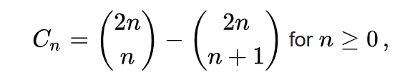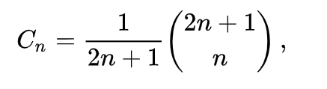
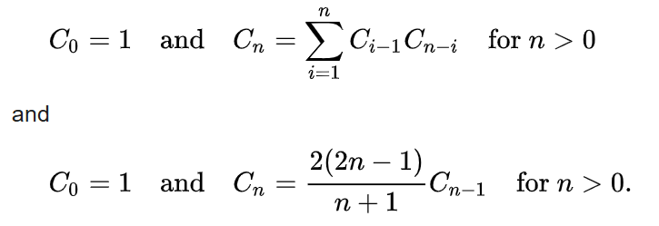

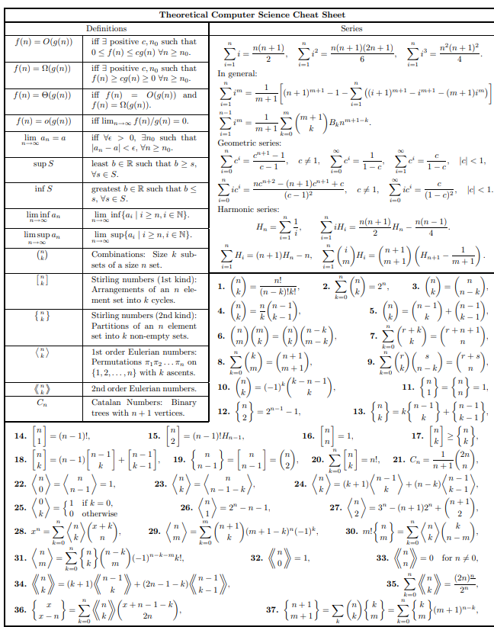
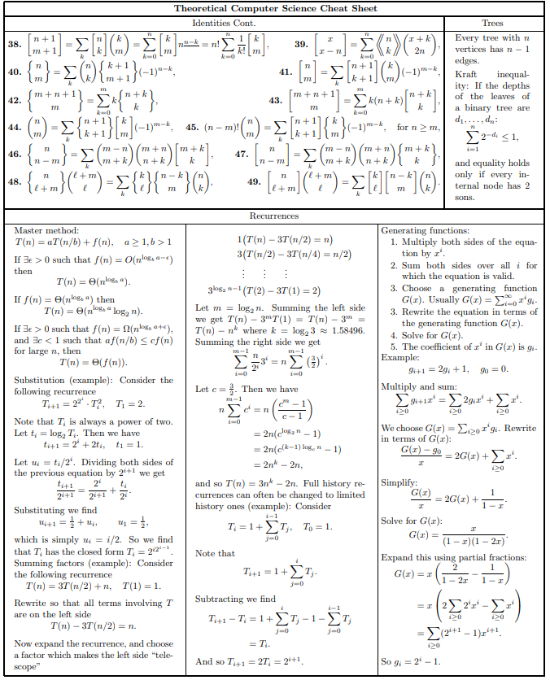
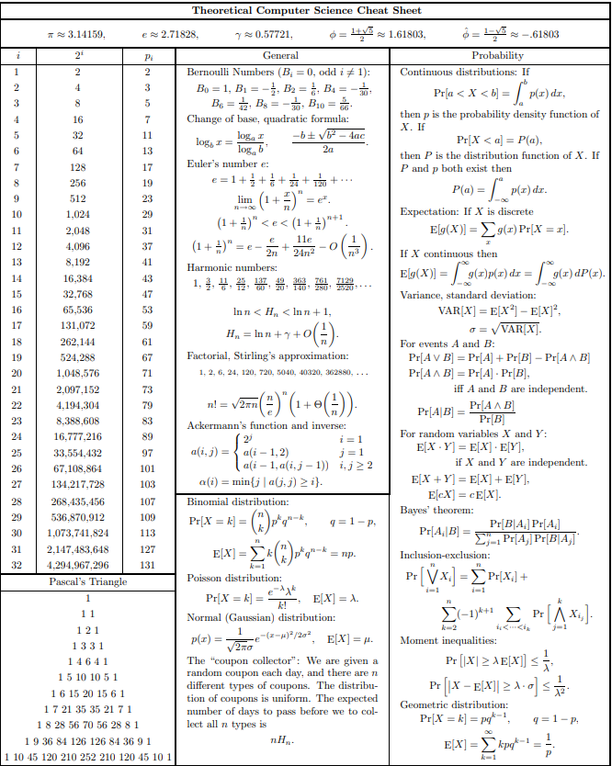
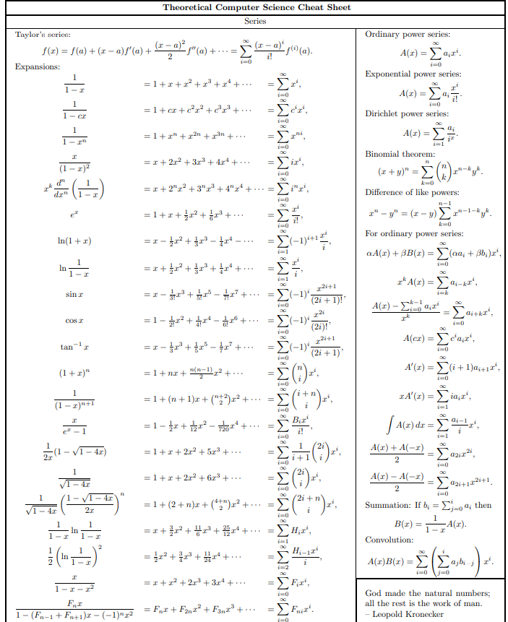

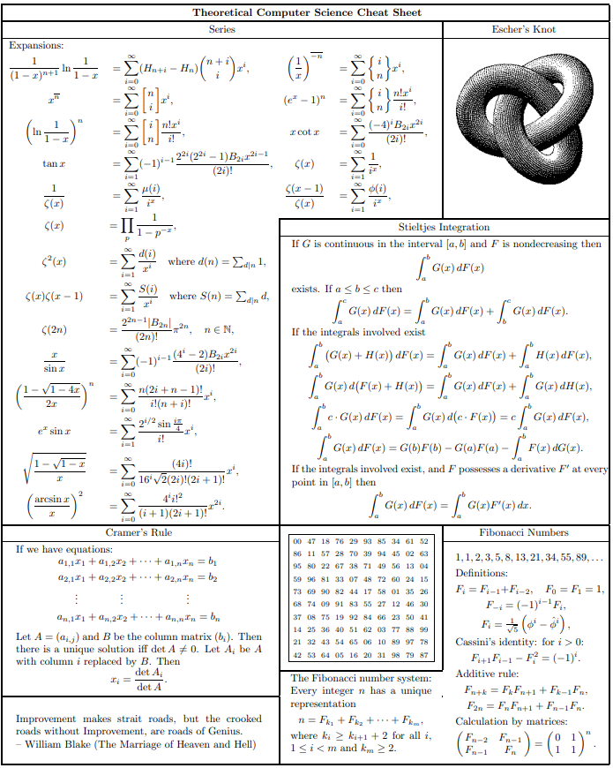

ICPC-2026-FINALISTS

