Chapter x

# EPS SUBSYSTEM

## Introduction

The primary EPS function is capturing solar energy from the sun and albedo with solar cells during the daylight and then to transmit it to the subsystems. So, a part of the captured solar energy must be kept in a battery in order to return it to the subsystems during the eclipse (during this time the solar cells are of course quasi inefficient. When sunlight reaches the Earth’s surface, some of it is absorbed and some is reflected. In the study of the CubeSat EPS we see that we must know the types of solar panels and how we design these to make higher current or higher voltage and the types of batteries we need. Also, we need to know subsystems that we will feed with electricity and calculate our power budget to ensure that our EPS can cover all requirements of our subsystems: On-Board Computer (OBC), Communications Subsystem (COMMS) and Attitude Determination and Control System (ADCS).

## Functional Description

The Electrical Power Subsystem (EPS) is responsible for charging the batteries from the solar panels using the MPPT technique, subsystems power management and batteries temperature control. It is also responsible for the post launch sequence that keeps the subsystems turned off for 30 minutes after the launch from the ISS and after the 30 minutes have passed, it deploys the antennas and the SU m-NLP probes by using a resistor to burn a thread that keeps the mechanism closed.

### Hardware main Components:

* 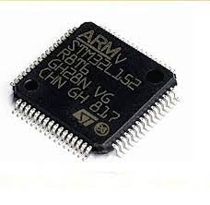STM32L152(Ultra Low Power Consumption) microcontroller with an ARM cortex M3 cpu core that runs the MPTT algorithm for charging the batteries.
* 3x 2600mAh 18650 Li-ion batteries.

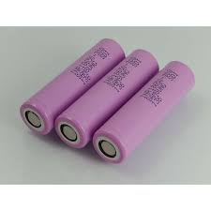

* MOSFET switches for controlling the subsystems power
* 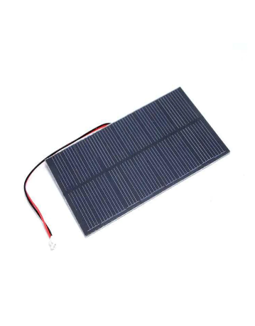4x 1.5W (6Vx250mA)

### Software main functions:

EPS Subsystem software is concerned with main functions or tasks like:

1. Communication with OBC.
2. Power management and distribution including:

MPPT battery charging system, load control (ON/OFF).

1. Measuring and Sensing:

for voltages, currents, and temperatures for the subsystems, batteries, and solar panels.

1. Performing Safety Checks:

Checking if the voltages, currents, and temperatures are within the safety limits.

1. Status and Error Reporting:

Sends error status via the UART debug port.

Functional description diagram fig-xx

## Static Software Design

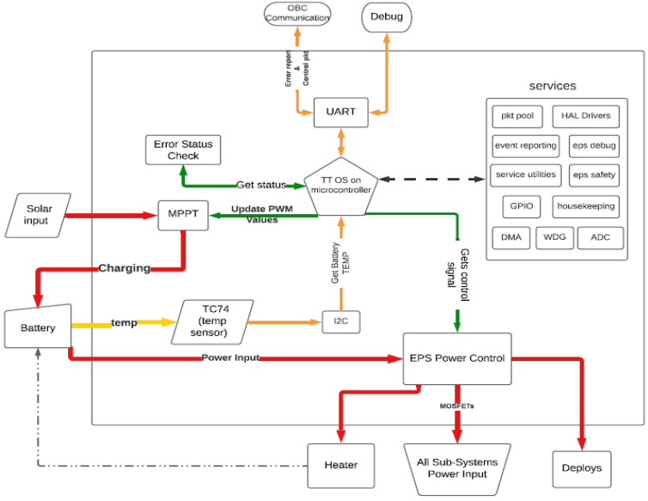

System Block Diagram fig-xx

## Time Triggered OS on microcontroller:

Here we mainly focus on the ttrd19a and its scheduler in which we add tasks in order with its best-case execution time (BCET) and worst-case execution time (WCET).

More details will be discussed in the Dynamic software design.

The EPS has a major tasks and functions that we have focused on while developing the software on the TTRD19A.

## Tasks:

OBC-EPS Communication:

which is done by UART in both directions.

This task includes two modes:

1. EPS to OBC Communication: EPS reports the voltages, currents of all subsystems and the battery status as well as the solar panels voltage, PWM duty cycle of MPPT phase.
2. OBC to EPS Communications: OBC gives packet to EPS which contains what subsystems to be ON or OFF because; each subsystem must report a heartbeat message to OBC and if not the OBC orders the EPS to turn off the power of this subsystem and restart it again

(Power ON RESET), Also if the subsystem consumes a higher current than the threshold will also lead to the same order.

## Power Control & MPPT:

1. This Task is responsible for getting the status of the subsystems, batteries, and solar panels.
2. Switching ON/OFF the power to the subsystems according to OBC packet or the startup sequence.
3. Updating the PWM duty cycle of the MPPT battery charging system.

## Get Reading:

Here the EPS gets all the readings voltages, currents as well as the battery temperature and the ambient temperature.

These readings are collected by ADC Pins except the ambient temperature which is taken by the TC74 sensor which is using I2C Protocol.

## Error Check & Error Reporting:

This task contains subtasks:

1. Load safety limits from the memory
2. Perform Safety limits check
3. UART debug service

## Dynamic Software Design

In run time, we have put our main tasks to the scheduler in order and with their BCETs and WCETs.

According to the given data the scheduler will construct a time line of execution.

## Hardware

### 1.Solar Panels

As we know the first spacecraft to use solar panels was the Vanguard 1 satellite, launched by the US in 1958. This was largely because of the influence of Dr. Hans Ziegler, who can be regarded as the father of spacecraft solar power. Gallium arsenide-based solar cells are typically favored over crystalline silicon in industry because they have a higher efficiency and degrade more slowly than silicon in the radiation present in space. The most efficient solar cells currently in production are multi-junction photovoltaic cells. These use a combination of several layers of gallium arsenide, indium gallium phosphide, and germanium to capture more energy from the solar spectrum.

### 1.1Types of Solar Panels

Thin film.

Polycrystalline.

Monocrystalline.

The variety of solar panel technologies available run on a scale of efficiency, price, durability and flexibility, depending on what you need. Photo voltaic (PV) solar technology generates power because substances like silicon generate an electrical current when they absorb sunlight, in a process known as the photovoltaic effect. Like semiconductors, solar PV technology needs purified silicon to get the best efficiency, and the price behind PV solar manufacturing is often driven by the crystalline silicon purification process.

Thin Film

The technology with the lowest market share is thin-film, but while it has several disadvantages, it is a good option for projects with lesser power requirements but needs for light weight and portability. Thin-film technologies have produced a maximum efficiency of 20.3%, with the most common material amorphous silicon at 12.5%. Thin-film panels can be constructed from a variety of materials, with the main options being amorphous silicon (a-Si), the most prevalent type, cadmium telluride (CdTe) and copper indium gallium selenide (CIS/CIGS). As a technology that’s still emerging, thin-film cells have the potential to be less expensive. Thin-film could be a driver in the consumer market, where price considerations could make it more competitive.

Figure x-x: Thin film.

#### Polycrystalline

The first solar panels based on polycrystalline silicon, which also is known as polysilicon (p-Si) and multi-crystalline silicon (mc-Si), were introduced to the market in 1981. Unlike monocrystalline-based solar panels, polycrystalline solar panels do not require the Czochralski process. Raw silicon is melted and poured into a square mold, which is cooled and cut into perfectly square wafers. The process used to make polycrystalline silicon is simpler and cost less. The amount of waste silicon is less compared to monocrystalline. The efficiency of polycrystalline-based solar panels is typically 13-16 % because of lower silicon purity.

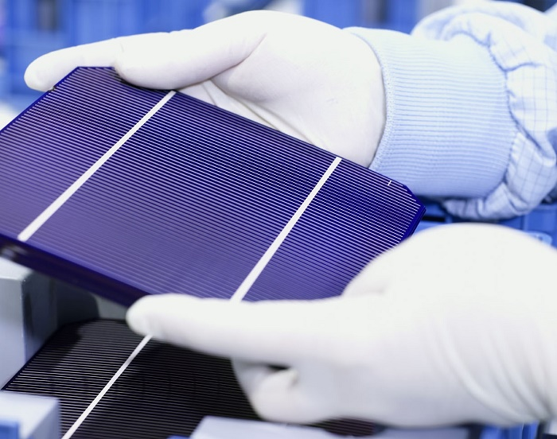

Figure x-x: Polycrystalline.

#### Monocrystalline

Solar cells made of monocrystalline silicon (mono-Si), also called single-crystalline silicon (single-crystal-Si), and are quite easily recognizable by an external even coloring and uniform look, indicating high-purity silicon. The efficiency rates of monocrystalline solar panels are typically 18-24%. Monocrystalline solar panels have the highest efficiency rates since they are made out of the highest-grade silicon but Monocrystalline solar panels are the most expensive.

Figure x-x Monocrystalline.

### 1.2Solar PV Efficiency

If we want to increase the efficiency of solar panels of course we must add junctions (layers) of solar cell in fabrication these junctions consist of compounds of semiconductor compound such as indium, gallium, arsenide, and phosphide. Once we add some junctions with good materials that make solar cell has more efficiency and more durability.

### 2 Batteries

A battery is a source of electrical energy, which is provided by one or more electrochemical cells of the battery after conversion of stored chemical energy. In today’s life, batteries play an important part as many household and industrial appliances use batteries as their power source.

### 2.1Types of Batteries

Batteries can be divided into two major categories, primary batteries and secondary batteries. A primary battery is a disposable kind of battery. Once used, it cannot be recharged. Secondary batteries are rechargeable batteries. Once empty, it can be recharged again. This charging and discharging can happen many times depending on the battery type. Alkaline batteries, Mercury batteries, Silver-Oxide batteries, and Zinc carbon batteries are examples of primary batteries whereas Lead-Acid batteries and Lithium ion and lithium polymer batteries fall into the secondary battery's category and that we will take about the rechargeable battery such as:

Nickel Cadmium (NiCd).

Nickel-Metal Hydride.

Lead Acid.

Lithium Ion (Li-ion).

Lithium Ion Polymer (Li-ion polymer).

The variety of batteries depend on the application and the user need of this battery. Also, by adding solar panels we will reduce the choices of which type we need at the small size and higher number of charge and discharge we decide to choose the lithium category because According to a U.S. Solar Energy Monitor report, lithium-ion batteries are the most common storage technology. Also, Lead Acid category is good but the problem is the huge size that take because our CubeSat is 10 by 10 by 30 cm and this is a small size can get size of battery like lithium batteries.

### 2.2 Important Parameters in Batteries

Table x-x: Comparison between lead acid and lithium ion.

|  |  |  |
| --- | --- | --- |
|  | **Lead acid** | **Lithium ion** |
| **Weight** | Heavy | One-third that of lead acid. |
| **Efficiency** | Low | High (almost 100%) |
| **Discharge** | Less than 80% | 100% |
| **Cycle life** | 400 – 500 cycle | 5000 cycles |
| **Voltage** | Short-lasting | Longer-lasting |
| **Cost** | Low | High |
| **Environmental Impact** | Not clean for environment. | Clean and safe. |

**Weight**: Lithium-ion batteries are one-third the weight of lead acid batteries.

**Efficiency**: Lithium-ion batteries are nearly 100% efficient in both charge and discharge, allowing for the same amp hours both in and out. Lead acid batteries’ inefficiency leads to a loss of 15 amps while charging and rapid discharging drops voltage quickly and reduces the batteries’ capacity.

**Discharge**: Lithium-ion batteries are discharged 100% versus less than 80% for lead acid. Most lead acid batteries do not recommend more than 50% depth of discharge.

**Cycle Life**: [Rechargeable lithium-ion batteries cycle 5000 times or more](http://www.relionbattery.com/lithium-applications-and-services) compared to just 400-500 cycles in lead acid. Cycle life is greatly affected by higher levels of discharge in lead acid, versus only slightly affected in lithium-ion batteries

**Voltage**: Lithium-ion batteries maintain their voltage throughout the entire discharge cycle. This allows for greater and longer-lasting efficiency of electrical components. Lead acid voltage drops consistently throughout the discharge cycle.

**Cost**: Despite the higher upfront cost of lithium-ion batteries, the true cost of ownership is far less than lead acid when considering life span and performance.

[**Environmental Impact**](http://www.relionbattery.com/why-relion/green-carpet-service): Lithium-ion batteries are a much cleaner technology and are safer for the environment.

By Looking of lithium ion and lithium polymer we see that Li-polymer is unique in that a micro porous electrolyte replaces the traditional porous separator. Li-polymer offers slightly higher specific energy and can be made thinner than conventional Li-ion, but the manufacturing cost is higher by 10–30 percent.

Table x-x: Comparison between lithium ion and lithium polymer.

|  |  |  |
| --- | --- | --- |
|  | Lithium polymer | Lithium ion |
| Chemical reaction | Varies, depending on electrolyte. | Varies, depending on electrolyte. |
| Operating temperature | Improved performance at low and high temperatures. | 4º F to 140º F ( -20º C to 60º C) |
| Recommended for | Cellular telephones, mobile computing devices. | Cellular telephones, mobile computing devices. |
| Initial voltage | 3.6 & 7.2 | 3.6 & 7.2 |
| Discharge rate | Flat | Flat |
| Charging temperature | 32º F to 140º F (0º C to 60º C) | 32º F to 140º F (0º C to 60º C) |
| Storage lite | Loses less than 0.1% per month. | Loses less than 0.1% per month. |
| Storage temperature | -4º F to 140º F ( -20º C to 60º C) | -4º F to 140º F ( -20º C to 60º C) |
| Notes | - Typically designed to be recharged in the device rather than in an external charger.  - Lighter than nickel-based secondary batteries with (Ni-Cd and NiMH).  - Can be made in a variety of shapes. | - Typically designed to be recharged in the device rather than in an external charger.  - The chemical construction of this battery limits it to a rectangular shape. |

After reading all specifications of both battery types, you can see that there isn’t much of a competition here. Although the lithium-polymer battery is sleeker and thinner, lithium-ion batteries have a higher energy density and cost less to manufacture. Therefore, we obviously know which one is chosen by companies like Samsung, Apple, Motorola, and more. Finally, with new chemicals batteries may make them the best choice for the AlexSate on the long run.

### 3.Power Distribution and Management

Electrical power subsystem will distribute the power for all other subsystems: OBC, ADCS and COMM. The electrical subsystem is presented in Figure x-x.

Figure x-x: Block diagram for power distribution