* **Components:**

1. L298N Motor Driver Pinout

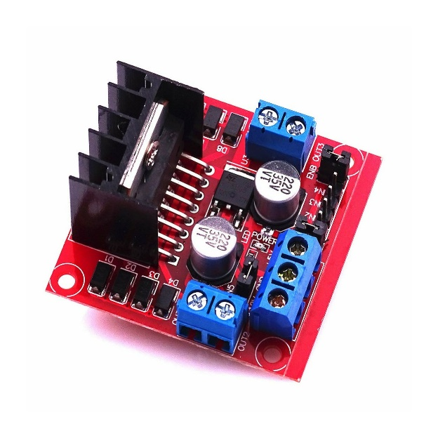The Module functions as a driver/controller for the wheel-geared motors, enabling control over both their direction and speed. As we are not utilizing the PWM signal generated by Arduino to regulate the speed, the geared motors will operate at their maximum speed because we keep the current state of the sorted PWM pins (ENA & ENB) present on the Board. Hence, the driver module is utilized only to alter the rotation direction of the motor, allowing the bot to move in all four directions.

1. HC-05 Bluetooth Pinout

It is a widely used module in electronic projects for wireless communication. It uses serial UART communication for data transfer.

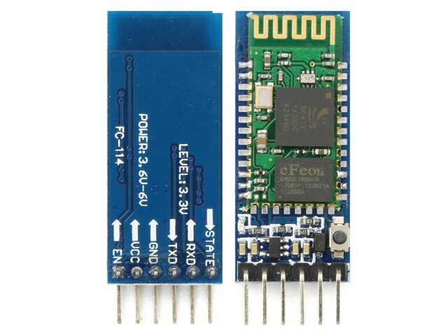

1. Chassis Assembly of Robot Car (2wd)

We have used an acrylic laser cut sheet with all necessary fittings compatible. It’s precisely cut with all the spaces provided for components fittings using screwdrivers. You can also refer to various online platforms to Buy Such types of chassis prototypes

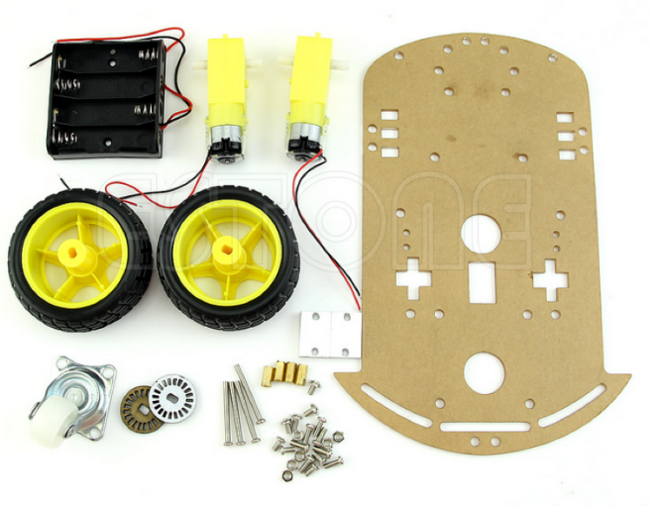

1. Arduino Uno

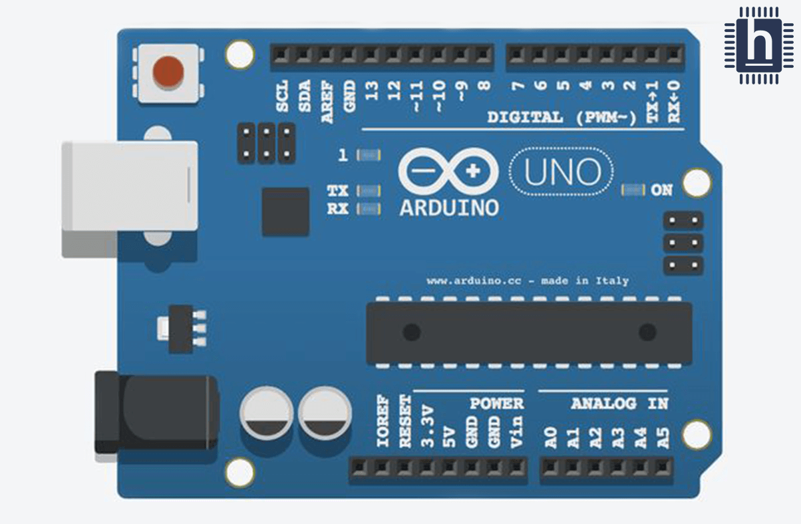The Arduino Uno is a popular microcontroller board used for building digital devices and interactive objects that can sense and control the physical world

1. Battery about 9 volt
2. Some jumper wires

* **The circuit diagram of connections**

