**ECE 241 – HOMEWORK 4**

**Fall 2019**

**Due: Thursday, November 07, 2019 at 11:00PM on gradescope**

Please answer the following questions. Submit your screenshots on Gradescope as one file (e.g., Word document or PDF). Please also submit your two commented Python files for the two questions.

1. (**20 points)** We have used the turtle module in our discussion to recursively draw trees. In this problem you are tasked with implementing a program that recursively draws a fern as defined below, using the turtle module. The specification of the fern is as follows:
   1. the recursive function should be called as fern(n,l)
   2. n = order or age
   3. l = length

Hints: Below are a few examples of ferns based on the initial call of the fern(n,l) function. Good angles to try out are 55, 40, and 5 degrees.

Fern(1,10)



Fern(3,10)



Fern(5,10)  
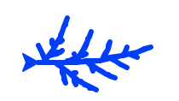

1. (**50 points**) A farmer wants to build a fence around his rectangular (a x b) field (see figure below). The planks that can be used to build the fence are of length plankList = [1,5,10, 21, 25]. The corresponding colors of the planks are plankColor = {1:'red',5:'blue',10:'black',21:'green',25:'violet'}. Using dynamic programing choose the least number of planks to make ‘a’ and ‘b’ dimension of the rectangle and draw it using the turtle module. Show the functionality of your program by showing the results for a=64, b=67, and a=25, b=27.

The following example shows the output your program should give for the first set of values for a and b:

Enter value for ‘a’: 64

Enter value for ‘b’: 67

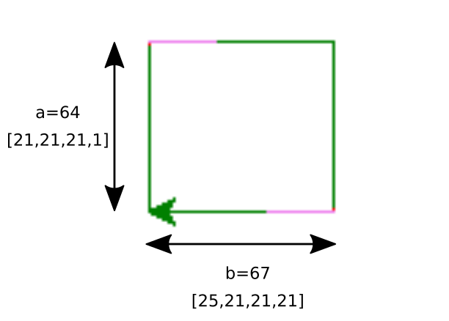

**(30 Points)** In this problem, you are tasked with determining the shortest paths from node a to all other nodes in the network shown in the figure below. You should use Dijkstra’s algorithm for calculating the shortest paths. Use the csv file that came in the archive or at <http://www.ecs.umass.edu/ece241/documents/hw4_q3.csv> as template to provide your solution and submit the file with your solution to gradescope.

