**DATABASES**

**1.**[**MySQL**](https://www.geeksforgeeks.org/mysql-common-mysql-queries/)**:** MySQL is an open-source relational database management system(RDBMS) based on Structured Query Language (SQL). It is currently developed and managed by Oracle Corporation, since acquisition by Sun Microsystems on 27 January 2010, which had itself acquired MySQL in 2008. It was initially released internally on 23 may 1995 by David Axmark, Allan Larsson and Michael “Monty” Widenius of MySQL AB from Sweden, though development for personal use by Widenius and Axmark began in 1994. Since acquisition of Sun by Oracle, the original developers left MySQL to work on a fork known as MariaDB. It is widely being used in many small and large scale industrial applications and capable of handling a large volume of data.

**2. SQLite :** SQLite is a software library that provides a relational database management system(RDBMS). It was designed by D. Richard Hipp on August 2000. The design goals of SQLite were to allow the program to be operated without installing a database management system(DBMS) or requiring a database administrator. The lite in SQLite means light weight in terms of setup, database administration, and required resource.

# What is Microsoft Azure: How Does It Work and Services

Lesson 1 of 5[By Shyamli Jha](https://www.simplilearn.com/authors/shyamli-jha)

Last updated on Jan 27, 20231881837

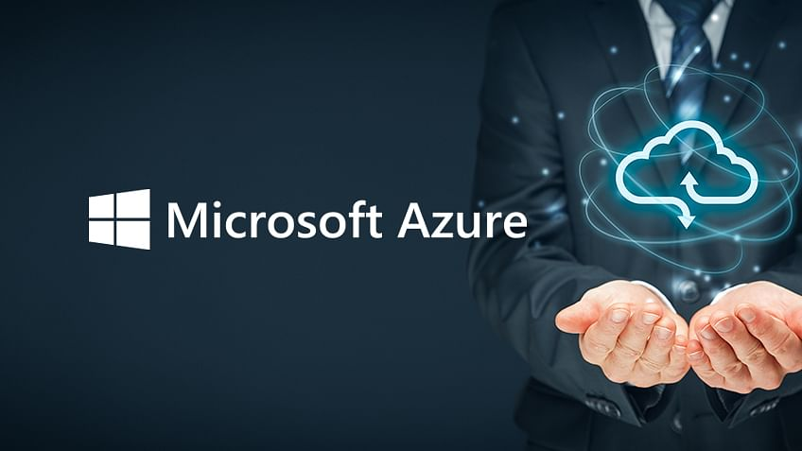

## What is Cloud Computing?

[Cloud computing](https://www.simplilearn.com/tutorials/cloud-computing-tutorial/what-is-cloud-computing) is a technology that provides access to various computing resources over the internet. All you need to do is use your computer or mobile device to connect to your cloud service provider through the internet. Once connected, you get access to computing resources, which may include serverless computing, virtual machines, storage, and various other things.

Basically, [cloud service providers](https://www.simplilearn.com/cloud-storage-article) have massive data centers that contain hundreds of servers, storage systems and components that are crucial for many kinds of organizations. These data centers are in secure locations and store a large amount of data. The users connect to these data centers to collect data or use it when required. Users can take advantage of various services; for example, if you want a notification every time someone sends you a text or an email, cloud services can help you. The best part about cloud platforms is that you pay only for the services you use, and there are no charges upfront.

## What is Microsoft Azure?

[Azure is a cloud computing platform](https://www.simplilearn.com/azure-cloud-services-and-its-importance-article?source=frs_author_page) and an online portal that allows you to access and manage cloud services and resources provided by Microsoft. These services and resources include storing your data and transforming it, depending on your requirements. To get access to these resources and services, all you need to have is an active internet connection and the ability to connect to the Azure portal.

Things that you should know about Azure:

* It was launched on February 1, 2010, significantly later than its main competitor, [AWS.](https://www.simplilearn.com/introduction-to-amazon-web-services-aws-article)
* It’s free to start and follows a pay-per-use model, which means you pay only for the services you opt for.
* Interestingly, 80 percent of the Fortune 500 companies use Azure services for their cloud computing needs.
* Azure supports multiple [programming languages](https://www.simplilearn.com/tutorials/programming-tutorial/first-programming-language), including [Java](https://www.simplilearn.com/best-java-programs-article), [Node Js](https://www.simplilearn.com/tutorials/nodejs-tutorial/what-is-nodejs), and [C#.](https://www.simplilearn.com/c-sharp-programming-for-beginners-article)
* Another benefit of Azure is the number of data centers it has around the world. There are 42 Azure data centers spread around the globe, which is the highest number of data centers for any cloud platform. Also, Azure is planning to get 12 more data centers, which will increase the number of data centers to 54, shortly.