**WEB-BASED INTERNSHIP RECORDS MONITORING SYSTEM**

**FOR SORSOGON STATE UNIVERSITY-BULAN CAMPUS**

An Undergraduate Thesis

Presented to the Faculty of the

College of Information and Communications Technology

**Sorsogon State University**

Bulan Campus

In Partial Fulfillment

Of the Requirements for the Degree

Bachelor of Science in Information Technology

By

Princess Kaye S. Rogacion

Sherrelyn G. Chavez

Vanessa Mariz T. Gracela

Ian Carl G. Grafil

April 2023

Chapter 1

**INTRODUCTION**

This chapter introduces the context of the project together with the presentation of its purpose, main objectives, scope and delimitations that explains the importance and essentiality of the project.

**1.1 Project Context**

**The global emergence into the 21st century technological advancement truly made an impact to the security and data management of industrial training programs or internships. From the traditional tools made to monitor different data stored in massive educational institutions, the phenomenal growth happened in websites and internet-based services brought convenience to the implementation of internship [16]. The convergence happened between the technology and academic institution should be progressive and be utilized with effectivity and efficiency to provide students the internship that establishes transparency and precision on the program’s mission.**

**In accordance to the Sorsogon State University Student’s Handbook that was comprehensively prepared by Dr. Pablito V. Marbella, the SSC Vice President for Academic Affairs, 1998-2000, the On-the-Job Training (OJT) Program is a series of planned activities in which students are sent to companies/industrial firms and other training agencies for actual job training as part of their course requirement. This program is undertaken to acquaint the students with the real work setting and prepare them for work in industry. It also stated the required number of hour that a student should finish each day which is eight hours per day until finishing the whole time allotted for the program depending on the curriculum being pursued by the student. The compliance of requisite is also explicitly discussed. Student Information Sheet, Parent’s Permit, Certificate of Registration, Medical Certificates, Police Clearance and etc. are some of the requirements that a student should comply to acquire an internship program.**

**The Industry Linkages and Development Office is responsible for the coordination and implementation of the On-The-Job Training program of the Sorsogon State University-Bulan Campus. To successfully apply the students for the program, the office requires the students to submit the prerequisites for the internship. The office is in charge of recommending companies and employers that comply with the requirements and operate in line with the students’ best interests. In most cases, students suggest their preferred companies and employers. After the students comply the requirements, the ILDO will now process the application of the interns and when approved, the students may now start their internship and they are required to submit narrative reports, daily time records and accomplishment reports.**

**The current practice of the Sorsogon State University - Bulan Campus in handling the internship of the students is quite effective but not efficient enough as the office practices semi-computerized system. Due to lack of required system features to mitigate the possible problems, the office may encounter uncontrollable delays on students’ requisites, manual managing of records and unaccompanied monitoring on students’ performances during the compulsory industrial attachment. Since accurate data is essential for each student's academic record, educational institutions must have a data management system in place for it to work properly [9].**

**It can be difficult and time-consuming for academic institutions and companies to manage and monitor internship records. It might be difficult to keep track of interns' progress, evaluate their work, and make sure they finish their degree programs on time, especially in large firms with lots of interns.** I**t was proven that the traditional paper-based system sets limitations on the capabilities that the management may exert** [16]. **Therefore, t**he **study suggests that an Internship Records Monitoring System (IRMS) could provide a more efficient and accurate means of managing internship records.**

**The existing manual system used to monitor OJT attendance and progress is vulnerable to fraud and tampering, which results in inconsistencies in the records. A hardware and software solution based on the internet of things (IOT) that monitors attendance and views data in real-time is required. By doing this, because the attendance system is secure, the frauds on attendances and records were also eradicated. Following a thorough evaluation of the system by stakeholders and developers, as well as a pilot test of the prototype, the system received 100% positive feedback and was found to function as intended.**

**The system [4] proved that integrating technology in manual monitoring system drastically improves the efficiency and security of the manual OJT monitoring system. That is why it is crucial to be receptive to developments that might help complete daily tasks more effectively.**

**This project, Web-based Internship Records Monitoring System, was created in an effort to address the aforementioned issues and enhance internship management. It is an online application system that aims to address issues with monitoring effectiveness, record-keeping, and interactive web-based platform efficiency between students and office management. This project centralizes its purpose on monitoring students’ internship schedules and on-time submission of reports. Furthermore, the project will establish record-keeping feature for requirements to have a secured database to look onto.**

**The system's particular features offer two accessibility segments, which depend on the type of user accessing it. The system identifies its users as students and administrators. Students can view their status, submit internship requirements before, during, and after the internship period, and customize schedules. On the other hand, administrators have full access to the system, including viewing, editing, providing feedback, and evaluating student performance.**

**1.2 Purpose and Descriptions**

The purpose of this study is to create a web-based application system that has record-keeping, monitoring, and viewing features of internship evaluation. Through this, the students involved and the Industry Linkages and Development Office (ILDO) of Sorsogon State University-Bulan Campus will have the platform where they can ensure that the progress in the internship will be secured and monitored accordingly.

The System will create accounts for both administrators and interns to distinguish users accessing the system's features. Interns will have limited access to the system's features, including viewing, editing the calendar, and logging in to the system's Daily Time Record (DTR). When the system recognizes the user as an administrator, it will grant full access to the system.

The project will include a monitoring feature that allows administrators to monitor the progress of trainees in real-time, including precise attendance records and performance evaluations. Additionally, the system will provide a feedback feature that enables administrators to rate trainees' performance and communicate with them in real-time. Moreover, the system will have a document management feature that allows trainees to upload and store their requisites, which supervisors can access.

Unlike the current semi-computerized and manual monitoring method, the system offers new methods of monitoring to mitigate the possibilities for the interns to submit summarized, outdated, and unauthentic reports. The system will be a user-friendly platform that will make them active, productive, and monitored during training.

There has been an attempt similar to the present study but the project establishes innovated features to be more accessible, convenient, and interactive.

The study “Web-based Internship Records Monitoring System” are being developed to establish more convenient way of securing internship data, monitoring interns effectively and evaluating the result of their internship. This study is deemed significant to the following:

**Industry Linkages and Development Office (ILDO).** The Study will provide a system that will carry out an objective in thoroughly monitor the trainee’s qualification by providing features that will secure and track their data, monitor their training, and store their reports throughout the duration of the internship.

**Interns.** The study will provide user-friendly platform for processing their data required for the internship and other paper works for it. The system may also challenge their discipline and authenticity on their internship as the system utilizes features that make these challenges happen.

**Proponents**. The study will significantly contribute to their knowledge and skills in developing beneficial systems.

**Future Researchers**. The study will serve as their guide for future innovation of studies related to this project.

**1.3 Objectives of the Study**

This study focuses in the development of a web-based internship records monitoring system to be used by the Office of the ILDO as a tool to keep and track the requirements and aid the monitoring of students throughout their internship period.

Specifically, this study aims to:

1. **Develop and design the following features related to monitoring and record-keeping of students’ requirements during their internship period:**

**1.1. Interns Pre-requisite Requirements**

**1.2. User Requirements**

**1.3. Enrollment Module**

**1.4. Interns’ Schedule**

**1.5. Daily Time Record**

**1.6. Interns’ Activity Reports**

**1.7. Evaluation Results**

1. **Create modules that will generate the following features:**

**2.1 Internship Records Checklist**

**2.2 Internship Monitoring Management**

**2.3 Company Information**

**2.4 Evaluation Result**

1. The Software Product Quality Model (ISO/IEC 25010) will be utilized to test and evaluate the proposed project, in terms of:

3.1. Functional Suitability;

3.2. Performance Efficiency;

3.3. Compatibility;

3.4. Usability;

3.5. Reliability;

3.6. Security;

3.7. Maintainability; and

3.8. Portability of the System

**Scope and Limitations of the Study**

This study focuses on assisting the Industry Linkages and Development Office and Sorsogon State University - Bulan Campus's interns to efficiently execute profiling and effectively monitor intern's performance and provide features for evaluation. The system will serve as a daily time recorder for the interns, data storing and checking day-to-day narrative reports, month-end, and terminal reports which will be monitored by the Industry Linkages and Development Office (ILDO). The system will also serve as a portfolio for keeping intern's files, like application requirements, time records, reports, and documentations. The system will also provide evaluation features in order to be a medium of transparency on the results of the program involved by the interns.

To protect and preserve intern’s data, the system will act as a data storage for the information that the interns will submit. By this, the data will be kept and can be easily track if needed to be disclosed for purposes and will secures it integrity. Both students and admin will be having an account to be used in the system and to start the storing of the requirements, the interns are required to submit the all the requirements for internship to determine their eligibility for the program.

The system's monitoring feature will provide functions such as the Daily Time Record, which will introduce a time-in and time-out feature for the system. Additionally, the feature will monitor the submission of required documents on a daily, weekly, and post-program completion basis.

For an organized and neat monitoring interface, the system would like to utilize a calendar-based interface for the monitoring of daily logs and submission of the reports needed in different dates. Through this system interface, the daily logs will be organized, resulting to a quick identification of time records. The submission of the reports can easily be determined as the calendar organizes its bin per calendar cells. Moreover, tracking this submitted documents will be neat and simple.

As for the evaluation feature, the systems will act as a portal to the interns where they can view the result of their performance in the internship that they had.

The system will be recognized solely as a web application that includes additional features, such as the feedback feature. This feature will be accessible only to users who have been granted permission to access the system, specifically interns and the office.

The system delimits the interns from accessing certain features of the system which are intended only to be accessed by the admin such as **changing the applied schedules in the system without prior notice and accessing other intern’s profile.** The linked companies or agencies will have no access to the system as they have their own methods on monitoring the interns. The system will only be utilized in Sorsogon State University-Bulan Campus but delimit its use from non-interns and not involved faculties. That being said, the other University branches will also have no access to the system.

Chapter 2

**REVIEW OF RELATED SYSTEMS**

The papers provided in this chapter are both related systems and literatures that are correlated on the presented objectives of the study. The review on information requirements, features of the system and usability are also being addressed.

The design and implementation of web-based internship information system at vocational school made by [32] where in a web-based internship information system— the website’s content, medical data, student personal data, participation data, user data, competencies, identities, viewing charts, and database backups may all be managed by administrators by logging in. Students participating in placements can enter daily or weekly activities into the portal, view guidance, view placement status, view information, and view placement scores by logging in first. University faculty, known as supervisors in this system, has functions to manage and monitor placements, manage instructions and values, and view information about placements after logging in.

The system of [32] which has the management of gathered data is related to the current study which will require logging in to determine the user and assign proposed access. The proposed study will require the same data in order to provide precise and accurate information that may help the internship program to attain high effectivity on information transparency.

The study of [19] states that one of the methods for evaluation that helps instructors in departments and students in self-regulated learning demonstrate their skills and progress through time is the ePortfolio. Video, audio, artwork, or photography are all acceptable forms of strong evidence for learning and success. While some ePortfolio are as straightforward as a logbook, others provide a broad, in-depth perspective over a considerable amount of time. The ePortfolio can be used to choose and validate competencies, increase thinking skills and learning techniques, assess (with the goal of formative and summative assessment), highlight the current successes and academic advancement of learners, and develop self-evaluation abilities.

The study [19] provides significant feature to the current study that strengthens the effectivity of data gathering and storing of the gathered data needed in the internship program. The system will provide a record-keeping function for documentation, reports, daily logs, and data backups of each intern for retrieval if needed. Though, the system will not be accepting video and audio type of documentation.

The Student Internship Portal (SIP) of [3] is a web-based solution for managing and arranging internship programs in educational institutions involving students and staff. It features a web-based placement information system, so students can monitor the institution's evaluations of their growth. Also, it was created to give students, teachers, and the institution a means of interactive communication whenever and wherever it is required.

The relevance of the system [3] in the current study is its purpose to give interactive means of communication to address the required information needed to eligibly start the internship programs. Through notification and feedback features that the current system will develop, it is expected that the purpose will be fulfilled.

To ensure the information and data stored are protected, the system Student Industrial Internship Web Portal (SIIWP) [1] emphasizes security features before users can access the system. Users are required to change the password during their first time login. Furthermore, each type of user only can access the restricted system functions and at certain period of time in order to ensure security of the data and the system itself. Coordinator will grant the access for each user according to the UiTM academic calendar.

The study [1] is relevant to the present study given that both involve setting up an account, signing in, and updating the password to make sure that only authorized users may access the system's data. Furthermore, restrictions on the accessibility of interns to certain features will be established to recognize the user’s role.

The study entitled “Web-Based Internship Information System” [16] aims to provide solutions for all issues that arise at each stage of the internship process, including registration, choosing an internship location, selecting a supervisor, submitting an internship report, and evaluation of internship reports through creating a web-based internship system. It compose of processes on internship registering, activating logins, group share of internship, and supervisor share of internship, uploading internship reports and internship assessments.

The study [16] is similar to the current study as it shows identical processing features and similarities in the purpose of the development of the system. The studies are both web-based system intended to minimize the current errors on the internship processes.

The Framework of University Internship Information System with Web-Based Design Analysis [25] contains different primary functions depending on the user’s roles, namely, Internship Coordinator, Lecturer, and the students. Approving internship registration and exam scheduling are the primary function of Internship Coordinator. Students have the function of submitting internship counseling book, and uploading reports and registration for internship exam. Lastly, the lecturer publishes announcements and responsible for grading students. The function’s main goal is to provide role-oriented features that leads to an organized and neat flow of information in the system.

The features of the proposed system have similarities to the system [25] The proposed system will be utilizing same features such in uploading of reports, control over announcements, and internship approval. Due to the fact that interns may have various working schedules, the system intends to develop a working time scheduling feature to be edited in the internship calendar in which the students have the authority to this function but should have supervision from the internship coordinator. This feature may be similar to the exam scheduling mentioned in the related system but has different purpose. The proposed system differs on the number of user’s roles and the system will just establish student and internship coordinator user roles only. Furthermore, exam related features that was developed in the related system will not be covered in the current system.

According to a study [10] to determine if the developed system is efficient and functional, trials were conducted utilizing test scenarios, test cases, and comparison tables. The developed system was evaluated using a survey questionnaire based on ISO 25010 software quality model for Product Quality. It obtained an overall mean of 4.32 with a standard deviation value of 0.666. This validates that the objectives of the study were met and achieved. Moreover, the system was able to reduce the cost and time spent on the previous process, which proves that it successfully integrated lean management principles into its design.

The study [10] is relevant to the present study because of the model used which is the ISO software quality model for product quality. As part of the present study’s evaluation tool, ISO model was also used to further explain a specific functions quality making it an additional asset to the system. The above study also states that there were trials conducted to an efficient and functional system which is crucial to further development of the system.

The Development of Internship Monitoring and Supervising Web-Based System [1] states that before online monitoring system is developed, a full understanding of the current workflow is required. Roles of the coordinator and students are identified based on the previous practice which has been conducted manually. Hence from this information, the flow of the activity is outlined to make sure all the procedures are covered by this system. System Development Life Cycle (SDLC) is used in the development of this system. Phase (1) Planning, (2) Analysis, (3) Design, (4) Implementation, and (5) Support and Maintenance measures through Waterfall model as a system development methodology. XAMPapplication is used to setup local-host server and HeidiSQL is used for database applications. Meanwhile, the programming tools used are Adobe Dreamweaver and PHP language.

The study [1] relates to the current study in terms of the system’s phases as well as the programming tools which will be applied in fully developing the system. The difference of the current study to the study [8] is the programming language that will be utilized in developing the current system. Python programming language will be used by the proponents.

In the study [23] internship industrial placement has been addressed as the company’s availability is one of the problem that the interns encounters. They designed a feature that allows a company to customize their requirements that may fit or compatible to the intern’s aptitude. The students have now the previlege to choose the company that they desire based on their interest while maintaining the standard that a certain company requires. Through these functions, it lessens the inconviniency selecting preferred companies without knowing the desired internship program under the institution.

The system of [23] shown similarities in this feature as the current system is working on developing section for announcement pages which will contain Company Recommendation. The only difference between the two system is that the current system will not include the privilege of the company’s customization of requirement. The system will just provide company information given by the adminitrator or internship coordinator.

The paper [20] presented an intervention for the Human Resource (HR) Department in PT Petrokimia Gresik’s decreasing quality of On-the-Job Training due to Work From Home Regulation during the COVID-19 era. After identifying the root causes of the problem, they designed digital-based OJT management applications that has these three main features, namely, lesson plan, daily activities monitoring system, and periodic competency achievement evaluation. Features like, user roles were defined and concepts on employee scheduling, lesson plan, daily report, placement, quiz, employee assessment and activity, as well as stories was prepared. An increase of 47.7% in user satisfaction was reached after the implementation of the system with zero complaints.

The system [20] is similar to the current project in terms of features of daily activities monitoring system and periodic competency achievement evaluation. The current system will be utilizing daily monitoring system with specific submissions bin properties for more convenient record-keeping and easy searching for specific inputs. Both systems have evaluation function to the performance of the interns throughout the internship. However, the current system does not include a feature on the development of lesson plan.

Due to the traditional methods of email and phone conversations being used for the supervision process of the School of Computing, College of Arts and Science, Universiti Utara Malaysia (UUM), the practicum program suffers from insufficient communication and poor administration. In the system [17] their study “Design and Development of UUM Internship Monitoring System: A Web-based Application for Monitoring Practicum Students,” they presented an intervention to the aformentioned problem. The functions exhibited in this system are similar to the other related studies sited in the current study but some of the features that the system presented is the setting up of task due dates under supervisor control and uses Gantt Chart as the presentation of tasks that the students should accomplish.

Similarly system [17] the current study also have this feature but the system offers automation in formulating task due dates which will depend on the student’s working hour that will affect the attributes of its own internship calendar. The current system will not be utilizing the Gantt Chart to monitor the interns. Instead, the system will provide a Daily Time Record-like function.

A study [2] about the Assessment of Online OJT Performance Monitoring which the results of the system’s evaluation are based on the ISO 9126 standard. It showed that the efficiency criteria had the highest ranking, followed by portability and dependability, functionality, and finally, maintainability and usability of the system. The online OJT performance website met its functionality needs by employing a contemporary method of operation and efficient use of the time of the students, advisers, and supervisors.

The above study is similar to the present study in terms of the concept used to show the efficiency of the criteria ranking. However, the present study variables like portability, dependability, and maintainability delimits this scope.

The study [15] states that the Usability Scale will provide significant findings on usability in terms of access and the interface of the system. Moreover, satisfaction is also related to internal constructs, and measuring this construct would emerge some hints for system developers, trainers, administrators, teachers, and teacher educators. Scales developed for measuring those variables all have different scopes and structures, but they can be used together as parts of a measurement model for considering obtained results with a holistic perspective about students, teachers, system developers, and administrators. Based on this, measuring the acceptance of students toward systems could contribute to teachers and system developers, and identifying the usability of systems may give a chance to improve the interface of the systems as well.

The above study is relevant to the present study in terms of the evaluation tool utilization, the USE Questionnaire or the Usefulness, Satisfaction, and Ease of use of the study that is beneficial to the client and the students as it gives a user-friendly approach and interface. Since this study will focus on the usefulness, satisfaction, and ease of use of the system in the interns and the Industry Linkages and Development Office in terms of their process, monitoring, and tracking of trainees, the above study proves relevance as it focuses on the scope of the satisfaction as it gives a holistic perspective of students, teachers, system developers, and administrators that will be valuable to the development of the study.

A study conducted [29] and was mentioned that the USE questionnaire consists of aspects of Usefulness, Ease of Use, Ease of Learning, and Satisfaction in the result of the study was beneficial as it indicates that user satisfaction in using the system which is in a good category and for assisting in terms of observing empirical data in the field and aiming to be more convincing in making judgments about the process of the policy used to complement survey methods. User satisfaction in using the proposed system has met the standards of effectiveness, monitoring management, and following the needs of the industrial revolution in the use of innovative technology.

In the study above, it is mentioned that the use of the USE Questionnaire is a crucial part of determining a large-scale user perspective and judgments about the process of the system. The study shows how it focuses on the standards of effectiveness, monitoring management, and the use of innovative technology which is relevant to the goal of this study.

In the study entitled “User-Centered Software Design: User Interface Redesign for Blockly-Electron, Artificial Intelligence Educational Software for Primary and Secondary Schools,” the usability of the system will be evaluated using the USE scale. In the linear relationship between ease of learning, ease of use, usefulness, and satisfaction, with ease of use as a mediator variable, five design deliverables and an attribution model were developed. This is significantly different from the findings of previous regression analyses for the USE scale [8].

The above-mentioned study is relevant to the current study because it mainly focuses on the relationship between variables as the USE scale being the primary method. This is because findings will be efficient and will provide enough approaches as it is separated into different variables and will be easier to filter out.

Spiral Development Method shows how exactly the group executes the study for Raymundo T. Tongson National High School Suay Extension. Attendance Monitoring System. Obviously, the planning covers all the process cycles in the study. This includes organizing the team members, how to collect data and analyze the problem and created a design for the database and user interface of the program according to the data analysis. Testing and implementation of the system are discussed in this section [18].

In terms of methodology, the current study shares similarities with the referenced study [18] as both utilize the Spiral Development Method, which emphasizes the importance of Planning, Analysis, Design, Development, Testing, Implementation, and Maintenance as integral phases that comprehensive.

Chapter 3

**TECHNICAL BACKGROUND**

This chapter contains a discussion of the project’s components. The specifications of both hardware and software requirements for the developer and for the users are being introduced, as well as the technical terms are comprehensively presented.

**3.1 System’s Development Specification**

The specifications for the system's hardware, software, and services are presented in this section. The proponents will utilize these components to develop the project.

**3.1.1 Hardware Specification**

**This section exhibits the hardware requirement’s specifications and its underlying functionalities that will be used by the proponents in developing the project.**

Table 3.1.1

Hardware Specification (Developer Side)

|  |  |
| --- | --- |
| **PARTICULAR** | **RECOMMENDED SPECIFICATION** |
| **Processor** | **Intel(R) Core (TM) i3-7100U 2.40 GHZ** |
| **Memory** | **16 GB RAM** |
| **Graphics Card** | **Intel(R) HD Graphics 620** |

Table 3.1.1 conveys the hardware requirements used by the project's proponents in constructing the project. The proponents used Intel(R) Core (TM) i3-7100U with 2.40 Gigahertz clock speed with 16 GB RAM and built-in Intel(R) HD Graphics 620. The hardware used in developing the system should be sufficient enough to handle varied tasks and can be loaded with different software. For the system's proponents to have a smooth development, it must be able to function effectively, with high performance and good quality. To provide the greatest and most effective performance required in creating the web-based internship records monitoring and evaluation system, the aforementioned parameters were more than adequate.

**3.1.2 Software Specification**

**This section provides the software requirements that the proponents will be utilized in developing the system. This section covers its underlying functionality and purposes in the study.**

**Table 3.1.2**

**System Software Requirements**

|  |  |
| --- | --- |
| **Particular** | **Recommended Specifications** |
| **Operating System** | **Windows 10 Pro 64-bit (10.0, Build 19045)** |
| **Browser** | **Google Chrome** |
| **Integrated Development Environment** | **PyCharm Community Edition 2022.3.3** |
| **Database** | **SQLite** |
| **Wireframe Design** | **Figma 116.7.6.0** |
|  |  |

**Table 3.1.2 outlines the software and its requirements to be used to create the suggested project. The system will be created using the Google Chrome web browser and the Windows 10 operating system. The Integrated Development Environment (IDE) and database that will be utilized in the system's backend, respectively, were PyCharm and SQLite. Figma will be used by the proponents to create wireframes. The proponents will employ various apps that they are accustomed to, which will allow them to enhance their expertise. It will make the project's development simpler, more effective, and quicker. To experience the updated features of the program and to ensure that there is a large enough user base to support them, the proponents will also make sure to utilize the current versions of the software.**

**3.2 User’s System Specification Requirements**

This section provided the users' systems’ approximate minimum and recommended hardware and software specifications. It is essential to identify their requirements so that the system can be used in the appropriate setting.

Table 3.2.1

Hardware and Software Specification Requirements

|  |  |  |
| --- | --- | --- |
| **COMPONENT** | **MINIMUM** | **RECOMMENDED** |
| **Processor** | **Dual Core** | **Intel core i3 or higher**  **AMD a4 or higher** |
| **Memory** | **2.00 GB RAM** | **4.00 GB RAM or higher** |
| **Hard Disk**  **Internet Connection**  **Peripherals** | **120GB**  **1 Mbps**  **Monitor, Mouse, Keyboard** | **120 GB or higher**  **2 Mbps or higher**  **Monitor, Mouse, Keyboard** |
| **Operating Systems**  **Browser** | **Windows 10**  **Google Chrome** | **Windows 7 or newer**  **Google Chrome** |

Table 3.2.1 shows the minimal and recommended user hardware and software requirements. The user of the system requires a computer with at least a dual-core processor, 2.00 gigabytes of RAM, a 120GB hard drive, a 1 Mbps internet connection, and all required accessories. To utilize the system with excellent quality and performance, it was necessary to have at least the listed requirements. The users, on the other hand, merely required an operating system and a browser. To use the system, the proponents mandated that users have at least a Google Chrome browser and a Windows 10 operating system.

**3.3 Technical Terms (Definition of Terms)**

Information Requirements**.** Information requirements refer to the inputs needed for the proposed system. It includes the data that are needed to be collected to further identify and understand the system operations. The system will be needing a list of internship requirements, data of linked companies needed in the system, and ILDO’s suggestions and preferred features that they want the system to utilize.

System Features**.** System features refer to the components of the proposed system that performs a specific task for record-keeping, monitoring, and evaluating interns’ performance. It includes the operational transactions of the proposed system which includes account creation, requirements compliance, customization of the internship calendar, daily time record monitoring, submission of requisites during an internship, and evaluation of the performance in the internship.

Level of Usability. Level of Usability refers to the measurement of how effectively, efficiently, and successfully a certain user can utilize a product or design in a specific situation. It also refers to a group of assessments that rate the usability of a system in terms of its utility, satisfaction, and usability—aspects that will need to be taken into account as the system is developed further. It relates to the assessment that monitors the degree of usability in terms of its utility, contentment, and simplicity of use—factors that will need to be taken into account as the system is developed further. To accurately assess the system's capability in the model's numerous various elements, the system additionally integrated the standards from the ISO/IEC 25010 Software Product Quality Model.

Monitoring System. A monitoring System is software that aids system administrators to keep track of their system. In this study, the monitoring system is utilized as a response to data security, data gathering, and the overall health of the system.

ILDO. The Industry Linkages and Development Office is an organization that supports on-the-job training, monitors and evaluates students as necessary for their field of specialization, and helps students develop their skills by managing and assisting them with various employment opportunities. In this study, ILDO will take part as the respondent for a clear understanding of this research.

Interns. Interns can be referred to as students or a trainee working at an establishment. In this study, interns were one of the sources of data that would be beneficial to the research.

Software Product Quality Model. Software Quality Models are a common method of evaluating software products. This eventually results in the requirement for assurance that the product so constructed at least satisfies the anticipated criteria. In this study, this model was used to determine which quality factors will be used when assessing a software product's qualities.

Web-based. Web-based refers to an external application that is accessed via a web browser over the internet. In this study, web-based is used as software specifically designed to let users communicate with a remote server using a web browser interface.

Web-based Internship Records Monitoring System. A proposed web application that provides record-keeping and monitoring features for internship programs of Sorsogon State University-Bulan Campus.

Chapter IV

**DESIGN AND METHODOLOGY**

This chapter aims to analyze the techniques, procedures, materials, and instruments used in the proponent's documentation. It presents several visual aids, such as diagrams, figures, and tables, that can assist in clarifying the process being discussed.

**4.1 Concept**

The project aims to create a web-based application system that has record-keeping, and monitoring features. Informatively includes training real-time logs, precise attendance monitoring, feedback system, and document management. It will be primarily used by interns and the Industry Linkages and Development Office (ILDO) of Sorsogon State University-Bulan Campus.

The Object-oriented Analysis and Design will serve as the guide for the project’s creation. An Iterative type approach will be used for the project’s development life cycle, and bottom-up approach will be utilized. Moreover, the project requires utilization of technology tools like HTML5, SQLite, and Microsoft Azure.

Any digital transformation has always required careful consideration of system architecture. A visual picture of how various technologies inside the system’s environment is the best approach to think about system design. Analyzing the essential operations and the required integrations is part of system architecture [27]. The system's architecture refers to the conceptual model that outlines the system's views, structure, and behavior. The figure below is the System Architecture Diagram which represents the deployment architecture of the system in general view.

Admin

Intern Users

Connection

Internet

Web App

Figure 4.1 System Architecture of the Proposed System

Figure 4.1 displays the general view of the architectural diagram that defines the structure of the system. The users should connect through LAN or WAN connections to be able to access the internet. and successfully open the system. The system’s user interface is the front-end component of the system that allows users to interact with the system. It includes the web interface that displays the internship records and allows users to view, add, edit or delete records. As the users access the system’s UI, applications servers will process user requests, executes business logic, and retrieves data from the database. It also communicates with other system components such as the database servers where in it provides database management services to client applications. It stores and manages data in a database and provides access to that data via a database management system (DBMS). The application server also recognizes external services that will be used in the system may require, such as authentication services, email notification services, or payment gateways.

**4.2 Analysis and Design**

The system approach method used in this study is an object-oriented approach using the UML (Unified Modeling Language) modeling method. Throughout the development process, object-oriented programming and visual modeling are used in an iterative and incremental process for system analysis and design.

The object-oriented approach is a way of looking at the problem from an objective perspective.  This approach is to make system elements more reusable, thus improving system quality and the productivity of systems analysis and design**.**

A use case model is a valuable tool in software development, helping to ensure that the system or application meets the needs and expectations of its users. It provides a structured way to define and describe the system's functionality, helping to facilitate communication and collaboration among stakeholders [7].

Figure 4.2 shows the system and its border depicted as a rectangle, the actors' interactions with the system's functions, and the functionalities in an oval form. The following actors and their scope of interaction were as follows:

**ILDO (Industry Linkages and Development Office)**

The ILDO will serve as the main admin of the system as it will manage the intern’s data, including enrolling or dropping students, adding company information, and making announcements. ILDO will also manage the schedule given by the student, arranging interns’ shifts and organizing their schedules. Progress Monitoring is also included wherein, ILDO will monitor the intern’s log, provide evaluation and feedback based on the intern’s progress, and manage student interns’ grades.

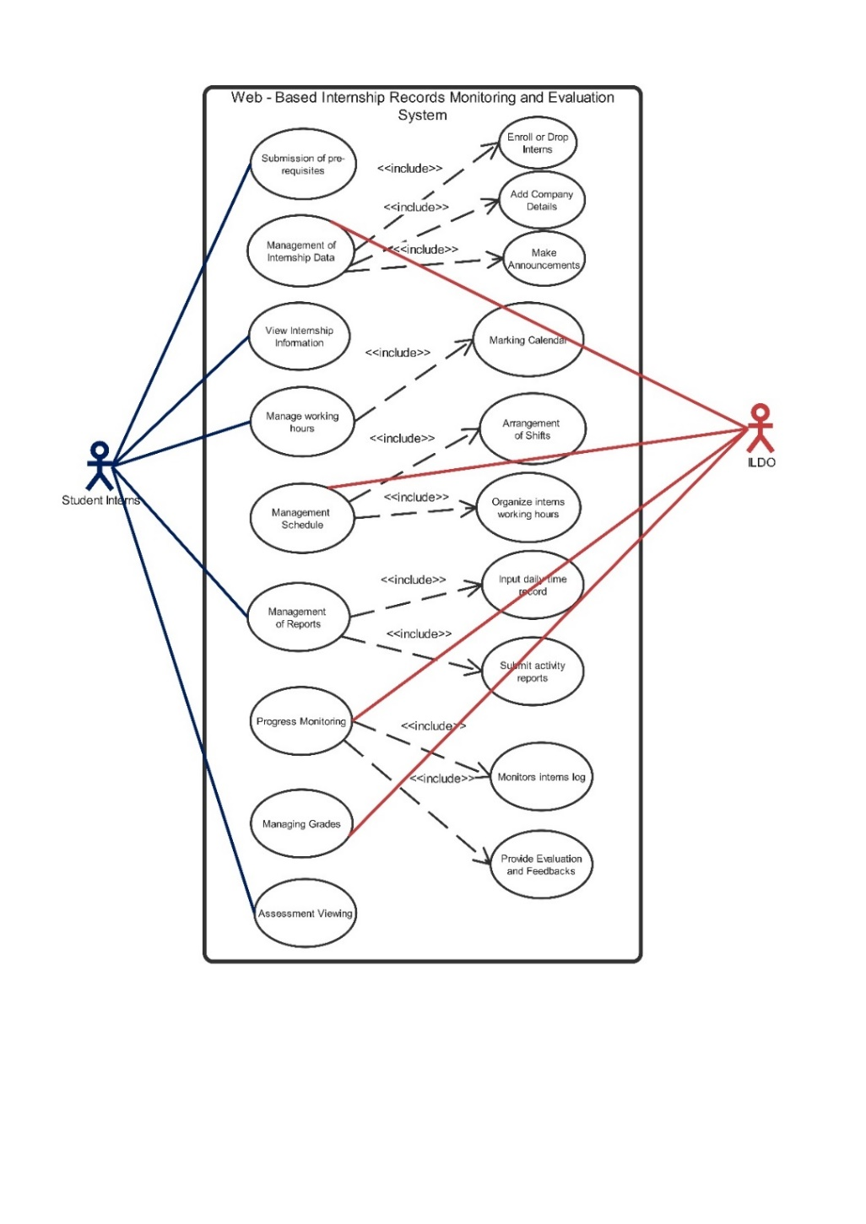Figure 4.2 Use Case Diagram of the Proposed System

**Students**

The student interns are actors that perform the activities within the system, upon logging in, they can submit pre-requisite requirements and can view their internship status and information. They can also manage their working hours such as marking their calendar, as it will help the admin in organizing the possible shifting of schedule among interns, and students can also manage their reports and view their assessments.

Activity diagram is a behavioral diagram that shows how an activity flow would occur in a system. They can be used to look at business processes and figure out their requirements and flow [5]. The following figures from Figure 4.3 presents the flow of the system’s sequences managed by the intended users. It includes the activity diagram from creating accounts, management of data and monitoring of the information.

Admin

Records Monitoring System

Intern

Login or Registration Form

Information

Verification

Display Dashboard

Display Calendar

Present Calendar Features

Saves and Secures the Records and Calendar Activity Histories

Display Evaluation Results

Login Information

Create Updates

Monitors Submitted Reports

Generate Reports

Registration Information

Edit Calendar

Submit Requirements and Reports

Access Denied

Incorrect

Verified

Figure 4.3 Activity Diagram of the Proposed System

Figure 4.3 shows the events that happens inside the system when interaction occurs. It illustrates the process of how interns will register and login to the system to attain the authorization of managing the system’s features, and how admin will manage the entire system’s features. Interns may edit the content of the calendar feature to set it up according to their internship information. After setting up the calendar, interns may now proceed in their internship monitoring phase by submitting requirements and daily time record login history through using specific functions in the system. The data that will be stored will be monitored by the admin and be evaluated, accordingly.

A class diagram is a visual representation of class objects in a model system, categorized by class types. For the class name, attributes, and operations, each class type is shown as a rectangle with compartments [13].

Figure 4.4 displays the system's class diagram, which highlights the logical structure of the database and includes the attributes, methods, and relationships between various classes. The above figure also shows the attributes of a class that represent the properties or characteristics of the class. The methods of a class represent the behaviors or operations that can be performed in the class, such as adding enrolling, or dropping an intern. The relationships between classes help to define how the entities in the system are related and how they interact with each other.

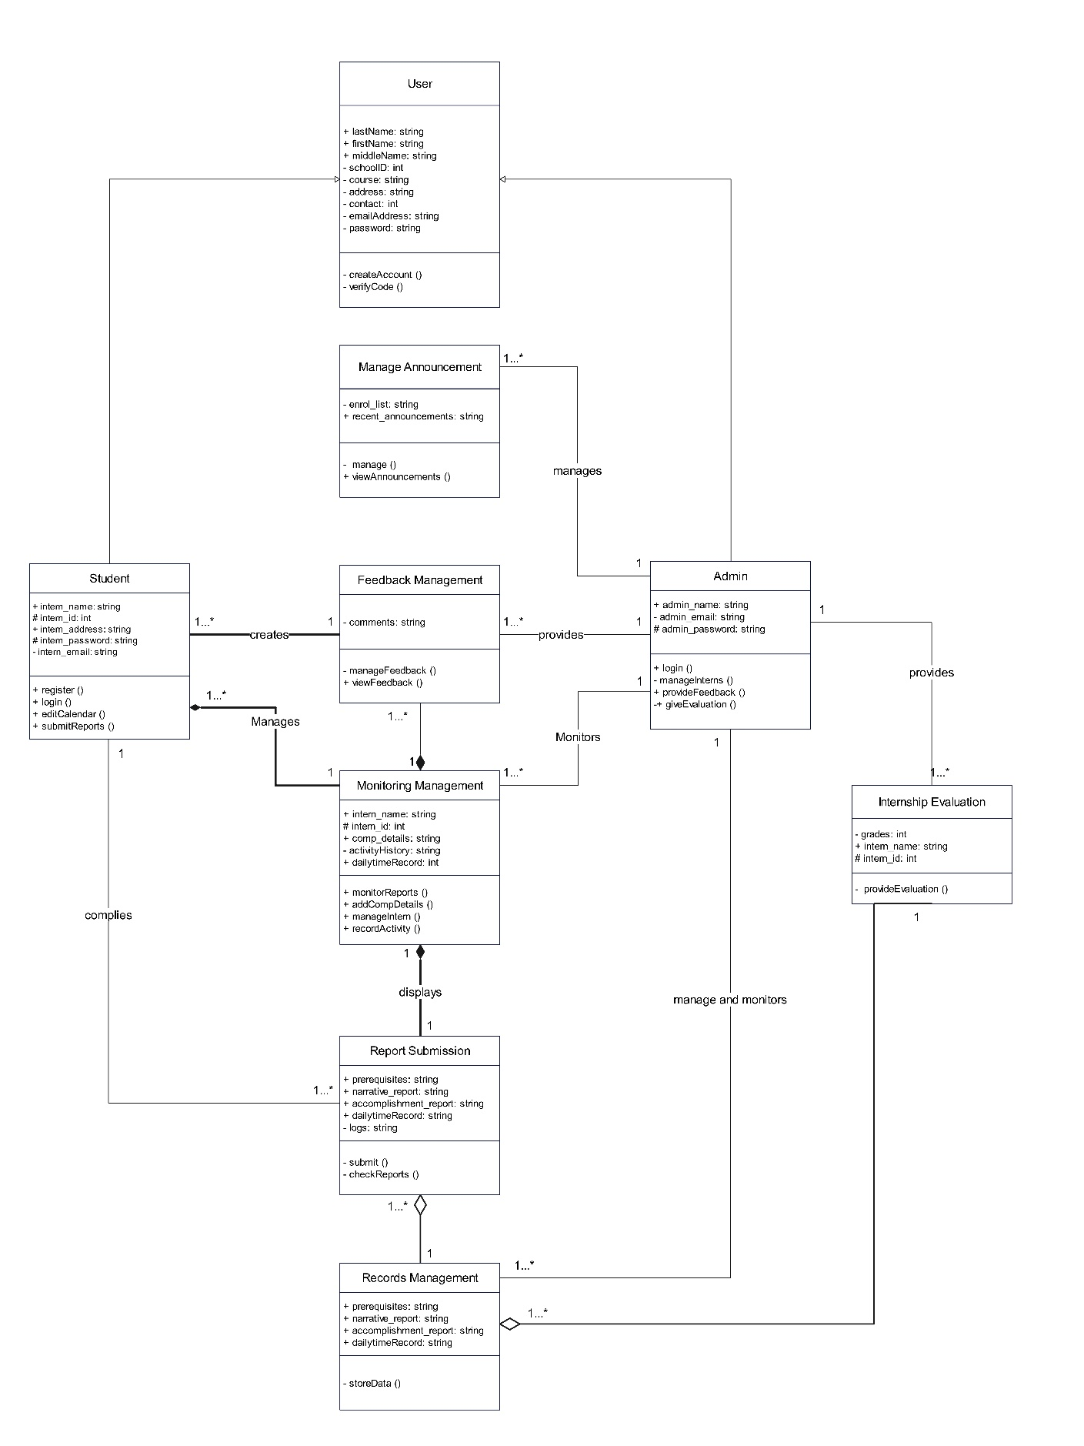

Figure 4.4 Class Diagram of Web-based Internship Records Monitoring System

**4.2.1 Requirement Analysis**

Requirement analysis is an element of project management that helps ensure clarity, completeness, and relevance. The goal is to define expectations for a project [11]. The system adhered to the functional and non-functional requirements listed in the tables, and to enhance the understanding of the functional requirements, diagrams were also provided.

**4.2.1.1 Functional Requirements**

Functional requirements are product features that developers must implement to enable the users to achieve their goals. They define the basic system behavior under specific conditions [6]. In Table 4.1, the functional requirements of the system were outlined with details on the task description and reference. The reference for task requirements was closely linked to the study's objectives.

Table 4.1. Functional Requirements

|  |  |
| --- | --- |
| Task Requirements | Task Reference |
| The students should be able to submit their e-version requirements. | **Interns**  **Requirements** |
| The user should be able to fill out the required fields to determine which system roles they will carry out. | User Requirements |
| The student should be able to provide their field’s information. | Company’s  Information |
| The admin should be able to monitor the list of enrolled interns. | Enrollment  Module |
| The student must fill out their training timetable. | Intern’s  Schedule |
| The system should be able to display the interns’ time logs. | Daily Time  Record |
| The system should enable the interns to submit their work records on time and viewed by the admin and moderators. | Intern’s Activity  Reports |
| The system should be able to display the admin’s evaluated works of the interns. | Evaluation Reports |
| The system should be able to store the intern’s records such as pre-requisite requirements and activity reports. | **Internship Records**  **Repository Management** |
| The system should be able to display the intern’s history of submitting their activity reports as well as their time logs and feedbacks from admin per calendar cells. | **Internship Calendar**  **System** |
| The system should be able to display the announcement page which the admin and moderators will carry out. | Announcement  Subsection |
| The system should be able to display the intern’s evaluation grades typed in by the admin. | **Interns’ Assessment**  **Viewing** |

**4.2.1.2 Non-Functional Requirements**

Non-functional requirements or NFRs are the set of requirements that defines how well a system will operate as opposed to functional requirements that focus on the specific business functionalities that an application performs [28]. Table 4.2 presented the non-functional requirements of the systems. The references given were obtained from ISO/IEC 25010, a set of software quality standards created by the International Organization for Standardization, and provided a presentation of each need and its accompanying job reference.

Table 4.2. Non-Functional Requirements

|  |  |
| --- | --- |
| Task Requirements | Task Reference |
| The system must be capable of carrying out all the functional specifications and give the adequate outcomes. | Functional Suitability |
| The response time and duration of the system, as well as the quantity and kind of resources used, must be appropriate. | Performance  Efficiency |
| The device should be able to exchange information with other or particular systems, products, or components. | Compatibility |
| The system needs to have accessibility for its diverse user base, offer aesthetically pleasing user interfaces that cater to its users, and be easily understood and recognized in terms of its usability and appropriateness. | Usability |
| The system needs to be stable and consistently available to users, with the ability to tolerate faults and recover from any failures. | Reliability |
| The system needs to provide accessibility for authorized users, prevent unauthorized access to the system, and only collect necessary and appropriate information. | Security |
| The system needs to have the ability to be modified or improved in the future, so that it can adapt to changes in its environment. | Maintainability |
| The system needs to be capable of operating in diverse and evolving technological or environmental contexts. | Portability of the System |

**4.3 Development Model**

In the design and development of the proposed system, the proponents will be using the Software Development Life Cycle (SDLC) model which is the Spiral Model. The Spiral Model is an iterative and methodical approach, wherein it is built on the spiral metaphor, with each spiral iteration standing in for a whole software development cycle, including requirements collection and analysis as well as design, implementation, testing, and maintenance [22,14]. Figure 4.3 shows the diagrammatic representation, wherein it resembles a spiral with several loops. In the system, the phase of the software development process is referred to as each spiral loop. And the project manager might alter the precise number of phases required to build the product depending on the project's risks.

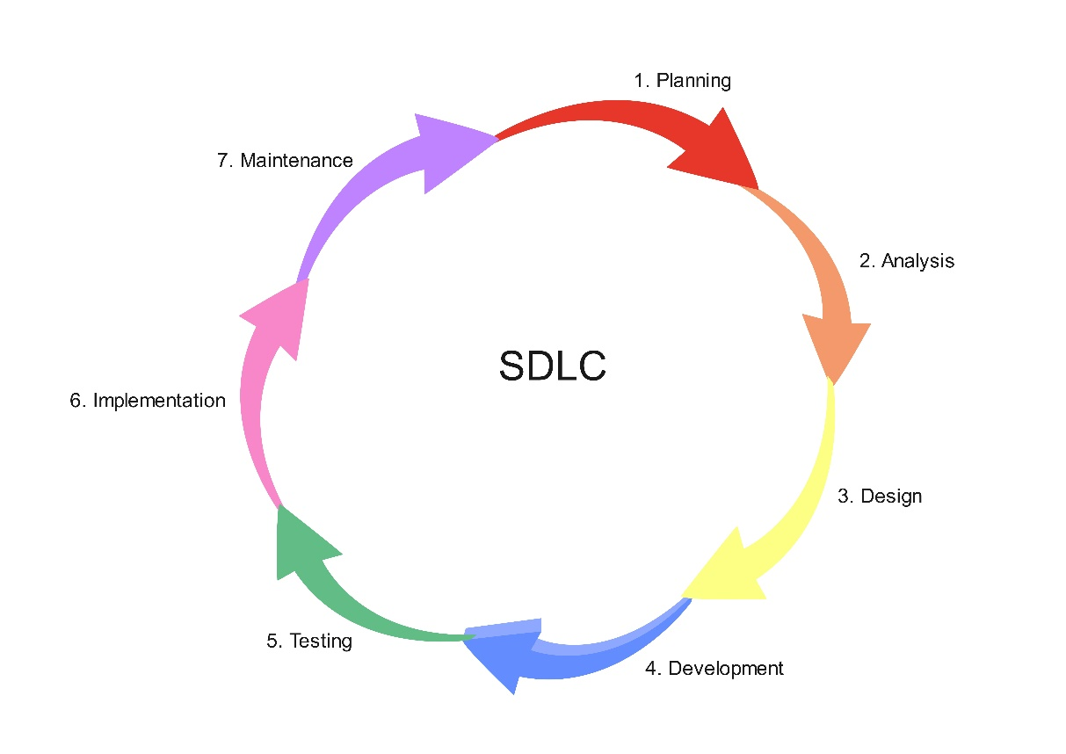

Figure4.3: Spiral Model

The following are the phases of the Spiral Model: [22,14]

1. Planning: The planning phase of the spiral model is where the project's scope is established and a plan is made for the spiral's following iteration. The proponents started the study by brainstorming possible ideas and systems that might be helpful to the school and the students as well. Upon coming up with a proposed system the proponents will gather from clients and will check if the requirements were possible and enough. The client of the system will be the ILDO (Industry Linkages and Development Office) and also the student interns of Sorsogon State University – Bulan Campus (SorSU-BC). In relation to this, the proponents will also create a plan and timeline for the following processes. Including the calculation of the iteration’s budget, timetable, and resources as well as understanding the system requirements for the communication between the system analyst and the client.

2. Risk Analysis: In the risk analysis phase, the risks associated with the project are identified and evaluated. The proponents utilize this phase as the basis for identifying the potential risk that the system might get while doing mitigation strategy planning and finalizing it. To further enhance the development of this study, the developers also studied and analyze existing projects that may be beneficial to the current study.

3. Design: In this stage, the software is developed based on the requirements gathered in the previous iteration. It also finalizes the technological requirements, database models, and business needs based on the plan. Make an algorithm, schematic, or working architecture that complies with your requirements. To give additional knowledge about the flow of the system, the proponents utilized different software by creating different figures, diagrams, and tables that were helpful in the visual representation of the features proposed by the developers and the interaction between the elements and other documents in the system.

4. Development: The development phase is the process by which the developers develop the software. The proponents in this stage write the code necessary to produce the result the proponents specified in the requirements and analysis using the software design papers including the different technologies for the development of the study and used up all their programming knowledge to develop the proposed system.

5. Testing: The testing phase is about determining and pinpointing what isn't functioning or performing as expected. Users and testers offer their opinions and personal experiences. After the development stage, features that are present in the system that wasn’t working properly will be addressed and fixed. The proponents also include reviewing for accurate spelling and proofreading content including page titles, checking links to ensure that they are not broken and are linked correctly, and checking graphics to confirm they display properly and are linked correctly.

6. Implementation: After completing all the phases, the software will be implemented in its work environment. Specifically, it will be deployed in SorSU-BC to be used by the ILDO and the student interns as its users.

7. Maintenance: The maintenance phase is the stage wherein it is the process of maintaining the system in its working state if there are some bugs or errors, or if there are new updates required. Specifically, the proponents will include the maintenance of the mismatched links that have gone unnoticed, errors in the content observed by the users, and make some changes based on the suggestions of the users who have tried browsing the sites.

**4.4 Development Approach**

The design strategy that will be used by the proponents in this study is the Bottom-up development approach. In bottom-up approach, a system is designed or analyzed by starting with its individual components and then combining them to create a larger system. The system is broken down into smaller parts that can be more easily understood and managed [26]. In the bottom-up approach, the initial stage involves developing and executing the system's lowest-level elements, which consist of functions or routines. These components usually have a particular purpose and are straightforward. After the implementation of the low-level components, they undergo testing and debugging to verify their proper functionality.

Following the testing and debugging of the low-level components, they are incorporated into more extensive elements such as modules, classes, or subsystems. The high-level components undergo testing and debugging to ensure their compatibility with the low-level components they rely on. Subsequently, the higher-level components are integrated into larger subsystems, and this process repeats until the entire system is developed and tested. A comprehensive testing and debugging process is then carried out to ensure the overall functionality of the system.

In this study, the object-oriented approach is combined with the bottom-up approach, as they both involve breaking down the structure and behavior of information systems into smaller modules that integrate data and processes. Additionally, the iterative life cycle is also suitable for the system's development. The approach adopted by the proponents involved creating the various components of the system initially and then assembling them to form the complete system.

**4.5 Software Development Tools**

The following were the software development tools and applications that the proponents will use for developing the system:

* **Front-End Development:**
  + **HTML**. The Hypertext Markup Language (HTML) programming language, which defines the structure and meaning of web content, is a building block for front-end development. Through HTML, browsers display text or load elements, rendering webpages, which contain hyperlinks and links to other webpages, for users [1]. Since the system will be implemented through using the web, HTML will be used in this project.
  + **CSS**.Cascading style sheets (CSS) is the standard language that specifies how to display HTML content: fonts, foreground and background colors, etc. With CSS, you can control the design layout and its components for various devices like desktops, tablets, and smartphones [9]. Through the use of CSS the proponents can manipulate the system’s HTML layout.
  + **JavaScript.** JavaScript (JS) extends the functionality of websites beyond HTML and CSS [1]. Websites can utilize JS to dynamically refresh themselves and respond to user actions without requiring page reloads or other changes. Pop-ups, picture sliders, and elaborate navigation menus can all be animated UI components. It provides interface interactivity between the user and the system.
  + **Figma.** It is a web-based graphics editing and user interface design app. It can be used to do all kinds of graphic design work from wireframing websites, designing mobile app interfaces, prototyping designs, crafting social media posts, and everything in between [24]. It also works direct on browser this means, it is accessible in any computer or platform without having to buy or install software. Lastly, it provides a large free plan that allows you to create and store three active projects at once. It's plenty of time to learn, experiment, and work on modest projects.
* **Back-End Development:**
* **SQLite**. SQLite is an in-process library that implements a self-contained, serverless, zero-configuration, transactional SQL database engine. The code for SQLite is in the public domain and is thus free for use for any purpose, commercial or private. SQLite is the most widely deployed database in the world with more applications than we can count, including several high-profile projects [31].
* **Python.** An interpreted, object-oriented, high-level programming language with dynamic semantics. Its high-level built in data structures, combined with dynamic typing and dynamic binding, make it very attractive for Rapid Application Development, as well as for use as a scripting or glue language to connect existing components together. Python supports modules and packages, which encourages program modularity and code reuse [30].
* **Text Editor and IDE**
* **PyCharm Community Edition**. It directly supports Python development. A user can just open a new file and begin coding. Python may be run and debugged directly from PyCharm, and it supports source control and projects [5]. PyCharm also allows programmers to effortlessly create a variety of web apps utilizing popular web technologies such as HTML, CSS, and JavaScript.
* **Version Control System**
* **Git.** Git is the most popular distributed version control system. It is commonly used for both open source and commercial software development, with significant benefits for individuals, teams and businesses. It lets developers see the entire timeline of their changes, decisions, and progression of any project in one place [12]. In addition, collaboration can take place at any time while the source code remains intact.

**4.6 Schedule and Timeline**

A horizontal bar chart known as a Gantt chart is used in project management to graphically depict a project plan across time. Gantt charts typically display the due date, current status, and assignees for each task in the project.

The project timeline, as shown in Table 4.3, covers the second academic semester of the year 2022-2023. The project title was conceived in the third week of February and finalized in May.

Table 4.3 Gantt Chart

|  |  |  |  |  |  |  |  |
| --- | --- | --- | --- | --- | --- | --- | --- |
| **ACTIVITIES** | **MONTHS** | | | | | | **OUTPUT(S)** |
| 1 | 2 | 3 | 4 | 5 | 6 |
| **Requirements Planning**  (*Brainstorming, Interview, Document, Analysis*) |  |  |  |  |  |  |  |
| Analysis |  |  |  |  |  |  | Gather data and break its concept into parts in order to analyze and understand it. |
| Interview |  |  |  |  |  |  | Conduct an interview in a specific client and asks few interns about the current manner of complying pre-requisites. |
| Document 1 |  |  |  |  |  |  | Layout and construct the chapter one, and then writes the introduction of the chapter. |
| Document 2 |  |  |  |  |  |  | Layout and construct the chapter two, and then writes the review of related systems of the chapter. |
| **User Design**  (*Document and Design phase – UML modeling*) |  |  |  |  |  |  |  |
| Document 3 |  |  |  |  |  |  | Layout and construct the chapter three, and then writes the technical background of the chapter. |
| UML modeling |  |  |  |  |  |  | Brainstorm, layout, and construct class diagram, use-case diagram, and activity diagram. |
| Prototype |  |  |  |  |  |  | Layout, design, and generate the project’s prototype. |
| Document 4 |  |  |  |  |  |  | Layout and construct the chapter four, and then writes the methodology of the chapter. |
| **Construction**  (*Document, System development, learning phase, Checking*) |  |  |  |  |  |  |  |
| Learning Phase |  |  |  |  |  |  | Learning different development tools related to the proponent’s system. |
| System’s Interface Development |  |  |  |  |  |  | Developing system’s interface from the prototype’s layout. |
| System’s Database Development |  |  |  |  |  |  | Developing the system’s database from the figure 4.1’s layout. |
| Prototype Checking |  |  |  |  |  |  | The system will undergo alpha and beta testing to determine the issues in the project. |
| Document Revision |  |  |  |  |  |  | Whole revision of the documents from chapter one up to chapter seven. |
| **Cutover**  (*Implementation, Deployment and Evaluation of the developed system)* |  |  |  |  |  |  |  |
| **Implementation** |  |  |  |  |  |  | Implementation of the system |
| **System Testing** |  |  |  |  |  |  | The system will undergo iterative and final testing. |
| **Deployment** |  |  |  |  |  |  | The proponents will prepare for deployment the system and; |
| **Maintenance** |  |  |  |  |  |  | Will do the system’s maintenance. |
| **Evaluation** |  |  |  |  |  |  | Both the panels and the client will evaluate the system’s implementation. |

After careful consideration and analysis, the proponents have come to the conclusion that completing the schedule is a necessary step towards improving their overall performance and productivity. As a result, they have decided to prioritize this task in order to achieve their desired outcomes. By ensuring that all tasks and deadlines are clearly defined and organized, the proponents can effectively manage their time and resources, leading to more efficient and effective work.

After gathering data through careful analysis, the proponents move on to conducting interviews with their target clients. Once they have obtained all the necessary information, they proceed to conceptualize the first two chapters of their project. This approach ensures that they have a comprehensive understanding of the topic at hand and allows them to develop a solid foundation for their work.

Following the completion of the initial stages, the proponents then move on to creating the technical background as well as developing the UML model and prototype of the system to ensure the successful implementation of the system.

The upcoming phase of the project will involve the construction of the system. This will encompass several key tasks, including document revision, system interface development, system database development, the proponents' learning phase, and prototype checking. This ensures that the documentation accurately reflects the system's functionalities and aligns with the project objectives.

The final phase of the project involves the implementation, deployment, and evaluation of the developed system. This includes iterative and final testing of the proponents' system to ensure that it is functioning correctly and meets all the necessary requirements. During the implementation stage, the system is installed and configured according to the project specifications. The deployment stage involves making the system available to the target users. The evaluation stage involves assessing the system's performance and effectiveness. Upon the successful completion of the implementation, deployment, and evaluation phase, the System's Development Life Cycle will reach its conclusion.

**4.7 Responsibilities**

The study is composed of four student proponents from BSIT and an adviser. The following discusses the roles and responsibilities together with their names.

* **Project Leader –** Princess Kaye S. Rogacion

The role of a project leader on a capstone project is crucial to the success of the endeavor. The project leader of this group is responsible for overseeing the proponent’s project's preparation, implementation, and conclusion, ensuring that the project objectives are completed within the provided schedule and budget. She is also responsible for directing the project team and promoting communication between team members with the assigned professor.

* **System Analyst –** Sherrelyn G. Chavez

A system analyst performs a significant function in a capstone project. Her major role is to examine the current system, identify flaws, and propose solutions that match the project's needs. She makes sure that the system is implemented appropriately and that it satisfies the needs of the proponents.

* **Software Engineer –** Ian Carl G. Grafil

Is responsible for fulfilling the position of software engineer, which plays a vital role in the project, especially because he is responsible for designing, creating, testing, and maintaining the software component of the project. To guarantee that the software component is seamlessly integrated with the other project components, the software engineer works hand in hand with the project members.

* **Technical Writer –** Vanessa Mariz Gracela

Is assigned the role of a technical writer to work on the document of the project's technical information, including the design, development, and testing procedures. She is responsible for ensuring that the project's technical details arwell-documented, intelligible, and aligned with the project's standards and requirements.

**4.8 Budget and Cost Management**

Cost management is the practice of organizing and regulating a company's operating expenses. In order to budget, anticipate, and monitor costs more accurately, it also involves gathering, evaluating, and reporting cost information. Cost management frequently focuses on making savings and increasing earnings over the long run.

During the execution of a project plan, it is important to document and track expenses to ensure they remain within the cost management plan. After the project is completed, a comparison of predicted and actual costs can be made, providing valuable benchmarks for future cost management plans and project budgets.

In order to effectively manage costs throughout the project's phases, it is crucial to prioritize the necessary hardware and software components of the system, and include the budgetary requirements for each component.

|  |  |  |  |
| --- | --- | --- | --- |
| **Budgetary Requirements** | | | |
| 1. **Materials and Supplies Budget** | | | |
| Item | Quantity | Cost | Total |
| Bond Paper (Hard Copy 70 gsm, 500 sheets) | 1 | Php. 210.00 | Php. 210.00 |
| Ink (Epson L3110 Ink 003) | 2 | Php. 646.00 | Php. 1292.00 |
| Binder Clip | 15 | Php. 8.00 | Php. 120.00 |
| 1. **Services** | | | |
| Services | Cost | | Total |
| Internet Service (GLOBE) | Php. 1500.00 | | Php. 4500.00 |
| Plagiarism Checker API (GRAMMARLY and QuillBot) | Free | | Free |
| 1. **Other Expenses** | | | |
| Travelling Expenses | | | Php. 2500.00 |
| Printing Expenses | | | Php. 1000.00 |
| Bookbinding | | | Php. 1000.00 |
| **Total Budgetary Requirements** | | | Php. 10,622.00 |

**BIBLIOGRAPHY**

[1] N. Afiza, R. Suziyani, M. Enzai F. Dzul M. Hilmi, F. Mohd, N. Nik, D. Nik, and A. Talmizie. Development of Internship Monitoring and Supervising Web-Based System. 10.1109/SCORED.2017.8305395. Available at https://www.researchgate.net/publication/322229792_Development_of_Internship_Monitoring_and_Supervising_Web-Based_System (2017)

[2] J. Almarinez. Assessment of Online OJT Performance Monitoring.International Journal of Computer Science and Software Engineering (IJCSSE) Volume 6 Issue 12 ISSN (Online): 2409-4285. Available at https://uphsl.edu.ph/research/r/cs/ASSESSMENT%20OF%20ONLINE%20OJT%20PERFORMANCE%20MONITORING.pdf (2017)

[3] A. Alsolais. Development of a Web-based Student Internship Portal for Students of Health Colleges. Fortune Journal of Health Sciences, 5(3), 451-460. (2022)

[4] E. N. Amora K. Romero R. Amoguis E. Olandria & J. J. Olavides OJT Attrack – On The Job Trainee Remote Attendance Monitoring System Using Face Recognition System pp. 248 (2022)

[5] A. Athuraliya. The Easy Guide to UML Activity Diagrams. Available at <https://creately.com/guides/activity-diagram-tutorial/> (2022)

[6] R. Baker. What are Functional Requirements? A Comprehensive Guide with Examples. Available at <https://www.ntaskmanager.com/blog/what-are-functional-requirements/> (2023)

[7] K. Brush. “use case” Software Quality. Available at <https://www.techtarget.com/searchsoftwarequality/definition/use-case> (2022)

[8] C. Chenghong, L. Guang, L. Lujia, L.Yilin, L. Kang, J. Tan, and X. Qiang. User-Centered Software Design: User Interface Redesign for Blockly--Electron Artificial Intelligence Educational Software for Primary and Secondary Schools. Sustainability. 15.5232.10.3390/su15065232. Available at https://www.researchgate.net/publication/369314064afiza (2023)

[9] Cloudinary. Front-End Development: The Complete Guide, Available at <https://cloudinary.com/guides/front-end-development/front-end-development-the-complete-guide#fe-1> (2023)

[10] Marco Del Rosario Jr and Ronnel Cruz. Internship Program Management Information System with Lean Management. International Journal of Information and Education Technology. 12. 7-14. 10.18178/ijiet.2022.12.1.1580. Available at http://ijiet.org/vol12/1580-IJIET-2906 (2022)

[11] K. Eby “Requirement Analysis Templates Tips and Techniques” Smartsheet. Available at <https://www.smartsheet.com/content/requirements-analysis> (2022)

[12] J. Fincher. “Python IDEs and Code Editors (Guide),” *realpython.com*, Sep., [Online]. Available at <https://realpython.com/python-ides-code-editors-guide/#visual-studio-code> (2022)

[13] L. Fonseca “How to Make a Class Diagram [+Examples]. Available at <https://venngage.com/blog/class-diagram/> (2022)

[14] GeeksforGeeks “Software Engineering Spiral Model”. Available at <https://www.geeksforgeeks.org/software-engineering-spiral-model/> (2023)

[15] N. B. Hamutoğlu Ö. C. Güngören İ. Duman M. B. Horzum M. Kıyıcı and Ö. E. Akgün. The scales for acceptance usability and satisfaction for web-based monitoring and support systems. International Online Journal of Education and Teaching (IOJET) 6(3). 563-580. Available at http://iojet.org/index.php/IOJET/article/view/4 (2019)

[16] N. Hasti S. Lesari and I. Gustiana. Web-Based Internship Information System. IOP Conference Series: Materials Science and Engineering 1-2. 10.1088/1757-899X/662/2/022090. Available at https://iopscience.iop.org/article/10.1088/1757-899X/662/2/022090 (2019)

[17] L. Hui and S. Yusof. Design and Development of UUM Internship Monitoring System: A Web-based Application for Monitoring Practicum Students. International Journal of Undergraduate Research 3(1) 44 43-48. Available at https://ijurjournal.weebly.com/uploads/2/6/8/1/26810285/31072022-ijur-43-48.pdf (2022)

[18] Itsourcecode “Attendance Monitoring System Thesis”. Available at <https://itsourcecode.com/fyp/attendance-monitoring-system-thesis/> (2022)

[19] A. Juhana A. G. Abdullah M. Somantri S. Aryadi D. Zakaria N. Amelia and W. Arasid. “E-portfolio web-based for students’ internship program activities” in 2nd International Conference on Innovation in Engineering and Vocational Education 25-26 October IOP Publishing Manado doi:10.1088/1757-899X/306/1/012003. Available at https://iopscience.iop.org/article/10.1088/1757-899X/306/1/012003 (2018)

[20] V. E. Kusumawardhani. Usage of on-the-job training application to increase the effectiveness of monitoring and control in pandemic era. In S. Noviaristanti (Ed.) Contemporary Research on Management and Business. (pp. 248-249). Available at https://library.oapen.org/bitstream/handle/20.500.12657/57755/1/9781000777840.pdf#page=271 (2022)

[21] P. Marbella Sorsogon State College Student’s Handbook pp. 38. (2000)

[22] M. Martin “Spiral Model: When to Use? Advantages and Disadvantages”. Available at <https://www.guru99.com/what-is-spiral-model-when-to-use-advantages-disadvantages.html#spiral-model-phases> (2023)

[23] L. Mia, B. Nath, A. Zahid, and H. Hoque. A Conceptual Design of Virtual Internship System to Benchmark Software Development Skills in a Blended Learning Environment. 23rd International Conference on Computer and Information Technology (ICCIT). 10.1109/ICCIT51783.2020.9392670. Available at https://www.researchgate.net/publication/359352826_A_Framework_of_University_Internship_Information_System_with_Web-Based_Design_Analysis (2020)

[24] R. Perera, “What is Figma? (And How to Use Figma for Beginners) - Theme Junkie,” *Theme Junkie*. Available at <https://www.theme-junkie.com/what-is-figma/> (2023/26/04)

[25] F. A. Pratama R. M. Silitonga and Y. Jou. A Framework of University Internship Information System with Web-based Design Analysis. Available at <https://www.researchgate.net/publication/359352826_A_Framework_of_University> (2022)

[26] Prepinsta Technologies Private Limited “Bottom-Up Approach. Available at <https://prepinsta.com/software-engineering/bottom-up-approach> (2023)

[27] R. Ramgopaul. What Is System Architecture? Available at What is System Architecture? - Third Stage Consulting (thirdstage-consulting.com) (2023)

[28] K. Rana “Non-Functional Requirements”. Available at <https://artoftesting.com/non-functional-requirements> (2021)

[29] Sutikno, Baedhowi, Siswandari & Roemintoyo. Satisfaction Of The E-Monprakerin Model Based On The Android System For Monitoring Vocational Student Internships. Humanities & Social Sciences Reviews. 8. 764-771. 10.18510/hssr.2020.8382. Available at https://www.sciencegate.app/document/10.18510/hssr.2020.8382 (2020)

[30] T. Tashia. What Is Python: Get to Know One of the Most Popular Programming Languages. Available at <https://www.hostinger.com/tutorials/what-is-python> (2023)

[31] James Walker, “What Is SQLite and Why Is It So Popular?.” Available at <https://www.howtogeek.com/devops/what-is-sqlite-and-why-is-it-so-popular> (2021)

[32] Y. Yannuar B. Hasan A. G. Abdullah D. L. Hakim and D. Wahyudin. “Design and implementation of web-based internship information system at vocational school” in 3rd Annual Applied Science and Engineering Conference 18 April Bandung doi:10.1088/1757-899X/434/1/012301. Available at https://iopscience.iop.org/article/10.1088/1757-899X/434/1/012301 (2018)