First Progress Report
A Data-Driven Decision Support for Game Development Planning
Student Name: Hsieh Lung Kwun
Student number: 2422 1546
Supervisor: Dr. XIAN, Poline Yin
Hong Kong Baptist University
BSc (Hons) in Business Computing and Data Analytics

Project focus
Historical game-data analysis and an updatable planning-support application for independent developers and small studios.

Reporting position as of 23 October 2026
Data preparation, development-stage model experiments, CSV updates and a local comparison application are available. A supplementary Steam revenue explorer and comparable-game search have also been implemented. Final model evaluation and the integrated presentation website remain unfinished.

Table of Contents
Project Objectives 2
Proposed System Solution 3
Work Completed 4
Data preparation and analysis design 4
Descriptive analysis and verification 4
Development model results 4
Application prototype 5
Problems and Mitigation 7
Schedule and Current Activities 7
References 8
Supporting Project Records 8
Acknowledgements 8

Project Objectives
This project aims to develop a data-driven decision support system for independent game developers and small studios during early development planning. It uses historical game data to help users compare attributes such as genre, platform support and monetisation characteristics against platform-specific outcome groups. The intended value is a traceable reference for planning; the system does not promise future sales, revenue or commercial success.
The working scope covers Steam and Android. They are analysed separately because their source dates, available attributes and outcome definitions differ. The combined scope remains subject to supervisor confirmation. The objectives are to:
- Prepare and validate platform-specific datasets, with recorded sources, cleaning decisions and reproducible analysis inputs.
- Describe historical attribute and outcome distributions, and explore supplementary revenue estimates with clear sample sizes, source dates and interpretation limits.
- Evaluate outcome-tier classification against simple baselines using developer-group validation and a reserved final test stage.
- Develop an application for historical condition comparison, comparable-game references, result export and validated updates through a specified CSV format.
- Assess reliability through sensitivity and functional checks, and assess usefulness through a small user-task evaluation if feasible.

Proposed System Solution
The solution combines a reproducible Python analysis workflow with a browser interface. Historical Steam and Google Play snapshots are processed into separate analysis tables. Selected attributes are used for descriptive analysis and model development. The local interface currently compares two sets of planning conditions within one platform, returning matching sample counts, outcome-tier distributions and overlap information.
The product scope has been refined from analysis of a fixed dataset to an updatable application. A data maintainer can validate a CSV against a defined contract, preview exclusions, save a version and explicitly activate it. Imported application snapshots remain separate from frozen research data. Importing a file does not automatically retrain a model or alter the research split.
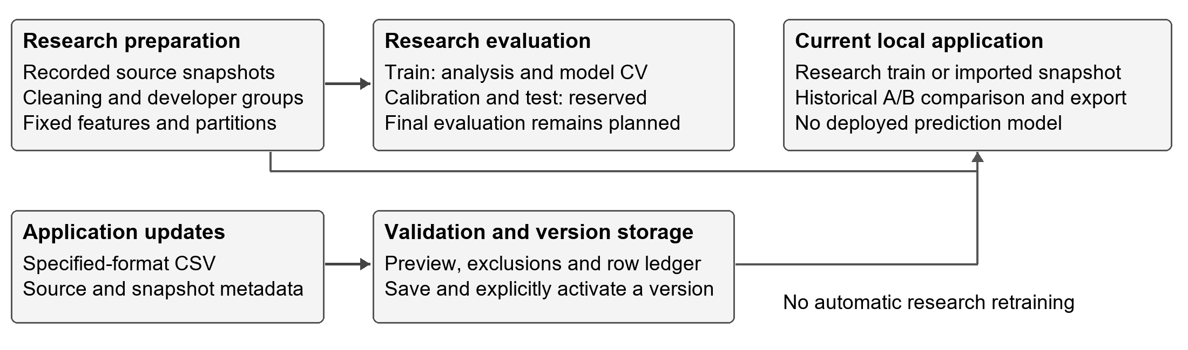
Figure 1. Research evaluation and application updates follow separate paths. The current interface provides historical comparisons; prediction deployment is not implemented.
The implementation uses Python, pandas, DuckDB and PyArrow for data handling; scikit-learn for model experiments; and HTML, CSS and JavaScript for the local interface. Power BI provides supporting descriptive views. A separate revenue path now supports Steam exploration and reference retrieval without changing the research outcomes or splits. A unified overview and research-results interface remain to be completed.

Work Completed

Data preparation and analysis design
The two principal inputs are the Steam Games Dataset 2025 March snapshot (Ermilov, 2025) and the Google Play Store Apps June 2021 collection (Prakash, 2021). Other downloaded sources were audited for comparison and feasibility; they were not all merged into the primary analysis. Original files are retained, while intermediate and processed tables are stored separately.
Completed preparation includes source inventories, structural and data-quality checks, conservative parsing, row-level inclusion records and a fixed feature policy. Missing values are distinguished from zero or false. Literal game names such as None and NULL are retained for review rather than automatically removed. Inconsistent Android free/price records have an unknown free status in the analysis version; non-USD or unknown currencies are not treated as USD.
The Steam primary sample excludes nonpositive observed prices, unavailable targets or developer groups, and software-only genre records under an explicit heuristic. Android uses 16 clearly identified game categories and excludes ambiguous Sports records. These choices define the scope of the findings and do not establish representativeness of the entire market.
Table 1. Fixed primary analysis cohorts and developer-group partitions.
Platform | Total | Train | Calibration | Test
Steam | 73,527 | 51,152 | 11,435 | 10,940
Android | 318,300 | 221,806 | 48,297 | 48,197

Steam labels are three groups mapped from estimated-owner intervals; an owners interval of 0-0 is treated as unknown. Android labels use installation lower bounds: below 1,000, 1,000 to below 100,000, and at least 100,000. Neither target is a measure of revenue or exact sales.
Developers are grouped before partitioning, so the same developer group does not cross train, calibration and test sets or the three training validation folds. Steam co-development links are included when forming groups. Learned encoding, imputation and scaling are fitted only on the fitting portion of each training fold. Outcome fields and developer identifiers are excluded from predictors. These controls address leakage risks rather than guaranteeing an unbiased model (Kapoor and Narayanan, 2023).

Descriptive analysis and verification
Training-set analysis covers outcome balance, genres or categories, monetisation, observation age and missingness. Verified exports support two Power BI overview pages. The original comparison version uses 51,152 Steam and 221,806 Android training rows. The 23 October review found no hash changes in the 27 inputs, dependencies and outputs tracked by the frozen analysis manifest. All 68 unit and integration tests passed, including new revenue and retrieval checks. The historical audit was also restricted to its original source folders so new downloads cannot enter its inventory. These checks do not establish predictive validity or user usefulness.

Development model results
The completed experiments compare a class-prior baseline, age-only models, Logistic Regression and Random Forest. P denotes planning-describable snapshot attributes; P+A adds the elapsed time between release and observation. P is not a set of verified pre-release measurements. A Steam variant without price was also evaluated because the original price currency remains unresolved.
Table 2. Mean macro-F1 over three training developer-group folds. These are development results, not final test scores.
Platform | Features | Prior baseline | Logistic regression | Random forest
Steam | P | 0.2860 | 0.4401 | 0.4458
Steam | P+A | 0.2860 | 0.4845 | 0.5062
Android | P | 0.2127 | 0.4758 | 0.4785
Android | P+A | 0.2127 | 0.5322 | 0.5376

Macro-F1 averages the F1 score across outcome classes and is useful when class sizes differ. The prior baseline is the same within each platform because it does not use P or P+A attributes. Both learned models exceed the baseline in all four platform/feature settings. Random Forest has a larger improvement over Logistic Regression for Steam P+A than for Android P, where the improvement is small. These comparisons reuse the folds used to select settings and therefore are not independent estimates of final performance.
Additional fixed-setting experiments restrict observation age, vary Steam sample eligibility, and test four Android outcome tiers. Some model-family rankings change with sample scope, and higher-install Android classes remain difficult. The original three-tier product behaviour is retained. Final model choice, calibration and reserved-test evaluation have not been completed, and no predictive probabilities have been deployed.

Application prototype
The local prototype supports Steam/Android selection, two-condition comparison, sample-size feedback and JSON export with provenance. CSV validation, preview, version saving, activation and return to the original research version are implemented; the active version persists between runs. Imports require a specified schema. A separate Steam page now provides revenue exploration and genre/price-based game references; its source and limitations are described on the following page.
The comparison prototype and CSV workflow have recorded automated and browser checks. A Power BI report and two overview screenshots have also been prepared. Figure 2 illustrates the Android training-sample overview; Power BI is supporting material rather than a required dependency of the application. The saved PBIX interactions and DAX have not been independently verified.
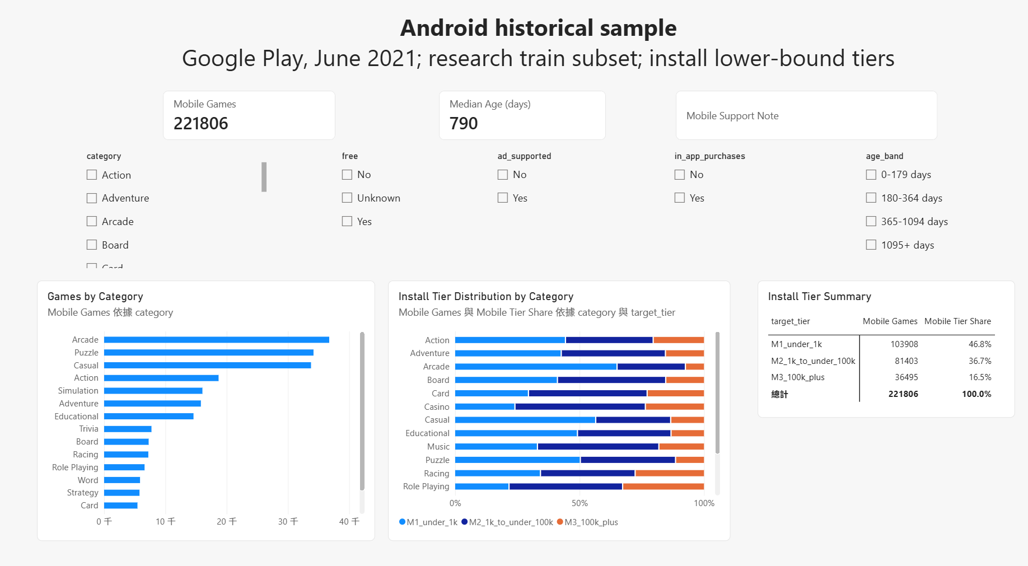
Figure 2. Existing Android Power BI overview screenshot, captured on 16 October 2026. Its 221,806-game denominator is the research training subset, not the full Android market.
Supplementary revenue analysis and game references
Revenue was absent from the primary owner/install targets, so three additional CSV sources were checked for structure, missing values, duplicates, units and matching coverage. They have separate audit records. Table 3 records their current use; none has replaced the frozen research targets or entered model training.
Table 3. Newly audited revenue sources and their use in the project.
Source | Rows | Current use and interpretation
Steam top revenue 2024 (alicemtopcu, 2024) | 1,500 | Active descriptive explorer. Estimated cumulative gross revenue for selected 2024 releases; snapshot labelled 9 September 2024. Not a complete Steam-market sample.
Highest Grossing Mobile Games (Mattop, 2022) | 104 | Context only. High-grossing mobile games across platforms, with no Android-only revenue split or consistent per-game observation cutoff. Name matches are unverified candidates.
Steam Launch Lever Panel (SteamForecast, 2026) | 10,403 | Method reference only. Week-one revenue is derived from estimated owners/reviews, price and assumed revenue shares, rather than observed first-week sales. It is not used as a prediction target.
The Steam preparation retains all 1,500 source rows without imputing revenue. Steam IDs match 1,406 rows to the March 2025 metadata, with usable genres for 1,401. These later genre labels support descriptive exploration only. The page supports filters, distribution and concentration summaries, a searchable/sortable/paginated table and JSON export.
In the default positive-observed-price subset (1,415 games), median estimated revenue is USD 105,087; the highest-revenue 142 games account for 92.05% of that subset’s total. The other 85 zero-price rows are available separately. These figures describe the selected dataset, not the typical Steam release or a new project’s expected revenue. USD follows provider conventions because the CSV has no currency column.
Gamalytic describes paid-game revenue as estimated gross base-game receipts before the Steam cut, whereas its free-to-play estimate covers broader revenue sources. The exact 2024 estimation version is not archived with the CSV. Release dates can reflect full release after Early Access, and observation windows differ; the values are neither profit nor comparable first-week receipts (Gamalytic, n.d.).
The reference search accepts gameplay genres and a target price. It requires at least one shared supported genre, separates zero and positive prices, and offers a price-range filter. Games are ranked by Jaccard genre similarity (shared genres divided by the combined genre set), then price difference and Steam ID. Revenue is displayed after selection and does not determine ranking. This is transparent historical retrieval, not a trained k-nearest-neighbour model or a revenue forecast. Automated and desktop/mobile browser checks cover the workflow.

Problems and Mitigation
Issue | Response and remaining work
Different snapshots and outcome meanings | Analyse Steam and Android separately; display source dates and scope. Do not interpret owner intervals or install lower bounds as revenue or combine them into a cross-platform success ranking.
Selection, missingness and revenue estimates | Retain explicit unknowns and source-specific cohorts. Report revenue as selected-sample estimates, not profit or expected returns. Keep zero-price games separate; later genre metadata and revenue-based publisher classes cannot establish launch-time or causal effects.
Limited predictive reliability | Retain simple baselines and inspect class/subgroup results. Complete the reserved evaluation before any prediction deployment; historical comparison remains useful without a deployed classifier.
Scope and delivery risk | Confirm the dual-platform scope. Integrate the existing comparison, import, revenue and reference functions before adding features. Keep optional deployment and user evaluation proportionate to the remaining time.

Schedule and Current Activities
Data audit and preparation were completed on 5-6 October, initial analysis and linear models on 7-8 October, CSV/version support and tree experiments on 10 October, and sensitivity checks by 13 October. Power BI material and program guidance followed by 17 October. On 23 October, three revenue sources were audited, a Steam revenue explorer and reference search were implemented, and regression checks were completed. The remaining work prioritises integration, research evaluation and preparation for assessment.
Table 4. Proposed work packages after this report. Timing is a working estimate to be aligned with the confirmed assessment dates.
Window | Planned work | Completion evidence
Next 1-2 weeks | Confirm scope; connect comparison, CSV updates, Steam revenue and reference search through a clear overview and navigation. | Coherent local demonstration with traceable counts and a documented user task.
Weeks 3-4 | Complete group-versus-random diagnostic and relevant literature review; test the usefulness and limits of genre/price references. | Recorded validation comparison and reference-search task results.
Weeks 5-6 | Fix model choices; refit on train, calibrate and evaluate the reserved test set in sequence. Decide whether prediction is suitable for the interface. | Final per-class and subgroup evaluation; explicit deployment decision.
Weeks 7-8 | Complete integration and functional checks; conduct a small user-task study if feasible; prepare presentation, setup guide and report updates. | Test evidence, user feedback where obtained, and a rehearsed demonstration.

Current activities focus on checking the new sources, documenting their appropriate uses and consolidating the working demonstration. The Steam revenue explorer and comparable-game retrieval are implemented. The integrated overview, final model evaluation and user-task evaluation remain outstanding. Public deployment is also undecided: the Python service currently runs locally, while GitHub Pages alone cannot host its backend. Scope and assessment timing still require confirmation.

References
alicemtopcu. 2024. Top 1500 games on steam by revenue 09-09-2024. Kaggle dataset. https://www.kaggle.com/datasets/alicemtopcu/top-1500-games-on-steam-by-revenue-09-09-2024
Ermilov, Artemiy. 2025. Steam Games Dataset 2025. Kaggle dataset, March 2025 snapshot. https://www.kaggle.com/datasets/artermiloff/steam-games-dataset
Gamalytic. n.d. About: methodology and glossary. Retrieved 23 October 2026 from https://gamalytic.com/about
Kapoor, Sayash, and Arvind Narayanan. 2023. Leakage and the reproducibility crisis in machine-learning-based science. Patterns 4, 9, Article 100804. https://doi.org/10.1016/j.patter.2023.100804
Mattop. 2022. Highest Grossing Mobile Games. Kaggle dataset. https://www.kaggle.com/datasets/mattop/highest-grossing-mobile-games
Prakash, Gautham. 2021. Google Play Store Apps. Kaggle dataset, June 2021 collection. https://www.kaggle.com/datasets/gauthamp10/google-playstore-apps
SteamForecast. 2026. Steam Launch Lever Panel 2026. Hugging Face dataset and data card. https://huggingface.co/datasets/steamforecast/steam-launch-lever-panel-2026

Supporting Project Records
The reported measurements and implementation checks are documented in the following records retained with the project:
- Data scope and partitions: Program/reports/2026-10-06/analysis_v1/manifest.json, analysis_protocol.md and verification.json.
- Initial data analysis and linear models: Program/reports/2026-10-07/train_eda_v1/ and model_dev_v1/.
- Tree comparison: Program/reports/2026-10-10/model_tree_v1/linear_tree_comparison.csv and verification.json.
- Age and sample/target sensitivity: Program/reports/2026-10-11/model_age_v1/ and reports/2026-10-13/model_scope_v1/.
- Application and import checks: Program/DEMO_GUIDE.md, CSV_IMPORT_GUIDE.md and reports/2026-10-10/csv_import_v1/verification_notes.md.
- Revenue audit and analysis: Program/reports/2026-10-23/revenue_sources/audit.json and analysis.json; implementation and checks in Program/src/analysis/ and Program/tests/.
- Power BI material: Program/reports/powerbi/. AI assistance record: Program/reports/planning/ai_assistance_log.md.
Large source files, processed data and saved model artifacts are retained locally and are not all included in Git. The repository documentation explains the required data and environment; a code-only clone is not a complete reproduction package.

Acknowledgements
OpenAI ChatGPT and Codex assisted with planning, source review, data processing, model experiments, implementation, testing, and report drafting and editing. The student supplied requirements and priorities, revised the report and prepared the Power BI material. Numerical results come from recorded program outputs. The student remains responsible for understanding, checking and explaining the submitted work.

