Sum Program

Exercise 2
Write a program, which is able to input two numbers from the screen, ask for which mathematical operation type to perform on them, and then display the result of the numerical operation on the two numbers.
Possible mathematical operations should be indicated by:
- + For addition
- - For subtraction
- / For division
- * For multiplication
Your program should make use of functions to input the numbers and for each of the possible mathematical operations. (Use the same function to get both numbers).
When a mathematical operation type is input, this should be validated, and the appropriate function executed.

Structure Diagrams.

Input Data Diagram

Output Data Diagram
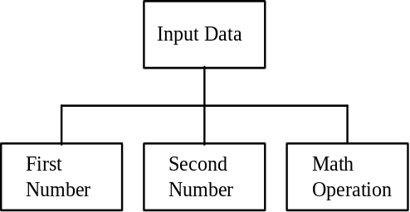
Note. The output data structure is very simple as it consists of only one numeric value.
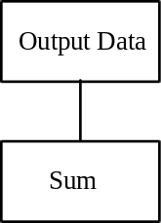
The following procedure structure diagram, represent the sequence of events and logical constructs which provide a solution to the sum problem. The mathematical assignments are assumed, basic operations do not need to define formula, i.e. the formula for addition assignment is represented as "Calculate addition", rather than include assignment formula/syntax, the terms producing result are included as they imply a requirement for a result identifier.

Procedure Structure Diagram
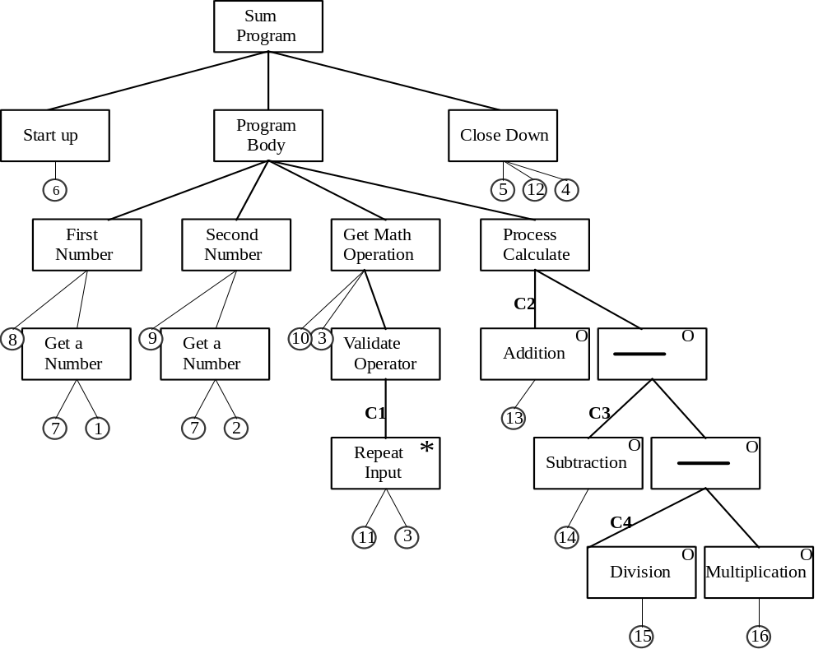

Conditions.
C1 - Mathematical operation is not equal to +, -, / or *.
C2 - Mathematical operation is equal to +.
C3 - Mathematical operation is equal to -.
C4 - Mathematical operation is equal to /.
Basic Operations.
1 - Read first number. | 9 - Display prompt second number.
2 - Read second number. | 10 - Display prompt mathematical operation.
3 - Read mathematical operation type. | 11 - Display invalid mathematical operation message.
4 - Read/wait for key. | 12 - Display "Any key to continue" message.
5 - Display result. | 13 - Calculate the result by addition.
6 - Display title headings. | 14 - Calculate the result by subtraction.
7 - Display prompt enter number. | 15 - Calculate the result by division.
8 - Display prompt first number. | 16 - Calculate the result by multiplication.

