Investment account model

Exercise 4
You are required to create a program, which will display an investment forecast.
The program is required to obtain from the user three values:
- Starting balance.
- Number of months to forecast/display.
- Interest rate per year.

Interest is to be compounded monthly, this will be calculated by maintaining a monthly total, updated with the current months interest earned, a suitable formula is:
- Monthly interest = 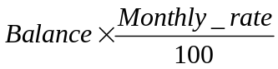
- Monthly rate = 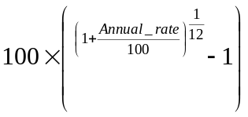
This could be implemented as a function, macro or coded directly.
A possible flow of the program might be described as follows:
- Obtain and validate the three values.
- Initialise start values.
- For number of month times.
- Update balance (balance = balance + interest)
- Display current months balance.
- Display final results.
Your program should be commented to facilitate readability, and must be correctly structured with indentation to illustrate this.

PROCEDURE.
At the start of program execution, the screen must clear and a suitable title be displayed. A message requesting the user to enter a starting balance figure must be displayed. The user will now enter a starting balance figure; this must be validated as a floating-point number not exceeding 8 digits. When a suitable number has been accepted, a message should be displayed requesting the user to enter the number of months to forecast between 1...60. The user now enters the number of months, this should be validated to be an integer between the range 1...60. When a suitable number of months have been accepted, a message must be displayed requesting the user to enter the rate of interest per annum. The user enters the interest rate per annum, as a floating point i.e. 10.5 for ten and a half percent, this must be validated to be a floating point number greater than 0 and less than 100.
When the starting values have been accepted as valid the screen may clear or scroll to display the appropriate values, these should be followed by a final results report with an option to print the final report.

