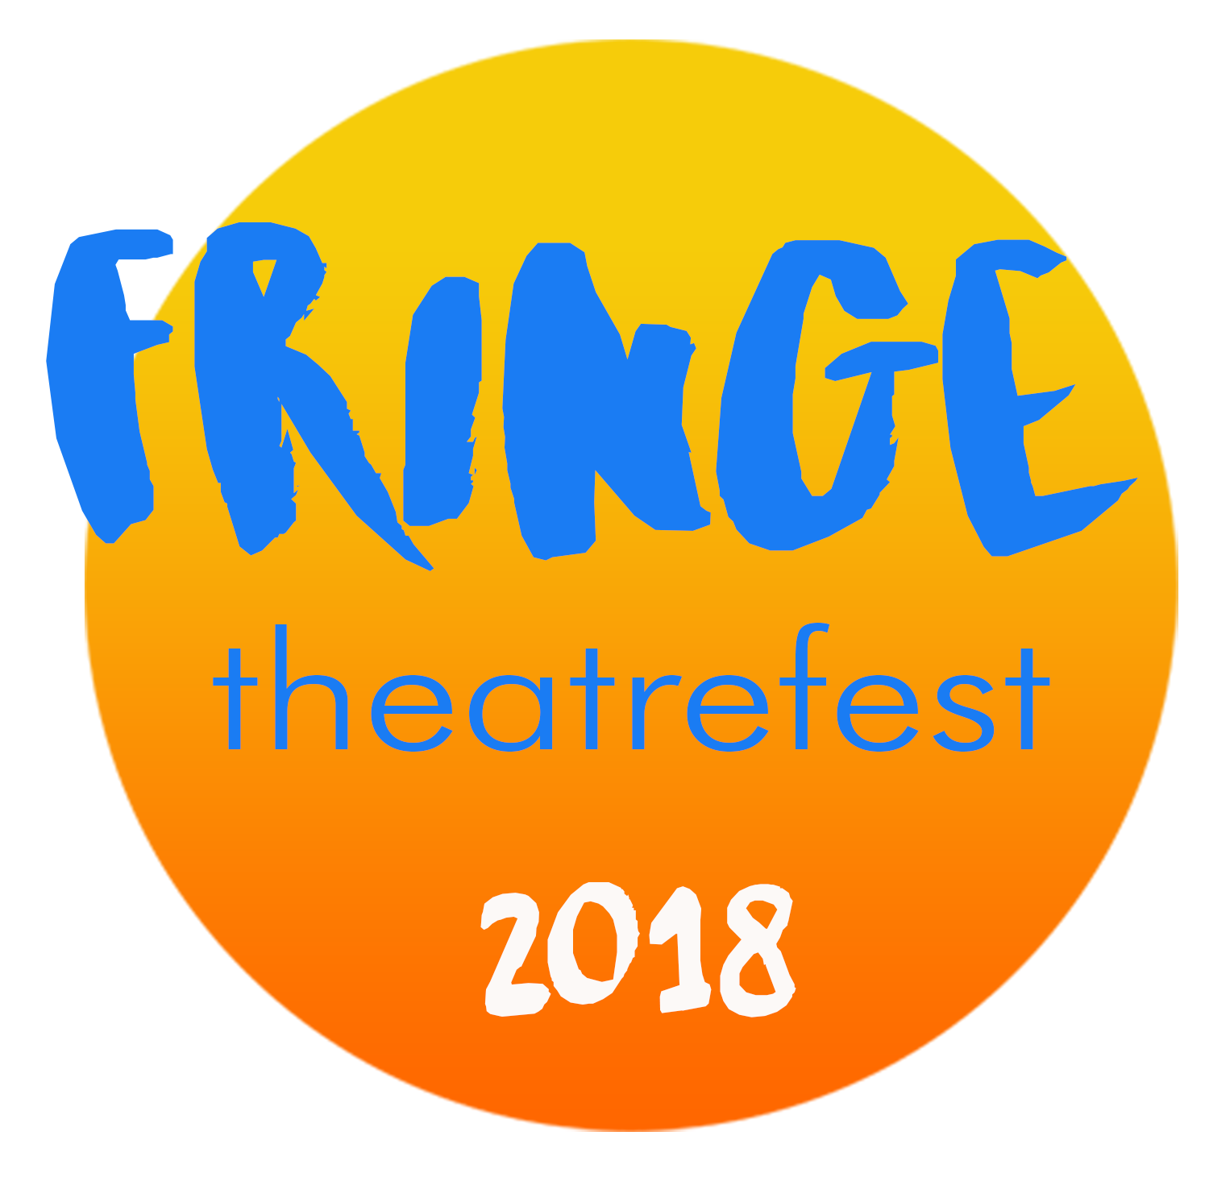

publicity

The following is by no means definitive and many of you will have your own tried and tested approaches to publicising your event. Different types of show also call for different approaches so treat the following as a general guide. But we hope that the information below is of use and we are more than happy to answer specific questions and do what we can to help you attract audiences to your show.

What is Fringe TheatreFest doing?
We promote Fringe TheatreFest as an entity around North Devon and the wider region through press, traditional media, social media, posters, brochures, newsletters, our e-mail list and word-of-mouth. We sometimes focus on a particular show, or set of shows, if we think that doing so will bring people to the Fringe. But our duty is to the Fringe as a whole rather than to any one show.

What can you do?
There are two distinct areas of activity. First, to promote your show to specific target audiences in the lead-up to the event. Second, to engage with audiences for other shows during the event and persuade them to become your audience.

In the lead-up
The pre-event work means identifying particular groups of people who might be persuaded to take an especial interest in your show. Successful examples from previous years include young mums, bed & breakfast guests and nursing staff (not for the same show!) You then need to think about and perhaps research how to reach the target group.

If you draw a blank then let us know what you are trying to achieve and we’ll see if we can help you with local knowledge.

You will then need to decide the most appropriate way of making contact – email, snailmail, social media, phone or pigeon-post – and proceed accordingly.

Best to make contact at least 3 weeks in advance (ie beginning of June).

ALSO take advantage of your page on the Fringe TheatreFest website. The potential punters who are looking for information on the website will want to know a bit about you – your experience, what makes you tick. They’re looking for more than the hard sell. DO make it worthwhile for someone to visit your page in terms of additional information but DON’T bombard them with an overload of words. Use images and video where you can. Remember that this is the page where they will click on for tickets if you’re appearing in a Ticketed Venue.

During the event
Activity during the event might include handing out flyers to people queuing for or leaving other shows and from the Fringe gazebo in the High Street.

You should think seriously about having a five minute extract or presentation for the ‘taster sessions’ that will take place at the Barnstaple Coffee Shop on Wed 27 June and Thu 28 June and in the Queen’s Theatre Café on Fri 29 June.

Most importantly, be prepared to engage with fringe punters at a personal level. Other companies and the volunteer force are also potential audience and an important part of spreading the word.

media
Take advantage of the media contacts (such as they are) listed at the end of the document. It’s worth making initial contact by phone or e-mail before sending a press release. In nearly all cases a short, sharp newsworthy story with a strong image is going to have more impact than a general press release. They’re often after the quirky human angle rather than the art!

Social media
Mount your own social media campaign linked into our Facebook, twitter and Instagram so that we can reinforce what you do.

Fringe TheatreFest Facebook:
https://www.facebook.com/Fringe-TheatreFest-665995770198280/?ref=hl

Fringe TheatreFest twitter:
@TheatreFestND

Fringe TheatreFest Instagram:
https://www.instagram.com/p/BT-5EbZlvgO/

Fringe TheatreFest Website:
http://www.theatrefest.co.uk/index.htm

Get your event posted on the following Facebook events groups:
EVENTS IN BIDEFORD!
Days out North Devon
What's on North Devon
Bideford Bay What's on
What's on Plymouth, and Surrounding Areas.
What's on Exeter

Many of these have a twitter prolfile as well, so get tweeting!

What it’s probably not worth doing.
Don’t waste time and money on untargeted leafleting of everybody in Barnstaple. Much better to concentrate on converting people already interested – and seeing other shows – into an audience for your show.

Posters and leaflets
Both posters and leaflets are important in establishing your presence within Fringe TheatreFest but keep this in proportion so that you don’t spend out unnecessarily. We recommend 20 posters (ideally a mix of A3 and A4) and 200 leaflets. We are more than happy to put posters up for you ahead of the event. To be of maximum use, posters and leaflets need to be with us by the end of May. Send to the contact address on the website and let us know by email that they are on the way so that we can keep track of them.

media contacts 2018

North Devon Journal weekly
The North Devon Journal is now edited from Exeter with some local journalists. They put a lot of emphasis on their on-line version, Devon Live. Make Joel Cooper your first port of call.
jcooper@northdevonjournal.co.uk
Tel : (01271) 347431

Twitter: @ThisisNDevon

North Devon Gazette weekly free paper
Tony favours short, punchy summaries with venue details and preferably, a hook. Not much space for entertainment in this paper so distil!
Tony Gussin
Reporter, North Devon Gazette
Tel: 01271 341628
Tony.Gussin@archant.co.uk
http://www.northdevongazette.co.uk
http://www.facebook.com/NorthDevonGazette#

The Voice DAB Radio Station for North Devon
Studio: 01271 323010
http://www.thevoicefm.co.uk/contact/studio.html
www.thevoicefm.co.uk
Twitter: @thevoicefm

Websites

http://www.fringereview.co.uk/pageView.php?pagename=Barnstaple%20Fringe%20Theatrefest
This is the Fringe TheatreFest page on Fringe Review. Fringe Review have been extremely supportive and are looking to increase their coverage this year. You can start by submitting an on-line interview (look for the Interview Submission Form link in the lower left-hand panel).

http://artsculture.newsandmediarepublic.org/

