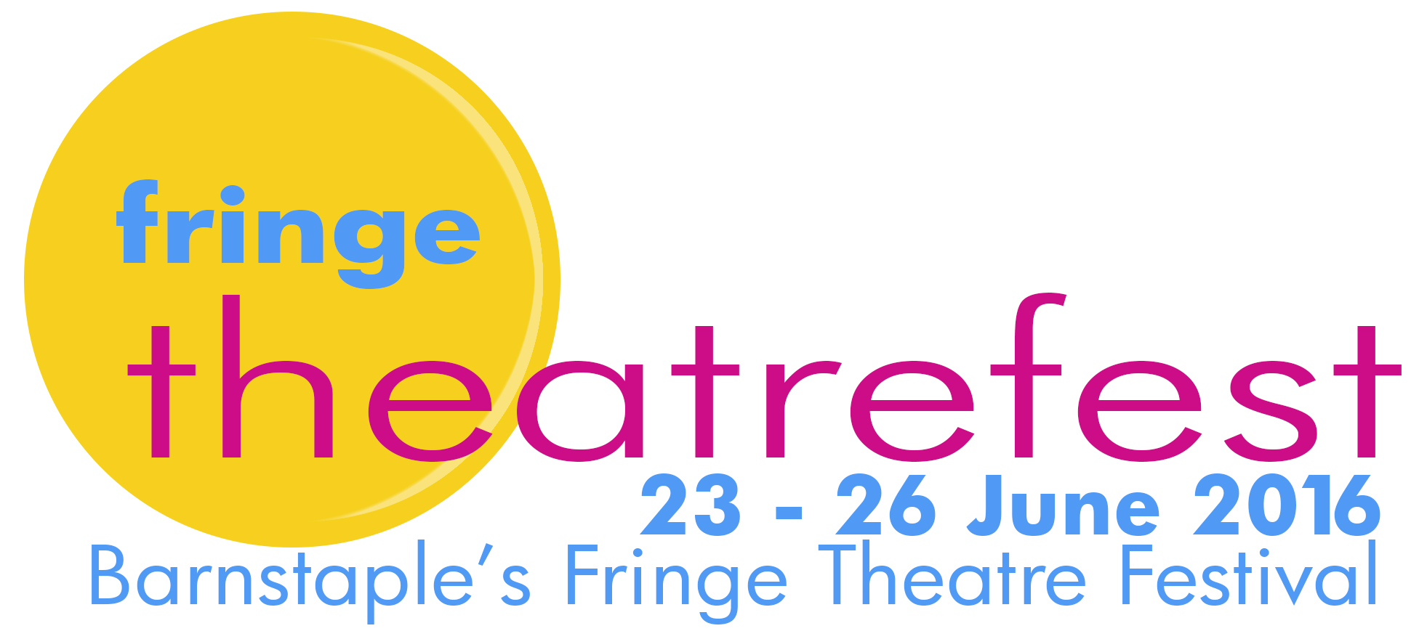

application information – site-specific venues

what is Fringe Theatrefest?

Fringe Theatrefest is a four-day Fringe Theatre Festival that takes place in Barnstaple, North Devon towards the end of June.

28 companies present 3 performances each in one of four basically equipped Fringe venues that seat between 50 and 150 audience. 4 companies present 5 performances each in a venue known as Room At The Top that seats 20 and has no technical equipment installed. And up to 4 companies can present work in a site-specific venue of their choosing. There are further details for regular-venue entries in a separate regular-venue application info document.

Fringe Theatrefest encompasses the widest possible range of theatrical forms. Previous Fringe Theatrefests have included drama, comedy, contemporary dance, dance theatre, African dance and song, children’s theatre, puppetry, cabaret, juggling, music theatre, performance poetry, magic and mind illusion.

the productions

The cast can be any size and the show in any theatre performance style – drama, comedy, cabaret, revue, dance, opera, musical, stand-up, improv, performance poetry etc .

In regular venues the maximum show length is 75 minutes and get-ins and get-outs must be managed within 15 minutes but these limitations don’t apply to site-specific productions.

Please note that companies including children or vulnerable adults will need to liaise with the North Devon Theatres Trust Education Officer at an early stage to ensure that they have the relevant licenses and chaperoning arrangements in place and that they can conform to the NDTT Child Protection Policy. This verification process will need to take place soon after the draw results are known.

how does it work financially?

You pay a participation fee of £35. You keep 100% of the box-office.

The non-returnable participation fee is £35 – and is payable once a slot has been confirmed. This secures a generous presence in the brochure and on the website, inclusion in generic Fringe Theatrefest publicity and the sale of tickets through the centralised box-office. We will endeavour to provide appropriate box-office and stewarding for the performances but this will need to be discussed during the application process since this will depend on the nature of the show.

You find the space you wish to perform in and you are responsible for securing and paying for such permissions, hire charges and licenses as might be necessary. You are also responsible for installing and paying for any technical equipment you might wish to use – lights, sound etc – and for their operation. You provide the production – including all scenic elements, stage furniture, props, performance rights etc – and publicity specific to your show.

We will discuss with you, during the application process, how (if at all) you wish to charge audiences for the event. This all depends on the nature of your show. Some site-specific productions have simply taken a collection. One was a free event. If you want us to issue tickets then generally they will follow the pricing structure for regular venues: £5/£3 concessions with a Frequent Fringer at £15 for 6 shows (which means each production visited gets £2.50). This has been varied in the past for a show that was just 11 minutes long.

You are able to programme more than just the 3 performances that productions in regular venues are limited to. This needs to be in consultation with us to ensure that we aren’t stretching our volunteer force of front-of-house staff and stewards beyond breaking point. Site-specific productions are not bound by the same time constraints in terms of performance length or get-in/get-out times.

The reason behind offering the opportunity of extra performances is to allow you to recoup extra costs that might be involved in hiring, licensing and equipping a venue.

why take part in fringe theatrefest?

Fringe Theatrefest is probably one of the lowest-cost Fringe Theatre Festivals in the world.

But you will be disappointed if you think of it as a money-making venture. Whilst it won’t break the bank, it won’t make your fortune. It provides an affordable context in which to develop new work, to give further life to existing work, to see a lot of very different kinds of theatre and to forge and foster new collaborative relationships.

In previous years, companies have used Fringe Theatrefest as an opportunity to develop work in preparation for Edinburgh Fringe, for the Canadian Fringe circuit, for Buxton Fringe, Camden Fringe, Prague Fringe and other festivals. And for preparing productions to offer to regular venues and touring circuits.

Companies have also taken the opportunity to introduce themselves to North Devon audiences and to invite local and regional promoters – and, where appropriate, schools and colleges – to see their work. This has led directly to employment in the region for some professional companies.

But primarily Fringe Theatrefest is a meeting place and somewhere to be inspired by a host of interesting work.

how does the entry procedure work?

Applications are via the on-line application form which will be live between 1 - 22 January. We will be talking with you about the practical aspects of your application (see “What we need from your proposal”). The draw takes place on Saturday 23 January.

Companies are limited to a single application for a site-specific production. However, companies could make a further application to mount a different show in a regular venue. Applications for shows in regular venues also take place between January 1 - 22 2016.

No distinction is made as to the status of the companies - amateur, professional or student. Fringe Theatrefest makes no value judgements in the programming of the Festival.

What we need from your proposal

We make no artistic judgements whatsoever. This is as true of site-specific productions as it is of shows in regular venues. But with site-specific productions we need to be confident that the proposal is technically and organisationally viable. So we will be checking with you during the application process to make sure that all bases are covered. This is so that neither the company nor Fringe Theatrefest finds itself at a later date with unexpected costs to meet or bureaucracy to deal with that compromise the production or mean Fringe Theatrefest getting involved to a degree that impacts on the smooth-running of the rest of the Festival.

Proposals need to include as clear an account as possible of the physical needs of the production. Specific buildings or spaces should be identified and outline permissions should have been sought. You should know what the hiring/ licensing/insurance costs are going to be (if applicable) and be able to give us an idea of any equipment you might be installing. Obviously we don’t expect any of this to be finalised at the application stage but we need a solid understanding of what’s involved. We will discuss your application with you to make sure that the practical issues are covered. If they are, then your application will be entered into the draw.

The site-specific venue must be secured by the end of February – with all relevant permissions – so that the programme can be announced and the brochure produced. If a company finds that it can’t secure the venue by the end of February then it will forfeit the slot and it will go to the first company on the waiting list with a viable venue.

Please contact us if you have questions or problems.

