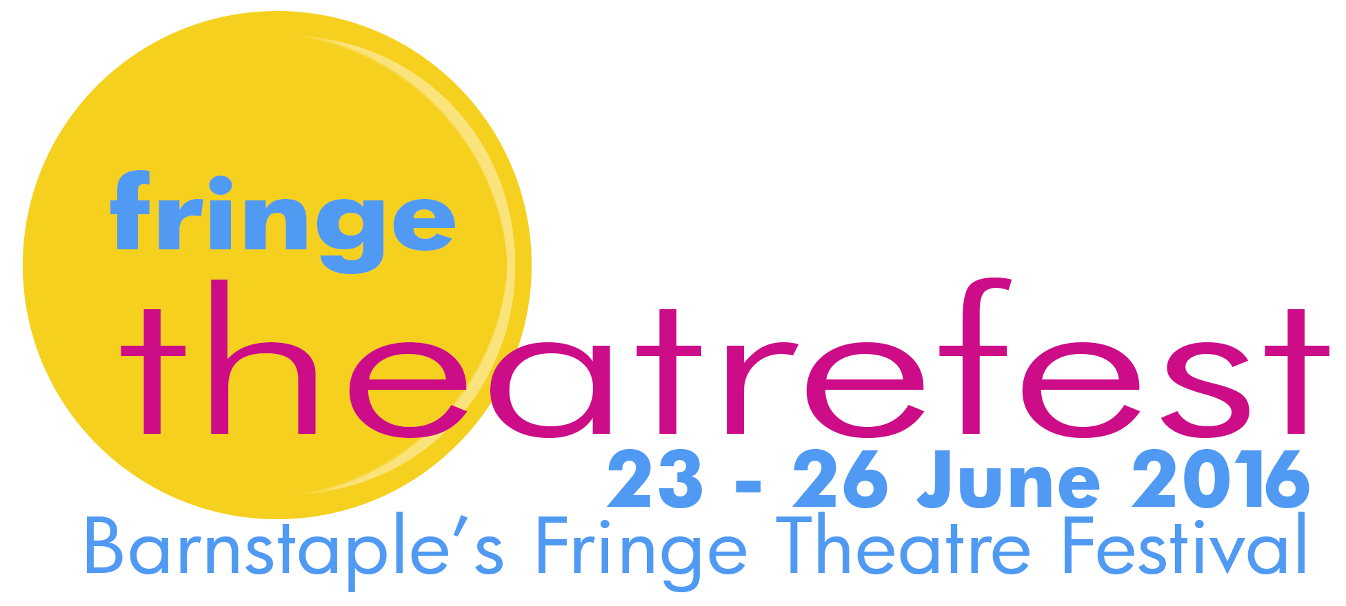

technical information

introduction

Two of the venues are basically-equipped studio theatre spaces (60 seats), purpose-built for Fringe Theatrefest. One is in a Baptist Hall, the other is in the café-gallery area of the Queen’s Theatre. A third venue is larger and more generously equipped as it is a permanent theatre space – the Queen’s Theatre main stage, configured as a studio space (studio@QT). A fourth venue, in St Anne’s Arts Centre, is less formal. It will be blacked out and equipped with a very basic lighting rig to focus the action but it is a Grade One listed building of historic interest and so care has to be taken with the fabric of the building . The fifth venue is meetings room with no theatre equipment installed that seats 20.

The lighting-rigs in the first three venues provide for a warm-wash, a cool-wash and two or three specials. The four larger venues are equipped with a CD player, microphone and PA system. Anything beyond this – additional lights, projection, video equipment etc – has to be provided by the companies and the technical feasibility of using any such additional equipment in the venues must be checked with Fringe Theatrefest at an early stage. Companies will need to provide evidence that any such equipment has up-to-date PAT testing.

We want to make things happen for you but we are working with a fairly basic infrastructure so let us know as early as possible what your needs might be and we will do our best.

the venues

The Baptist Hall (60 seats) has an acting area 5m wide, 6m deep with plenty of height. Wing space is adequate. Entrances are viable Upstage Right and Left, Downstage Right and Left and Upstage Centre. The 3 ‘specials’ in The Baptist Hall will be in fixed positions because of the height of the lighting bar. They will be open white and focussed to cover (separately) stage-left, centre and stage-right.

*We have to be sensitive to the suitability of a production for The Baptist Hall. There can’t be real alcohol in the building – though there can be fake alcohol. And there can’t be extreme language or sexual content. If your application is successful, you will be asked to flag up anything that might be a problem in the ‘comments’ section of the on-line tech form.

gallery@QT (60 seats) has an acting area 5m wide, 3.8m deep and with plenty of height. There is no wing space or possibility of entrances stage left. Entrances can be made Upstage Centre and Stage Right.

The 2 ‘specials’ in gallery@QT can be re-focussed and re-coloured for each show.

studio@QT (150 seats) has a stage area 7m wide, 5m deep with plenty of height. Wing space is good. Entrances are viable Stage Right and Stage Left.

The 3 ‘specials’ in studio@QT will be in fixed positions because of the height of the lighting bar. They will be open white and focussed to cover (separately) stage-left, centre and stage-right.
St Anne’s Arts Centre (50 seats) is a converted chapel. The space is approximately 4m wide, 10 m long with about 5m height. There are fixed pews either side of the space. There is no raised stage and no fixed chairs (so the chairs can be re-arranged for each production) and no installed lights other than a pair of fresnels to focus the space. It is a very atmospheric space and has proved very popular since we started using it in 2013 – especially for shows that benefit from something ‘different’ in terms of a spatial arrangement.

Room At The Top is a meetings room at The Queen’s Theatre that provides a simple, intimate space for a performer or two and an audience of 20. It has white walls and is carpeted. There is not stage-lighting or sounds system installed. It’s proved to be a very popular space with performers and audiences alike for the right kind of intimate show. Companies have done fairly sophisticated things with projection, torchlight and simple engagement. Companies are allocated 5 performances (rather than the usual 3 in other venues) to make up for the smaller capacity.

time restraints

All companies must operate within the following time constraints:

- a one hour technical rehearsal
- a maximum performance time of 75 minutes (recommended max 60 mins) and a minimum performance time of 30 minutes
- a maximum set-up time before each performance of 15 minutes only
- a maximum get-out time also of 15 minutes

There is no room for manoeuvre within this framework because Fringe Theatrefest has to be very tightly scheduled to cram in the number of performances.

storage

Each company will have an area of 1 square metre for storage. If you’re burdened with massive scenery of furniture then either rethink or let us know straight away!

operation

Either the venue technician or a volunteer technician will be there to operate your show but remember that you have only 1 hour to tech the show with you so if the operation of lights or sound is complicated and crucial you would be well advised to provide your own operator.

Each company is responsible for the set-up and get-out of each of their performances. If you think you might need additional bodies to help, let us know.

