Multimedia Report

Ricardo O'hara Camones x12425828, Graham Robinson x12486282

Project Proposal

For our project we decided to make an advertising campaign to promote a movie.

The movie we came up with is titled “Wrestler VS. Zombiez”.

The movie we took inspiration from is “Machete” directed by Robert Rodriguez, starring Danny Trejo alongside Robert De Niro.

We wanted to use some aspects of flash in our advertising campaign and came up with some ideas, one of which was to make a flash game.

For the game we wanted to make a side-scrolling beat ‘em up where the user plays as the main character Zapatos who is a Mexican wrestler. As Zapatos, the player must fight their way through hordes of zombies to escape the arena. In our game we hope to include some aspect of a health system.

Marketing/Production Log

In marketing our project we will make a Facebook/Twitter page and we will also look into other marketing options such as flash banners to put on webpages, blogs, etc.

We researched existing marketing techniques in this area and found some examples we could work from.

Many games and films sponsor popular TV shows. Thinkbox develops research focused on issues surrounding television advertising. Thinkbox.tv believes that the market was worth over £190m in 2007 rising 8.5% since 2006.

This statistic shows how much of an impact sponsoring a TV show can have and why we thought it would be a good idea to sponsor a show fitting the genre of the game such as The Walking Dead due to its high ratings and popularity.

We designed a poster for the movie using Fireworks taking inspiration from old Mexican wrestling posters but we mainly took inspiration from the DC comic “Darkseid vs. Superman Archival Print” as shown on the right below as a template to begin with.

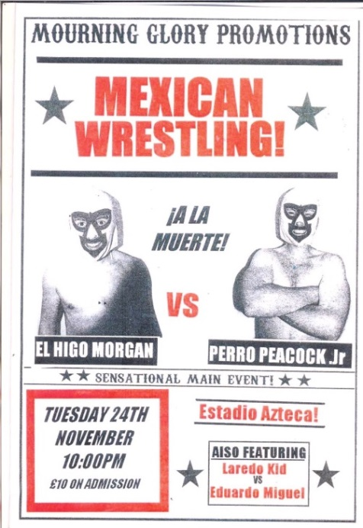 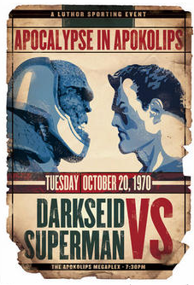

*Mexican wrestling poster *DC comic

In our final poster we used a similar style to the DC comic above and added the star of “Wrestler VS. Zombiez” Danny Trejo. The finished poster can be seen below. Overall we had no technical issues with the production of our final poster.

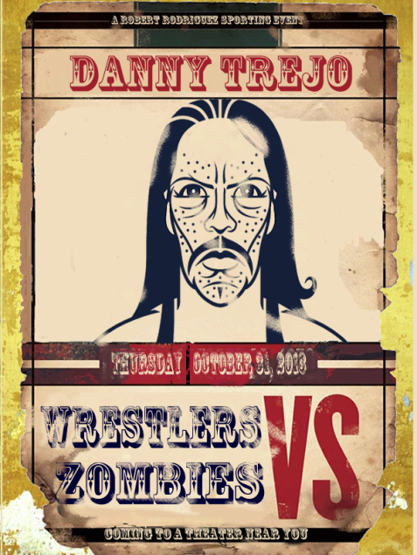

*Finished poster

Using flash we designed flash banners that would play a short animation on web browsers to promote the movie. These flash banners would fade in each of the films main characters Danny Trejo, Jessica Alba, Michelle Rodriguez and Steven Segal. Individually, then show the title of the movie overlaying the characters pictures and finally a clip of a zombie horde. I planned on changing the background of the characters and use the same one we had for our menu but due to our deadline this could not be achieved. Our only technical issue was when we demoed it again on a different computer the names underneath the character change the style font to a more plain one where originally we had use the style “Blackoak Std”.

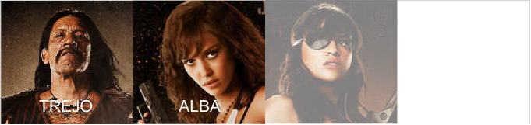

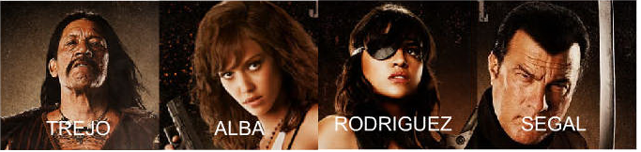

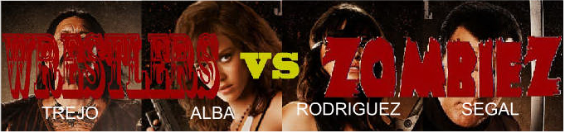

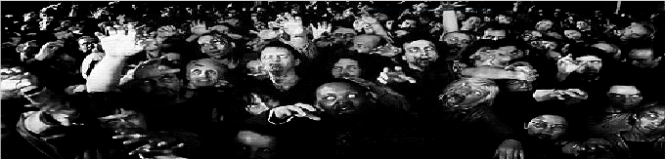

Our primary marketing strategy is to make a working and playable flash game set in the same genre as the film and also using the same title.

In the planning of the game we decided to split it into three manageable parts these parts were, the title menu, the opening cinematic and the actual gameplay.

For the title menu we wanted to add a small aspect of animation. To do this we started out with a background image that we designed ourselves and cut out the head and arm to be animated at a later stage as shown below.

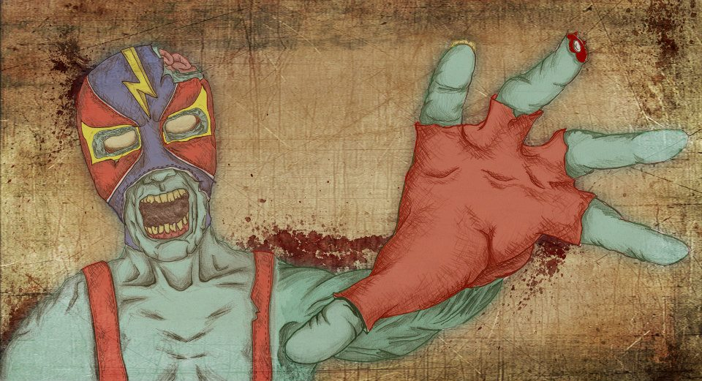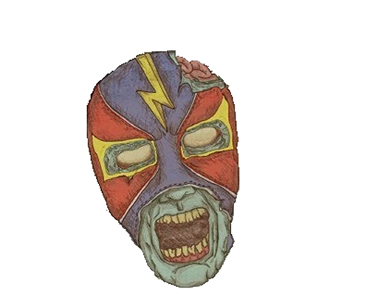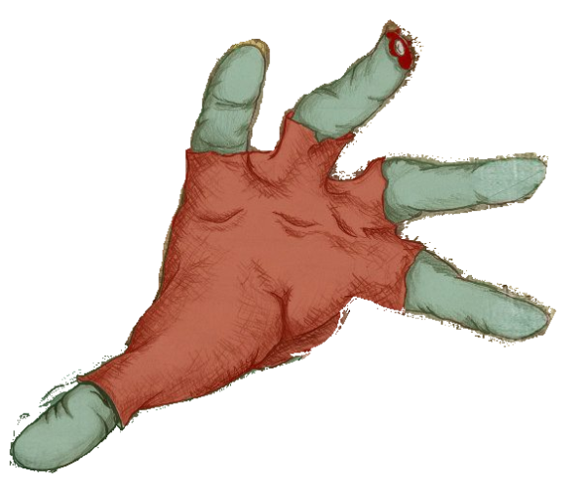

In the final menu we would have the head and the hand moving seamlessly from left to right and up to down respectively. We also added animation of when you click on the start button to begin the game to have a bullet come across the screen to shoot the zombie in the head and he drops from the screen. Our Twitter and Facebook links would also fade from the screen at this time. We created the logo for the movie that is in the zombies hand in Using MS Paint and had to download the font for the “Zombiez” to give it a more fitting look. MS Paint was also used to create our buttons (Twitter, Facebook and Start) to give it a different look from the usual that is more representative of the style we have chosen for the menu.

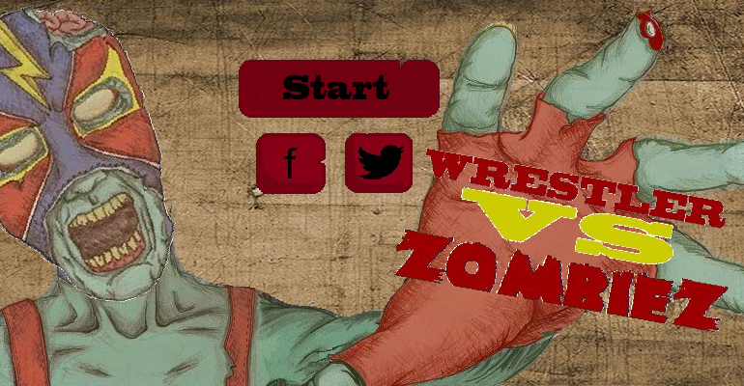

We also added in a hover function in our buttons to give an extra added effect to our menu.



Before we go in to gameplay from the Start button we decided to make a short humorous animation that we are very proud of. It begins with our hero trying to get a can of coke but is soon attacked by a zombie who he defeats then runs away from. It was all created using a fusion of MS Paint, Fireworks & Adobe Flash Professional in college. The initial character design was created in Fireworks for our game that we would be using to advertise our product. Once we had the design we would be using through the game we continued to make our character & zombies using MS Paint as we found using Citrix to access Fireworks when we were not in SCR3 difficult. This is due to our own personal belief that Citrix is very slow & has rarely but occasionally closes down without our work being saved.

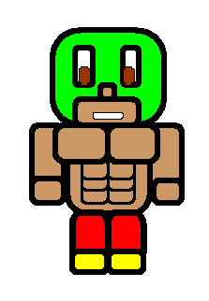

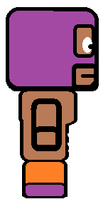

*Original Design made on Fireworks *Final design on MS Paint

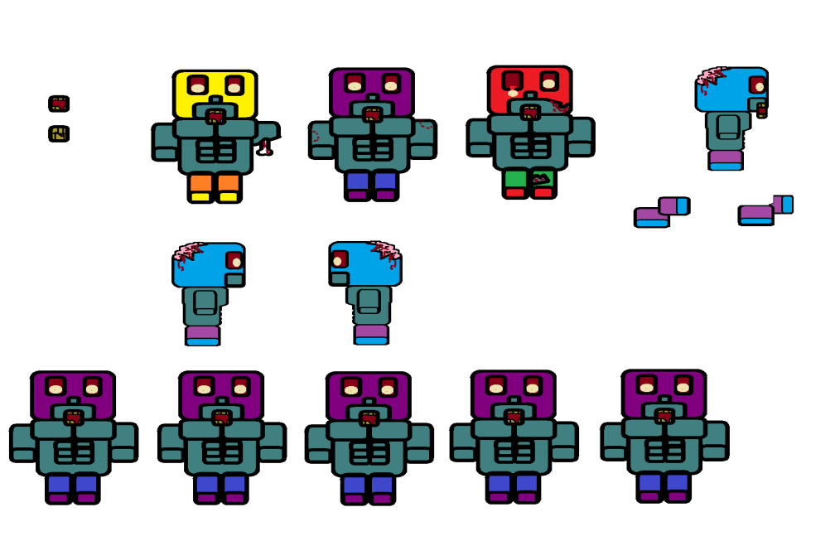

*Several design for our zombie

Our background for the animation is the more or less the same apart from the poster for the animation being more prominent as it plays a part in to our animation. We had a few issues when placing the poster in the background it became very pixilated for some reason but this small problem was soon resolved.

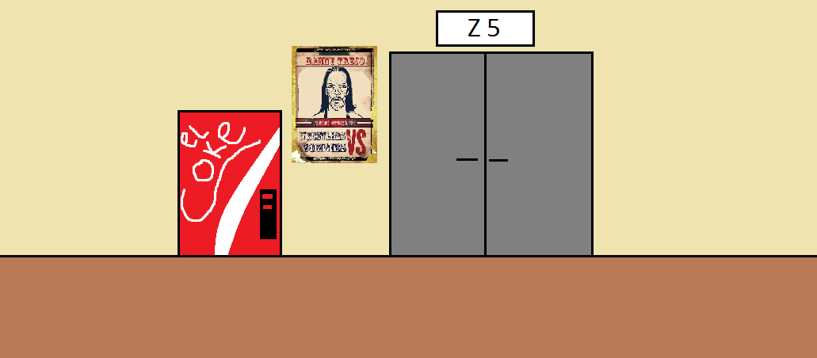

*Background of opening animation

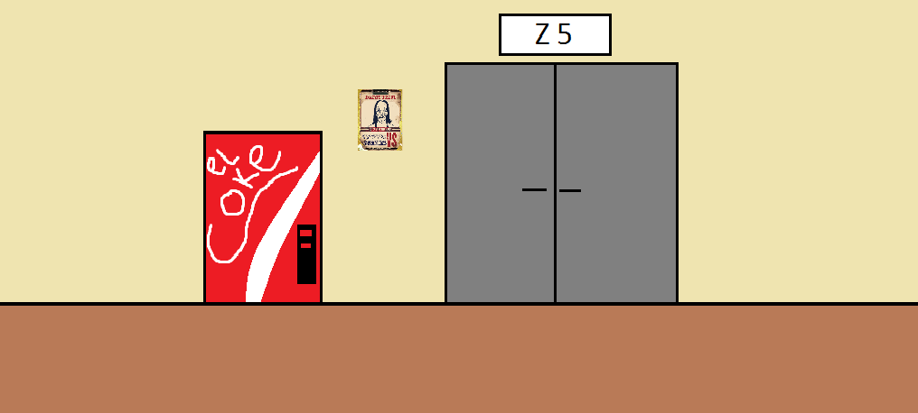

*Background of gameplay

We decide against using sound in our opening cinematic and instead used speech bubble which we made in MS paint to show what the characters on scree were thinking and saying.

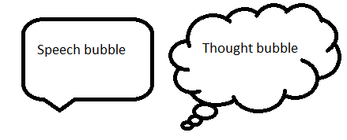

After the opening cinematic the gameplay will start. In the game the player will play as Zapatos fighting off zombies. Zapatos can move from right to left and can also punch any zombies in his path. The zombies will automatically walk towards Zapatos and injure him if they get too close. If Zapatos’ health falls to zero he will die and the player will be brought to a death screen were they will have two options, retry or return to the main menu. In coding the game we used a combination of collision and keyboard inputs. Here is the code we used for the collision:

Zombie.addEventListener(Event.ENTER_FRAME, zomHit);

function zomHit(event:Event):void {

if (Zombie.hitTestObject(Zapatos)) {

currentHP -= 3;

//if the zombie has collided with Zapatos his health will lower by 3

{

else {

Zombie.x-=15;

//if the zombie has not collided with Zapatos it will continue to move 15 towards him until they collide

}

Here is the code we used for the keyboard inputs:

stage.addEventListener(KeyboardEvent.KEY_DOWN, hearKey);

function hearKey(yourEvent:KeyboardEvent):void{

if (yourEvent.keyCode==Keyboard.RIGHT){

Zapatos.x+=5

gotoAndStop(1);

//if the user has pressed the right arrow key Zapatos will move forward 5

};

if (yourEvent.keyCode==Keyboard.LEFT){

Zapatos.x-=5

gotoAndStop(4);

//if the user presses the left arrow key Zapatos will move backwards 5 and the game will be brought to the scene were Zapatos is facing in the opposite direction

};

if (yourEvent.keyCode==Keyboard.UP){

nextFrame();

//if the user pushes the up arrow the game will be brought to the scene of Zapatos extending his arm, effectively punching the oncoming zombie.

};

};

In coding the health bar we looked for tips on sites such as <http://forums.adobe.com> and <http://as3gametuts.com> with the latter being of more use. The code used for the health bar is shown below.

var maxHP:int = 100;

var currentHP:int = maxHP;

var percentHP:Number = currentHP / maxHP;

//declaring the necessary variables

function updateHealthBar():void

{

percentHP = currentHP / maxHP;

healthBar.barColor.scaleX = percentHP;

}

We also had several technical issues with gameplay (zombies kept increasing speed when they died, health bar restarted) but soon figured this out either through our own initiative or with the help of our lecturer Sam Cogan.

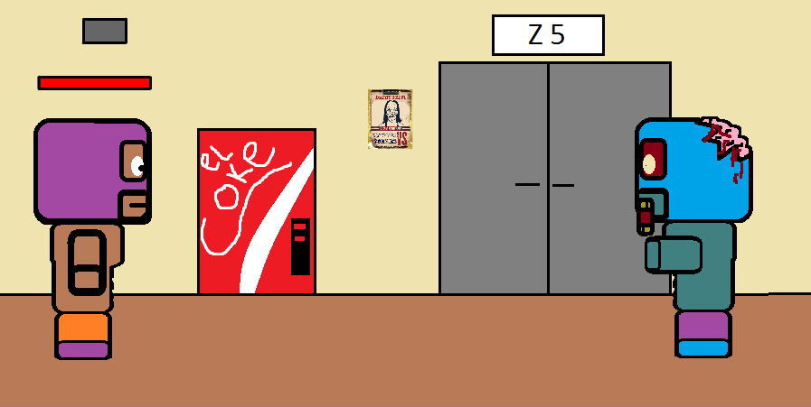

The game will start off with Zapatos on screen by himself and then a zombie will slowly make his way towards Zapatos.

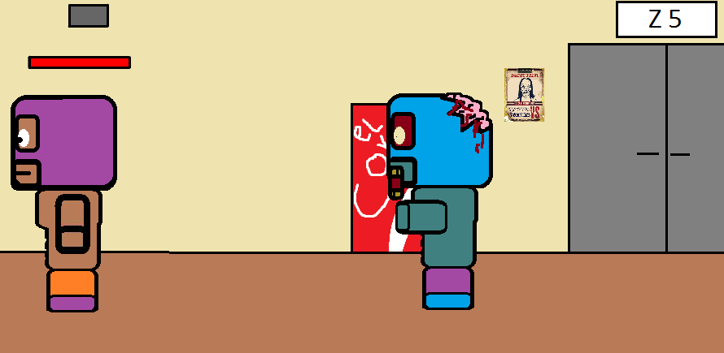

The player can move left or right using the left and right arrow keys respectively.

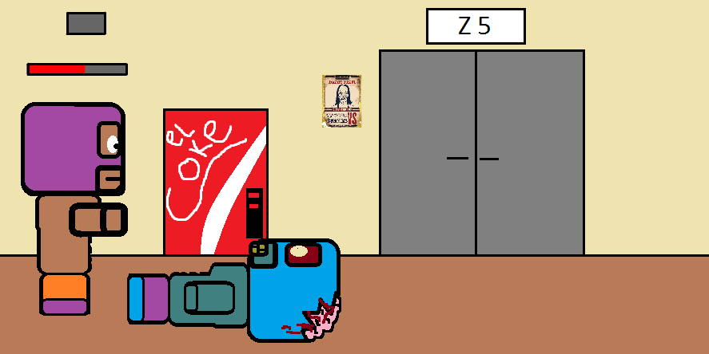

Zapatos’ method of attack is to punch the zombies, the player can do this by pushing the up arrow key. We chose the up arrow key to make it easier to play.

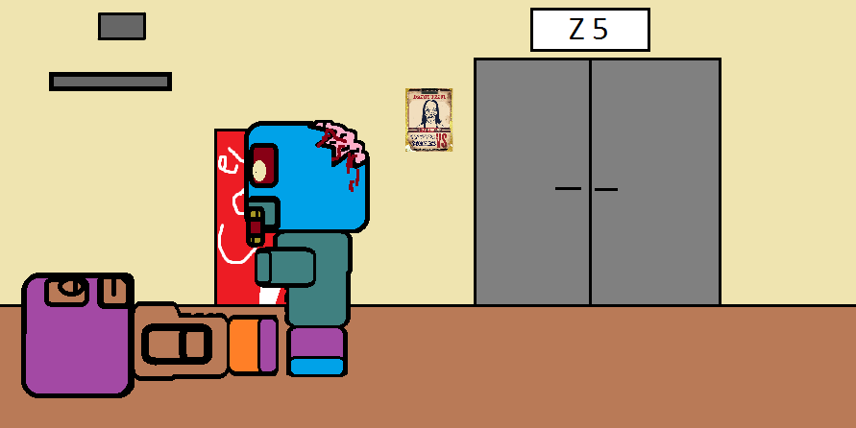

When Zapatos’ health has drained completely he will die.

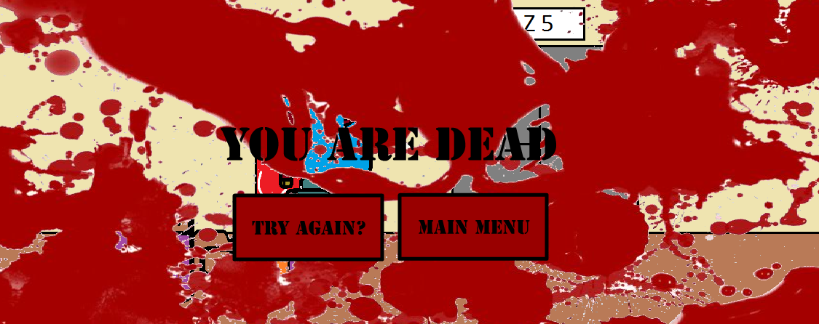

After dying the player will be brought to a death screen where they have to options, try again or return to the main menu.

We are using Twitter & Facebook as our way to socially connect to our audience as we’ve stated before but on Facebook this is where our game could be accessed to play and post your high score for a chance to win the grand prize and in the case of a draw we would choose a winner randomly and you can invite your friends to join as well for a chance to get VIP tickets to the premiere in Cinepolis imax theatre Mexico City meet all stars (Danny Trejo, Jessica Alba, Michelle Rodriguez & Steven Segal) & stay in a five star hotel for a week with three other friends. This would also include a $5,000 dollar spending money for your week there. Unfortunately we were unable to actually have this feature in the game due to time constraints and technical issues of not knowing how to make this function with our game.

Research

Similar products do exist as the zombie genre is huge at the moment with shows like “The Walking Dead” who have found a huge success with the genre in its third season that it hasn’t reached before. The Season 3 premiere of AMC's The Walking Dead delivered the biggest ratings in the adult demo than any other entertainment series this fall (including all broadcast shows), earning its highest rating to date, more than 50% over last season's premiere. The third season premiere aired to the tune of 10.9 million viewers for its first telecast, with an adult 18-49 demo rating of 5.8. We figured we’d “hop on the bandwagon” & reap the rewards to make a movie about zombies but with a twist to make us stand out from the crowd & to not cheat out our audience by giving them something they’ve already seen hence why we came up with the idea “Wrestler VS. Zombiez”.

Summary

Overall we are very pleased with what we have accomplished and believe our project to be a success. We did everything we planned on doing and more so. We could in future develop our project by adding in the high score counter in our game have a variety of posters for the movie and flash banners. Even go more in depth with our advertising campaign but for what we have done we are very proud of our product “Wrestler VS. Zombiez”.

Bibliography

References

Nicholson, M. (2012) Walking Dead Premiere Tops Fall TV Ratings. *IGN*, p.1. Available at: http://ie.ign.com/articles/2012/10/16/walking-dead-premiere-tops-fall-tv-ratings [Accessed: 1st March 2013].

Unknown. (n.d.) TV sponsorship: a brand’s best friend. *thinkbox*, p.1. Available at: http://www.thinkbox.tv/server/show/nav.1036 [Accessed: 12th April 2013].

Unknown. (2005) Thinkbox. *Wikipedia*, p.1. Available at: http://en.wikipedia.org/wiki/Thinkbox [Accessed: 12th April 2013].

Adobe Forums (2011) *Re: How to make a*. [online] Available at: http://forums.adobe.com/message/3681017 [Accessed: 20 Apr 2013].

AS3 Game Tutorials (2012) *AS3 Health Bar Tutorial (Mini-Lesson)*. [online] Available at: http://as3gametuts.com/2012/02/10/actionscript-health-bar-tutorial/ [Accessed: 20 Apr 2013].