 | MINISTRY OF EDUCATION AND TRAINING

FPT UNIVERSITY
Capstone Project Document
HomeCycle - Used Household Goods Seller–Buyer Matching Platform

<Group Name>
Group Members | Nguyễn Thị Ngọc Trâm - Team Leader - SE184488  Nguyễn Trần Hải Đăng - Team Member - SE170366  Trần Minh Tiến - Team Member - SE171937
Supervisor | Trần Ngọc Như Quỳnh
Ext Supervisor
Capstone Project code | SU26SE047

- HoChiMinh, September/2026 -

Table of Contents

Acknowledgement 4
Definition and Acronyms 5
I. Project Introduction 6
1. Overview 6
2. Product Background 6
3. Existing Systems 6
4. Business Opportunity 7
5. Software Product Vision 8
6. Project Scope & Limitations 8
II. Project Management Plan 11
1. Overview 11
2. Management Approach 15
3. Project Deliverables 17
4. Responsibility Assignments 19
5. Project Communications 19
6. Configuration Management 20
III. Software Requirement Specification 22
1. Product Overview 22
2. User Requirements 22
3. Functional Requirements 35
4. Non-Functional Requirements 107
5. Requirement Appendix 109
IV. Software Design Description 124
1. System Design 124
2. Database Design 131
3. Detailed Design 139
V. Software Testing Documentation 169
1. Scope of Testing 169
2. Test Strategy 169
3. Test Plan 174
4. Test Cases 174
5. Test Reports 174
VI. Release Package & User Guides 176
1. Deliverable Package 176
2. Installation Guides 176
3. User Manual 179

Acknowledgement
First and foremost, we would like to express our sincere gratitude to Ms. Tran Ngoc Nhu Quynh, our Capstone Project supervisor, for her dedicated guidance and support throughout the development of HomeCycle – Used Household Goods Seller–Buyer Matching Platform (SU26SE047).
Throughout the project, her valuable advice, constructive feedback, and careful supervision helped us identify weaknesses, improve our ideas, and maintain a clear direction during both the research and development stages. Her guidance encouraged us not only to focus on technical implementation but also to consider the practical value, feasibility, and overall quality of the system. We greatly appreciate the time, patience, and effort she devoted to supporting our team during this challenging journey.
We would also like to extend our sincere appreciation to the lecturers and faculty members who have accompanied us throughout our studies. The knowledge, professional skills, and problem-solving mindset gained from our academic courses provided an essential foundation for us to undertake this Capstone Project. Their teaching has contributed significantly to our development as Information Technology students and future software engineers.
Our gratitude also goes to all individuals who provided comments, suggestions, and practical feedback during the development and evaluation of HomeCycle. Their perspectives helped us better understand real-world expectations for a platform that connects buyers and sellers of used household goods. Through their feedback, we were able to identify areas for improvement and gradually refine the system in terms of functionality, usability, and reliability.
We are especially thankful to our families for their continuous encouragement, understanding, and support throughout our academic journey. Developing a Capstone Project required considerable time, effort, and persistence, particularly during periods of high workload and tight deadlines. Their patience and motivation gave us the strength to continue working through difficulties and complete the project.
We would also like to thank our friends and classmates who supported us during the project, whether through discussions, testing, sharing experiences, or simply providing encouragement when challenges arose. Their companionship made this demanding process more manageable and meaningful.
Finally, we would like to acknowledge the effort and commitment of every member of the HomeCycle team. Each member contributed their knowledge, time, and responsibility toward a shared objective. The process of analyzing requirements, designing the system, developing its features, solving technical problems, testing, revising, and responding to feedback has given us valuable experience in teamwork and software development beyond what could be learned from theory alone.
Although HomeCycle may still have areas that can be further improved, completing this project represents an important milestone in our academic journey. We are grateful to everyone who directly or indirectly contributed to its development and supported us throughout this experience.
We sincerely appreciate all the guidance, encouragement, and opportunities that made this project possible.

Definition and Acronyms
Acronym | Definition
HC | HomeCycle platform
AI | Artificial Intelligence
API | Application Program Interface
UC | Use Case
BR | Business Rule
ERD | Entity Relationship Diagram
GHN | Giao Hàng Nhanh, a shipping service provider
PK | Primary Key
FK | Foreign Key
BE | Backend
FE | Frontend

I. Project Introduction

1. Overview

1.1 Project Information
- Project name: HomeCycle - Used Household Goods Seller–Buyer Matching Platform
- Project code: SU26SE047
- Group name: GSU26SE57
- Software type: Website and Mobile app

1.2 Project Team
Full Name | Role | Email | Mobile
Tran Ngoc Nhu Quynh | Lecturer | Quynhtnn4@fpt.edu.vn
Nguyen Thi Ngoc Tram | Leader | TramNTNSE184488@fpt.edu.vn | 0902542322
Nguyen Tran Hai Dang | Member | TienTMSE171937@fpt.edu.vn | 0823808804
Tran Minh Tien | Member | DangNTHSE170366@fpt.edu.vn | 0848007071

2. Product Background
In recent years, the demand for buying and selling used household goods in Vietnam has increased significantly due to cost-saving needs, environmental awareness, and the growing number of students, workers, and households that frequently relocate or replace home appliances. However, most transactions are still conducted through social media groups or manual communication channels, resulting in fragmented product information, difficult price comparisons, and limited transaction transparency
Both sellers and buyers face challenges in managing negotiations, verifying trading partners, arranging inspections, and tracking transaction progress efficiently. Existing platforms also lack a centralized system that supports quotation management, scheduling, and transaction coordination throughout the trading process
To address these issues, this project proposes HomeCycle – Used Household Goods Seller–Buyer Matching Platform, a web and mobile marketplace system that connect individual users and businesses in a transparent and efficient trading environment. The platform supports listing creation, buying request posting, offer comparison, transaction tracking, and inspection scheduling to facilitate convenient and professional transactions

3. Existing Systems
Currently, the market for used household goods trading in Vietnam is growing rapidly, with many people relying on social media groups, online marketplaces, and informal trading channels to buy and sell second-hand items. However, most existing platforms mainly focus on general product listings and basic communication features, while lacking a specialized system for managing quotations, transaction tracking, and matching between sellers and purchasing units.

3.1 Chợ tốt
Description: Chợ Tốt is one of the most popular online marketplaces in Vietnam, allowing users to buy and sell a wide range of products, including used household appliances and furniture. It operates as a classified advertisement platform connecting individual sellers and buyers.
Website: https://www.chotot.com/
Key Features:
- Product Listings: Users can post used household items with images and descriptions.
- Search & Filtering: Supports searching products by category, location, and price range.
- Direct Communication: Buyers and sellers can contact each other through chat or phone numbers.
- Mobile Accessibility: Available on both website and mobile application.
Pros:
- Large User Base: High traffic and wide market reach across Vietnam.
- Easy Posting Process: Sellers can quickly create product listings.
- Diverse Categories: Supports many types of second-hand products.
Cons:
- Lack of Specialized Matching: No dedicated mechanism to match sellers with professional purchasing units.
- Manual Negotiation: Price discussion and transaction tracking are handled manually through chat.
- Limited Transaction Management: No centralized system for managing quotations, inspection schedules, or transaction status.

3.2 Facebook Marketplace
Description: Facebook Marketplace is a social-commerce platform integrated into Facebook, enabling users to buy and sell products locally. Many users in Vietnam utilize it for trading used household goods and electrical appliances.
Website: https://www.facebook.com/marketplace/
Key Features:
- Local Product Listings: Allows users to browse products within nearby locations.
- Messenger Integration: Buyers and sellers communicate directly through Facebook Messenger.
- Personalized Recommendations: Displays products based on user interests and activities.
- Community-Based Trading: Connected with Facebook groups and local communities.
Pros:
- Massive Community Reach: Access to a very large number of users and communities.
- Convenient Communication: Integrated messaging system simplifies interaction.
- Free to Use: No listing fees for most users.
Cons:
- Lack of Verification: Difficult to verify seller or buyer credibility.
- No Quotation Management: The platform does not support offer comparison or structured pricing workflows.
- Unprofessional Transaction Process: Transactions are highly dependent on manual communication and trust between users.

4. Business Opportunity
The market for used household goods liquidation in Vietnam is expanding as consumers increasingly seek affordable products and sustainable disposal options. However, transactions between individual sellers and second-hand collection businesses are still primarily conducted through Facebook groups, Zalo chats, Messenger conversations, and general classified platforms. Communication, price negotiation, and appointment arrangements are managed manually across multiple channels, resulting in fragmented information, difficulty tracking agreements, and a lack of transparency throughout the transaction process
Product information is often incomplete or inconsistent, making it difficult for users to assess item conditions accurately. In addition, inspections, deliveries, and appointment schedules are managed manually, leading to inefficient coordination, increased operational costs, and frequent appointment cancellations. Without a dedicated platform, both individual users and businesses face challenges in managing transactions efficiently and transparently
The proposed platform addresses these issues by providing a specialized marketplace that centralizes listings, buying requests, offer management, transaction tracking, scheduling, delivery coordination, and payment processes. Through standardized item information, integrated transaction management, and business verification mechanisms, the platform improves transparency, reduces transaction risks, and supports the growing trend of digital commerce and circular economy practices

5. Software Product Vision
For individual households seeking a convenient and trustworthy way to sell used household goods, and for collection businesses looking for reliable inventory sources and efficient transaction management, the HomeCycle – Used Household Goods Seller–Buyer Matching Platform is a web and mobile marketplace application that connects sellers with qualified buyers through a structured and transparent trading process.
The platform enables users to publish product information, compare offers, schedule inspections and collections, track transaction progress, and complete payments within a single system. By centralizing communication, transaction management, and operational coordination, the platform reduces manual effort, improves transaction visibility, and supports more efficient decision-making for both parties.
Unlike transactions conducted through Facebook groups, Zalo chats, Messenger conversations, and general classified platforms, HomeCycle provides standardized product information, verified user identities, transaction tracking, and reputation-based trust mechanisms. As a result, users can trade used household goods with greater confidence, lower transaction risks, and improved operational efficiency, contributing to a more sustainable and digitally connected second-hand marketplace.

6. Project Scope & Limitations
This platform bridges the gap between informal used-goods disposal and inefficient commercial procurement processes by implementing structured workflows. Its operational scope encompasses the entire transaction lifecycle—ranging from professional listing and pricing guidance to secure payment (escrow) processes—with a primary focus on the Vietnamese market.

6.1 Major Features
FE-01: User registration, authentication and verification
- Register and log in using email/password or supported authentication methods
- Forgot password, reset password, and email verification via OTP
- Manage personal or company profile information
- Verify individual accounts through personal identity verification
- Verify business accounts through business registration documents
- Manage bank account information for transaction settlement and withdrawal requests
FE-02: Product Listing and marketplace post management
- Create, update, and manage used household item listings
- Upload product images and descriptions with category-specific condition information
- Define product attributes such as brand, condition, usage duration, quantity, and expected price range
- Track post status and manage published listings
FE-03: Product discovery and marketplace search
- Search and filter products by category, item specifications, condition, location, and price range
- View detailed product information, images, seller information, and transaction-related details
- AI-powered product price suggestions and external reference price search.
- Save products to a cart list for future reference
FE-04: Offer management and negotiation
- Submit, receive, and compare purchase offers
- Conduct private negotiations through an integrated chat system
- Discuss pricing, transportation methods, delivery schedules, and transaction terms
- Review negotiation history and offer records throughout the transaction lifecycle
FE-05: Transaction agreement and confirmation
- Create transaction agreements after successful negotiations
- Confirm product information, quantity, condition, price, transportation method, and payment method
- Record transaction commitments and agreement history
- Notify both parties of transaction confirmations and updates via platform notifications and email
FE-06: Payment management
- Support online payment processing through integrated payment gateways
- Process payment confirmations, refunds, and transaction settlements
- Support withdrawal requests from sellers to verified bank accounts
- Maintain payment history and transaction records
FE-07: Appointment and schedule management
- Schedule item inspections and collection
- Manage appointment confirmations, rescheduling requests, and cancellations
- Track inspection and collection schedules and their current statuses
FE-08: Delivery tracking and management
- Support direct collection and third-party delivery workflows
- Calculate shipping fees through integrated delivery services
- Record handover information and delivery evidence
- Track delivery status and shipment information
FE-09: Transaction tracking and history
- Monitor transaction, payment, transportation, and appointment statuses
- View transaction history and payment records
- Track completed, ongoing, cancelled, and disputed transactions
FE-10: Dispute and complaint management
- Submit dispute requests with supporting evidence
- Manage fraud reports, product condition disagreements, pricing disputes, and appointment violations
- Allow moderators to review transaction evidence and communication history
- Track dispute resolution outcomes and case status updates
FE-11: Rating and reputation management
- Allow users to rate each other after completed transactions
- Submit reviews and feedback regarding transaction experiences
- Display public reputation information to improve marketplace transparency
FE-12: Moderation and content review
- Review and approve business verification requests
- Review withdrawal requests and transaction-related activities
- Review reported content and disputes
- Monitor transaction, payment, and scheduling activities across the platform
FE-13: Platform administration and configuration
- Manage user accounts, roles, and subscriptions
- Manage product categories, policies, and platform configurations
- Configure transaction rules, appointment settings, payment policies, withdrawal policies, rating policies, and file-upload policies
- Monitor platform activities, operational reports, audit logs, and business statistics
- Manage platform policies and subscription packages

6.2 Limitations & Exclusions
LI-1: The platform supports only used household goods and excludes vehicles, personal electronics, jewelry, luxury goods, consumable products, and other restricted items
LI-2: The platform does not provide GPS tracking, route optimization, or transportation management for buyer collection vehicles
LI-3: AI-generated price recommendations are provided for reference purposes and may not accurately reflect the market value of uncommon, customized, or heavily damaged products
LI-4: For transactions that involve offline balance settlements, the platform can record transaction status but cannot verify or secure payments made outside the system
LI-5: The platform does not perform independent physical inspections or quality verification of listed products. Product assessment remains the responsibility of buyers and sellers
LI-6: The platform is designed for transactions within Vietnam and does not support international trading, shipping, or cross-border payments

II. Project Management Plan

1. Overview

1.1 Scope & Estimation
# | WBS Item | Complexity | Est. Effort  (man-days)
1 | Authentication & User Management |  | 18
1.1 | User Registration, Login and Profile Management | Medium | 8
1.2 | User Registration, Login and Profile Management | Medium | 5
1.3 | Role-based authorization (Individual/Business/Moderator/Admin) | Medium | 5
2 | Identity Verification & Business Verification |  | 17
2.1 | Personal Identity Verification Workflow | Medium | 8
2.2 | Business document upload and verification workflow | Medium | 9
3 | Marketplace Post Management & Moderation |  | 24
3.1 | Create and update selling and buying posts | Medium | 6
3.2 | Post image upload | Medium | 5
3.3 | Dynamic item specifications by category | Complex | 8
3.4 | Post approval workflow for Moderator | Medium | 5
4 | Product Discovery & Offer Management |  | 22
4.1 | Product search and filtering | Medium | 6
4.2 | Favorite products management | Simple | 3
4.3 | Send request purchase offers | Medium | 6
4.4 | Review and compare offers | Medium | 7
5 | Negotiation & Communication |  | 20
5.1 | Real-time chat between transaction participants | Complex | 12
5.2 | Negotiation and agreement records | Medium | 5
5.3 | Email notifications for negotiation confirm | Simple | 3
6 | Transaction & Appointment Management |  | 33
6.1 | Transaction creation and confirmation | Medium | 7
6.2 | Appointment scheduling | Medium | 6
6.3 | Transaction status tracking | Medium | 5
6.4 | Delivery workflow and handover management | Medium | 6
6.5 | Price adjustment request after inspection | Medium | 4
6.6 | Transaction history management | Medium | 5
7 | Payment & Withdrawal Management |  | 18
7.1 | Payment initiation and confirmation | Medium | 6
7.2 | Withdrawal request submission | Simple | 3
7.3 | Payment gateway integration | Medium | 4
7.4 | Payment history management | Medium | 5
8 | Dispute & Complaint Management |  | 14
8.1 | Submit complaint/dispute request | Medium | 5
8.2 | Upload evidence and supporting documents | Simple | 3
8.3 | Dispute handling workflow | Medium | 6
9 | Rating & Feedback System |  | 8
9.1 | Submit ratings and reviews | Simple | 5
9.2 | Moderation of reviews and feedback | Medium | 3
10 | Moderator Management Functions |  | 17
10.1 | Verification document and post review management | Medium | 5
10.2 | Account review and suspension management | Medium | 5
10.3 | Monitor transaction, payment and schedule history | Simple | 4
10.4 | Review negotiation history when dispute occurs | Medium | 3
11 | Platform Administration |  | 18
11.1 | User management and permissions | Medium | 5
11.2 | Category and tag management | Simple | 3
11.3 | Subscription package management | Medium | 4
11.4 | Platform policy and configuration management | Medium | 3
11.5 | Transaction rule and schedule configuration | Medium | 3
11.6 | Transaction statistics dashboard | Medium | 5
11.7 | System Monitoring & Reporting | Medium | 6
12 | Notification System |  | 8
12.1 | Email notifications | Medium | 4
12.2 | In-app notifications | Medium | 4
Total Estimated Effort (man-days) |  |  | 217
Table 3: Scope & Estimation (Work Breakdown Structure)

1.2 Project Objectives

1.2.1 Quality
# | Testing Stage | Test Coverage | No. of Defects | % of Defect | Notes
1 | Reviewing | 100% requirements documents | ≤ 15 | ≤ 20% | Early defect detection through peer review
2 | Unit Test | ≥ 70% of source code | ≤ 12 | ≤ 15% | Focus on service and business layers
3 | Integration Test | ≥ 85% business workflows | ≤ 10 | ≤ 15% | Verify module interaction
4 | System Test | 90% functional requirements | ≤ 8 | ≤ 16% | Validate complete system stability and performance
5 | Acceptance Test | 100% of business requirements | ≤ 5 | ≤ 10% | Final validation by supervisors
Table 4: Quality Objectives by Testing Stage

1.2.2 Milestone Timeliness (%):
# | Milestone | Planned Completion
1 | Requirement Analysis & Use Cases | Week 2
2 | UI/UX Design & Database Design | Week 3
3 | Core Module Development | Week 8
4 | Integration & Feature Completion | Week 11
5 | Testing & Bug Fixing | Week 12
6 | Documentation & Final Deployment | Week 15
Table 5: Project Milestones

1.2.3 Time Objectives
- Total project duration: 14 – 16 weeks
- At least 90% of planned milestones completed on time.
- No critical milestone delayed more than one week.
- Weekly sprint review conducted throughout the project.

1.2.4 Cost / Effort Objectives (Effort Allocation)
# | Activity | Effort (man-days) | Effort Allocation (%)
1 | Requirement Analysis | 25 | 11%
2 | System Design (Architecture, Database, UI/UX) | 40 | 18%
3 | Coding & Implementation | 110 | 49%
4 | Testing & Bug Fixing | 30 | 13%
5 | Deployment & Documentation | 8 | 4%
6 | Project Management & Meetings | 10 | 5%
Total Allocated Effort (man-days) |  |  |  | 100%
Table 6: Effort Allocation by Activity

1.3 Project Risks
# | Risk Description | Impact | Possibility | Response Plans
1 | Team members have different technical skill levels, causing uneven task completion speed | Low | Medium | Divide tasks based on strengths, conduct weekly progress reviews, and perform peer support when needed
2 | Requirement changes from supervisor during development may affect design and implementation | Low | Medium | manage changes through discussion before implementation
3 | AI-based features (price suggestion) may produce inaccurate results due to limited training data | Medium | Medium | AI is used only as a recommendation tool and does not make decisions on behalf of users
4 | Third-party delivery service integration may face technical challenges due to limited team experience and API complexity | Medium | High | Conduct early API research, build a proof of concept, and prepare fallback manual delivery workflows
5 | Transaction payment records may become inconsistent due to user cancellation or status synchronization issues | High | Medium | Implement transaction status validation, audit logs, and approval workflows before payment confirmation
6 | disputes may occur throughout the transaction lifecycle, including negotiation, inspection, payment, and delivery processes | High | High | Maintain complete transaction records, negotiation history, inspection evidence, and dispute resolution workflows to support transparent conflict handling
7 | High volumes of uploaded files, transaction records, and concurrent user activities may affect system performance, leading to slow response times or potential data loss | High | Medium | Apply input validation, file size limitations, database backup mechanisms, pagination, and performance testing. Monitor system resources and optimize data storage strategies during development
Table 7: Project Risks

2. Management Approach
The project is managed using the Scrum framework, which supports iterative development, continuous feedback, and incremental delivery. This approach enables the team to adapt to requirement changes, manage project risks effectively, and ensure the timely completion of project milestones
The management approach includes:
- Source Code Management: Source code is managed through GitHub using a centralized repository structure. Git branching strategies are applied to separate development, testing, and production-ready code, ensuring version control and collaboration among team members
- Communication and Collaboration: Team communication is conducted through Discord and Zalo for daily discussions, issue resolution, and project coordination. Project tasks, sprint backlogs, and progress tracking are managed using Jira
- Continuous Integration CI/CD: GitHub Actions are used to automate build verification and code integration processes. Pull requests and code reviews are performed before merging major features into the main branch
- Meetings and Progress Tracking: The team holds 1–2 meetings per week, including sprint planning, progress review, and retrospectives to ensure alignment and timely issue resolution

2.1 Project Process
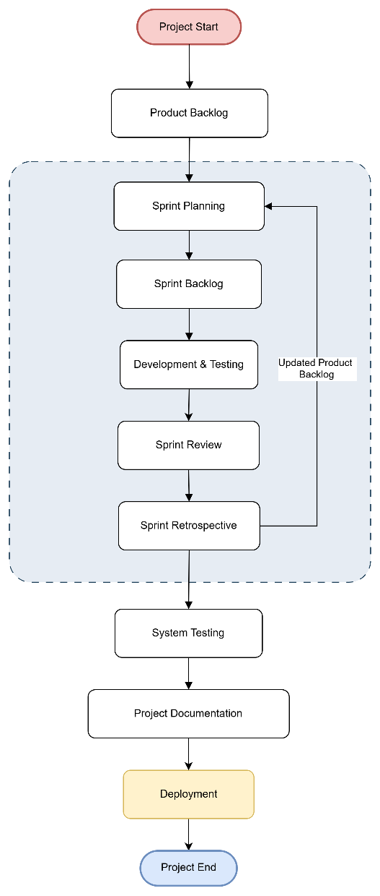
Diagram 2: Software development process model

2.2 Quality Management
The HouseCycle project applies continuous quality management practices throughout the Scrum development lifecycle. Quality assurance activities are performed during each sprint to reduce defects, improve software reliability, and ensure that the system satisfies both functional and non-functional requirements
- Defect Prevention: Requirements, business rules, and user workflows are reviewed before implementation to reduce misunderstandings and development errors. Regular team discussions are used to maintain consistency across the project
- Reviewing: Requirements, database design, UI prototypes, and source code are reviewed by team members before completion. Early reviews help identify issues and improve overall solution quality
- Unit Testing: Unit testing is performed for critical backend functions such as authentication, product management, offer processing, and transaction validation. This ensures that individual modules behave according to the specified business rules
- Integration Testing: Integration testing is conducted to verify the interaction between frontend, backend services, databases, and external APIs. Key scenarios such as product posting, offer negotiation, and transaction processing are tested end-to-end
- System Testing: System focuses on checking the main user flows of the system, testing validates the complete HouseCycle platform against the defined requirements

2.3 Training Plan

Training Area | Participants | When, Duration | Waiver Criteria
AWS Deployment & Cloud Services | TramNTN, DangNTH | 1 Week | Mandatory
Third-Party Service Integration (Delivery APIs, Payment Gateway, AI Pricing) | TramNTN, DangNTH | 2 Weeks | Mandatory
Mobile Development & Project Structure | TienTM | 1 Week | Mandatory
Jira Project Management & Scrum Practices | TramNTN | 3 days | Mandatory
Table 8: Training Plan

3. Project Deliverables

# | Deliverable | Due Date | Notes
1 | Project Start | 10/05/2026 | Official project kickoff and confirmation of project scope and objectives
2 | Requirement Analysis & Modeling | 13/05/2026 | Requirement clarification, feature refinement, business workflow analysis, and creation of initial requirement diagrams and system models
3 | Report 1 – Project Introduction | 25/05/2026 | Project background, problem statement, objectives, stakeholders, and scope
4 | UI/UX Prototype (Web & Mobile) | 30/05/2026 | Initial user interface design and business workflow visualization
5 | Report 2 – Project Management Plan | 25/05/2026 | Project planning, estimation, quality management, risks, and schedule
6 | Report 3 – Software Requirements Specification (SRS) | 01/06/2026 | Functional requirements, non-functional requirements, business rules, and use cases
7 | Database Design & Development Environment Setup | 01/06/2026 | ERD, database schema, cloud environment, and repository setup
8 | Incremental Software Release 1 | 11/06/2026 | Authentication, profile management, individual/business verification, and basic administration features
9 | Report 4 – Software Design Document (SDD) | 15/06/2026 | System architecture, database design, API design, and component specifications
10 | Incremental Software Release 2 | 25/06/2026 | Selling and buying post management, moderation workflow, search/filter, offers, and negotiation features
11 | Incremental Software Release 3 | 09/07/2026 | Transaction management, appointments, withdrawal requests, delivery integration, dispute handling, and notifications
12 | System Integration & Final Testing | 13/07/2026 | Complete integration testing, bug fixing, and system validation
13 | Report 5 – Testing Documentation | 16/07/2026 | Test scenarios, defect reports, test execution results, and quality evaluation
14 | Report 6 – User Guide | 20/07/2026 | User manual for Individual Users, Business Users, Moderators, and Platform Admins
15 | Final Software Package & Source Code | 21/07/2026 | Stable release version, deployment package, and source code repository
16 | Report 7 – Final Project Report | 22/07/2026 | Comprehensive documentation of analysis, design, implementation, testing, and evaluation
17 | Project Presentation Slides | 24/07/2026 | Presentation materials for final defense
Table 9: Project Deliverables

4. Responsibility Assignments

Responsibility | Tramntnse184488 | Dangnthse170366 | Tientmse171937 | Quynhtnn4
Project Planning & Tracking | D | S | R | R
Prepare Project Introduction Document | S | I | D | R
Requirement Analysis & Use Case Modeling | S | D | R | R
Prepare SRS Document | D | S | S | R
Database Design & Data Modeling | D | S | I | R
UI/UX Design Prototype (Figma) | S | R | D | R
Cloud & Development Environment Setup | D | S | I | I
Backend Architecture & API Design | D | D | I | R
AI-based Price Suggestion Integration | D | S | S | R
Payment Management & Withdrawal Processing | S | D | I | I
Transportation Service Integration & Delivery Tracking | D | S | I | I
Web UI Development | R | I | S | R
Mobile UI Development | R | I | D | R
System Testing & QA | D | S | S | R
Deployment & Environment Configuration | D | S | I | I
Table 10: Responsibility Assignments

5. Project Communications

Communication Item | Who/ Target | Purpose | When, Frequency | Type, Tool, Method(s)
Daily Progress  Meeting | Team | Discuss progress problems, report task,  solving problems | Daily | Discord, Offline, Zalo
Mentor Meeting | Supervisor | Report progress, Q&A with mentor | Weekly | Google Meet, Offline
Sprint Planning Meeting | Team | Plan sprint goals and assign development tasks | Weekly | Discord, Zalo
Backend Technical Meeting | Backend Developers | Discuss API design, database schema, system architecture, third-party integrations | 1–2 Times per Week or As Needed | Discord, Offline, Zalo
Frontend Technical Meeting | Frontend Developers | Discuss UI implementation, component structure, state management, responsive design | 1–2 Times per Week or As Needed | Discord, Offline, Zalo
Emergency  communication | Team | Quick resolution or urgent issues that affect the system | As Needed | Zalo, Discord, Offline
Table 11: Project Communications

6. Configuration Management

6.1 Document Management
Project documents are managed using a centralized repository on Google Drive to ensure accessibility, consistency, and traceability throughout the project lifecycle
- Document Storage: All project artifacts, including reports, requirement specifications, diagrams, meeting notes, UI designs, and supporting materials, are stored in a shared Google Drive workspace organized by document category and project phase.
- Version Control: Google Drive version history is used to track document modifications. Major updates are maintained with version identifiers to distinguish draft, reviewed, and finalized documents.
- Access Control: Editing permissions are granted only to project members, while important deliverables are reviewed before finalization to prevent unauthorized or unintended changes.
- Task Traceability: Jira is used to manage project tasks, assignments, sprint progress, and requirement updates. Relevant document links are attached to Jira issues to maintain traceability between requirements, design artifacts, and implementation activities.

6.2 Source Code Management
Source code is managed using GitHub to support collaborative development, version tracking, and controlled integration of changes
- Repository Organization: The project is separated into three repositories: Backend API, Web Frontend, and Mobile Application, allowing independent development and maintenance of each component
- Branching Strategy: The team follows a simplified Git workflow consisting of:
main – Stable and release-ready source code
dev – Active development branch used for integration and testing
[<type>] - <feature-name> : <action> Temporary branches created for implementing specific features or bug fixes
- Code Integration: All changes are merged through Pull Requests. Team members review code before merging into the develop branch to ensure coding standards and functional correctness
- Commit Convention: Developers use descriptive commit messages to clearly indicate implemented features, bug fixes, or configuration updates
- Supervisor Review Process: During weekly progress meetings, the team demonstrates completed functionalities to the supervisor for evaluation and feedback. After approval and successful testing, changes are merged from the develop branch into the main branch. Feedback and identified issues are tracked in Jira and resolved as soon as possible.

6.3 Tools & Infrastructures
Category | Tools / Infrastructure
Technology | ReactJs (FrontEnd website), ReactNative (Frontend mobile), .NET (Backend)
Database | PostgreSQL, FireBase
IDEs/Editors | Visual Studio Code, Visual Studio
Diagramming | DrawIO
Documentation | Google Docs, Google Sheet, Word, Canva
Version Control | GitHub (Source Codes), Google Drive (Documents & diagram)
Deployment server | Render
Project management | Jira
Table 12: Tools & Infrastructures

III. Software Requirement Specification

1. Product Overview
HomeCycle is a digital platform that connects individuals who want to sell used household goods with businesses that specialize in purchasing second-hand items. The platform aims to simplify the traditional buying and selling process, which is often conducted through social media, personal contacts, or informal channels. These methods usually lack transparency, trust, and effective transaction management.
The system provides a centralized environment where sellers can post item information, receive offers from multiple buyers, compare offers, negotiate transaction terms, schedule inspections or collections, complete payments, and track transaction progress. At the same time, business users can efficiently search for suitable items, submit offers, manage transactions, arrange delivery activities, and monitor business performance.
In addition to supporting the core matching process, HomeCycle integrates several external services such as payment processing, delivery services, email notifications, and AI-based price recommendations. The platform also provides administrative tools for user verification, content moderation, dispute management, policy configuration, and system monitoring.

2. User Requirements

2.1 Actors
# | Actor | Description
1 | Personal User | An individual human actor representing individual retail buyers and sellers. They interact with the system to manage personal profiles, create used household goods listings, search/filter items, negotiate prices, schedule on-site inspections, place escrow deposits, and submit post-transaction feedback or disputes
2 | Business User | A company or purchasing unit that buys second-hand household goods. Beyond standard user capabilities, they have exclusive privileges to create corporate profiles, publish buying requests to source items in bulk, view business analytics dashboards, and manage batch collection schedules.
3 | Moderator | An internal human operational actor responsible for day-to-day platform sanitization. They interact with the back-office system to process account and company verification requests, manage review, and execute initial dispute resolutions
4 | Administrator (Admin) | Manages the overall system operation. Admin manages system users, configures third-party API integration rules, defines business policies, creates service packages for users, and audits system history and financial reports
5 | AI Pricing Service | An external intelligent service that receives item metadata and condition details from the platform and responds with automated, data-driven market price recommendations to assist sellers during listing creation
6 | Payment Gateway | An external payment service that processes QR code payments and returns payment status updates to both users and the HomeCycle platform. It is used only for payment transactions and does not handle withdrawal operations
7 | Delivery Service | A third-party logistics provider that supports item transportation. It receives delivery requests from the platform and returns shipping fees, shipment tracking information, and delivery status updates
8 | Email Service | An external notification service responsible for sending OTP verification emails, account notifications, transaction updates
Table 13: Actors

2.2 Use Cases

2.2.1 Diagram(s)
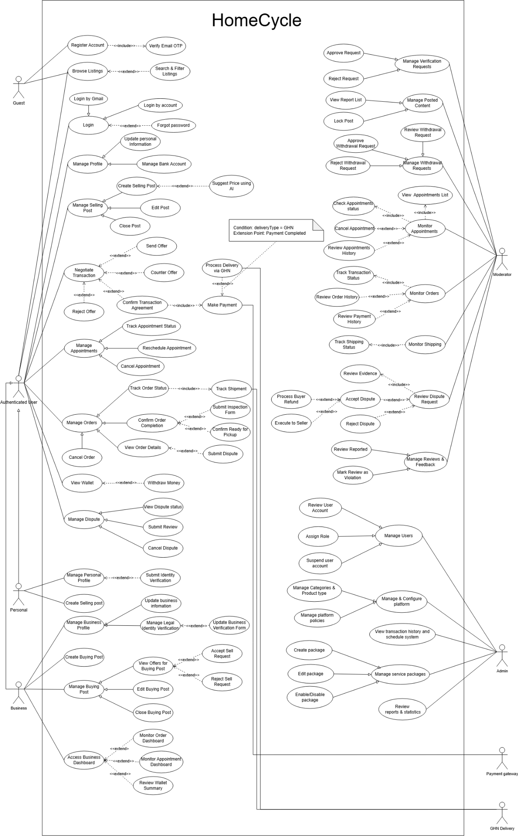
Diagram 3: HomeCycle Use Case Diagram

2.2.2 Descriptions
ID | Use Case | Actors | Use Case Description
01 | Guest; Authenticated User | Browse Listings | Allows guests to browse currently available selling posts without authentication. The system returns a list of active listings and basic product information.
02 | Guest; Authenticated User | Search & Filter Listings | Allows guests to search and filter active listings by supported criteria such as keyword, category, location, condition, and price range. The system returns matching results.
03 | Guest | Register Account | Allows a guest to create a new platform account by providing the required registration information. The system validates the data and creates the account when the information is valid.
04 | Guest | Verify Email OTP | Allows a user to verify the email address using a one-time password sent by the system. Successful verification activates the verified email state for the account.
05 | Authenticated User | Login | Allows a registered user to authenticate and access features permitted for the account. The system validates the selected login method and creates an authenticated session when successful.
06 | Authenticated User | Login by account | Allows a registered user to sign in using the platform account credentials. The system validates the email and password before granting access.
07 | Authenticated User | Login by Gmail | Allows a registered user to authenticate through a Google account. The system validates the external authentication result and signs the user in when successful.
08 | Authenticated User | Manage Profile | Allows an authenticated user to manage account profile information and related profile settings. The system displays current information and saves valid changes.
09 | Authenticated User | Update Information | Allows an authenticated user to update editable profile information such as display name, phone number, avatar, and operating location. The system validates and stores the updated data.
10 | Authenticated User | Manage Bank Account | Allows an authenticated user to add or update bank account information used for eligible withdrawal and payout operations. The system validates required banking information before saving it.
11 | Authenticated User | Forgot Password | Allows users to set a password by verifying their identity via a Gmail OTP
12 | Authenticated User | Manage Selling Post | Allows an authenticated user to manage selling posts owned by the account, including editing or closing active posts. The system applies ownership and post-state rules to each action.
13 | Authenticated User | Create Selling Post | Allows an authenticated user to publish a selling post for a used household item by providing required product information, condition, images, quantity, location, and expected price. The post does not require moderator pre-approval before publication.
14 | Authenticated User | Suggest Price using AI | Allows a seller to request an AI-generated price range based on available product information and condition data. The suggestion is advisory and the seller may use or override it.
15 | Authenticated User | Edit Post | Allows the post owner to modify eligible information of an existing selling post. The system validates and saves the changes without requiring moderator pre-approval.
16 | Authenticated User | Close Post | Allows the post owner to manually close an active selling post when the item is no longer available or the owner no longer wants to sell it. The system marks the post as inactive.
17 | Authenticated User | Negotiate Transaction | Allows transaction parties to negotiate price, quantity, and other agreed terms associated with an offer. The system maintains the negotiation state and related offer history.
18 | Authenticated User | Send Offer | Allows a buyer to submit an offer for a selling post with a proposed price and quantity. The system records the offer and notifies the relevant seller.
19 | Authenticated User | Counter Offer | Allows either negotiation party to propose revised terms for an active negotiation. The system records the new proposal and preserves the offer history.
20 | Authenticated User | Reject Offer | Allows a negotiation participant to reject an offer that is not acceptable. The system updates the offer status and notifies the other party.
21 | Authenticated User | Confirm Transaction Agreement | Allows the transaction parties to confirm the final negotiated terms before payment and order processing. The system records the confirmed agreement and advances the transaction when required confirmations are complete.
22 | Authenticated User; Payment Gateway | Make Payment | Allows an authenticated user to initiate the required order payment through the integrated payment gateway. The system records the payment request and updates the transaction after receiving a valid payment result.
23 | Authenticated User | Manage Appointments | Allows authenticated users to manage transaction-related appointments for inspection, collection, or handover. The system provides appointment information and permitted scheduling actions.
24 | Authenticated User | Track Appointment Status | Allows a user to check the current state of a transaction appointment, including scheduled, completed, cancelled, or overdue status. The system returns the latest recorded appointment information.
25 | Authenticated User | Reschedule Appointment | Allows an eligible participant to propose a new appointment date or time within platform rules. The system records the proposed change and updates the appointment after required confirmation.
26 | Authenticated User | Cancel Appointment | Allows an authorized participant to cancel an eligible appointment. The system updates the appointment status and notifies affected participants.
27 | Authenticated User | Submit Inspection Form | Allows the party responsible for inspection to submit product-condition findings, notes, images, and checklist information for the scheduled inspection. The system stores the inspection record.
28 | Authenticated User | Manage Orders | Allows an authenticated user to manage orders in which the account participates. The system provides order status information and actions permitted by the current order state.
29 | Authenticated User | View Order Details | Allows an authenticated user to open a specific order and review its recorded details, including participants, products, agreed price, payment, appointment, delivery, and current order status. The system validates access and returns the latest order information.
30 | Authenticated User | Confirm Order Completion | Allows the required transaction participant to confirm that the order has reached the completion condition. The system validates the current state and records the confirmation.
31 | Authenticated User | Cancel Order | Allows an eligible transaction participant to request cancellation of an order when cancellation rules permit it. The system validates the request, updates the order state, and triggers any applicable follow-up handling.
32 | Authenticated User | Submit Review | Allows a transaction participant to submit a rating and feedback for the counterparty after an eligible completed transaction. The system records the review and updates reputation information according to platform rules.
33 | Authenticated User | Track Order Status | Allows an authenticated user to monitor the current lifecycle status of an order. The system returns the latest order, payment, appointment, and delivery-related state information available for that order.
34 | Authenticated User | View Wallet | Allows an authenticated user to review the platform wallet, including available balance, held balance, and relevant wallet activity. The system retrieves and displays the latest recorded wallet information.
35 | Authenticated User | Withdraw Money | Allows a user to submit a withdrawal request for eligible available wallet funds to a registered bank account. The system validates the amount and account information before creating the request.
36 | Authenticated User | Manage Dispute | Allows an authenticated user to manage disputes related to eligible transactions or reviews. The system supports creating a dispute, following its status, and cancelling it when business rules permit.
37 | Authenticated User | Submit Dispute | Allows a user to submit a dispute or complaint by providing the related target, reason, description, and supporting evidence. The system records the case and forwards it to the moderation workflow.
38 | Authenticated User | View Dispute status | Allows an authenticated user to check the current status and handling progress of a submitted dispute. The system retrieves the latest dispute state, resolution progress, and available result information.
39 | Authenticated User | Cancel Dispute | Allows the dispute creator to cancel an eligible dispute before a final resolution has been issued. The system validates the current dispute state and records the cancellation.
40 | Personal | Manage Personal Profile | Allows a Personal user to manage personal-profile information and personal identity settings required for platform activities. The system displays current data and stores valid updates.
41 | Personal | Submit Identity Verification | Allows a Personal user to submit identity information and required identification documents for verification. The system records the verification submission and its processing status.
42 | Personal | Create Selling post | Allows a Personal user to create a selling post for a used household item by providing the required product information, condition, images, quantity, location, and expected price. The system validates the information and publishes the post according to platform rules.
43 | Business | Manage Business Profile | Allows a Business user to manage business profile information and business-specific settings. The system applies verification rules to legal information that requires re-verification after changes.
44 | Business | Manage Legal Identity Verification | Allows a Business user to manage legal identity and business-verification information required for business operations. The system presents verification data and applicable submission or update actions.
45 | Business | Update Business Verification Form | Allows a Business user to update or resubmit required business-verification information when documents or legal information change or additional information is requested. The system records the new submission for review.
46 | Business | Create Buying Post | Allows a Business user to publish a buying post describing desired item categories, condition, location, quantity, target price range, and expiration. The post does not require moderator pre-approval before publication.
47 | Business | Manage Buying Post | Allows a Business user to manage buying posts owned by the account, including editing, closing, and handling sell requests received from potential sellers.
48 | Business | View Offers for Buying Post | Allows a Business user to review responses and offers associated with a buying post. The system displays relevant seller, product, price, and request information for evaluation.
49 | Business | Close Buying Post | Allows a Business user to close an active buying post when the required quantity has been reached or purchasing demand has ended. The system stops accepting new responses for the post.
50 | Business | Edit Buying Post | Allows a Business user to modify eligible requirements of an active buying post. The system validates and stores the changes without moderator pre-approval.
51 | Business | Accept Sell Request | Allows a Business user to accept a sell request submitted in response to a buying post. The system updates the request status and enables the parties to continue to negotiation.
52 | Business | Reject Sell Request | Allows a Business user to reject a sell request that does not meet the buying requirements. The system records the decision and notifies the requester.
53 | Business | Access Business Dashboard | Allows a Business user to access a consolidated overview of business activities. The system presents summary information for orders, appointments, wallet activity, and other business metrics.
54 | Business | Monitor Order Dashboard | Allows a Business user to monitor order counts and statuses through the business dashboard. The system summarizes orders by relevant state and provides access to detailed order information.
55 | Business | Monitor Appointment Dashboard | Allows a Business user to monitor inspection and collection appointments through the business dashboard. The system summarizes schedules and appointment statuses for operational planning.
56 | Business | Review Wallet Summary | Allows a Business user to review a summarized view of wallet activity for a selected period. The system presents values such as income, withdrawals, and held balance.
57 | Moderator | Manage Verification Requests | Allows a Moderator to review and process business or account verification requests assigned to moderation. The system provides request details and permitted approval or rejection actions.
58 | Moderator | Approve Request | Allows a Moderator to approve a verification request after reviewing required information and documents. The system updates the verification status and notifies the requester.
59 | Moderator | Reject Request | Allows a Moderator to reject a verification request when required information or documents do not satisfy platform rules. The system records the reason and notifies the requester.
60 | Moderator | Manage Posted Content | Allows a Moderator to manage posts that are reported or detected as violating platform rules. Normal selling and buying posts do not require moderator pre-approval before publication.
61 | Moderator | Lock Post | Allows a Moderator to lock or disable a reported or violating post when moderation action is justified. The system updates the post status and records the moderation action.
62 | Moderator | Manage Withdrawal Requests | Allows a Moderator to manage withdrawal requests that require manual review before funds are released. The system provides request and related wallet information for decision-making.
63 | Moderator | Review Withdrawal Request | Allows a Moderator to review a withdrawal request, including requester, amount, bank account, verification state, wallet balance, and relevant transaction history before deciding the request.
64 | Moderator | Approve Withdrawal Request | Allows a Moderator to approve an eligible withdrawal request after validation. The system updates the request status and proceeds with the configured withdrawal processing flow.
65 | Moderator | Reject Withdrawal Request | Allows a Moderator to reject an ineligible withdrawal request and record the rejection reason. The system updates the request status and notifies the requester.
66 | Moderator | Monitor Appointments | Allows a Moderator to monitor transaction appointments across the platform. The system provides appointment lists, statuses, and operational actions permitted to the Moderator.
67 | Moderator | View Appointments List | Allows a Moderator to view appointments across platform transactions. The system returns relevant participant, time, appointment type, location, and status information so appointments requiring attention can be identified.
68 | Moderator | Check Appointments status | Allows a Moderator to check the latest recorded status of a specific appointment. The system validates the appointment and returns its current details and status information.
69 | Moderator | Cancel Appointment | Allows an authorized participant to cancel an eligible appointment. The system updates the appointment status and notifies affected participants.
70 | Moderator | Review Appointments History | Allows a Moderator to review completed, cancelled, overdue, and other historical appointment records associated with platform transactions.
71 | Moderator | Monitor Orders | Allows a Moderator to monitor active and historical orders for operational support and issue handling. The system provides current order status and related transaction information.
72 | Moderator | Review Payment History | Allows a Moderator to review payment records related to platform transactions for monitoring, withdrawal review, or dispute investigation. The system returns the recorded financial history.
73 | Moderator | Track Transaction Status | Allows a Moderator to track the current processing status of a transaction across its major workflow states. The system returns the latest recorded status and status history.
74 | Moderator | Review Order History | Allows a Moderator to review historical order records and status changes for audit, support, or dispute investigation purposes.
75 | Moderator | Monitor Shipping | Allows a Moderator to monitor third-party shipments associated with platform orders. The system presents available carrier, tracking, and shipment-status information.
76 | Moderator | Track Shipping Status | Allows a Moderator to retrieve and review the latest recorded delivery status for a shipment. The system synchronizes available status information from the shipping integration.
77 | Moderator | Review Dispute Request | Allows a Moderator to review disputes awaiting resolution and select a case for investigation. The system displays key case information and current handling status.
78 | Moderator | Review Dispute Details | Allows a Moderator to examine detailed dispute information, including involved parties, related transaction or review, complaint content, evidence, and status history.
79 | Moderator | Review Evidence | Allows a Moderator to examine evidence submitted for a dispute, such as images, transaction records, inspection information, and relevant communication records available under platform rules.
80 | Moderator | Accept Dispute | Allows a Moderator to accept a dispute claim after reviewing the case and supporting evidence. The system records the decision and enables the applicable resolution action.
81 | Moderator | Reject Dispute | Allows a Moderator to reject a dispute claim when the available information does not support the complaint. The system records the reason, updates the case status, and notifies involved parties.
82 | Moderator | Process Buyer Refund | Allows a Moderator to process an eligible refund after a dispute or transaction issue is resolved in the buyer's favor. The system validates eligibility, records the refund, updates balances and statuses, and notifies involved parties.
83 | Moderator | Execute to Seller | Allows a Moderator to execute the seller-side financial resolution when a dispute is accepted in favor of the seller. The system releases the eligible held transaction funds, records the payout, updates relevant balances and statuses, and notifies the involved parties.
84 | Moderator | Manage Reviews & Feedback | Allows a Moderator to manage reviews or feedback reported for possible policy violations. The system provides reported content and moderation actions according to platform policies.
85 | Moderator | Review Reported | Allows a Moderator to review reported reviews or feedback together with the related report information. The system displays the reported content, reporter information, and relevant transaction context for moderation.
86 | Moderator | Mark Review as Violation | Allows a Moderator to mark a reported review as violating platform rules after review. The system records the moderation decision and applies the configured visibility or removal action.
87 | Admin | Manage Users | Allows an Admin to manage platform user accounts, account states, and role-related administrative operations. The system provides authorized account-management controls and audit information.
88 | Admin | Review User Account | Allows an Admin to review detailed user information, account status, assigned roles, activity history, and relevant violation or moderation records.
89 | Admin | Assign Role | Allows an Admin to grant or revoke authorized platform roles for eligible accounts. The system validates the change, updates permissions, and records the administrative action.
90 | Admin | Suspend user account | Allows an Admin to temporarily suspend a user account according to platform policy. The system restricts applicable access and records the suspension action.
91 | Admin | Manage & Configure platform | Allows an Admin to manage global platform configuration required for system operation. The system displays current configuration values and saves authorized changes after validation.
92 | Admin | Manage Categories & Product type | Allows an Admin to create, edit, organize, or disable product categories and product types used to classify listings.
93 | Admin | Manage platform policies | Allows an Admin to maintain platform policies such as transaction, refund, dispute, and community rules. The system stores authorized policy updates for platform use.
94 | Admin | View transaction history and schedule system | Allows an Admin to view the platform’s overall transaction history and scheduled activities (appointments and orders) for monitoring purposes. The system retrieves and displays the consolidated transaction and schedule records.
95 | Admin | Manage service packages | Allows an Admin to manage the VIP subscription packages offered on the platform. The system displays existing packages and applies authorized changes.
96 | Admin | Create package | Allows an Admin to create a new subscription package by defining its name, price, duration, and included entitlements. The system validates and saves the new package.
97 | Admin | Edit package | Allows an Admin to modify the details of an existing subscription package. The system validates and stores the updated information.
98 | Admin | Enable/Disable package | Allows an Admin to enable or disable a subscription package to control whether it is currently available for purchase. The system updates the package’s availability status.
99 | Admin | Review reports & statistics | Allows an Admin to review platform-wide reports and statistics covering users, posts, transactions, and finances. The system aggregates and presents the relevant reporting data.
Table 14: Use Case Descriptions

3. Functional Requirements

3.1 System Functional Overview

3.1.1 Screens Flow
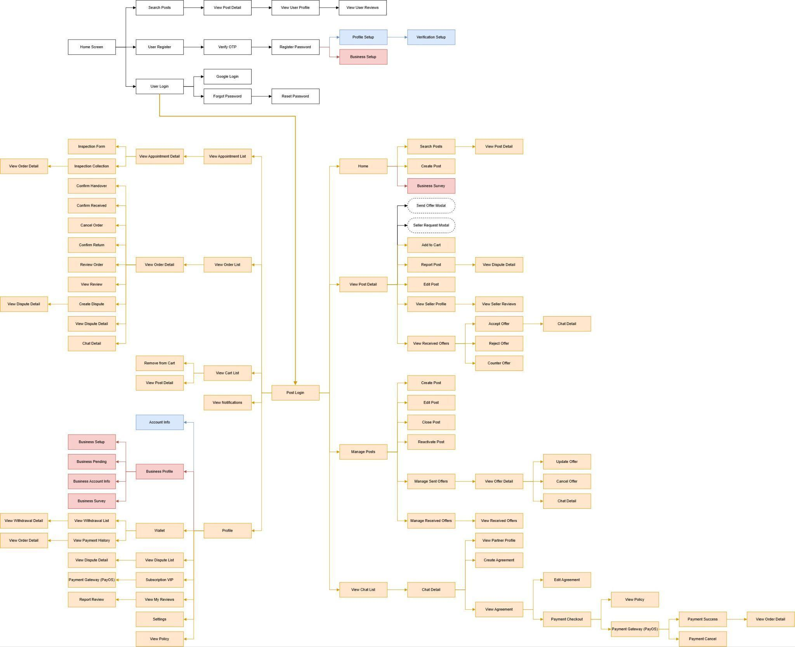
Diagram 4: Screen Flow Diagram (Mobile)
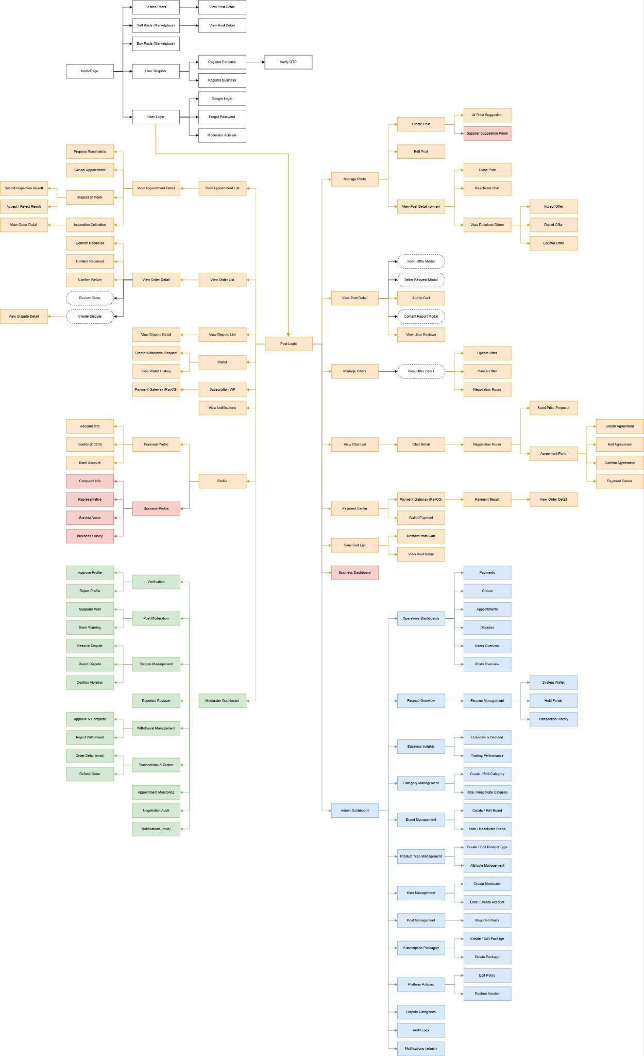
Diagram 5: Screen Flow Diagram (Website)

3.1.2 Screen Descriptions
No. | Feature | Screen | Description
1 | Public | HomePage | The entry screen of the application, accessible without logging in. Available on the mobile app and the website.
2 | Public | Search Posts | Allows users to search posts by keyword and filter them by category, product type, condition and location. Available on the mobile app and the website.
3 | Public | View Post Detail | Displays detailed information about a post, including images, description, price and the owner's rating. Available on the mobile app and the website.
4 | Public | View User Profile | Displays the public profile of another user. Available on the mobile app.
5 | Public | View User Reviews | Displays the reviews received by a user. Available on the mobile app and the website.
6 | Authentication | User Register | Allows new users to start registration with an email and an account type (Personal or Business). Available on the mobile app and the website.
7 | Authentication | Verify OTP | Allows users to enter the OTP code sent to their email. Available on the mobile app and the website.
8 | Authentication | Register Password | Allows users to set the password for the new account. Available on the mobile app.
9 | Authentication | Profile Setup | Allows personal users to enter basic profile information such as name, phone number and avatar. Available on the mobile app.
10 | Authentication | Verification Setup | Allows personal users to submit identity and bank information for verification. Available on the mobile app.
11 | Authentication | Business Setup | Allows business users to submit the business profile and legal documents for verification. Available on the mobile app.
12 | Authentication | User Login | Allows users to log in with email and password or a Google account. Available on the mobile app and the website.
13 | Authentication | Google Login | Allows users to sign in with their Google account. Available on the mobile app and the website.
14 | Authentication | Forgot Password | Allows users to request a password reset via their registered email. Available on the mobile app and the website.
15 | Authentication | Reset Password | Allows users to set a new password after OTP verification. Available on the mobile app.
16 | Authentication | Post Login | Redirects authenticated users to the main area matching their role. Available on the mobile app and the website.
17 | Home | Home | Displays the post feed and product categories, with shortcuts to search, cart and post creation. Available on the mobile app.
18 | Post | Create Post | Allows users to create a new sell or buy post with product information, images and price. Available on the mobile app and the website.
19 | Home | Business Survey | Allows business users to define the purchasing criteria used to match sell posts. Available on the mobile app and the website.
20 | Offer | Send Offer Modal | A modal to propose a price and quantity for a sell post. Available on the mobile app and the website.
21 | Offer | Seller Request Modal | A modal for a seller to offer one of their sell posts to a buy post. Available on the mobile app and the website.
22 | Cart | Add to Cart | Allows users to save a post to their cart. Available on the mobile app and the website.
23 | Dispute | Report Post | Allows users to report a post that violates platform rules. Available on the mobile app.
24 | Post | Edit Post | Allows the post owner to update an existing post. Available on the mobile app and the website.
25 | Offer | View Received Offers | Displays the offers received for a specific post. Available on the mobile app and the website.
26 | Offer | Accept Offer | Allows the post owner to accept an offer and open the negotiation chat. Available on the mobile app and the website.
27 | Offer | Reject Offer | Allows the post owner to reject an offer. Available on the mobile app and the website.
28 | Offer | Counter Offer | Allows the post owner to respond with a new price and quantity. Available on the mobile app and the website.
29 | Post | Manage Posts | Displays the user's posts by status, together with sent and received offers. Available on the mobile app and the website.
30 | Post | Close Post | Allows the owner to close an active post. Available on the mobile app and the website.
31 | Post | Reactivate Post | Allows the owner to reopen a closed post. Available on the mobile app and the website.
32 | Offer | Manage Sent Offers | Displays the offers the user has sent. Available on the mobile app.
33 | Offer | View Offer Detail | Displays the details and status of an offer. Available on the mobile app and the website.
34 | Offer | Update Offer | Allows the sender to change the price or quantity of a pending offer. Available on the mobile app and the website.
35 | Offer | Cancel Offer | Allows the sender to withdraw a pending offer. Available on the mobile app and the website.
36 | Offer | Manage Received Offers | Displays the offers received on the user's posts. Available on the mobile app.
37 | Chat & Negotiation | View Chat List | Displays the user's negotiation conversations. Available on the mobile app and the website.
38 | Chat & Negotiation | Chat Detail | A real-time chat for negotiating a transaction, showing offer and agreement updates. Available on the mobile app and the website.
39 | Agreement | Create Agreement | Allows the seller to create the transaction agreement with delivery and payment terms. Available on the mobile app and the website.
40 | Agreement | View Agreement | Displays the agreement terms for both parties to review and confirm. Available on the mobile app.
41 | Agreement | Edit Agreement | Allows the seller to revise an unpaid agreement. Available on the mobile app and the website.
42 | Payment | Payment Checkout | Allows the buyer to pay for the agreement using the wallet or PayOS. Available on the mobile app.
43 | Payment | View Policy | Displays the platform's rules and policies. Available on the mobile app.
44 | Payment | Payment Gateway (PayOS) | Redirects the buyer to the external PayOS payment page. Available on the mobile app and the website.
45 | Payment | Payment Success | Displays the result of a successful payment. Available on the mobile app.
46 | Payment | Payment Cancel | Displays a cancelled payment with an option to retry. Available on the mobile app.
47 | Appointment | View Appointment List | Displays the user's inspection and collection appointments. Available on the mobile app and the website.
48 | Appointment | View Appointment Detail | Displays appointment details and allows rescheduling or cancellation. Available on the mobile app and the website.
49 | Inspection | Inspection Form | Allows the inspecting party to record the inspection result and the seller to accept or reject it. Available on the mobile app and the website.
50 | Inspection | Inspection Collection | Allows both parties to schedule the handover after an accepted inspection, which creates the order. Available on the mobile app and the website.
51 | Order | View Order List | Displays the user's orders as buyer or seller with their status. Available on the mobile app and the website.
52 | Order | View Order Detail | Displays order details, delivery tracking and available order actions. Available on the mobile app and the website.
53 | Order | Confirm Handover | Allows the seller to confirm that the item has been handed over. Available on the mobile app and the website.
54 | Order | Confirm Received | Allows the buyer to confirm receipt of the item. Available on the mobile app and the website.
55 | Order | Cancel Order | Allows the user to cancel an order. Available on the mobile app.
56 | Order | Confirm Return | Allows the parties to confirm the return of an item. Available on the mobile app and the website.
57 | Review | Review Order | Allows the user to rate and review the transaction partner after a completed order. Available on the mobile app and the website.
58 | Review | View Review | Displays a review received on an order. Available on the mobile app.
59 | Dispute | Create Dispute | Allows the user to open a dispute on an order with a description and evidence. Available on the mobile app and the website.
60 | Dispute | View Dispute Detail | Displays the details, evidence and resolution of a dispute. Available on the mobile app and the website.
61 | Cart | View Cart List | Displays the posts saved in the user's cart. Available on the mobile app and the website.
62 | Cart | Remove from Cart | Allows users to remove a post from the cart. Available on the mobile app and the website.
63 | Notification | View Notifications | Displays system and transaction notifications. Available on the mobile app and the website.
64 | Profile | Profile | Displays the user's profile overview and the menu of account features. Available on the mobile app and the website.
65 | Profile | Account Info | Allows personal users to view and edit their account information. Available on the mobile app and the website.
66 | Profile | Business Profile | Provides business users access to their business profile according to its verification status. Available on the mobile app and the website.
67 | Profile | Business Pending | Informs business users that their profile is awaiting review. Available on the mobile app.
68 | Profile | Business Account Info | Displays the approved business profile information. Available on the mobile app.
69 | Wallet | Wallet | Displays the wallet balance and allows users to request a withdrawal. Available on the mobile app and the website.
70 | Wallet | View Withdrawal List | Displays the user's withdrawal requests. Available on the mobile app.
71 | Wallet | View Withdrawal Detail | Displays the details and status of a withdrawal request. Available on the mobile app.
72 | Wallet | View Payment History | Displays the user's payment history for orders. Available on the mobile app.
73 | Dispute | View Dispute List | Displays the user's disputes and reports. Available on the mobile app and the website.
74 | Profile | Subscription VIP | Displays the current subscription plan and allows upgrading to VIP. Available on the mobile app and the website.
75 | Review | View My Reviews | Displays the reviews the user has received. Available on the mobile app.
76 | Dispute | Report Review | Allows users to report a review that violates platform rules. Available on the mobile app.
77 | Profile | Settings | Allows users to configure notifications and the app's appearance. Available on the mobile app.
78 | Public | Sell Posts (Marketplace) | Displays the marketplace of sell posts published by personal users. Available on the website.
79 | Public | Buy Posts (Marketplace) | Displays the marketplace of buy posts published by businesses. Available on the website.
80 | Authentication | Register Personal | Allows a guest to register a personal account with email, password and basic information. Available on the website.
81 | Authentication | Register Business | Allows a guest to register a business account and submit the business profile for verification. Available on the website.
82 | Authentication | Moderator Activate | Allows an invited moderator to activate the account created by the administrator. Available on the website.
83 | Post | AI Price Suggestion | Provides a reference price range for a sell post from the entered product information. Available on the website.
84 | Post | Supplier Suggestion Panel | Shows business users the sell posts matching the buy post being created. Available on the website.
85 | Post | View Post Detail (owner) | Displays the owner's own post with management actions and received offers. Available on the website.
86 | Dispute | Content Report Modal | A modal to report a post or a review that violates platform rules. Available on the website.
87 | Offer | Manage Offers | Displays the offers the user has sent and received with their status. Available on the website.
88 | Chat & Negotiation | Negotiation Room | Displays the negotiation session of an accepted offer with the agreed terms and the agreement status. Available on the website.
89 | Chat & Negotiation | Send Price Proposal | Allows a party to propose a new price in the negotiation for the partner to accept or reject. Available on the website.
90 | Agreement | Agreement Form | Displays the transaction agreement of a negotiation for both parties. Available on the website.
91 | Agreement | Confirm Agreement | Allows the buyer to confirm the agreement terms before payment. Available on the website.
92 | Payment | Payment Center | Displays the user's payments and the agreements awaiting payment. Available on the website.
93 | Payment | Payment Result | Displays the result of a payment (success or cancelled). Available on the website.
94 | Payment | Wallet Payment | Allows the buyer to pay an agreement from the HomeCycle wallet. Available on the website.
95 | Business | Business Dashboard | Displays the business's purchasing performance: orders bought and sold, wallet movements and appointment calendar. Available on the website.
96 | Appointment | Propose Reschedule | Allows a party to propose a new appointment time for the partner to accept or reject. Available on the website.
97 | Appointment | Cancel Appointment | Allows a party to cancel an appointment with a reason. Available on the website.
98 | Inspection | Submit Inspection Result | Allows the inspecting party to record and send the inspection result to the seller. Available on the website.
99 | Inspection | Accept / Reject Result | Allows the seller to accept or reject the inspection result. Available on the website.
100 | Wallet | Create Withdrawal Request | Allows personal users to request a withdrawal to their bank account. Available on the website.
101 | Wallet | View Wallet History | Displays the wallet's balance movements and withdrawal requests. Available on the website.
102 | Profile | Personal Profile | Allows personal users to view and edit their profile. Available on the website.
103 | Profile | Identity (CCCD) | Allows personal users to submit identity information for moderator verification. Available on the website.
104 | Profile | Bank Account | Allows users to maintain the bank account used for withdrawals. Available on the website.
105 | Profile | Company Info | Allows business users to update the company's registration information. Available on the website.
106 | Profile | Representative | Allows business users to update the legal representative's information. Available on the website.
107 | Profile | Service Areas | Allows business users to manage the areas in which they operate. Available on the website.
108 | Moderator | Moderator Dashboard | Displays an overview of pending moderation work. Available on the website.
109 | Moderator | Verification | Displays business and identity verification requests awaiting review. Available on the website.
110 | Moderator | Approve Profile | Allows moderators to approve a verification request. Available on the website.
111 | Moderator | Reject Profile | Allows moderators to reject a verification request with a reason. Available on the website.
112 | Moderator | Post Moderation | Displays posts for moderation, including reported posts. Available on the website.
113 | Moderator | Suspend Post | Allows moderators to suspend a post that violates platform rules. Available on the website.
114 | Moderator | Send Warning | Allows moderators to send a warning to a post owner. Available on the website.
115 | Moderator | Dispute Management | Displays disputes and reports awaiting resolution. Available on the website.
116 | Moderator | Resolve Dispute | Allows moderators to record the conclusion of a dispute in favour of the buyer or the seller. Available on the website.
117 | Moderator | Reject Dispute | Allows moderators to reject a dispute or report. Available on the website.
118 | Moderator | Confirm Violation | Allows moderators to confirm that a reported post or review violates platform rules. Available on the website.
119 | Moderator | Reported Reviews | Displays reviews reported by users for moderation. Available on the website.
120 | Moderator | Withdrawal Management | Displays withdrawal requests awaiting processing. Available on the website.
121 | Moderator | Approve & Complete | Allows moderators to approve and complete a withdrawal request. Available on the website.
122 | Moderator | Reject Withdrawal | Allows moderators to reject a withdrawal request and return the held amount. Available on the website.
123 | Moderator | Transactions & Orders | Displays orders and payment transactions for monitoring. Available on the website.
124 | Moderator | Order Detail (mod) | Displays the details of an order for moderation. Available on the website.
125 | Moderator | Refund Order | Allows moderators to refund an order to the buyer. Available on the website.
126 | Moderator | Appointment Monitoring | Displays appointments for monitoring, including inspection results. Available on the website.
127 | Moderator | Negotiation Audit | Displays the history of negotiations for auditing. Available on the website.
128 | Moderator | Notifications (mod) | Displays notifications for the moderator. Available on the website.
129 | Admin | Admin Dashboard | Displays system-wide operational statistics. Available on the website.
130 | Admin | Operations Dashboards | Displays detailed dashboards by operational area. Available on the website.
131 | Admin | Payments | Displays payment statistics. Available on the website.
132 | Admin | Orders | Displays order statistics and history. Available on the website.
133 | Admin | Appointments | Displays appointment statistics and history. Available on the website.
134 | Admin | Disputes | Displays dispute statistics and history. Available on the website.
135 | Admin | Users Overview | Displays user statistics. Available on the website.
136 | Admin | Posts Overview | Displays post statistics. Available on the website.
137 | Admin | Finance Overview | Displays revenue and financial statistics. Available on the website.
138 | Admin | Finance Management | Displays the system wallet, held funds and transaction history. Available on the website.
139 | Admin | System Wallet | Displays the balances of the system wallet. Available on the website.
140 | Admin | Held Funds | Displays the amounts currently held in escrow. Available on the website.
141 | Admin | Transaction History | Displays all wallet transactions in the system. Available on the website.
142 | Admin | Business Insights | Displays statistics about business accounts. Available on the website.
143 | Admin | Overview & Demand | Displays business overview and purchasing demand statistics. Available on the website.
144 | Admin | Trading Performance | Displays the trading performance of businesses. Available on the website.
145 | Admin | Category Management | Displays product categories. Available on the website.
146 | Admin | Create / Edit Category | Allows administrators to create or edit a category. Available on the website.
147 | Admin | Hide / Reactivate Category | Allows administrators to hide or reactivate a category. Available on the website.
148 | Admin | Brand Management | Displays product brands. Available on the website.
149 | Admin | Create / Edit Brand | Allows administrators to create or edit a brand. Available on the website.
150 | Admin | Hide / Reactivate Brand | Allows administrators to hide or reactivate a brand. Available on the website.
151 | Admin | Product Type Management | Displays product types by category. Available on the website.
152 | Admin | Create / Edit Product Type | Allows administrators to create or edit a product type. Available on the website.
153 | Admin | Attribute Management | Allows administrators to manage the attributes and options of a product type. Available on the website.
154 | Admin | User Management | Displays user accounts of all roles. Available on the website.
155 | Admin | Create Moderator | Allows administrators to create a moderator account. Available on the website.
156 | Admin | Lock / Unlock Account | Allows administrators to lock or unlock a user account. Available on the website.
157 | Admin | Post Management | Displays all posts in the system. Available on the website.
158 | Admin | Reported Posts | Displays posts reported by users. Available on the website.
159 | Admin | Subscription Packages | Displays the VIP subscription packages. Available on the website.
160 | Admin | Create / Edit Package | Allows administrators to create or edit a subscription package and its entitlements. Available on the website.
161 | Admin | Delete Package | Allows administrators to delete a package that has no subscriptions. Available on the website.
162 | Admin | Platform Policies | Displays the platform policies and their versions. Available on the website.
163 | Admin | Edit Policy | Allows administrators to edit a platform policy. Available on the website.
164 | Admin | Restore Version | Allows administrators to restore a previous version of a policy. Available on the website.
165 | Admin | Dispute Categories | Allows administrators to manage the dispute and report categories. Available on the website.
166 | Admin | Audit Logs | Displays the system audit log. Available on the website.
167 | Admin | Notifications (admin) | Displays notifications for the administrator. Available on the website.
Table 15: Screen Descriptions

3.1.3 Screen Authorization
Screen | Guest | Personal | Business | Moderator | Admin
HomePage | X | X | X
Search Posts | X | X | X
View Post Detail | X | X | X
View User Profile | X | X | X
View User Reviews | X | X | X
User Register | X
Verify OTP | X
Register Password | X
Profile Setup | X
Verification Setup | X
Business Setup | X |  | X
User Login | X
Google Login | X
Forgot Password | X
Reset Password | X
Post Login |  | X | X | X | X
Home | X | X | X
Create Post |  | X | X
Business Survey |  |  | X
Send Offer Modal |  | X | X
Seller Request Modal |  | X
Add to Cart |  | X | X
Report Post |  | X | X
Edit Post |  | X | X
View Received Offers |  | X | X
Accept Offer |  | X | X
Reject Offer |  | X | X
Counter Offer |  | X | X
Manage Posts |  | X | X
Close Post |  | X | X
Reactivate Post |  | X | X
Manage Sent Offers |  | X | X
View Offer Detail |  | X | X
Update Offer |  | X | X
Cancel Offer |  | X | X
Manage Received Offers |  | X | X
View Chat List |  | X | X
Chat Detail |  | X | X
Create Agreement |  | X | X
View Agreement |  | X | X
Edit Agreement |  | X | X
Payment Checkout |  | X | X
View Policy |  | X | X
Payment Gateway (PayOS) |  | X | X
Payment Success |  | X | X
Payment Cancel |  | X | X
View Appointment List |  | X | X
View Appointment Detail |  | X | X
Inspection Form |  | X | X
Inspection Collection |  | X | X
View Order List |  | X | X
View Order Detail |  | X | X
Confirm Handover |  | X | X
Confirm Received |  | X | X
Cancel Order |  | X | X
Confirm Return |  | X | X
Review Order |  | X | X
View Review |  | X | X
Create Dispute |  | X | X
View Dispute Detail |  | X | X
View Cart List |  | X | X
Remove from Cart |  | X | X
View Notifications |  | X | X
Profile |  | X | X
Account Info |  | X
Business Profile |  |  | X
Business Pending |  |  | X
Business Account Info |  |  | X
Wallet |  | X | X
View Withdrawal List |  | X | X
View Withdrawal Detail |  | X | X
View Payment History |  | X | X
View Dispute List |  | X | X
Subscription VIP |  | X | X
View My Reviews |  | X | X
Report Review |  | X | X
Settings |  | X | X
Sell Posts (Marketplace) | X | X | X
Buy Posts (Marketplace) | X | X | X
Register Personal | X
Register Business | X
Moderator Activate | X
AI Price Suggestion |  | X
Supplier Suggestion Panel |  |  | X
View Post Detail (owner) |  | X | X
Content Report Modal |  | X | X
Manage Offers |  | X | X
Negotiation Room |  | X | X
Send Price Proposal |  | X | X
Agreement Form |  | X | X
Confirm Agreement |  | X | X
Payment Center |  | X | X
Payment Result |  | X | X
Wallet Payment |  | X | X
Business Dashboard |  |  | X
Propose Reschedule |  | X | X
Cancel Appointment |  | X | X
Submit Inspection Result |  | X | X
Accept / Reject Result |  | X | X
Create Withdrawal Request |  | X | X
View Wallet History |  | X | X
Personal Profile |  | X
Identity (CCCD) |  | X
Bank Account |  | X
Company Info |  |  | X
Representative |  |  | X
Service Areas |  |  | X
Moderator Dashboard |  |  |  | X
Verification |  |  |  | X
Approve Profile |  |  |  | X
Reject Profile |  |  |  | X
Post Moderation |  |  |  | X
Suspend Post |  |  |  | X
Send Warning |  |  |  | X
Dispute Management |  |  |  | X
Resolve Dispute |  |  |  | X
Reject Dispute |  |  |  | X
Confirm Violation |  |  |  | X
Reported Reviews |  |  |  | X
Withdrawal Management |  |  |  | X
Approve & Complete |  |  |  | X
Reject Withdrawal |  |  |  | X
Transactions & Orders |  |  |  | X
Order Detail (mod) |  |  |  | X
Refund Order |  |  |  | X
Appointment Monitoring |  |  |  | X
Negotiation Audit |  |  |  | X
Notifications |  |  |  | X | X
Admin Dashboard |  |  |  |  | X
Operations Dashboards |  |  |  |  | X
Payments |  |  |  |  | X
Orders |  |  |  |  | X
Appointments |  |  |  |  | X
Disputes |  |  |  |  | X
Users Overview |  |  |  |  | X
Posts Overview |  |  |  |  | X
Finance Overview |  |  |  |  | X
Finance Management |  |  |  |  | X
System Wallet |  |  |  |  | X
Held Funds |  |  |  |  | X
Transaction History |  |  |  |  | X
Business Insights |  |  |  |  | X
Overview & Demand |  |  |  |  | X
Trading Performance |  |  |  |  | X
Category Management |  |  |  |  | X
Create / Edit Category |  |  |  |  | X
Hide / Reactivate Category |  |  |  |  | X
Brand Management |  |  |  |  | X
Create / Edit Brand |  |  |  |  | X
Hide / Reactivate Brand |  |  |  |  | X
Product Type Management |  |  |  |  | X
Create / Edit Product Type |  |  |  |  | X
Attribute Management |  |  |  |  | X
User Management |  |  |  |  | X
Create Moderator |  |  |  |  | X
Lock / Unlock Account |  |  |  |  | X
Post Management |  |  |  |  | X
Reported Posts |  |  |  |  | X
Subscription Packages |  |  |  |  | X
Create / Edit Package |  |  |  |  | X
Delete Package |  |  |  |  | X
Platform Policies |  |  |  |  | X
Edit Policy |  |  |  |  | X
Restore Version |  |  |  |  | X
Dispute Categories |  |  |  |  | X
Audit Logs |  |  |  |  | X
Table 16: Screen Authorization

3.1.4 Non-Screen Functions
No. | Feature | System Function | Description
1 | Authentication | JWT Authentication & Token Refresh | Service that issues access and refresh tokens on login (email/password or Google) and silently renews expired access tokens.
2 | Authentication | OTP Service | Service that generates a 6-digit OTP, sends it by email for account registration and password reset, and validates it within its expiry window.
3 | Authentication | Role-Based Authorization | Middleware that checks the user's role and, where applicable, ownership (post owner, buyer or seller of a transaction) on every request.
4 | Account Management | Business Onboarding Status Tracking | Service that maintains the business profile status (missing, pending approval, rejected, survey pending, completed) and gates business features accordingly.
5 | Account Management | Sensitive Data Masking | Service that masks citizen ID and bank account numbers in API responses and on screen.
6 | Post Management | Post Lifecycle Management | Service that manages post statuses (Pending, Active, Closed, Deleted) and automatically closes a sell post when its remaining quantity reaches zero, or a buy post when its target quantity is reached or it expires.
7 | Post Management | AI Price Suggestion | Integrated AI service that recommends a price range for a sell post from its product information.
8 | Post Management | AI Supplier Matching | Integrated AI service that matches sell posts to a business's buy post based on the purchasing survey.
9 | Post Management | Business Discovery Feed | Service that filters the home feed for business accounts to sell posts matching their purchasing criteria.
10 | Negotiation & Chat | Real-time Chat Service | SignalR hub that creates a negotiation conversation when an offer is accepted and delivers messages, offer and agreement updates in real time.
11 | Agreement | Agreement Revision Control | Service that versions each agreement and rejects updates made on an outdated revision to prevent overwriting the partner's changes.
12 | Appointment | Appointment Scheduling Service | Service that creates inspection and collection appointments from the agreement, handles reschedule proposals and cancellations, and creates the order once collection is scheduled.
13 | Shipping Integration | GHN Fee Calculation | Integrated API that calculates the shipping fee from package dimensions, weight and pick-up/delivery addresses.
14 | Shipping Integration | GHN Shipment Tracking | Integrated API that creates the GHN shipping order on handover confirmation and syncs tracking status to the order.
15 | Payment | Payment Processing (Wallet / PayOS) | Service that charges the deposit or full amount from the buyer's wallet or via a PayOS checkout session and returns the result to the app through a deep link.
16 | Payment | PayOS Webhook Handler | Webhook that verifies payment results from PayOS and updates order, subscription and wallet status.
17 | Payment (Escrow) | Escrow Hold & Release | Job that holds the buyer's payment, releases it to the seller after the dispute window closes without a dispute, and refunds the buyer on cancellation or dispute resolution.
18 | Wallet | Withdrawal Quota Enforcement | Service that validates withdrawal requests against the minimum and maximum amount and the daily amount and count limits.
19 | Reputation & Dispute | Reputation & Dispute Window | Service that updates the user's reputation score from reviews and enforces the complaint window on each order.
20 | Subscription | Subscription Entitlement Check | Service that validates the active VIP package, applies its entitlements (e.g. post limits) and downgrades the account to the free plan when it expires.
21 | Notification | Notification Dispatch | Service that sends in-app, push (Expo) and email notifications for chat, offer, order, appointment, dispute and payment events.
22 | Logging | Audit Logging | Service that records critical user and financial actions to the audit log for traceability.
Table 17: Non-Screen Functions

No. | Feature | System Function | Description
1 | Authentication | User Authentication | Authenticates users using email/username and password before granting system access.
2 | Authentication | Role-Based Authorization | Controls access to system functions and screens based on user roles (Personal, Business, Moderator, Admin).
3 | Authentication | Session Management | Maintains user login sessions and automatically expires sessions after inactivity.
4 | Authentication | Password Encryption | Encrypts user passwords before storing them in the database to ensure security.
5 | Authentication | OTP Generation & Validation | Generates secure OTP tokens for registration/password reset requests and validates token expiration via Email.
6 | Account Management | Account Activation | Activates user accounts after successful registration and OTP verification.
7 | Account Management | Account Ban/Unban | Allows administrators to suspend or restore user access without deleting data based on policy violations.
8 | Identity Verification | OCR Data Extraction | Integrates with 3rd-party OCR API to automatically extract information (Name, ID, DOB) from user's citizen ID cards.
9 | Identity Verification | Verification Workflow | Handles submission, review, approval, or rejection of KYC and Business Licenses by moderators.
10 | Identity Verification | Sensitive Data Masking | Automatically encrypts and masks sensitive ID strings (e.g., 001202) on UI instances for privacy compliance.
11 | Post Management | Post Status Management | Manages post lifecycle statuses such as Draft, Pending Approval, Active, and Hidden.
12 | Post Management | Post Approval Workflow | Handles submission, review, approval, or rejection of selling posts by moderators.
13 | Post Management | Auto-Close Post | Automatically closes or hides selling posts when the remaining item quantity reaches zero after transactions.
14 | Negotiation & Chat | Chat Session Management | Creates secure chat sessions between buyers and sellers upon accepted quotes.
15 | Appointment | Appointment Validation | Ensures appointments (Inspection/Collection) are booked with valid time slots and tracks their statuses.
16 | Appointment | Auto-Cancel Appointment | Automatically cancels appointments and freezes orders if no interaction occurs 2 hours past the scheduled time.
17 | Shipping Integration | GHN Fee Calculation | Calls GHN API to calculate dynamic shipping fees based on package dimensions, weight, and routing locations.
18 | Shipping Integration | GHN Order Creation | Automatically calls GHN API to generate shipping orders and retrieve Tracking Numbers upon seller handover confirmation.
19 | Payment (PayOS) | Payment Processing | Integrates with PayOS gateway to process Escrow deposit (20%) and full (100%) transactions securely via QR codes.
20 | Payment (PayOS) | Webhook Processing | Listens to PayOS webhooks to verify payment results and updates order/wallet statuses automatically.
21 | Payment (Escrow) | Auto-Release Funds | Automatically transfers funds from Holding Balance to Available Balance 72h-120h after successful delivery if no disputes exist.
22 | Payment (Escrow) | Refund Handling | Handles refund requests by reversing funds from Escrow to the buyer's wallet based on dispute resolutions or failed inspections.
23 | Reputation System | Auto-Score Calculation | Automatically calculates and updates user reputation scores (+2, -5, -10) based on post-transaction star ratings.
24 | Reputation System | Penalty Enforcer | Automatically restricts posting, quoting, or withdrawal rights if a user's reputation score drops below defined thresholds (60 or 20).
25 | Dispute Management | Dispute Workflow | Manages the lifecycle of dispute claims, including evidence submission, review, and resolution by moderators.
26 | Dispute Management | Comment Moderation | Manages comment states (Active, Hidden, Deleted) when ratings are reported for false information.
27 | Subscription | Package Validation | Validates active Business Pro subscriptions to grant infinite posts or buying demand creation rights.
28 | Subscription | Auto-Expire Subscription | Automatically tracks and expires subscription packages after 1 month, downgrading users to the free tier.
29 | Notification | System Notification Dispatch | Sends real-time in-app notifications for events such as chat messages, appointment updates, and payment results.
30 | Notification | Email Notification Service | Sends emails for registration confirmation, password reset, and system alerts.
31 | Policy Management | Policy Enforcement | Enforces system rules and policies across all modules (e.g., Escrow holding time, withdrawal limits).
32 | Security | Input Validation | Validates user input forms to prevent invalid data and injection attacks.
33 | Security | Access Logging | Logs user access and critical system actions for security auditing.
34 | Data Management | Data Integrity Check | Ensures consistency and correctness of stored data across Orders, Transactions, and Wallets.
35 | Analytics | Usage Analytics | Collects system usage data, transaction volumes, and user stats for admin dashboard monitoring and reporting.
36 | Logging | Error Logging | Records system errors and API integration failures (PayOS, GHN, OCR) for debugging and maintenance.
37 | Logging | Activity Logging | Records important user actions and financial transactions for traceability and auditing.
Table 18: Non-Screen Functions (Extended List)

3.1.5 Entity Relationship Diagram
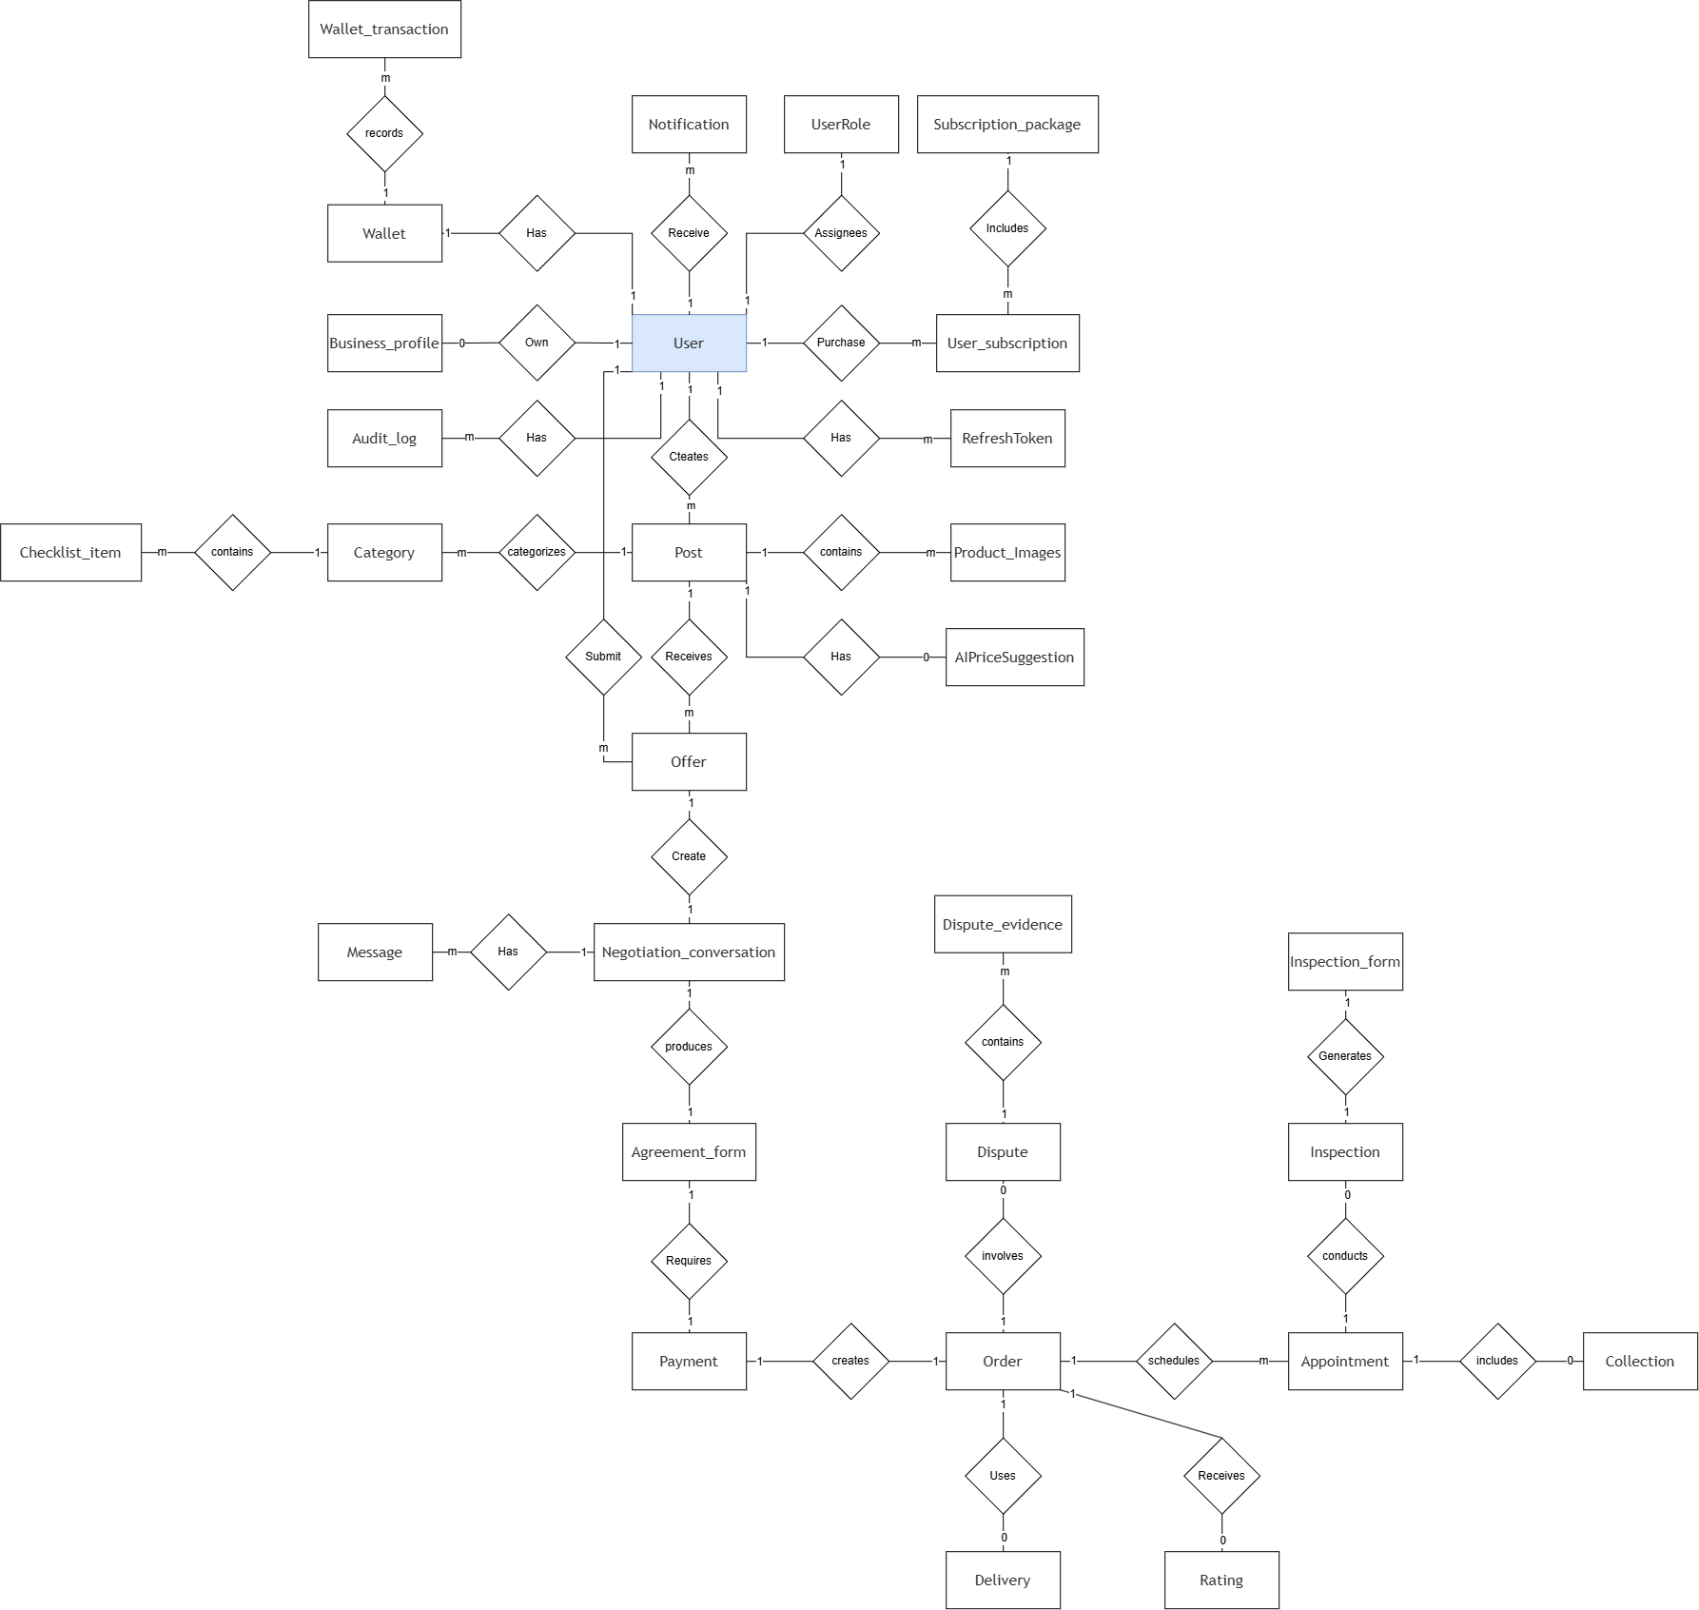
Diagram 6: Entity Relationship Diagram
Entities Description
# | Entity | Description
1 | User | Represents a registered platform user. A user can act as a seller, buyer, business purchaser, moderator, or administrator depending on the assigned role
2 | UserRole | Defines the role assigned to a user, including permissions and access levels within the system
3 | Business_profile | Stores verified business information for business users, including company details, verification status
4 | Wallet | Maintains the user's available balance generated from completed transactions and used for withdrawal management
5 | Wallet_transaction | Records all balance changes related to the wallet, such as earnings, withdrawals, refunds, and financial adjustments
6 | Notification | system-generated notifications sent to users regarding transactions, appointments, disputes, payments, and account activities
7 | Subscription_package | Defines service packages available for business users, including feature limits, benefits, and subscription duration
8 | User_subscription | Records subscription purchases made by business users and tracks package activation, expiration, and subscription status
9 | RefreshToken | Stores authentication refresh tokens used to maintain secure user sessions
10 | Audit_log | Records important system activities and user actions for monitoring, auditing, and traceability purposes
11 | Category | Represents a product category used to classify used household goods listed on the platform
12 | Checklist_item | category-specific quality standards and technical parameters dynamically rendered during the physical verification process to assess item condition
13 | Post | A product listing created by a seller to offer used household goods for sale or collection
14 | Product_Images | Product images uploaded for a listing to provide visual information about the product condition and appearance
15 | AIPriceSuggestion | AI-generated pricing recommendations for a listing based on product information and historical market data
16 | Offer | Represents a purchase offer submitted and custom pricing by a buyer or business user for a specific listing
17 | Negotiation_conversation | Opens a direct chat for trading parties to haggle prices and coordinate logistics for a specific offer
18 | Message | Represents individual messages exchanged within a negotiation conversation
19 | Agreement_form | Stores the final transaction agreement confirmed by both parties before payment processing
20 | Payment | Records payment information associated with a confirmed agreement, including amount, payment method, and payment status
21 | Order | Manages the lifecycle of a confirmed transaction after successful payment, including order processing, status tracking, payment information, and appointment-related activities
22 | Appointment | Schedules meetings for inspection, collection, or product handover activities
23 | Inspection | Facilitates product condition verification during a scheduled appointment
24 | InspectionForm | Documents inspection findings, product conditions, and verification results
25 | Collection | Manages the collection or handover process of goods after inspection and transaction confirmation
26 | Delivery | Tracks third-party delivery activities, including shipping status, tracking information, and transportation details
27 | Dispute | Manages complaints or conflicts raised during the transaction lifecycle
28 | DisputeEvidence | Provides supporting materials submitted by users to assist dispute investigation and resolution
29 | Rating | Captures transaction-based feedback and evaluation submitted after order completion
Table 19: Entities Description

3.2.1 Register Account
Function trigger: When a Guest opens User Login, taps “Đăng ký”, enters an email, selects the account type (“Cá nhân” or “Doanh nghiệp”) on User Register and taps “Đăng ký”.
Function description: Allows a Guest to create a Personal account, or a Business account whose legal profile is sent to moderators for verification.
Function details:
Normal Flow:
- The Guest enters an email, selects “Cá nhân” and taps “Đăng ký”; the system sends a 6-digit OTP to the email.
- The Guest enters the OTP on Verify OTP, then sets a password (6–50 characters) on Register Password.
- The Guest enters full name, username, phone number and an optional avatar on Profile Setup.
- The Guest enters the citizen ID information, uploads the front/back ID images and the payout bank account on Verification Setup.
- The system validates each step, creates the account and signs the user in, then redirects to Home.
Alternative Flows:
A1 – Register a Business account:
- The Guest selects “Doanh nghiệp”, completes Verify OTP and Register Password; the system opens Business Setup.
- The Guest selects the business model (“Hộ kinh doanh” or “Doanh nghiệp”) and taps “TIẾP TỤC”.
- The Guest enters the business, legal representative and bank information, uploads the required documents and taps “GỬI YÊU CẦU”.
- The system saves the profile with status “Đang chờ duyệt”, notifies moderators and shows “Nộp hồ sơ thành công!”. A rejected profile can be resubmitted with “NỘP LẠI HỒ SƠ”.
Exception Flows:
E1 – Invalid data:
- The Guest leaves a required field empty or enters data in a wrong format (e.g., citizen ID not 12 digits, missing ID image, invalid phone number).
- The system highlights the field and shows the message, e.g., “Địa chỉ email không đúng định dạng.”, “Số CCCD phải gồm đúng 12 chữ số.”, “Vui lòng cung cấp đủ mặt trước và mặt sau CCCD.”
E2 – Email already registered or OTP invalid:
- The system rejects the email or the OTP (wrong or expired) and keeps the Guest on the current step so that a new OTP can be requested.
E3 – Registration session expired:
- The system shows “Phiên xác thực email không còn hợp lệ. Vui lòng xác thực lại email để tiếp tục đăng ký.” and returns to User Register.
Screen layout:
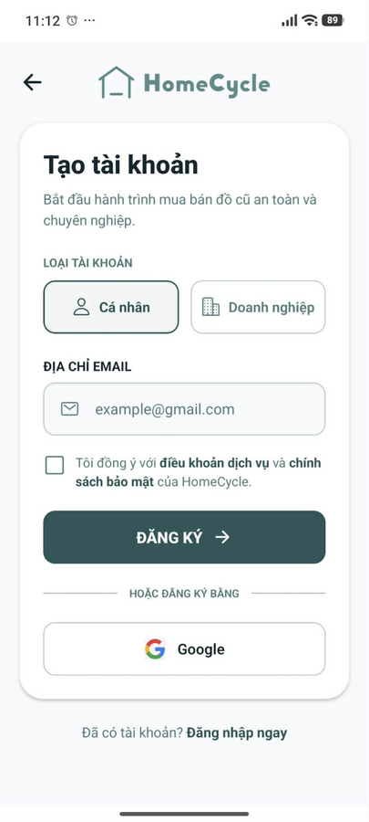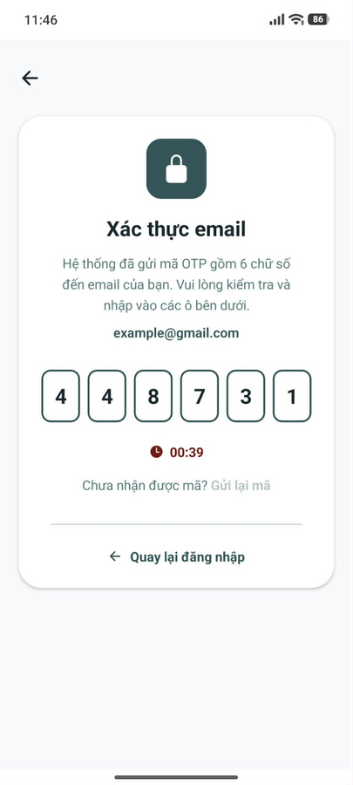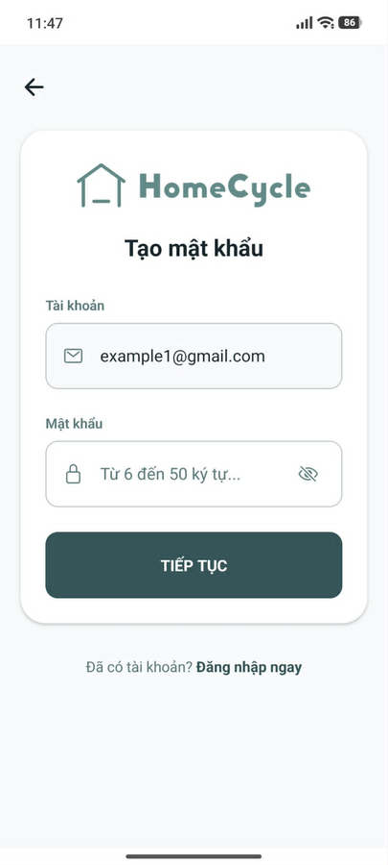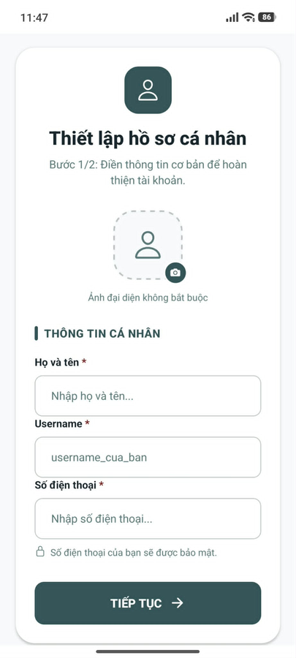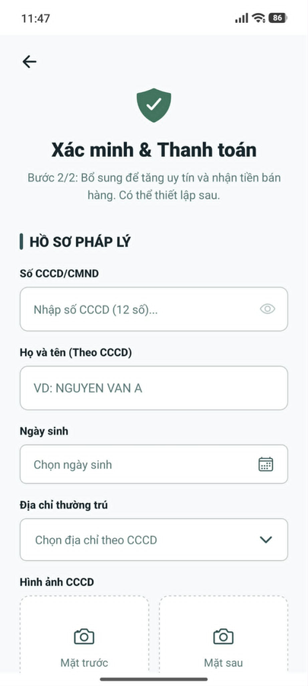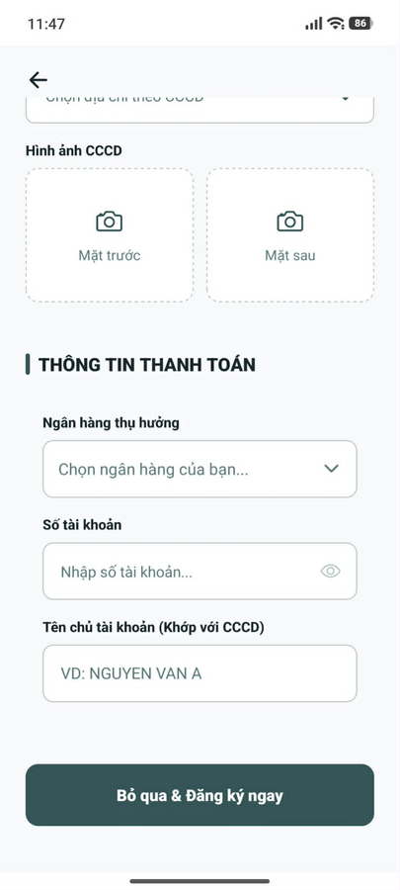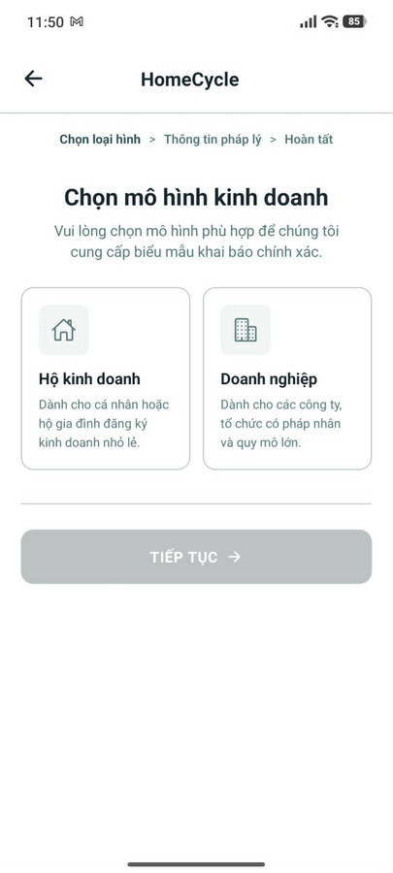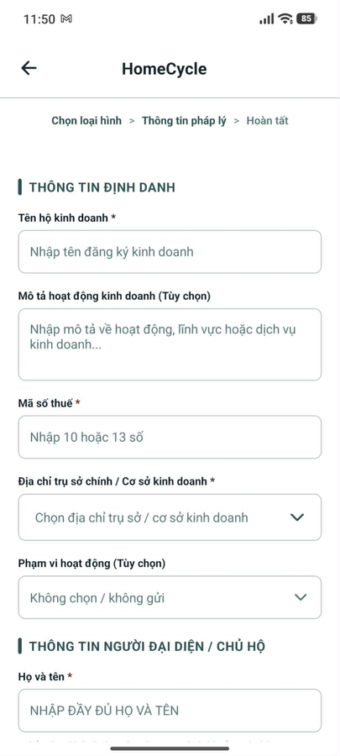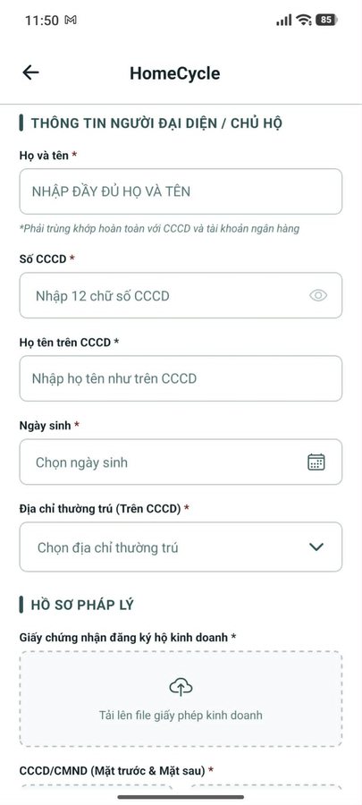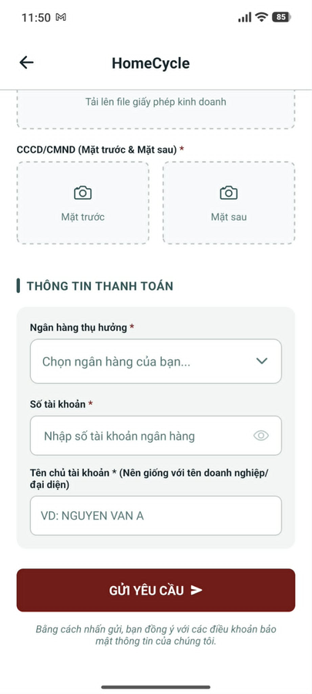
Figure 1: Register Account screens

3.2.2 Login
Function trigger: When a Guest opens User Login, enters email and password and taps “Đăng nhập”, or chooses to sign in with Google.
Function description: Allows Personal and Business users to authenticate and access the features of their role.
Function details:
Normal Flow:
- The user opens User Login from the header or from an action that requires signing in.
- The user enters email and password and taps “Đăng nhập”.
- The system verifies the credentials, stores the session and loads the profile and role.
- The system redirects the user to the previous screen or to Home.
Alternative Flows:
A1 – Sign in with Google:
- The user taps the Google sign-in button and selects a Google account.
- The system verifies the Google account and signs the user in.
- If the Google account is not registered yet, the system opens Register Password to complete the registration.
Exception Flows:
E1 – Incorrect information:
- The user enters an empty or wrong email/password.
- The system shows “Vui lòng nhập địa chỉ email.” or “Đăng nhập thất bại. Vui lòng kiểm tra lại.” and keeps the entered email.
E2 – Google sign-in cancelled or failed:
- The system shows an error message and lets the user try again.
Screen layout:
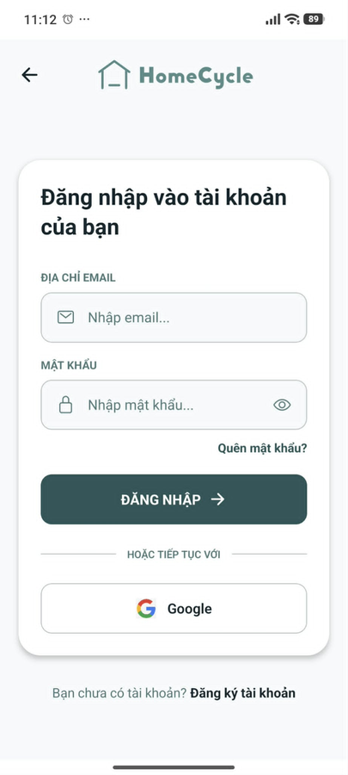
Figure 2: Login screen

3.2.3 Logout
Function trigger: When a logged-in user opens Profile, taps “Đăng xuất” and confirms.
Function description: Allows the user to end the current session securely.
Function details:
Normal Flow:
- The user taps “Đăng xuất” on Profile and confirms in the dialog.
- The system revokes the session and clears the local authentication data.
- The system redirects to Home in guest mode.
Exception Flows:
E1 – Session already expired:
- The system clears the local data and redirects to Home without an error.
E2 – Connection or server error:
- The system shows “Không thể đăng xuất lúc này. Vui lòng thử lại.” and keeps the user signed in.
Screen layout:
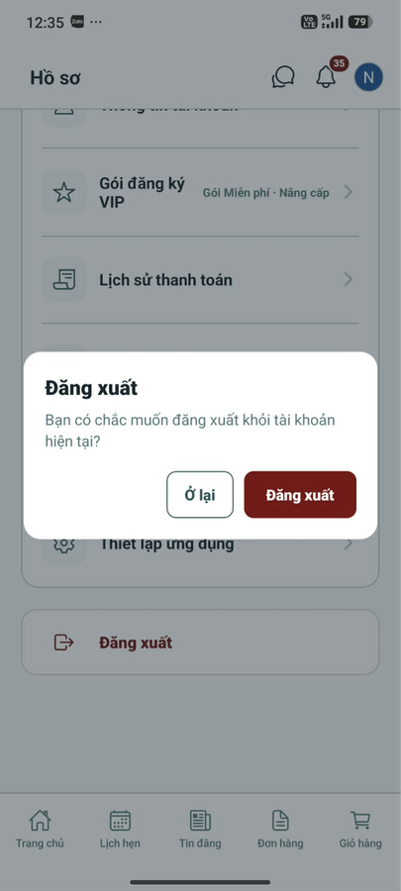
Figure 3: Logout screen

3.2.4 Forgot Password
Function trigger: When a Guest taps “Quên mật khẩu” on User Login, enters the registered email and submits.
Function description: Allows the user to recover the account by setting a new password after email OTP verification.
Function details:
Normal Flow:
- The user enters the registered email on Forgot Password and submits; the system sends an OTP.
- On Reset Password, the user enters the OTP, the new password and its confirmation.
- The system verifies the OTP, updates the password and redirects to User Login with “Đặt lại mật khẩu thành công. Vui lòng đăng nhập bằng mật khẩu mới.”
Exception Flows:
E1 – OTP wrong or expired:
- The system shows “Mã OTP đã hết hạn. Hãy gửi lại mã mới.”; the user can request a new OTP.
E2 – Invalid password:
- The new password is outside 6–50 characters or the confirmation does not match; the system highlights the field.
Screen layout:
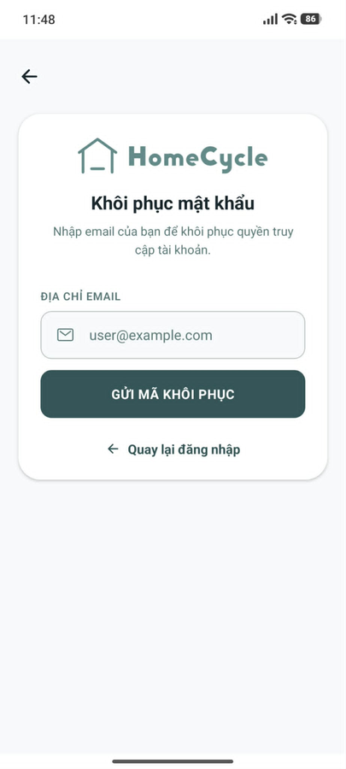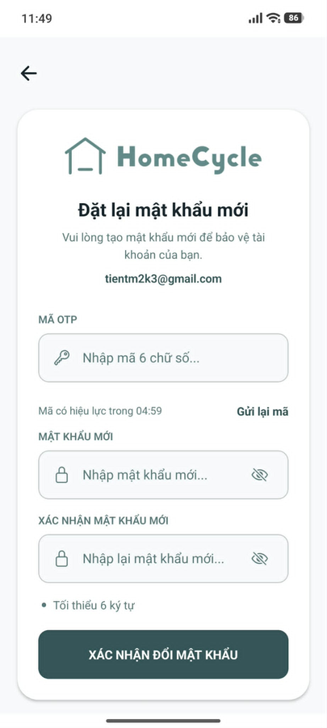
Figure 4: Forgot Password screens

3.2.5 Manage Profile
Function trigger: When a logged-in user opens Profile, or opens Account Info, changes the information and taps “Xác nhận chỉnh sửa”.
Function description: Allows the user to view the account overview (rating, reputation score, active posts, wallet shortcut) and update basic information and the payout bank account.
Function details:
Normal Flow:
- The user opens Profile; the system shows the profile summary and the account menu.
- The user opens Account Info and changes username, full name, phone number or avatar.
- The user taps “Xác nhận chỉnh sửa”.
- The system validates and saves the data, then shows “Cập nhật thông tin thành công.”
Alternative Flows:
A1 – Update bank account:
- The user selects a bank and enters the account number and account holder name, then taps “Xác nhận chỉnh sửa”.
- The system checks that the holder name matches the verified identity name and shows the masked account number.
Exception Flows:
E1 – Invalid data:
- The system shows the field message, e.g., “Số điện thoại phải bắt đầu bằng 02, 03, 05, 07, 08 hoặc 09.”, “Vui lòng chọn ngân hàng và điền đủ số tài khoản, tên chủ tài khoản.”
E2 – Nothing changed:
- The system shows “Không có thông tin nào bị thay đổi.”
Screen layout:
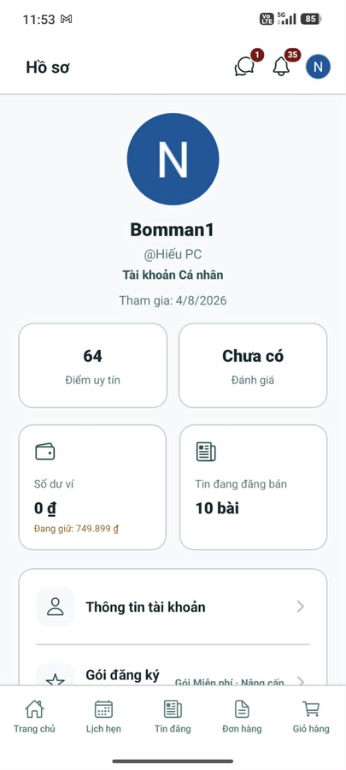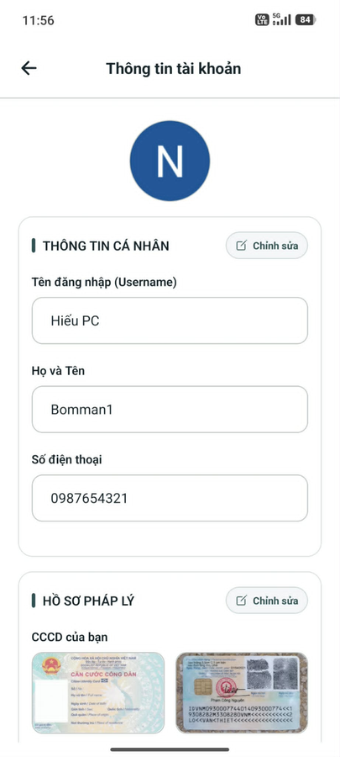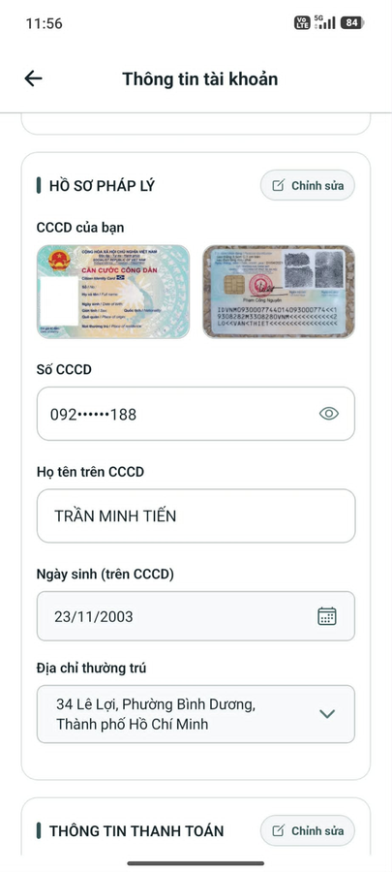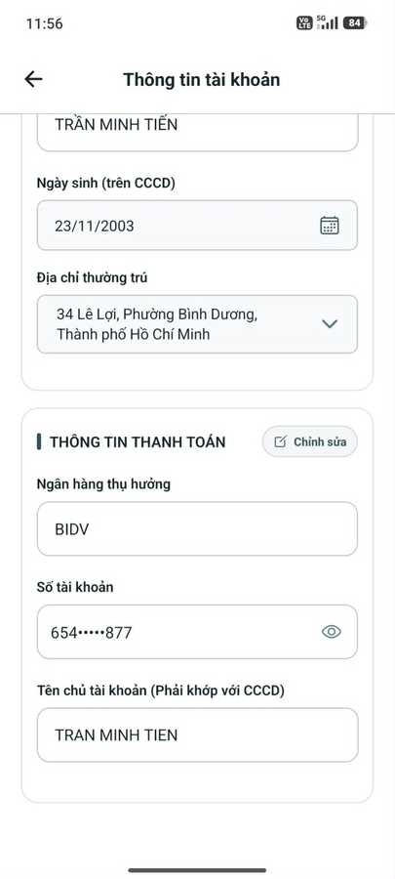
Figure 5: Manage Profile screens

3.2.6 Verify Identity (CCCD)
Function trigger: When a personal user reaches Verification Setup during registration, or edits the identity section on Account Info and taps “Xác nhận chỉnh sửa”.
Function description: Allows a personal user to submit citizen ID information so that the account can trade and receive payouts.
Function details:
Normal Flow:
- The user enters the citizen ID number, full name, date of birth and permanent address.
- The user uploads the front and back images of the ID and submits.
- The system validates and stores the identity information, then shows the “Đã xác thực” status on Profile after verification.
Exception Flows:
E1 – Invalid identity data:
- The citizen ID is not 12 digits, a field is missing or an ID image is missing.
- The system shows “Số CCCD phải gồm đúng 12 chữ số.” or “Vui lòng cung cấp đủ mặt trước và mặt sau CCCD.”
E2 – Upload failed:
- The system shows “Không thể lưu thay đổi. Vui lòng kiểm tra lại thông tin và thử lại.” and keeps the entered data.
Screen layout:
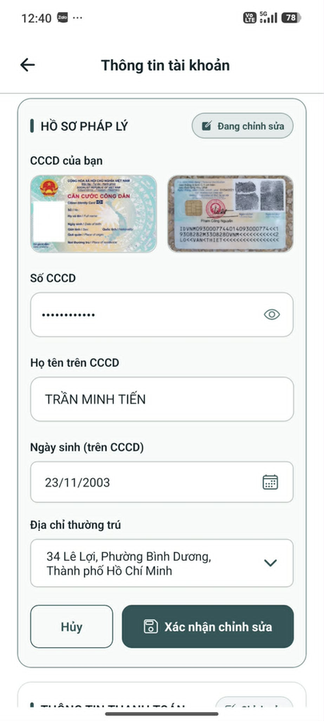
Figure 6: Verify Identity (CCCD) screen

3.3 Personal Functions

3.3.1 Create Post
Function trigger: When a logged-in user taps “Đăng tin bán ngay” on Home (or the create button on Manage Posts), fills in the form and taps “Đăng tin mới”.
Function description: Allows a user to publish a sell post for a used household item.
Function details:
Normal Flow:
- The user opens Create Post and selects the category and product type; the system loads the attributes of that product type.
- The user enters the title, description, specifications, condition and 1–5 images.
- The user enters the price and quantity, chooses the delivery method (“Người bán tự giao”, “Người mua đến lấy” or “Giao hàng (GHN)”) and the address.
- The user taps “Đăng tin mới”; the system validates the data, uploads the images and creates the post.
- The system redirects to Manage Posts, where the new post is listed.
Alternative Flows:
A1 – Suggest price with AI:
- The user taps “Gợi ý giá với AI”; the system returns a reference price range that the user may apply or ignore.
- If no suggestion can be made, the system shows “Chưa thể tạo giá tham khảo. Bạn vẫn có thể nhập giá thủ công.”
Exception Flows:
E1 – Invalid data:
- A required field is missing, no image is selected, more than 5 images are selected, or the GHN weight/size is out of limit.
- The system highlights the field and shows e.g. “Vui lòng nhập tên sản phẩm.”, “Vui lòng chọn ít nhất 1 ảnh.”, “GHN chỉ hỗ trợ khối lượng sản phẩm tối đa 50 kg.”
E2 – System error:
- The system shows “Không thể lưu bài đăng lúc này.” and keeps the entered data for retry.
Screen layout:
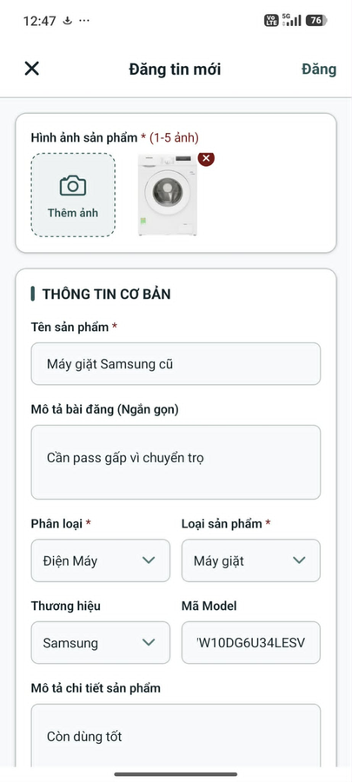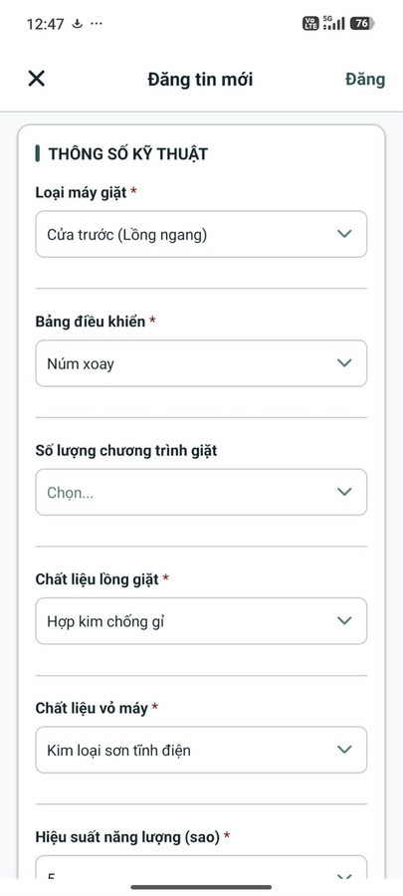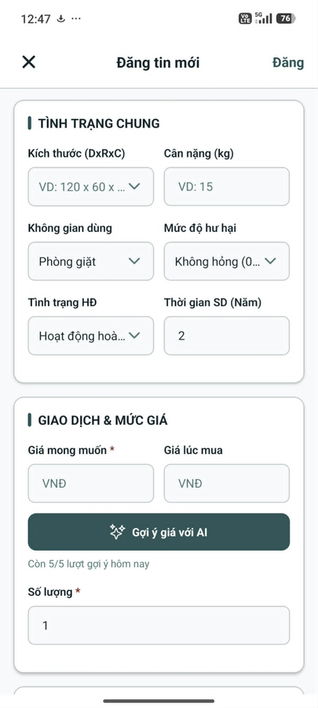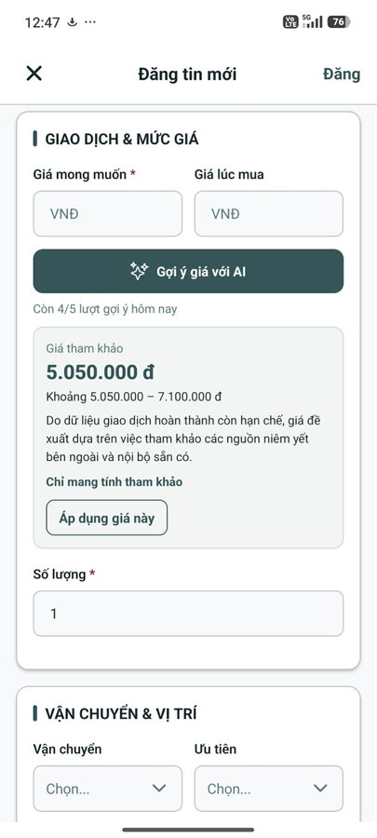
Figure 7: Create Post screens

3.3.2 Manage Posts
Function trigger: When a logged-in user opens the Posts tab (Manage Posts) and taps “Sửa tin đăng”, “Đóng bài” or “Mở lại” on a post.
Function description: Allows the owner to view their posts by status, edit a post, and close or reopen it.
Function details:
Normal Flow:
- The user opens Manage Posts; the system lists the posts with status filters “Tất cả”, “Đang hoạt động”, “Đã đóng”.
- The user taps “Đóng bài” and confirms; the system shows “Đã đóng bài đăng.” and hides the post from the public.
- The user taps “Mở lại” on a closed post that still has quantity and confirms; the system shows “Đã mở lại bài đăng.”
Alternative Flows:
A1 – Edit post:
- The user taps “Sửa tin đăng”; the system opens the form pre-filled with the post data.
- The user changes the information and taps “Cập nhật”; the system validates with the Create Post rules and saves the post.
Exception Flows:
E1 – Post cannot be reopened:
- The post is sold out; the system hides the “Mở lại” action.
E2 – System error:
- The system shows “Không thể tải danh sách bài đăng.” / “Không thể đóng bài đăng lúc này.” and keeps the post status unchanged.
Screen layout:
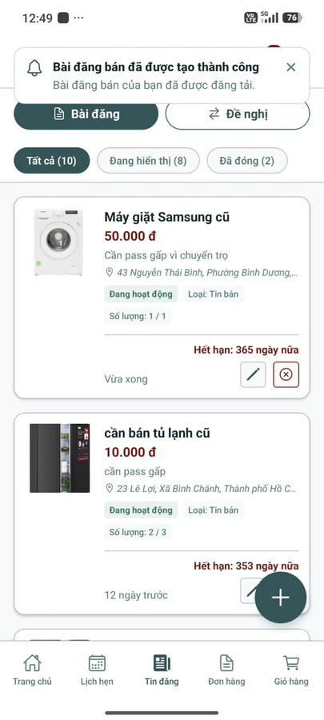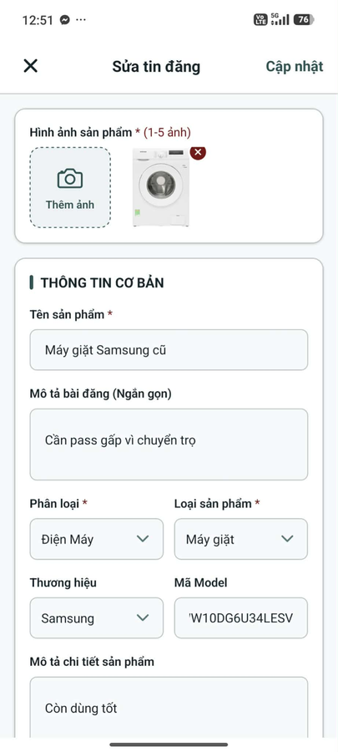
Figure 8: Manage Posts screens

3.3.3 Search and Filter Posts
Function trigger: When a user taps the search bar, enters a keyword and/or sets filters in “Lọc chi tiết” and taps “Áp dụng tìm kiếm”.
Function description: Allows Guests and members to find posts by keyword and narrow the results with filters.
Function details:
Normal Flow:
- The user enters a keyword or picks one from “Lịch sử tìm kiếm”.
- The user opens “Lọc chi tiết” and sets the filters (category, product type, condition, price range, delivery method, province) and the sort order.
- The user taps “Áp dụng tìm kiếm”; the system returns the matching posts.
- The user taps a post to open View Post Detail, or taps “Thiết lập lại” to clear the filters.
Exception Flows:
E1 – No result:
- The system shows the empty result state.
E2 – Filter data cannot be loaded:
- The system shows “Không thể tải bộ lọc mở rộng. Bạn vẫn có thể dùng các bộ lọc khác.”
Screen layout:
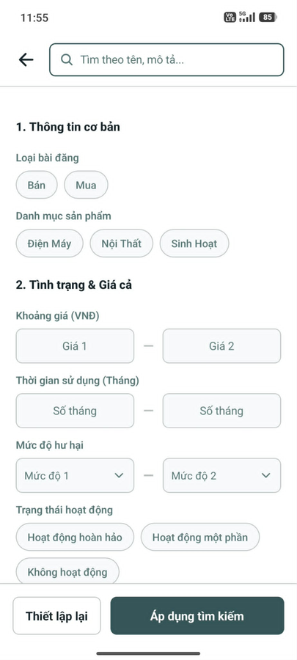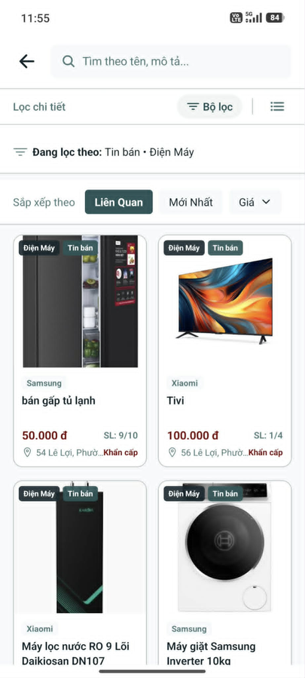
Figure 9: Search and Filter Posts screens

3.3.4 View Post Detail
Function trigger: When a user taps a post card on Home, Search Posts, Manage Posts, the cart or a notification.
Function description: Shows the full information of a post and the actions available to the current user.
Function details:
Normal Flow:
- The user opens a post; the system shows images, price, remaining quantity, condition, specifications, location and the owner’s rating.
- For a member, the system shows “Thương lượng giá”, “Thêm vào giỏ hàng” and “Báo cáo bài đăng”.
- For the owner, the system shows “Sửa tin đăng”, “Đóng bài đăng” / “Mở lại tin” and “Đề nghị đã nhận”.
Exception Flows:
E1 – Guest uses a member action:
- The system redirects to User Login and returns to the post after login.
E2 – Post not available:
- The system shows “Bài đăng này hiện không còn hoạt động.” or “Sản phẩm này hiện đã hết số lượng.” and disables the offer action.
Screen layout:
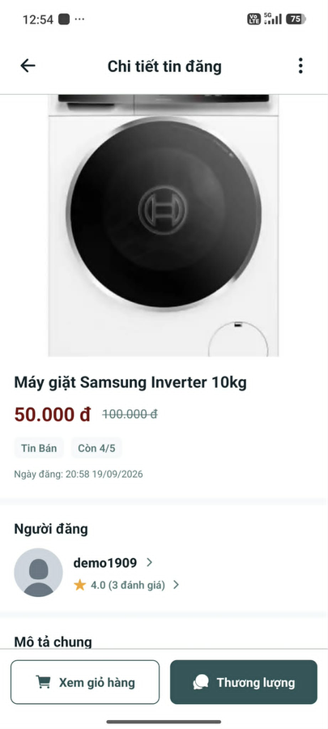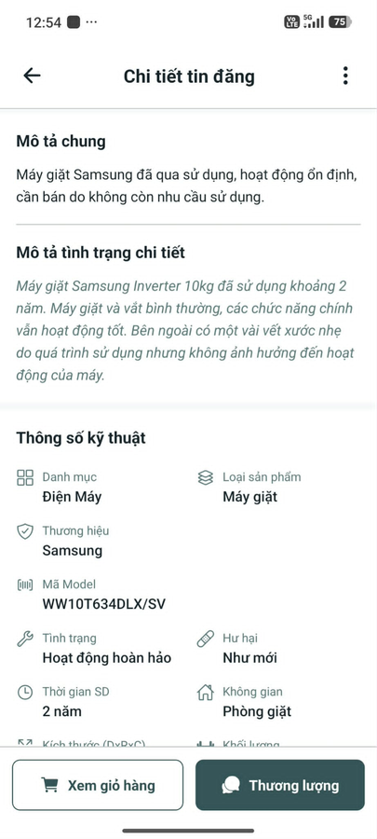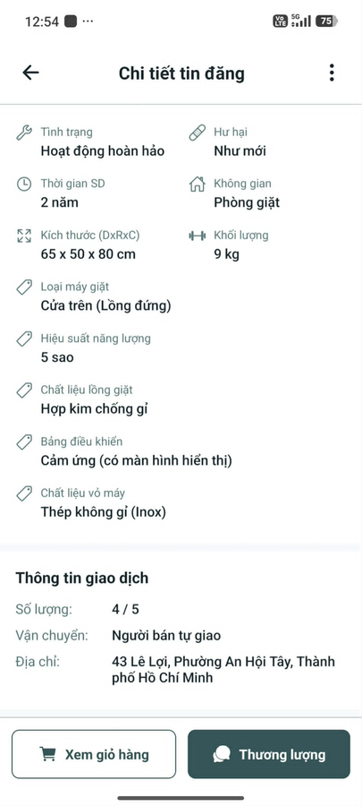
Figure 10: View Post Detail screens

3.3.5 Manage Cart
Function trigger: When a logged-in user taps “Thêm vào giỏ hàng” on a sell post, or opens the Cart tab and removes an item.
Function description: Allows the user to save sell posts to revisit and negotiate later.
Function details:
Normal Flow:
- The user taps “Thêm vào giỏ hàng”; the system adds the post and offers “Xem giỏ hàng”.
- The user opens View Cart List; the system lists the saved posts with their current availability.
- The user removes an item and confirms; the system shows “Đã xóa sản phẩm khỏi giỏ hàng.”
Exception Flows:
E1 – Post cannot be added:
- The system shows “Bạn không thể thêm bài đăng của chính mình vào giỏ hàng.” or “Tin thu mua không thể thêm vào giỏ hàng.”
E2 – Saved post no longer available:
- The system marks the item “Sản phẩm hiện không khả dụng”.
Screen layout:
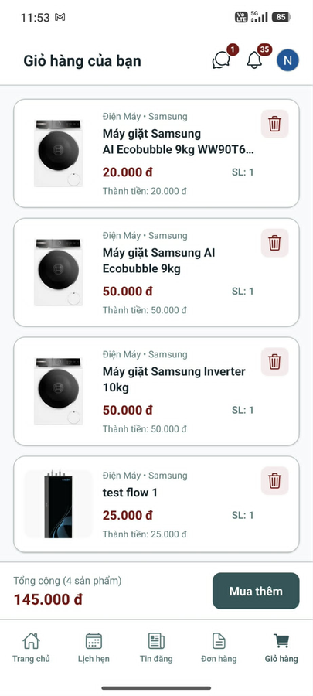
Figure 11: Manage Cart screen

3.3.6 Send Offer
Function trigger: When a logged-in user taps “Thương lượng giá” on a sell post, enters the quantity and price and taps “Gửi đề nghị”.
Function description: Allows a buyer to propose a price and quantity to the seller, or a personal seller to offer an item to a business’s buy post.
Function details:
Normal Flow:
- The user taps “Thương lượng giá”; the system opens the Send Offer Modal.
- The user enters the quantity and proposed price and taps “Gửi đề nghị”.
- The system creates the offer and notifies the seller, then shows “Đã gửi đề nghị thương lượng.”
Alternative Flows:
A1 – Send seller request to a buy post:
- A personal user taps “Chào bán sản phẩm” on a business’s buy post.
- The user selects one of their sell posts, enters the quantity and price and taps “Gửi chào bán”.
- The system creates the request, notifies the business and shows “Đã gửi chào bán sản phẩm.”
Exception Flows:
E1 – Invalid quantity or price:
- The system shows “Số lượng phải là số nguyên lớn hơn 0.” or “Giá thương lượng phải lớn hơn 0.”
E2 – Post not accepting offers:
- The system shows “Bài đăng này hiện không còn hoạt động.” or “Tin thu mua đã đủ số lượng cần mua.”
Screen layout:
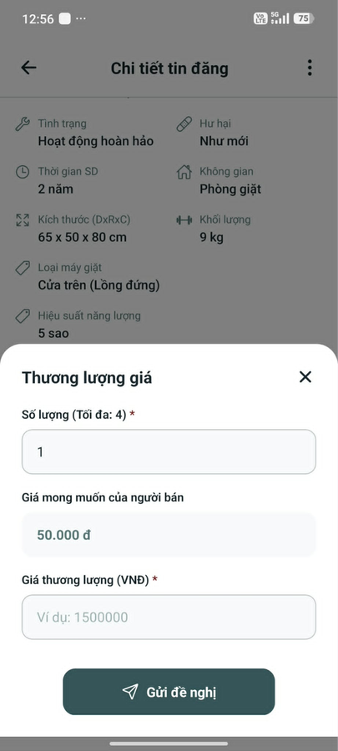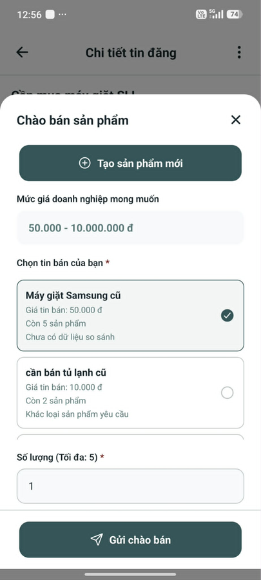
Figure 12: Send Offer screens

3.3.7 Manage Offers
Function trigger: When a user opens the “Đề nghị” section on Manage Posts and selects the “Đã gửi” or “Đã nhận” tab, or opens “Đề nghị đã nhận” on their post.
Function description: Allows the sender to follow, update or cancel sent offers, and the post owner to accept, reject or counter received offers.
Function details:
Normal Flow:
- The user opens the “Đã gửi” tab; the system lists sent offers with status (“Đang chờ phản hồi”, “Đã chấp nhận”, “Đã từ chối”, “Đã hủy”).
- The user opens an offer on View Offer Detail and taps “Chỉnh sửa” to change price/quantity, or “Hủy đề nghị” to withdraw it.
- The system saves the change and shows “Đã cập nhật đề nghị.” or “Đã hủy đề nghị thương lượng.”
Alternative Flows:
A1 – Respond to received offers:
- The owner opens View Received Offers of a post.
- The owner taps “Đồng ý” and confirms; the system opens Chat Detail for the negotiation.
- Or the owner taps “Từ chối” (“Đã từ chối đề nghị.”), or “Trả giá” with a new price and quantity (“Đã gửi đề xuất giá mới.”).
Exception Flows:
E1 – Offer no longer pending:
- The system shows “Đề nghị này không còn ở trạng thái có thể chỉnh sửa.” and hides the actions.
E2 – Offer changed by the other party:
- The system reloads the offer and shows “Đề nghị đã thay đổi. Vui lòng xem lại thông tin mới nhất trước khi phản hồi.”
Screen layout:
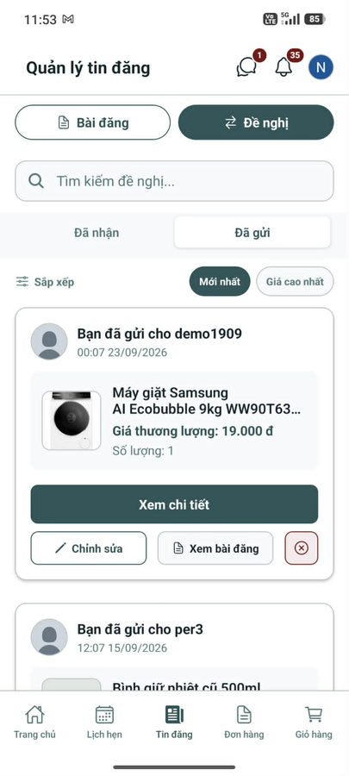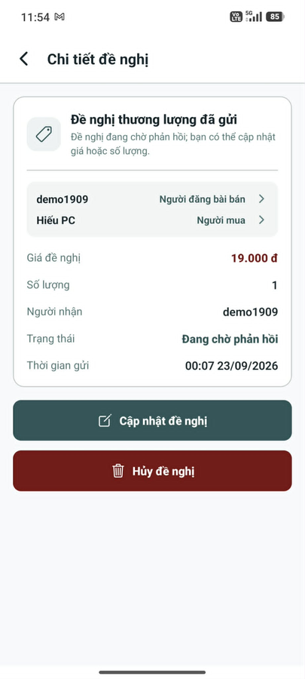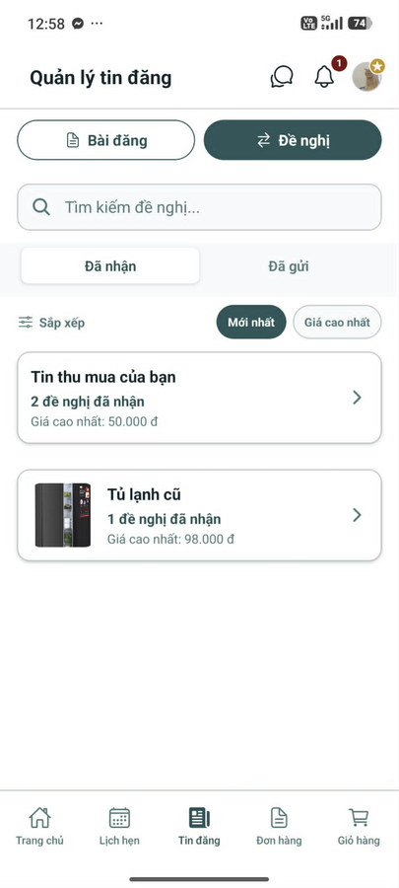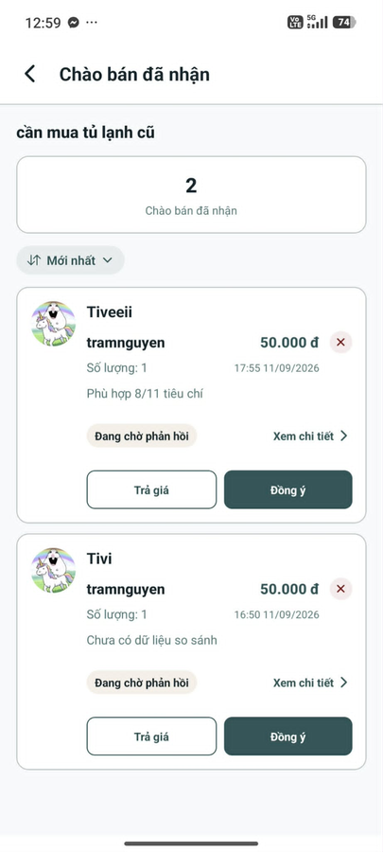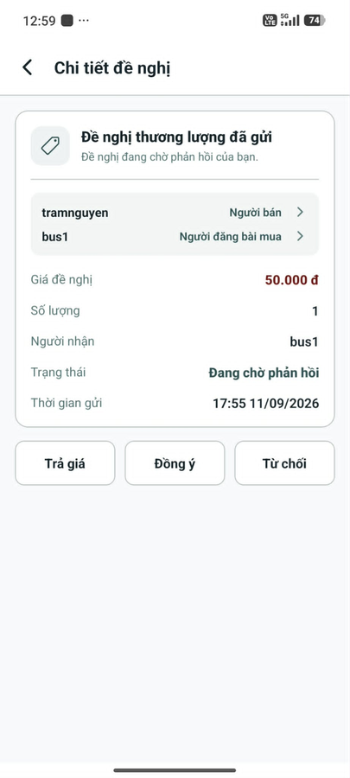
Figure 13: Manage Offers screens

3.3.8 Chat and Negotiate
Function trigger: When a user opens View Chat List and selects a conversation, or opens Chat Detail from an accepted offer, an order or a notification.
Function description: Allows the buyer and seller to negotiate the final price and quantity in real time.
Function details:
Normal Flow:
- The user selects a conversation; the system loads the messages and the negotiation status.
- The user sends a message; the partner receives it in real time.
- The user enters a new price and taps “Gửi đề xuất”; the proposal appears as a card for the partner.
- The partner accepts the proposal; the status becomes “Đã thống nhất” and the seller sees “Tạo hợp đồng”.
Exception Flows:
E1 – Invalid price proposal:
- The system shows “Vui lòng nhập mức giá hợp lệ.”
E2 – Negotiation closed:
- The negotiation was cancelled or completed; the system disables the message box and keeps the history readable.
E3 – Connection lost:
- The system shows “Đang chờ mạng…” and reconnects automatically.
Screen layout:
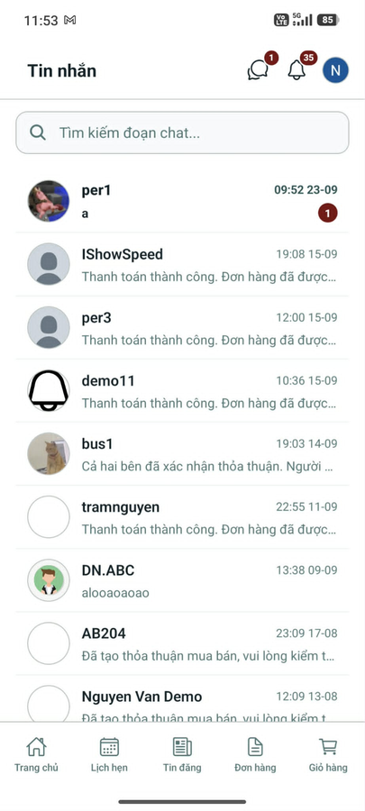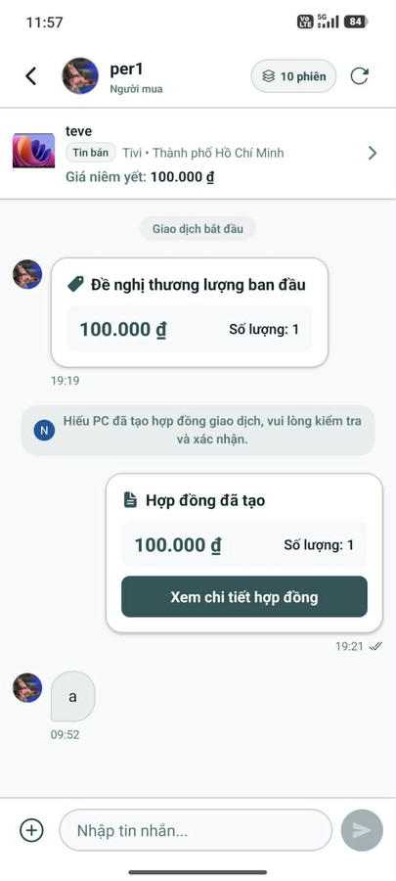
Figure 14: Chat and Negotiate screens

3.3.9 Create and Confirm Agreement
Function trigger: When the seller taps “Tạo hợp đồng” in Chat Detail after the terms are agreed, or the buyer taps “Xem chi tiết hợp đồng” and “Xác nhận hợp đồng”.
Function description: Turns the negotiated terms into a transaction agreement that both parties confirm before payment.
Function details:
Normal Flow:
- The seller taps “Tạo hợp đồng”; the system opens the form with the agreed price and quantity.
- The seller chooses the transaction type (“Có kiểm định trước” or “Không kiểm định (Thu gom)”), the payment type (“Đặt cọc” or “Toàn phần”), the schedule, the delivery method and the addresses, then taps “Tạo hợp đồng”.
- The system creates the agreement and shows “Đã tạo hợp đồng và xác nhận phía người bán.”
- The buyer reviews View Agreement and taps “Xác nhận hợp đồng”; the system shows “Hai bên đã xác nhận hợp đồng. Bạn có thể chuyển sang thanh toán.”
Alternative Flows:
A1 – Delivery by GHN:
- The seller enters the parcel size and weight and taps “Tính phí giao hàng”; the system adds the GHN fee to the agreement.
A2 – Edit agreement:
- The seller taps “Cập nhật thông tin” on an unpaid agreement; the system saves a new revision and the buyer must confirm again.
Exception Flows:
E1 – Invalid schedule or address:
- The system shows e.g. “Thời gian thu gom phải ở tương lai.” or “Địa chỉ người nhận không được giống hoàn toàn địa chỉ người gửi.”
E2 – Agreement has a newer revision:
- The system reloads the agreement and asks the buyer to check it and confirm again.
Screen layout:
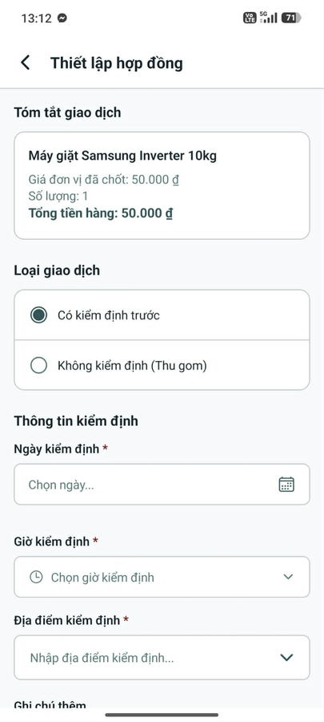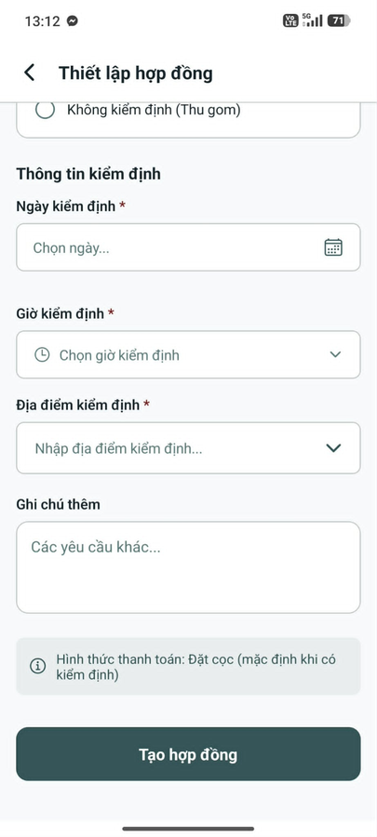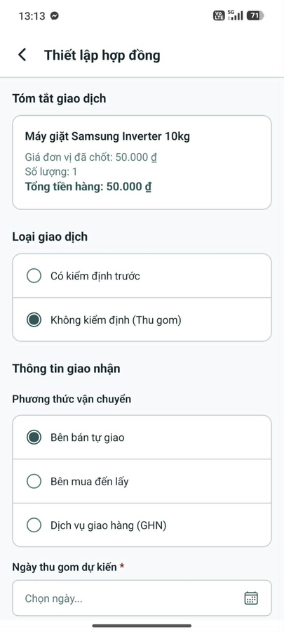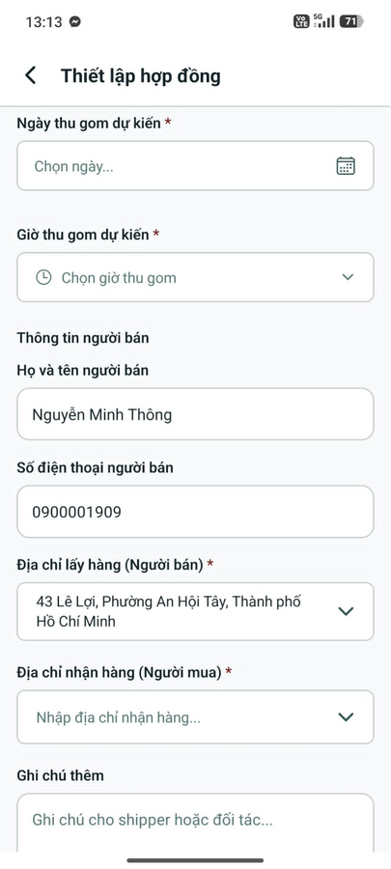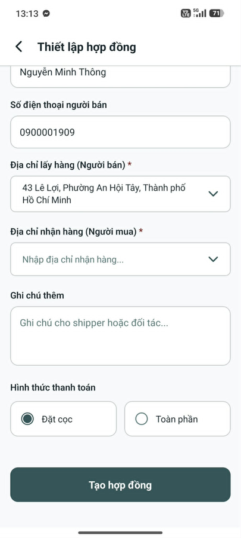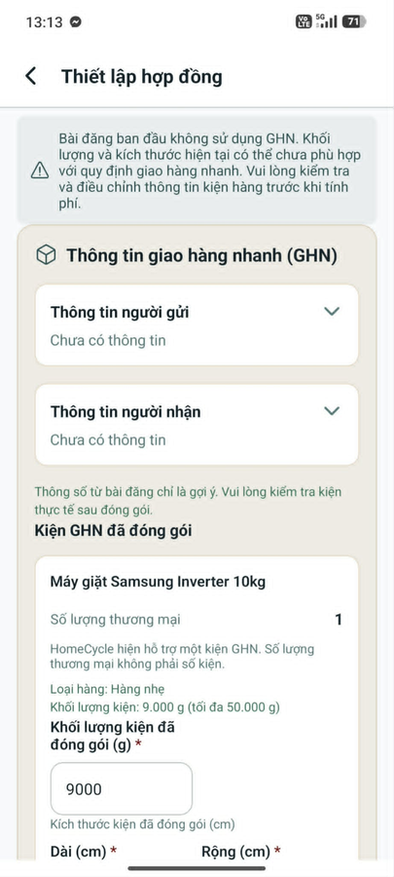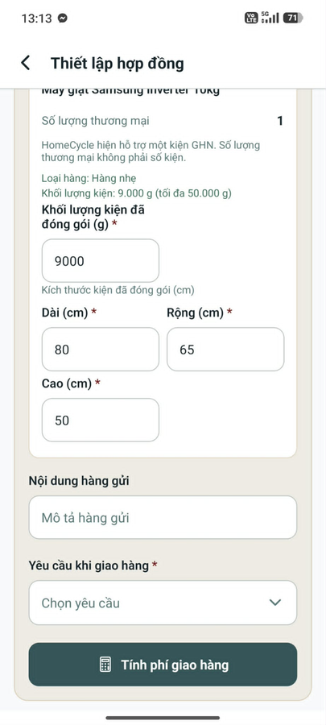
Figure 15: Create and Confirm Agreement screens

3.3.10 Make Payment
Function trigger: When the buyer taps “Đi đến thanh toán” on a confirmed agreement, selects a payment method and taps “Thanh toán”.
Function description: Allows the buyer to pay the deposit or the full amount into escrow, which creates the order (and the appointment).
Function details:
Normal Flow:
- The buyer opens Payment Checkout; the system shows the item value, shipping fee, deposit rate and total.
- The buyer selects “Ví HomeCycle”, ticks “Tôi đã đọc và đồng ý với điều khoản thanh toán.” and taps “Thanh toán”.
- The system debits the wallet, creates the order and shows Payment Success (“Thanh toán thành công!”).
Alternative Flows:
A1 – Pay with PayOS:
- The buyer selects PayOS; the system opens the PayOS page.
- The buyer completes the transfer and is returned to the app; the system verifies the payment and shows Payment Success.
Exception Flows:
E1 – Terms not accepted or balance insufficient:
- The system shows “Vui lòng xác nhận đã đọc và đồng ý với điều khoản thanh toán trước khi tiếp tục.” or disables the wallet option.
E2 – Payment cancelled:
- The system shows Payment Cancel (“Thanh toán đã bị hủy”) with “Thử lại thanh toán”; the agreement remains unpaid.
Screen layout:
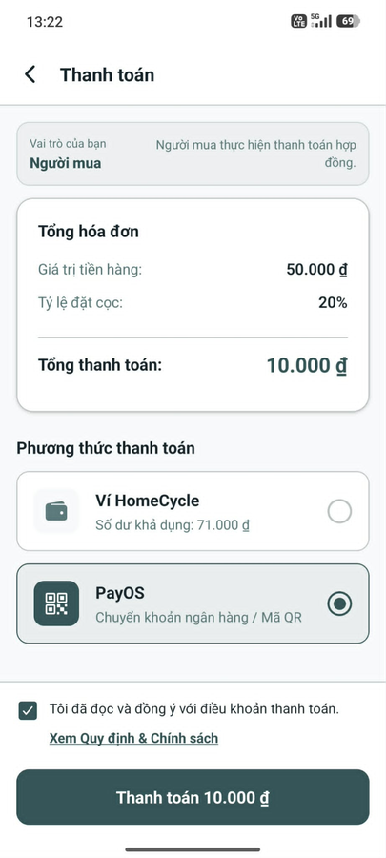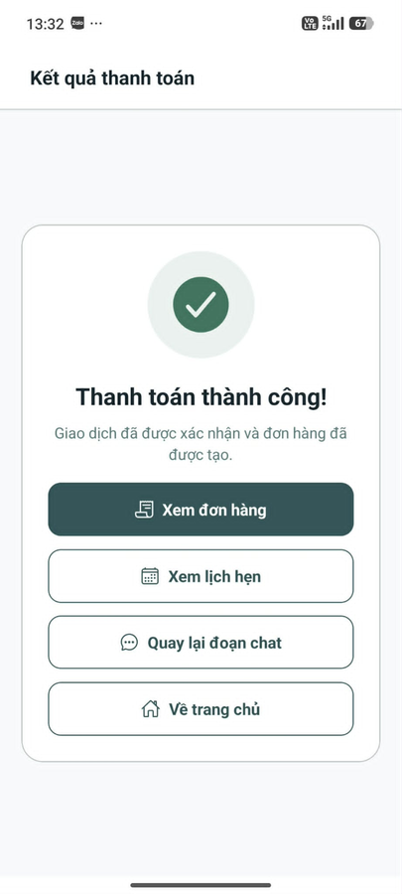
Figure 16: Make Payment screens

3.3.11 Manage Appointments
Function trigger: When a user opens the Appointments tab and taps an appointment, then taps “Xác nhận có mặt tại điểm hẹn”, “Đề xuất đổi lịch hẹn” or “Hủy lịch hẹn”.
Function description: Allows the parties to track inspection and collection appointments, confirm attendance, reschedule or cancel.
Function details:
Normal Flow:
- The user opens View Appointment List; the system shows the weekly calendar (switchable to month) with filters by type and status.
- The user taps an appointment; the system opens View Appointment Detail with time, place, product, partner and status timeline.
- At the meeting, the user taps “Xác nhận có mặt tại điểm hẹn”; the system records the check-in.
Alternative Flows:
A1 – Reschedule appointment:
- The user taps “Đề xuất đổi lịch hẹn”, selects a new date and time and taps “Gửi đề xuất”.
- The partner taps “Xác nhận” or “Từ chối”; the system updates the appointment accordingly.
A2 – Cancel appointment:
- The user taps “Hủy lịch hẹn”, enters the reason and confirms; the system marks the appointment “Đã hủy”.
Exception Flows:
E1 – Invalid time or missing reason:
- The system shows “Thời gian đề xuất phải ở tương lai.” or “Vui lòng nhập lý do hủy lịch hẹn.”
E2 – Appointment closed:
- The appointment is cancelled, completed or overdue; the system hides the actions and shows the status.
Screen layout:
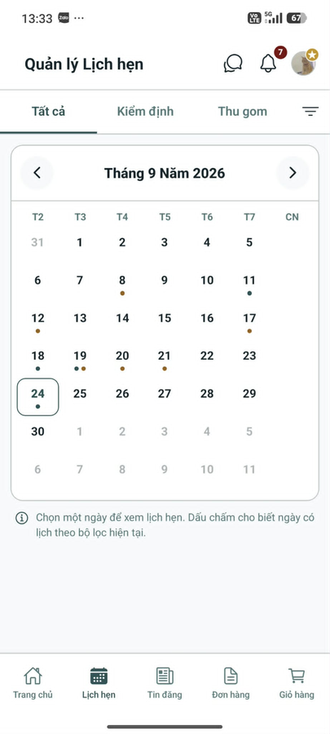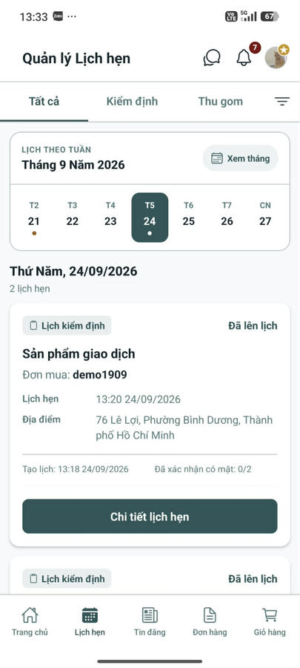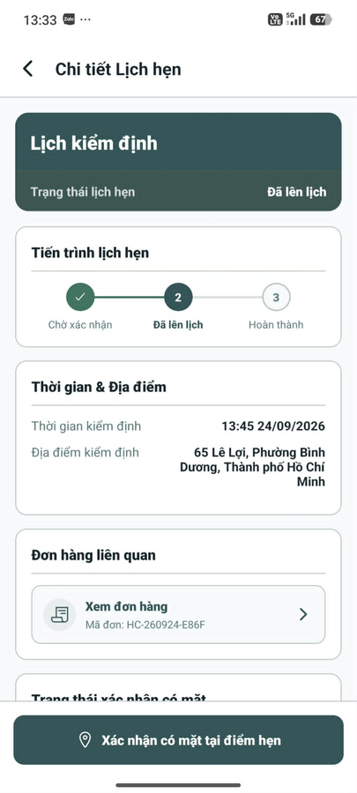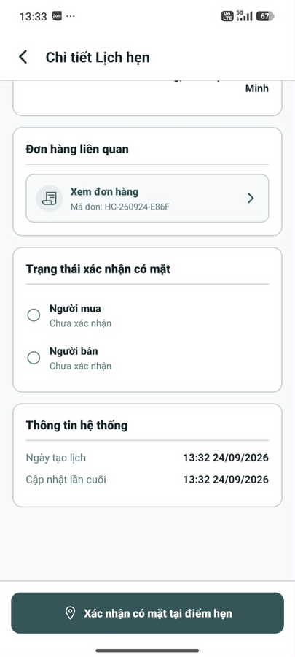
Figure 17: Manage Appointments screens

3.3.12 Inspect Item and Schedule Collection
Function trigger: When the inspecting party opens “Phiếu kiểm định” on an ongoing inspection appointment, fills in the checklist and taps “Gửi kết quả kiểm định”.
Function description: Allows the buyer to record the item’s actual condition, the seller to accept or reject the result, and both parties to arrange the handover, which creates the order.
Function details:
Normal Flow:
- The inspector completes the checklist (“Tình trạng hoạt động”, “Ngoại quan”, “Bộ phận / phụ kiện”, “Mức độ khớp với mô tả”), adds up to 5 photos and notes.
- The inspector selects the conclusion (“Đạt yêu cầu”, “Đạt, đề xuất điều chỉnh giá” or “Không đạt yêu cầu”) and taps “Gửi kết quả kiểm định”.
- The seller opens the result and taps “Xác nhận kết quả”; the system fixes the final price.
- A party taps “Nhận hàng ngay”, or “Đặt lịch giao nhận” and enters the method, time and places on Inspection Collection.
- The system creates the order and opens View Order Detail.
Alternative Flows:
A1 – Seller rejects the result:
- The seller taps “Từ chối kết quả” and enters the reason (max 500 characters); the transaction does not proceed.
Exception Flows:
E1 – Checklist incomplete:
- The system shows “Vui lòng hoàn thành đầy đủ checklist và chọn kết luận trước khi gửi.”
E2 – Attendance not confirmed:
- The system shows “Cả hai bên cần xác nhận có mặt trước khi gửi kết quả kiểm định.”
Screen layout:
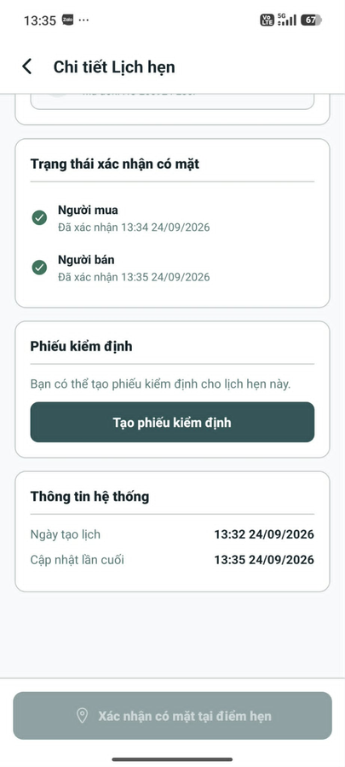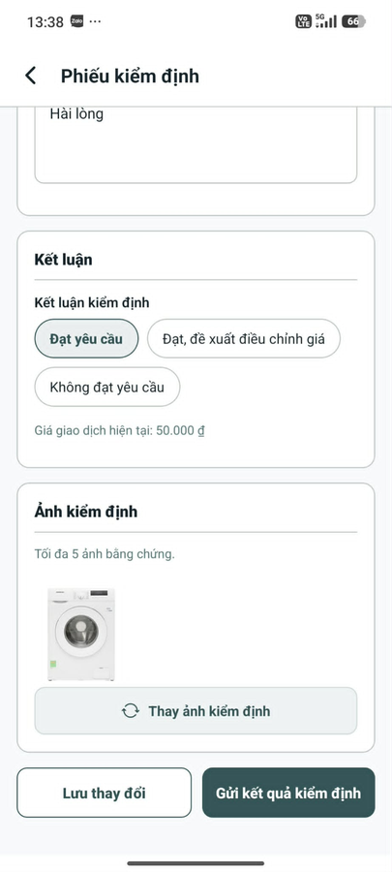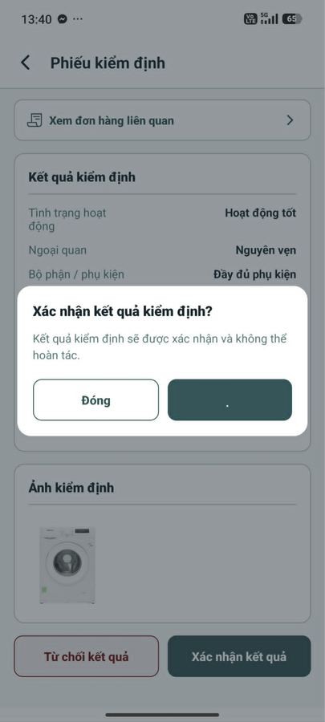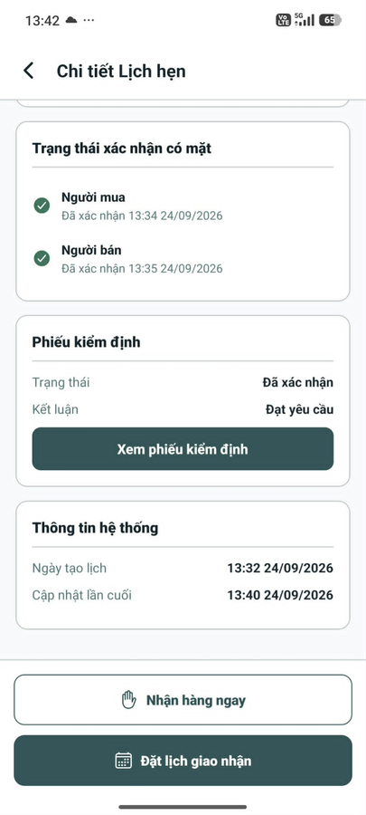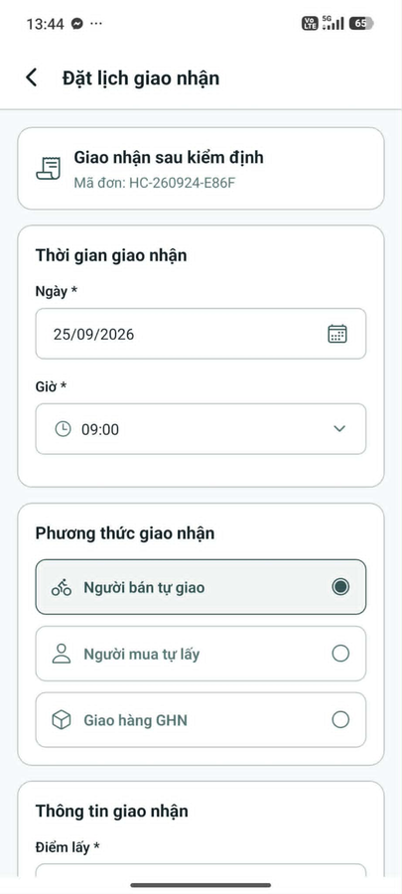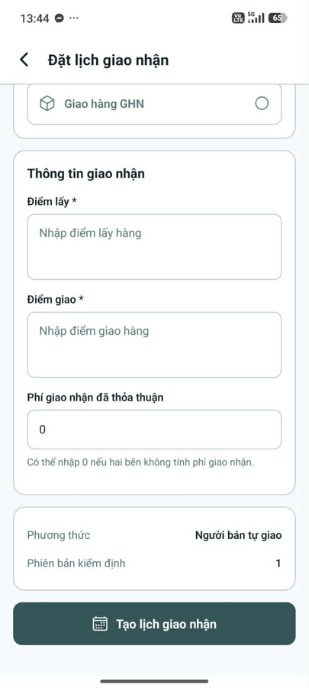
Figure 18: Inspect Item and Schedule Collection screens

3.3.13 Manage Orders
Function trigger: When a user opens the Orders tab, filters the list and taps “Xem chi tiết” on an order.
Function description: Allows the buyer and seller to follow their orders, view payment and delivery tracking, and cancel an order before handover.
Function details:
Normal Flow:
- The user opens View Order List; the system lists orders with tabs “Tất cả”, “Đơn mua”, “Đơn bán” and a status filter.
- The user taps “Xem chi tiết”; the system shows product, partner, payment breakdown, delivery method and status.
- For GHN deliveries, the system shows the waybill code and the latest tracking step.
Alternative Flows:
A1 – Cancel order:
- The user taps “Hủy đơn hàng” and confirms; the system cancels the order, refunds the buyer to the wallet and shows “Đã hủy đơn hàng.”
Exception Flows:
E1 – Order under dispute:
- The system shows “Đơn hàng đang có tranh chấp” with “Xem tranh chấp” and hides the order actions.
E2 – Cancellation not allowed:
- The order was already handed over or completed; the option is not shown.
Screen layout:
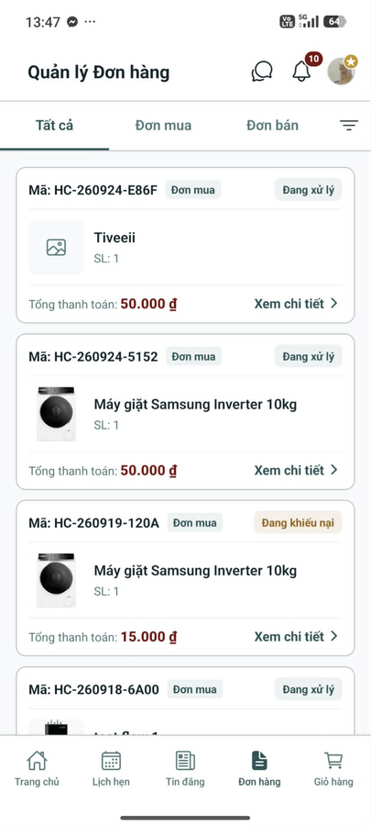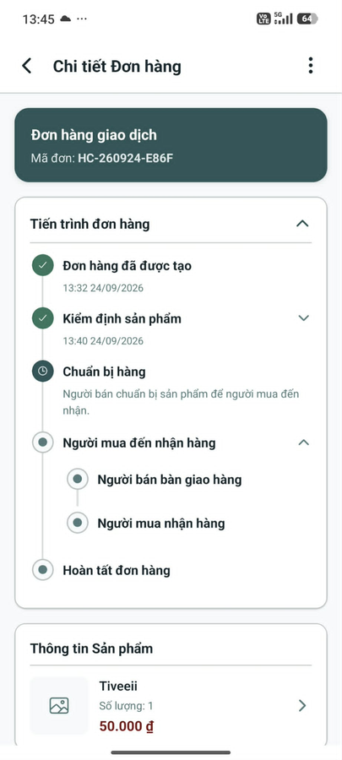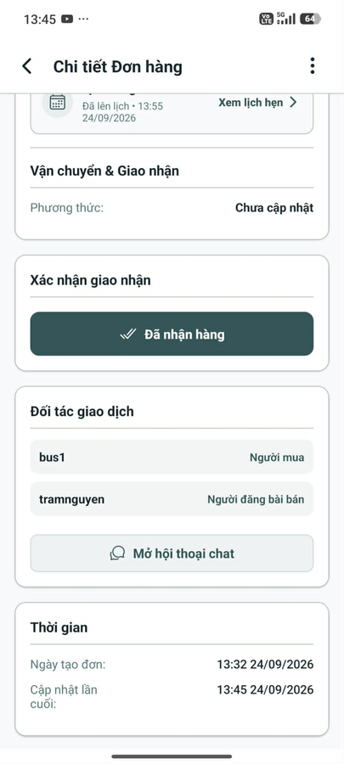
Figure 19: Manage Orders screens

3.3.14 Confirm Handover and Receipt
Function trigger: When the seller taps “Hàng đã sẵn sàng” / “Đã bàn giao hàng”, or the buyer taps “Đã nhận hàng” on View Order Detail.
Function description: Allows both parties to confirm the handover and receipt of the item so the order is completed and the seller is paid from escrow.
Function details:
Normal Flow:
- The seller taps “Hàng đã sẵn sàng”, then “Đã bàn giao hàng” and confirms; for GHN the system creates the waybill.
- The buyer receives the item, taps “Đã nhận hàng” and confirms.
- The system completes the order and shows “Đã xác nhận nhận hàng. Đơn hàng đã được hoàn thành.”; the order now offers “Đánh giá giao dịch”.
Alternative Flows:
A1 – Confirm return:
- After a dispute is resolved with a return, the buyer taps “Xác nhận đã trả hàng”.
- The seller taps “Xác nhận đã nhận lại hàng”; the system refunds the buyer and sets the order to “Đã hoàn trả”.
Exception Flows:
E1 – Action not available:
- The previous step is not done or the order is under dispute; the system shows “Thao tác này hiện không khả dụng.”
E2 – GHN waybill cannot be created:
- The system shows “Chưa thể tạo vận đơn”; the seller can retry from the order.
Screen layout:
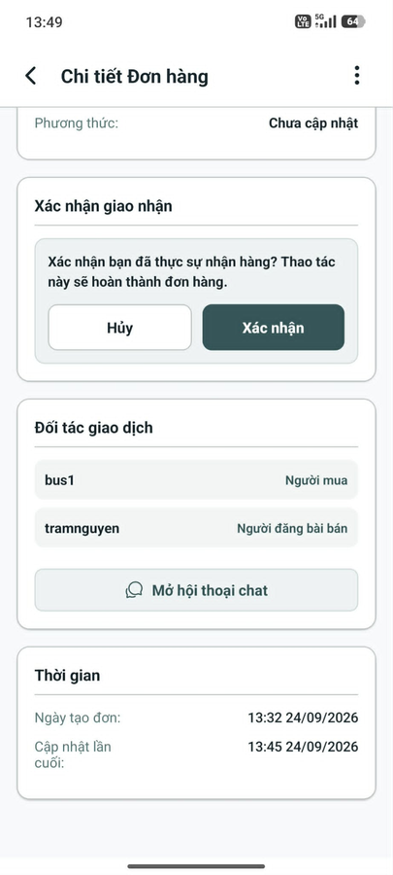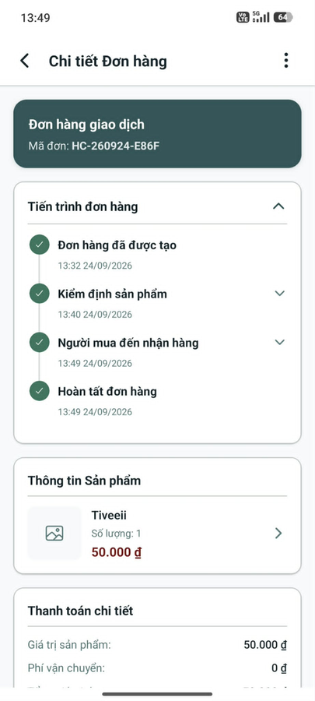
Figure 20: Confirm Handover and Receipt screens

3.3.15 Review Order and View Reviews
Function trigger: When the buyer taps “Đánh giá giao dịch” on a completed order, rates the partner and taps “GỬI ĐÁNH GIÁ”.
Function description: Allows the buyer to rate the transaction partner and all users to view the reviews a user has received.
Function details:
Normal Flow:
- The buyer selects 1–5 stars, writes a comment and adds up to 3 photos.
- The buyer taps “GỬI ĐÁNH GIÁ”; the system saves the review, updates the partner’s rating and shows “Đã gửi đánh giá thành công.”
Alternative Flows:
A1 – View reviews:
- A user opens another user’s profile (or “Đánh giá nhận được” on Profile); the system lists the reviews with stars, comments and photos.
Exception Flows:
E1 – Invalid review:
- The system shows “Vui lòng chọn từ 1 đến 5 sao.” or “Mỗi đánh giá chỉ được đính kèm tối đa 3 ảnh.”
E2 – Order not reviewable:
- The system shows “Chỉ có thể đánh giá sau khi đơn hàng hoàn thành.” or “Bạn đã đánh giá đơn hàng này.”
Screen layout:
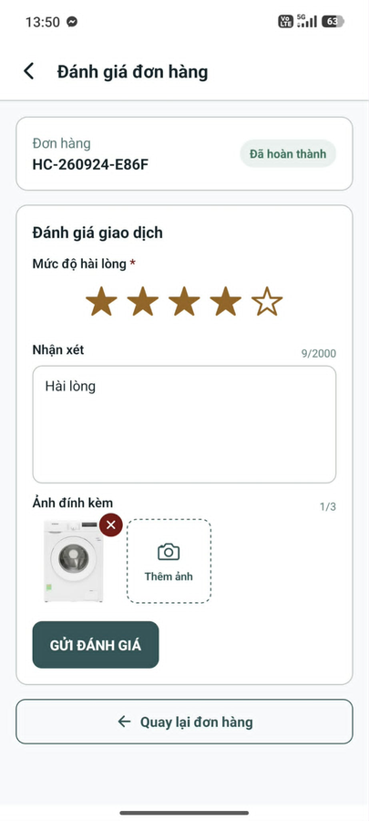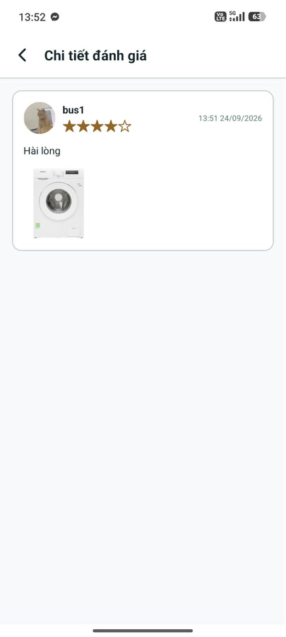
Figure 21: Review Order and View Reviews screens

3.3.16 Report and Dispute
Function trigger: When a party taps “Gửi khiếu nại” on View Order Detail, or a user taps “Báo cáo bài đăng” / “Báo cáo đánh giá”.
Function description: Allows users to open a dispute on an order, or report a post or review, and follow its handling by moderators.
Function details:
Normal Flow:
- The party opens Create Dispute; the system checks the order conditions and loads the dispute types.
- The party selects the type, writes the description, attaches 2–5 evidence photos and taps “Gửi khiếu nại”.
- The system creates the dispute, holds the escrow and opens View Dispute Detail.
Alternative Flows:
A1 – Report post or review:
- The user selects the reason, describes the problem, adds photos and taps “Gửi báo cáo”; the system creates the report for moderators.
A2 – Follow or close a dispute:
- The user opens “Tranh chấp của tôi” to see the status, evidence and “Kết quả xử lý”; the complainant can tap “Đóng tranh chấp”.
Exception Flows:
E1 – Invalid dispute data:
- The system shows “Vui lòng chọn loại khiếu nại.” or “Cần cung cấp từ 2 đến 5 ảnh bằng chứng.”
E2 – Dispute not allowed:
- The system shows “Đơn hàng đã hết thời hạn tạo khiếu nại.” or “Đơn hàng đã có một tranh chấp đang được xử lý.”
Screen layout:
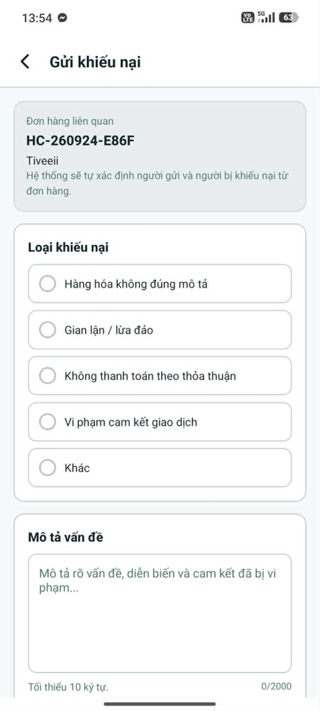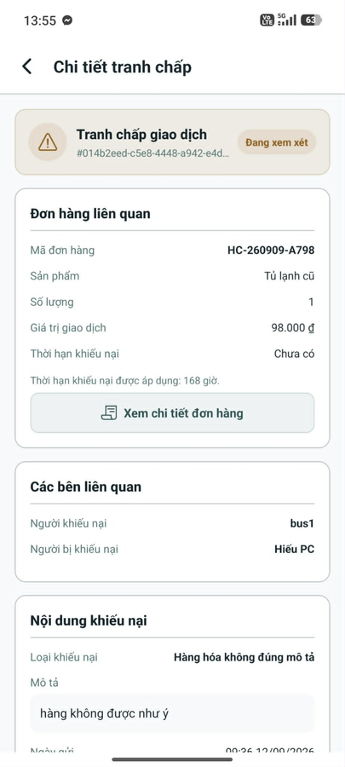
Figure 22: Report and Dispute screens

3.3.17 Wallet and Withdrawal
Function trigger: When a logged-in user taps the wallet shortcut on Profile, or enters an amount and taps “GỬI YÊU CẦU RÚT TIỀN”.
Function description: Allows the user to view balances and wallet movements, request a withdrawal to the bank account and view withdrawal and payment history.
Function details:
Normal Flow:
- The user opens Wallet; the system shows “Số dư khả dụng”, “Tiền đang giữ”, the withdrawal limits and “Biến động ví”.
- The personal user enters the amount and taps “GỬI YÊU CẦU RÚT TIỀN”.
- The system moves the amount to the held balance, creates the request and shows “Đã tạo yêu cầu rút tiền.”
Alternative Flows:
A1 – View history:
- The user taps “Lịch sử rút tiền” or “Xem lịch sử thanh toán”, filters by status or time and opens an entry to see its detail.
Exception Flows:
E1 – Invalid amount:
- The system shows “Số tiền rút vượt quá số dư khả dụng.” or “Bạn đã sử dụng hết số lượt rút tiền trong ngày.”
E2 – Bank account not verified:
- The system shows “Tài khoản ngân hàng chưa được xác thực nên chưa thể rút tiền.”
Screen layout:
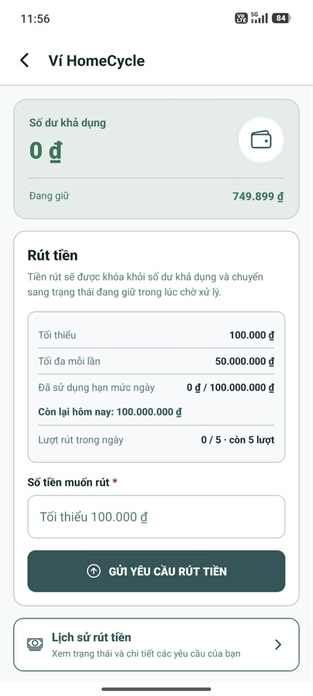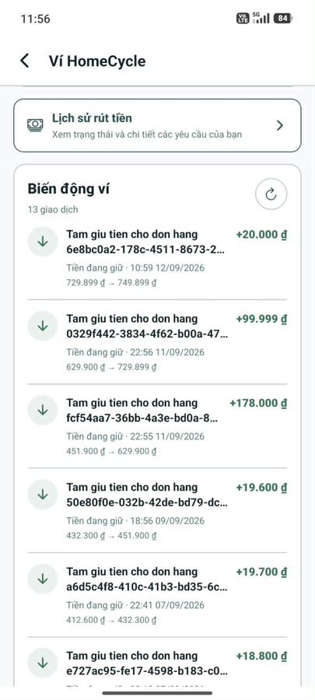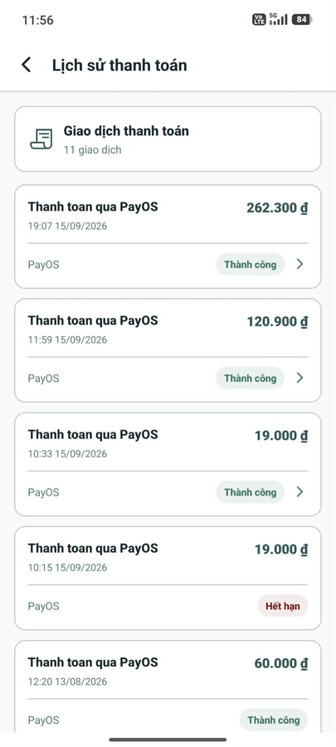
Figure 23: Wallet and Withdrawal screens

3.3.18 Manage Subscription
Function trigger: When a logged-in user opens “Gói đăng ký VIP” from Profile, selects a package and taps “Nâng cấp VIP”.
Function description: Allows the user to upgrade to a VIP package for higher daily AI quotas and advanced filters, or cancel it.
Function details:
Normal Flow:
- The user opens Subscription VIP; the system shows the current plan and the available packages.
- The user selects a package, chooses “Ví HomeCycle” or PayOS and taps “Xác nhận thanh toán”.
- The system activates the package and shows “Thanh toán bằng ví thành công. Gói VIP đã được kích hoạt.”
Alternative Flows:
A1 – Cancel VIP:
- The user taps “Hủy gói VIP” and confirms; the system shows “Đã hủy gói VIP. Quyền lợi VIP kết thúc kể từ bây giờ.”
Exception Flows:
E1 – Pending payment session:
- The system shows “Bạn đang có một phiên thanh toán chưa kết thúc…”
E2 – Payment cancelled or expired:
- The system shows “Bạn đã hủy phiên thanh toán.” or “Phiên thanh toán đã hết hạn. Bạn có thể tạo thanh toán mới.”; the plan remains unchanged.
Screen layout:
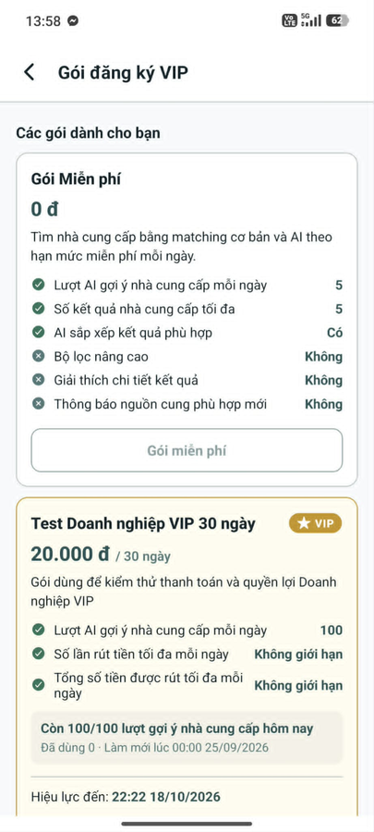
Figure 24: Manage Subscription screen

3.4 Business Functions

3.4.1 Create and Manage Buy Posts
Function trigger: When a business user taps “Đăng tin thu mua” on Home (or the create button on Manage Posts), fills in the purchasing requirement and taps “Đăng tin thu mua”.
Function description: Allows a business to publish a buy post describing what it wants to purchase, and to edit, close, reopen or top up the quantity of its buy posts.
Function details:
Normal Flow:
- The business opens Create Post; the system selects buy mode according to the account role.
- The business enters the title, category, product type and description of the requirement.
- The business enters the required quantity, price range (“Giá tối thiểu” / “Giá tối đa”), priority and location, then taps “Đăng tin thu mua”.
- The system creates the buy post and lists it under “Đang thu mua” on Manage Posts.
Alternative Flows:
A1 – Edit, close or reopen a buy post:
- The business taps “Sửa tin đăng”, “Đóng bài” or “Mở lại” on Manage Posts and confirms; the system updates the post.
A2 – Top up quantity:
- When the target quantity is reached, the business taps “Bổ sung số lượng”, raises the quantity and updates the post.
Exception Flows:
E1 – Invalid requirement:
- The system shows “Vui lòng nhập mô tả cho tin thu mua.”, “Số lượng thu mua tối đa là 99.999.” or “Giá từ không được lớn hơn giá đến.”
E2 – System error:
- The system shows “Không thể lưu bài đăng lúc này.” and keeps the entered data.
Screen layout:
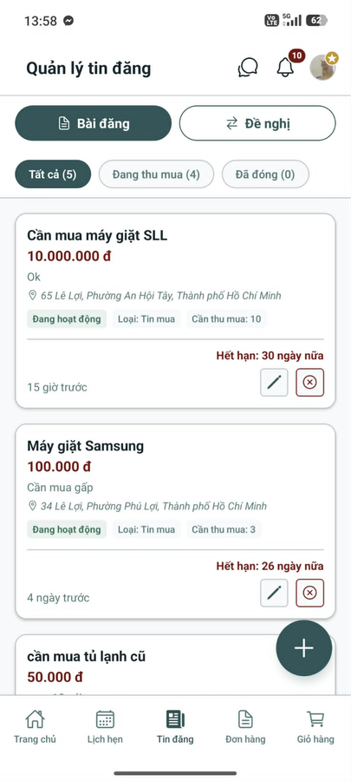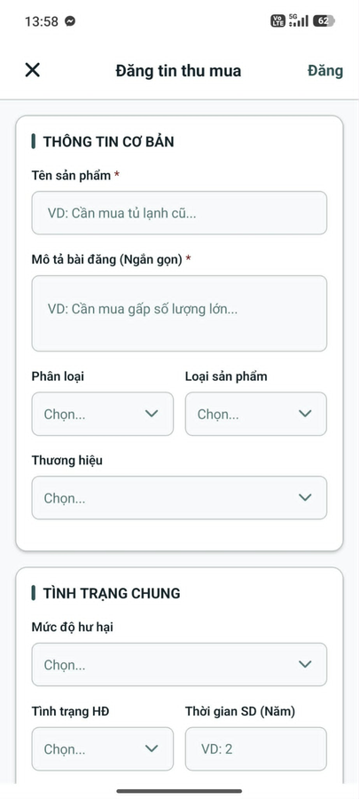
Figure 25: Create and Manage Buy Posts screens

3.4.2 Respond to Seller Requests
Function trigger: When a business user opens “Chào bán đã nhận” on its buy post and taps “Đồng ý”, “Từ chối” or “Trả giá” on a seller request.
Function description: Allows a business to choose which sellers to buy from among the items offered for its buy post.
Function details:
Normal Flow:
- The business opens the received seller requests; the system lists them with the seller, offered item, quantity and price.
- The business taps “Xem bài đăng” to check the offered sell post.
- The business taps “Đồng ý” and confirms; the system opens Chat Detail to negotiate and create the agreement.
Alternative Flows:
A1 – Reject or counter:
- The business taps “Từ chối” (“Đã từ chối đề nghị.”), or “Trả giá” with a new price and quantity (“Đã gửi đề xuất giá mới.”).
Exception Flows:
E1 – No request yet:
- The system shows “Tin thu mua này chưa nhận được chào bán nào từ người bán.”
E2 – Request changed by the seller:
- The system reloads the list and shows “Đề nghị đã thay đổi. Vui lòng xem lại thông tin mới nhất trước khi phản hồi.”
Screen layout:
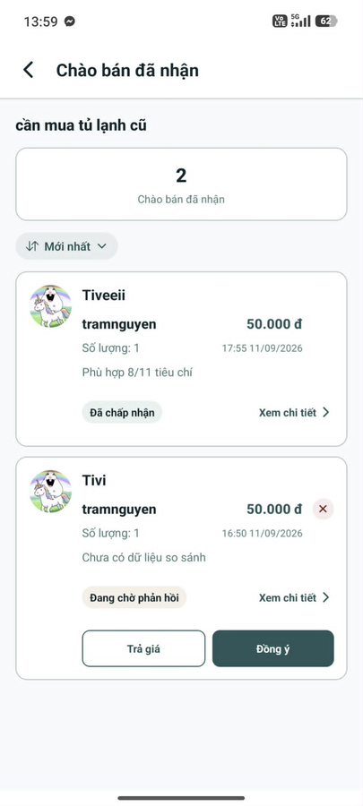
Figure 26: Respond to Seller Requests screen

3.4.3 Find Suppliers with AI
Function trigger: When a business user opens “Gợi ý nhà cung cấp phù hợp” on its buy post (or while creating one) and taps “Gợi ý lại”.
Function description: Allows a business to find matching sell posts with AI, based on its buy post and its purchasing survey.
Function details:
Normal Flow:
- The business opens the supplier suggestion panel and optionally sets “Bộ lọc nâng cao” (VIP).
- The business taps “Gợi ý lại”; the system shows “Đang tìm nhà cung cấp...”.
- The system lists the matching sell posts with the match level (“Phù hợp cao / trung bình / thấp”) and the reasons.
- The business taps “Xem bài bán” to open the sell post and negotiate with the seller.
Alternative Flows:
A1 – Purchasing survey:
- After approval (or from “Khảo sát thu mua” on Profile), the business selects the product types, accepted condition, purchasing scale and provinces.
- The business taps “LƯU KHẢO SÁT THU MUA”; the system shows “Đã lưu khảo sát thu mua.”
A2 – Discover matching sell posts:
- The business opens Home; the system shows the “Phù hợp với nhu cầu” section with sell posts matching the survey.
Exception Flows:
E1 – Daily quota used up:
- The system shows the quota message, or returns basic results with “Gói hiện tại chưa hỗ trợ bộ lọc nâng cao.”
E2 – No matching post:
- The system shows “Chưa tìm thấy bài bán phù hợp với nhu cầu này.”
E3 – AI service unavailable:
- The system shows “Không thể gợi ý nhà cung cấp lúc này. Vui lòng thử lại.”
Screen layout:
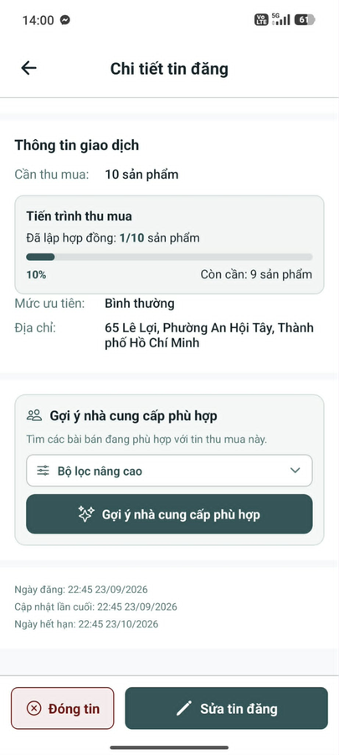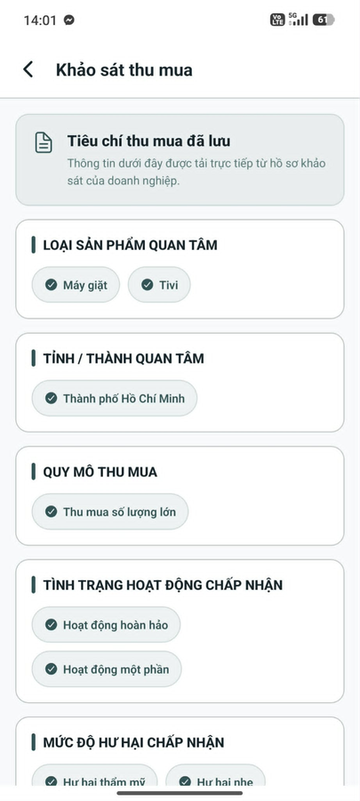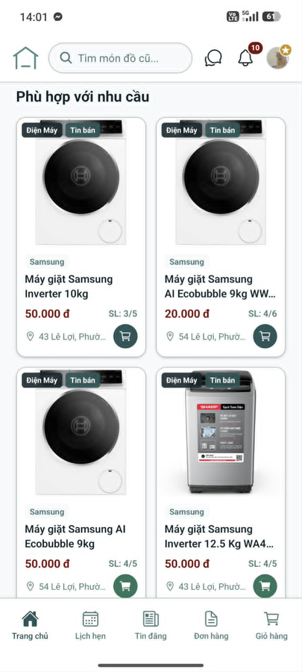
Figure 27: Find Suppliers with AI screens

3.4.4 Manage Business Profile
Function trigger: When a business user opens “Hồ sơ Doanh nghiệp” from Profile, edits a section and taps “Xác nhận chỉnh sửa” or “Lưu khu vực”.
Function description: Allows a business to track the verification of its profile and keep its account, legal, bank and service-area information up to date.
Function details:
Normal Flow:
- While the profile is under review, the business opens Business Pending to view the submitted details.
- After approval, the business opens Business Account Info and edits a section (account, identity, business registration, bank, service areas).
- The business taps “Xác nhận chỉnh sửa” / “Lưu khu vực”; the system saves the section and shows e.g. “Đã cập nhật khu vực dịch vụ.”
Alternative Flows:
A1 – Resubmit a rejected profile:
- The business opens Business Setup and taps “NỘP LẠI HỒ SƠ” (see 3.2.1).
Exception Flows:
E1 – Invalid data:
- The system shows e.g. “Vui lòng nhập mã số thuế.” or “CCCD phải đúng 12 số.”
E2 – Documents not re-uploaded:
- The system shows “Vui lòng tải lại giấy đăng ký kinh doanh khi cập nhật thông tin này.”
Screen layout:
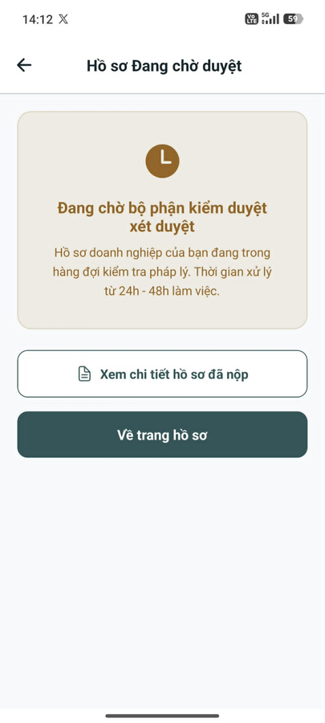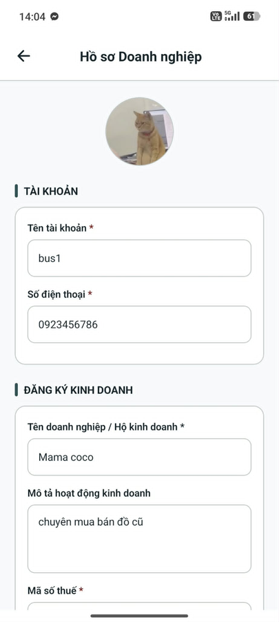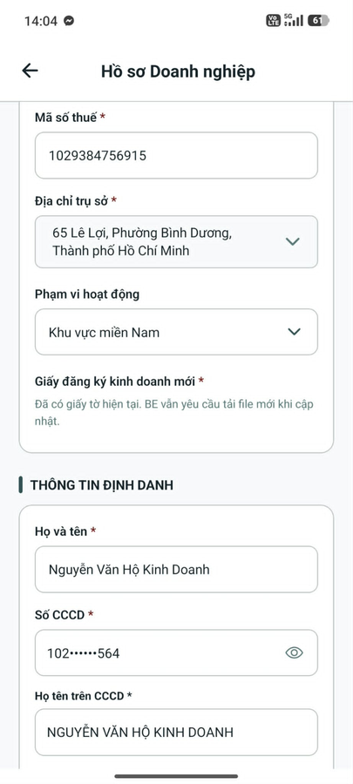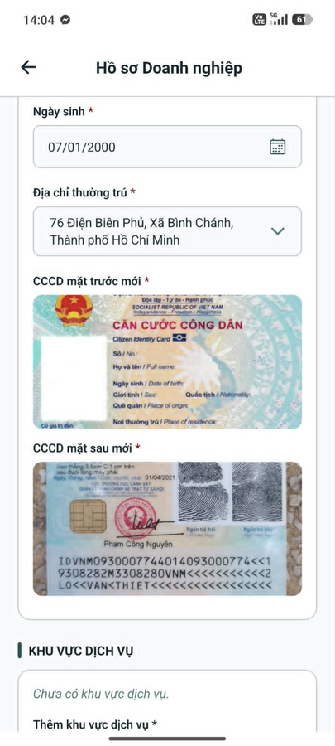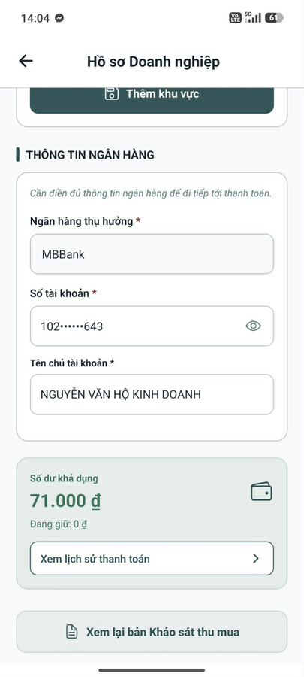
Figure 28: Manage Business Profile screens

3.5 Moderator Functions

3.5.1 Review Verification Requests
Function trigger: When a Moderator opens Verification from the Moderator Dashboard, selects a pending request and clicks “Phê duyệt” or “Từ chối”.
Function description: Allows Moderators to review business and identity (CCCD) verification requests and approve or reject them.
Function details:
Normal Flow:
- The Moderator opens the Moderator Dashboard, which shows the pending moderation work.
- The Moderator opens Verification and selects a pending request; the system shows the submitted information and documents.
- The Moderator clicks “Phê duyệt”; the system marks the profile as verified and notifies the user.
Alternative Flows:
A1 – Reject request:
- The Moderator clicks “Từ chối” and enters the reason.
- The system sets the request to rejected and notifies the user, who can resubmit the profile.
Exception Flows:
E1 – Missing rejection reason:
- The system shows “Vui lòng nhập lý do từ chối” and does not update the request.
E2 – Request already processed:
- The system shows “Yêu cầu này đã được xử lý trước đó” and reloads the list.
Screen layout:
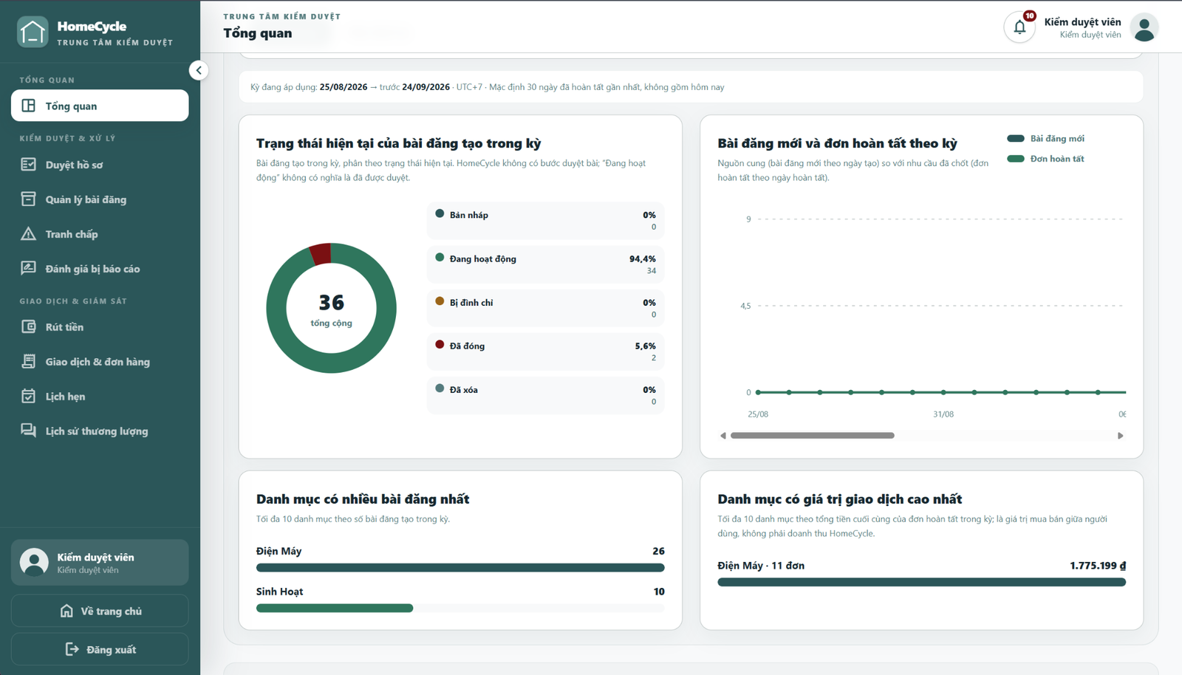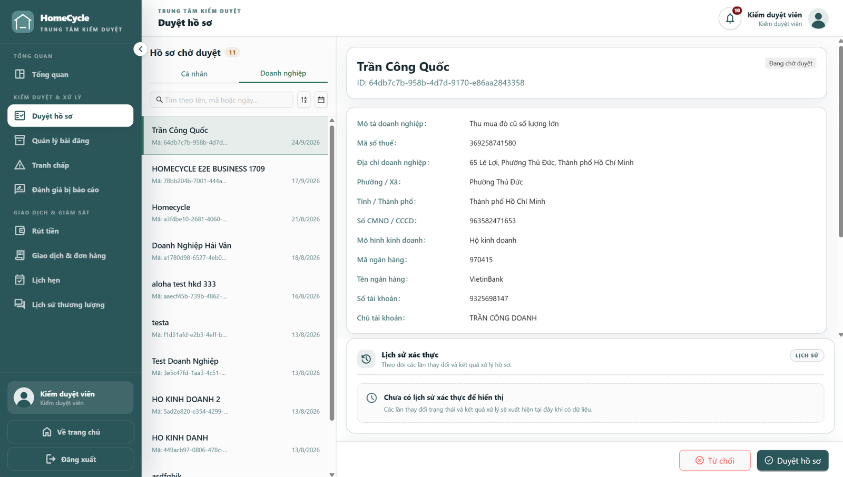
Figure 29: Review Verification Requests screens

3.5.2 Process Withdrawal Requests
Function trigger: When a Moderator opens Withdrawal Management, selects a pending request and approves or rejects it.
Function description: Allows Moderators to check a user’s withdrawal request and bank information and complete or reject the payout.
Function details:
Normal Flow:
- The Moderator opens Withdrawal Management; the system lists withdrawal requests awaiting processing.
- The Moderator selects a request; the system shows the amount, bank account and the user’s wallet information.
- After transferring the money, the Moderator selects Approve & Complete; the system completes the request and notifies the user.
Alternative Flows:
A1 – Reject withdrawal:
- The Moderator selects Reject Withdrawal and enters the reason; the system returns the held amount to the user’s available balance.
Exception Flows:
E1 – Missing rejection reason:
- The system shows “Vui lòng nhập lý do từ chối”.
E2 – Request already processed:
- The system shows “Yêu cầu này đã được xử lý trước đó”.
Screen layout:
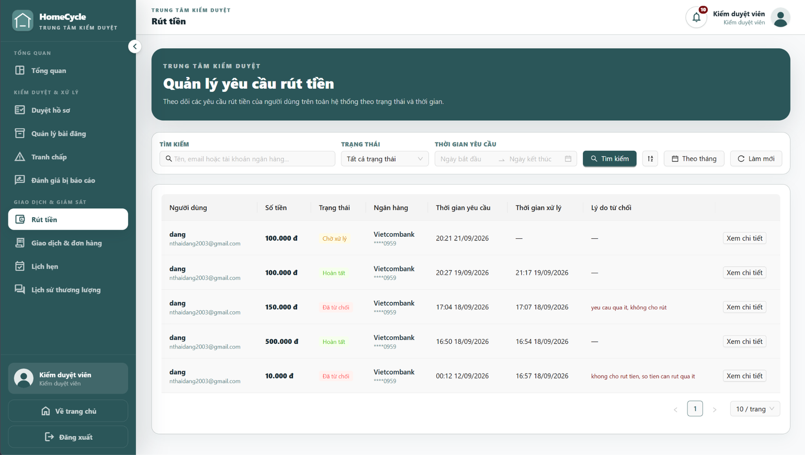
Figure 30: Process Withdrawal Requests screen

3.5.3 Moderate Posts and Reviews
Function trigger: When a Moderator opens Post Moderation or Reported Reviews, selects an item and chooses an action.
Function description: Allows Moderators to handle posts and reviews that violate platform rules, including those reported by users.
Function details:
Normal Flow:
- The Moderator opens Post Moderation; the system lists posts, including reported posts.
- The Moderator opens a post and selects Suspend Post (with a reason) or Send Warning to the owner.
- The system updates the post status and notifies the owner.
Alternative Flows:
A1 – Moderate reported reviews:
- The Moderator opens Reported Reviews and selects a report.
- The Moderator selects Confirm Violation to hide the review, or rejects the report; the system notifies the reporter.
Exception Flows:
E1 – Content no longer exists:
- The post or review was deleted by its owner; the system shows an error and refreshes the list.
Screen layout:
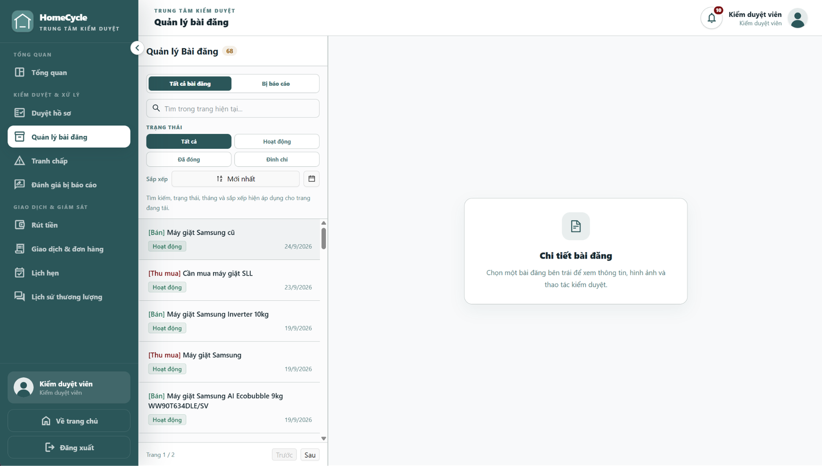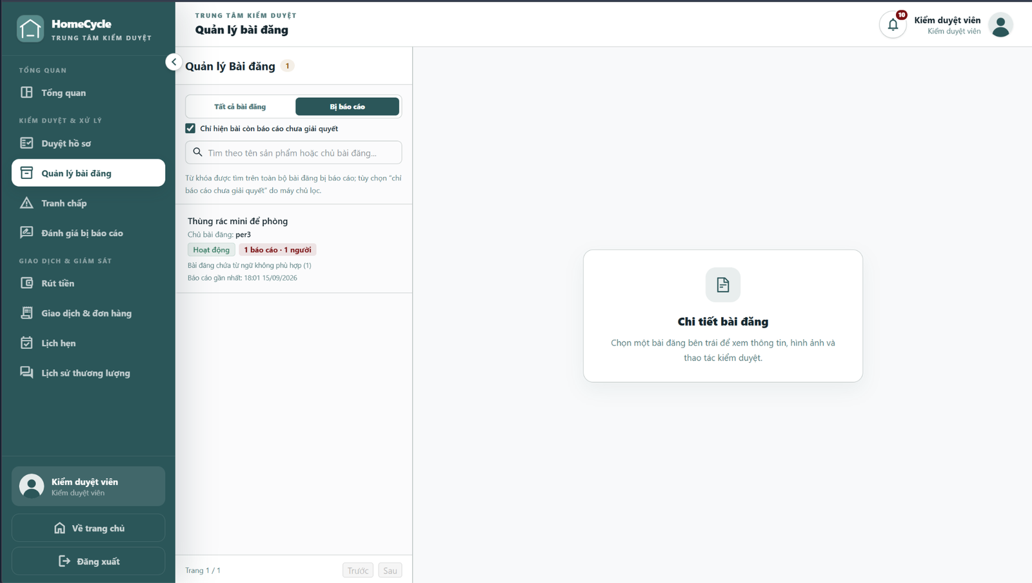
Figure 31: Moderate Posts and Reviews screens

3.5.4 Resolve Disputes
Function trigger: When a Moderator opens Dispute Management, selects a dispute, reviews the evidence and records a decision.
Function description: Allows Moderators to investigate disputes and reports and resolve them in favour of the buyer or the seller.
Function details:
Normal Flow:
- The Moderator opens Dispute Management; the system lists disputes and reports awaiting resolution.
- The Moderator opens a dispute to review the description, evidence photos, related order and negotiation history.
- The Moderator selects Resolve Dispute, chooses the result (for the buyer or for the seller) and enters notes.
- The system updates the dispute and the order, releases or refunds the escrow, and notifies both parties.
Alternative Flows:
A1 – Reject dispute:
- The Moderator selects Reject Dispute and enters a reason; the order continues its normal flow.
A2 – Refund order and monitor transactions:
- From Transactions & Orders, the Moderator opens Order Detail and selects Refund Order to refund the buyer.
- The Moderator can also review appointments and inspection results (Appointment Monitoring) and negotiation history (Negotiation Audit).
Exception Flows:
E1 – Missing decision or notes:
- The system highlights the required fields and does not save the decision.
Screen layout:
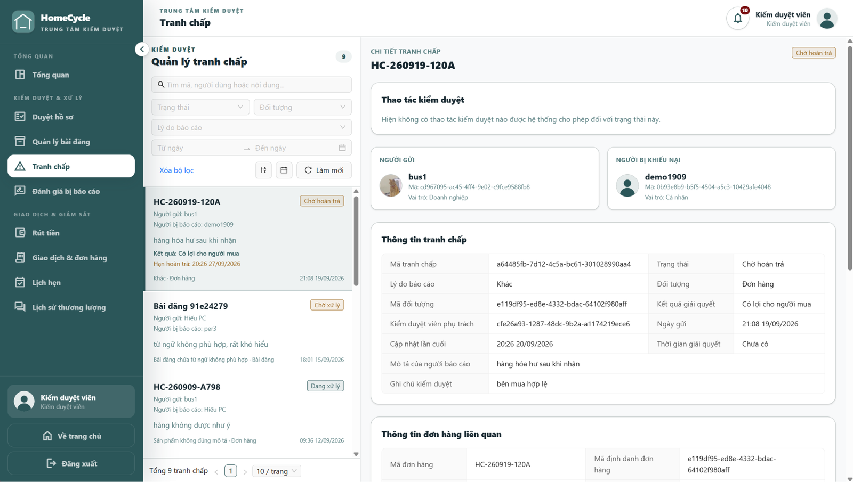
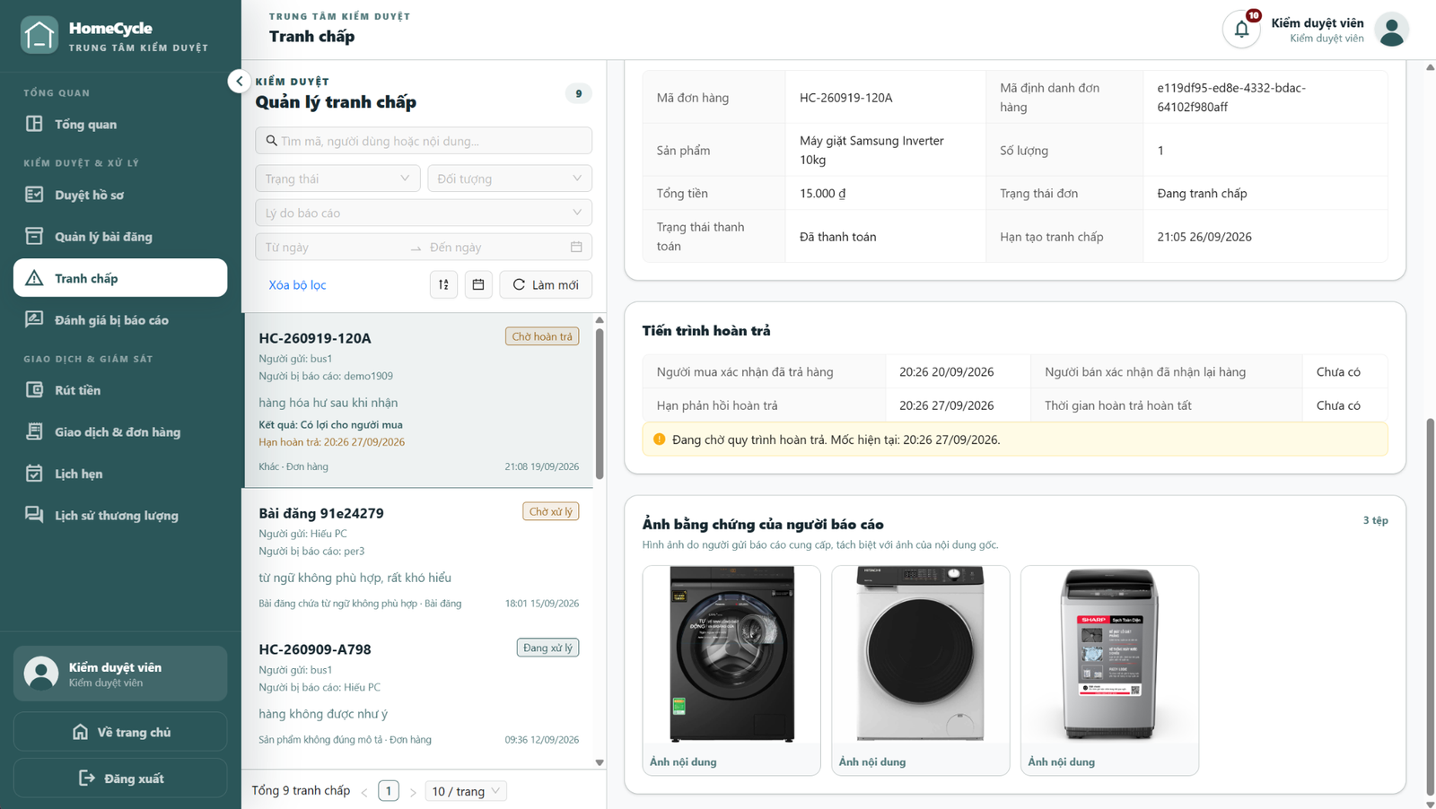
Figure 32: Resolve Disputes screens

3.6 Admin Functions

3.6.1 View System Statistics
Function trigger: When an Admin logs in and opens the Admin Dashboard or one of the Operations Dashboards.
Function description: Allows Admins to monitor system-wide statistics on users, posts, orders, payments, disputes, finance and businesses.
Function details:
Normal Flow:
- The Admin opens the Admin Dashboard; the system shows the key operational statistics.
- The Admin opens a dashboard by area (Payments, Orders, Appointments, Disputes, Users, Posts) and selects the time range.
- The Admin opens Finance Management to view the system wallet, held funds and transaction history.
Alternative Flows:
A1 – Business insights and audit:
- The Admin opens Business Insights to view demand and trading performance of businesses, or Audit Logs to review system activities.
Exception Flows:
E1 – Invalid time range:
- The system highlights the filter and keeps the previous data.
E2 – Data cannot be loaded:
- The system shows an error message with a retry action.
Screen layout:
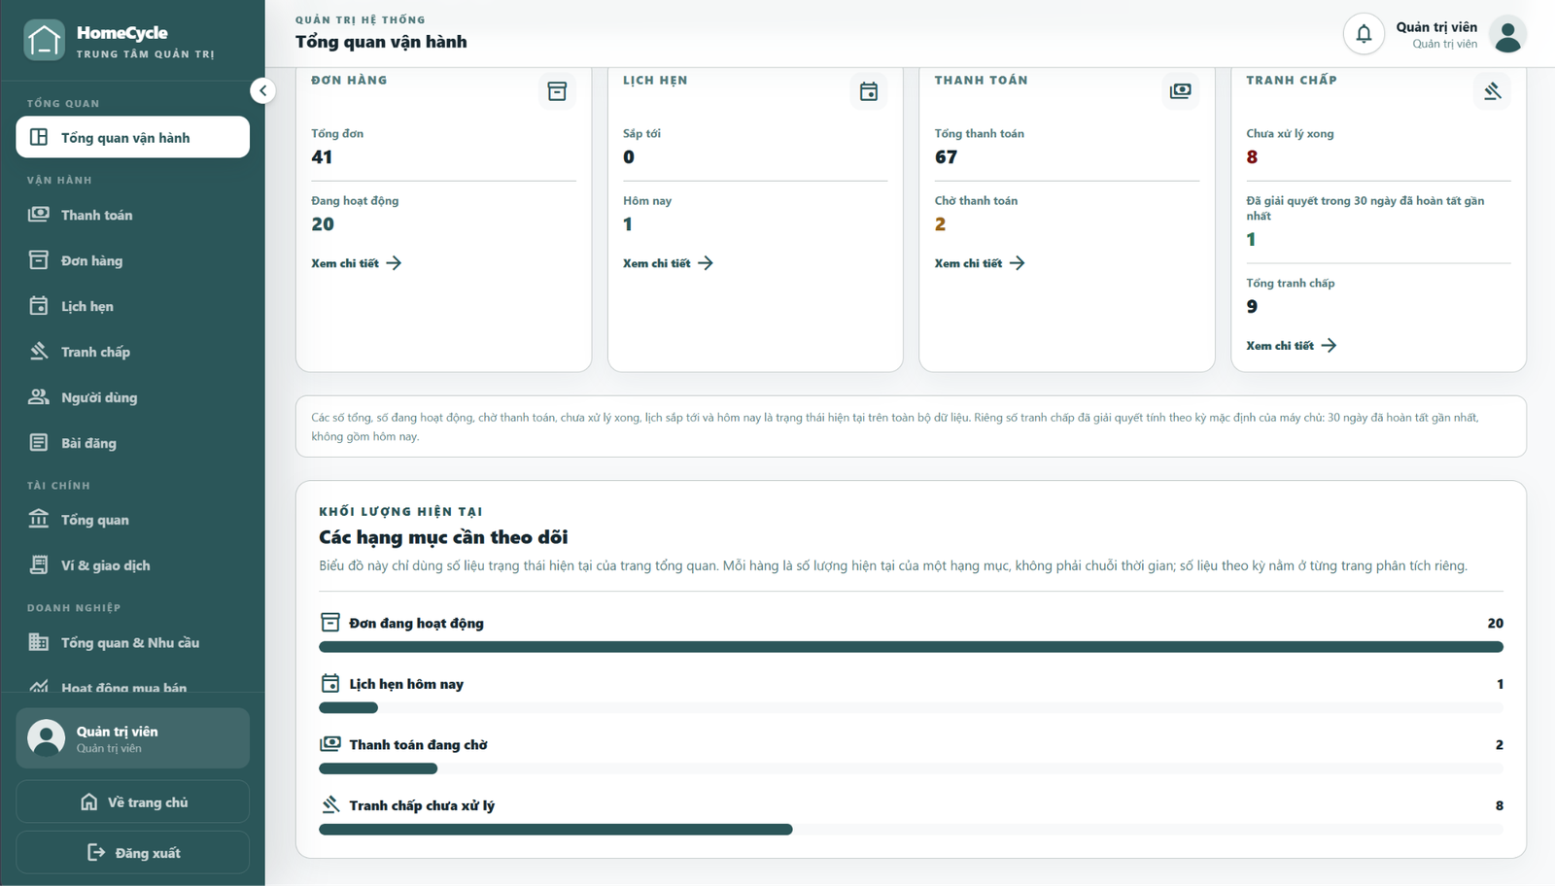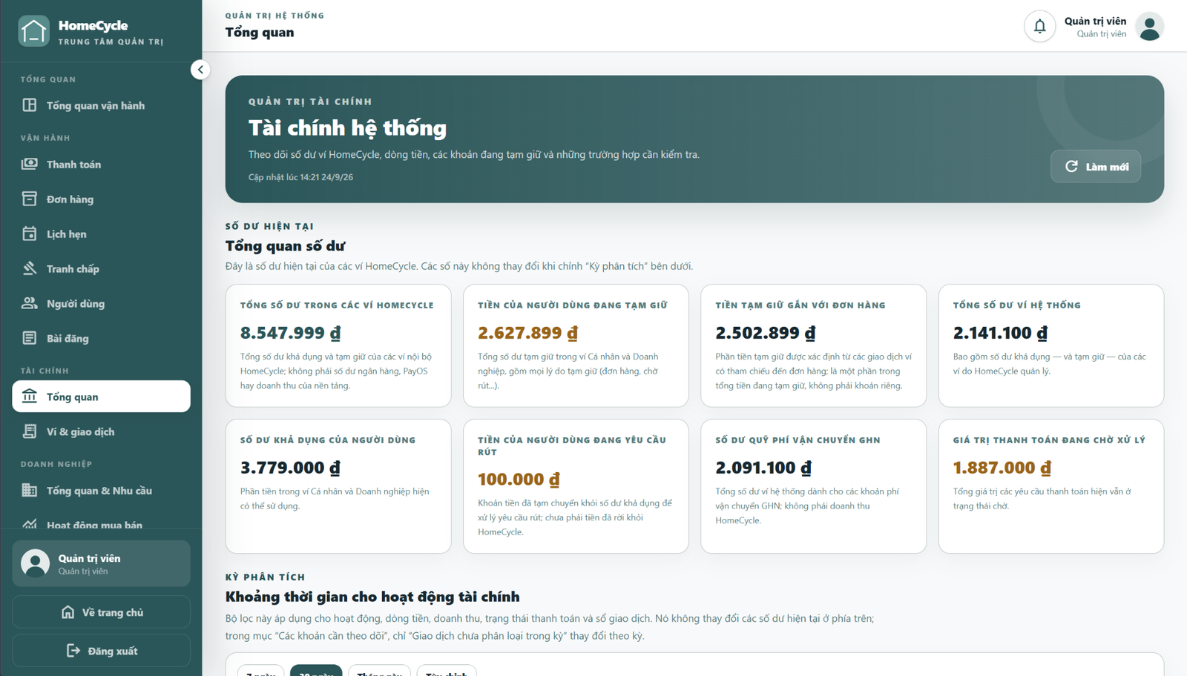
Figure 33: View System Statistics screens

3.6.2 Manage Users
Function trigger: When an Admin opens User Management, searches for an account and chooses an action.
Function description: Allows Admins to view accounts of all roles, create Moderator accounts and lock or unlock accounts.
Function details:
Normal Flow:
- The Admin opens User Management and searches or filters accounts by role and status.
- The Admin selects an account and locks it with a reason (Lock / Unlock Account); the system suspends the account and notifies the user.
- The Admin unlocks a locked account; the system restores the account to active.
Alternative Flows:
A1 – Create Moderator:
- The Admin opens Create Moderator and enters the account information.
- The system creates the account and sends an invitation; the Moderator activates it on Moderator Activate.
A2 – View Moderator detail and history:
- The Admin clicks “Xem chi tiết” on a Moderator to view the profile and moderation activity history.
Exception Flows:
E1 – Invalid account state:
- The account is already locked or already active; the system shows “Tài khoản đã bị đình chỉ” or “Tài khoản đang hoạt động bình thường”.
Screen layout:
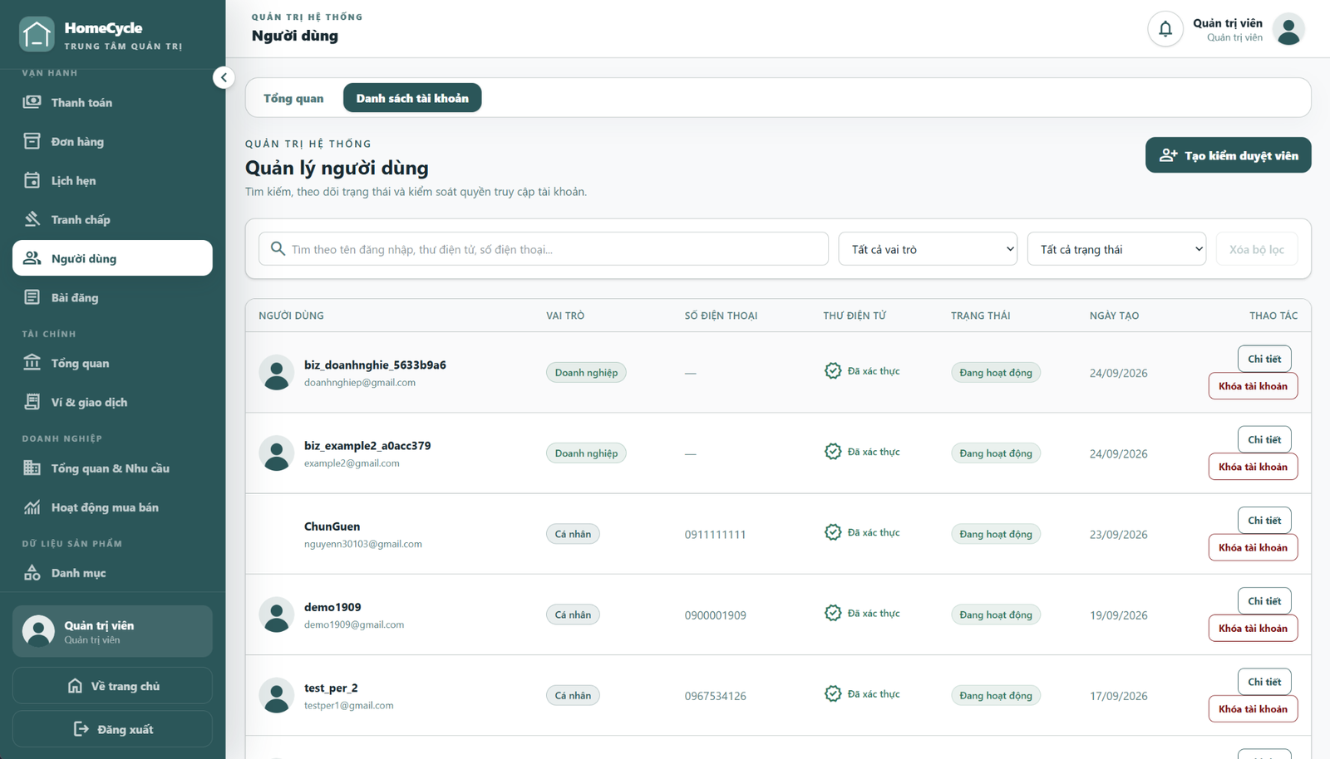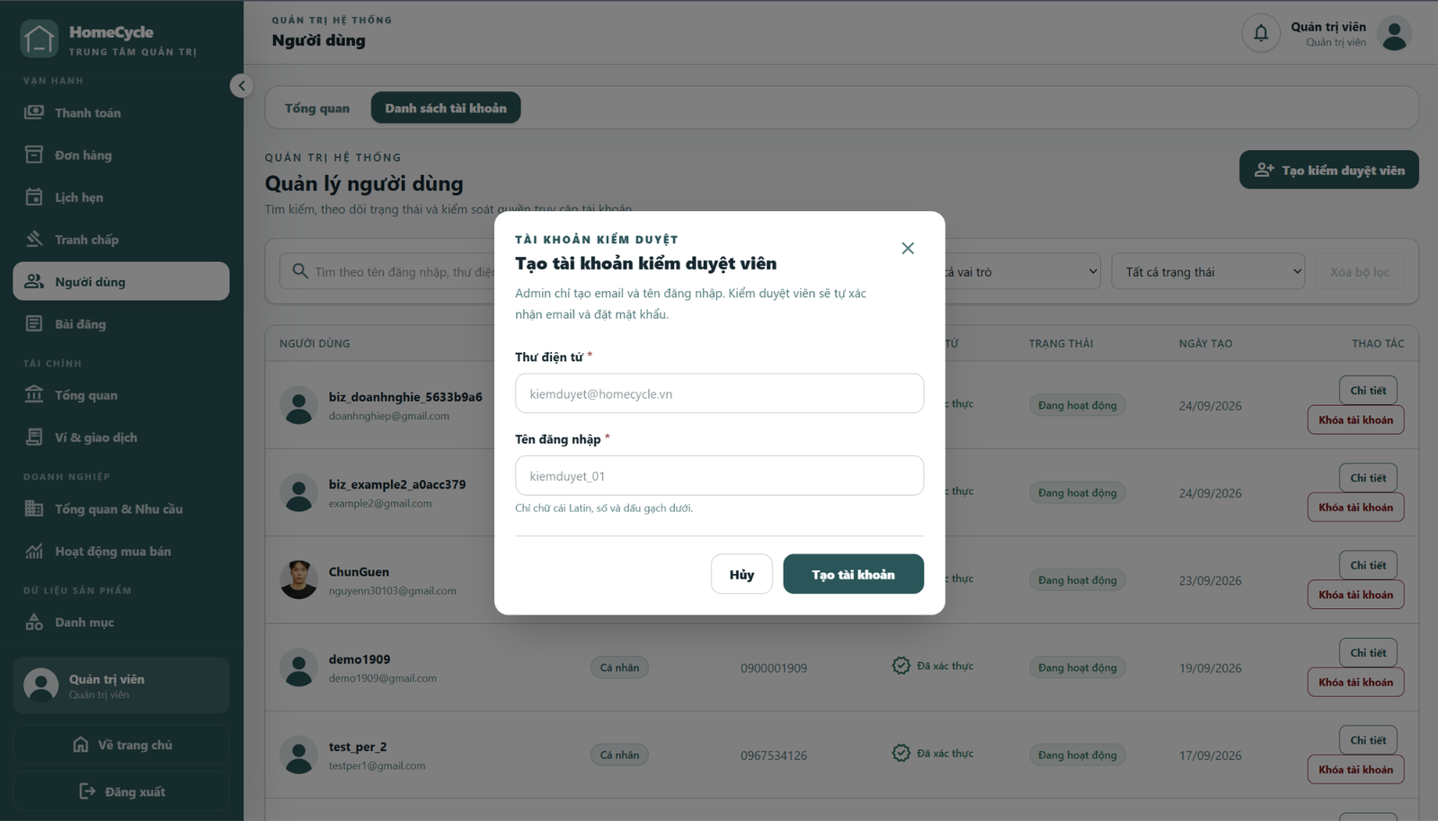
Figure 34: Manage Users screens

3.6.3 Manage Catalog
Function trigger: When an Admin opens Category Management, Brand Management or Product Type Management and clicks create, edit, hide or reactivate.
Function description: Allows Admins to manage the categories, brands, product types and attributes used by posts and search filters.
Function details:
Normal Flow:
- The Admin opens Category Management; the system lists the categories.
- The Admin clicks create or edit, enters the information and saves; the system updates the catalog.
- The Admin hides a category that is no longer used, or reactivates a hidden one.
Alternative Flows:
A1 – Brands, product types and attributes:
- The Admin manages brands the same way on Brand Management.
- On Product Type Management, the Admin creates product types and manages their attributes and options (Attribute Management).
Exception Flows:
E1 – Invalid or duplicate data:
- A required field is empty or the name already exists; the system highlights the field and does not save.
Screen layout:
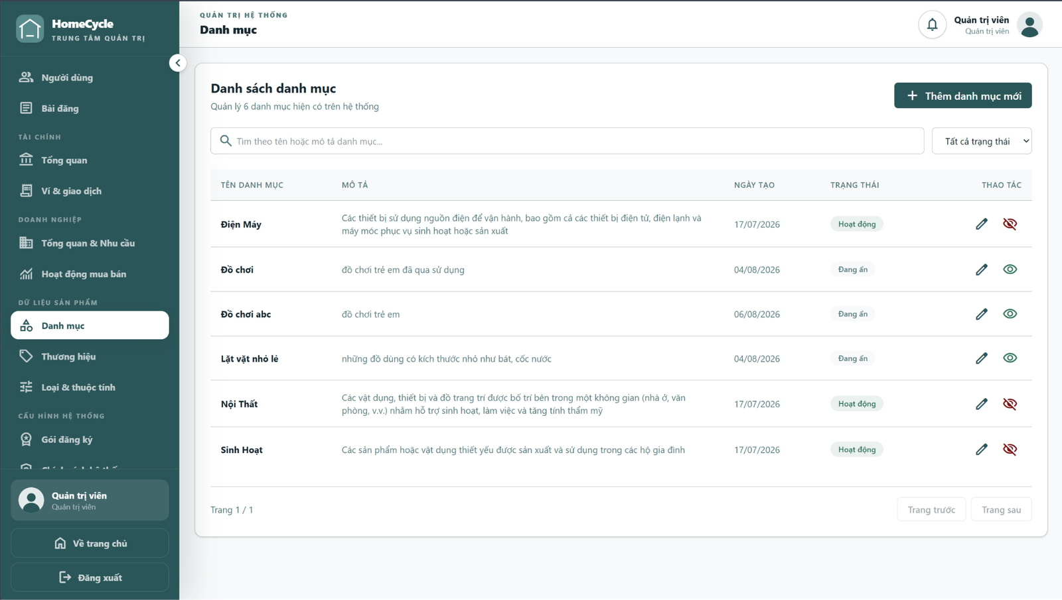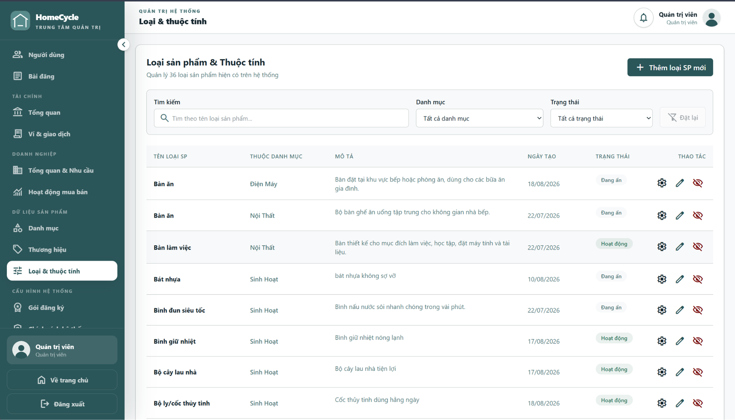
Figure 35: Manage Catalog screens

3.6.4 Manage System Configuration
Function trigger: When an Admin opens Subscription Packages, Platform Policies or Dispute Categories and saves a change.
Function description: Allows Admins to manage VIP packages, platform policies and dispute/report categories.
Function details:
Normal Flow:
- The Admin opens Subscription Packages and creates or edits a package with its price, duration and entitlements (AI quotas, advanced filters).
- The Admin saves; the system applies the package to new subscriptions.
Alternative Flows:
A1 – Platform policies:
- The Admin opens Platform Policies, edits a policy and saves a new version, or restores a previous version.
A2 – Dispute categories:
- The Admin manages the dispute and report categories shown to users.
Exception Flows:
E1 – Package in use:
- The Admin tries to delete a package that already has subscriptions; the system does not allow the deletion.
E2 – Invalid values:
- A price or duration is empty or invalid; the system highlights the field and does not save.
Screen layout:
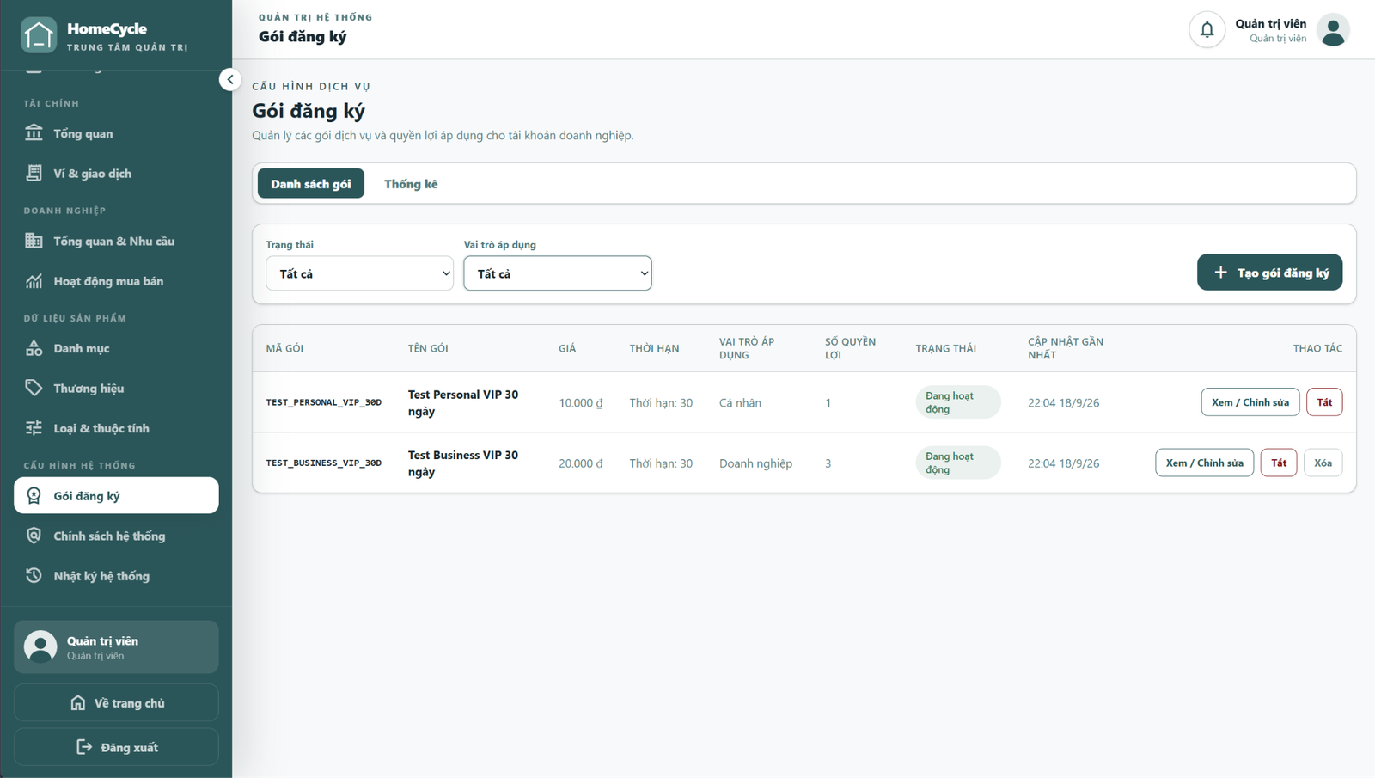
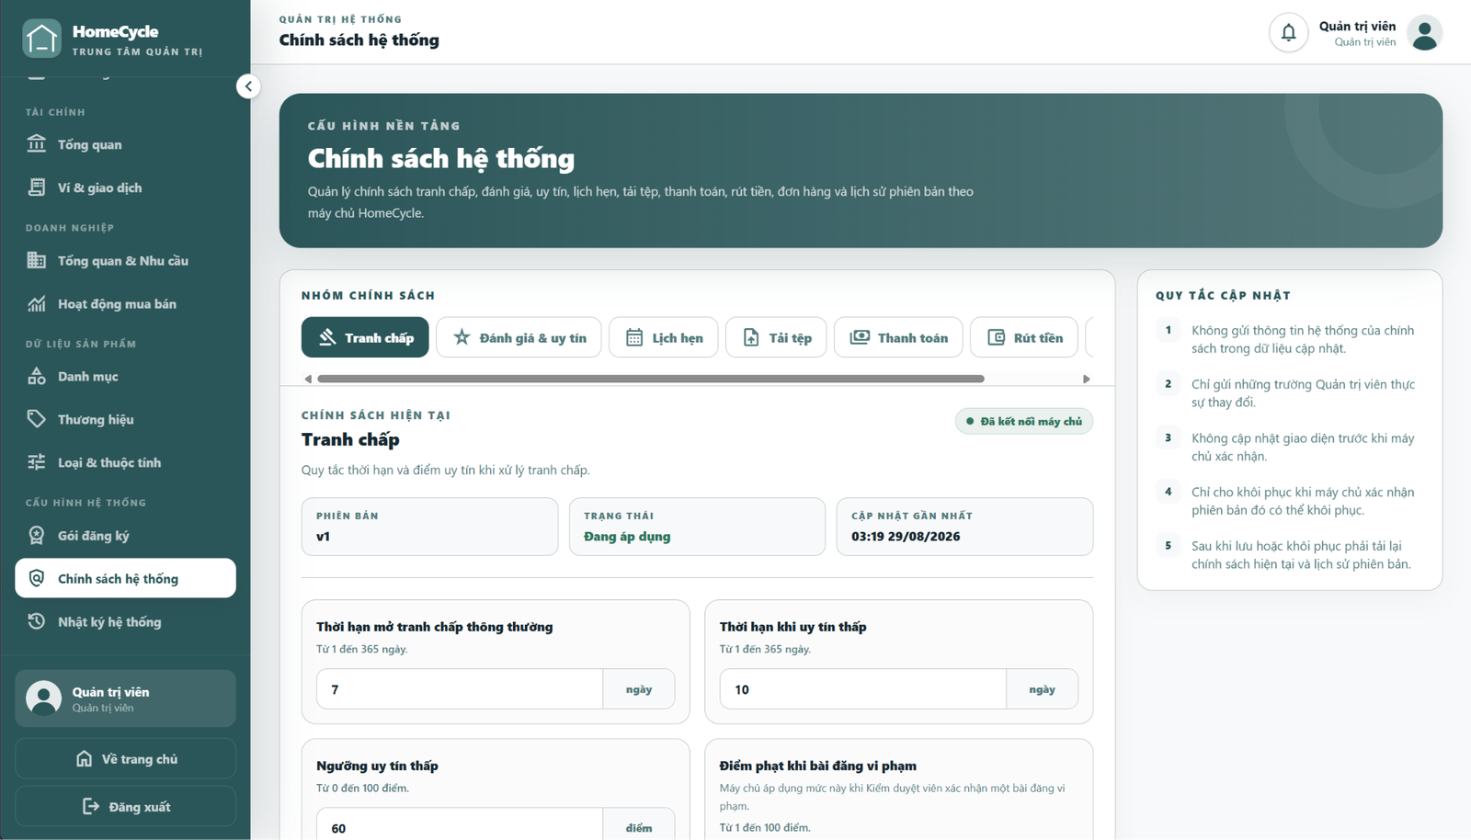
Figure 36: Manage System Configuration screens

4. Non-Functional Requirements

4.1 External Interfaces
The system will provide distinct, responsive graphical user interfaces optimized for web browsers and mobile viewports to accommodate the four main system actors
- PayOS Payment Gateway API: Handles the financial execution layer. The platform will call PayOS APIs to create secure transaction links for order deposits, hold funds in an escrow state, and execute validated balance payouts to user bank accounts.
- Giao Hàng Nhanh (GHN) Logistics API: Integrates directly with the logistics subsystem. When a user selects third-party shipping, the system transmits item dimensions, weight, and detailed street addresses to the GHN API to calculate real-time shipping costs and retrieve package tracking numbers.
- Firebase Services: Utilizes Firebase Storage to store and manage user-uploaded images, including product images, inspection images, and dispute evidence images. The service provides scalable and secure cloud storage with efficient file retrieval through public or authenticated URLs.
- SMTP Email Service: An external mail server will handle automated administrative operations, including One-Time Password (OTP) verification codes and official transaction billing receipts

4.2 Quality Attributes

4.2.1 Usability
Training Time:
- Standard Personal Users: Require zero prior training; capable of navigating the marketplace, posting items, or interacting via chat within less than 15 minutes of initial exploration.
- Power Users (Business Managers / Moderators): Require less than 2 hours of system orientation to efficiently navigate financial data views, bulk calendars, or verification queues.
Task Efficiency:
- Typical operations must be streamlined to minimize user friction.
- Item Listing: Constructing and submitting a standard item listing post must take under 3 minutes.
Negotiation Module:
- Executing a custom price proposal or confirmation step must resolve in less than 3 user interactions.
Design Standards Compliance:
- Error messages are simple and understandable
- Ensures a consistent style guide, proper color contrasts for visual accessibility, clear typographical hierarchies, and intuitive navigation structures.

4.2.2 Reliability
- System Availability: The platform must maintain 99% uptime, excluding scheduled maintenance windows (maximum 4 hours per month).
- Data Consistency: Payment status, order status, and shipment tracking must always remain synchronized. Orders can only proceed to completion after payment confirmation.
- Error Handling: Critical failures (database disconnect, payment gateway timeout) trigger automatic alerts to the admin team for immediate resolution. Recovery must be completed within 30 minutes.
- Data Integrity: All financial transactions use database rollback mechanisms to prevent partial state corruption. User transaction history maintains complete audit logs.

4.2.3 Performance
- Response Time: Standard API requests such as Browse Listings (UC01) or Login (UC03) must return data within 500ms under normal testing conditions.
- Third-Party Integrations (Maximum): Transactions involving external services like Make Payment (UC09) or GHN shipping calculations must complete within 10 seconds.
- Real-time Operations: Chat messaging and appointment notifications must deliver within 500ms of user action.
The platform can comfortably accommodate up to 50 concurrent users navigating the app simultaneously during the live demonstration without any lag.
- Resource Utilization: The backend application is optimized to run efficiently on a standard local machine or a basic cloud container, maintaining a low memory footprint of less than 256MB RAM at idle state.

5. Requirement Appendix

5.1 Business Rules
ID | Rule Definition
BR-01 | Each registered account must be associated with a unique email address. Email verification (OTP) is required to complete registration
BR-02 | A business account is expected to complete business profile verification before submitting purchase offers
BR-03 | Refresh tokens expire automatically 7 days after issuance (an absolute lifetime, not based on inactivity). Each refresh operation rotates the token and issues a new one with a fresh 7-day lifetime, forcing re-authentication on expiry
BR-04 | An account may be deactivated by its owner at any time. Administrators may additionally remove accounts that stay inactive
BR-05 | National ID numbers and text visible in uploaded CCCD images must be dynamically masked on the client UI, visible only to authorized staff via an explicit lookup override
BR-06 | Identity documents and ID numbers are protected in transit via TLS
BR-07 | The registered account holder's legal name on the banking profile must match 100% with the user's personal profile name and verified identity documents (CCCD)
BR-08 | Company registration requires the owner/legal representative to complete all mandatory fields and upload required corporate documents. A policy-confirmation step should only be claimed here if the request actually records a consent flag/version
BR-09 | Submitted company registration requests enter a pending state for manual Moderator review. Approved accounts are activated immediately; rejected requests allow users to modify details and resubmit for re-evaluation.
BR-10 | Modification of critical corporate legal profiles or personal identity documents requires the account to re-submit a validation payload to the Moderator queue; previous privileges remain active or are placed under temporary review pending approval
BR-11 | Updating personal CCCD information resets VerificationStatus to Pending and clears VerifiedBy/VerifiedAt. Updating a business profile follows its own per-endpoint rules rather than one blanket statement
BR-12 | A buy listing is created by a verified business user to express purchasing demand for specific categories of used household goods
BR-13 | Each listing specifies an available quantity. The quantity is reduced when payment succeeds and the order is materialized, not simply "on order creation" in the abstract. Certain cancel/refund flows restore the quantity
BR-14 | When the available quantity of a listing reaches zero, the listing shall be automatically marked as unavailable and prevented from receiving new offers or transaction requests until the owner updates the quantity or removes the listing
BR-15 | Product information tied to a transaction is captured and preserved at order-creation time. Later edits to the original listing do not affect the information stored in the order
BR-16 | All transaction processing, inspections, dispute resolutions, and financial settlements shall be based on the product information preserved in the order rather than the current version of the listing
BR-17 | Sell listings must provide all mandatory product information before submission
BR-18 | A sell listing may receive multiple offers from different buyers. The listing owner may review and compare all submitted offers before deciding to accept or reject any proposal Offer details are visible only to the listing owner and the respective buyer who submitted the offer; buyers are not permitted to view offers submitted by other participants
BR-19 | Only verified business users are authorized to create buy listings. Sellers responding to a buy listing must provide sufficient product details, including descriptions and supporting information that accurately represent the offered item
BR-20 | Business users may review, compare, negotiate, accept, or reject seller submissions associated with a buy listing. Acceptance of one submission does not automatically affect the status of other pending submissions unless otherwise specified by the business user
BR-21 | Negotiation conversations are accessible only to participants directly involved in the discussion
BR-22 | Negotiation messages cannot be modified or deleted by users. A 30-day post-closure retention window for authorized dispute/fraud review is the intended policy
BR-23 | Once transaction terms have been agreed upon during negotiation, both parties must confirm the system-generated agreement form before proceeding to payment.
BR-24 | An order and its related transaction activities may only be created after the agreement form has been mutually confirmed and the required payment has been successfully completed. Transactions that bypass this process are not recognized or protected by the platform.
BR-25 | An order shall only be generated from the confirmed agreement form once the buyer successfully completes the payment, matching the exact amount and method specified in that agreement
BR-26 | PayOS and Internal Wallet are the payment methods currently supported by the platform
BR-27 | Each order shall be associated with exactly one valid payment record. Duplicate successful payments for the same order are not permitted
BR-28 | All payment activities shall be systematically recorded in the payment history log to ensure traceability, allowing both users and system administrators to review and audit transaction records as necessary
BR-29 | Payment requests not completed within the configured deadline (a platform policy value, not a fixed number) are automatically expired and do not result in order creation. Expired records are kept, not deleted
BR-30 | Once a payment record is generated, it shall not be deleted or permanently removed under any status
BR-31 | Subscription package payments and transaction payments must be managed as separate payment records
BR-32 | Once completed, all components of the order will be stored in a read-only state. It will be impossible to modify or delete the order history data for all roles in the system
BR-33 | Appointment scheduling becomes available only after an order has been successfully created
BR-34 | Participants are permitted to submit a schedule modification request only if the current time is more than 24 hours prior to the scheduled appointment
BR-35 | Participants may request a schedule change before a configurable cutoff (platform policy; commonly 24 hours), not necessarily a fixed 24 hours in every case
BR-36 | The system shall automatically disable the rescheduling interface for both inspection and collection appointments once the remaining time to the appointment is 24 hours or less
BR-37 | Any modification requests received within the 24-hour deadline window shall be rejected by the system to enforce transaction commitments
BR-38 | A single order may contain multiple appointments when required by the transaction process
BR-39 | Requesting an appointment reschedule shall not alter the total transaction amount or trigger any financial compensation or penalties for any involved parties
BR-40 | If an appointment cancellation is mutually confirmed by both parties more than 24 hours prior to the transaction, the system shall refund 100% of the paid amount to the buyer’s wallet. No penalties or deductions shall be applied to the reputation/rating scores of either party
BR-41 | A unilateral cancellation more than 24 hours before the appointment still results in a full refund to the buyer, with the canceling party receiving a failed-transaction record and a rating penalty
BR-42 | If neither party interacts with the appointment within a defined window after the scheduled time, it is automatically marked ‘Expired’, and further order-status updates are paused until rescheduled or cancelled.
BR-43 | When an appointment is marked as Expired, both parties are required to either reschedule the appointment or cancel the transaction through the platform. Transactions remaining unresolved after expiration shall not proceed to subsequent transaction stages, and the platform shall not assume responsibility for any offline agreements conducted outside the system workflow.
BR-44 | After the inspection form is submitted, both parties must confirm the inspection result. If accepted, the transaction may proceed to immediate collection or collection scheduling with an updated price if necessary. Otherwise, the transaction may be cancelled or escalated to dispute resolution
BR-45 | If the inspected product significantly differs from the original listing or does not satisfy the buyer, the buyer may cancel the transaction and receive a full refund of the deposited amount according to the platform's refund policy
BR-46 | Product inspection and collection are independent schedules. The platform shall only document inspection results and assume responsibility for product quality for transactions that explicitly include a inspection appointment.
BR-47 | After an inspection appointment, the buyer must submit an inspection form before proceeding to collection
BR-48 | Inspection forms include supporting images or notes describing the actual product condition. Inspection findings must be documented before the collection process can proceed
BR-49 | For listings valued above 3,000,000 VND, the system shall prompt a high-value warning and mandate an inspection recommendation. If the inspection is waived, the platform disclaims full dispute resolution and strictly waives any commitment to a 100% order value refund for subsequent product damages or discrepancies
BR-50 | Collection activities may only occur after the inspection stage has been completed or waived according to transaction rules
BR-51 | For self-delivery or buyer pickup, the order shall maintain the agreed delivery location, delivery status, and delivery fee. The agreed delivery fee shall be added to the total order amount
BR-52 | After a successful transaction, participants may submit ratings and written feedback regarding their transaction experience. Ratings shall contribute to the user's overall reputation score on the platform
BR-53 | Each transaction participant may rate the counterparty once per order (1–5 stars, up to 3 images), within a configured edit window. The Display Star Rating shown to users and the internal Reputation Score are calculated separately
BR-54 | Users may submit disputes regarding transactions, listings, or ratings when they detect violations, misleading information, or behaviors that conflict with platform policies
BR-55 | Transaction disputes may be submitted for issues including failure to fulfill agreements, missed appointments, non-delivery, non-payment, products significantly different from their descriptions, or fraudulent behavior during the transaction process
BR-56 | Rating disputes may be submitted when ratings or comments contain false information, personal attacks, harassment, or content that violates community guidelines
BR-57 | Listing disputes may be submitted when a listing contains misleading descriptions, prohibited content, false product information, or other violations of marketplace policies
BR-58 | A dispute submission must include a category, a description of 10–2000 characters, and 2 to 5 supporting images
BR-59 | Refund requests shall only be processed for transactions that have been created, confirmed, and paid through the platform according to the official transaction workflow.
BR-60 | A full refund applies when inspection confirms the product differs significantly from the listing or fails to meet agreed requirements
BR-61 | A full refund of the deposited amount shall be granted to the affected party when an appointment is unilaterally cancelled or when a transaction participant fails to attend the scheduled appointment without completing the required transaction procedures.
BR-62 | If one party stops progressing the transaction after confirming the agreement or completing payment, the other party may request cancellation and a refund through the dispute-resolution process
BR-63 | Refund eligibility and amount depend on the approved dispute outcome and current platform policy
BR-64 | Orders affected by third-party delivery issues, including non-delivery, damaged products, lost items, incorrect items, or item substitution, are eligible for a full refund when sufficient evidence is provided and the dispute is approved by the platform
BR-65 | The refund amount shall be calculated from the final confirmed order amount stored in the system, including any approved price adjustments and shipping charges associated with the transaction
BR-66 | Approved refunds shall be credited to the user's wallet balance maintained by the platform. The refunded amount shall be immediately reflected in the wallet after the refund is successfully processed
BR-67 | Approved refunds shall be processed within 3 to 5 days after the final refund decision is issued by the platform
BR-68 | Each order is eligible for only one refund process. Duplicate refund requests for the same order shall not be accepted after the refund has been completed
BR-69 | The wallet holds an Available balance (withdrawable, and usable for payment — see BR-73) and a Hold balance (escrow, not withdrawable)
BR-70 | For individual users and household businesses, withdrawal requires the linked bank account to be ‘Verified’
BR-71 | For business accounts, withdrawal requires the linked bank account to be ‘Verified’ against the business or its legal representative
BR-72 | Wallet Available Balance can be used to pay for marketplace orders and subscription packages
BR-73 | Each user shall have only one wallet associated with their account throughout the account lifecycle
BR-74 | Withdrawal requests cannot exceed the Available balance, and are also subject to configured per-request min/max limits and a daily amount/count quota. Business accounts may receive quota overrides via subscription entitlements
BR-75 | All withdrawal requests are reviewed and approved by moderators; the review period is targeted at 3–5 business days
BR-76 | Once approved, the withdrawal amount shall be transferred from the platform's bank account to the verified bank account linked to the user's account and reflected as a completed withdrawal transaction in the wallet history
BR-77 | For inspection-type agreements, delivery is restricted to buyer pickup at the seller's inspection location
BR-78 | For inspection-type agreements, payment is restricted to deposit; full payment is allowed only after inspection is confirmed.
BR-79 | A shipment is created as part of the payment/order materialization flow, once the order is Paid and the agreement is confirmed
BR-80 | Each order shall have exactly one active shipment. Creation of multiple concurrent shipments for the same order is not permitted
BR-81 | Shipment creation is strictly dependent on the delivery method defined in the agreement form and cannot be modified after shipment initialization
BR-82 | If the delivery method is GHN, the system must route shipment creation through the carrier integration layer and generate an external shipment record before dispatch
BR-83 | Carrier-specific shipment data (such as service type, weight, dimensions, and ward/district codes) must be stored separately from the core shipment entity to ensure carrier independence
BR-84 | The shipping fee stored in the order shall be considered the final authoritative value, regardless of carrier-calculated fee differences
BR-85 | For GHN shipments, the fee is synchronized from the carrier response after order creation and is not manually editable afterward. A signed quote/preview proof expires after 30 minutes, and weight/service constraints are validated server-side.
BR-86 | Registration (for individuals and businesses) can only be performed using a valid registration token issued upon successful OTP verification; an access token cannot be used to bypass this process. The token has a TTL of 60 minutes
BR-87 | The registration OTP is a 6-digit number (100000–999999) that expires after 5 minutes, is valid for single use only, and is valid only when the email-and-code pair matches.
BR-88 | The OTP is sent only to unregistered email addresses; requests to send an OTP to existing email addresses will be rejected
BR-89 | For every registered account, a wallet matching the account's role is automatically created (Personal → Wallet Personal; Business → Wallet Business) with zero balances
BR-90 | A new personal account has been created with personal_profile VerificationStatus=Pending and account status=Active
BR-91 | Suspended/Deleted accounts are blocked from logging in (including via Google OAuth); email verification status is NOT checked during login
BR-92 | 93 An administrator cannot lock their own account or another administrator's account, and can only unlock accounts currently ‘Suspended’
BR-93 | Avatar: mandatory, max 5MB, .jpg/.jpeg/.png/.webp only; general file rules applicable across the entire platform (ID card photos, post images, etc.) also carry the 5MB limit
BR-94 | Any update to the CCCD/identity resets the VerificationStatus to "Pending" and clears the VerifiedBy and VerifiedAt fields, necessitating re-verification
BR-95 | When reviewing personal citizen ID cards, moderators only receive a "Verified" or "Rejected" decision; a reason (≤1000 characters) is mandatory for "Rejected" status; this applies only to Personal accounts where the profile is in "Pending" status and the citizen ID card details are complete
BR-96 | The initial Google login does not create an account; instead, it returns a registration token (including email, picture, and provider=Google) to proceed with the registration flow
BR-97 | Each user has only one business profile (unique index UserId). Submission is permitted only when the profile status is "Rejected"; editing is blocked for profiles with "Pending" or "Approved" status. Upon resubmission, the status resets to "Pending" and re-enters the moderator queue
BR-98 | Onboarding is considered "Complete" only if a procurement survey exists; if the profile is "Approved" but the survey is missing, the status is "SurveyPending"
BR-99 | Service areas can only be managed by Enterprise-model businesses; an Enterprise submission must include at least one service area (City, Street, and Ward are mandatory), which must be unique based on the combination of City, Street, and Ward
BR-100 | Survey is only complete when all 5 dimensions are complete: TargetCities, AcceptableDamageLevels, AcceptableFunctionalityStatuses, ProcurementScales, ProductTypeIds
BR-101 | Only Personal accounts can create sell posts; only Business accounts can create buy posts
BR-102 | The post quantity must be greater than 0; the original price/expected price must be greater than or equal to 0; when editing, the new quantity must not be lower than the quantity already sold
BR-103 | Sell posts automatically expire 12 months after creation. Buy posts also expire — by default 30 days after creation; when the expiry date is edited, it cannot exceed 6 months from the original creation date. A background worker automatically closes expired buy posts
BR-104 | Only the owner may edit, close, reactivate, or delete a post; only a moderator may suspend a post; a post that has been deleted or suspended cannot be suspended; an expired post cannot be edited
BR-105 | When the Remaining Quantity reaches zero after fulfillment, the listing automatically switches to "Closed" status
BR-106 | An offer can only be sent, edited, accepted, or countered when the post is in "Active" status; the sender cannot make an offer on their own post; and the sender's account must be active
BR-107 | The offer price must fall within the range of [20% BasePrice, 300% BasePrice]; posts without a BasePrice do not accept offers; the offer price must be greater than 0, with a maximum of 18 digits and 2 decimal places
BR-108 | Offer quantity ≤ Remaining Quantity (checked upon submit, update, accept, or counter); a sender can have at most one "Pending" offer on the same post
BR-109 | Message text can only be sent when the negotiation is in the 'Open' or 'Agreed' state; otherwise, the conversation is read-only
BR-110 | A counter-proposal is permitted only when the negotiation is open; a counter-proposal cannot be submitted while one's own proposal is still pending; a new counter-proposal will mark the counterparty's proposal as "Superseded" (as only one proposal may be pending per negotiation)
BR-111 | A negotiation can only be cancelled when in the 'Open' status; cancellation also cancels the associated offer
BR-112 | Only the Seller can create an agreement; there is only one agreement per negotiation; the seller is automatically marked as "confirmed" at the time of creation
BR-113 | Price/quantity are frozen based on the negotiation (InitialPrice=OfferPrice, FinalPrice=Negotiation.FinalPrice); a full product snapshot (post + product + media) is saved to the PSnapshot JSON
BR-114 | For agreements of the "Inspection" type, `InspectionAddress` and a future `InspectionDate` are mandatory; if `DeliveryMethod` is present, both `PickupAddress` and `DeliveryAddress` are required; for "No_Inspection," `DeliveryMethod` is mandatory
BR-115 | Only the Buyer can initiate payment (PayOS, wallet, sync status); this is only possible when the agreement is in the 'Awaiting_Payment' state
BR-116 | The payment window expiry is a configurable platform policy (currently 1–1440 minutes), not a fixed 15-minute value. Expired pending payments are marked Expired/Failed, not deleted
BR-117 | An internal wallet payment requires the buyer's Personal wallet Available balance ≥ amount; it debits the buyer's Available balance and credits the seller's Hold (escrow) balance in one transaction, and still creates a Payment record marked Completed together with a wallet transaction/ledger entry
BR-118 | One order per agreement, the order is created only after successful payment; only the agreement's buyer or seller can view the order
BR-119 | Only the buyer or seller associated with the agreement can view details and perform a check-in; check-in is blocked if the appointment has been cancelled or completed
BR-120 | An appointment will only automatically switch to "Completed" once both the buyer and the seller have checked in
BR-121 | A shipment is created only when the order is fully paid and the agreement is NOT for inspection
BR-122 | The GHN fee is recalculated by the server via the carrier API when an agreement is created or updated. The GHN service type accepts only 2 (lightweight goods) or 5 (heavy goods)
BR-123 | For GHN order creation, the buyer has to paid the shipping fee to HomeCycle, so GHN does not collect COD
BR-124 | Only the buyer or seller involved in the agreement may provide a rating; the person being reviewed is always the counterparty
BR-125 | Only the buyer or seller involved in the agreement may provide a rating; the person being reviewed is always the counterparty
BR-126 | Display Star Rating = (PriorWeight × PriorMean + Σratings) / (PriorWeight + n), default PriorWeight = 5, PriorMean = 4.0. Reputation Score changes by a configurable point delta per rating/policy event and is clamped to a configured min–max range
BR-127 | Only "Active" sell posts can be added to the cart ("buy" posts are rejected); users cannot add their own posts; quantity must be ≥ 1 and ≤ RemainingQuantity; each post appears only once in the cart; only the cart owner can remove items
BR-128 | The product type must belong to the selected category; attributes must belong to the product's product type; and all attributes marked as "IsRequired" must be provided.
BR-129 | A password-reset OTP expires after 5 minutes, is rate-limited, is invalidated after successful use, and is available only to eligible Active or Pending password-based accounts.
BR-130 | Moderator accounts may only be created by an active Administrator. A newly created Moderator stays Pending until the email activation token is verified and a password is set; activation and password tokens have independently configured lifetimes.
BR-131 | Platform policies for appointment cutoffs, payment expiry, deposit rate, dispute/return windows, rating points, order confirmation timeout, withdrawal limits, and file-upload rules are active versioned configuration; transactions use the effective policy, or a saved snapshot where one applies.
BR-132 | A review may be created only once per participant per order, must target the counterparty, uses 1–5 stars, may include up to 3 images, and may only be edited within the configured review-edit window.
BR-133 | The Display Star Rating and Reputation Score are separate metrics. The Display Star uses Bayesian smoothing with a configurable prior mean/weight; the Reputation Score changes by configurable point deltas and is clamped to configured bounds.
BR-134 | A dispute submission requires a valid, active category for the chosen target type, a description of 10–2000 characters, and 2–5 evidence images. The window to open an order dispute is configurable and may be extended for low-reputation sellers.
BR-135 | Post/review violation decisions may nullify the effect of an invalid review and/or apply configurable reputation penalties; all moderator decisions and any resulting financial/operational changes are auditable.
BR-136 | Buyer payment funds are held in the seller's escrow (HoldBalance) until a valid settlement/release condition occurs; the shipping fee may be credited to a designated system wallet. Every wallet movement produces an immutable transaction and ledger entry.
BR-137 | Internal Wallet is a supported payment method for both marketplace orders and subscription packages when AvailableBalance is sufficient; PayOS and Wallet flows must be idempotent and must never settle the same obligation twice.
BR-138 | A withdrawal requires a verified bank account, sufficient available balance, configured per-request limits, a daily amount/count quota, and moderator approval. Business subscription entitlements may override the daily withdrawal quota.
BR-139 | Subscription packages are role-specific and purchasable only by an eligible Active user. A user may have at most one open (Pending/Active) subscription at a time; an inactive package cannot be newly purchased.
BR-140 | A paid subscription stores an immutable snapshot of the package name, duration, and entitlements at purchase time. Later edits to the package do not retroactively change existing subscriptions; expiry is calculated from the snapshot duration.
BR-141 | A subscription package that has ever been referenced by a subscription cannot be deleted and must instead be deactivated; deactivation blocks new purchases but does not revoke already-paid benefits.
BR-142 | Personal AI price suggestions and Business supplier matching are governed by daily quotas derived from the active subscription (or the free plan). Quotas reset at Vietnam midnight; an exhausted quota returns a limit status instead of silently consuming more usage.
BR-143 | Supplier matching only considers active sell posts with positive quantity and price, ranks a bounded candidate set, enforces the package's result-count limit, and may fall back to a cached/backend-only ranking if AI reranking is unavailable.
BR-144 | GHN quotes are calculated server-side. A signed quote/preview proof expires after 30 minutes and becomes invalid if the shipment snapshot changes; total shipment weight cannot exceed 50 kg, and service/dimension constraints must pass validation.
BR-145 | GHN shipment creation is asynchronous and retryable. Carrier creation status is tracked separately from core shipment/order status, and webhook/tracking updates are mapped through the carrier integration layer.
BR-146 | An order may auto-complete after the configured buyer-confirmation timeout only when delivery/collection prerequisites are met and no blocking dispute exists; the dispute-window end time is then persisted.
BR-147 | Escrow release and buyer-return timeout processing are idempotent lifecycle operations. They may only transition order/payment/dispute states from allowed predecessor states, and every transition is recorded in the audit/history log.
BR-148 | Audit events are written through a durable outbox for authentication, profile, post, offer, negotiation, payment, wallet, withdrawal, subscription, dispute, and order lifecycle actions; sensitive payload fields are sanitized, and audit retention is configured separately.
BR-149 | An Administrator may suspend or warn a post only when an open Post dispute/report exists against it. Suspension is a soft, reversible action that preserves the post's and dispute's history.
BR-150 | Dynamic file-upload rules are applied per upload context. Each context defines its own allowed extensions and maximum size, and no configured per-context maximum may exceed the application-wide safety ceiling of 25 MiB.
Table 20: Business Rules

5.2 Common Requirements

5.3 Application Messages List
# | Message code | Message Type | Context | Content
1 | AUTH_INVALID_CREDENTIAL | API error response | Username/email or password is incorrect | Invalid username or password.
2 | AUTH_PASSWORD_RESET_EMAIL_NOT_FOUND | API error response | Auth | The email is not registered in the system
3 | AUTH_PASSWORD_RESET_UNAVAILABLE | API error response | Auth | Only Personal or Business accounts that have not been locked or deleted are eligible for a password reset
4 | AUTH_PASSWORD_RESET_OTP_INVALID | API error response | Auth | The OTP is invalid, expired, or has already been used
5 | AUTH_PASSWORD_RESET_OTP_LOCKED | API error response | Auth | You have entered the wrong OTP too many times. Please try again in 15 minutes
6 | AUTH_MODERATOR_CREATION_FORBIDDEN | API error response | Auth | Only an active admin can create moderators
7 | AUTH_MODERATOR_TOKEN_INVALID | API error response | Auth | The activation link or password setup session is invalid, expired, or already used
8 | AUTH_MODERATOR_EMAIL_FAILED | API error response | Auth | The pending account was created, but the confirmation email could not be sent.
9 | AUTH_MODERATOR_CONFIGURATION_INVALID | API error response | Auth | Moderator activation settings are invalid.
10 | AUTH_EMAIL_REQUIRED | API error response | Auth | Email is required.
11 | AUTH_EMAIL_INVALID | API error response | Auth | Email format is invalid.
12 | AUTH_FULLNAME_REQUIRED | API error response | Auth | Full name is required.
13 | AUTH_FULLNAME_INVALID | API error response | Auth | Full name may contain letters and spaces only.
14 | AUTH_USERNAME_REQUIRED | API error response | Auth | Username is required.
15 | AUTH_USERNAME_INVALID | API error response | Auth | Username may contain letters, numbers, and underscores only.
16 | AUTH_PASSWORD_REQUIRED | API error response | Auth | Password is required.
17 | AUTH_PASSWORD_LENGTH_INVALID | API error response | Auth | Password must be between 6 and 20 characters.
18 | AUTH_PHONE_REQUIRED | API error response | Auth | Phone number is required.
19 | AUTH_PHONE_INVALID | API error response | Auth | Phone number must contain 9 or 10 digits and start with 0.
20 | AUTH_INVALID_CREDENTIAL | API error response | Auth | Invalid username or password.
21 | AUTH_USER_NOT_FOUND | API error response | Auth | User not found.
22 | AUTH_INVALID_REFRESH_TOKEN | API error response | Auth | Refresh token is invalid.
23 | AUTH_REFRESH_TOKEN_EXPIRED | API error response | Auth | Refresh token has expired.
24 | AUTH_REFRESH_TOKEN_REVOKED | API error response | Auth | Refresh token has been revoked.
25 | AUTH_EMAIL_NOT_VERIFIED | API error response | Auth | Email has not been verified.
26 | AUTH_INVALID_OTP | API error response | Auth | Invalid OTP.
27 | AUTH_OTP_SEND_FAILED | API error response | Auth | Failed to send OTP. Please try again later.
28 | AUTH_OTP_RATE_LIMITED | API error response | Auth | Bạn chỉ có thể yêu cầu OTP lại sau {minutes} phút.
29 | AUTH_ACCOUNT_SUSPENDED | API error response | Auth | Account has been suspended.
30 | AUTH_CANNOT_LOCK_SELF | API error response | Auth | Admin cannot lock their own account.
31 | AUTH_CANNOT_LOCK_ADMIN | API error response | Auth | Cannot lock another admin account.
32 | AUTH_ACCOUNT_ALREADY_LOCKED | API error response | Auth | Account is already locked.
33 | AUTH_ACCOUNT_NOT_LOCKED | API error response | Auth | Account is not locked.
34 | AUTH_ACCOUNT_DELETED | API error response | Auth | Account has been deleted.
35 | AUTH_EMAIL_EXISTS | API error response | Auth | Email already exists.
36 | AUTH_USERNAME_EXISTS | API error response | Auth | Username already exists.
37 | AUTH_INVALID_REGISTRATION_SESSION | API error response | Auth | The registration session is invalid or has expired.
38 | AUTH_USER_NOT_FOUND | API error response | Profile | User not found! Please try again.
39 | AUTH_PROFILE_NOT_FOUND | API error response | Profile | Profile not found! Please try again.
40 | PROFILE_AVATAR_UPLOAD_FAILED | API error response | Profile | Failed to upload avatar or logo image to storage.
41 | PROFILE_AVATAR_UPDATE_FAILED | API error response | Profile | Failed to update avatar or logo image.
42 | CATEGORY_NOT_FOUND | API error response | Category | Category not found.
43 | CATEGORY_ALREADY_EXISTS | API error response | Category | Category name already exists.
44 | CATEGORY_INACTIVE | API error response | Category | Category has been deactivated.
45 | BRAND_NOT_FOUND | API error response | Brand | Brand does not exist.
46 | BRAND_ALREADY_EXISTS | API error response | Brand | Brand already exists.
47 | PRODUCT_TYPE_NOT_FOUND | API error response | ProductType | Product type does not exist.
48 | PRODUCT_TYPE_ALREADY_EXISTS | API error response | ProductType | Product type already exists.
49 | CATEGORY_NOT_FOUND | API error response | ProductType | Category does not exist.
50 | ATTRIBUTE_ALREADY_EXISTS | API error response | ProductType | Attribute already exists.
51 | ATTRIBUTE_NOT_FOUND | API error response | ProductType | Attribute does not exist.
52 | ATTRIBUTE_ALREADY_IN_USE | API error response | ProductType | Attribute already in use.
53 | DATA_TYPE_CANNOT_CHANGE_IN_USE | API error response | ProductType | Cannot change the data because in used
54 | INPUT_MODE_CANNOT_CHANGE_IN_USE | API error response | ProductType | Cannot change the Input Mode because in used
55 | ATTRIBUTE_NOT_FOUND | API error response | ProductAttribute | Product attribute does not exist.
56 | ATTRIBUTE_ALREADY_EXISTS | API error response | ProductAttribute | Attribute already exists in this product type.
57 | ATTRIBUTE_REQUIRED_MISSING | API error response | ProductAttribute | Required attribute is missing.
58 | ATTRIBUTE_OPTION_NOT_FOUND | API error response | ProductAttributeOption | Attribute option does not exist.
Table 21: Application Messages List

5.4 Other Requirements…

IV. Software Design Description

1. System Design

1.1 System Architecture
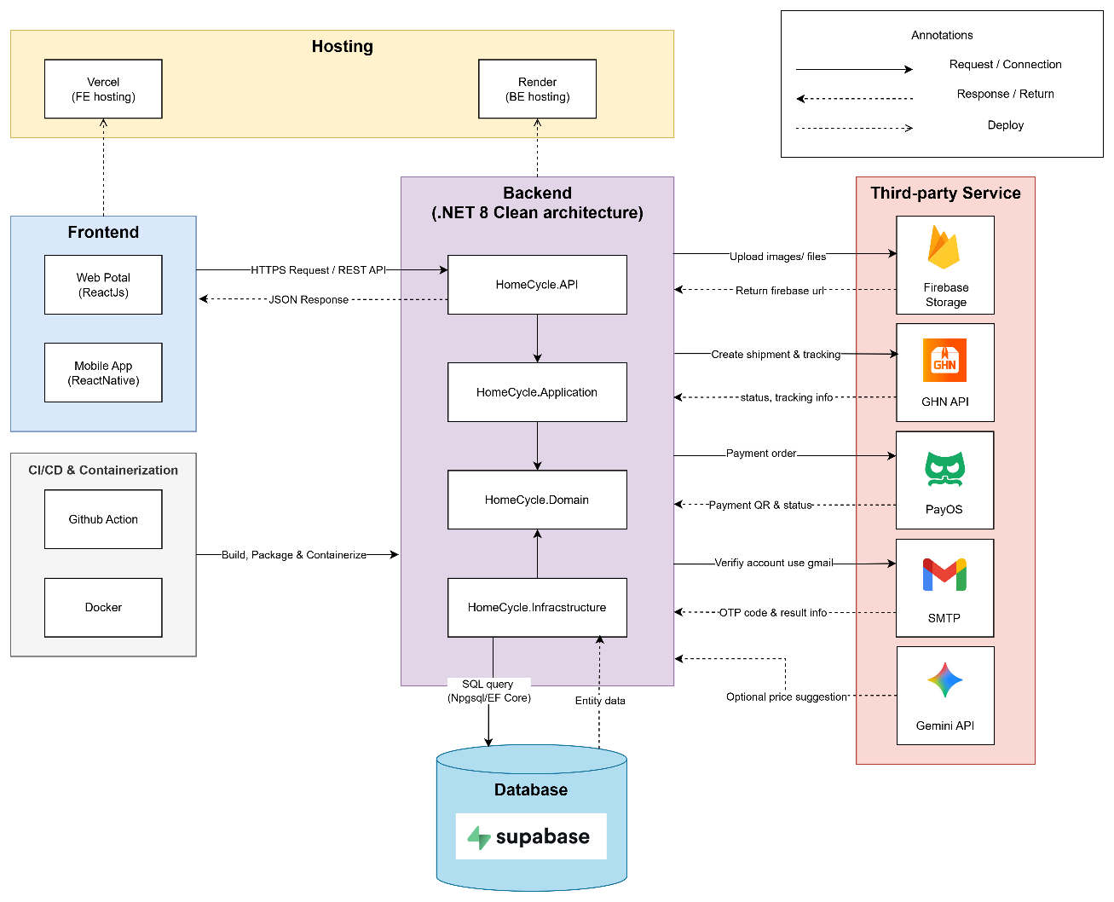
Diagram 7: System Architecture
Component Explanations
The HomeCycle system architecture is designed following the Monolithic pattern combined with Clean Architecture principles to optimize development velocity, ensuring maintainability and high reliability for a 4-member engineering team. The system is logically structured into four main layers and physical partitions:
Presentation Layer (Frontend): This layer handles the user interface and interactions for all target actors (Personal Users, Business Users, Moderators, and Administrators):
- Web Portal (ReactJS): A responsive web application hosted on Vercel, tailored for Business Users to manage bulk household listings, and for Admins/Moderators to access back-office management dashboards.
- Mobile App (React Native): A cross-platform mobile application deployed directly to user devices, optimizing real-time interaction features such as peer-to-peer negotiation chat and instant push notifications.
Network & Proxy Layer:
- Nginx (Reverse Proxy): Acts as the secure gateway standing at the front line of the server infrastructure. It intercepts all incoming client traffic over standard HTTPS protocols, handles SSL termination, prevents unauthorized port exposure, and forwards valid requests to the inner application server.
Backend Application Layer: This tier encompasses the entire central business logic, running as a single, cohesive deployment unit inside an Render instance:
- Web API (.NET Core 8): Structured strictly around Clean Architecture principles—spanning distinct layers including HomeCycle.API, HomeCycle.Application, HomeCycle.Domain, and HomeCycle.Infrastructure. This monolithic service processes core business capabilities, including account authentication, negotiation pricing calculations, order fulfillment, scheduling, and electronic escrow wallets
- CI/CD & Containerization (Docker & GitHub Actions): Ensures automated and reliable software delivery. Every code modification pushed to the repository automatically triggers GitHub Actions to build and pack the source code into a standardized Docker Image, which is then seamlessly deployed onto the target Render host.
Persistence & Cloud Storage Layer
- Supabase (PostgreSQL): Serves as the primary relational database management system, providing robust persistence, high-performance indexing, and data integrity across the entire platform. Leveraging Supabase as the backend-as-a-service infrastructure, PostgreSQL securely maintains all operational domain records.
- Firebase Storage: Managed via the backend service. Client applications send physical image files to the backend for validation. The backend then handles the upload to Firebase Storage and returns the secure URL strings to the frontend while storing them in the database.
External Services Integration (Third-Party APIs): The system communicates with external platforms via secure RESTful APIs to automate end-to-end user operations:
- PayOS API: The central financial gateway. It generates dynamic VietQR codes for secure escrow deposits and triggers real-time Webhooks to Nginx when transactions are successfully executed, allowing the backend to instantly advance order states.
- Giao Hàng Nhanh (GHN) API: The integrated logistics service used to calculate accurate dynamic delivery fees based on parcel weight/dimensions and automatically generate tracking numbers.
- Gemini API: The integrated generative Artificial Intelligence module that ingests household item descriptions and depreciation factors to output real-time market value suggestions for users.
- Gmail SMTP: The standard Simple Mail Transfer Protocol used to dispatch email verifications and secure registration OTP codes

1.2 Package Diagram

1.2.1 Backend Package Diagram
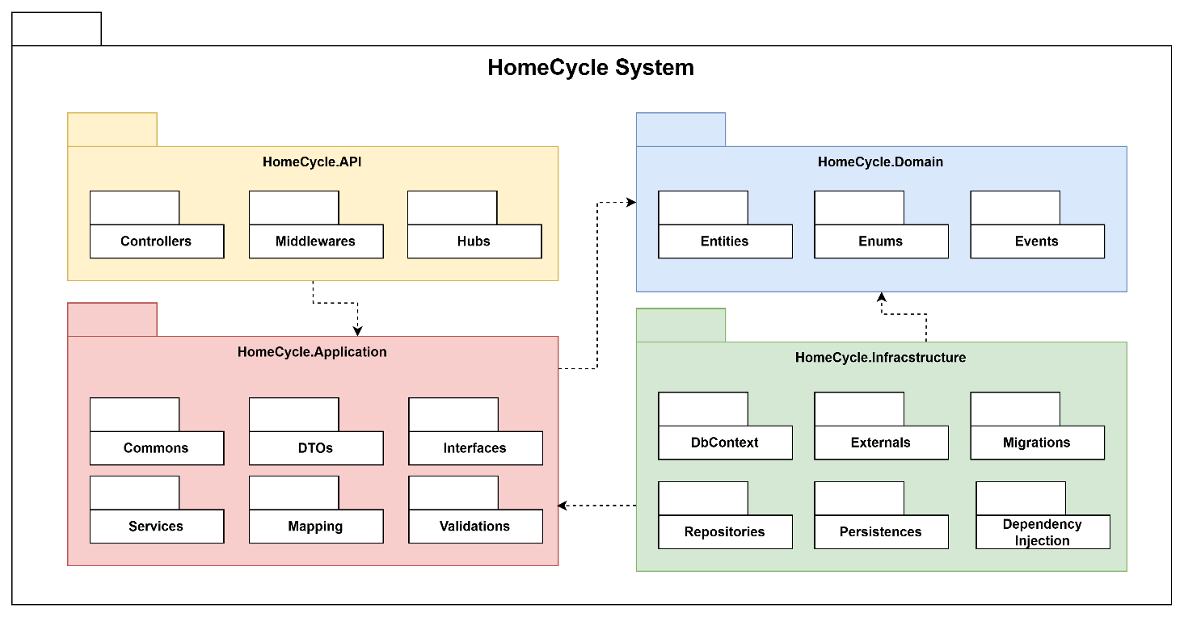
Diagram 8: Backend Package Diagram
Package Descriptions
No | Package | Description
01 | HomeCycle.API | Represents the presentation and entry-point layer of the HomeCycle backend. It receives HTTP or real-time requests, performs request-pipeline processing, and delegates application operations to the Application layer.
02 | HomeCycle.API.Controllers | Contains REST API controllers that expose HomeCycle endpoints, receive request DTOs, obtain authenticated-user information, invoke Application services, and convert processing results into HTTP responses.
03 | HomeCycle.API.Middlewares | Contains middleware components for cross-cutting request-pipeline concerns such as exception handling, authentication processing, request logging, and standardized error responses.
04 | HomeCycle.API.Hubs | Contains SignalR hub endpoints used to support server-to-client real-time communication for features such as notifications or transaction updates.
05 | HomeCycle.Application | Contains HomeCycle application use cases and coordinates interactions between the API, Domain, repositories, and external-service abstractions. This package does not directly depend on database or third-party implementation details.
06 | HomeCycle.Application.Commons | Provides reusable application-level components such as result and error models, pagination models, shared constants, common exceptions, and utility definitions.
07 | HomeCycle.Application.DTOs | Defines request and response data-transfer objects used to exchange data between the API and Application layers without exposing Domain entities directly.
08 | HomeCycle.Application.Interfaces | Defines contracts for application services, repositories, Unit of Work, file storage, payment, shipping, email, and other external-service operations. Infrastructure provides the concrete implementations of these interfaces.
09 | HomeCycle.Application.Services | Implements application use cases and workflow orchestration, including authentication, post management, offers, negotiations, agreements, payments, shipping, verification, and moderation operations.
10 | HomeCycle.Application.Mapping | Contains mapping configurations, such as AutoMapper profiles, used to convert between request/response DTOs, Domain entities, and other application models.
11 | HomeCycle.Application.Validations | Contains FluentValidation validators that verify request formats, required values, input ranges, and application-specific conditions before use cases are executed.
12 | HomeCycle.Domain | Represents the core business layer of HomeCycle. It contains the principal business models, states, and rules and remains independent of ASP.NET Core, EF Core, Supabase, and external APIs.
13 | HomeCycle.Domain.Entities | Contains Domain entities and business objects such as User, Post, Product, Offer, Negotiation, Agreement, Payment, Order, Shipment, and related transaction models.
14 | HomeCycle.Domain.Enums | Defines controlled business values and lifecycle states, such as post types, post statuses, negotiation statuses, agreement statuses, payment types, delivery methods, and verification statuses.
15 | HomeCycle.Domain.Events | Defines domain-event objects representing significant business-state changes that other components may respond to without tightly coupling domain operations to infrastructure concerns.
16 | HomeCycle.Infrastructure | Provides technical implementations for the interfaces declared by the Application layer, including persistence, repositories, external API integrations, database migrations, and dependency-registration configuration.
17 | HomeCycle.Infrastructure.DbContext | Contains the Entity Framework Core database context, entity sets, model-building configuration, and database connection behavior used to access the HomeCycle PostgreSQL database hosted on Supabase.
18 | HomeCycle.Infrastructure.Externals | Contains adapters and API clients for integrated third-party services, including GHN shipping, PayOS payments, Firebase Storage, Gmail SMTP, and optional Gemini services.
19 | HomeCycle.Infrastructure.Migrations | Contains Entity Framework Core migration files used to create, version, and update the PostgreSQL database schema consistently across environments.
20 | HomeCycle.Infrastructure.Repositories | Contains concrete EF Core repository implementations for the repository interfaces defined in the Application layer and performs database queries and persistence operations
21 | HomeCycle.Infrastructure.Persistences | Contains persistence-related implementations and configurations, such as entity configurations, Unit of Work, database transactions, and other components supporting reliable data storage.
22 | HomeCycle.Infrastructure.DependencyInjection | Contains extension methods that register Infrastructure implementations, database services, repositories, external adapters, and configuration settings with the ASP.NET Core dependency-injection container
Table 22: Backend Package Descriptions

1.2.2 Frontend Package Diagram (Website)
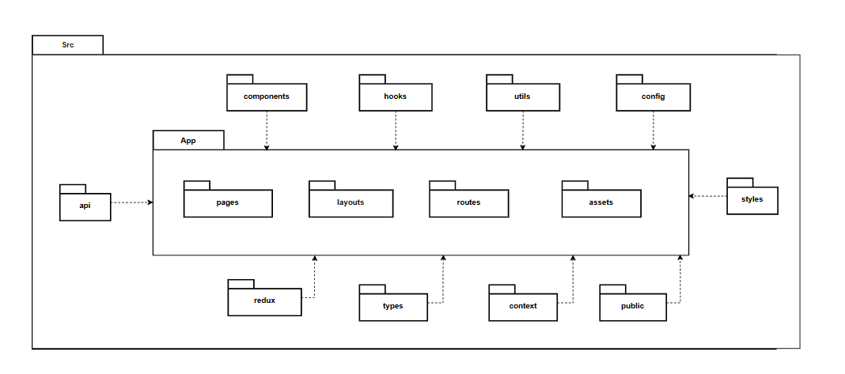1.2.2. Frontend website package diagram
Diagram 9: Frontend Package Diagram (Website)
Package Descriptions
No | Package | Description
01 | src/components | Contains shared UI components (buttons, inputs, modals, tables, etc.)
02 | src/hooks | Contains custom hooks for reusable business logic
03 | src/utils | Contains utility functions (formatting, validation, calculations, etc.)
04 | src/config | Contains environment configuration, environment variables, and system constants
05 | src/api | Contains API service modules for communicating with the backend
06 | src/app/pages | Contains all application pages/screens
07 | src/app/layouts | Contains shared layouts (MainLayout, AuthLayout, etc.)
08 | src/app/routes | Defines routes, route protection, lazy loading, etc.
09 | src/app/assets | Contains images, icons, Lottie files, and other static assets used by the application
10 | src/styles | Global styles, themes, global CSS, Tailwind configuration, etc
11 | src/redux | Manages global state (slices, actions, reducers, store)
12 | src/types | Defines TypeScript types and interfaces used across the application
13 | src/context | React Context providers (AuthContext, ThemeContext, etc.)
14 | src/public | Publicly accessible static files (favicon, robots.txt, etc.)
Table 23: Frontend Package Descriptions (Website)

1.2.3 Frontend Package Diagram (Mobile)
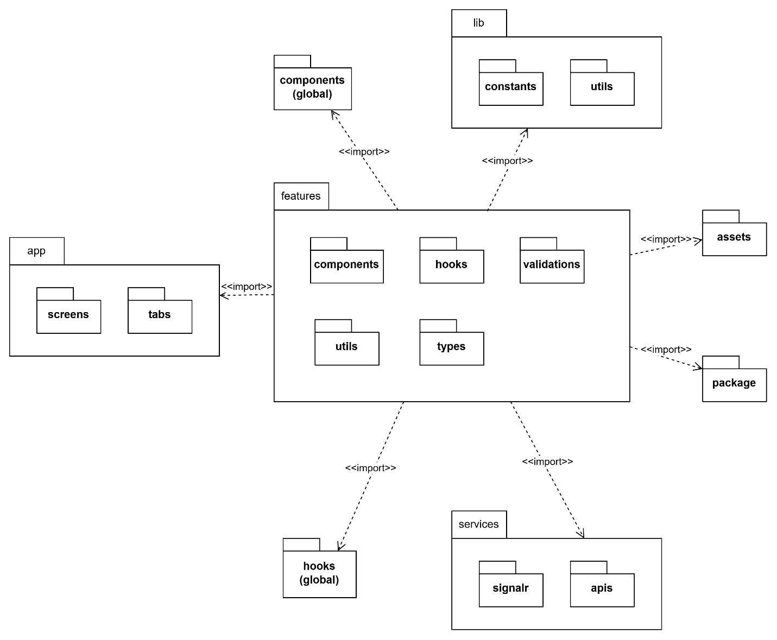
Diagram 10: Frontend Package Diagram (Mobile)
Package Descriptions
No | Package | Description
01 | Screens | Screen-level components for routing and navigation, directly rendered by the app
02 | Tabs | Tab-based navigation layouts and configurations for organizing screens
03 | Components (global) | Reusable UI elements (e.g. buttons, dialogs) shared across the application
04 | Hooks (global) | Application-wide hooks for cross-cutting concerns (authentication, listeners,...)
05 | Signalr | Real-time communication setup and utilities for managing persistent connections
06 | Apis | Service layer for API calls, request/response handling, and integration with backend endpoints
07 | Types (global) | Shared type definitions and models used across services, features, and app.
08 | Assets | Global static resources such as images, icons, SVGs, and other media.
09 | Constants | Centralized configuration values, enums, and constant definitions.
10 | Utils | Generic helper functions and utilities not bound to a specific feature.
11 | Features/Components | Feature-scoped UI components encapsulated within each feature domain.
12 | Features/Validations | Feature-specific validation logic and schemas for forms or inputs.
13 | Features/Hooks | Hooks scoped to a particular feature, encapsulating its state and logic.
14 | Features/Types | Feature-local type definitions, isolated from global types for modularity.
15 | Features/Utils | Utility functions designed for use only inside a specific feature.
Table 24: Frontend Package Descriptions (Mobile)

2. Database Design
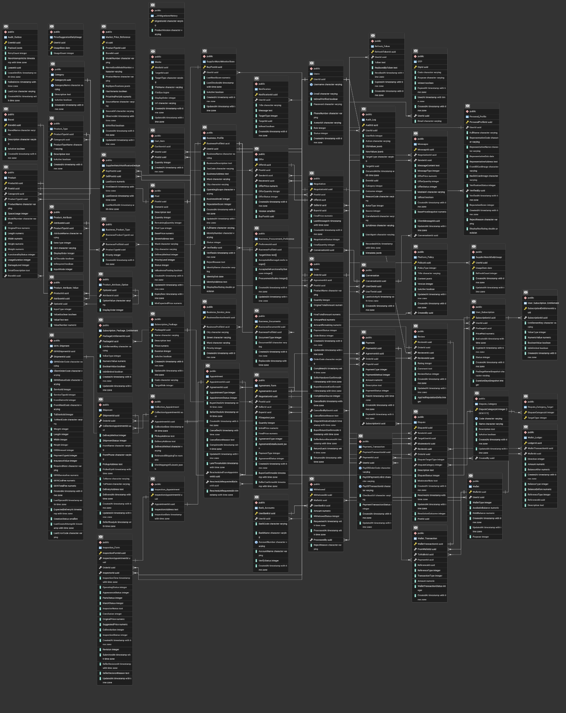
Diagram 12: Database Diagram

Table Descriptions
No | Table | Description
01 | Agreement_Form | Records an agreement derived from a negotiation, including participants, product snapshot, quantity, prices, terms, payment type, status, and confirmation times.  - Primary keys: AgreementId  - Foreign keys: NegotiationId, PostId, SellerId, BuyerId
02 | Appointment | Tracks inspection or collection appointments, attendance, status, cancellation, completion, and requests to reschedule an earlier appointment.  - Primary keys: AppointmentId  - Foreign keys: RescheduledFromAppointmentId, RescheduleRequestedByUserId, AgreementId
03 | Audit_Log | Records user and system actions with actor context, target identifiers, before-and-after values, outcome, time, and request metadata.  - Primary keys: AuditId  - Foreign keys: UserId
04 | Audit_Outbox | Queues audit event payloads for later processing, with retry, lease, scheduling, and failure information.  - Primary keys: EventId  - Foreign keys: None
05 | Bank_Accounts | Stores bank account details and verification status for a user.  - Primary keys: UserBankId  - Foreign keys: UserId
06 | Brand | Stores product brand names, descriptions, activation status, and creation time.  - Primary keys: BrandId  - Foreign keys: None
07 | Business_Documents | Stores document type, URL, creation time, and replacement time for a business profile.  - Primary keys: BusinessDocumentId  - Foreign keys: BusinessProfileId
08 | Business_Procurement_Preference | Stores a business profile's target cities, accepted damage and functionality levels, and procurement scales.  - Primary keys: PreferenceId  - Foreign keys: BusinessProfileId
09 | Business_Product_Type | Associates a business profile with a product type and its priority.  - Primary keys: BusinessProductTypeId  - Foreign keys: BusinessProfileId, ProductTypeId
10 | Business_Profile | Stores business identity, address, operating details, verification decisions, and reputation information for a user.  - Primary keys: BusinessProfileId  - Foreign keys: UserId, VerifiedBy
11 | Business_Service_Area | Lists a business profile's service locations by city, street, and ward, with a priority value.  - Primary keys: BusinessServiceAreaId  - Foreign keys: BusinessProfileId
12 | Cart_Item | Stores the post and quantity added to a user's cart.  - Primary keys: CartItemId  - Foreign keys: UserId, PostId
13 | Category | Stores top-level product categories, descriptions, activation status, and creation time.  - Primary keys: CategoryId  - Foreign keys: None
14 | Collection_Appointment | Stores collection date, pickup and delivery addresses, delivery method, estimated shipping fee, and GHN information for an appointment.  - Primary keys: CollectionAppointmentId  - Foreign keys: AppointmentId
15 | Conversation | Links two users in a conversation and records its creation and last activity times.  - Primary keys: ConversationId  - Foreign keys: UserOneId, UserTwoId
16 | Dispute | Records a dispute about an order, review, or other identified target, including involved users, category, status, moderator notes, and resolution.  - Primary keys: DisputeId  - Foreign keys: DisputeCategory, SenderId, TargetUserId, ModeratorId, ReviewId, OrderId
17 | Dispute_Category | Defines configurable dispute categories, descriptions, activation status, and the user who created each category.  - Primary keys: DisputeCategoryId  - Foreign keys: CreatedBy
18 | Dispute_Category_Target | Maps a dispute category to allowed target types; the category and target type together identify each row.  - Primary keys: DisputeCategoryId, TargetType  - Foreign keys: DisputeCategoryId
19 | GHN_Shipment | Stores GHN shipment codes, package details, charges, creation state, delivery estimate, and last synchronization information for a shipment.  - Primary keys: GHNShipmentId  - Foreign keys: ShipmentId
20 | Inspection_Appointment | Stores the inspection address and date associated with an appointment.  - Primary keys: InspectionAppointmentId  - Foreign keys: AppointmentId
21 | Inspection_Form | Records inspection findings, suggested price, revision, status, inspector, and seller decision for an order and inspection appointment.  - Primary keys: InspectionFormId  - Foreign keys: OrderId, InspectionAppointmentId, InspectorId
22 | Market_Price_Reference | Stores observed external product prices, model and specification evidence, source details, verification status, and observation date.  - Primary keys: Id  - Foreign keys: None
23 | Media | Stores media file metadata, URL, and a polymorphic target identified by TargetType and TargetId; the target has no declared foreign key.  - Primary keys: MediaId  - Foreign keys: None
24 | Messages | Stores conversation messages, including sender, content or media, offer details, read state, and optional negotiation context.  - Primary keys: MessageId  - Foreign keys: ConversationId, NegotiationId, SenderId
25 | Negotiation | Tracks negotiation participants, related offer and post, conversation, final price and quantity, status, and message activity.  - Primary keys: NegotiationId  - Foreign keys: ConversationId, PostId, OfferId, SellerId, BuyerId
26 | Notification | Stores a user notification with title, message, target identifiers, read state, and creation time.  - Primary keys: NotificationId  - Foreign keys: UserId
27 | Offer | Records a price and quantity offer on a post, its sender and receiver, status, version, and optional BuyPostId.  - Primary keys: OfferId  - Foreign keys: PostId, SenderId, ReceiverId
28 | Order | Tracks an agreed order, amounts and payment status, order status, delivery confirmations, cancellation, return, and dispute window.  - Primary keys: OrderId  - Foreign keys: CancelledByUserId, AgreementId, PostId
29 | OTP | Stores one-time codes, purpose, email or optional user association, expiration, and use status.  - Primary keys: OtpId  - Foreign keys: UserId
30 | Payment | Stores a payer's payment request and its amount, type, method, status, timestamps, and related agreement, order, or subscription.  - Primary keys: PaymentId  - Foreign keys: AgreementId, OrderId, PayerId, SubscriptionId
31 | Payment_Transaction | Tracks PayOS checkout codes and links, transaction identifier, processing status, and timestamps for a payment.  - Primary keys: PaymentTransactionId  - Foreign keys: PaymentId, UserId
32 | Personal_Profile | Stores a user's personal and representative identity information, ID-card images, verification decision, and reputation.  - Primary keys: PersonalProfileId  - Foreign keys: UserId, VerifiedBy
33 | Platform_Policy | Stores versioned platform policies as JSON content, with type, title, activation status, and optional creator.  - Primary keys: PolicyId  - Foreign keys: CreatedBy
34 | Post | Stores buy or sell listing details, owner identifier, quantity, prices, location, delivery method, status, and expiry.  - Primary keys: PostId  - Foreign keys: None
35 | PriceSuggestionDailyUsage | Tracks the number of price suggestions used by a user on a given date.  - Primary keys: UserId, UsageDate  - Foreign keys: None
36 | Product | Stores the item associated with a post, including category, product type, brand, model, size, weight, condition, and original price.  - Primary keys: ProductId  - Foreign keys: BrandId, PostId, CategoryId, ProductTypeId
37 | Product_Attribute | Defines product-type attributes, value type, unit, display order, filtering, requirement, and input mode.  - Primary keys: AttributeId  - Foreign keys: ProductTypeId
38 | Product_Attribute_Option | Defines selectable values and display order for a product attribute.  - Primary keys: OptionId  - Foreign keys: AttributeId
39 | Product_Attribute_Value | Stores an attribute value for a product as an option, text, number, or boolean.  - Primary keys: ProductId, AttributeId  - Foreign keys: ProductId, AttributeId, OptionId
40 | Product_Type | Defines product types under a category, with description and activation status.  - Primary keys: ProductTypeId  - Foreign keys: CategoryId
41 | Refresh_Token | Stores refresh tokens for users, their replacement and revocation information, and expiration time.  - Primary keys: RefreshTokenId  - Foreign keys: UserId
42 | Review | Stores a review of an order, including reviewer, reviewee, rating, comment, status, and reputation adjustment.  - Primary keys: ReviewId  - Foreign keys: OrderId, ReviewerId, RevieweeId
43 | Shipment | Tracks delivery method and status, pickup and delivery contacts and locations, and handover milestones for an order.  - Primary keys: ShipmentId  - Foreign keys: OrderId, CollectionAppointmentId
44 | Subscription_Package | Defines subscription package code, target role, price, duration, description, and activation status.  - Primary keys: PackageId  - Foreign keys: None
45 | Subscription_Package_Entitlement | Defines a package entitlement by key and value type, with numeric, boolean, or unlimited value.  - Primary keys: PackageEntitlementId  - Foreign keys: PackageId
46 | SupplierMatchDailyUsage | Tracks each user's supplier-match refresh count for a given day.  - Primary keys: UserId, UsageDate  - Foreign keys: UserId
47 | SupplierMatchMonitorState | Tracks a buy post's supplier-match monitoring state, user, best score, and latest check.  - Primary keys: BuyPostId  - Foreign keys: BuyPostId, UserId
48 | SupplierMatchNotificationDedupe | Tracks matched buy and sell post pairs, score, first and last sightings, and most recent notification time.  - Primary keys: BuyPostId, SellPostId  - Foreign keys: BuyPostId, SellPostId
49 | User_Subscription | Records a user's subscription to a package, price paid, activation and expiry, status, and package snapshots.  - Primary keys: SubscriptionId  - Foreign keys: UserId, PackageId
50 | User_Subscription_Entitlement | Stores an entitlement snapshot for a user subscription, including its key, value type, and numeric, boolean, or unlimited value.  - Primary keys: SubscriptionEntitlementId  - Foreign keys: SubscriptionId
51 | Users | Stores user authentication and contact details, email verification, role, status, and creation time.  - Primary keys: UserId  - Foreign keys: None
52 | Wallet | Stores a user's wallet type, purpose, available balance, and held balance.  - Primary keys: WalletId  - Foreign keys: UserId
53 | Wallet_Ledger | Records wallet balance entries before and after transactions, including amount, direction, balance type, and reference information.  - Primary keys: LedgerId  - Foreign keys: WalletTransactionId, WalletId
54 | Wallet_Transaction | Records amounts transferred between optional source and destination wallets, with payment reference, type, and status.  - Primary keys: WalletTransactionId  - Foreign keys: FromWalletId, ToWalletId, PaymentId
55 | Withdrawal | Tracks requests to withdraw wallet funds to bank accounts, including amount, status, processing user, and rejection reason.  - Primary keys: WithdrawalId  - Foreign keys: WalletId, UserBankId, ProcessedBy
56 | __EFMigrationsHistory | Tracks applied EF Core migration identifiers and their product versions.  - Primary keys: MigrationId  - Foreign keys: None
Table 25: Database Table Descriptions

3. Detailed Design

3.1 Manage Personal Profile

3.1.1 Class Diagram
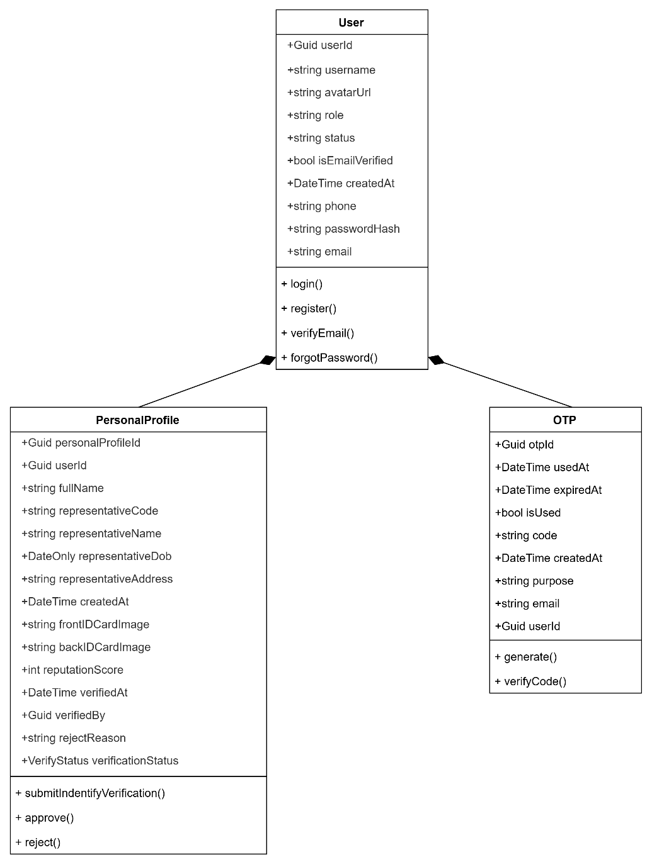
Diagram 13: Manage Personal Profile class diagram
3.1.2 Verify email and otp
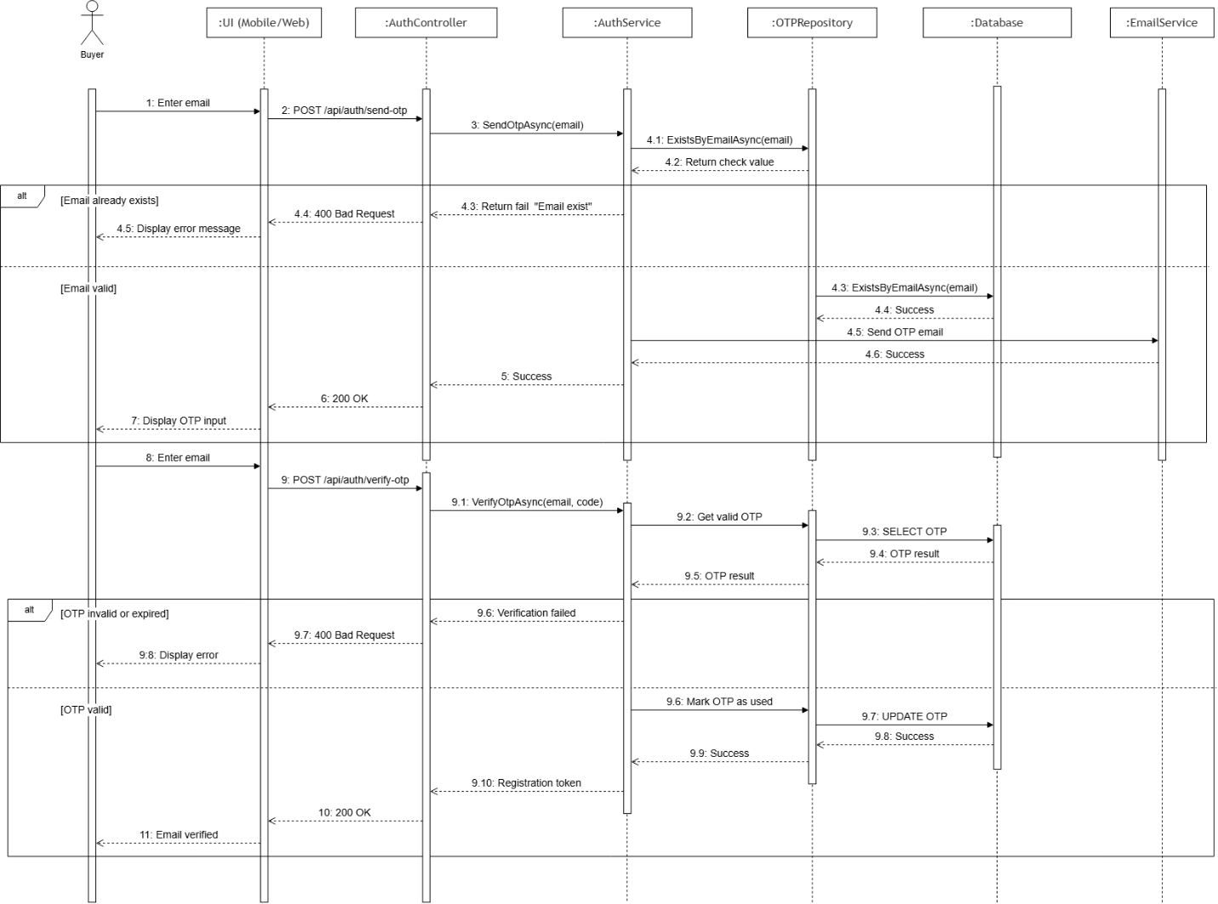
Diagram 14: Verify Email and OTP sequence diagram
3.1.3 Register account
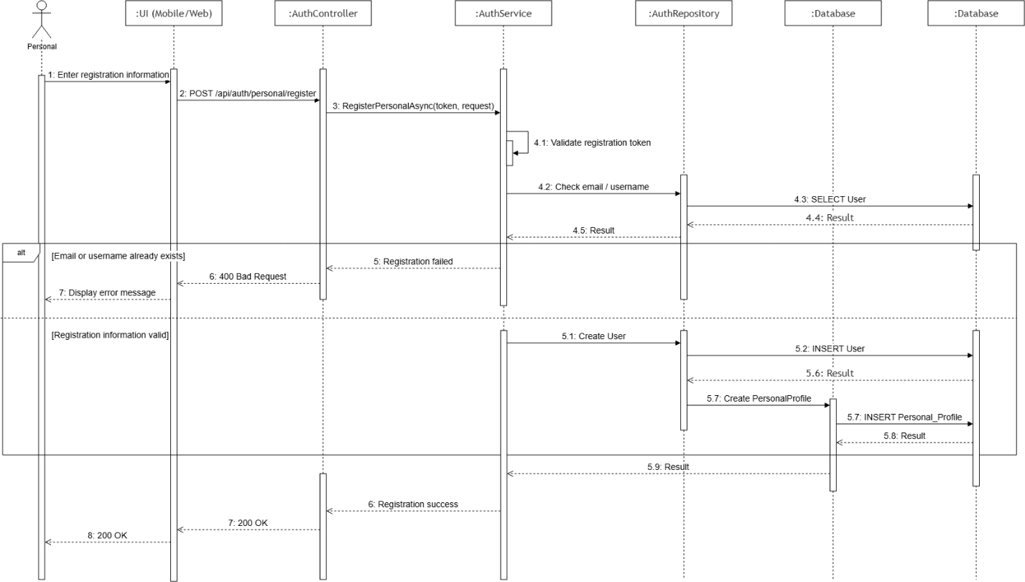
Diagram 15: Register Personal Account sequence diagram
3.1.4 Submit Identity Verification
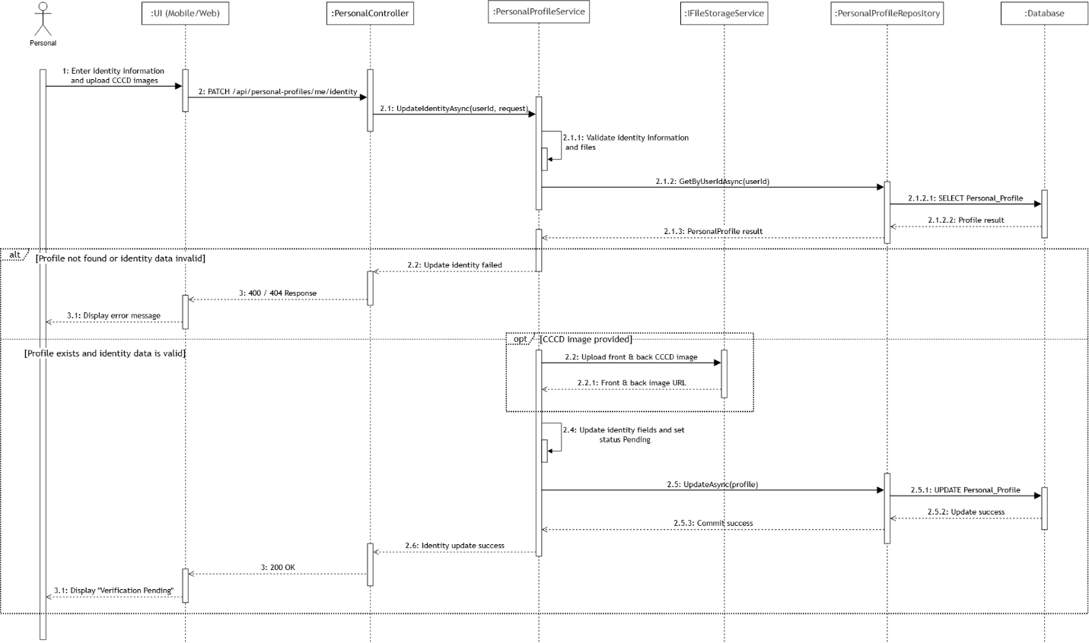
Diagram 16: SubmitIdentity Verification sequence diagram

3.2 Manage Business Profile

3.2.1 Class Diagram
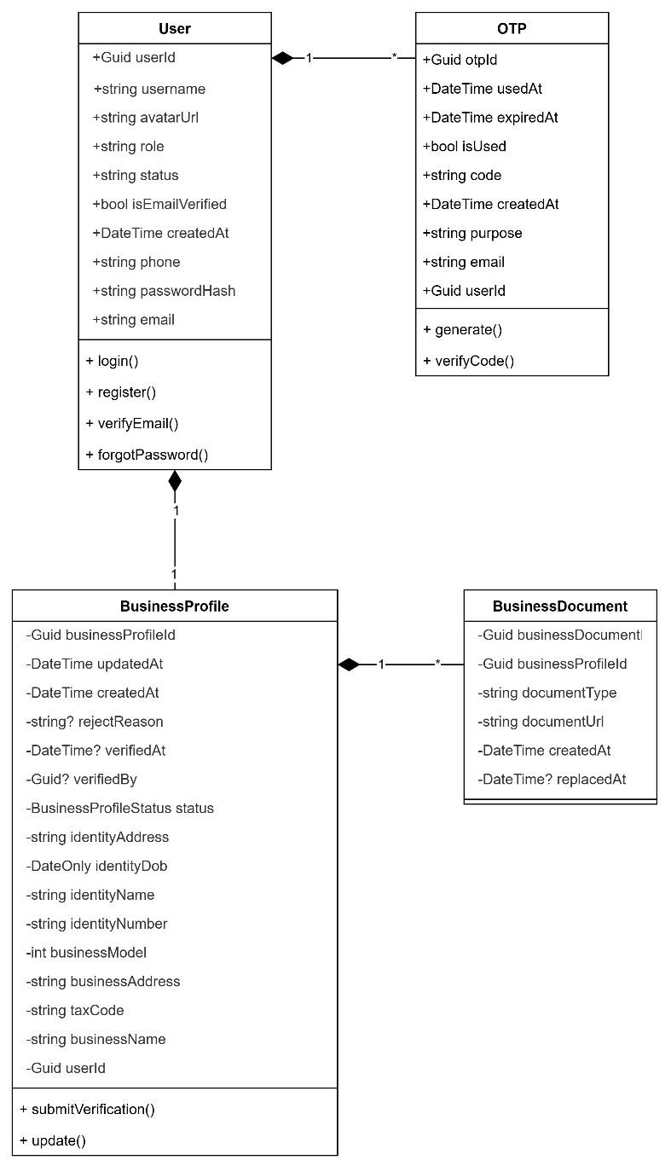
Diagram 17: Manage Business Profile class diagram

3.2.2 Register account
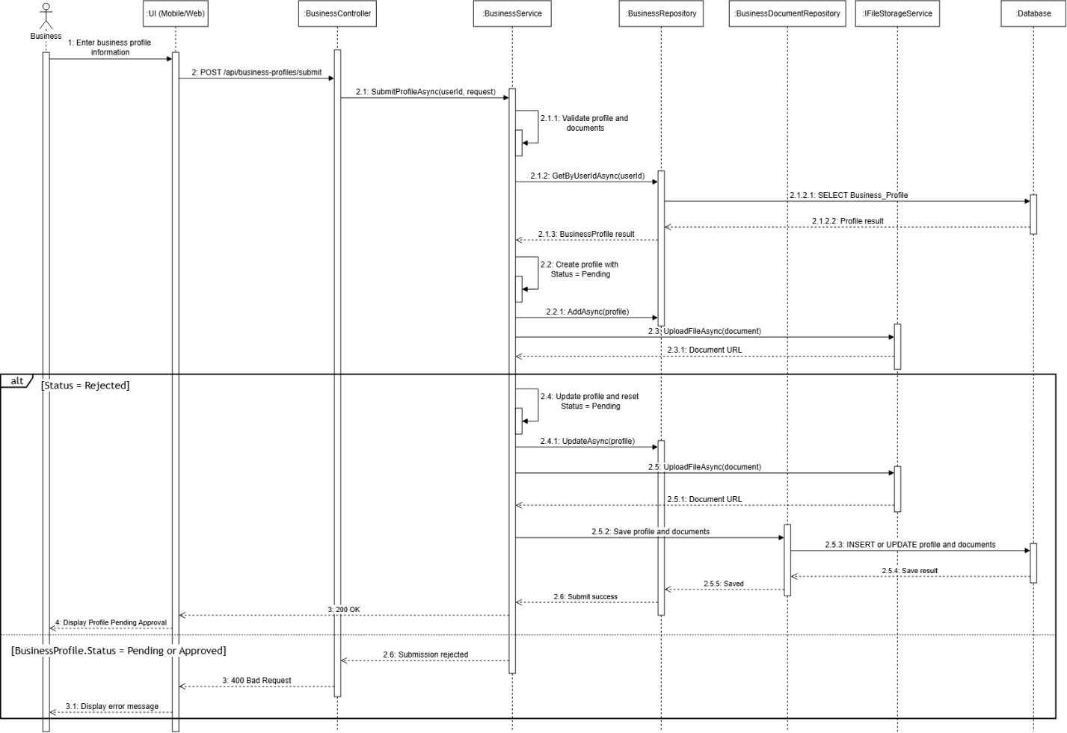
Diagram 18: Register Business Account sequence diagram

3.2.3 Moderator verify business account
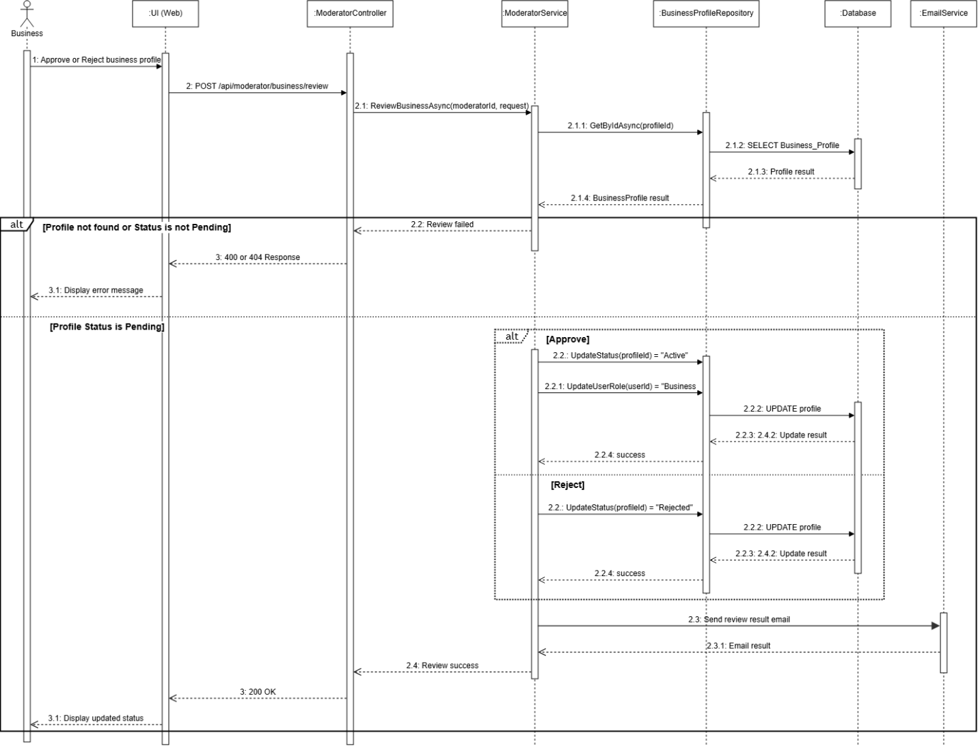
Diagram 19: Moderator Verify Business Account sequence diagram

3.3 Post Management

3.3.1 Class Diagram
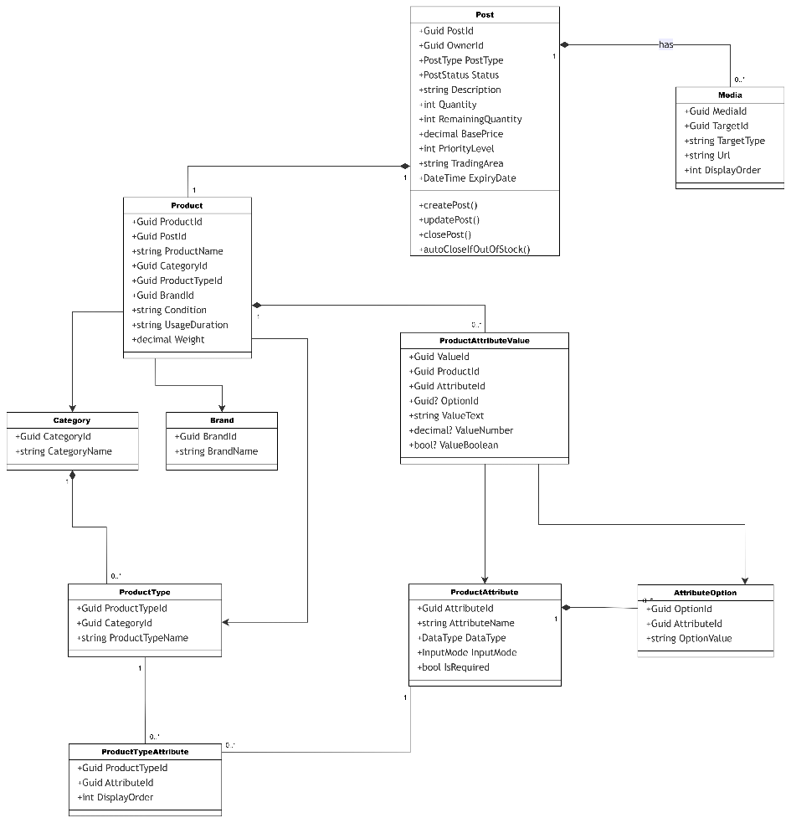
Diagram 20: Post Management class diagram

3.3.2 Create Product Post (Sell)
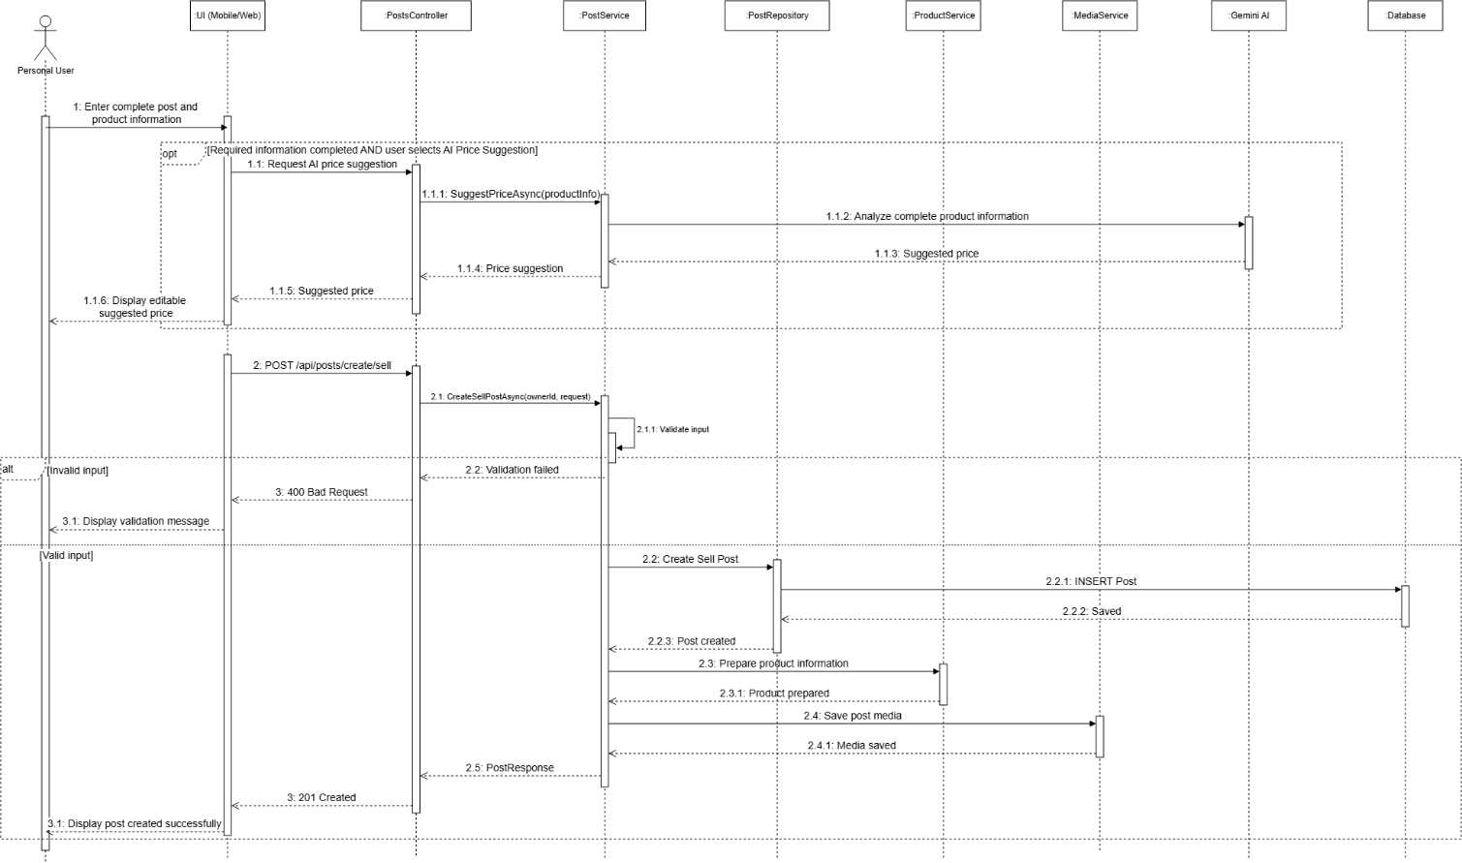
Diagram 21: Create Product Post (Sell) sequence diagram

3.3.2 Create Product Post (Buy)
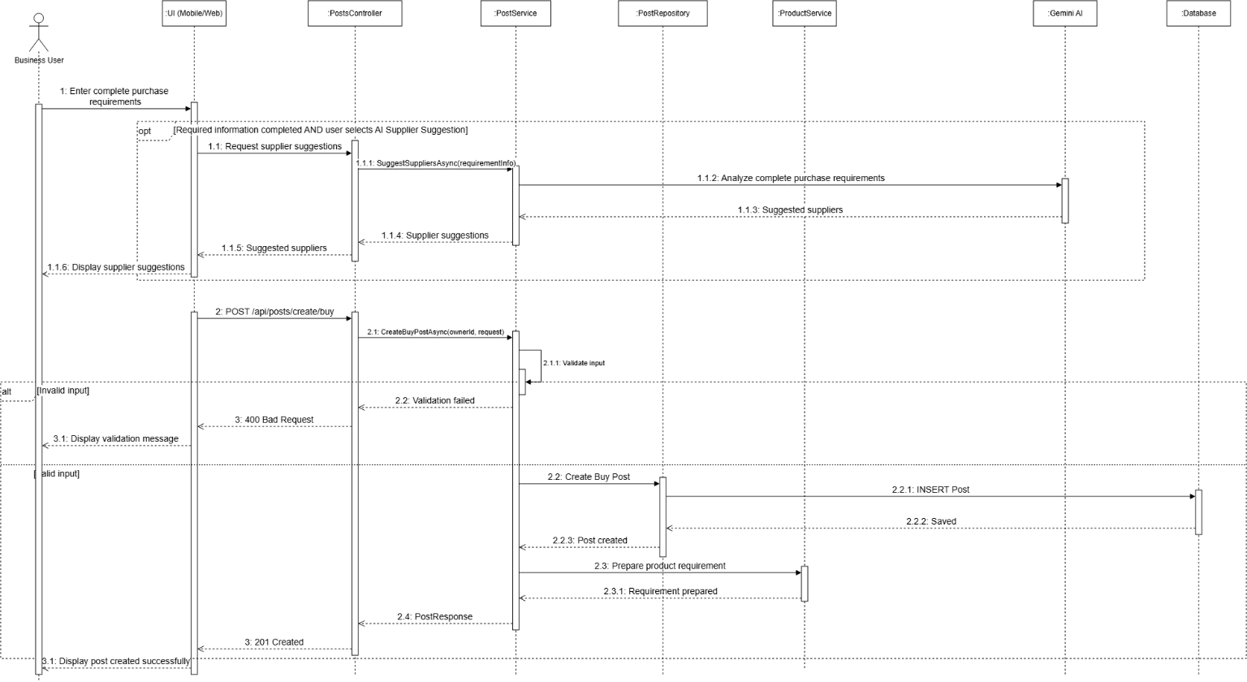
Diagram 22: Create Product Post (Buy) sequence diagram

3.3.3 Search & Filter Post
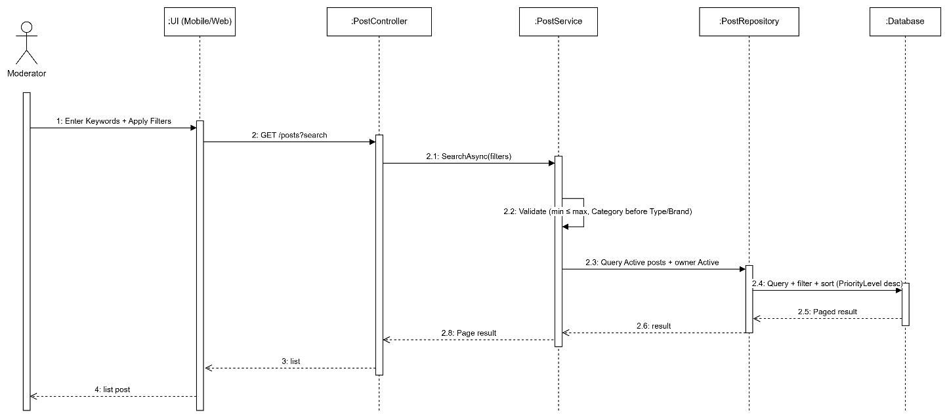
Diagram 23: Search & Filter Post sequence diagram

3.3.4 Moderator suspend post
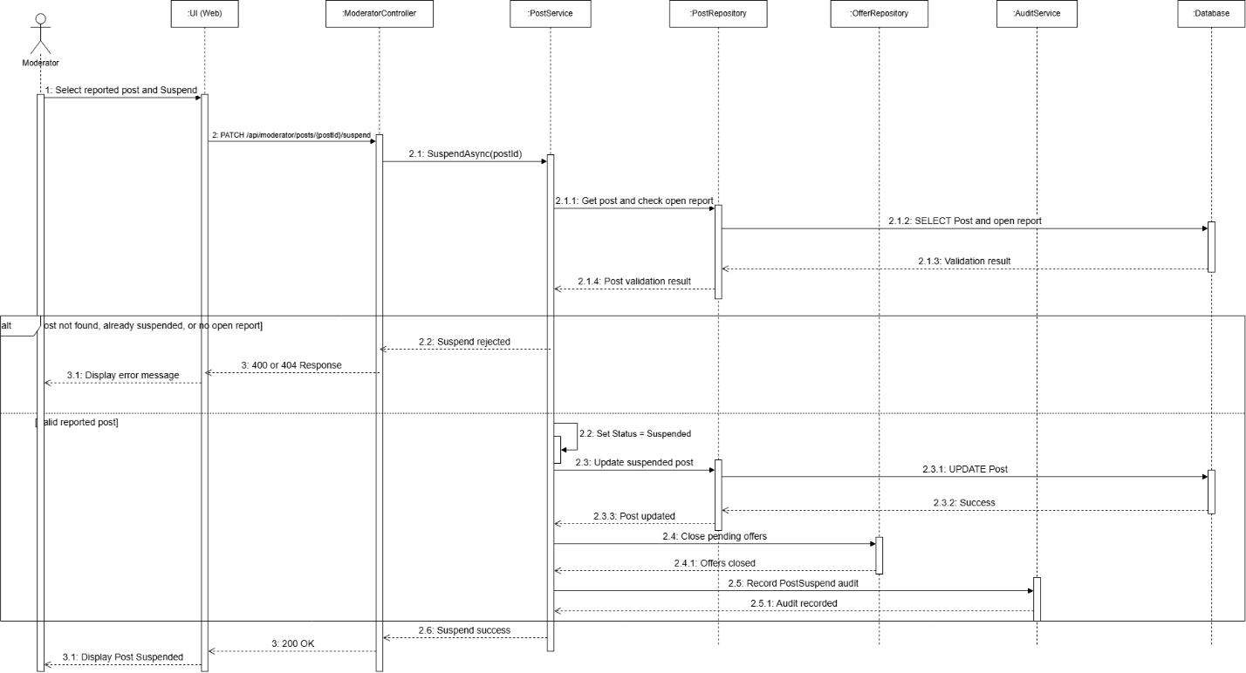
Diagram 24: Moderator Suspend Post sequence diagram

3.4 Cart Management

3.4.1 Class Diagram
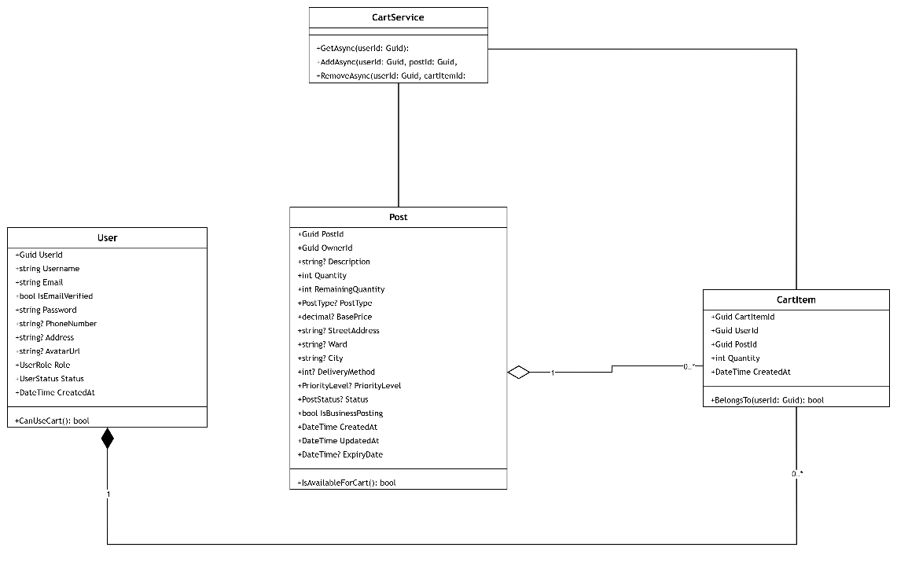
Diagram 25: Cart Management class diagram

3.4.2 Add post to cart
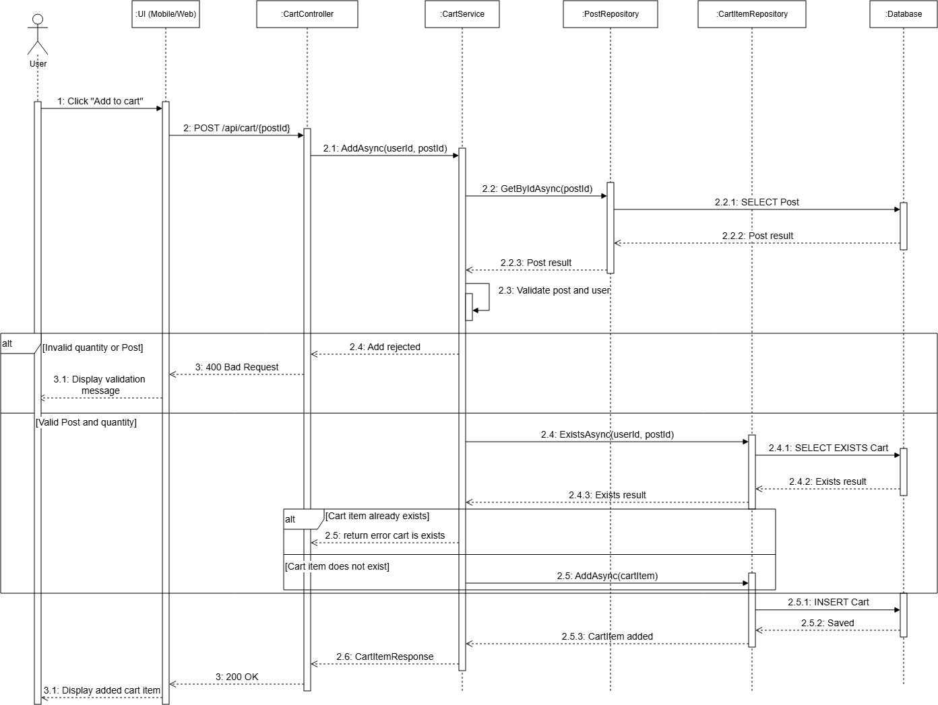
Diagram 26: Add Post to Cart sequence diagram

3.4.3 Remove cart
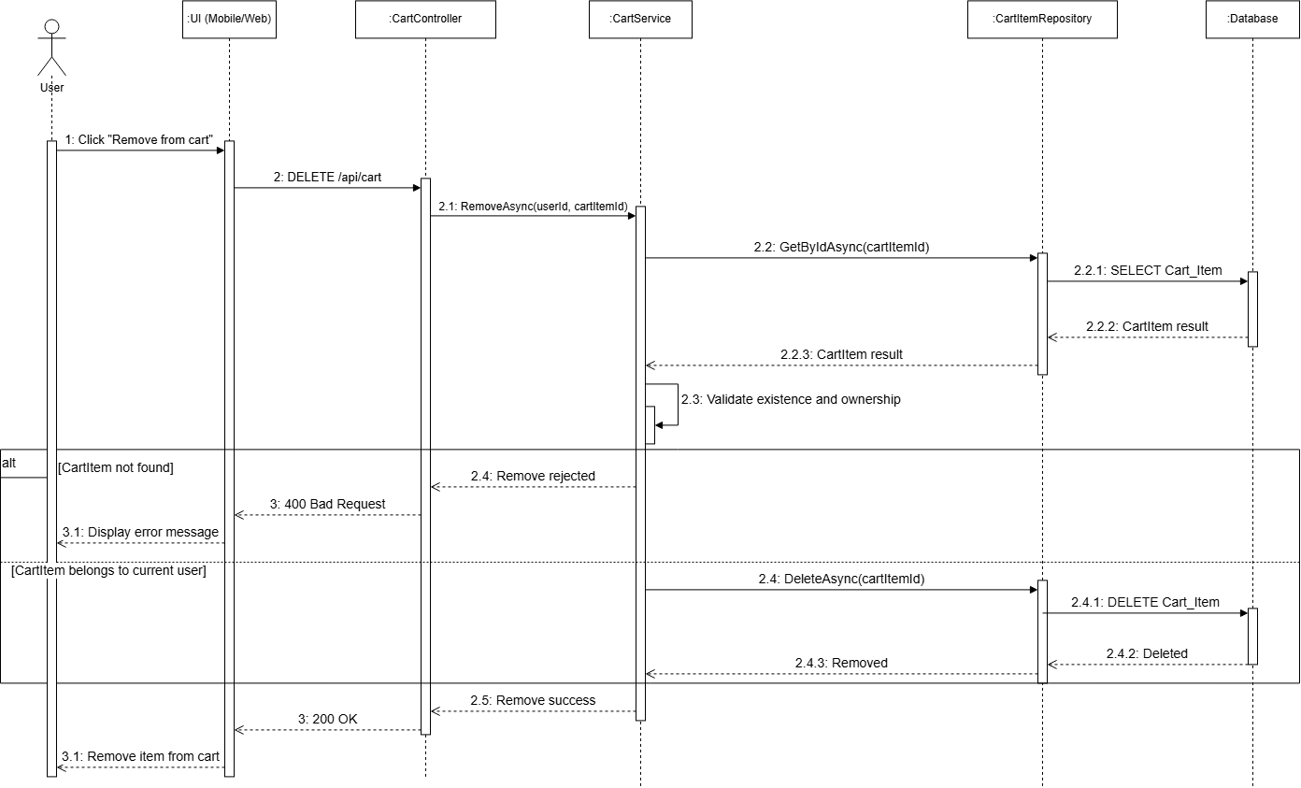
Diagram 27: Remove Cart Item sequence diagram

3.5 Offer Management

3.5.1 Class Diagram
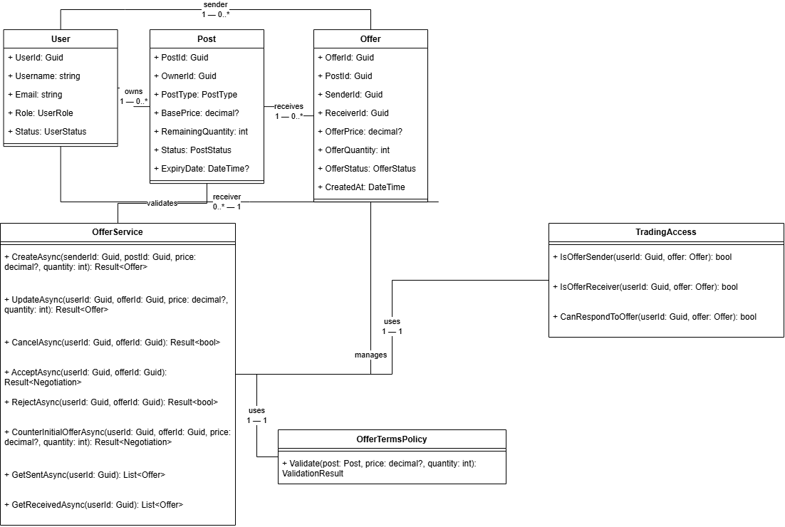
Diagram 28: Offer Management class diagram

3.5.2 Send offer
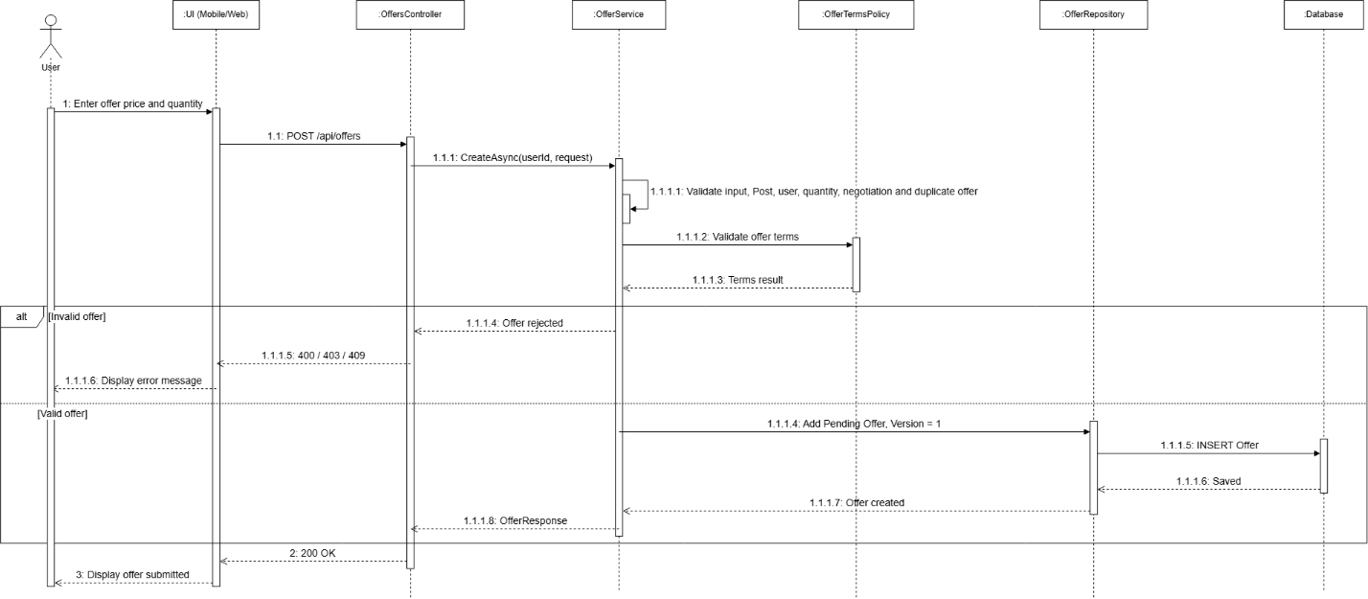
Diagram 29: Send Offer sequence diagram

3.5.3 Accept offer
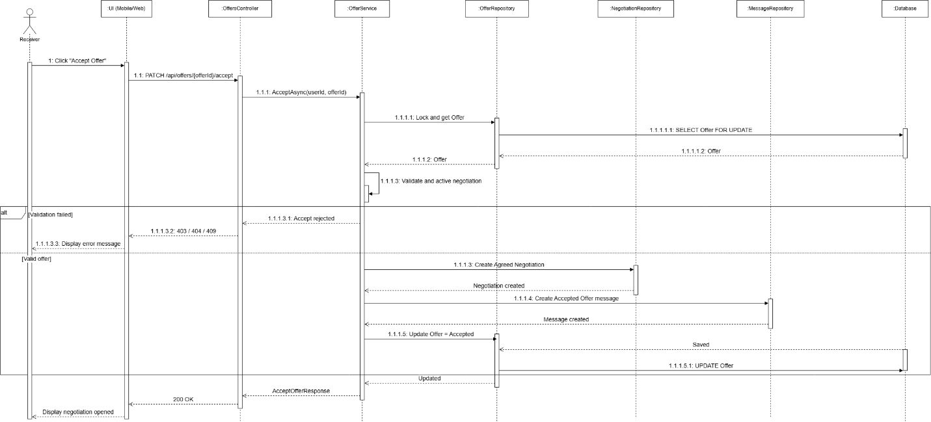
Diagram 30: Accept Offer sequence diagram

3.5.4 Counter offer
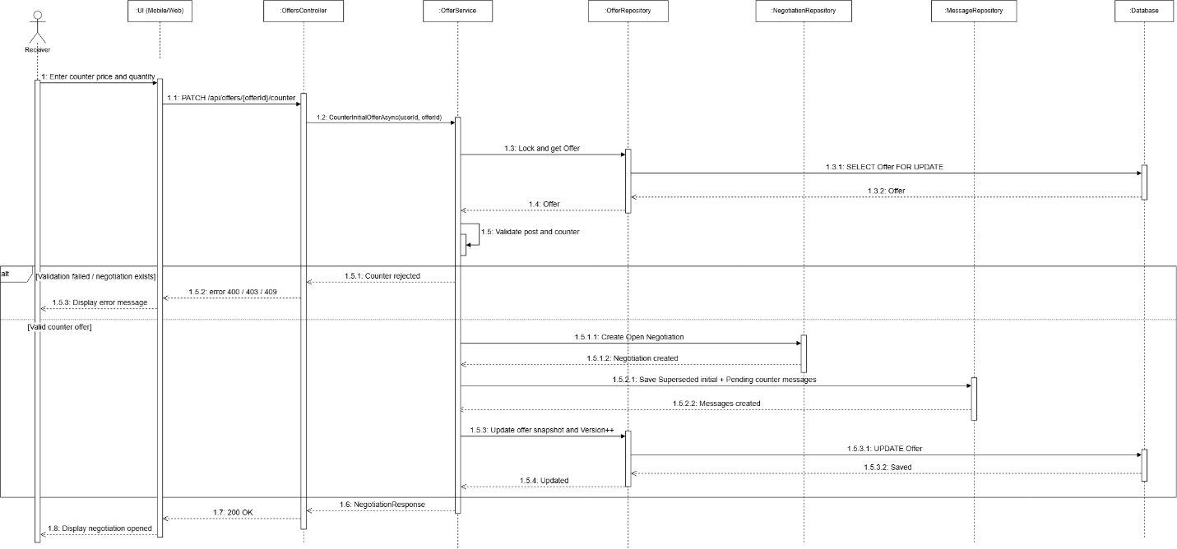
Diagram 31: Counter Offer sequence diagram

3.6 Negotiation and agreement

3.6.1 Class Diagram
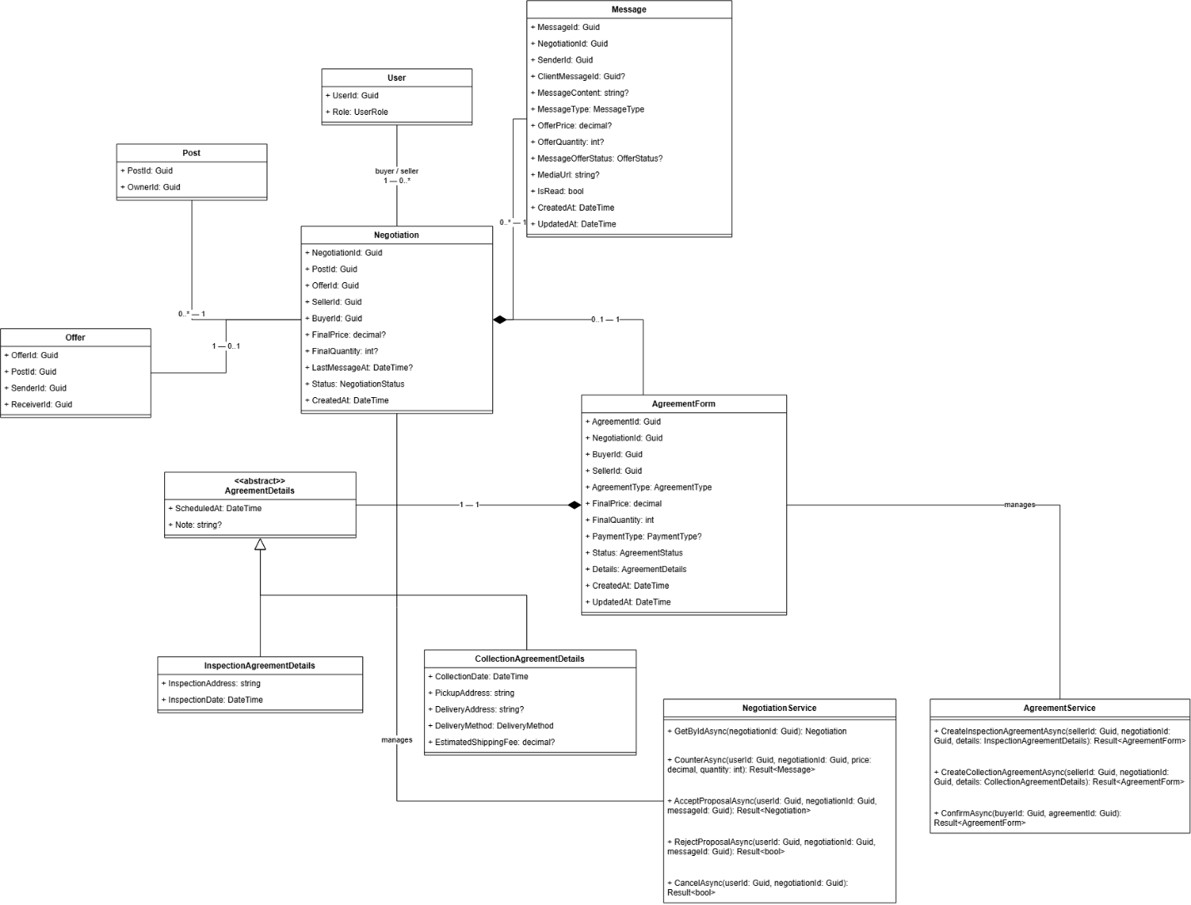
Diagram 32: Negotiation and Agreement class diagram

3.6.2 Chat in Negotiation
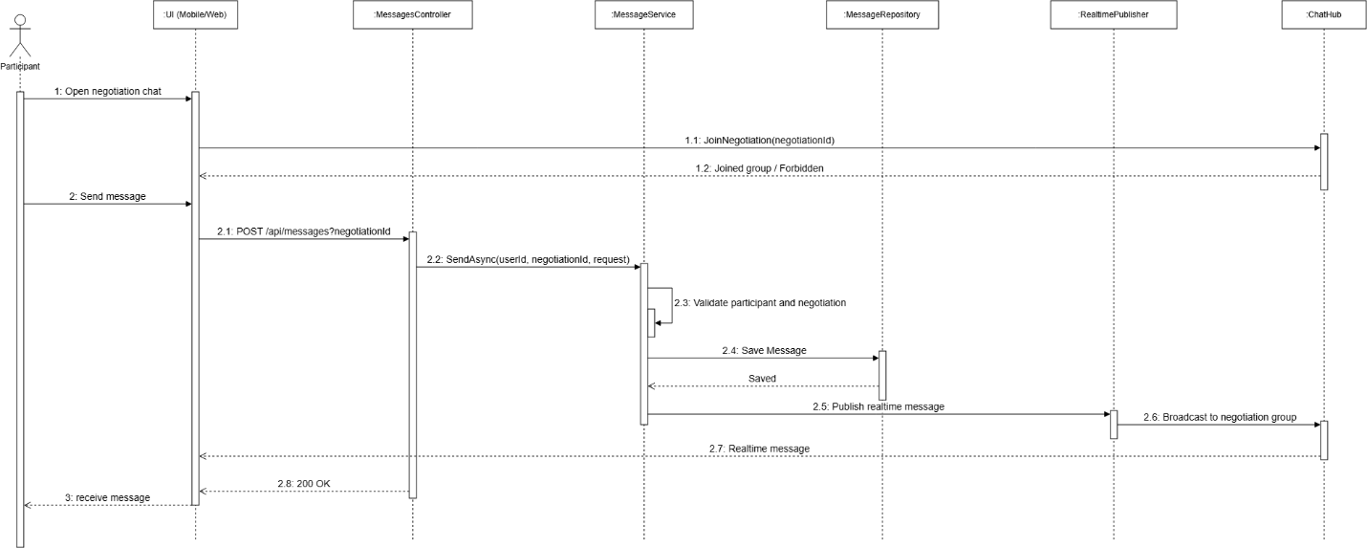
Diagram 33: Chat in Negotiation sequence diagram

3.6.3 Cancel negotiations
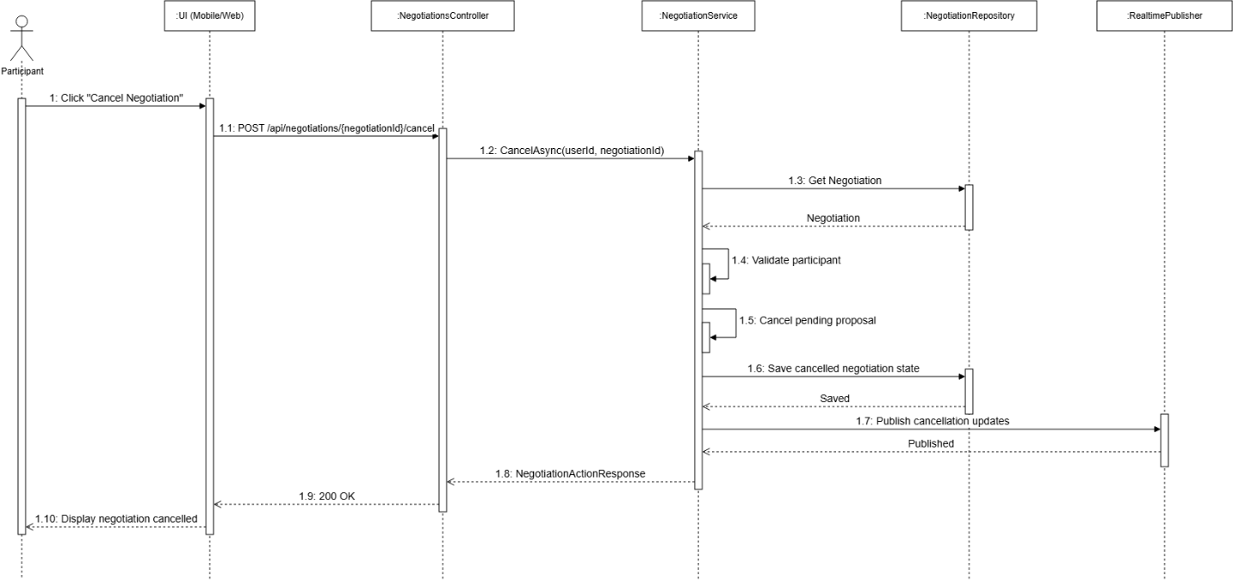
Diagram 34: Cancel Negotiation sequence diagram
3.6.4 Create Inspection Agreement
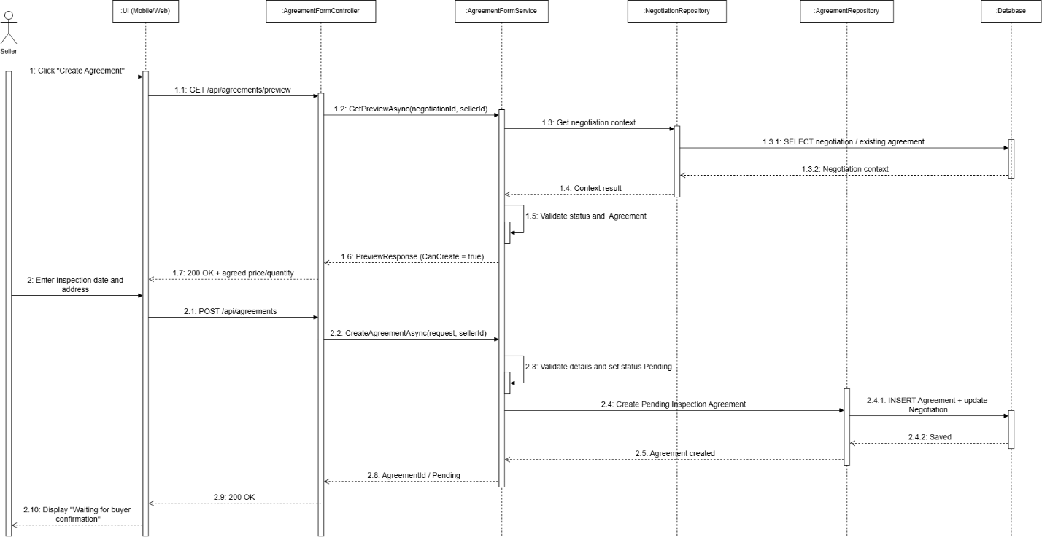
Diagram 35: Create Inspection Agreement sequence diagram
3.6.4 Create Collection Agreement
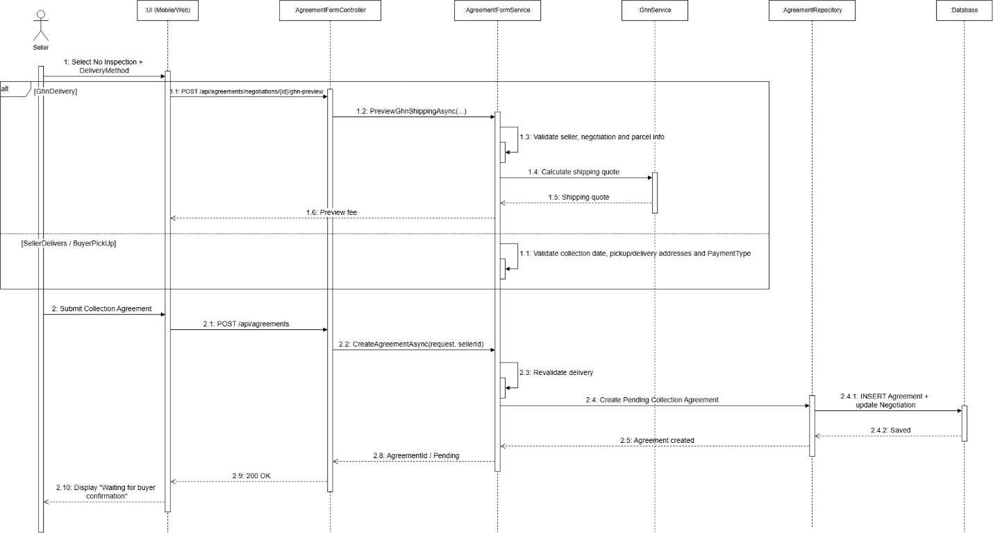
Diagram 36: Create Collection Agreement sequence diagram

3.7 Payment agreement

3.7.1 Class diagrams
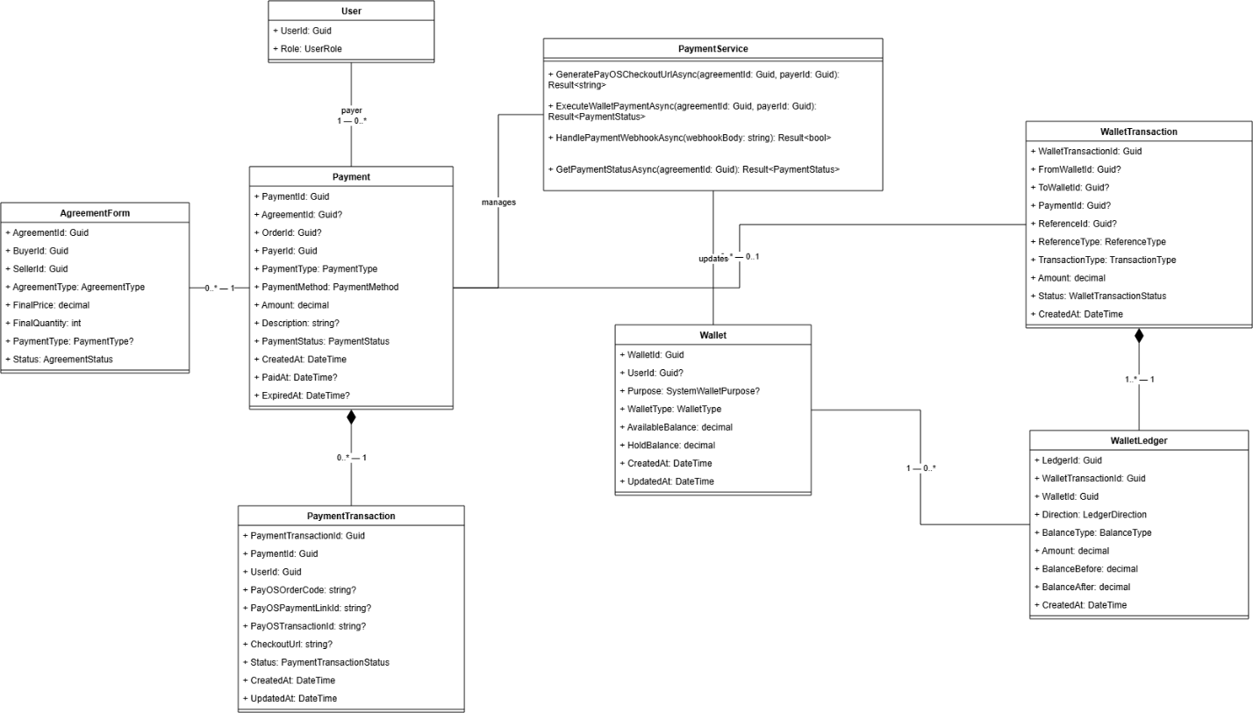
Diagram 37: Payment Agreement class diagram

3.7.1 Create PayOS Checkout
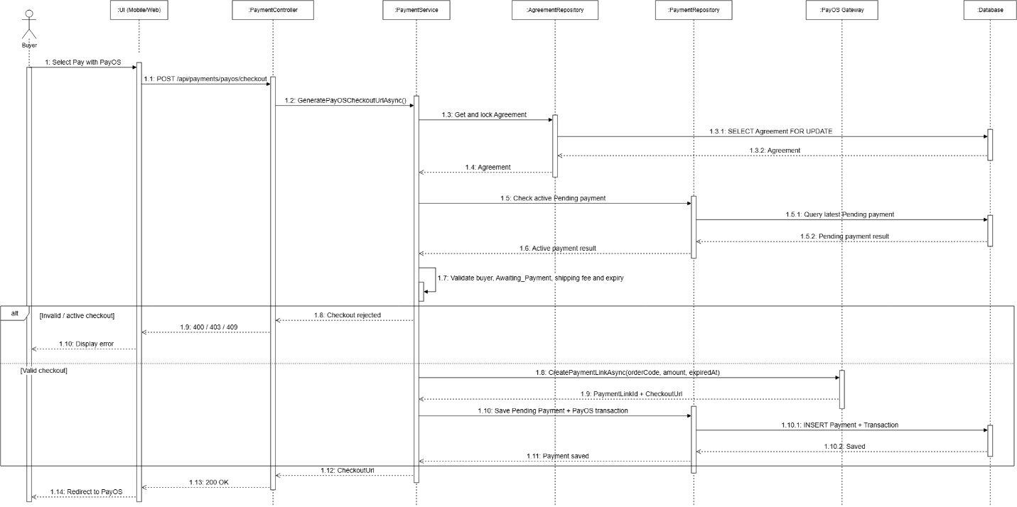
Diagram 38: Create PayOS Checkout sequence diagram

3.7.2 Internal wallet payment
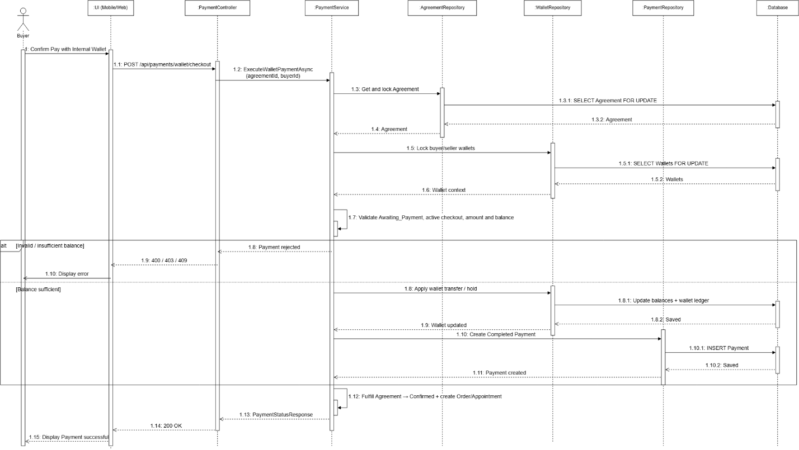
Diagram 39: Internal Wallet Payment (Agreement) sequence diagram

3.8 Order management

3.8.1 Class diagram
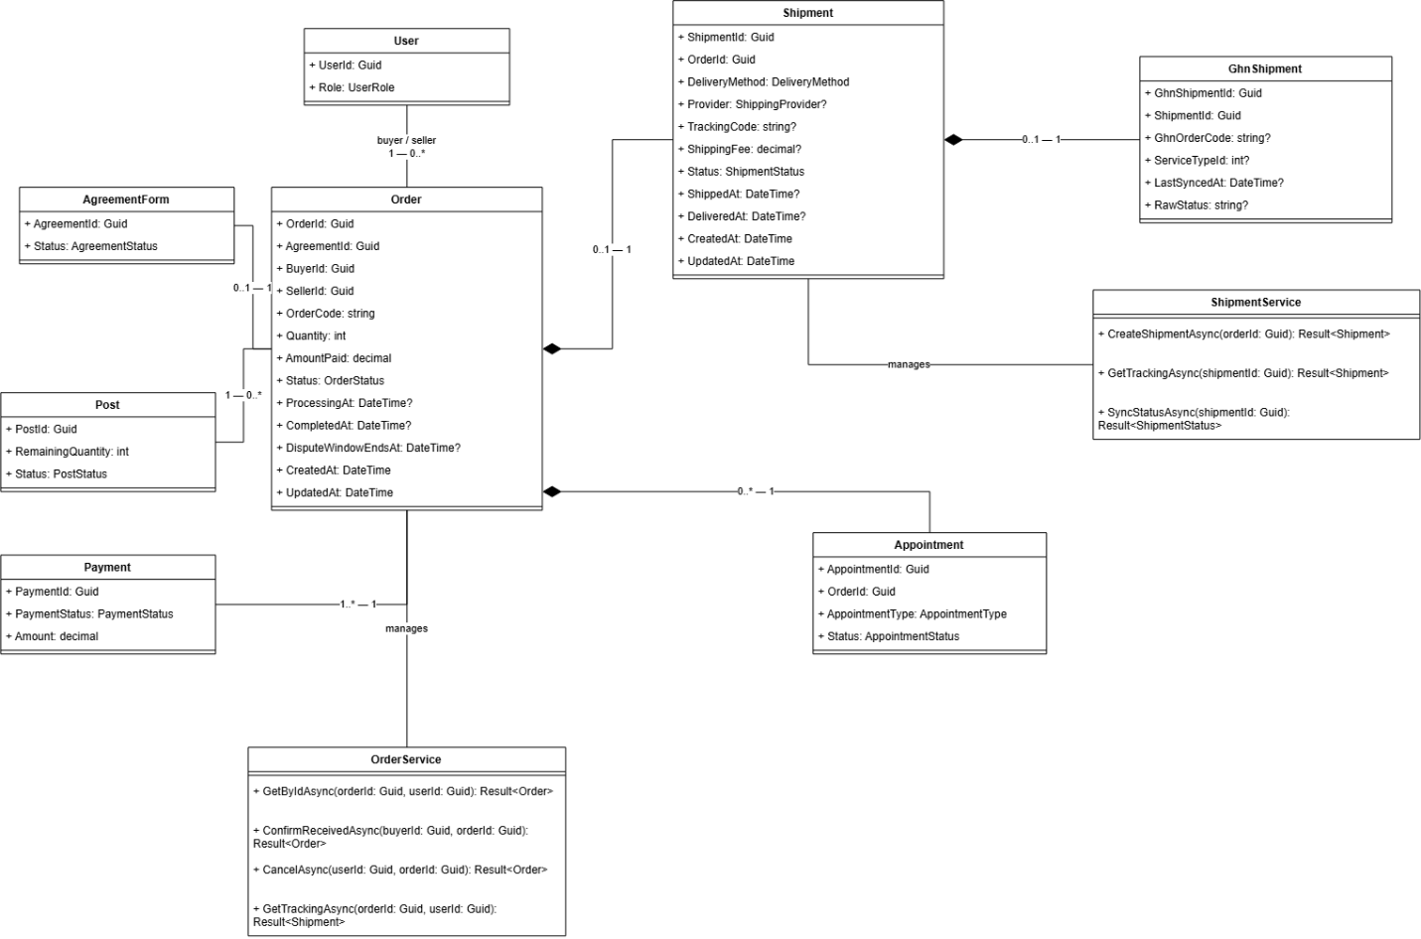
Diagram 40: Order Management class diagram

3.8.2 Create Order
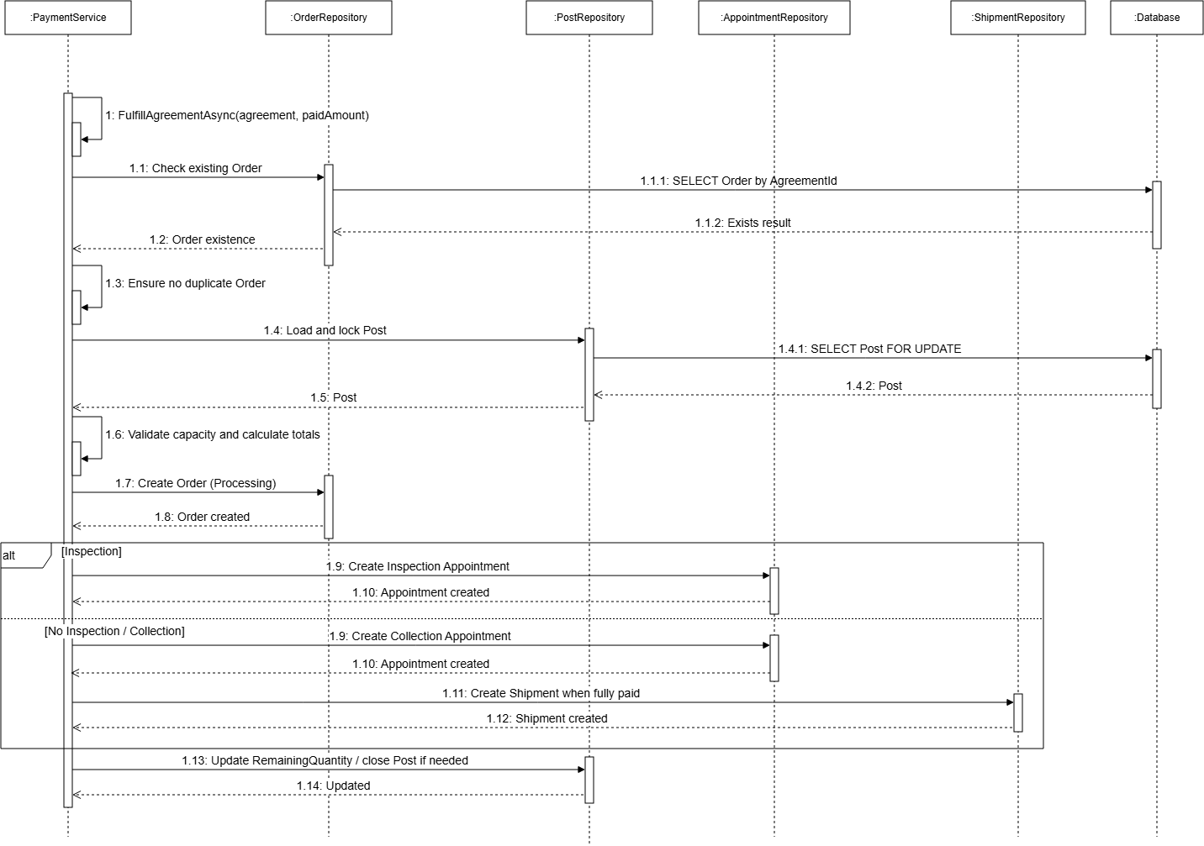
Diagram 41: Create Order sequence diagram

3.8.2 Tracking Order
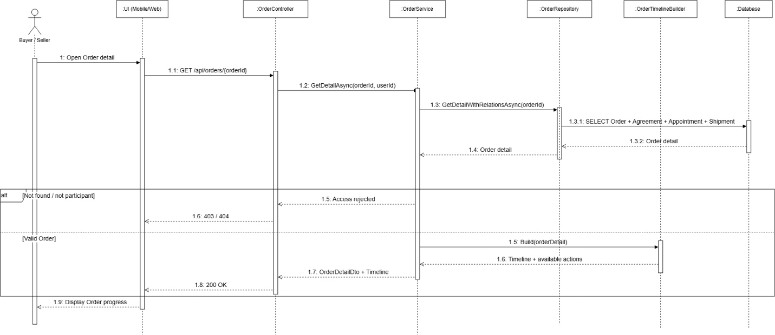
Diagram 42: Tracking Order sequence diagram

3.8.2 SellerDelivers / BuyerPickUp
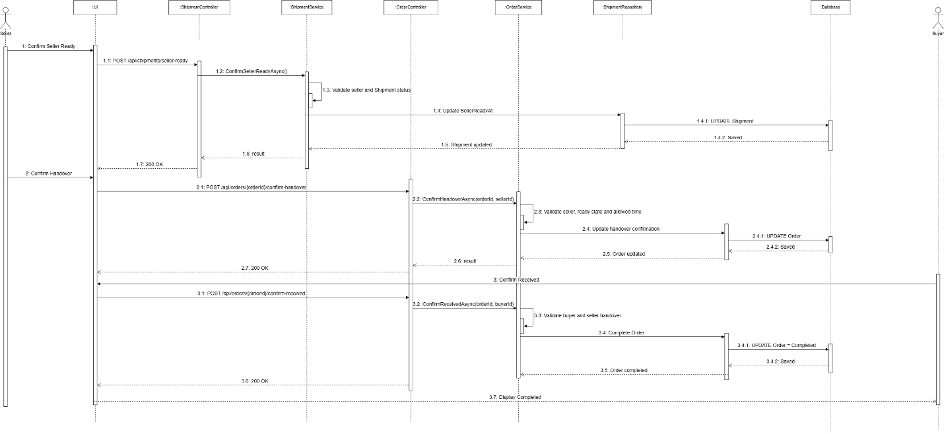
Diagram 43: Seller Delivers / Buyer Pick Up sequence diagram

3.8.2 GHN Delivery
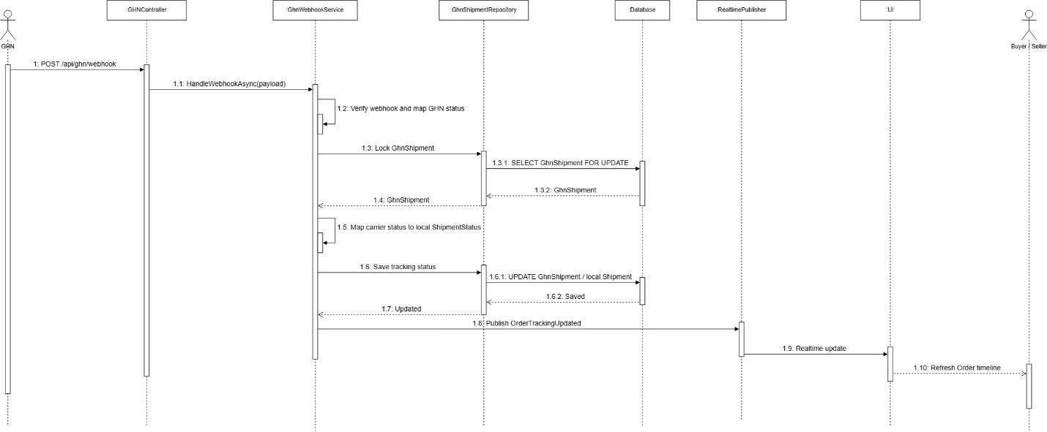
Diagram 44: GHN Delivery sequence diagram

3.9 Appointment management

3.9.1 Class Diagram
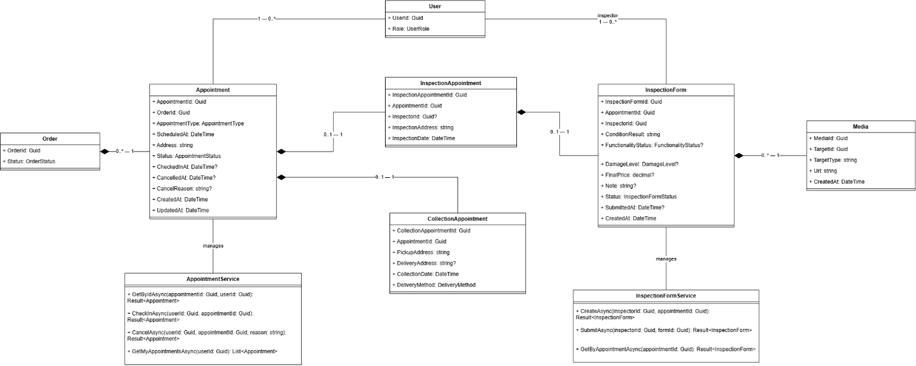
Diagram 45: Appointment Management class diagram

3.9.2 Check-in Appointment
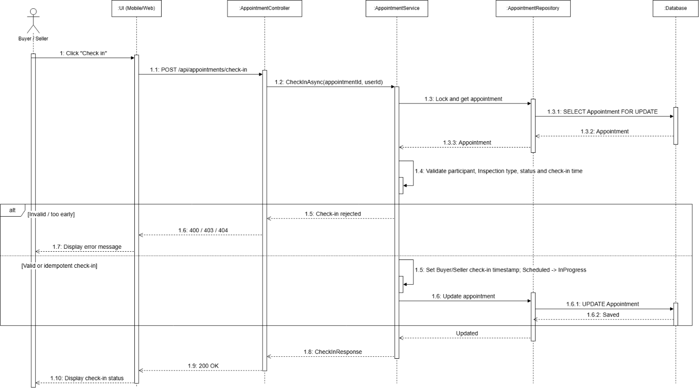
Diagram 46: Check-in Appointment sequence diagram

3.9.2 Submit Inspection Form
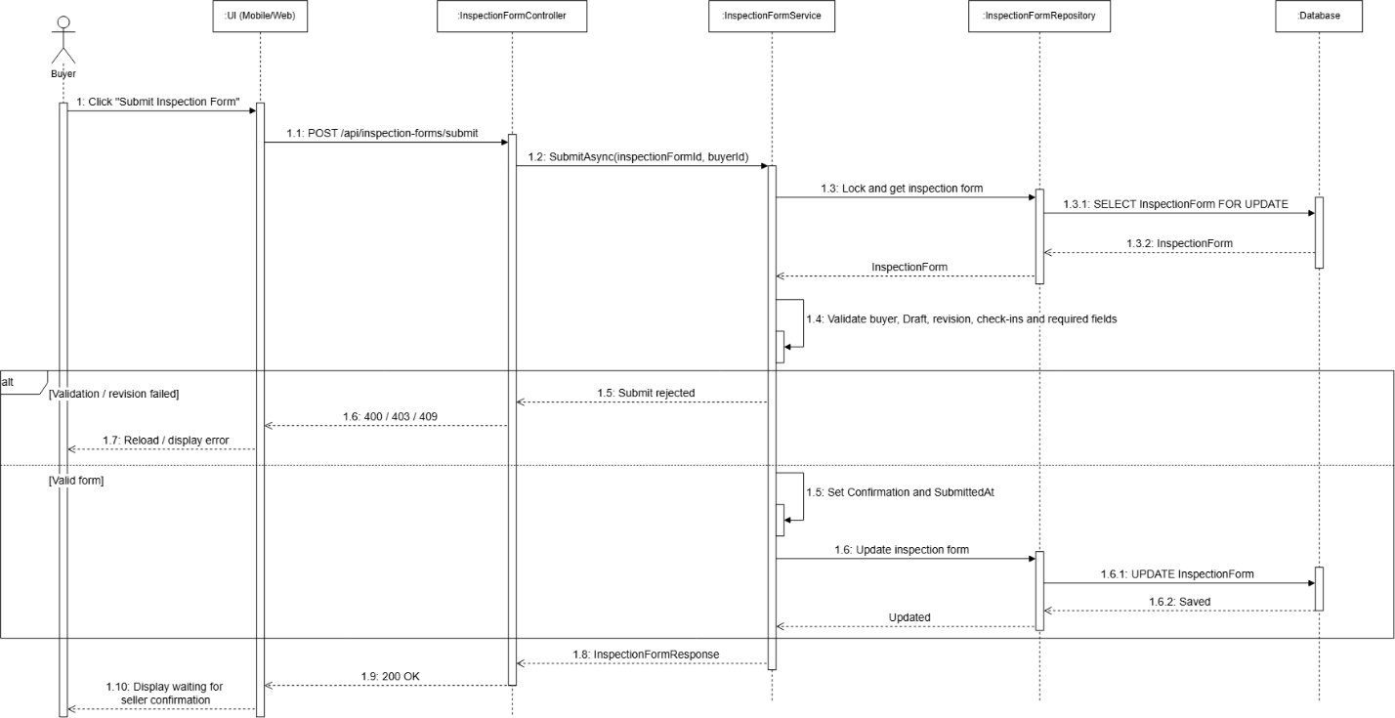
Diagram 47: Submit Inspection Form sequence diagram

3.10 Wallet management

3.10.1 Class Diagram
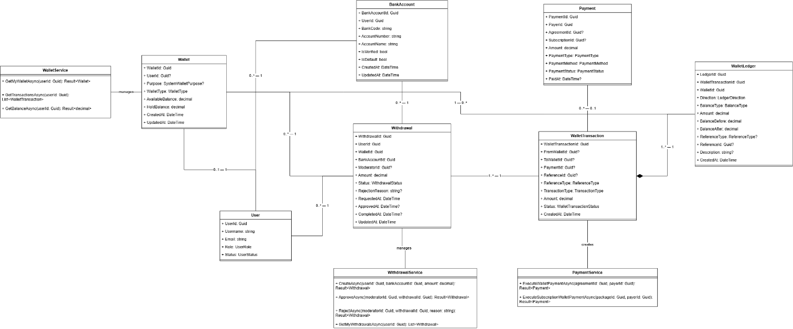
Diagram 48: Wallet Management class diagram

3.10.2 Internal Wallet Payment
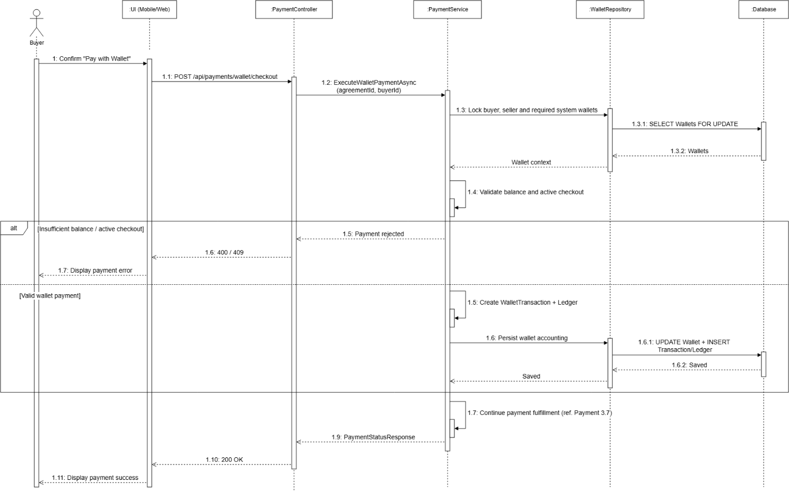
Diagram 49: Internal Wallet Payment sequence diagram

3.10.2 withdrawal
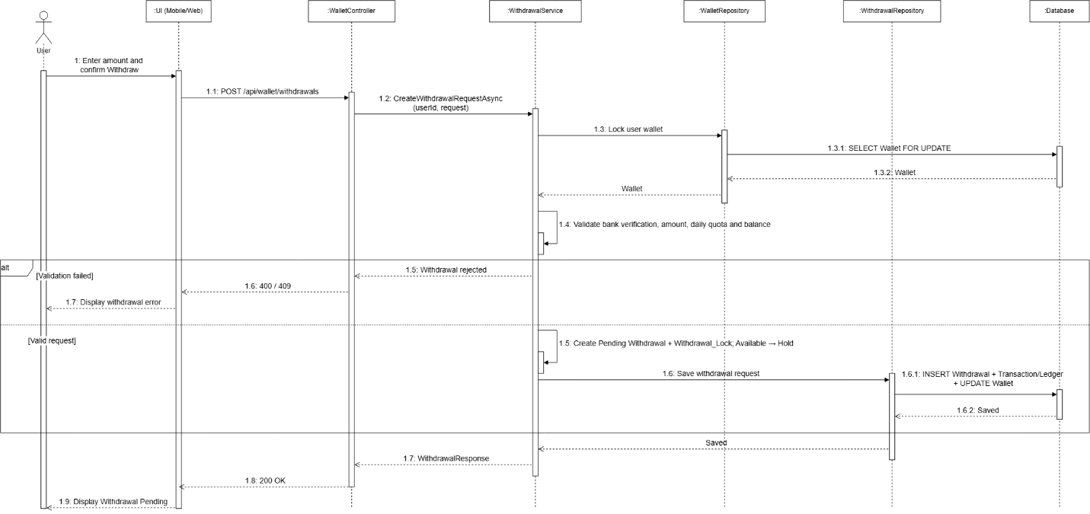
Diagram 50: Withdrawal sequence diagram

3.11 Review Management

3.11.1 Class Diagram
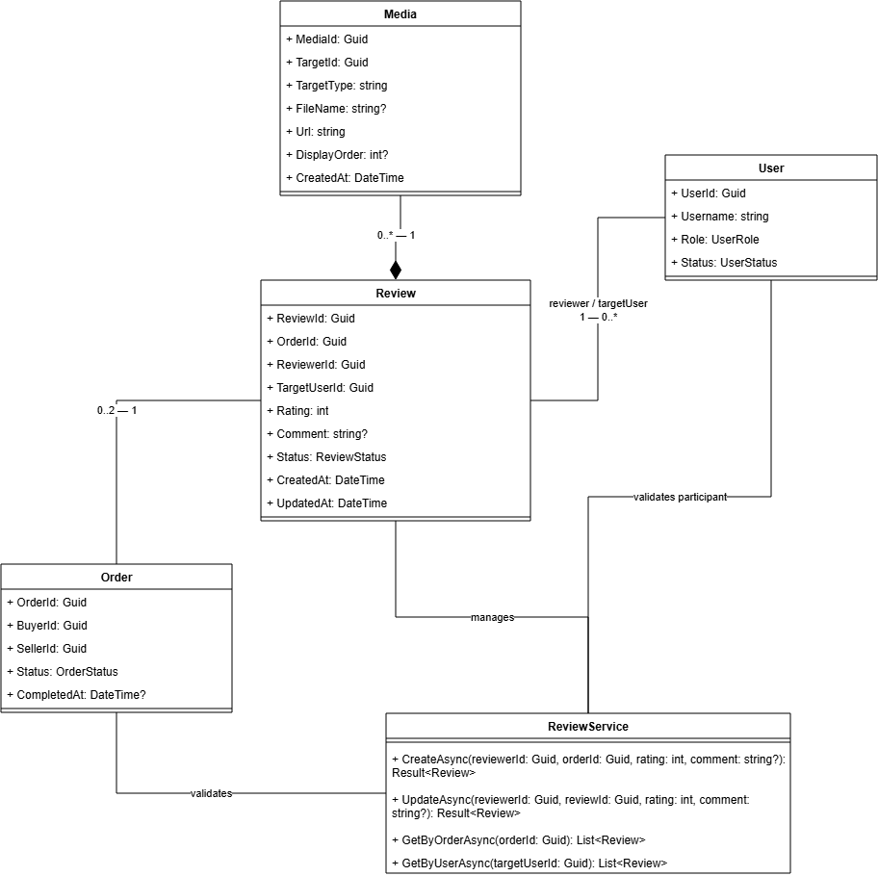
Diagram 51: Review Management class diagram

3.11.2 Create Review
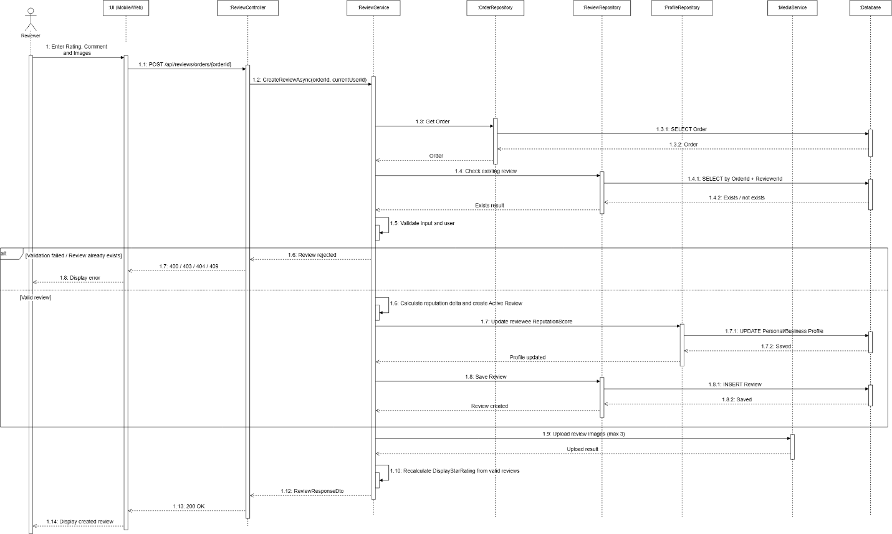
Diagram 52: Create Review sequence diagram

3.12 Disputes & Complaints

3.12.1 Class Digram
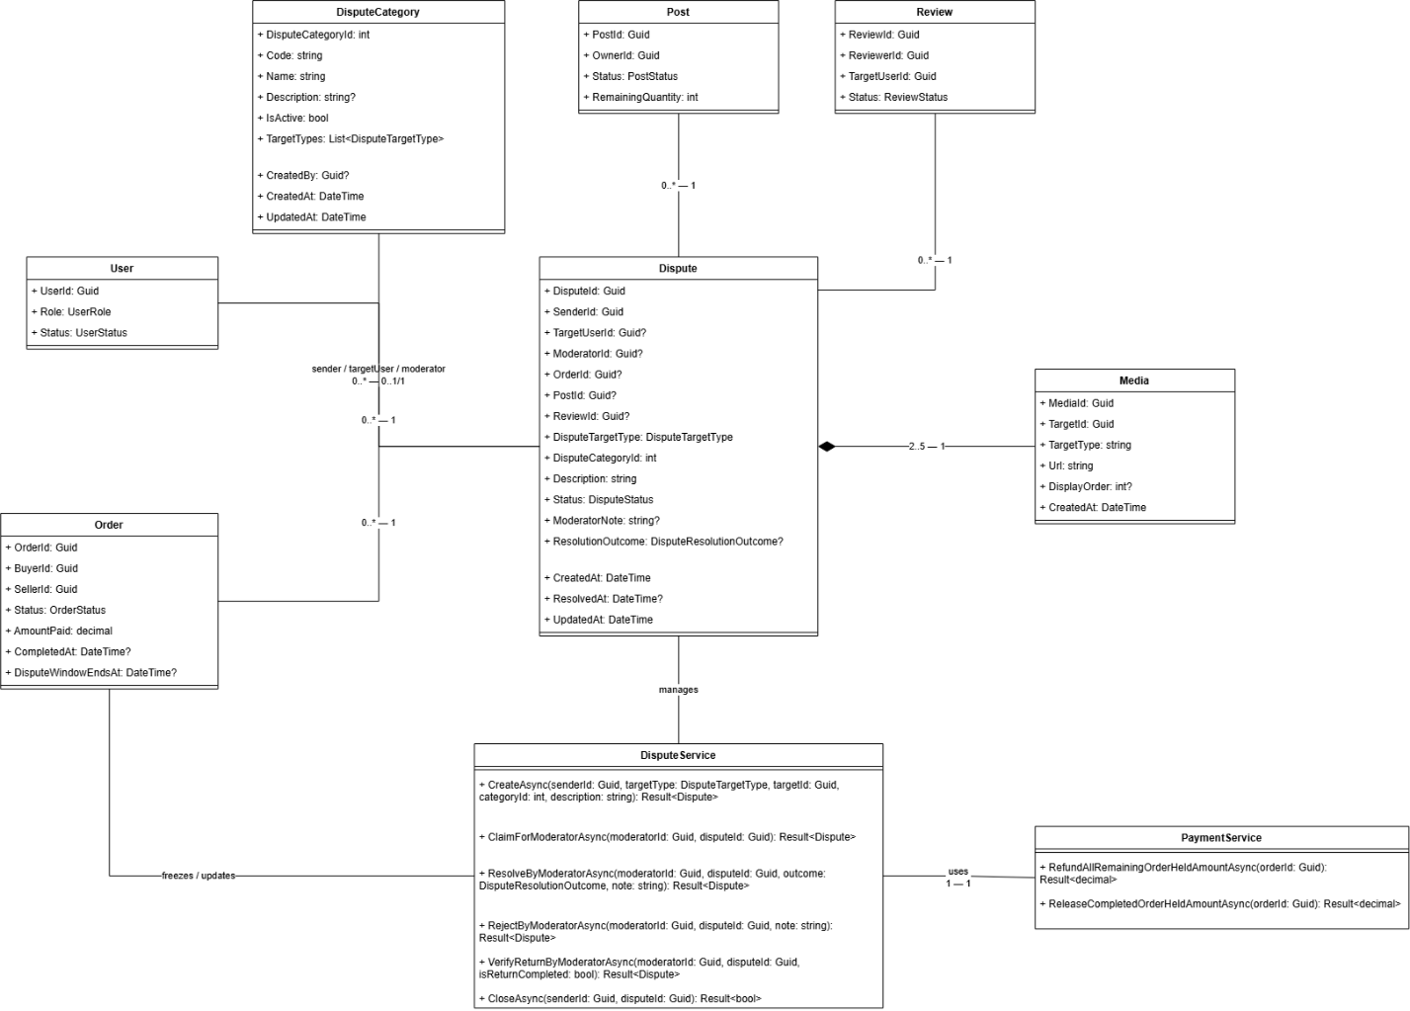
Diagram 53: Disputes & Complaints class diagram

3.12.2 Create dispute form
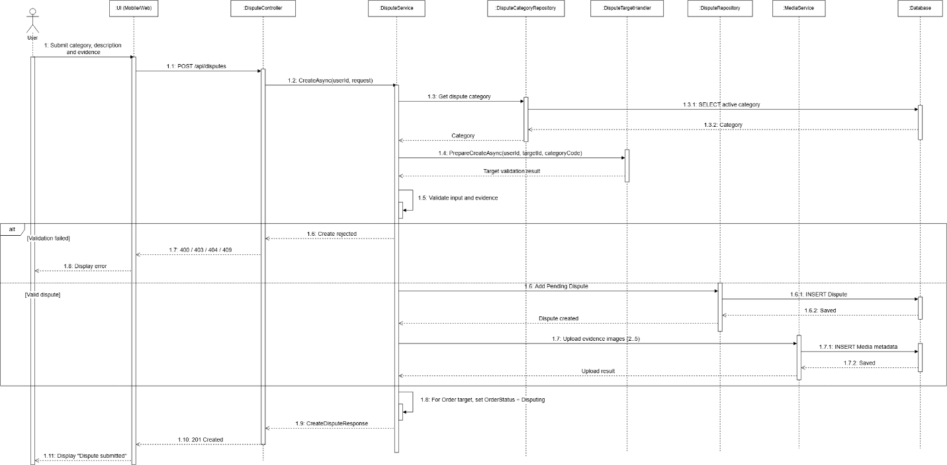
Diagram 54: Create Dispute Form sequence diagram

3.12.2 Claim and Resolve Order Dispute
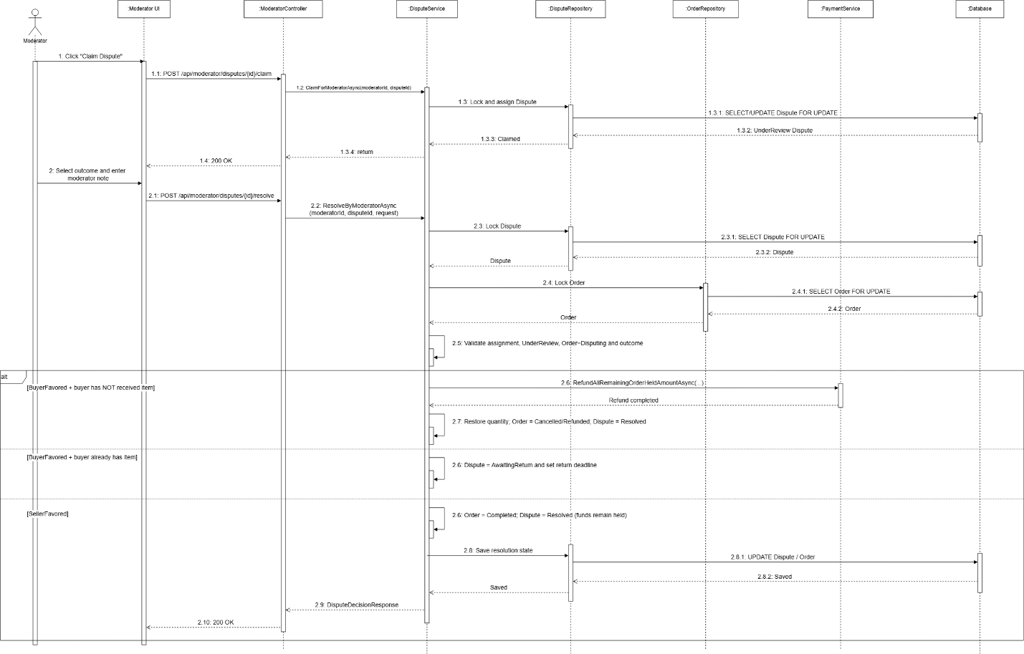
Diagram 55: Claim and Resolve Order Dispute sequence diagram

3.13 Subcription Package

3.13.1 Class Digram
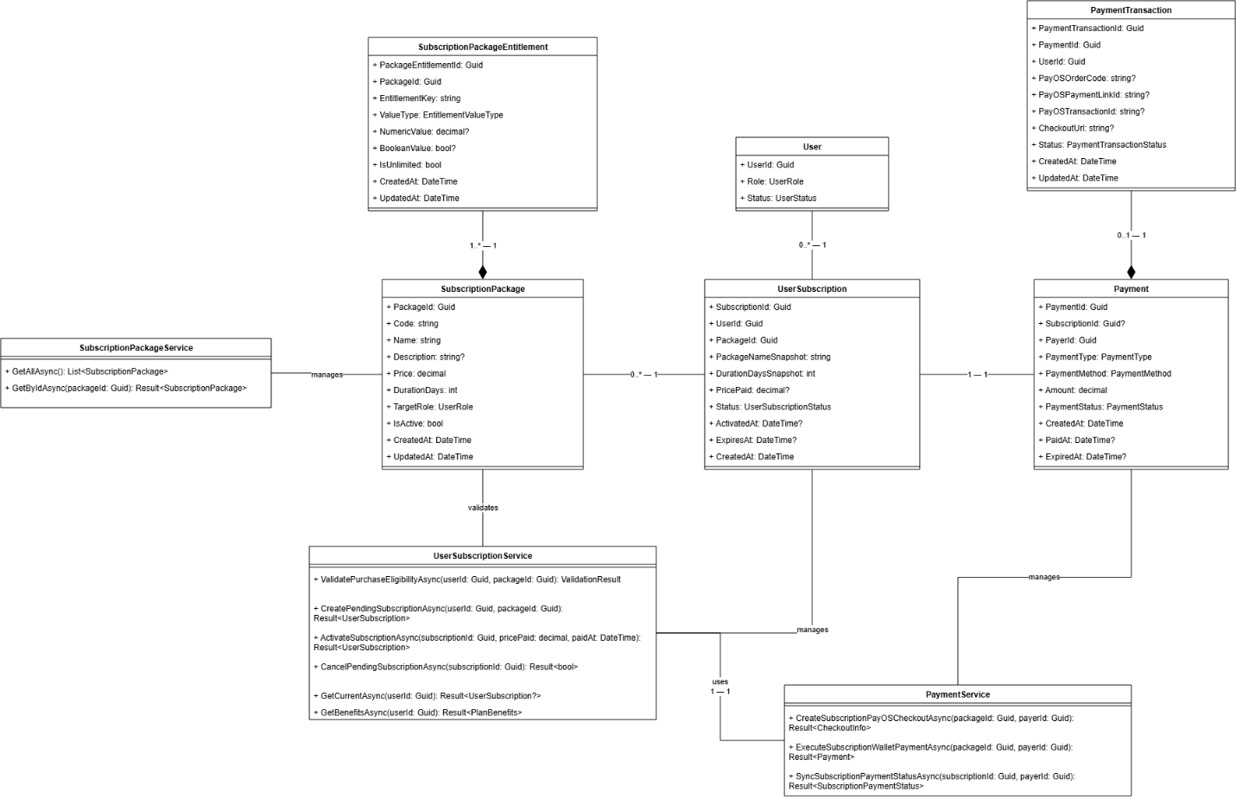
Diagram 56: Subscription Package class diagram

3.13.2 Register and Pay Subscription Package
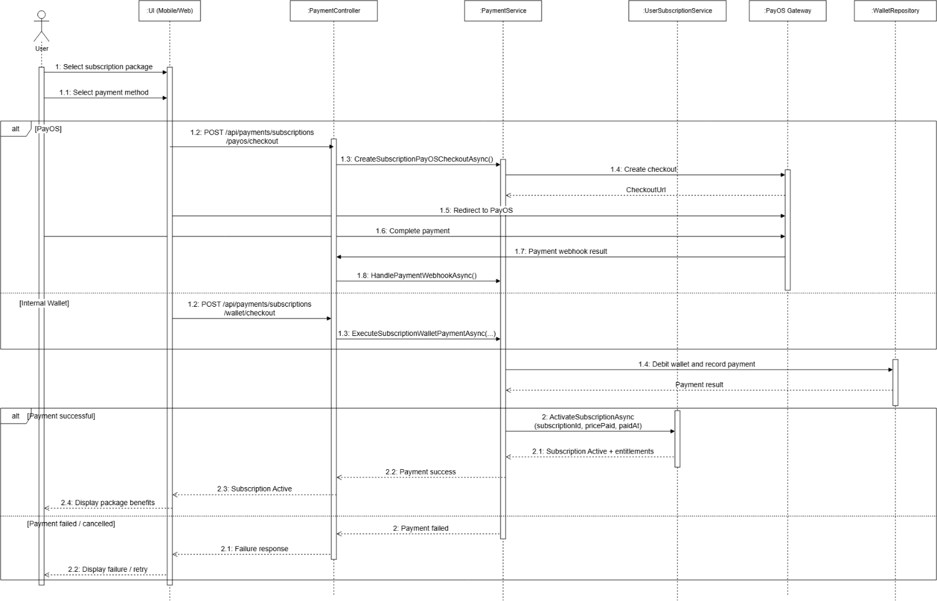
Diagram 57: Register and Pay Subscription Package sequence diagram

V. Software Testing Documentation
In recent years, the demand for buying and selling used household goods in Vietnam has increased significantly due to cost-saving needs, environmental awareness, and the growing number of students, workers, and households that frequently relocate or replace home appliances. However, most transactions are still conducted through social media groups or manual communication channels, resulting in fragmented product information, difficult price comparisons, and limited transaction transparency

1. Scope of Testing
- Users and Verification Module: Registration, login, JWT authentication, profile management, personal and business verification, moderator approval/rejection, and role/ownership-based access for Seller, Buyer, Business, Moderator, and Admin
- Catalog and Dynamic Attributes Module: Category, product type, brand, attribute definition, input mode, option list, required-field, and administrator reference-data management.
- Search and Discovery Module: Keyword search, filtering, sorting, and pagination by category, product type, brand, location, condition, price, and active/available status.
- Offer and Negotiation Module: Offer creation and response, private negotiation, counteroffers, messages, participant permissions, concurrency handling, and valid status transitions.
- Agreement Module: Agreement preview, creation, editing, two-party confirmation, product snapshot, final price and quantity, delivery/payment/inspection details, and protection of server-controlled financial and shipping fields
- Appointment Module: Inspection-required and no-inspection/direct-collection paths are verified separately, including scheduling, confirmation, check-in, cancellation, completion, collection, and fulfillment.
- Payment and Wallet Module: Amount and shipping-fee calculation, wallet and PayOS payment, payment-link and callback processing, transaction status, idempotency, and balance consistency.
- GHN Shipping Module: Address lookup, shipping-fee preview, package/address validation, order creation, tracking, status mapping, webhook processing, and duplicate or out-of-order events
- Dispute and Transaction Closure Module: Dispute eligibility, evidence, participant/moderator permissions, resolution, cancellation, failure handling, and consistency across agreement, payment, and shipment states
- Ratings, History, Notifications, and Administration: Post-completion ratings, one-rating-per-transaction, reputation, user history, notifications, moderation, reference data, transaction oversight, and basic reports

2. Test Strategy

2.1 Testing Types
2.1.1 Functional Testing
Objective:
Verify that HomeCycle's functional requirements are implemented correctly according to the system requirements, use cases, and defined business rules.
Technique:
Black-box testing based on test cases derived from use cases, user stories, business rules, and acceptance criteria. Test cases include normal flows, alternative flows, validation cases, and exception scenarios.
Major functional areas include:
- Registration, authentication, and profile management
- Selling and buying post management
- Product search and filtering
- Offer creation and management
- Negotiation and counter-offer processing
- Agreement and transaction processing
- Inspection and collection appointment management
- Payment and refund processing
- Delivery and GHN shipping
- Rating, review, notification, and dispute management
- Administrative monitoring and configuration
Completion Criteria:
- 100% of critical and high-priority test cases pass.
- At least 95% of medium-priority test cases pass.
- No unresolved Critical or High severity defects remain.
- All critical business workflows can be completed successfully.
2.1.2 Unit Testing
Objective:
Validate individual backend components, especially services, validators, utilities, and business rules, independently from databases and external systems.
Technique:
White-box testing using xUnit for the .NET backend and Moq or equivalent mocking frameworks to isolate dependencies such as repositories, file storage services, payment services, GHN services, and notification services.
Priority is given to business-critical logic such as:
- Offer and negotiation state transitions
- Payment amount calculation
- File upload validation
- GHN parcel and shipping calculation
- Authorization and ownership validation
- Appointment and order status transitions
- AI price suggestion filtering and matching logic
Completion Criteria:
- Service-layer and business-logic code achieves at least 70% test coverage where automated unit testing is applicable.
- All critical business rules have positive and negative test cases.
- All unit tests pass without failures.
- No unit test depends on production databases or live external services
2.1.3 Integration Testing
Objective:
Verify that multiple HomeCycle components work correctly together, including the interaction between controllers, services, repositories, the database, and infrastructure services.
Technique:
Integration testing using ASP.NET Core testing facilities such as WebApplicationFactory, together with a dedicated test database or PostgreSQL-compatible test environment.
Typical integration chains include:
Controller → Application Service → Repository → PostgreSQL
and, where applicable:
Application Service → External Service Adapter
Integration tests verify database persistence, transaction behavior, dependency injection, serialization, validation, and application-level error handling.
Completion Criteria:
- Critical API workflows successfully interact with the database.
- Expected records are created, updated, or retrieved correctly.
- Database transactions are rolled back correctly when operations fail.
- Invalid operations do not leave inconsistent partial data.
- All critical integration tests pass in the designated testing environment.
2.1.4 API Testing
Objective:
Validate the correctness, consistency, stability, and reliability of HomeCycle REST API endpoints.
Technique:
API testing is performed using Postman, Swagger UI, and automated Postman collections where applicable. Both valid and invalid requests are tested.
Testing covers:
- HTTP methods and routes
- Request validation
- Response structures
- HTTP status codes
- Authentication
- Role-based authorization
- Ownership authorization
- Pagination, searching, and filtering
- Error responses and edge cases
Completion Criteria:
- Publicly used API endpoints are documented in Swagger.
- Request and response structures conform to their defined DTOs.
- Expected HTTP status codes are returned for success and failure scenarios.
- Authentication and authorization are verified for applicable roles.
- Invalid input is rejected with appropriate validation responses.
- Critical API endpoints pass all defined API test cases
2.1.5 Security Testing
Objective:
Verify that HomeCycle protects user accounts, sensitive data, system resources, and privileged operations against unauthorized access and common security vulnerabilities.
Technique:
Manual security testing, API authorization testing, negative test cases, and source-code review are applied to security-sensitive functionality.
Testing includes:
- JWT access-token validation and expiration
- Refresh-token validation and rotation
- Role-based access control
- Resource ownership authorization
- OTP expiration and reuse prevention
- Password protection
- File upload validation
- Request validation
- Unauthorized API access
- SQL injection attempts
- Malicious or invalid input
- Exposure of sensitive information through API responses or logs
Completion Criteria:
- Expired or invalid JWT tokens cannot access protected resources.
- Refresh tokens cannot be reused after being invalidated where token rotation is applied.
- Users cannot access or modify resources belonging to other users unless explicitly authorized.
- Administrative APIs are accessible only to authorized administrators.
- OTPs cannot be reused after successful verification and cannot be used after expiration.
- Uploaded files comply with configured type and size restrictions.
- Passwords are never stored in plaintext.
- Common injection attempts and malformed requests do not compromise the system.
- Sensitive credentials, tokens, and secrets are not exposed through application responses.

2.2 Test Levels
Type of Tests | Test Level
Type of Tests | Unit | Integration | System | Acceptance
Functional Testing |  |  | X | X
User Interface Testing |  |  |  | X
API Testing |  | X | X
Security Testing | X | X | X | X
Table 26: Test Levels

2.3 Supporting Tools
Purpose | Tool | Vendor/In-house | Version
Mobile Application Testing | Expo Development Build | Expo | SDK 54
Web Application Testing | Visual Studio Code | Microsoft | Latest
API Tesing | Swagger | Swagger | Latest
CI/CD | GitHub Actions | GitHub
Table 27: Supporting Tools

3. Test Plan

3.1 Human Resources
Worker/Doer | Role | Specific Responsibilities/Comments
Nguyễn Thị Ngọc Trâm | Leader - Backend | Participates in planning, reviews testing outputs, and handles backend interface testing according to plan.
Nguyễn Trần Hải Đăng | Backend | Contributes to development, ensures testing deliverables meet standards, and performs interface testing as planned.
Trần Minh Tiến | Frontend | Performs Frontend functional, UI/UX, integration, and regression testing for both Mobile and Web applications. Records test results, verifies Frontend bug fixes, and performs final regression testing on supported user flows.
Table 28: Test Human Resources

3.2 Test Environment
Purpose | Tool | Provider | Version
Web Testing | React Web Application | Vercel | Latest
Mobile Testing | Expo Development Build | Expo | SDK 54
API Testing | Swagger | Swagger | Latest
Table 29: Test Environment

3.3 Test Milestones
Milestone Task | Start Date | End Date
Create test plan | 20/08/2026 | 01/09/2026
Create unit test document and execute test case | 01/09/2026 | 08/09/2026
Create a test report document and execute the test  case | 08/09/2026 | 16/09/2026
Full system testing | 16/09/2026 | 22/09/2026
Table 30: Test Milestones

4. Test Cases
- Unit Test Cases: Report5_Unit Test.xls
- Test Cases: Report5_Test Report.xls

5. Test Reports
5.1. Unit Test
Unit testing occurs during the development phase. It involves testing individual units or components of the software in isolation to ensure they perform as expected.
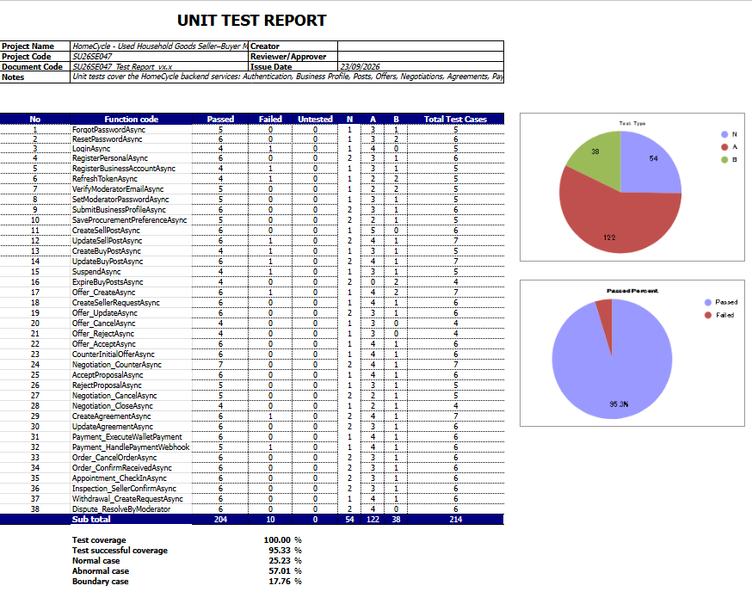
Figure 37: Unit Test Report
5.2 System Test
Unit testing occurs during the development phase. It involves testing individual units or components of the software in isolation to ensure they perform as expected.

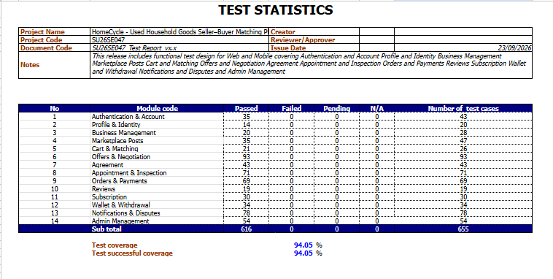Figure 38: System Test Statistics

VI. Release Package & User Guides

1. Deliverable Package
No. | Deliverable Item | Description
1 | Project Backlog | Project Weekly Report_GSU26SE57.xlsx.xlsx
2 | Source Codes | Mobile: HomeCycle-mobile.zip  Website: HomeCycle-website.zip  Backend: HomeCycle-platform.zip
3 | Database Script(s) | HomeCycleDb.sql
4 | Final Report Document | Report7_Final Project Report.docx
5 | Test Cases Document | Report5_Test_Documentation.docx
6 | Defects List | Report3_Project Tracking.xlsx
7 | Issues List | Report3_Project Tracking.xlsx
8 | Slide | HomeCycle_final_present.pdf
Table 31: Deliverable Package

2. Installation Guides

2.1 System Requirements
The following environment is required to install, configure, and run the HomeCycle system.
Hardware
- 64-bit processor, 4 cores or higher recommended.
- Minimum 8 GB RAM; 16 GB recommended when running the mobile emulator.
- At least 10 GB of available storage for source code, dependencies, and development tools.
- Internet connection is required for external services and package installation.
Operating System
- Windows 10/11 recommended for development.
- Other environments that support .NET and Node.js may also be used.
Development Tools
- Git
- Visual Studio 2022 or Visual Studio Code
- .NET 8 SDK
- Node.js: v22.16.0
- npm: 11.8.0
- Android Studio or Expo Go for mobile development
- Modern web browser such as Google Chrome or Microsoft Edge
Backend
- ASP.NET Core / .NET 8
- Entity Framework Core
- PostgreSQL with Npgsql provider
- AutoMapper
- FluentValidation
- JWT Authentication
- SignalR
- Swagger / OpenAPI
Web Frontend
- React 19.2.6
- React DOM 19.2.6
- React Router DOM 7.18.0
- Vite 8.0.12
- Ant Design 6.6.0
- Axios 1.18.1
- SignalR 8.0.29
- Tailwind CSS 4.3.1
Mobile Application
- Expo SDK 54
- React 19.1.0
- Expo Auth Session 7.0.11
- Expo Dev Client 6.0.21
- Axios 1.18.1
- Microsoft SignalR Client 10.0.11
- React Native Google Sign-In 16.1.4
- React Native AsyncStorage 2.2.0
- JWT Decode 4.0.0
- React Native Reanimated 4.1.1
- React Native Gesture Handler 2.28.0
Database and External Services
- PostgreSQL / Supabase
- Firebase Storage
- Google OAuth
- PayOS Payment Gateway
- GHN Shipping API
- Other service credentials configured by the development team

2.2 Installation Instruction
Web Frontend
1. Clone the repository and install dependencies
- git clone https://github.com/Tien-AB204/HomeCycle-FE-Web.git
- cd HomeCycle-FE-Web
- npm install
2. Configure the environment
- Create the required environment configuration file if environment variables are used by the frontend.
- VITE_API_BASE_URL=https://homecycle-backend.onrender.com/api
- The API URL must point to the running HomeCycle Backend API.
3. Run the application
- npm run dev
- For local development, the application can be accessed at: http://localhost:5173
- The deployed HomeCycle Web application is available at: https://home-cycle-fe-web.vercel.app/
Mobile Application
1. Clone and install dependencies
- git clone https://github.com/Tien-AB204/HomeCycle-FE-Mobile.git
- cd HomeCycle-FE-Mobile
- npm install
2. Start the Expo development server
- npm start
To run directly on Android:
- npm run android
- The application can also be tested using Expo Go or an Android emulator.
Backend API
1. Clone the Backend repository
- git clone https://github.com/NguyenThiNTram/HomeCycle-backend.git
2. Restore NuGet packages
- dotnet restore
3. Configure application settings
- Configure appsettings.Development.json, .NET User Secrets, or environment variables with the required values for:
- PostgreSQL/Supabase connection string
- JWT configuration
- Firebase configuration
- Google Authentication
- PayOS credentials
- GHN API Token and Shop ID
- Sensitive credentials such as API keys, JWT secrets, payment credentials, and database passwords should not be committed to the source repository.
4. Initialize the database
- If the development environment uses Entity Framework Core migrations, apply the available migrations:
- dotnet ef database update
- This step can be skipped when connecting to an existing database whose schema has already been initialized.
5. Run the Backend API
- From the API project directory:
- dotnet run
- The Backend API URL and Swagger URL depend on the launch configuration of the HomeCycle API project:
- Swagger URL: https://homecycle-backend.onrender.com/swagger/index.html
- After the Backend API is running, configure the Web and Mobile applications to use the corresponding API URL.

3. User Manual

3.1 Overview
HomeCycle is an online marketplace platform built for the circular economy in Vietnam. It connects individual sellers who own used, second-hand, or damaged household items (electronics, home appliances, furniture, etc.) with businesses that collect, repair, refurbish, and resell those items. Instead of letting still-usable products end up in landfills, users can list them for sale so businesses can give them a second life. The platform does not stop at listing items — it manages the entire transaction lifecycle on behalf of both parties:
- Listing used goods with detailed, category-based product attributes
- Price negotiation through offers and real-time chat
- Formal agreements with product snapshots
- Secure payment with escrow (20% deposit or full payment) via PayOS or the internal wallet
- Delivery handled by GHN (Giao Hàng Nhanh) with real-time shipment tracking
- Post-transaction reviews and reputation scoring
- Seller withdrawals of earnings to their bank accounts
By combining trading, payments, logistics, and moderation into one platform, HomeCycle provides a trusted and transparent environment for circular commerce.

3.2 Workflow 1: Personal Registration

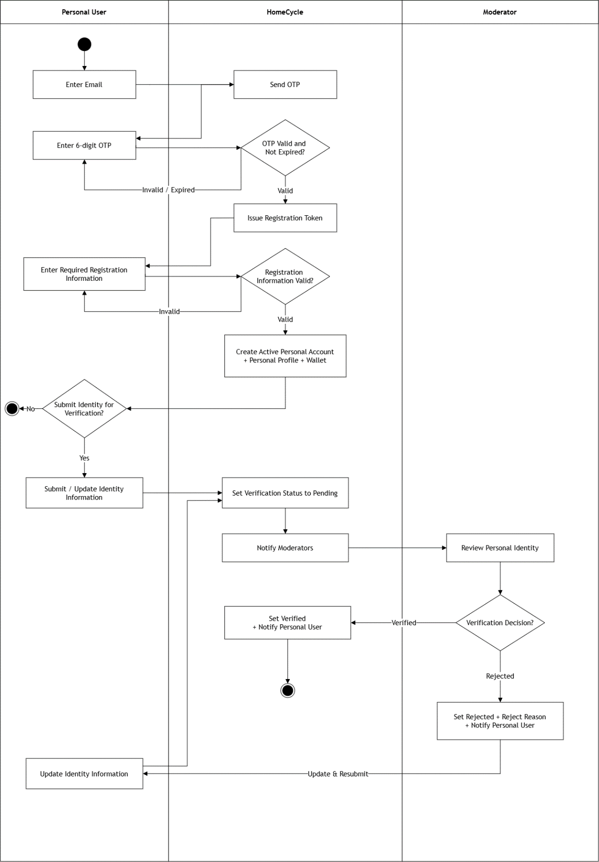
Diagram 58: Workflow 1 – Personal Registration
Describe: The Personal Registration workflow describes how a personal user registers for a HomeCycle account through email verification. The user submits an email, receives and verifies an OTP, then completes the required registration information. After the information is validated, HomeCycle creates an active Personal account together with the Personal Profile and Wallet, allowing the user to use the platform immediately. Identity verification is optional. If the user chooses to submit identity information, the profile enters the Pending verification state and is reviewed by a Moderator. The Moderator may verify the identity or reject it with a reason, after which the user can update and resubmit the identity information for another review.

3.3 Workflow 2: Business Registration
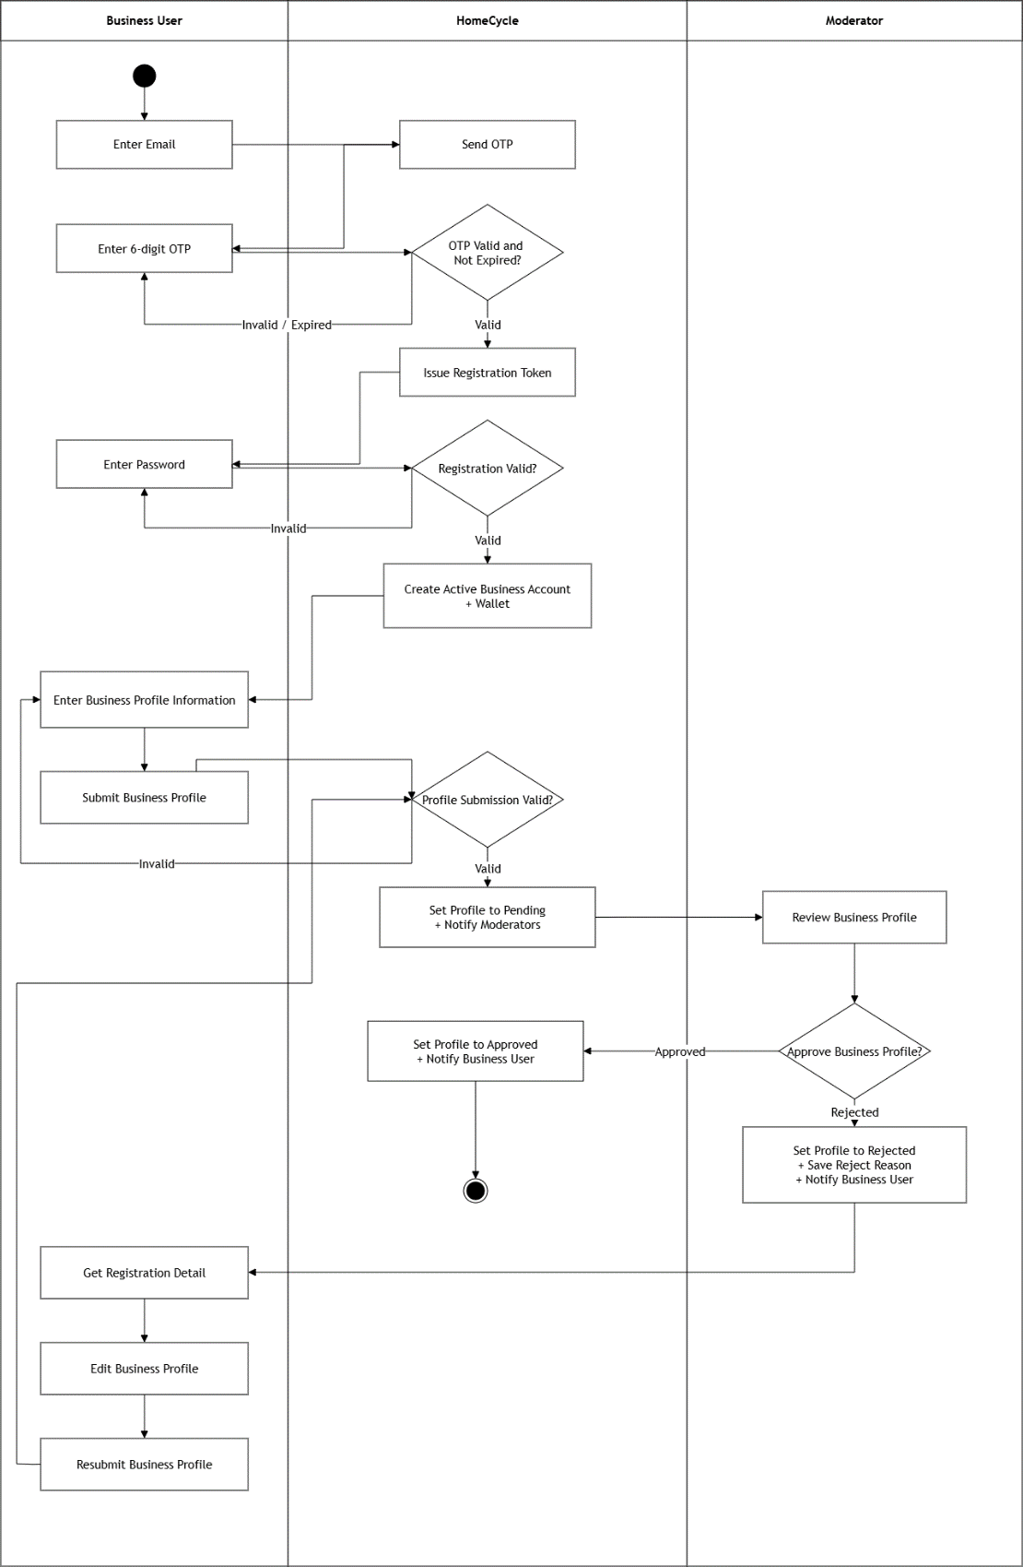
Diagram 59: Workflow 2 – Business Registration

Describe: The Business Registration workflow describes how a business user registers for a HomeCycle account through email verification and completes the required business profile approval process. The user submits an email, receives and verifies an OTP, then provides a password to create an active Business account together with a Wallet. After the account is created, the user completes and submits the Business Profile for verification. The submitted profile enters the Pending state and is reviewed by a Moderator. The Moderator may approve the profile or reject it with a reason. If the profile is rejected, the business user can retrieve the previous registration details, update the Business Profile, and resubmit it for another review. The business onboarding process is completed when the Business Profile is approved.

3.4 Workflow 3: Create Sell Post
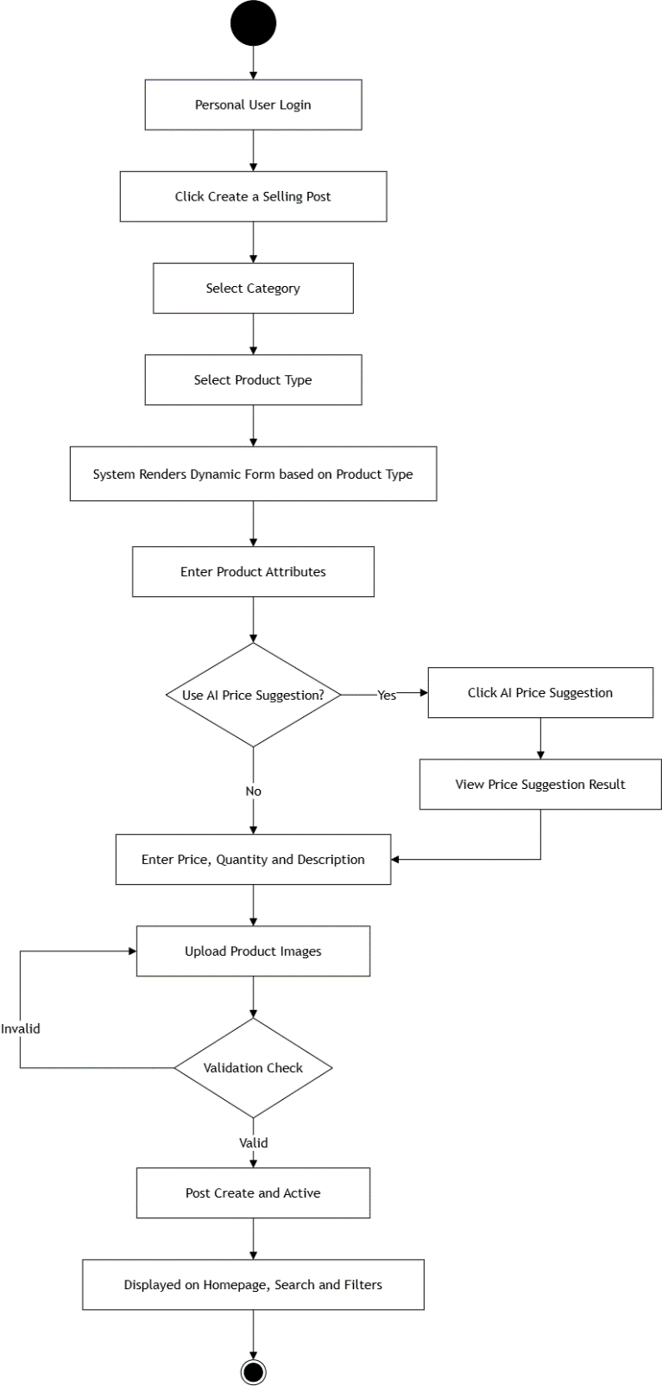
Diagram 60: Workflow 3 – Create Sell Post
Describe: The Create Sell Post workflow describes how a Personal user creates a selling post for a product on HomeCycle. The user logs in, chooses to create a selling post, selects a category and product type, and the system displays the corresponding product information form. The user then enters the required product attributes. At this stage, the user may optionally click AI Price Suggestion to receive a price suggestion result based on the provided product information before continuing to enter the price, quantity and description. The user uploads product images and submits the post for validation. If the information is invalid, the user updates the required information and submits it again. If the information is valid, HomeCycle creates the selling post and sets it to Active. The active post can then be displayed on the homepage and accessed through the platform’s search and filtering functions.

3.5 Workflow 4: Create Buy Post & Matching
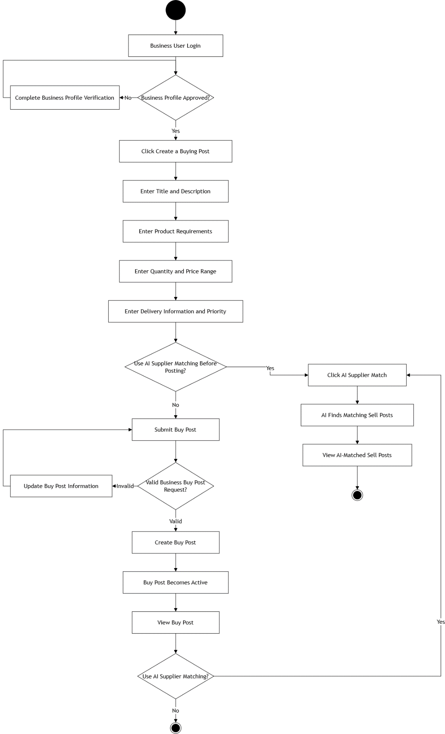
Diagram 61: Workflow 4 – Create Buy Post & Matching

Describe: The Create Buy Post workflow describes how an approved Business user creates a buying request and optionally uses AI Supplier Matching to find suitable Sell Posts on HomeCycle. The user logs in, chooses to create a buying post, and enters the title, description, product requirements, quantity, expected price range, delivery information and priority. Before submitting the Buy Post, the user may optionally use AI Supplier Matching based on the current draft information to view Sell Posts that match the purchasing requirements. The user can then continue editing or submit the Buy Post for validation. If the information is invalid, the user updates the required information and submits it again. If the information is valid, HomeCycle creates the Buy Post and sets it to Active. After opening the created Buy Post, the user may use the same AI Supplier Matching function again, this time based on the saved Buy Post information, to view suitable Sell Posts.

3.6 Workflow 5: Offer & Negotiation
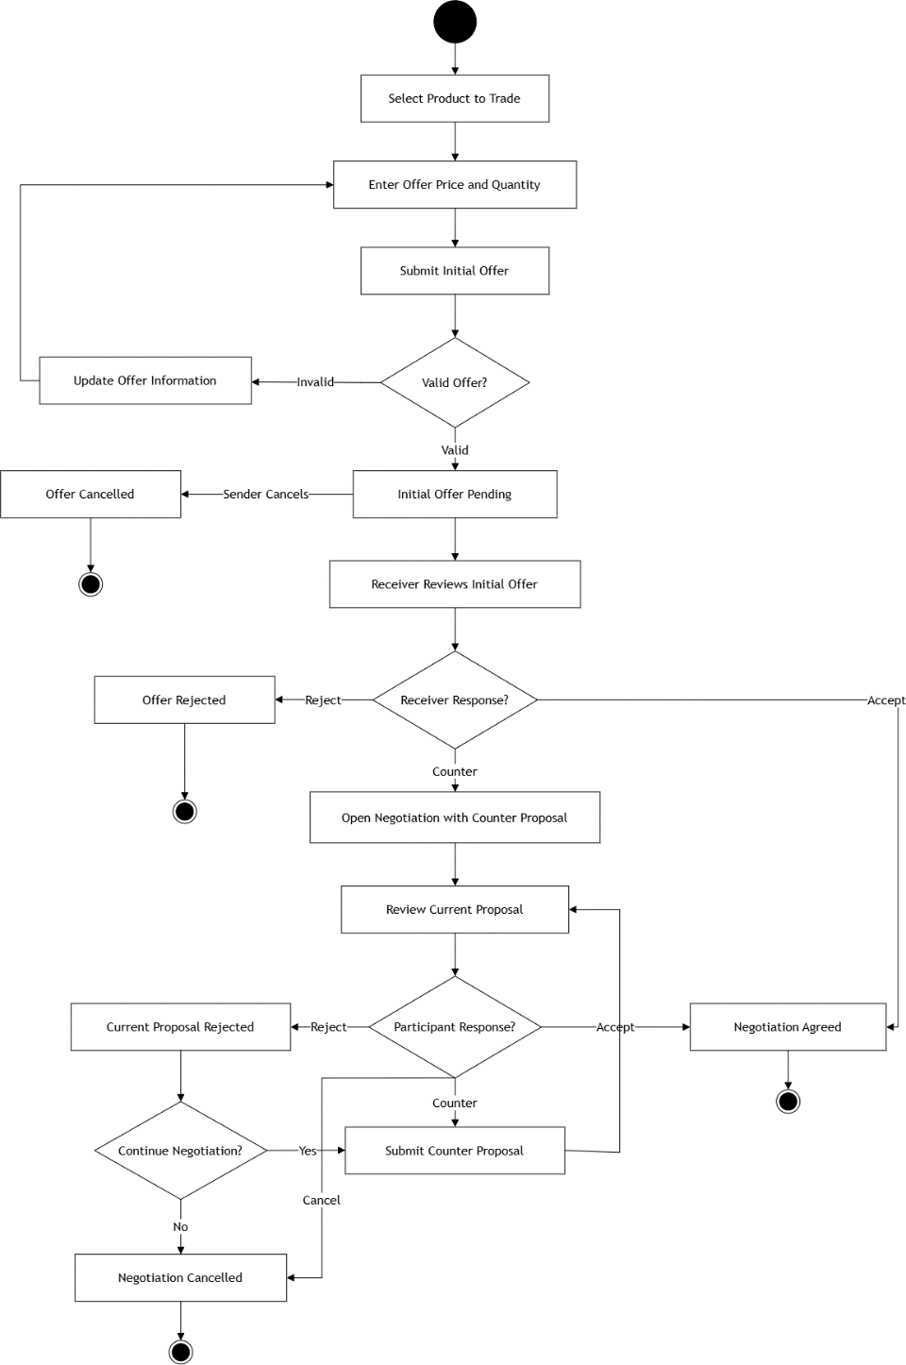
Diagram 62: Workflow 5 – Offer & Negotiation
Describe: The Offer and Negotiation workflow describes how two users establish and negotiate the price and quantity of a transaction on HomeCycle. A user selects a product, enters the proposed price and quantity, and submits an initial offer. After validation, the offer enters the Pending state and the receiver reviews it. While the offer is pending, the sender may cancel it, while the receiver may reject, accept, or counter the offer. Accepting the initial offer results in an Agreed negotiation, while countering the offer opens the negotiation process. During an open negotiation, either participant may review the current proposal and respond by accepting, countering, rejecting, or cancelling. Accepting a proposal completes the negotiation as Agreed, countering continues the negotiation with a new proposal, and rejecting a proposal allows the participants to either continue negotiating or cancel the negotiation.

3.7 Workflow 6: Agreement and payment
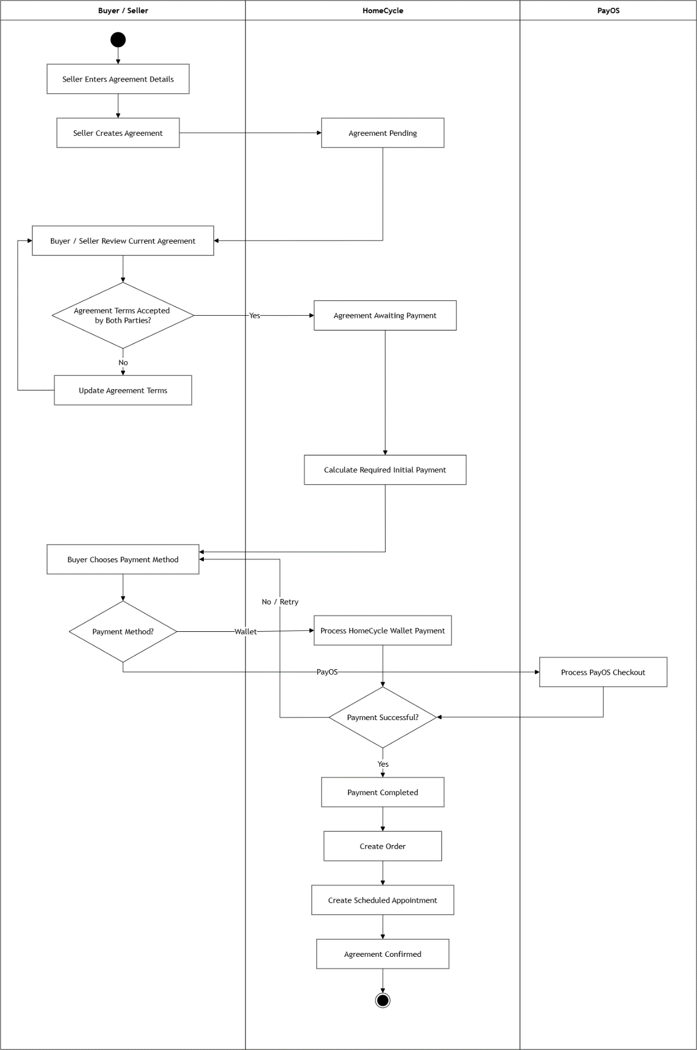
Diagram 63: Workflow 6 – Agreement and Payment
Describe: The Agreement and Payment workflow describes how Buyer and Seller finalize the transaction terms and complete the required initial payment on HomeCycle. After a negotiation reaches the Agreed state, the Seller enters the agreement details and creates the Agreement. The Agreement remains Pending while the parties review the current terms. Either party may update the Agreement while it is Pending, and the updated terms must be reviewed again before both parties confirm them. Once both parties have confirmed the Agreement, its status changes to Awaiting Payment. HomeCycle then calculates the required initial payment according to the Agreement type, payment type, delivery method and platform payment policy. The Buyer may complete the payment using the HomeCycle Wallet or PayOS. If the payment is unsuccessful, the Buyer may try again using an available payment method. After successful payment, HomeCycle records the payment as completed, creates the Order and the corresponding scheduled Appointment, and then confirms the Agreement for the next fulfillment stage.

3.8 Workflow 7: Order Fulfillment, Appointment, Inspection & Delivery
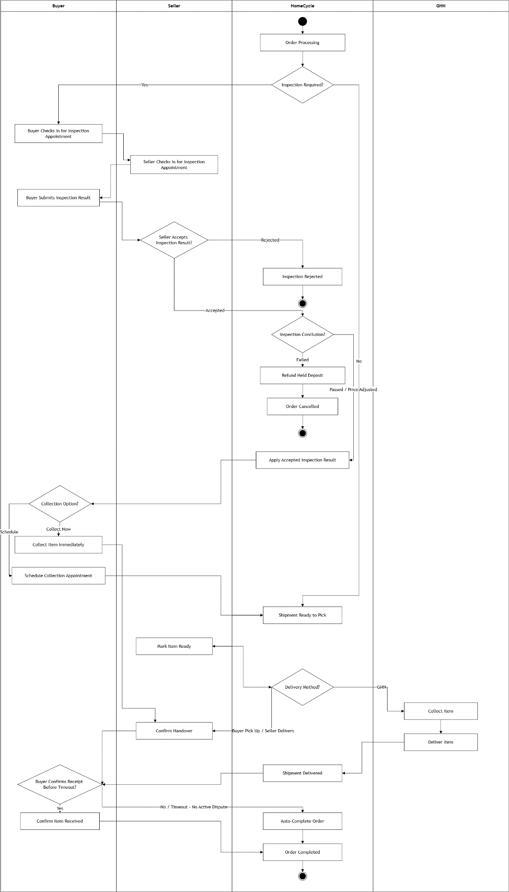
Diagram 64: Workflow 7 – Order Fulfillment, Appointment, Inspection & Delivery
Describe: The Order Fulfillment, Appointment, Inspection and Delivery workflow describes how a Processing order progresses through scheduled appointments, inspection, collection and delivery until completion on HomeCycle. If inspection is required, the Buyer and Seller check in for the Inspection Appointment, the Buyer submits the inspection result, and the Seller reviews it. A rejected inspection stops the normal fulfillment flow, while an accepted Failed result causes HomeCycle to refund the held deposit and cancel the Order. For a Passed or Price Adjusted result, the Buyer may collect the item immediately or schedule a Collection Appointment. Orders without inspection proceed directly to the shipment stage. The Seller marks the item as ready before delivery begins. For Buyer Pick Up or Seller Delivers, the Seller confirms the direct handover. For GHN delivery, GHN collects and delivers the item, after which the Shipment becomes Delivered. The Buyer may then confirm receipt to complete the Order. If the confirmation timeout expires and there is no active dispute, HomeCycle automatically completes the Order.

3.9 Workflow 8: Order Dispute, Return & Refund
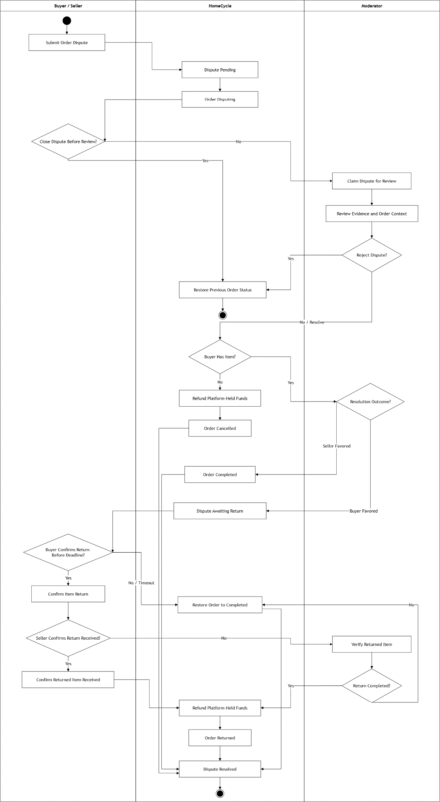
Diagram 65: Workflow 8 – Order Dispute, Return & Refund
Describe: The Order Dispute, Return and Refund workflow describes how Buyer or Seller raises and resolves an Order dispute on HomeCycle. A valid dispute is created in the Pending state and the related Order is placed in Disputing status, temporarily interrupting the normal fulfillment lifecycle. Before a Moderator claims the dispute, the sender may close it and HomeCycle restores the previous Order status. Otherwise, the Moderator claims the dispute for review, examines the submitted evidence and Order context, and may reject the dispute or resolve it in favor of either the Buyer or Seller. A rejected dispute restores the previous Order status. For a Buyer-Favored resolution, HomeCycle determines whether the Buyer already holds the item. If the Buyer does not hold the item, the platform-held funds are refunded and the Order is cancelled. If the Buyer already holds the item, the dispute enters Awaiting Return and the Buyer must return the item within the configured return period. The Seller may confirm receipt of the returned item, while a Moderator may verify the return when necessary. A completed return causes the platform-held funds to be refunded, the Order to become Returned, and the dispute to become Resolved. If the return deadline expires or the return is not verified as completed, HomeCycle restores the Order to Completed and resolves the dispute. For a Seller-Favored resolution, HomeCycle completes the Order when the Buyer already holds the item, while an Order in which the Seller still retains the item is cancelled and the platform-held funds are refunded.

3.10 Workflow 9: Review & Reputation
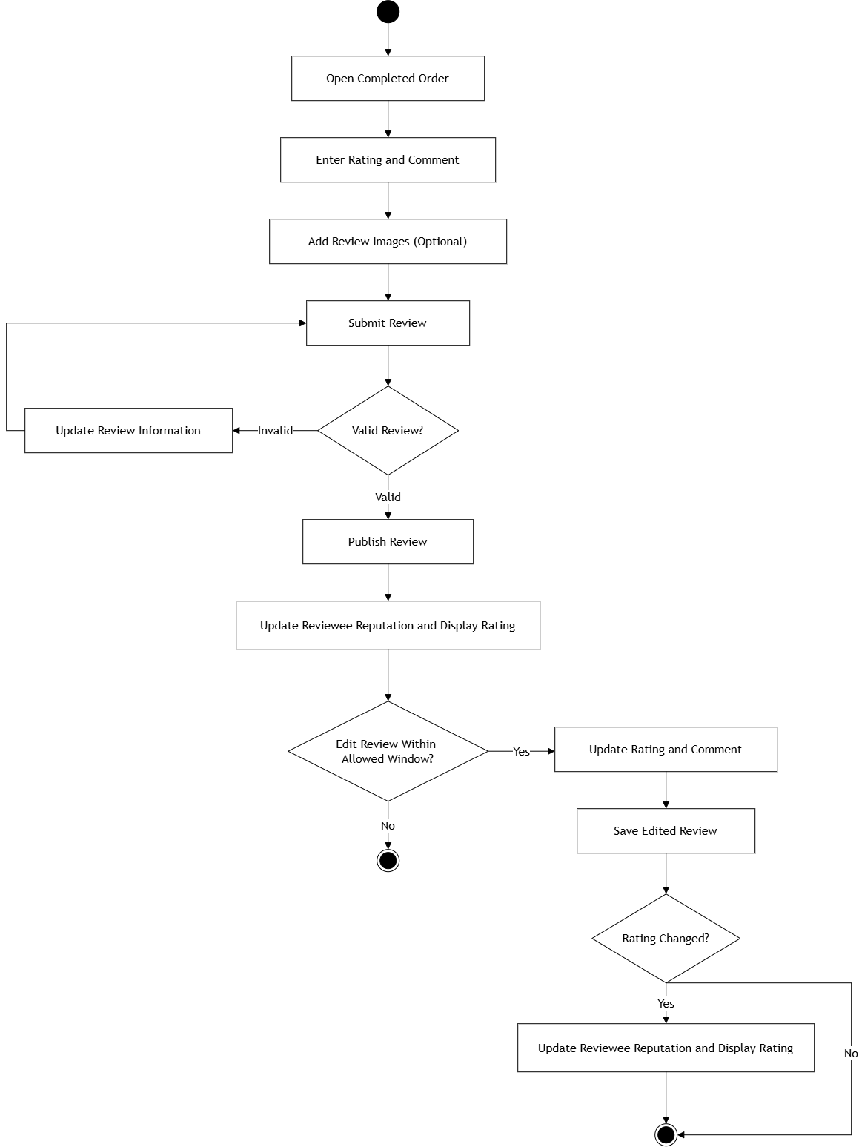
Diagram 66: Workflow 9 – Review & Reputation

Describe: The Review and Reputation workflow describes how Buyer or Seller evaluates the other participant after a completed transaction on HomeCycle. A user opens a Completed Order, enters a rating and optional comment, may attach review images, and submits the review. HomeCycle validates that the reviewer participated in the Order, the Order is Completed, the user is not reviewing themselves, and the user has not already reviewed the same Order. A valid review is published and its rating is applied to the reviewee’s Reputation Score and displayed star rating. The reviewer may later edit their own visible review within the configured review edit window. If the rating is changed, HomeCycle replaces the previous reputation impact with the impact of the new rating and recalculates the displayed rating; changing only the comment does not alter the reputation impact.

3.11 Workflow 10: Withdrawal
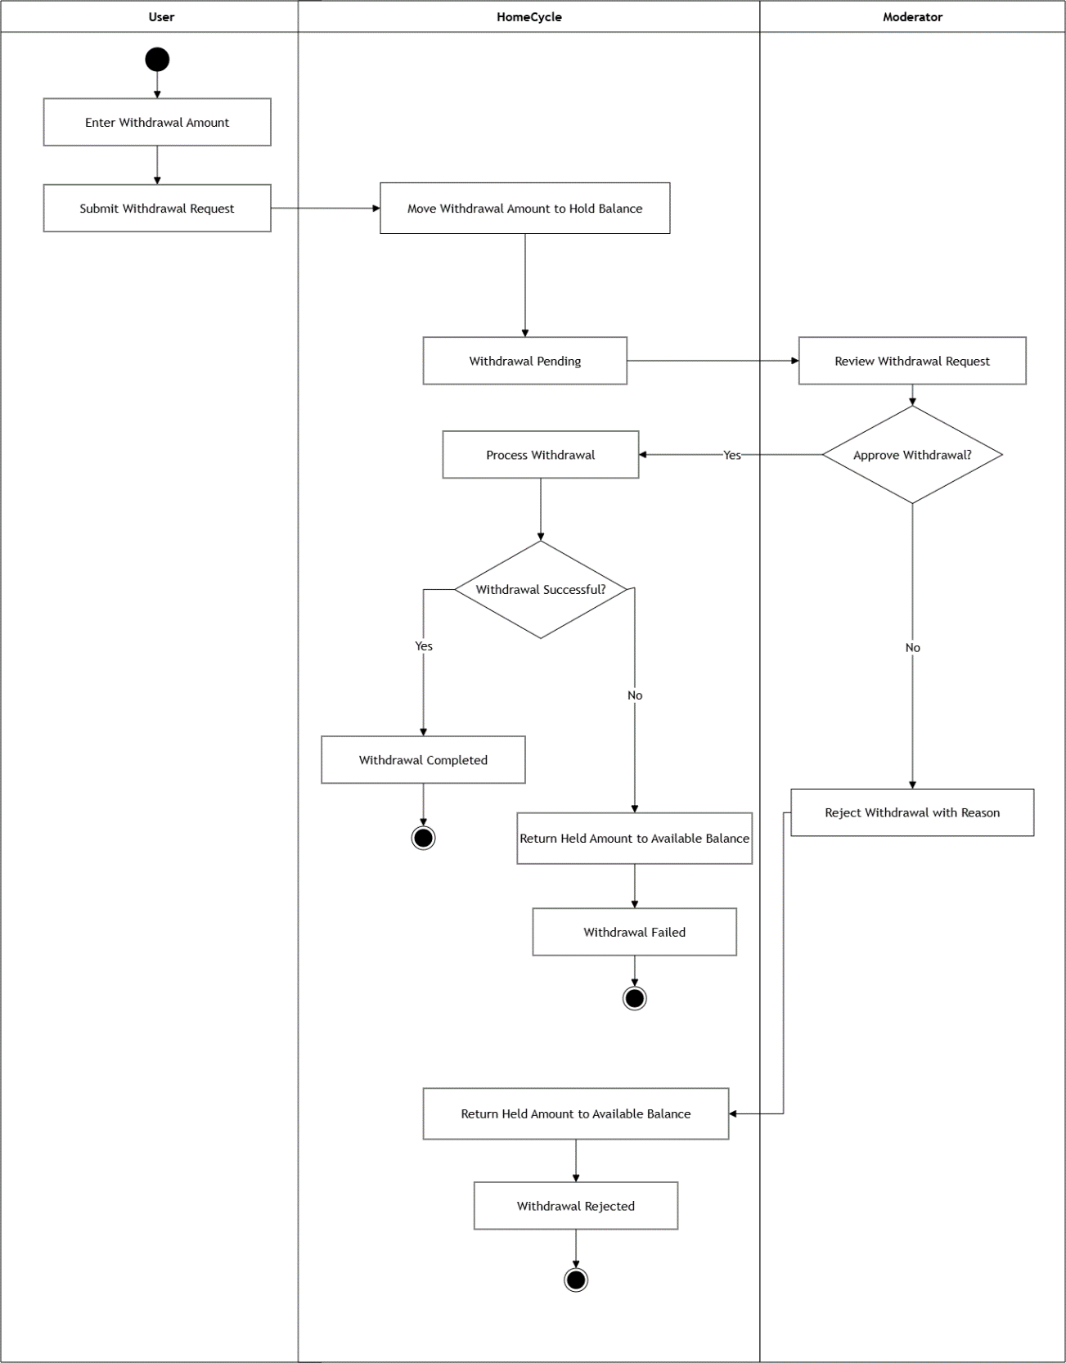
Diagram 67: Workflow 10 – Withdrawal
Describe: The Withdrawal workflow describes how a user requests to withdraw available funds from the HomeCycle Wallet. The user enters the withdrawal amount and submits the request. For a valid request, HomeCycle moves the requested amount from the Available Balance to the Hold Balance and creates the withdrawal in the Pending state for Moderator review. The Moderator reviews the request and may approve or reject it. If the request is rejected, HomeCycle returns the held amount to the user’s Available Balance and marks the withdrawal as Rejected. If the request is approved, HomeCycle processes the withdrawal. A successful withdrawal is marked as Completed, while a failed withdrawal causes the held amount to be returned to the Available Balance and the withdrawal to be marked as Failed

