**40847041S朱自宇 hw3**

**Problem statement:**

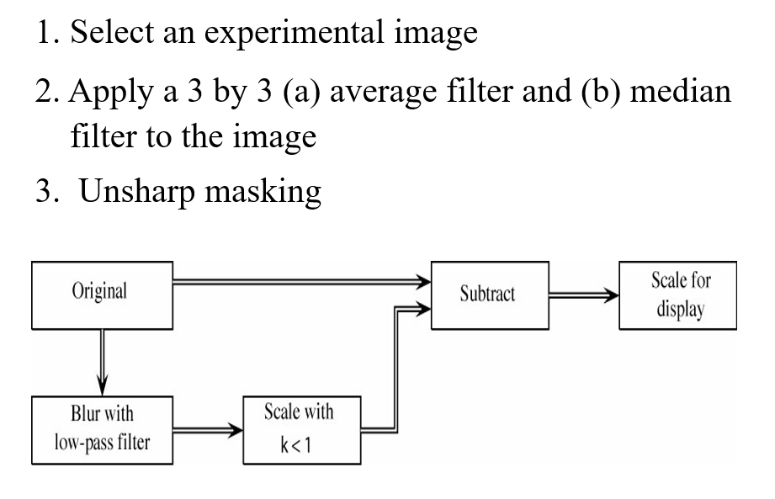

**Experimental results:**

* **Input/Output images:**

**Input grayscale image:**

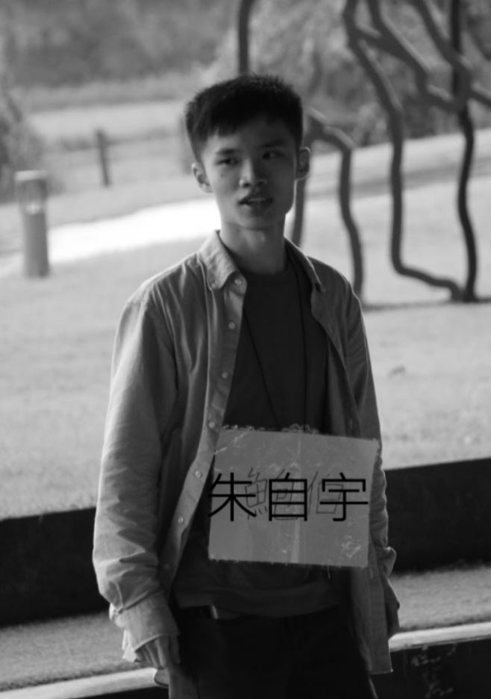

**Output average filter unsharp masking image:**

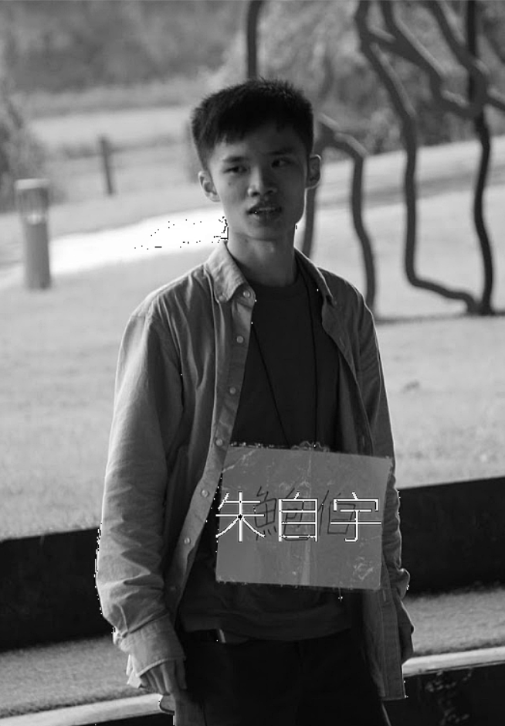

**Output median filter unsharp masking image:**

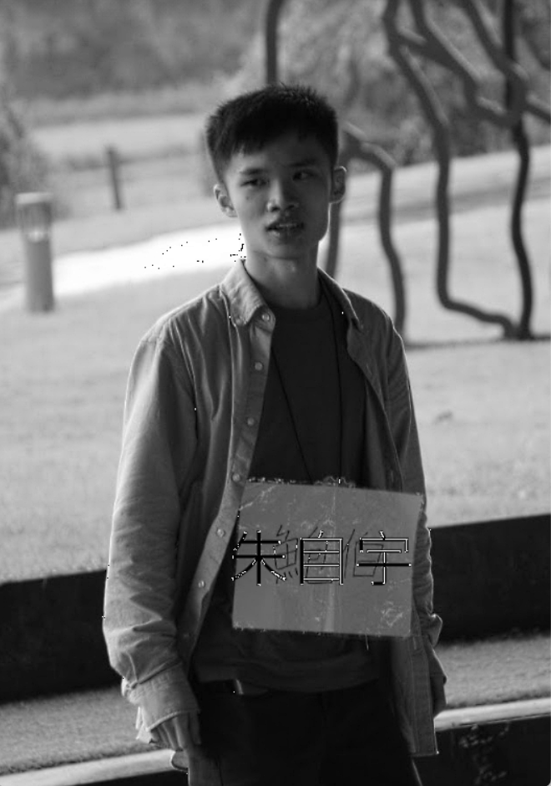

* **Source code:**

"""

110-2 NTNU CSIE

ImageProcessing

Assignment4

by 40847041S 朱自宇

"""

import numpy as np

import cv2

import matplotlib as plt

# Load the image

img = cv2.imread("me.png")

grayImg = cv2.cvtColor(img, cv2.COLOR_BGR2GRAY)

# do the average filter

averageFilter = cv2.blur(grayImg, (3,3))

# do the median filter

medianFilter = cv2.medianBlur(grayImg, 3)

# do the unsharp masking

k = 0.6

averageImg = ( grayImg - k*averageFilter ) / ( 1 - k )

averageImg = averageImg.astype(np.uint8)

medianImg = ( grayImg - k*medianFilter ) / ( 1 - k )

medianImg = medianImg.astype(np.uint8)

# show the results

cv2.imshow("origin picture", grayImg)

cv2.imshow("average filter", averageImg)

cv2.imshow("median filter", medianImg)

# wait until the user press any button to close the img window

cv2.waitKey(0)

cv2.destroyAllWindows()

* **Comments:**

I made a few mistakes, so it took longer than I expect ☹