Technical DOC
The wrapper is built upon Facade architecture.
- springBoot: 3.2.0
- Gradle 8.5
- Java 17
Workflow diagram
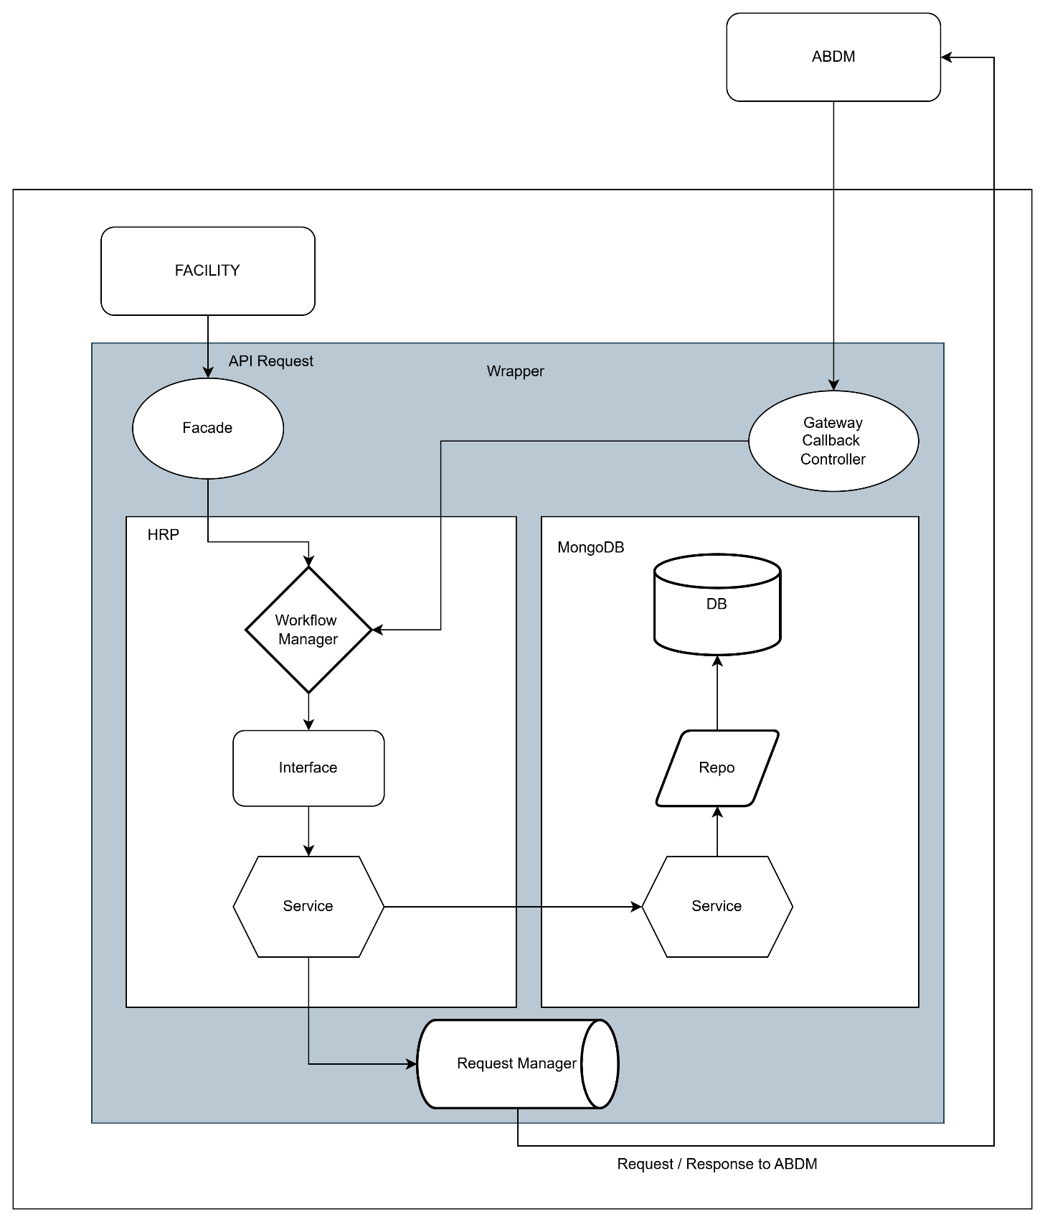

Let’s start with MongoDB
MongoDB uses the storage of the server instance, there is no fixed storage allocated to MongoDB,
if the system has 100GB storage it can store 100GB worth data.

There are 7 tables inside adbm_wrapper MongoDB
- Patient
- request-logs
- link-tokens
- consent-patient
- consent-requests
- consent-careContexts
- consent-cipher-key-mappings
patient: Patient table has all the details related to patient, their consent, their careContexts
request-logs: All the transaction logs stored with current timestamp in IST format
link-tokens: This table consists the linking token with abhaAddress and its expiry
consent-patient: This table has the abhaAddress and its related consentId’s
consent-requests: This table has the gatewayRequestId along with its clientRequestId
consent-careContexts: This table has the list of careContexts related to consent
consent-cipher-key-mappings: This table has the keys related to encryption and decryption for both HIU and HIP.

Docker
There are two Docker related files
- Docker file
- Docker-compose file
Docker file: The docker file is written in such a way that, it installs gradle and java and creates a path /app and copies all the files present in the working directory and then build and run the JAR file.
Docker-compose file: This file is an config file where the services were written in this file.
like abdm-wrapper and MongoDB mentioning the port number and the network.

Example of Linking workflow
When the facility calls the API: /v3/link-carecontexts
This request will land on the controller present in in/nha/abdm/wrapper/v3/hip/facade/link/HIPFacadeLinkV3Controller.java
- First Validation Check:
With the POJO class annotated with @Valid and @NotNull, spingBoot will check the mandatory attributes, if any field is missing the GlobalExceptionHandler.java gets invoked.

- Workflow Manager:
From controller it gets passed to workflow manager and from here to interface

- Interface: HIPLinkV3Interface.java
In the interface the addCareContexts() gets invoked

- Service: HIPLinkV3Service.java
  - First patient search: If found continue for linking or else asking facility for patient details
  - Checking of careContext: If care context is present with that particular hiType,
calling /link/context/notify for updation of existing care context.
  - Check of linkToken: If token expired or null, requesting ABDM for generation of linkToken and returning back to the facility with 202: Requested successfully
  - After receiving the linkToken: updating the DB and initiating the linking of careContext.
  - If Token is not expired, care context linking is initiated.

- Request Manager: RequestV3Manager.java
- All the requests to ABDM are forwarded to this common class for sending POST and GET requests.
- Which consumes webclient from webflux.

