U01L04 – Minecraft Color Codes Reference & Planning Sheet
Purpose: Use this sheet to observe Minecraft text colors, choose section codes, and plan your story BEFORE editing your code.
Run the color demo shared by your teacher. Do not edit the demo code.

Part A: What Minecraft Colors Look Like
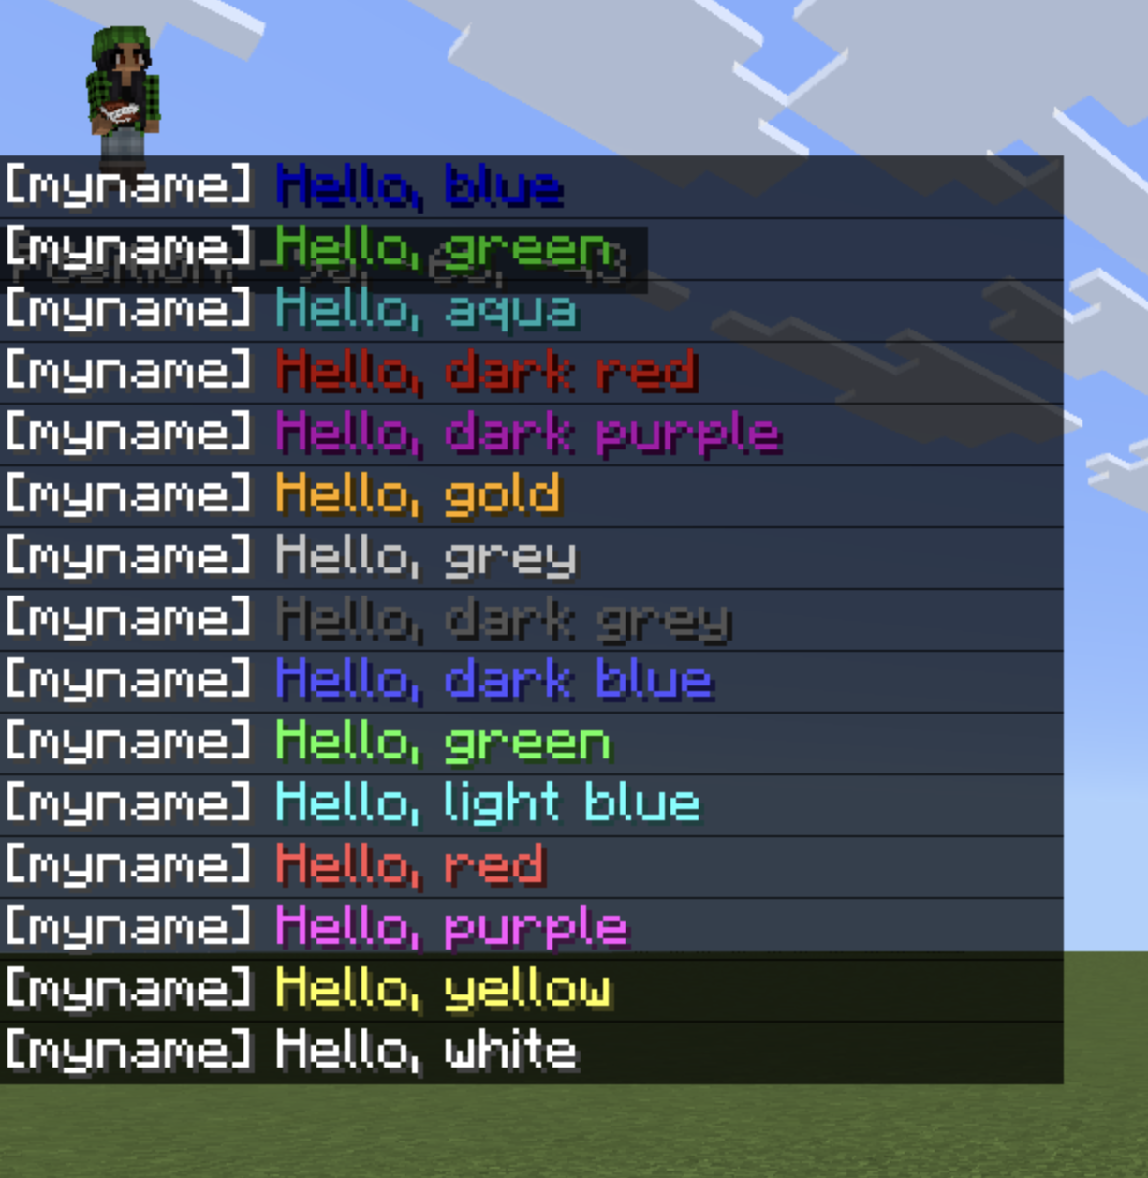
These are examples of Minecraft chat colors. Do NOT try to type these symbols yourself. Copy only the section code you need from Part B.
§ is a section sign. Try this!
§0: Black text
§1: Blue text
§2: Green text
§3: Aqua text
§4: Dark red text
§5: Dark purple text
§6: Gold text
§7: Gray text
§8: Dark gray text
§9: Dark blue text
§a: Green text
§b: Light blue text
§c: Red text
§d: Purple text
§e: Yellow text
§f: White text

Part B: Section Code Bank (Copy ONLY the symbol)
§0 §1 §2 §3 §4 §5 §6 §7 §8 §9 §a §b §c §d §e §f
Reminder: Copy ONLY the section code (example: §6). Do NOT copy entire lines of code.

Part C: Plan Your Story Colors (Do This First)
Line 1 text: ________________________________
Color code I will use: _______
Line 2 text: ________________________________
Color code I will use: _______
Line 3 text: ________________________________
Color code I will use: _______
Line 4 text: ________________________________
Color code I will use: _______
Line 5 text: ________________________________
Color code I will use: _______
Line 6 text: ________________________________
Color code I will use: _______

Quick Check (Optional)
• Which line is most important in your story? ____________________________
• How did you make it stand out using color? ____________________________
• Did you use at least three colors? ____________________________

