The Coding Editor & Your First MakeCode Python Project

This guide walks students through signing into Minecraft Education, opening the coding window, choosing MakeCode, and creating their first Python project. Screenshots have been included to show exactly what to click.

1. Open the Coding Menu in Minecraft Education

1. Press C on your keyboard.
2. Look for the Coding menu.
3. Select the pink puzzle piece icon to choose MakeCode.

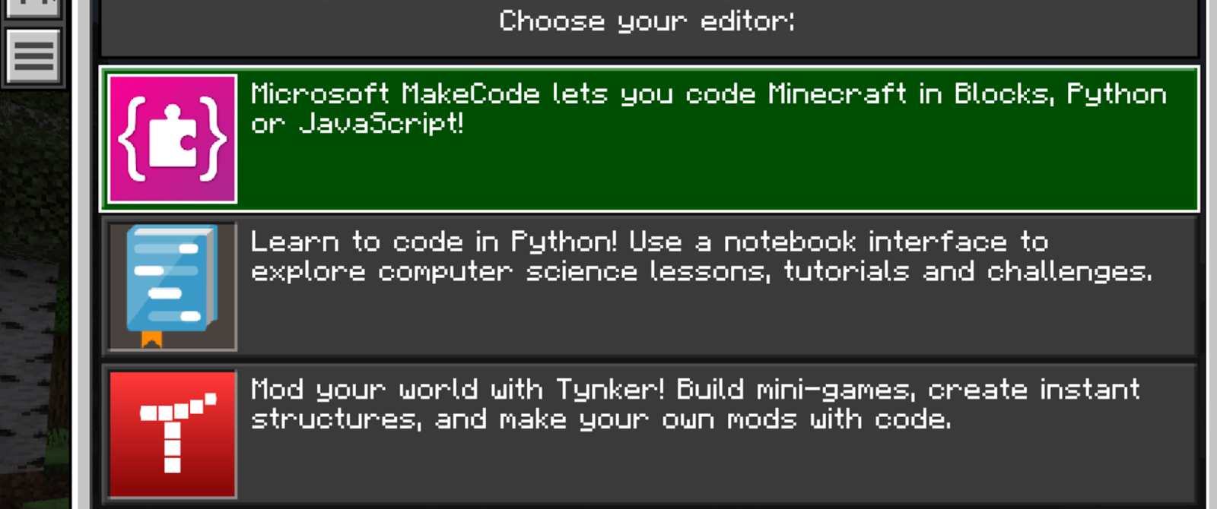

If you do NOT see the puzzle piece:
- Click the hamburger menu (three lines)
- Select OK
- The MakeCode screen will appear

2. Start a New Project in MakeCode

Once MakeCode is open:
1. Click the green plus sign to create a new project.
2. Type a project name.
Good classroom names include:
"HelloWorld-Firstname"
"U00-Example-Lastname"
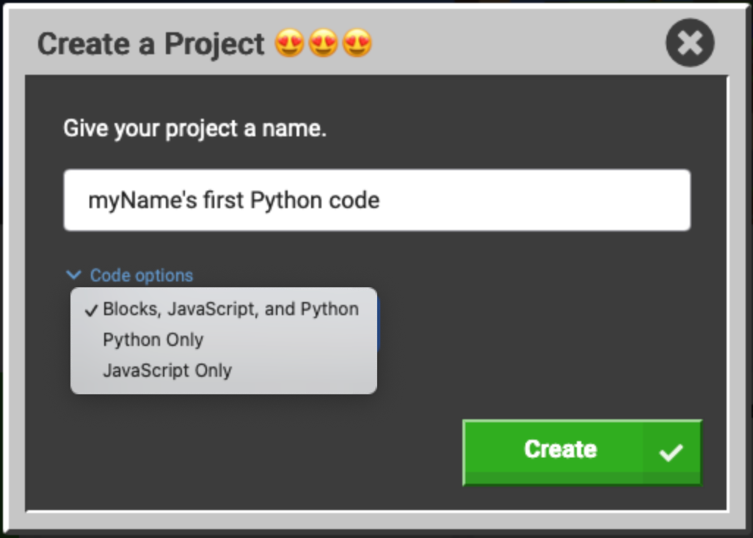

3. Choose Python Only

Below the name box:
1. Select Python Only from the dropdown options (Gray box)
2. Click Create (green button)

MakeCode Python will now open in your coding workspace.

4. Explore the MakeCode Workspace

Students should see:
- The toolbox (colorful drawers)
- The coding workspace
- The Run button
- The Share icon
- The Python language in the top line
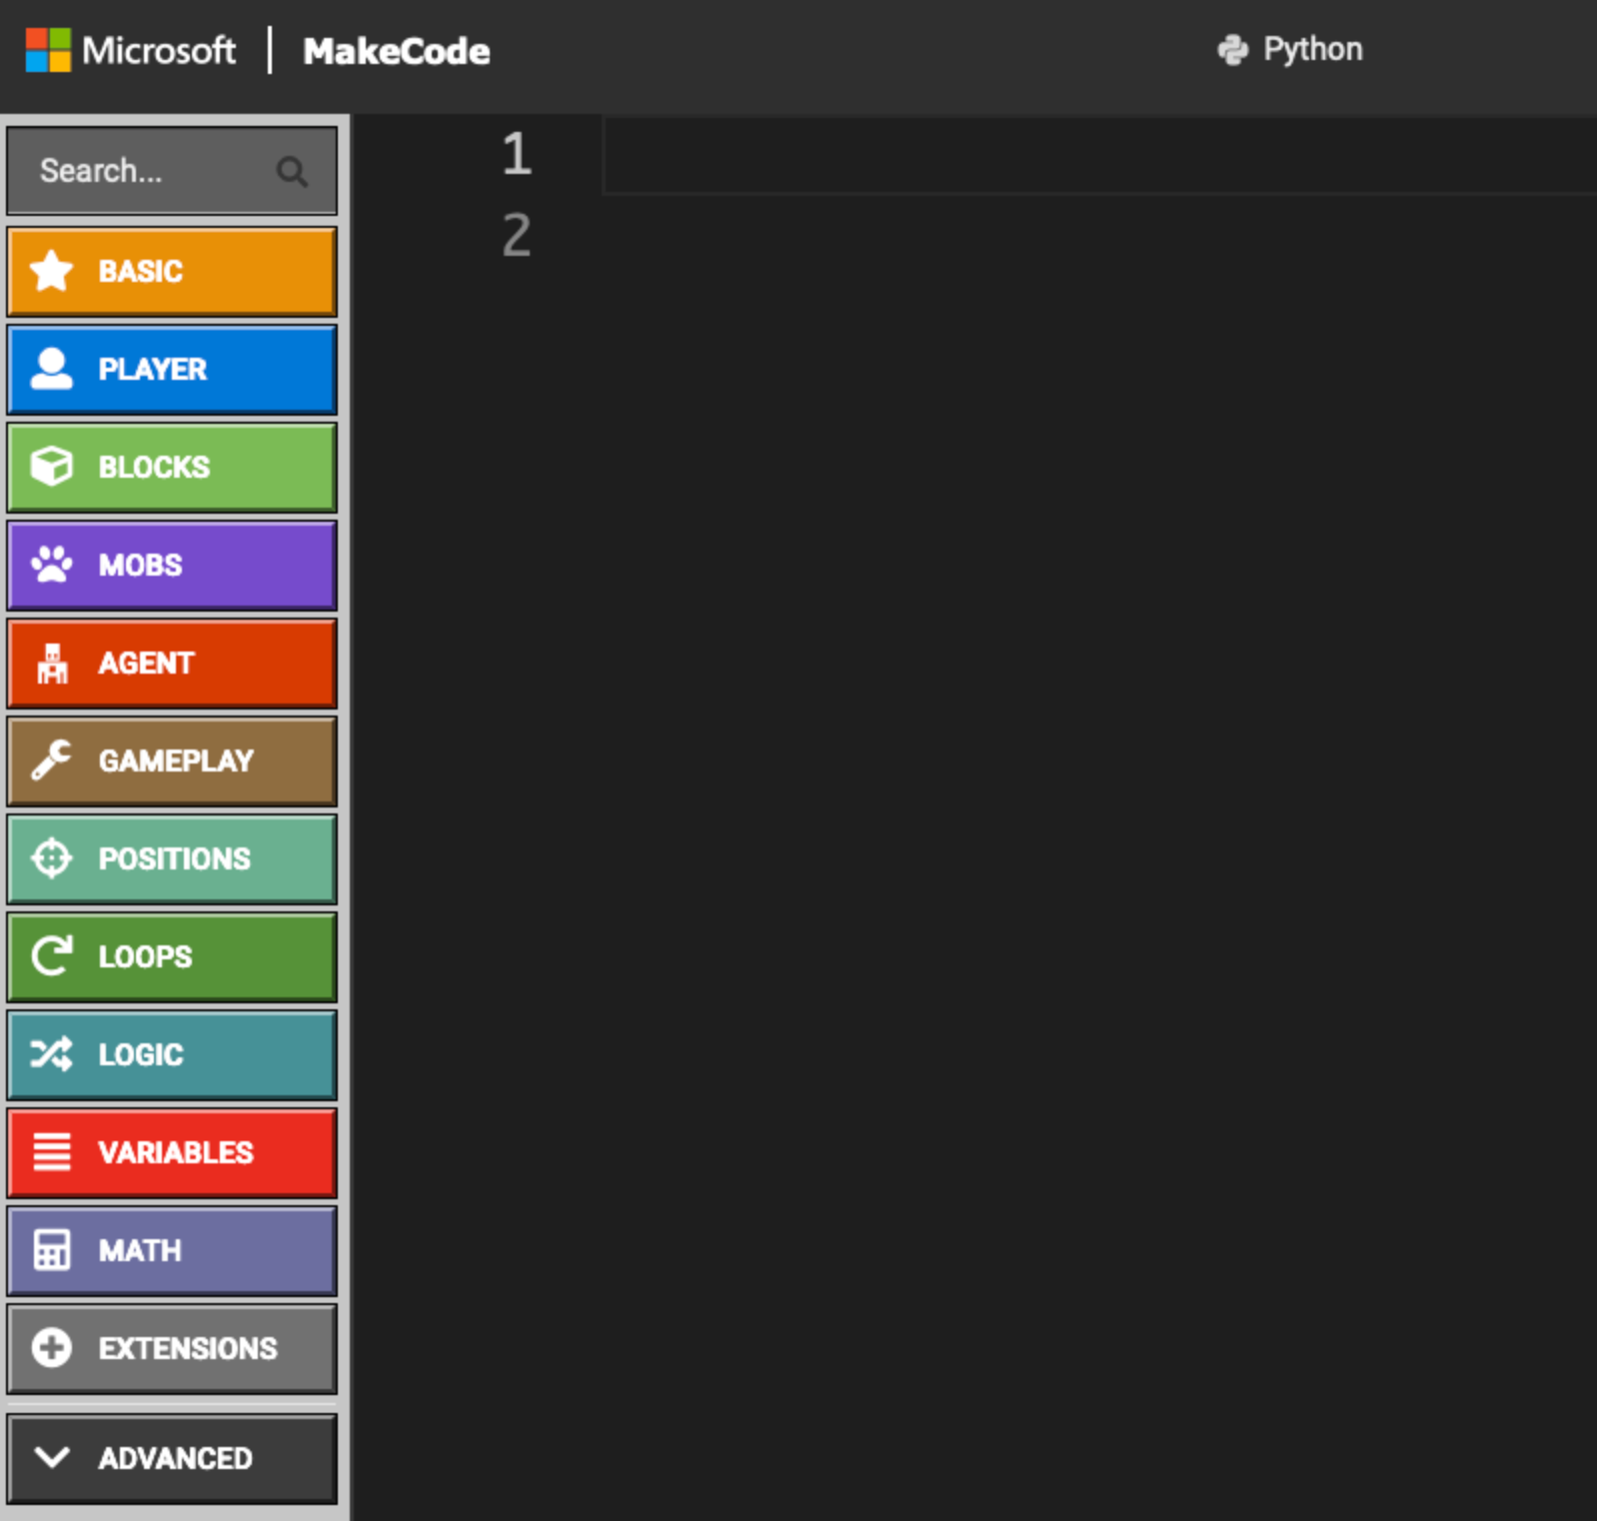
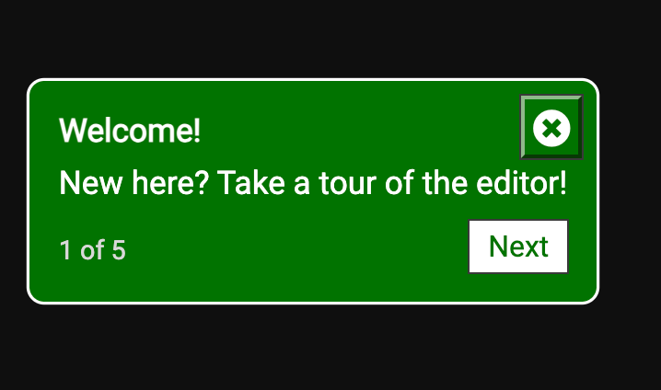

Instructor Tip:
Let students hover over drawers and items — this exploration builds confidence.

5. Your First Line of Code

Have students click on the blue Player drawer
Students will drag the say command into the workspace

Students will edit the player.say command to read:
player.say("Hello, World!")

Student will click Run, and see their message in their very own Minecraft world.

Instructor Tip:
Students are just beginning to code. These are some common errors:
Student have not learned about syntax rules yet. , They do not know how important to have matching parentheses around their message. Similarly, they may not include the quotation marks around their message.
Let the coding adventure begin!

6. Troubleshooting: Switch to Python Mode

If students do not set their code option to Python only, MakeCode opens with two tabs:
- Blocks
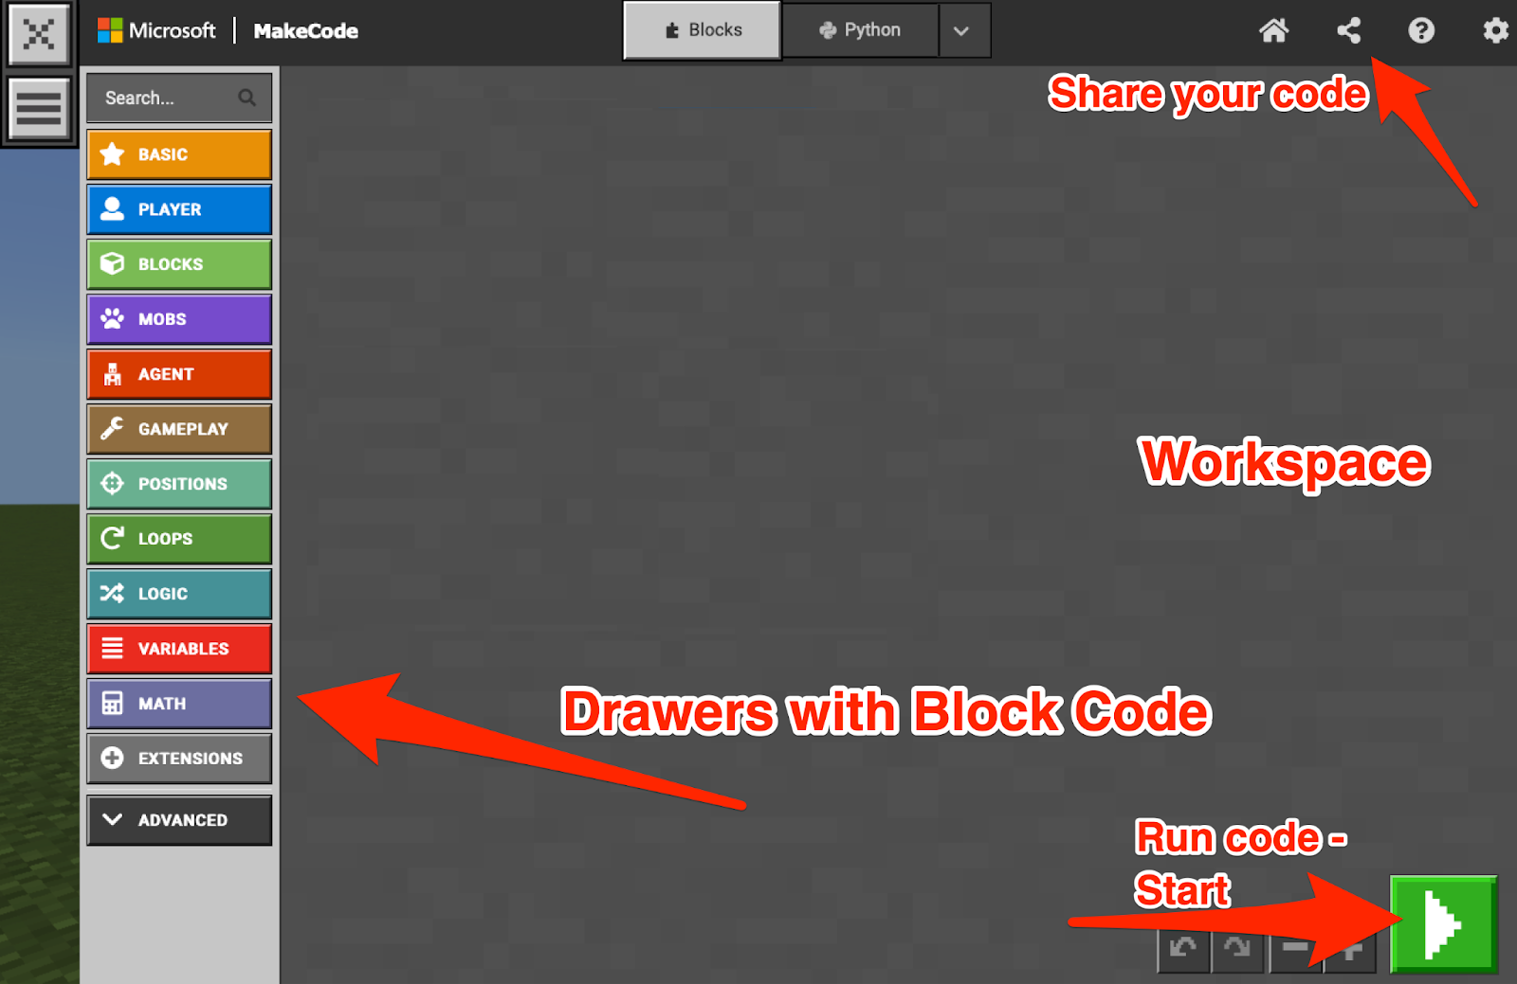
- JavaScript/Python

To switch back:
Click the Python tab (or use the dropdown) and choose Python.
There will be leftover code from the blocks window. It should be deleted.
In CS1, students will work in Python regularly, and should develop the habit of choosing Python before they create their project.

Materials Needed
- Student login credentials for school accounts
- Access to Office.com
- Access to Minecraft Education on devices
- Access to: https://minecraft.makecode.com

