03: GPS and data management

- The GPS module:
The next part that we set up is the: GY-NEO8MV2.
This is a compact and high-performance GPS receiver module, designed for precision and low power consumption. It supports all the standard satellite systems and has an accuracy of around 3 meters by using a ceramic antenna. Other GPS modules like this one boot up and start receiving in around 5 minutes, but this device is capable of performing a warm or a hot start, because of a built-in backup battery that allows it to remember the satellite data for a while after losing power, resulting in a much faster calibration.
- GPS testing
First to communicate with the GPS we must download an appropriate micropython driver.
The driver is found here: https://github.com/inmcm/micropyGPS/tree/master?tab=readme-ov-file.
With that done we have total control over the GPS and receive the data provided by it. This includes latitude, longitude, altitude, speed, connected satellites and time. To extract these values, I have written a simple testing script. Unfortunately, at this point the code is getting a little to long to paste the entire thing into the documentation, so from now on I will only show completely relevant snippets.
def updateGPSdata():
if gps_serial.any():
data = gps_serial.read()
if data:
for byte in data:
try:
my_gps.update(chr(byte))
except Exception as e:
print(f"An error occurred: {e}")

So essentially what this code does is read the incoming data from the GPS and update all its parameters according to it. Afterwards we can just use simple calls (example.: my_gps.latitude ) to get the values from the GPS. The problem that arises when doing this is the format of the received coordinates. Right now, when using my_gps.latitude, we get a list with four numbers in it: degrees, minutes and the hemisphere. This is not very ideal for data storage and later visualization, so we convert them into decimal values, that are then multiplied until integers for efficient storage. The code that is responsible for this is here:
def latFormat():
global lastLat
lat = my_gps.latitude
if not my_gps.valid:
return lastLat

deg = lat[0]
min = lat[1]
hemi = lat[2]

decimal = deg + (min / 60)

if hemi == 'S':
decimal *= -1

decimal = int(decimal * 1e6)
lastLat = decimal
return decimal

This function not only formats the data, but it also gives the last valid data if the GPS data is not valid for some reason. The function responsible for formatting longitude is extremely similar. The only difference is changing the names of the parameters and replacing the south hemisphere check with a west one.
The other significant information we must get from the GPS is time. For this we use the RTC (real time clock) library and sync the local timer with the time received from the GPS. To do this we have to mess around with the my_gps.date and my_gps.timestamp calls that both return lists with 3 elements (year, month, day, hour, minute, second). Here is the function for getting the correct time:
def getTime():
if my_gps.valid == 1:
rtc = RTC()
rtc.datetime((
2000 + my_gps.date[2],
my_gps.date[1],
my_gps.date[0],
0,
(my_gps.timestamp[0] + 1) % 24,
my_gps.timestamp[1],
int(my_gps.timestamp[2]),
0
))

return time.time()

You might notice that I have added 2000 to the years and one to the hours. The reason I had to do this, is because my_gps.date[2] returns the years passed since 2000 and I had to add one hour to correct the time considering the time zone I am in.
And with that we are done with GPS testing and here are the results:
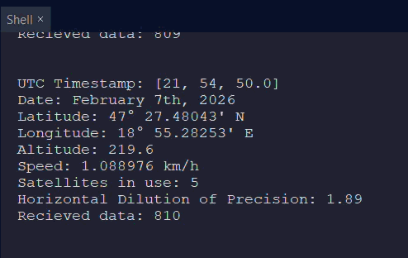

- Data management, saving and retrieving (Ground Unit, live saving and plotting)
Data handling on the ground unit is relatively simple. The main process consists of two data saving methods. The first we use is for graphing the data in real time. The steps of this are: the microcontroller receives the data via radio, it prints it, the connected computer listens to the serial port and receives, saves, processes and graphs the data. The relevant receiver and print code are this:
# Start listening. Non blocking event loop
lora.setBlockingCallback(False, callBack)

# Read message into usable data
def callBack(events):
if events & SX1262.RX_DONE:
msg, err = lora.recv()
error = SX1262.STATUS[err]
printData (msg, error)

def printData(msg, error):
# Unpacking the data using struct
t1, p = struct.unpack("<hh", msg)

if error == "ERR_NONE":
error = "OK"

# Converting to floats
t1 /= 100
p /= 10

# Sending the data to the connected computer
print(f"{t1}, {p}, {now - start}, {error}")

Next the computer reads the printed data trough serial:

import serial

# Setting up the serial port
ser = serial.Serial('COM5', 115200, timeout=10)

# Reading and converting the data
line = ser.readline().decode('utf-8').strip()
data = line.split(',')

t = float(data[0])
p = float(data[1])
time = float(data[2]) / 1000
error = data[3]

# Saving the data into lists
tempList.append(t)
presList.append(p)
timeList.append(time)
errList.append(error)

Saves it:
# Saving the data in a text file
with open("LiveData.txt", "w") as f:
if len(timeList) != 0:
for i in range(len(timeList)):
f.write(f"{timeList[i]},{tempList[i]},{presList[i]},{errList[i]}\n")
f.flush()

And finally plots all of it using matplotlib:
import matplotlib.pyplot as plt

# Setting up grid display
fig, axs = plt.subplots(1, 2)
# Enabling interactive mode (so we can constantly dipslay new data)
plt.ion()

while True:
axs[0].clear()
axs[1].clear()

# Plotting temperature as a function of time
axs[0].plot(timeList, tempList)
axs[0].set_xlabel("Time")
axs[0].set_ylabel("Temp1")
axs[0].set_title("Temp1")

# Plotting pressure as a function of time
axs[1].plot(timeList, presList)
axs[1].set_xlabel("Time")
axs[1].set_ylabel("Pressure")
axs[1].set_title("Pressure")

plt.tight_layout()
plt.show()
plt.pause(0.5)

The last step of making this as convincing as possible, is to read the saved data file. This is also trivial:
with open("LiveData.txt", "r") as f:
for lI, line in enumerate(f):
data = line.strip().split(",")
if data[3] == " OK":
time = float(data[0])
temp = float(data[1])
pres = float(data[2])

tempList.append(temp)
presList.append(pres)
timeList.append(time)
else:
print(f"Error found in data line {lI + 1} with error {data[3]}")

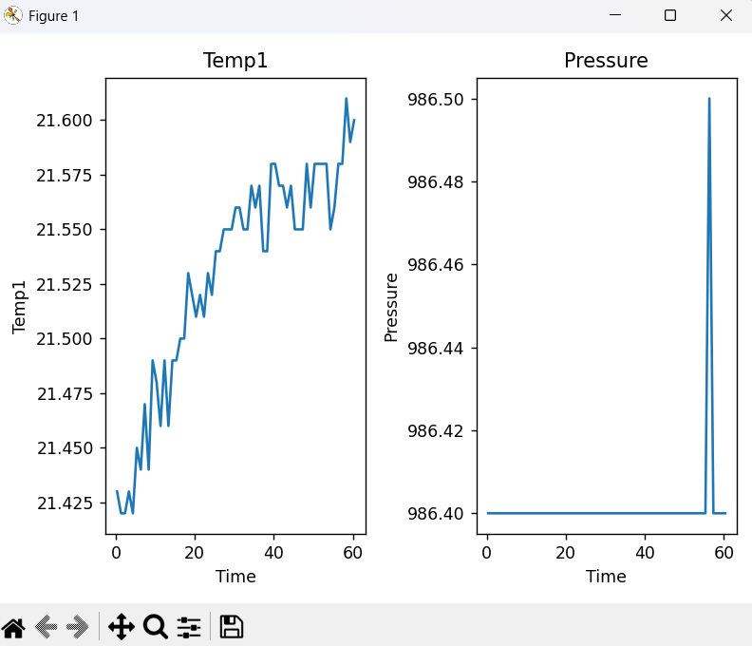
This code not only reads the file into lists that we can display the same way that we did before, but it also checks, excludes and prints any errors. Reading and plotting data results in this graph:

- Data management, saving and retrieving (Ground Unit, file saving):
As I mentioned above there is a second way we save the data, that is much more full proof than the last method. These are the steps of the process: when the microcontroller receives the data it saves it into a buffer that when reaching a specified amount, saves it onto the 2MB storage available on this ESP32. Every new session creates a new file with a new, auto generated name and the old files are deleted if there is a shortage of free space of if there are too many files. Later we can upload a script to the microcontroller that just prints out all the data in binary that a computer can read, decode and store in a separate file. Ok, so let’s begin with the saving logic on the microcontroller. First, we must create some functions to get the required data:

def listLogFiles():
files = []
for f in os.listdir("/"):
if f.startswith("log_") and f.endswith(".bin"):
files.append(f)
files.sort()
return files

This simple function, as its name suggests, goes through all the files on the ESP32 and gives us a list containing the ones that are log files. We will need this data to generate the name of a new log file, as shown here:

def nextLogFilename():
files = listLogFiles()
if not files:
return "log_0001.bin"

last = files[-1]
number = int(last[4:-4])
return "log_%04d.bin" % (number + 1)

So, this function gets the filenames, checks the last and using that information, it adds one to the index number and formats it to our needs. The next function that we will need is the storage check:
def storageCheck():
stat = os.statvfs("/")
free = stat[0] * stat[3]
total = stat[0] * stat[2]
used = total - free
return used, free, total

This function uses the os library to read the stats of the machine, which include the used, the free and the total space on our device. We will need this for checking whether there is enough space to create a new log, because if there isn’t, we must delete al least the last file to free up space. In the following function we also delete the last file if there are too many of them:
def cleanUpLogs():
# Get filenames
files = listLogFiles()

# Run until storage is clean
while True:
# Get storage stats
used, free, total = storageCheck()

# If there is enough space and not too many files, we can exit the function
if free > MIN_FREE_BYTES and len(files) < MAX_LOG_FILES:
break
# If there are no files, we can exit the function
if not files:
break

# Delete oldest file
oldest = files.pop(0)
print("Deleting", oldest)
os.remove(oldest)
Now the storage of the ESP32 is ready to start saving data. For this I have written the logData function:
def logData():
global firsLog
record = struct.pack(LOG_STRUCT, int(timeList[-1] * 1000), int(temp1List[-1] * 100), int(presList[-1] * 10), int(errList[-1]))
logBuffer.append(record)

if len(logBuffer) >= LOG_BUFFER_SIZE:
if firsLog:
firsLog = False
with open(LOG_FILE, "wb") as f:
pass

with open(LOG_FILE, "ab") as f:
for r in logBuffer:
f.write(r)
logBuffer.clear()
oled.text("Data saved", 64, 32)
oled.show()

We can call this every time we receive data, and it saves it instantly. To do this, it first converts the data into integers and then binary to save it efficiently and appends it to a buffer list. If the buffer reaches a specified amount, it first checks if it is the first time it has to log and if yes it creates a new file using the generated name. The reason why we do this is because otherwise, we would create a new file every time we start the microcontroller and that would flood the storage with empty files, if there was no received data or power fluctuations. Afterwards we write the data into the file, clear the buffer and show that we saved on the OLED display (there is an OLED display because we are running this on a LoRa 32 which contains it).
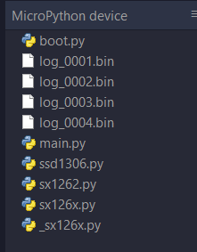
If we do some test runs and then check the storage of the device using Thonny we can see the results:

The next logical step is somehow reading the data off the ESP. As I explained before, to achieve this we upload a completely different python file to the microcontroller with the name of main.py, so it runs it upon booting up. This code looks something like this:

import struct, ubinascii, os, time, sys

START = b"\xAA\x55"
PREPARATION_TIME = 10
CHUNK_SIZE = 512
DELAY = 0.01

def sendAllLogs():
# Get filenames
files = listLogFiles()

# Print header and filecount
sys.stdout.buffer.write(START)
sys.stdout.buffer.write(struct.pack("<H", len(files)))

for fname in files:
size = os.stat(fname)[6]

# Print filename size, filename and filesize
sys.stdout.buffer.write(struct.pack("B", len(fname)))
sys.stdout.buffer.write(fname.encode())
sys.stdout.buffer.write(struct.pack("<I", size))

# Open file and print data in chunks with a delay
with open(fname, "rb") as f:
while True:
chunk = f.read(CHUNK_SIZE)
if not chunk:
break

sys.stdout.buffer.write(chunk)
time.sleep(DELAY)
# Calculate and print CRC32 checksum
crc = ubinascii.crc32(open(fname,"rb").read()) & 0xFFFF
sys.stdout.buffer.write(struct.pack("<H", crc))

# Wait some time to let me start the software on the pc
time.sleep(PREPARATION_TIME)
sendAllLogs()

So, let’s go through it. First, we import the required libraries, like some that we already know like struct and time, but also new ones, like ubinascii, os and sys. Ubinascii is used for CRC calculations, os is for filesystem access and sys useful, because it allows us to use stdout which is similar to print(), but more customizable. Next, we create the main constants: START which is a header, PREPARATION_TIME that is important, because without it we would not have enough time to set up the receiving software on the computer. CHUNK_SIZE and DELAY are used to decrease the amount of data transmitted at once, to let the receiver catch up with the transmission and avoid any transmission corruption. Afterward we get the filenames and start printing data. We start with the header to tell the receiver that the transmission is beginning. Then we print the number of files we want to transmit, and we can move onto the files themselves. For every log file we print the length of the name, the name of the file, the size of the file, the data in the file and finally we end it with printing the CRC. At this point we can start writing the receiving software running on the computer.

# Paste ReceiveGroundLogData.py here and continue.

