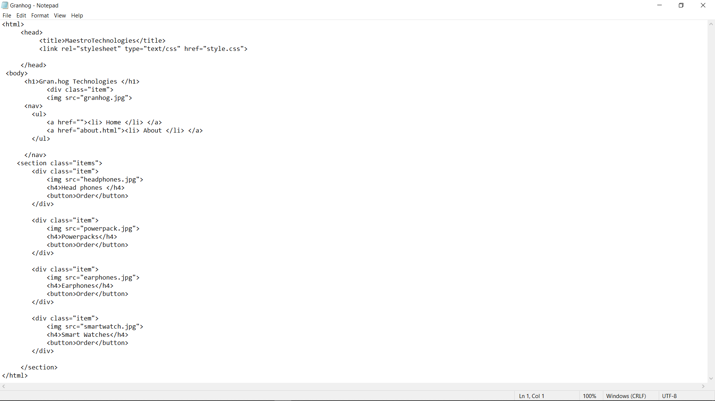

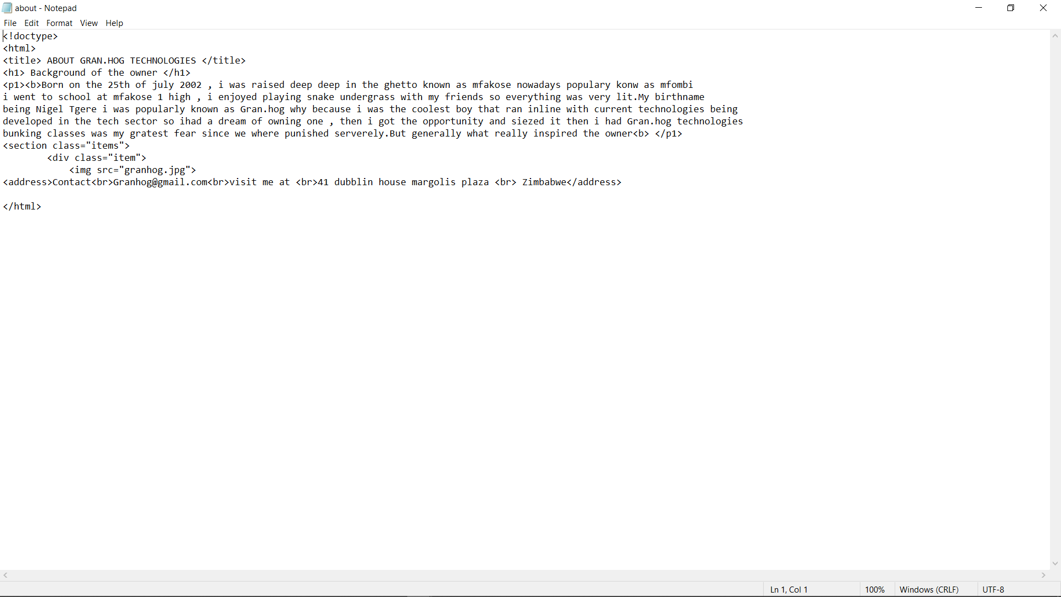

CODES FOR THE WEBSITE

<html>

<head>

<title>MaestroTechnologies</title>

<link rel="stylesheet" type="text/css" href="style.css">

</head>

<body>

<h1>Gran.hog Technologies </h1>

<div class="item">

<img src="granhog.jpg">

<nav>

<ul>

<a href=""><li> Home </li> </a>

<a href="about.html"><li> About </li> </a>

</ul>

</nav>

<section class="items">

<div class="item">

<img src="headphones.jpg">

<h4>Head phones </h4>

<button>Order</button>

</div>

<div class="item">

<img src="powerpack.jpg">

<h4>Powerpacks</h4>

<button>Order</button>

</div>

<div class="item">

<img src="earphones.jpg">

<h4>Earphones</h4>

<button>Order</button>

</div>

<div class="item">

<img src="smartwatch.jpg">

<h4>Smart Watches</h4>

<button>Order</button>

</div>

</section>

</html>

CODE FOR THE ABOUT PAGE

<html>

<head>

<title>MaestroTechnologies</title>

<link rel="stylesheet" type="text/css" href="style.css">

</head>

<body>

<h1>Gran.hog Technologies </h1>

<div class="item">

<img src="granhog.jpg">

<nav>

<ul>

<a href=""><li> Home </li> </a>

<a href="about.html"><li> About </li> </a>

</ul>

</nav>

<section class="items">

<div class="item">

<img src="headphones.jpg">

<h4>Head phones </h4>

<button>Order</button>

</div>

<div class="item">

<img src="powerpack.jpg">

<h4>Powerpacks</h4>

<button>Order</button>

</div>

<div class="item">

<img src="earphones.jpg">

<h4>Earphones</h4>

<button>Order</button>

</div>

<div class="item">

<img src="smartwatch.jpg">

<h4>Smart Watches</h4>

<button>Order</button>

</div>

</section>

</html>