**CRStoXML**

[https://github.com/Grant3Carter/CRS-tools](   %20https://github.com/Grant3Carter/CRS-tools)

This is a simple tool with a basic UI that reads native CRS data files (.def, .dat, and .dvm) and converts them to industry standard XML.

- A configuration file in MyDocuments\CRStoXML.txt lists the required files for export.

e.g.

cd c:\crsapp\pmswin

maximumRows 50

pms.def

pmsdomai.def

pmsatten.def

- Normally pms.def is the first “def” file.

-   the tool is designed to find all child records for pms records for other tables listed in the .txt file and export them along with the patient record

-   all lookups are resolved where possible

-  all data types are supported

   - The ‘C’ (Document type) can only be exported if it contains text

   - Encrypted tables cannot be exported

**UI**

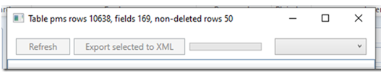

* Click refresh to read the CRStoXML.txt file

A preview of the first table in this file is shown (pms.def is the recommended first file)

Use the combo box to preview other table’s contents

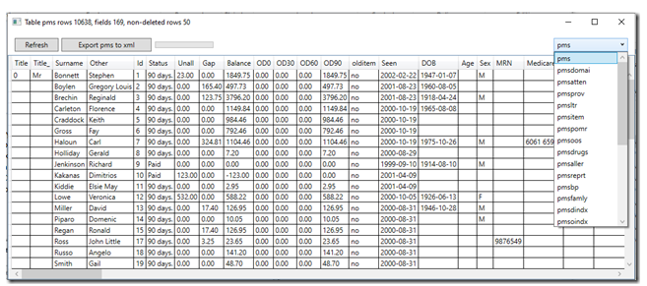

To export the full data set of the selected table  – Click Export

- Progress is shown as follows

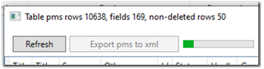

xml files are typically about 10 times (or more) the size of the original .dat file (which was a model of efficiency in its day)

You can see here how several PMS tables have been exported as a hierarchical XML structure – this eliminates the need to reconstruct data relationships after export.

