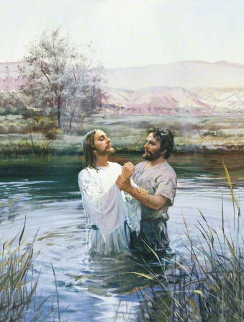

“*Jesus answered, Verily, verily, I say unto thee, except a man be born of water and of the Spirit, he cannot enter into the kingdom of God.”*

*John 3:5*

**C**hurch

Your Sabbath day behavior is an outward expression of your love for the Savior Jesus Christ and shows your Heavenly Father your real intent to follow him.

*3 Nephi 18:1-14 –Sabbath Day Observance*

**P**rayer

God cannot answer a question you never ask. If you ask your Heavenly Father in prayer, you can receive an answer from him through the Holy Ghost, who testifies of truth.

*Galatians 5:22—Holy Bible*

*3 Nephi 18:20—Book of Mormon*

**R**ead Scriptures

Consider the evidence of the Restoration of the fullness of the Gospel of Jesus Christ; The Book of Mormon, another testament of Jesus Christ. It was brought forth by the gift and power of God and translated by the prophet Joseph Smith.

*Moroni 10:3-5 pg. 529, The Book of Mormon*

|  |  |  |  |  |  |  |
| --- | --- | --- | --- | --- | --- | --- |
| Sunday | Monday | Tuesday | Wednesday | Thursday | Friday | Saturday |
| |  | | --- | |  | | |  | | --- | |  | | |  | | --- | |  | | |  | | --- | |  | | |  | | --- | |  | | |  | | --- | |  | | |  | | --- | |  | |
| |  | | --- | |  | | |  | | --- | |  | | |  | | --- | |  | | |  | | --- | |  | | |  | | --- | |  | | |  | | --- | |  | | |  | | --- | |  | |
| |  | | --- | |  | | |  | | --- | |  | | |  | | --- | |  | | |  | | --- | |  | | |  | | --- | |  | | |  | | --- | |  | | |  | | --- | |  | |
| |  | | --- | |  | | |  | | --- | |  | | |  | | --- | |  | | |  | | --- | |  | | |  | | --- | |  | | |  | | --- | |  | | |  | | --- | |  | |
| |  | | --- | |  | | |  | | --- | |  | | |  | | --- | |  | | |  | | --- | |  | | |  | | --- | |  | | |  | | --- | |  | | |  | | --- | |  | |
| |  | | --- | |  | | |  | | --- | |  | | |  | | --- | |  | | |  | | --- | |  | | |  | | --- | |  | | |  | | --- | |  | | |  | | --- | |  | |