*John the Baptist Baptizing Jesus,* detail, is copyright 2007, Intellectual Reserve. Used by permission.

*(Insert date here)*

(insert name here)

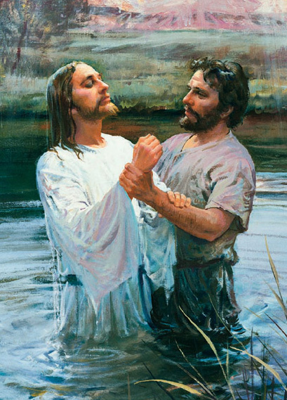

*(insert ward name)Ward of the   
Church of Jesus Christ of Latter-day Saints,*

Song Lyrics:

**When I am Baptized**

1. I like to look for rainbows whenever there is rain  
And ponder on the beauty of an earth made clean again.

2. I know when I am baptized my wrongs are washed away,  
And I can be forgiven and improve myself each day.

***Chorus***

I want my life to be as clean as earth right after rain.  
I want to be the best I can and live with God again.

**I am a Child of God**

1. I am a child of God,  
And He has sent me here,  
Has given me an earthly home  
With parents kind and dear.

2. I am a child of God,  
And so my needs are great;  
Help me to understand His words  
Before it grows too late.

3. I am a child of God.  
Rich blessings are in store;  
If I but learn to do His will,  
I’ll live with Him once more.

***Chorus***Lead me, guide me, walk beside me,  
Help me find the way.  
Teach me all that I must do  
To live with him someday.

**Conducting:** (insert name here)

**Pianist:** (insert name here)

**Music Leader:** (insert name here)

**Welcome:** (insert name here)

**Opening Song:** *When I am Baptized*

**Opening Prayer:** (insert name here)

**Talk on Baptism:** (insert name here)

**Baptismal Ordinance:** (insert name here)

**Witnesses:** (insert name here)

**Missionary Moment:** (insert name here)

**Talk on Holy Ghost:** (insert name here)

**Confirmation:** (insert name here)

**Welcome:** (insert name here)

**Bishopric Welcome:** (insert name here)

**Closing Song:** *I am a Child of God*

**Closing Prayer:** (insert name here)