Grant Medlyn
12016119

Artificial Intelligence in a Procedurally Generated World

Research Report

Abstract
This report summarizes research in the area of AI path finding in a procedurally generated world, it will focus on the techniques for both of these and will be used to determine the best methods for the future prototype. There are multiple algorithms used for procedural generation such as Perlin noise, Midpoint Displacement and Cellular Automata as well as different methods for path-finding including A* and Dijkstra's Algorithm which will all be looked into with more detail in this report and as a conclusion how both procedural generation and path-finding can possibly be used together to create a complete procedural generated world and AI with the ability to traverse it intelligently.

Author Keywords
Procedural generation; Path-finding; Cellular Automata; Perlin noise; Interpolation; Midpoint-Displacement; Diamond Square algorithm; A* algorithm; Dijkstra's algorithm

Introduction
The aim of this project is to produce a solution where AI path finding can be used in a procedurally generated world with nodes that are placed by AI intelligently by following some simple rules. At the very least this project will provide a model of a procedurally generated 2D landscape with nodes being placed by the user in various places and AI traversing the procedural terrain via the nodes with a long term goal of creating the AI to place the nodes itself and having different AI agents with different preferences or abilities as it traverses the procedural terrain.

Research Questions
- Is it possible and if so how to create a procedurally generated world with AI that has the ability to calculate the placing of all nodes and assigning the expected heuristic and movement costs based on the heights and depths of the terrain and then successfully finding the optimal paths between certain nodes.
- What is the best interpolation algorithm to use for procedurally generated terrain for the most organic look.
- What post processing can be done after procedural generation to create chasms and rivers throughout the terrain.
- Which path finding algorithm is best for traversing open terrain of varying heights and depths.

Research Methods

For this report, the research carried out consists of a mixture of primary and secondary research. The different methods of procedural generation and path finding were studied using secondary research through the reading of journals, books and online pdf documents. This method was chosen over actual existing RTS game AI implementations as successful companies tend not to release their work to the public to protect their products, examples of actual implementations are hard to find and so it has proven more reliable to study the individual techniques and algorithms that make up the wider AI of RTS games. Furthermore, one of the goals of this project is to find a solution to combine both procedural generation with path finding together and provide a model that is capable of generating a world and mapping nodes to it without any additional human intervention, and to do this it is necessary to strip down the AI techniques of RTS games to find opportunities for solutions and potential modifications of existing techniques.

For primary research, a prototype was created demonstrating Perlin noise with linear and cosine interpolation, it was necessary to do this to properly understand how Perlin noise and interpolation works as well as obtain some qualitative data and determine whether or not these methods are suitable for the project and goals at hand.

During the research it was found that Perlin noise can be very demanding on the computer of which it is running and so it is necessary to limit the amount of generated terrain at any one time creating a window for the viewer. It was also found that while linear interpolation successfully produced the effect expected, cosine interpolation proved superior for it's increased organic look and ease of implementation on top of linear interpolation.

Linear interpolation was first attempted as it was the simplest interpolation method and initially the problem of the discontinuing lines between gradient was not realised until the results of the first implementation were evaluated, after this it became apparent that cosine interpolation would provide a solution to more organic looking results and since the conversion between linear and cosine interpolation is fairly straight forward, cosine was implemented and the results were desirable.

Research Findings

Procedural Generation
Procedural generation is when data is generated algorithmically instead of manually, this means that the data takes up less space as it is not stored on the hard drive, however this data takes time to generate which can be a problem when needing to generate a large amount of data. There are different methods of procedural generation and each have their own advantages and disadvantages.

Cellular Automata
Cellular automata is an algorithm that starts with an input and over a time period will uses rules to generate a new state based off of the previous state, it is simple in its application and is capable of generating incredibly complex and unpredictable patterns. Cellular automata is a fractal noise algorithm, fractal noise is noise generated using some initial data and a set of rules to create interesting shapes and patterns, sometimes by adjusting the rule sets and starting conditions incredibly complex and unpredictable changes in the noise can be created.

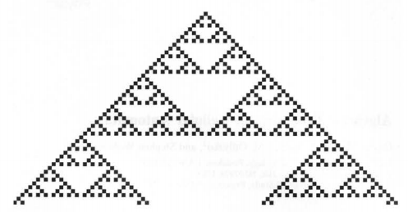
Figure 1: An example of a cellular automaton. [5]

“In the simplest case, a cellular automaton consists of a line of sites with each site carrying a value of 0 or 1. The site values evolve synchronously in discrete time steps according to the values of their nearest neighbours.” [1]

The data is usually represented with cells and a number of states of which each cell could be, the rules dictate which cells change and what state they change to based on the cells in their neighbourhood, the type of neighbourhood can be determined in the rule set, whether the states of the adjacent cells are considered or even the cells of all neighbours and all neighbours neighbouring cells etc. Cellular automata can produce a new generation in one of two ways, either stepping over each cell and making the changes as it goes (causing the new cell state to affect the new state of cells after it on the grid) or evaluating each and every cell first and then applying the changes at the end.

Using cellular automata, highly complex looking cave systems and landscapes can be created though multiple passes are almost always needed to smooth out the final result.

A cellular automaton is one of the more simple methods to implement and it doesn't require much processing, its downfall however is that while it is possible to create some incredibly unpredictable sets of data, it is also just as easy to create predictable and repetitive patterns as seen in figure 1, this depends on the initial data and the rules that are applied.

Perlin Noise
Another method of procedural generation is Perlin noise. Perlin noise uses a random seed to procedurally generate data, for every seed there will be a unique set of data, random functions may be used to generate this data, but because the same seed is re-used in any one instance it is not classed as random data, but procedural data generated from a random seed. The seed could also be something defined by the user.

Perlin noise can be represented by starting with an empty grid and specifying an amplitude and frequency for a single octave (layer of noise) the amplitude will represent the amount of weighting to put at a specific gradient value and the frequency represents the frequency of the gradient values. The gradient values are the pieces of data procedurally generated. As the first octave is calculated, the selected gradient values are given a value within the constraints of the amplitude specified for that octave, once all values have been assigned the attention is turned to the sample points in between the gradients, the values of these points and assigned by interpolating between the four gradient values closest to the sample point. Once this is complete more octaves can be added with higher frequencies and lower amplitudes to achieve a more unpredictable affect when the layers are applied on top of one another.
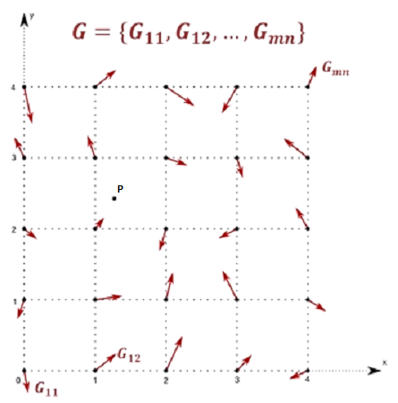
Figure 2: Perlin noise gradient vectors, where G represents gradients and P represents the sample point [12]

When generating terrain using Perlin noise some very organic looking landscapes can be produced, however it is not capable of generating rivers or chasms and thus a corrosion layer must be applied apart from Perlin noise, this is additional processing that needs to be done and is one of the limitations of Perlin noise. Another limitation is that even without the post processing of adding rivers and such, the Perlin noise algorithm including the interpolation between the gradient values requires much processing to be done and sometimes it is much more efficient to just store the data that you are trying to represent.

Interpolation Techniques
Interpolation has more than one method and each are practically better in different situations, two particular methods are linear interpolation and cosine interpolation, both of these can be implemented for 2D grid based terrain.

“Applying linear interpolation to a sequence of points results in a polygonal line where each straight line segment connects two consecutive points of the sequence. Therefore, every segment (P, Q) is interpolated independently as follows: P(t) = (1 − t).P + t .Q (1) where t ∈ [0, 1]. By varying t from 0 to 1 we get all the intermediate points between P and Q. Note that P(t) = P for t = 0 and P(t) = Q for t = 1. For values of t < 0 and t > 1 result in extrapolation, that is, we get points on the line defined by P, Q, but outside the segment (P, Q). “ [9]

Linear interpolation can be achieved between 4 points of a square by first marking a sample point S somewhere in-between the four points, then taking the two top gradient vectors of the square A and B and interpolating along the X axis of the sample point S, then doing the same for the two lower gradient vectors C and D, with the two values that have resulted from these calculations they are themselves interpolated between along the Y axis of the sample point S to reach the final value of the sample point S through linear interpolation.

Linear interpolation is the simplest type of interpolation to implement and has a drawback when trying to generate organic looking terrain. Linear interpolating is as the name states linear which means it is not capable of generating curves or gradual increases/decreases, on a graph this would look like straight lines draw between each other and on terrain each hill or ditch is pointed at it's midpoint or gradient vector where the slope changes direction

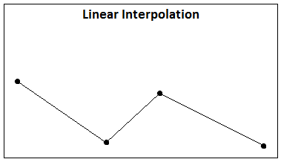
Figure 3: Linear interpolation

“the curve resulting from Linear interpolation has discontinuities at each point. In certain circumstances, we need a smoother interpolating function, that is a function that allows for a smooth transition between consecutive segments. The cosine interpolation carries out a transition that looks smooth, though every segment is interpolated independently too” [8]

Cosine interpolation is similar to that of linear interpolation except it includes a cosine function when calculating the sample point value, this means that a curve is introduced as the gradient vectors are passed between and provides a more organic look in the terrain.

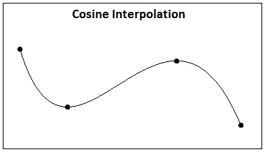
Figure 4: Cosine interpolation, a smooth transition between points instead of discontinued lines as seen in linear interpolation.

Cosine interpolation however does still force the passing through of each gradient and so if there are for example four points on a graph with three of them being situated very low on the Y axis and the fourth very high on the Y axis, the line created will at some point create a very pointed mountain at the gradient vector who's Y axis is very high and thus creating a less organic looking curve if it were to be generated as terrain. This is because in cosine interpolation each segment is still interpolated independently.

Midpoint Displacement
For procedural terrain generation Midpoint Displacement is another method, this method is similar to Perlin noise in that it can take a randomly generated or fixed seed and use that to determine its values, but its method of generating the terrain is different. Midpoint Displacement can be represented by starting out with a 2D straight line from left to right and setting the Y coordinate of that line in the centre along the X axis to a procedurally generated value, creating either an inclination or a ditch depending on the generated value, this procedure is then repeated for each of the other midpoints either side of the previous midpoint and so on, after a few iterations a more unpredictable line is produced and this can be used to represent the terrain. The variation in the terrain can be adjusted by changing the amplitude of the change in the Y axis and how many iterations are applied. Some interpolation method may still be needed to draw the area in-between the affected points and with cosine or cubic interpolation this will provide a smooth affect.

Midpoint displacement could be used to apply a corrosion layer on top of Perlin noise by drawing a line through the Perlin noise and then using some passes of Midpoint Displacement to manipulate the line. Once the line has been manipulated the Perlin noise values at these point can be lowered to give the corrosive effect.

Midpoint displacement can also be implemented on a 2D plane with a top down perspective, this is known more as the Diamond Square algorithm because the algorithm works the same way as on the 2D line representation but instead divides the 2D plane into multiple squares and diamonds.

“In three dimensions the algorithm works by starting with four known points forming a square. This square is then subdivided into four smaller squares. The vertices that have to be added to form the new squares are displaced along the vertical axis similar to the midpoint displacement in 2d. First the middle vertex is displaced as part of the diamond step. Then, the vertices directly between existing points are displaced as part of the square step. The algorithm can, just like in 2d, be applied interatively until a certain level of detail has been reached.“ [4]

With Midpoint Displacement, particularly Diamond Square algorithm, artefacts can sometimes ruin the organic look of the terrain that is generated, this is because of the fact that the landscape is divided into squares and diamonds. However this is not an issue for Perlin noise because a smooth transition is given when cosine interpolation is used, but when using linear interpolation, artefacts may still be generated.

“Perlin noise has a distinct advantages over midpoint displacement algorithms. First and foremost, perlin noise looks more natural since it lacks the square and diamond artifacts along major gridlines. Both noise-based heightmaps and fractal heightmaps have some degree of control over terrain features by adjusting the input for the first step. After generation of a heightmap often more realism can be added by simulating erosion or smoothing the noise.” [3]

Path Finding

A* - A star
There are a number of different path finding algorithms used and each have their own merits. Algorithms such as the A* path finding algorithm use a node system which have their own values and cost of movement. Each node can cost a different amount to traverse based on things like attributes which could relate to difficultly, height, depth, distance from goal node etc. The main point is that when travelling between two nodes there needs to be some value that can be recorded to take into account the cost of that decision, this allows for path finding to take place where the algorithm will locate the path that results in finding the goal node whilst having the lowest cost of the sum of all of it's decisions compared to other routes.

In the A* path finding algorithm each node is assigned a parent node starting by assigning the start node the parent of all of it's adjacent nodes, reassigning parents can also be an occurrence where if the current node who's children are being calculated finds that an already assigned child has a cheaper connection with this new node than it does with it's previously assigned parent, then the new parent will be assigned which is the node currently being calculated. As each node is calculated they are added to a closed list to signify that they have already been calculated, another list is kept, sometimes called an open list which stores all of the current nodes that have been assigned parents but have not yet had their children calculated.

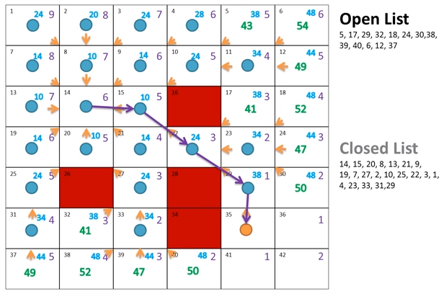
Figure 5: A* path finding [11]

”h stands for heuristic which is an estimated cost from the current node to the goal node (usually the straight line distance from this node to the goal)” [2]

Using the heuristic, the algorithm will prioritise certain nodes during calculation so if a barrier is encountered then the nodes adjacent will be calculated until a way around is found. For example if the start and goal nodes had no obstacles in-between them then the A* path finding algorithm should be able to plot a straight line between the two nodes, however if there is an obstacle then the path finding algorithm will head in a straight line following the nodes with the most favourable heuristic and cost and when the obstacle is encountered it will attempt to search around the obstacle always prioritising the nodes with the best heuristic and lowest cost until it finally overcomes the obstacle and can continue toward the goal node.

Dijkstra's Algorithm
Dijkstra's Algorithm is another path finding technique, in Dijkstra's algorithm each node has a cost for traversing to it's neighbouring nodes and this information is what is used to calculate the best path to the goal node.

First, all neighbouring nodes to the start node are given temporary cost values based on the cost from the start node A, then the least costly neighbour node B is selected from all of the current temporary nodes and is given a permanent cost value as the shortest path from the start node A to node B has been found, next all neighbours to node B are given temporary values adding the current running cost from the start node A to the cost between the two nodes and assigning this value as the temporary cost of the new neighbour. Again, the cheapest node out of all of the current temporary nodes is selected and assigned it's permanent value (which will be the latest temporary value that it has been assigned), all of the neighbours to this node is now evaluated and this process is repeated until the goal node has been selected as permanent. From that point the path is traced back from the goal node to the start node by taking the total cost (or permanent value) of the goal node and subtracting it against the cost of traversing back to it's neighbours, the result will equal the running cost at that neighbouring node if it is the optimal path.

“Consider then the problem consisting of n > 1 cities {1, 2, . . . , n} and a matrix D representing the lengths of the direct links between the cities, so that D(i, j) denotes the length of the direct link connecting city i to city j. This means that there is at most one direct link between any pair of cities. Formally we assume that −∞ < D(i, j) ≤ ∞, ∀i, j ∈ C := {1, . . . , n} with D(i, i) = ∞, ∀i ∈ C. We interpret D(i, j) = ∞ as an indication that there is no direct link from city i to city j.” [6]

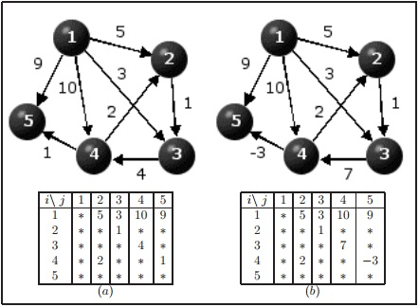
Figure 6: The shortest path problem above (b) shows that having negative numbers as a cost between two nodes can cause Dijkstra's algorithm to fail finding an optimal solution. [10]

Dijkstra's algorithm does not take into account the distance between the nodes and the goal node as A* does, this means that A* tends to gravitate more towards the goal node which can result in a faster solution when there are less obstacles between the start and goal node, whereas Dijkstra's algorithm always moves and evaluates the next best node out of the list of temporary nodes disregarding the distance to the goal node, however when an area has more obstacles both algorithms seem to perform in a more equal amount of steps.
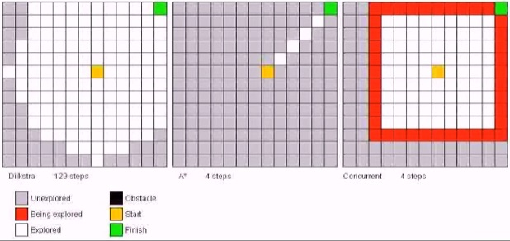

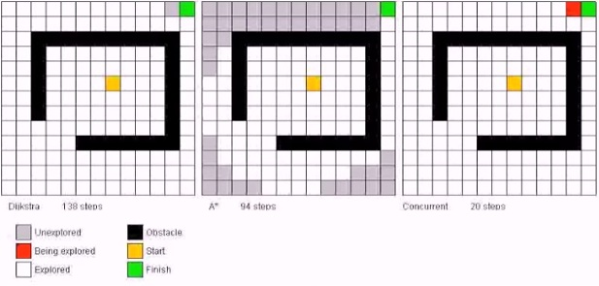
Figures 7 and 8: Dijkstra's algorithm versus A* search. [7]

The presence of the obstacles only affects Dijkstra's algorithm slightly in terms of speed while impeding A* greatly in figure 8 compared to figure 7, however with no obstacles present A* is clearly by far the superior algorithm.

Conclusion and Recommendations

From the conclusions of the primary and secondary research the procedural generation technique that will be implemented into the final prototype will be the Perlin noise algorithm. The main reasoning for this is that the appearance of the terrain can be better controlled when using Perlin noise because both the frequency and amplitude can be specified as well as the number of passes/octaves to process, on top of this, different interpolation techniques can be used to further modify the appearance of the terrain. From the results of the first prototype, cosine interpolation was the better algorithm for it's natural curves between gradients, an improvement on this however and possibility for the final prototype would be to use a more advanced interpolation technique that doesn't force all gradients to be passed through as cosine interpolation does by interpolating each segment independently.

Another advantage that Perlin noise has is that after the generation of the terrain, additional processing can easily be implemented to produce rivers and chasms in the terrain and bring about an even more organic look, possibly by using Midpoint Displacement.

Midpoint displacement or Diamond Square algorithm is prone to creating artefacts that aren't seen in Perlin noise, the artefacts appear in the form of flat edges in Midpoint Displacement and squares and diamonds in Diamond Square algorithm and this is simply because the data or terrain is made up of lines, squares and diamonds. The smaller the number of passes the more obvious these artefacts can become.

The results of the path finding research suggests that A* path finding would be better suited for the procedurally generated open terrain as when there are no obstacles present and it locates the optimal path 125 steps faster than Dijkstra's algorithm in figure 7. When there are obstacles present Dijkstra's algorithm holds up stronger against A* but never surpasses it in terms of speed or the amount of steps it takes to reach the goal node.

A* path finding algorithm can potentially be mapped on top of the grid based 2D procedurally generated terrain by placing nodes at certain intervals, then evaluating the height values of the sample points at that grid position and assigning the g value or movement cost based off of that value. The location of the goal node will also need to be known so that the heuristic or estimated cost from the goal node can be calculated for the placed node. Once that data is in place the start node can be specified and the optimal solution should be found, gravitating more toward the lower areas of the terrain and traversing to higher areas only when absolutely necessary.

References

[1] Olivier Martin, Andrew M. Odlyzko, Stephen Wolfram, 1984, Algebraic Properties of Cellular Automata, California Institute of Technology, Pasadena, http://www.stephenwolfram.com/publications/academic/algebraic-properties-cellular-automata.pdf, pg 1.

[2]Ross Graham, Hugh McCabe and Stephen Sheridan, (N/D) Path-finding in Computer Games, School of informatics and engineering, institute of technology, Blanchardstown, Pg 10.

[3](N/D), 2010 Chllanges in procedural Terrain Generation, Twente University, https://www.inter-actief.utwente.nl/studiereis/pixel/files/indepth/JoeriVanDerLei.pdf, pg 3.

[4](N/D), 2010 Chllanges in procedural Terrain Generation, Twente University, https://www.inter-actief.utwente.nl/studiereis/pixel/files/indepth/JoeriVanDerLei.pdf, pg 2.

[5] Olivier Martin, Andrew M. Odlyzko, Stephen Wolfram, 1984, Algebraic Properties of Cellular Automata, California Institute of Technology, Pasadena, http://www.stephenwolfram.com/publications/academic/algebraic-properties-cellular-automata.pdf, pg 2.

[6] Moshe Sniedovich, 2006, Dijkstra's algorithm revisited: the dynamic programming connexion, The University of Melbourne, Australia, http://matwbn.icm.edu.pl/ksiazki/cc/cc35/cc3536.pdf, pg 4 (labelled as 602)

[7] UNSWMechatronics, 2013, Dijkstra's Algorithm vs. A* Search vs. Concurrent Dijkstra's Algorithm, https://www.youtube.com/watch?v=cSxnOm5aceA

[8-9] Abel Gomes, 2010, Interpolating Methods, (N/D), http://www.di.ubi.pt/~agomes/tcg/lectures/04-lecture.pdf, pg 2.

[10] Moshe Sniedovich, 2006, Dijkstra's algorithm revisited: the dynamic programming connexion, The University of Melbourne, Australia, http://matwbn.icm.edu.pl/ksiazki/cc/cc35/cc3536.pdf, pg 7 (labelled as 605)

[11] CodeCompile, 2012, A* Pathfinding Tutorial, https://www.youtube.com/watch?v=KNXfSOx4eEE

[12] Aleksander Spiridonov, 2012, Programming! [EP1] – 2D Perlin Noise, https://www.youtube.com/watch?v=Or19ilef4wE

Appendixes

Figure 2: https://www.youtube.com/watch?v=Or19ilef4wE

Figure 5: https://www.youtube.com/watch?v=KNXfSOx4eEE

Figures 7 and 8: https://www.youtube.com/watch?v=cSxnOm5aceA

