**Grant Medlyn**

Cwmbran, 1 Kingsland Walk, NP44 4RE

07944549202

grant2600@googlemail.com

EDUCATION

2008 – 2010 Falmouth School – Cornwall

Maths, English Literature, English Language, Physics, Biology, Chemistry, Graphics Design and I.C.T all at GCSE Level.

2010 – 2012 Truro college – Cornwall

Software development national diploma

Distinction, Distinction, Merit

Modules include: Game development, Excel spread sheets, Databases, Web design and Computer systems architecture.

2012 – 2016 University of west England - Bristol

Games Technology BSc (Hons) Graduated July 2016 with a 2:1

Modules Include: C++ and C# programming, 3D design, Theory of games, Development of games, Game Engine Architecture, Simulated Worlds, Entertainment software development, Game Development evolution, Principles of 3D environment, Artificial intelligence in games., Advanced Technology, Commercial Games Development, Creative Technology Dissertation, Mobile Device Development.

SKILLS

**Confident C++ programming:**

Before starting my software development diploma in college I taught myself through online research and books, how to program in C++, I also learnt how to use C++ while using object orientation and have a good understanding of polymorphism, inheritance, pointers and classes.

**IT skills:**

Throughout college and university I have become proficient with many software applications including Microsoft Word, Excel, and PowerPoint and other Microsoft products including Microsoft Visual studio for programming in C++ and C#. In college I have developed different games using Game Maker and Delphi/Pascal and in University I have developed games and game engines using C++, C# and XNA. During my free time I have worked on my own text based games written in C++ and also build an autonomous robot which follows light, with the embedded programming written in C. I have also experimented with developing Genetics algorithms, AI path finding and server-client based multithreaded applications all in C/C++.

**Personal Projects and Automated Trading:**

My latest personal project I'm working on involves developing an application to analyze markets such as forex, equities and commodities etc and perform or give signals on trades and investments which I'm also looking to apply some AI such as genetic algorithms to see if results can be optimized in that way. So far I have a spreadsheet that analyses a year's worth of historic minute forex data for a given currency pair applying simulated trades where the criteria given is met and producing a success rate. The rule set can also be configured to only apply trades between certain times of the day where different strategies may perform better.

I have also built an automated trading program which consists of two parts, a C++ program that analyses market data and makes trading decisions which are then stored in a queue, and an automated process built in UIPath which then executes those trades on a brokerage. The UIPath process is also responsible from pulling the necessary market data from online data sources to be fed into the C++ application.

Photo of my autonomous robot (2014): The servos are controlled using PWM and the microcontroller uses analogue to digital to read the input from the LDR.

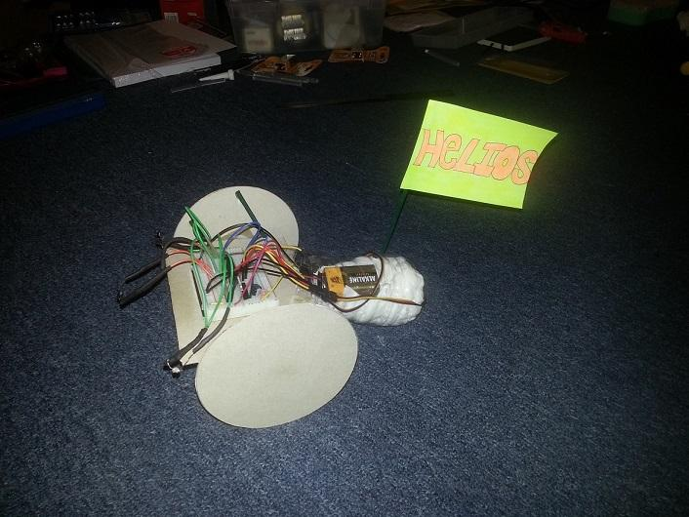

I did my dissertation on artificial intelligence in a procedurally generated world. It was presented as an application along with a research paper. The application had a basic GUI with some options for configuring the simulation. The idea was a single agent navigating a procedurally generated world whilst appearing intelligent in its route planning. Blocks can be placed which the agent will avoid and pheromones that the agent will be attracted to. The algorithm is based on the A* path finding algorithm. The procedural world is generated using Perlin noise and a random function which is passed a random or selected seed and then uses the seed to generate the lattices of the world using the current coordinates to allow variation but also consistency so that if the agent should return to the same coordinates they will see the same landscape. Cosine interpolation is used to generate a smooth transition between the gradient values. Textures are then applied to different thresholds to give the look of terrain from a top down view point. The algorithm uses a seed that is randomly generated at the start of the program and the current X,Y coordinates of the centre of the screen to generate a set of data for the gradient vectors. This was originally a personal project to experiment with procedural generation but I later took it further as part of my dissertation which was when the path finding came into the project.

The research paper that went alongside my project looked at multiple different types of technologies including Dijkstra's algorithm, D*, Cellular automata, Midpoint displacement.

**Github repository with some of my work:**

<https://github.com/GrantCTP12016119/Portfolio>

**Existing Games:**

I have also modified several games that are written in C++ such as The Elder Scrolls: Skyrim and received positive feedback from users on the internet. [http://www.nexusmods.com/skyrim/mods/29560/?tab=4HYPERLINK "http://www.nexusmods.com/skyrim/mods/29560/?tab=4&navtag=http%3A%2F%2Fwww.nexusmods.com%2Fskyrim%2Fajax%2Fcomments%2F%3Fthread_id%3D878498%26mod_id%3D29560"&HYPERLINK "http://www.nexusmods.com/skyrim/mods/29560/?tab=4&navtag=http%3A%2F%2Fwww.nexusmods.com%2Fskyrim%2Fajax%2Fcomments%2F%3Fthread_id%3D878498%26mod_id%3D29560"navtag=http%3A%2F%2Fwww.nexusmods.com%2Fskyrim%2Fajax%2Fcomments%2F%3Fthread_id%3D878498%26mod_id%3D29560](http://www.nexusmods.com/skyrim/mods/29560/?tab=4&navtag=http%3A%2F%2Fwww.nexusmods.com%2Fskyrim%2Fajax%2Fcomments%2F%3Fthread_id%3D878498%26mod_id%3D29560)

**Hobbies and activities:**

During university, I have taken part and acted as part of the committee of the UWE Tae-Kwon-Do society. During my final year I founded the UWE Robotics Society as president, as a society we have been building various robots and participating in local robotics events such as the BEEES ant-weight robot wars at the University of Bristol. I also enjoy mountain climbing with friends and have climbed Pen Y Fan and Snowden in Wales.

Here is a list of the societies that I have taken part in:

* UWE Robotics Society
* Tae Kwon Do sports club
* Pool / Snooker sports club
* Airsoft society
* UWE Gym

**Volunteering:**

I have partaken in various volunteering opportunities during my time at university including volunteering in the Voxxed days event in Bristol and working with senior lecturer's and companies such as Digimakers to aid in the education of children surrounding the world of Robotics and Programming by visiting schools and holding events at the @ Bristol Science Museum.

**Team work:**

While working in a number of teams in my university course to develop games and other pieces of software, I have developed good team working and management skills and also enjoy working with others on the both the design and technical development of not only games but many kinds of software. One particular module in my final year was to develop a number of games with the entire class as one cohort and a final larger game for the PlayStation 4, this required a lot of focus on the pipeline of commercial games development and teamwork throughout

**WORK EXPERIENCE:**

Robot Process Automation developer (Full time) at Genfour (soon to be Accenture due to an acquisition) - September 2016 - Present

* Robotics Process Automation developer
* UI Path and Blue Prism experience with a UIPath accreditation certificate
* Using Visual Basic and C#

My latest employment involves building robotic processes to automate back office processes, these are primarily built using UIPath and Blue Prism. Where security is an important need to our clients I often travel in order to build these processes on site so upholding a good communication and relationship with the client is key.

June 2016 – August 2016 – DroneX at the Bristol Robotics Laboratory (Summer work)

* Working with heavy duty drones
* Software engineering with C++
* Robot Operating System (ROS)

September 2014 – September 2015 – Craddys (Placement year)

* Mobile applications developer
* Developing cross platform mobile application written in C++
* Providing IT support to office staff

During my placement year my main task was to develop a cross platform business application for windows phone, iPhone and android devices. I was put in charge of the application and worked on it on my own. I decided to use a cross platform development kit called Marmalade which is written in C++ and is the language that I used to develop the app.

Call Centre – Bristol, ELM legal services - November 2013 – December 2013

* Calling up members of the public and providing information and an offer to write a Will with the company I was working for.
* Communication skills

Pendennis castle (Work experience) – English heritage, Falmouth, Cornwall - June 2008 – July 2008

* Dealing with the general public (Giving tours, serving customers)
* Inputting financial data into an excel worksheet
* Managing and keeping track of floats
* Working in a Cafe and gift store
* Maintaining the security of a site (the proper closing of the site at close of business, locking doors and shutting off power etc.)
* Stock checking