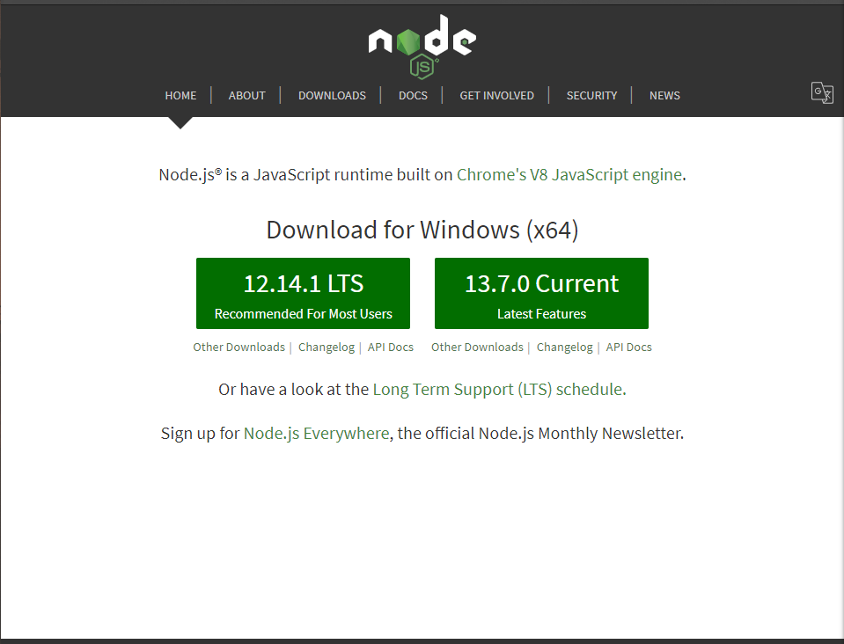First step install node.js @<https://nodejs.org/en/>

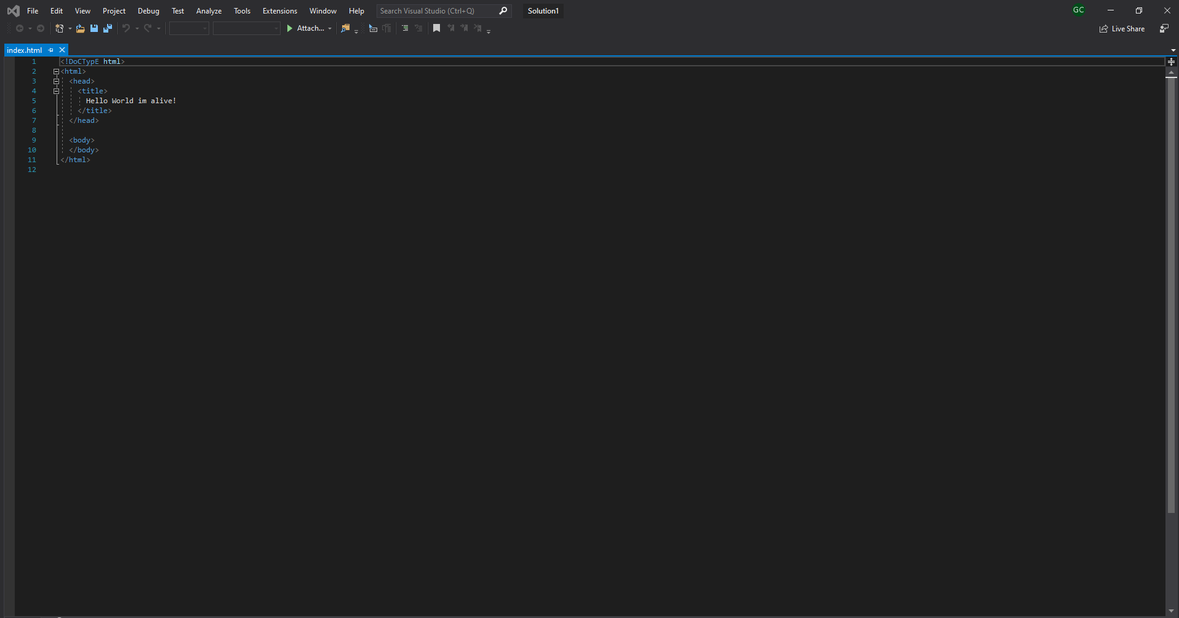

Take a file with html code and save it somewhere.

Open bash and navigate to the location of your html file

Using bash commands.

Finally type the following code in to run the server from your pc:

$ npm install -g http-server

Then, http-server to run

And visit the site at ur local IP as said on screen 😊