**Design Document for CODE42**

Group 2_AN_4

Nathan Stark: % contribution

Nolan Brown: % contribution

Andrew Bowen: % contribution

Grant DeWaay: % contribution

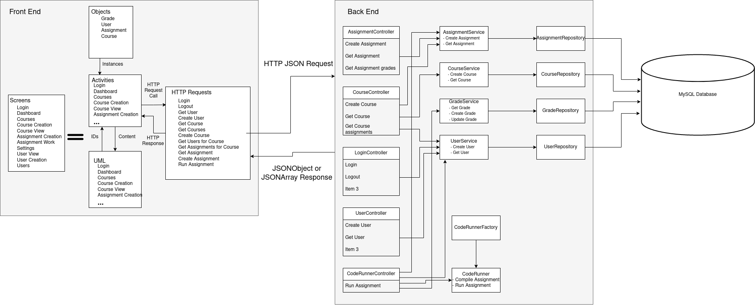

**Design Description**

**Assignment Storage, Code Execution, and Grading Pipeline**

The system of handling assignments is perhaps the most robust and complicated aspect of CODE42. *Assignments* are the tasks that Teachers create for Students. Teachers can specify the assignment name, the description of the assignment, the possible points, the code that the Student will start with (called the boilerplate) when they begin an assignment, and the expected output that will be compared to the output of the Student’s compiled and executed code that they write. This customization allows Teachers to get the most out of CODE42. Part of that customization includes three supported programming languages that assignments can be written in: C, Java, and Python.

We are especially proud of the method used to verify the correctness of the Student’s code for an assignment. When a Student submits an assignment, we send the assignment code to the spring boot backend via Volley HTTP, where the code is compiled in whichever language the assignment is written in. The code is then executed on the server and the output of the code saved. We can then compare the expected output with the actual output. If the outputs match, we say that the test was “passed,” and points are rewarded for that Student on that assignment. Feedback is then given to the client, where the Student can see the feedback given by the automated grader.

