README

# How to use the template

Copy and paste ‘DPLTemplateSolution.zip’ to ‘C:\Users\[username]\Documents\Visual Studio 2017\Templates\ProjectTemplates’.

Once the zip file is in that location, you can use the template by

1. Creating a new project 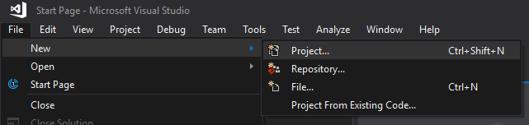
2. Select ‘DPL Template Soluction’ from the list
3. Name the solution with your namespace
4. 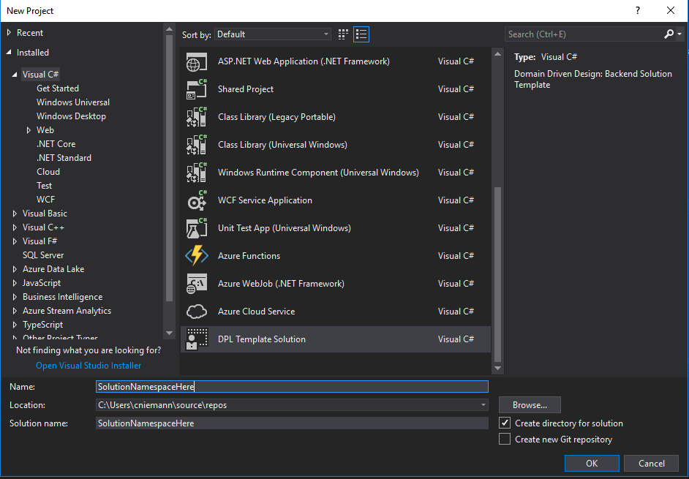
5. Done

# How to Make a template

1. Use this folder

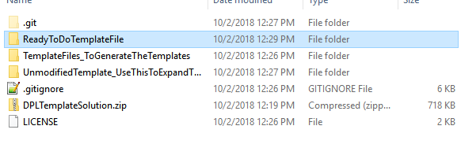

1. It contains all files you need to make a template
2. 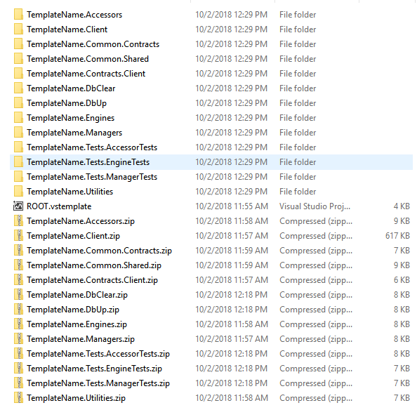
3. Note that the zip files are there as placeholders, since they are already extracted.
4. The ROOT.vstemplate file contains everything you need to make the template.
5. 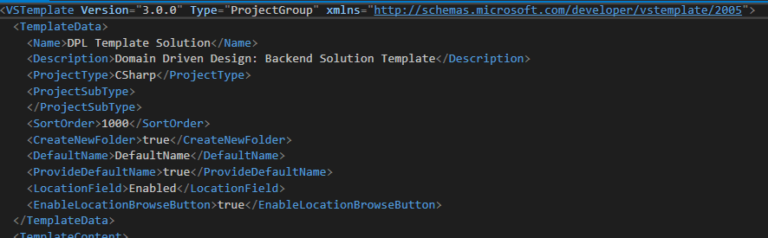
6. Change the variables in this file to see what they do. The name should match what you will see in the ‘new project’ dialog.
7. File paths in this file are relative, but need to exist in order for the template to work.
8. Once you have everything updated to your liking, zip up all NON-Zip files.
9. 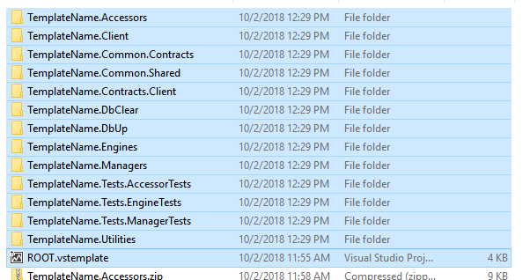
10. Place that zip file here: ‘C:\Users\[username]\Documents\Visual Studio 2017\Templates\ProjectTemplates’ to use the new template

# Update existing templates

1. Open 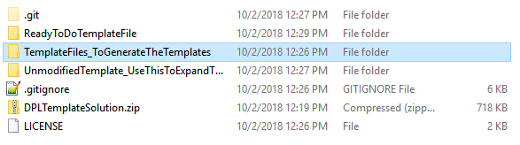
2. Open the solution
3. This solution already has template specific variables, and cannot be build or run. If you require that functionality, use the unmodifiedTemplate
4. Once you have made your changes use the VS Template Wizzard
5. 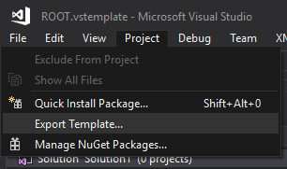
6. Select the project you want to use for the template
7. VS will create a zip file in C:\Users\[username]\Documents\Visual Studio 2017\My Exported Templates
8. You need to extract this zip file to use it for the solution template and then follow the steps of ‘how to make a template’

# DOTNET NEW

It may be possible to run this template from the command line….to install the template update the template.json file with names. Then install the template with dotnet new -i ROOTPATH.

You should see your template now when you run dotnet new -l.

You can install the template with dotnet new -i templateName, but something may be wrong with the cli, because none of my templates installed.

More info: <https://docs.microsoft.com/en-us/dotnet/core/tools/custom-templates>