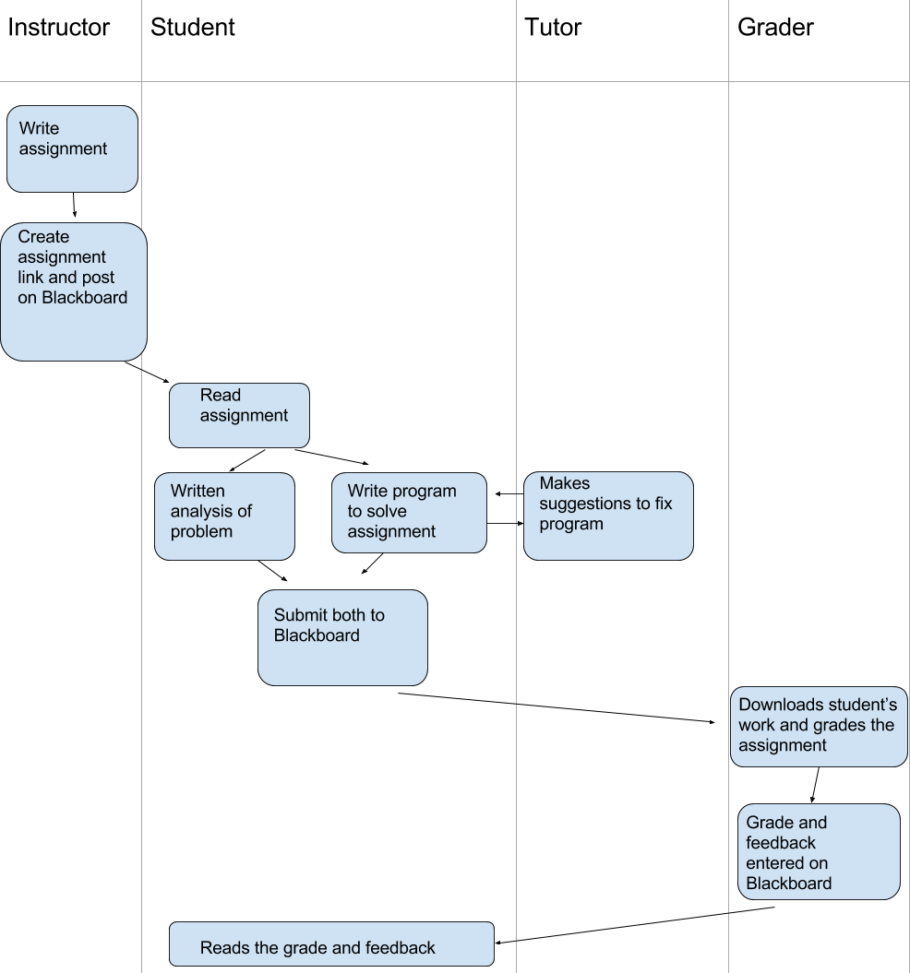

Errors that could occur involve the instructor mistakenly uploaded the wrong file, the tutor giving incorrect suggestions to fix the program, or the grader submitting the wrong grade and/or feedback to Blackboard. The first would lead to the student, tutor, and grader having to redo all the steps they had completed up to that point. The tutor giving incorrect suggestions to fix the program would lead to the student going back to the tutor, so the error is already accounted for in the diagram. The third error would lead to the student sending an email to the grader about the grade/feedback received and the grade checking the grade/feedback received by the student and the intended grade/feedback for the student. The grader would then post the correct grade/feedback on Blackboard and email the student who would read the updated grade/feedback.