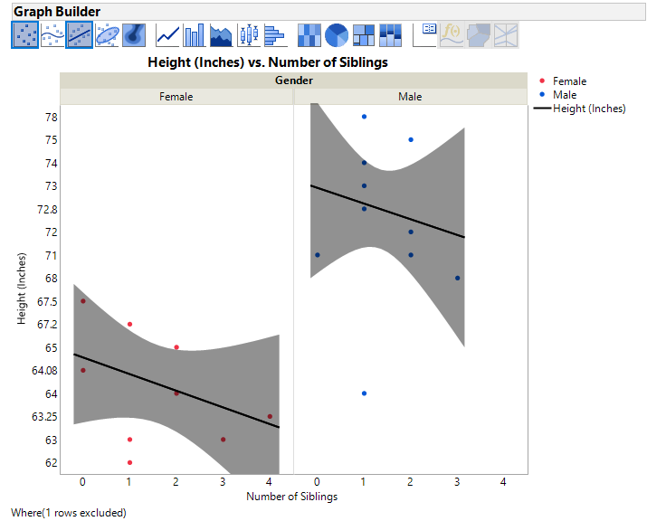

This graph shows the effect that increasing the number of siblings has on a person of a specific gender’s height. The stratification by gender was chosen because of the known difference in heights between men and women. This allows for comparisons on the effects of number of siblings on height for each gender. However, both males and females show a negative linear correlation. This implies that any reason for height to decrease as the number of siblings increases is independent of gender as both show a negative linear correlation. A possible explanation would be the availability of food during childhood as households with fewer children would generally be able to afford more food than those with more children.

Note: 1 outlier value, (16, 71, Male), was excluded.