The height varies from 62 to 78 inches and has a median of 71 inches. There are 16 males in the class and 10 females for a total of 26 students with the mode being male. The number of siblings varies from 0 to 16 with a median of 1 sibling.

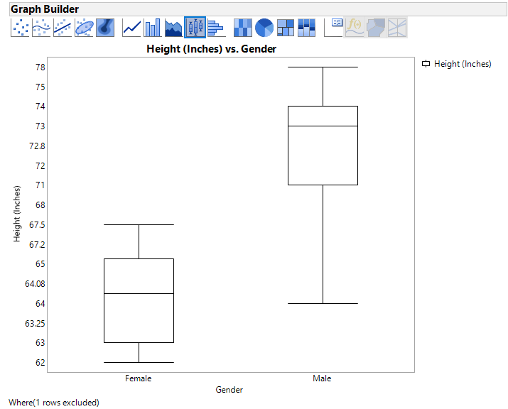

Stratifying by gender produces a distribution of height for each gender. From this it can be observed that females ranged in height from 62 to 67.5 inches with a median of 64.08 inches. Males ranged from 64 to 78 inches with a median of 73 inches.

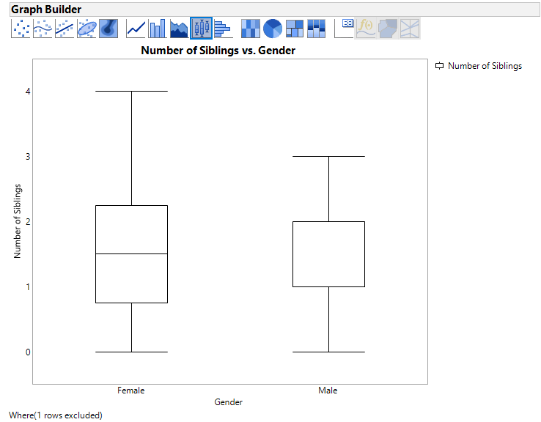

Stratifying the number of siblings by gender allows the observation to be made that females had greater variation in number of siblings from 0 to 4 with a median of 2.5 siblings while male varied from 0 to 3 and a median of 1 sibling.

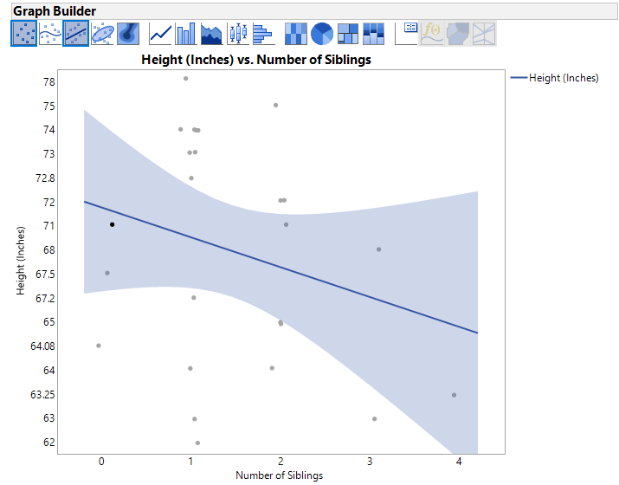

The graph shows a very weak negative linear correlation between height in inches and the number of siblings.

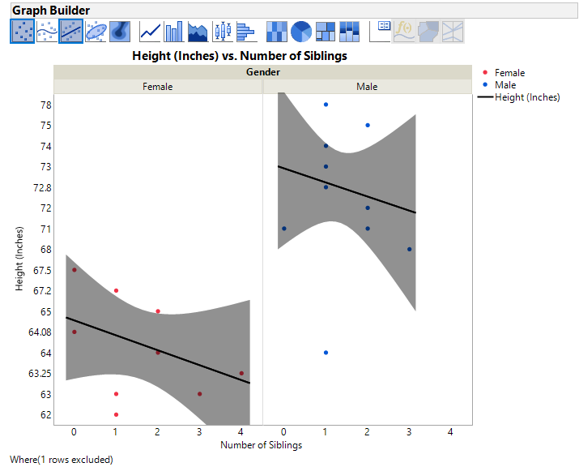

Stratifying by gender gives a much stronger correlation for each graph. Although the two still show negative linear correlations, the correlation is much stronger because there is less variation in heights when accounting for gender.