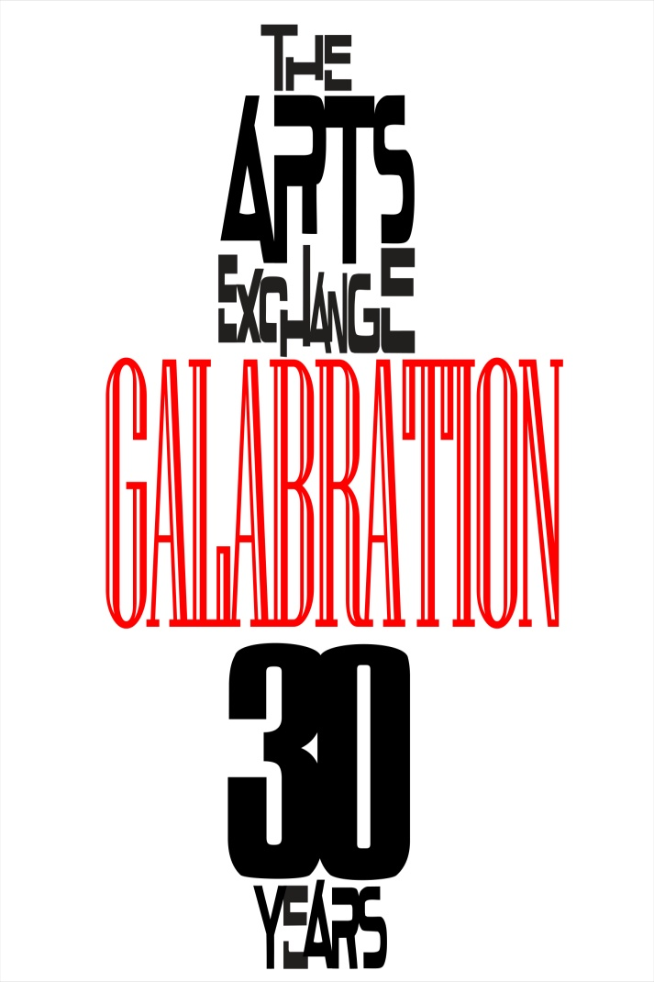 **GALABRATION!**

**The Arts Exchange’s 30th Anniversary Celebration**

**750 Kalb Street SE, Atlanta 30312**

**September 21, 2014**

**EVENTS**

***Open House***/Open Studios

The Xchange Gallery Studio Artists Group Exhibition- *Photography +*

**Sunday, September 21, 2pm-6pm** Free and open to the public

***GALABRATION!***

Celebration Benefit Party with live music, spoken word, drama, and dancing Featuring: The SaNa Band, Tommy Bottoms, Georgia Me, Cola Rum, Abyss Graham, Atlanta Word Works, DJ Jose Jimenez and DJ Tabone

The Paul Robeson TheatreVendors Hall  **Sunday, September 21, 6pm-9pm Donation: $30 for 30 years**

Free parking **Location** The Arts Exchange  
750 Kalb Street SE  
Atlanta, GA 30312

MESSAGE:

The public is invited to join The Arts Exchange as it celebrates 30 years of service to Atlanta’s arts community at GALABRATION! On Sunday, September 21, 2 to 6pm, The Arts Exchange opens its doors for Open House, when studio artists open their visual and performing arts studios to the public. The Studio Artists Group Exhibition- *Photography +* will be on view in the Xchange Gallery as well. Sunday evening, September 21, 6-9pm GALABRATION! A Benefit Party with live music, spoken word, drama, and dancing takes place in the Paul Robeson Theatre. Featuring: The SaNa Band, Tommy Bottoms, Georgia Me, Cola Rum, Abyss Graham, Atlanta Word Works, DJ Jose Jimenez and DJ Tabone. The evening begins with spoken word by some of Atlanta’s most powerful spoken word artists and dynamic drama that will propel you to the dance floor for an eclectic mix of magical music by The SaNa Band, a band on fire, and DJ Jose Jimenez and DJ Tabone, two of Atlanta’s hottest DJ’s. Come out to support The Arts Exchange for its 30 years of arts innovation, exploration and excellence. All events take place at The Arts Exchange, 750 Kalb St. SE Atlanta, GA 30312. To purchase tickets **:**[**http://www.eventbrite.com/e/the-arts-exchange-30th-anniversary-galabration-tickets-12826820365?aff=efbevent**](http://www.eventbrite.com/e/the-arts-exchange-30th-anniversary-galabration-tickets-12826820365?aff=efbevent) For more information call 404-624-4211, or emaiLartsexcommunications@gmail.com or visit our Facebbook page or website- [thearts-exchange.org](http://thearts-exchange.org/)