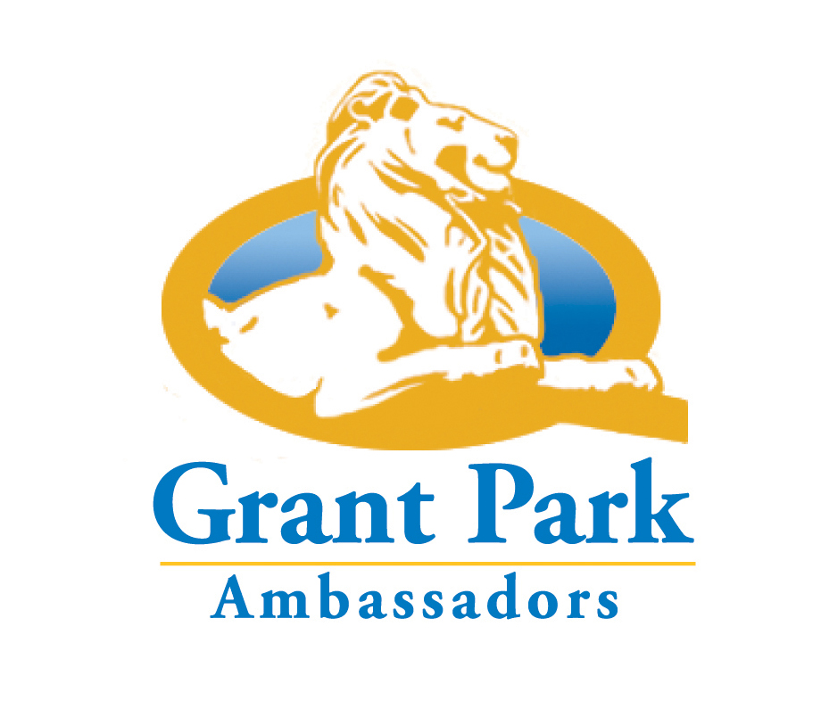
Wish List
Stuff we need donated (in-kind contributions)
- bicycles
- 2-way radios
- digital cameras
- litter sticks/grabbers
- couple buckets/pales to scoop cool coals into
- few shovels to scoop up cool coals
- hot coal cans (for folks who are far removed from red coal cans)
- pooper-scoopers
- paint brushes
- clipboards
- pens
- blue painters tape
Services we need donated (pro bono contributions)
- graphic designer
- copywriter
- data entry (familiar with Microsoft Excel)
Cash donations
- $25 for basic Ambassador uniform (t-shirt & ball cap)
- $15 for litter stick
- $25 for litter grabber
Local business sponsorships
- Email Phred Huber for more information: parksandrecreation@gpna.org
Grant Park Ambassadors is a pilot program led by the Grant Park Neighborhood Association in partnership with the Atlanta Police Department; the City of Atlanta Department of Parks, Recreation and Cultural Affairs; the Grant Park Conservancy; and Zoo Atlanta.

