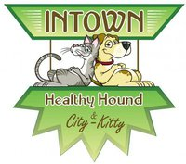
Get your pup clean in time for Halloween! Intown Healthy Hound and City Kitty are sponsoring a Dog Wash with proceeds to benefit the Grant Park Community Garden!
Date: Saturday, October 27th
Time: 11:00am to 3:00pm
Location: Intown Healthy Hound (891 Cherokee Ave. )
Cost: $15.00
