Grant Moorlag

3rd Hour

**Disease Name:** Dutch Elm's Disease

**Scientific Name:** Ophiostoma Novo-Ulmi

**Transmission:** The Dutch Elm’s Disease is transmitted by the Bark Beetle.

**Symptoms:** The tree dies after getting infected.

**Treatments:**  If you find Dutch Elm’s Disease early enough, you can cure it by pruning, or fungicide injection, or both.

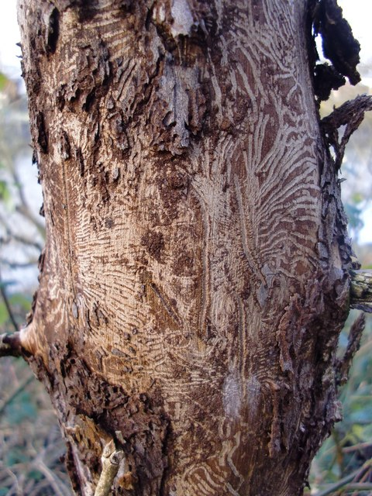

**Fact:** Dutch Elm’s Disease was found in England, and after 20 years, it had killed 17 million Dutch Elm trees.

**Fact:** Fully mature Elm trees can last for at least 300 years.