Grant Moorlag

3rd Hour

Giraffe

Common Name: Giraffe

Scientific Name: *Giraffa camelopardalis*

Habitat: Giraffes usually live in Savannahs, Grasslands, and Open Woodlands.

Adaptation: Giraffes can drink up to 12 gallons a day to stay hydrated.

Adaptation: They also obtain water from the dew of the leaves they eat.

Adaptation: They have long necks to reach up to eat leaves off of trees.

Adaptation: Giraffes need a strong heart to pump blood up their long necks, their heart is about 2 - 3 times stronger than a human’s heart.

Fact: Giraffes can use their necks as a weapon against other Giraffes and predators.

Fact: The Giraffe is the tallest mammal in the world.

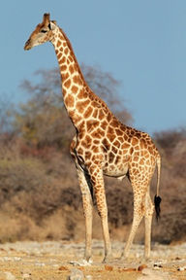

Fact: No two Giraffes’ fur pattern is the same.

