Grant Moorlag

3rd Hour

Science

Find A Virus

**Disease Name:** Warts

**Virus Name:**  Human Papillomavirus

**Transmission:** Warts are transmitted through direct contact with another wart. It may also spread throughout you to another part of your body.

**Symptoms:** Warts are little formations on your hands, feet, and other parts of your body. The common wart is usually located on your hand and has a rough, grainy texture to them. Plantar warts are medium-sized black bumps on the bottom of your feet, they constantly hurt whenever you walk.

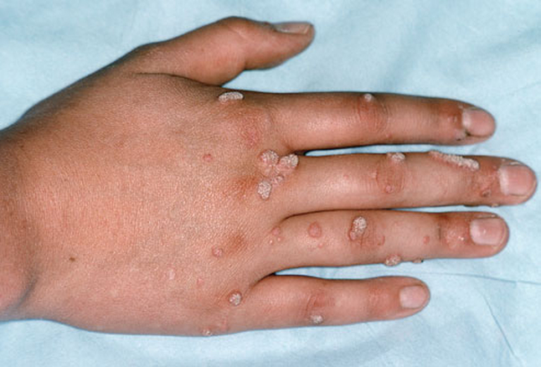

**Treatments:**  To treat common warts, you can freeze, cut, or burn them off, there are other treatments than the three shown, but might not work as well as the top three methods.

**Fact:**  Even if you remove the wart, you will still have the virus inside of you, in turn, my give you more warts.

**Fact:**  Warts can disappear on their own.

