Grant Moorlag

3rd hour

Science

**Disease Name:** Giardia

**Scientific Name:** Giardia Lamblia

**Transmission:** Giardia is spread by water, food, or soil that has been contaminated by feces.

**Symptoms:**  Watery Diarrhea, Fatigue, Abdominal cramps, and gas.

**Treatments:** You can treat Giardia by taking anti-parasites and/or antibiotics.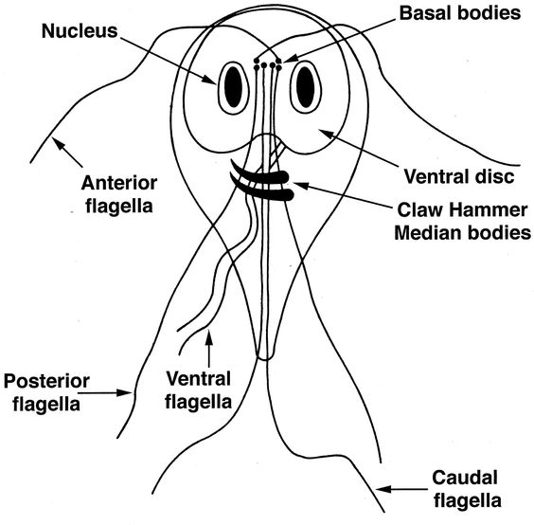

**Fact:** Nicknamed, “beaver fever”.

**Fact:** About 200,000 cases in North America every year.

