Grant Moorlag

3rd Hour

Science

**Disease Name:** Gangrene

**Scientific Name:** Clostridial Myonecrosis and Myonecrosis

**Transmission:** Gangrene isn’t transmitted, it occurs when blood flow is cut off from a certain part of your body.

**Symptoms:** When you have Gangrene, your skin shrivels up and turns a dark, black color, your skin is cold and numb. It may hurt, and it may not, it depends on what type of Gangrene you have.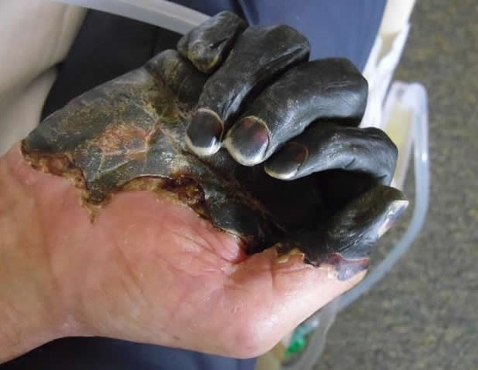

**Treatments:** Gangrene can be treated by antibiotics, or the removal of the dead skin. In worst cases, even amputation occurred.

**Fact:**  50% of all gangrene cases occur from a traumatic injury, an example would include car accidents and gunshots.

**Fact:** Gangrene can occur from surgeries.

