C# ATM Banking Application – Checkpoint 1
Design & Planning

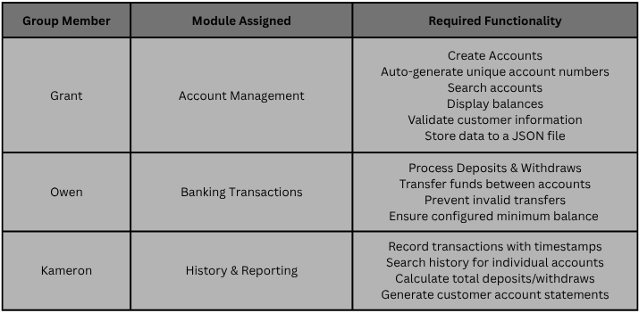
---------- Member Responsibilities ----------

---------- Account Management – Zach ----------
