Develop application in C# using Visual Studio. Windows Forms is the preferred interface. Students should demonstrate classes, objects, methods, arrays or collections, loops, conditional statements and event handling.

1. ATM Banking Simulator
  - 3 students
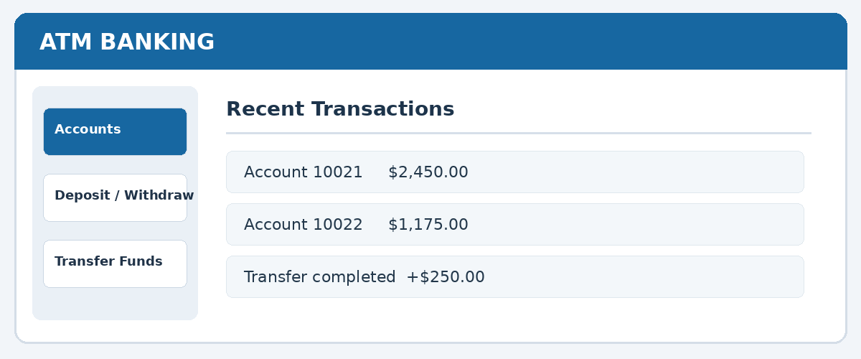
Illustrative Windows Forms interface concept
Objective: Develop a banking application that manages multiple customer accounts, deposits, withdrawals, transfers and transaction history.
Student / Module | Required functionality
Student 1 — Account management | Create accounts, generate unique account numbers, search accounts, display balances and validate customer information.
Student 2 — Banking transactions | Deposit, withdraw and transfer funds between accounts; prevent overdrafts and invalid transfers.
Student 3 — History and reporting | Record transactions with timestamps, search history, calculate totals and generate account statements.
Additional requirements: Support at least 10 accounts, maintain a minimum balance if configured, validate transaction amounts and save account information to a file. Use fictional customers and simulated money only.
Expected demonstration: Create two accounts, deposit funds, transfer money, attempt an invalid withdrawal and generate a transaction statement.

Common Requirements for All Projects
- At least three meaningful classes per project with separate responsibilities.
- Use loops, conditional statements, methods, arrays or collections, and input validation.
- Provide a functional Windows Forms interface with meaningful colors and error messages.
- Implement file-based saving and loading so application data persists after restart.
- Include search functionality, appropriate reports and at least five documented test cases.
- Handle invalid inputs without crashing; integrate all student modules into one working application.

Submission and Presentation
Submit the complete executable Visual Studio solution as a ZIP file, all .cs source files, and a Word document containing screenshots, class descriptions, test results and each student’s contribution. Follow the finalized weekly status report, peer evaluation and grading rubric. Every student must demonstrate their assigned module and explain the relevant code during the group presentation.

Checkpoint 1 – Project Design and Planning
Before coding begins, each group should submit a class diagram, proposed interface, module assignments and integration plan to your instructor.

Checkpoint 2 – Module Development and Individual Code Review
Each group must demonstrate that every student has completed at least 70% of their assigned module. Each student should submit their source code, demonstrate the working functionality, explain the classes and methods implemented, and identify any technical challenges. The instructor will review individual contributions and provide feedback before integration begins.

Checkpoint 3 – System Integration and Testing
Each group must demonstrate a fully integrated application with all individual modules working together. Students should submit the integrated Visual Studio project, test cases with results, screenshots, and a list of identified bugs and pending fixes. The instructor will verify that the application meets the project requirements and provide feedback before final submission.
Important: All three checkpoints are mandatory. Each student must demonstrate their individual contribution, and all identified issues should be addressed before the final project presentation.

