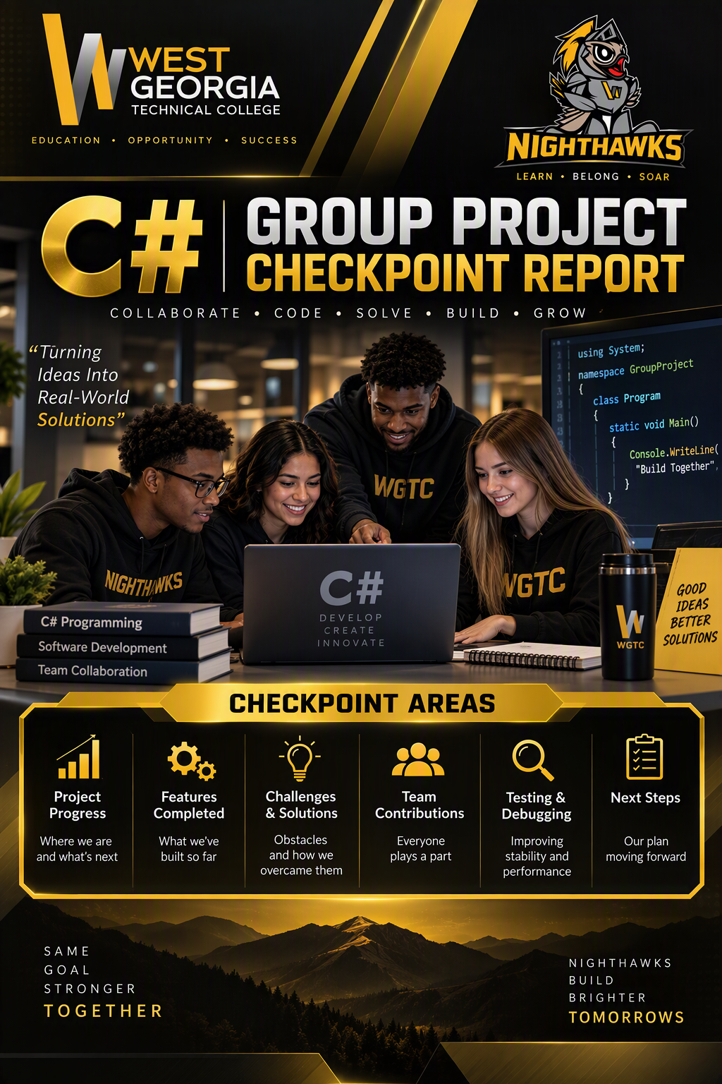

Project Title: ATM Banking Application
Team Members: Owen Smith
Kameron Warren
Grant Ball
Group Number: 1
Report: II
Submitted on: 02-Nov-2026

CHECKPOINT 2
Module Development & Individual Code Review
ATM Banking Application | Group 1

1. Objective and completion standard
Each student must demonstrate at least 70% of their individually assigned module using their own C# source files. Explain classes, methods, object creation, input validation, and running features. A percentage alone is not evidence: show working code and record the remaining tasks.

2. Student module ownership and progress
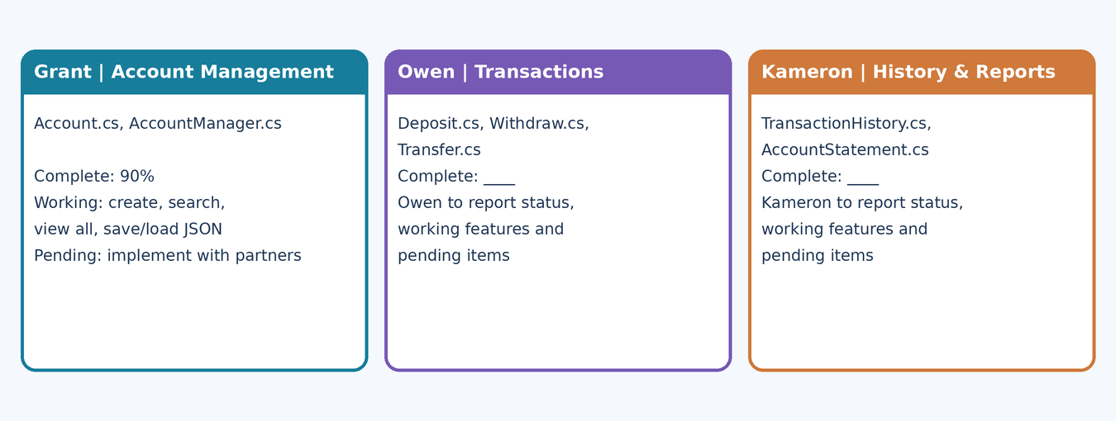
Figure 1. Module status for each group member.
Student | Files / owned module | Working demonstration | % complete
Grant | Account.cs, AccountManager.cs | Create account with validation and an auto-generated number; search by name / ID; view all accounts; save and reload JSON. Pending: implement with partners | 90%
Owen | Deposit.cs, Withdraw.cs, Transfer.cs | Finds accounts and alters the accounts balance using the users input and choice of transaction. | 70%
Kameron | TransactionHistory.cs, AccountStatement.cs | Record transactions with timestamps, search history, calculate totals, and generate account statements. | 70%

3. Working Windows Forms demo
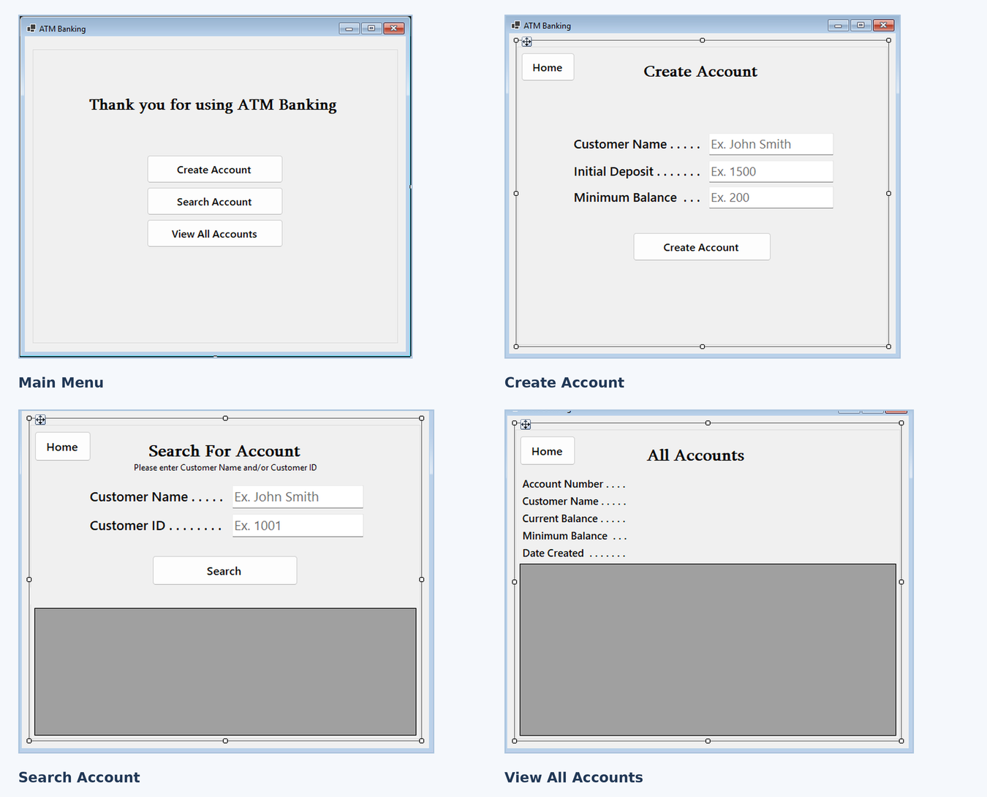
Figure 2. Account Management screens (Windows Forms designer view): Main Menu, Create Account, Search Account and View All Accounts.
Demo steps: from the Main Menu click Create Account; enter Customer Name, Initial Deposit and Minimum Balance (for example John Smith, 1500, 200) and click Create Account to show the green status with the new account number; repeat with a blank name or a non-numeric deposit to show the red error; click Home, open Search Account and search by name and/or ID; open View All Accounts and click a row to show its details; close and reopen the application to show the accounts reload from UserAccounts.json.

4. Module demonstration workflow
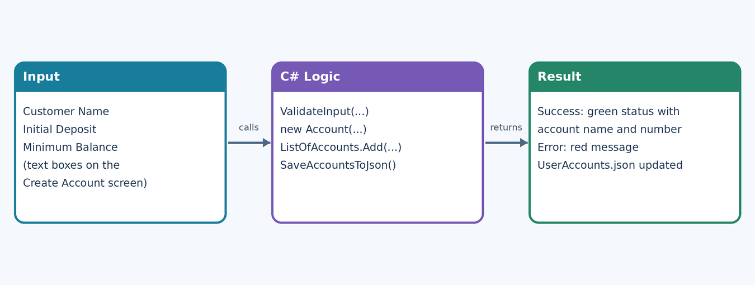
Figure 3. Inputs flow through ValidateInput and the Account / AccountManager logic to a visible status message and the saved JSON file.

5. Class, object and method review
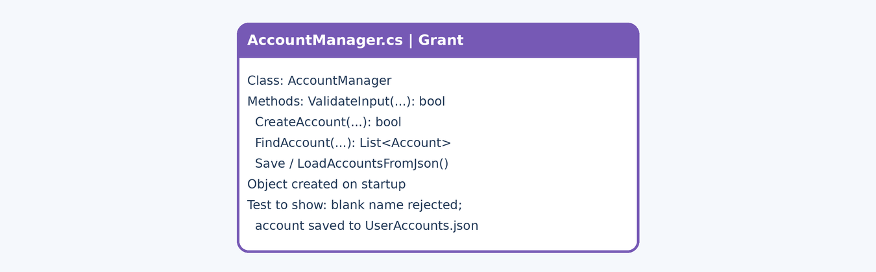
Figure 4. Talking points for the Account Management code walkthrough: AccountManager.cs.

Representative C# logic — input validation (AccountManager.ValidateInput)
public bool ValidateInput(
string customerName,
string BalanceTextbox,
string MinimumBalanceTextbox,
out decimal ParsedBalance,
out decimal MinimumBalance,
out string ErrorMessage)
{
ParsedBalance = 0m;
MinimumBalance = 0m;
ErrorMessage = string.Empty;

if (string.IsNullOrEmpty(customerName))
{
ErrorMessage = "Customer Name can not be blank.";
return false;
}

if (!(decimal.TryParse(BalanceTextbox, out ParsedBalance)))
{
ErrorMessage = "Initial Deposit must be a valid number.";
return false;
}

if (!(decimal.TryParse(MinimumBalanceTextbox, out MinimumBalance)))
{
MinimumBalance = 0;
}

if (ParsedBalance < MinimumBalance)
{
ErrorMessage =
"Initial Deposit must be greater than minimum balance requirement.";
return false;
}

return true;
}

Explain: this runs when the user clicks Create Account. A blank name is rejected, the Initial Deposit must be a number, an unreadable Minimum Balance is treated as 0, and a deposit below the minimum balance is rejected. On success CreateAccount builds the Account, adds it to ListOfAccounts and saves the list to UserAccounts.json. Code is taken from the project source.

Object instantiation
// AccountManager.cs, CreateAccount: new Account added to the list, then saved
Account NewAccount = new Account(
AccountNumber, CustomerName, InitialDeposit, MinimumBalance);
ListOfAccounts.Add(NewAccount);
SaveAccountsToJson();

// AccountManager.cs, LoadAccountsFromJson: Account objects created from the file
ListOfAccounts = JsonSerializer.Deserialize<List<Account>>(jsonString)
?? new List<Account>();

Where each object is created: AccountManager once on startup (one instance, which loads accounts from JSON); Account in AccountManager.CreateAccount for new accounts and in JsonSerializer.Deserialize for loaded accounts. The AccountManager reference is stored by the main form and passed to the other modules.

6. Individual code review and evidence
Review item | Grant | Owen | Kameron
Opens own .cs source | ☐ | ☐ | ☐
Explains class/properties/method | ☐ | ☐ | ☐
Shows valid-input execution | ☐ | ☐ | ☐
Shows invalid-input execution | ☐ | ☐ | ☐
Shows ≥70% of assigned module | ☐ | ☐ | ☐
Explains object instantiation | ☐ | ☐ | ☐

Code review notes
Student | Reviewer observation | Next action
Grant | ____ | ____
Owen | ____ | ____
Kameron | Transaction history and account statement modules are assigned. Working demonstrations are pending. | Implement transaction timestamps, history searching, date filtering, deposit and withdrawal totals, and account statements.

7. Open issues and integration readiness
ID | Issue / reproduction | Owner | Priority | Resolution target
M-01 | Start the application with no UserAccounts.json: LoadAccountsFromJson throws because the file does not exist | Grant | Medium | Before integration
 | Transaction history and account statements are not yet integrated with the account and transaction modules. | Kameron | Medium | Before final integration
 | Transactions have no way of sending the changes they make to accounts to the transaction history module. | Owen | Medium | Before final integration
Handoff contracts: Account exposes AccountNumber, CustomerName, Balance, MinimumBalance, DateCreated, Deposit(amount), returning bool. AccountManager exposes CreateAccount(...), FindAccount(...), GetAllAccounts(), SaveAccountsToJson() and LoadAccountsFromJson(). Owen's transaction classes receive the existing AccountManager; Kameron's history and statement classes read AccountNumber and Balance. Merge shared models first, then connect forms, then persistence.

8. Checkpoint 2 review form
Field | Entry
Project | ATM Banking Application
Review date | ____________
Team / reviewer | Group 1 / Instructor ____
Grant / Owen / Kameron progress | 90% / 70% / 70%
Demo evidence | Source files (Account.cs, AccountManager.cs) + live walkthrough + screenshots (to be attached)
Outstanding blockers | M-01 (Account Management)
Ready for integration? | Conditional — resolve M-01, then connect Owen's and Kameron's classes

Required submission checklist
☐ Individual C# source files ☐ Working demo for each student ☐ ≥70% demonstrated per module ☐ Method/class explanation ☐ Valid and invalid test evidence ☐ Progress and reviewer notes ☐ Open issue log ☐ Completed Checkpoint 2 form
Evidence note: entries for Account Management come from the project source files (Account.cs, AccountManager.cs) and the saved UserAccounts.json. Attach screenshots of the running application and complete the walkthrough before submitting.

9. Cross-Student Class, Object & Method Reuse
  - REQUIRED CHECKPOINT 2 EVIDENCE
Each student must document how classes, objects, properties, and methods authored by another team member are used in their own module. Identify whether the code is reused as-is, extended with additional members, or adapted through a new collaborating class. Demonstrate the actual code and object interactions—not only a proposed integration plan.

Planned handoffs: ATM Banking project
Original author / asset | Using student / location | Reuse approach | Evidence to show
Grant: AccountManager (FindAccount, GetAllAccounts) | Owen: Deposit, Withdraw, Transfer | As-is: each receives the existing AccountManager and looks up accounts | Deposit(accountManager) constructor call; ProcessDeposit finds the account; valid and invalid account number
Grant: Account (Balance, MinimumBalance, Deposit) | Owen: ProcessDeposit, ProcessTransfer | As-is: calls Account.Deposit and checks the bool result | Call site; an invalid amount is rejected
Grant: Account (AccountNumber, Balance) | Kameron: AccountStatement, TransactionHistory | As-is: reads AccountNumber and Balance from an Account | AccountStatement(account, StartDate, EndDate) call; statement shows correct balances
Owen: transaction records (Transaction class) | Kameron: TransactionHistory.AddTransaction | As-is: history stores the transactions created by Owen's classes | AddTransaction call after a deposit or withdrawal; search and date-filter results
Kameron | Grant: Account.cs  Account.AccountNumber and Account.Balance | As-is | Display account number and balance in account statement.
Kameron | Owen: Transaction class  TransactionHistory.AddTransaction | As-is | Store deposit and withdrawal records, search history, and filter by date.

C# code other students will reuse (Account.cs / AccountManager.cs, Grant)
// Account.cs (members other modules use)
public class Account
{
public string AccountNumber { get; set; }
public string CustomerName { get; set; }
public decimal Balance { get; set; }
public decimal MinimumBalance { get; set; }
public DateTime DateCreated { get; set; }

public bool Deposit(decimal depositAmountInput) { ... }
}

// AccountManager.cs (public methods other modules can call)
public bool CreateAccount(
string CustomerName, decimal InitialDeposit, decimal MinimumBalance,
out string AccountNumber, out string ErrorMessage)

public List<Account> FindAccount(
string CustomerName, string AccountNumber, bool NameSearch, bool NameAndID)

public List<Account> GetAllAccounts()
public void SaveAccountsToJson()
public void LoadAccountsFromJson()

// Owen and Kameron call these through the existing AccountManager
// once their modules are merged

Reuse rule: Owen and Kameron use the Account and AccountManager classes as-is and write their own collaborating classes (Deposit, Withdraw, Transfer, TransactionHistory, AccountStatement) instead of editing Account.cs or AccountManager.cs. If a shared class must change, record the added property or method, the author, the approval, and the regression tests.

Required cross-module reuse log (complete one row per dependency)
Student using asset | Original student + file | Class / object / method | As-is / extended / new helper | Call site, change, test evidence
Owen | Grant: AccountManager.cs | AccountManager.FindAccount / GetAllAccounts | As-is | Call site in Deposit / Withdraw / Transfer; pending Owen's merged code (owner Owen, target date ____)
Owen | Grant: Account.cs | Account.Deposit (bool result) | As-is | Valid and invalid amounts; target date ____
Kameron | Grant: Account.cs | Account.AccountNumber, Account.Balance | As-is | AccountStatement(account, StartDate, EndDate) call; pending Kameron's merged code (target date ____)

Individual demonstration questions
- Which teammate created the class or method you are calling? Show its source file.
- Where is the object instantiated, and how is it passed to your module?
- Which properties and methods do you use, and what values are exchanged?
- Did you reuse the class unchanged, add properties/methods, or write a collaborating class? Explain why.
- If shared code changed, who approved it and how did you check that the original module still works?
- Run one successful and one invalid/failed cross-module scenario.
Checkpoint 2 acceptance: Each student submits a completed reuse log, identifies at least one real cross-student dependency where applicable, and demonstrates a working call or clearly documents a blocked dependency with owner and resolution date. Independent modules with no reuse must explicitly justify that design and show the agreed integration interface. The Account Management module is an independent base layer: it does not call the transaction or history code, and the agreed interface is the Account / AccountManager contract listed under handoff contracts.

