

Project Title: ATM Banking Application
Team Members: Owen Smith
Kameron Warren
Grant Ball
Group Number: 1
Report: I
Submitted on: 02-November-2026

1. Project scope
Bank users create accounts, search accounts and view balances, make deposits and withdrawals, transfer funds between accounts, and review transaction history and account statements. Customer information is validated and account data is stored in a JSON file.
2. Requirements and acceptance criteria
R1: create accounts with validated customer information and auto-generated unique account numbers; R2: search accounts and display balances; R3: store and reload account data from a JSON file; R4: process deposits and withdrawals; R5: transfer funds between accounts and prevent invalid transfers; R6: enforce the configured minimum balance; R7: record transactions with timestamps; R8: search history for an account and calculate total deposits/withdrawals; R9: generate customer account statements.
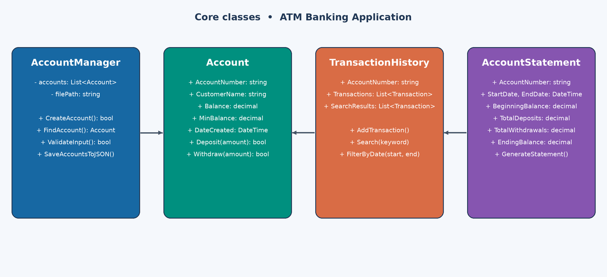

Figure 1. Core classes of the ATM Banking Application.

3. Object creation and use
AccountManager is created once on startup and loads existing accounts from the JSON file. Account objects are created during deserialization and whenever a user creates a new account. Deposit, Withdraw and Transfer are created on startup and when the user selects that option; each receives the existing AccountManager. TransactionHistory is created when a user opens an account's transaction history, and AccountStatement when a user requests an account statement.
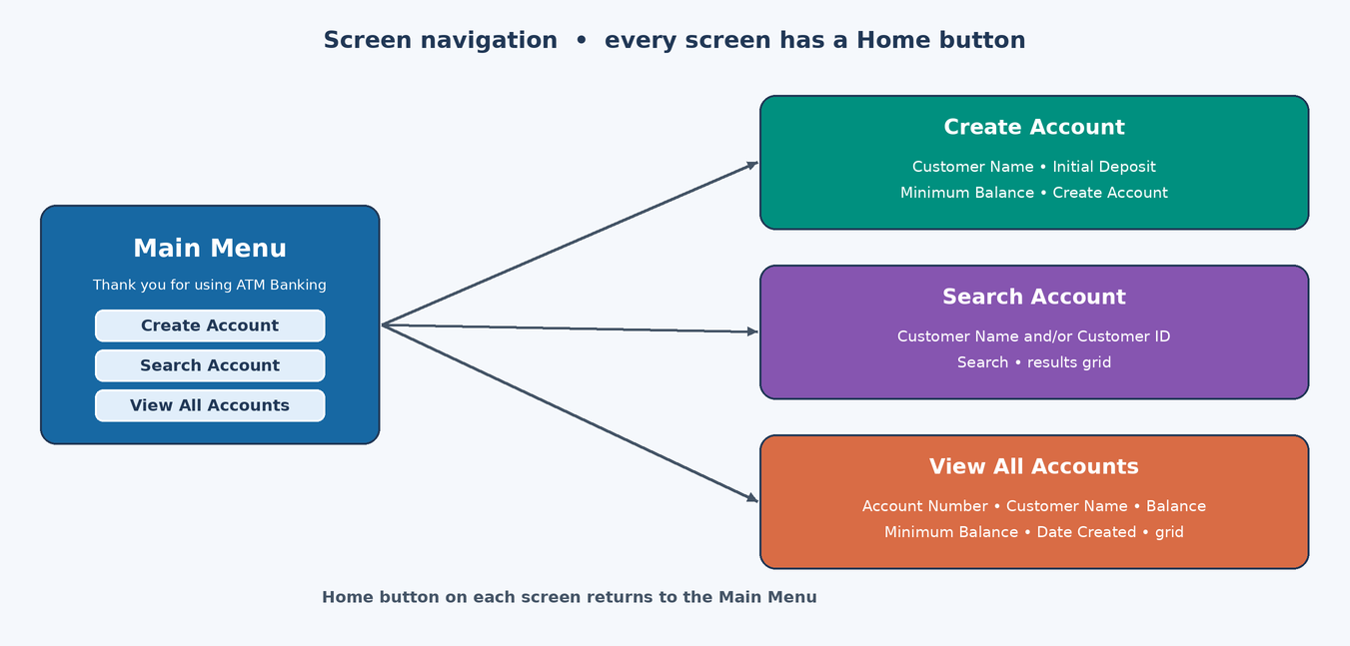

Figure 2. Proposed screen navigation: the main menu opens each screen, and each screen returns Home.

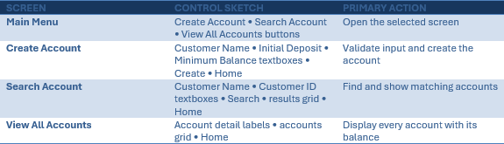

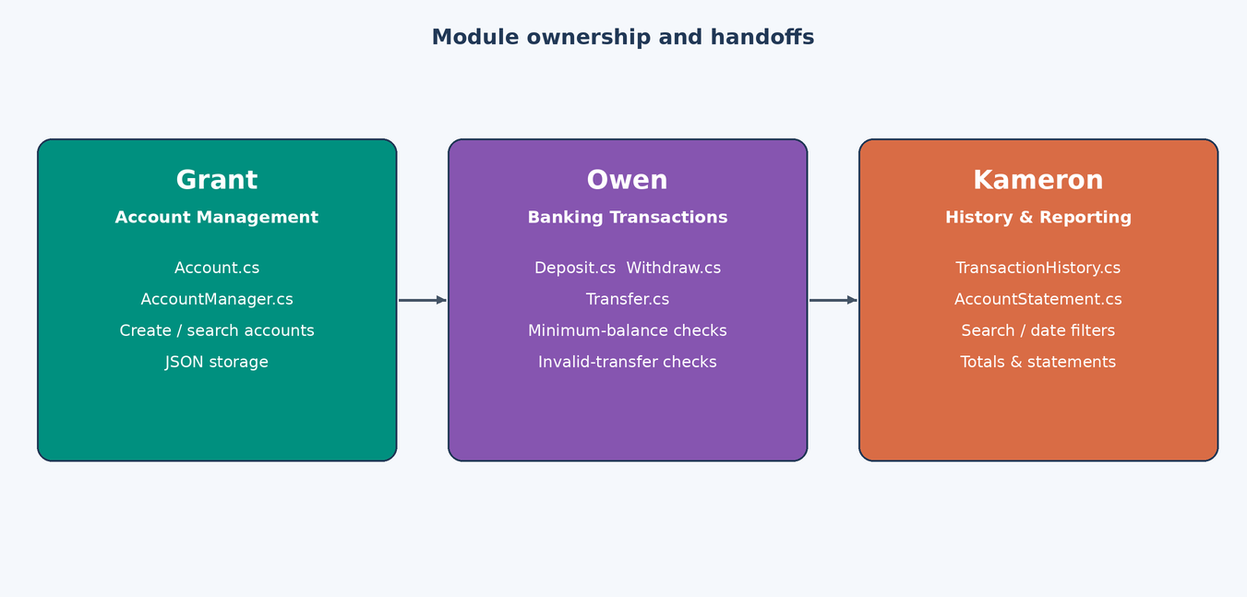

Figure 3. Proposed individual module responsibilities.
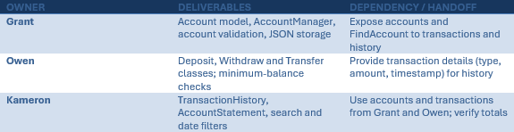

4. Data and integration plan
AccountManager keeps accounts in memory as List<Account> and saves them to a JSON file (loaded on startup; saved when accounts are created or modified and on closing). TransactionHistory is built from the same JSON data. Repository - integrate account and transaction classes, then history/reporting, then UI and persistence; test search and date filters, verify deposit and withdrawal totals, confirm statements show accurate information.

5. Expanded diagrams and interface mockups
The following diagrams and interface sketch document the ATM Banking Application design: class definitions, sample runtime objects, the screen mockups, and how the modules connect.
6.1 Class diagram
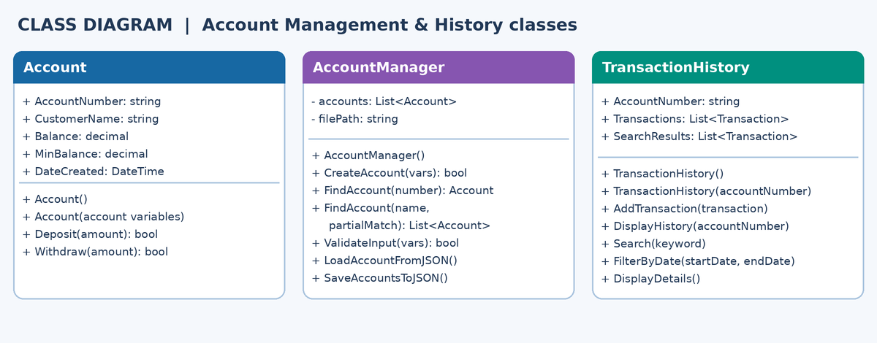

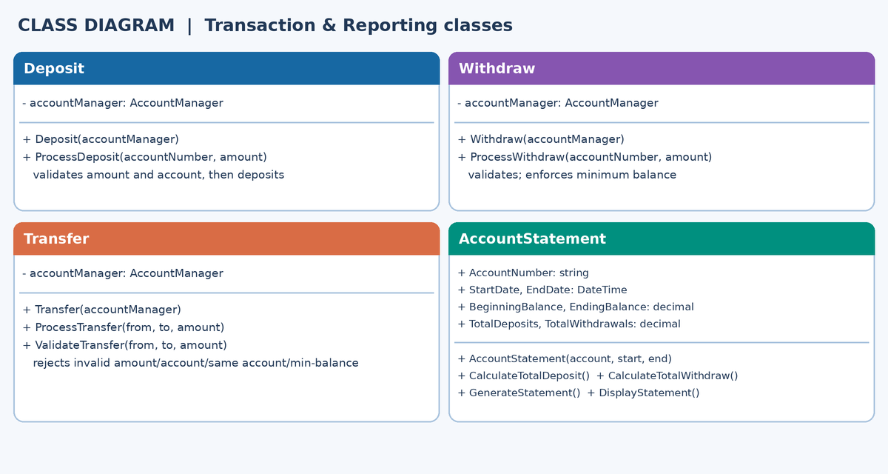
Class definitions list the properties and methods of each class; AccountManager holds the list of Account objects.

Transaction and reporting classes: each of Deposit, Withdraw and Transfer receives the existing AccountManager.
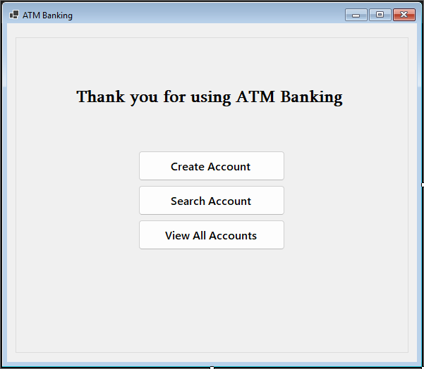
6.2 Interface mockup — Main Menu

Main Menu of the ATM Banking Windows Forms application.
6.3 Interface mockup — Create Account
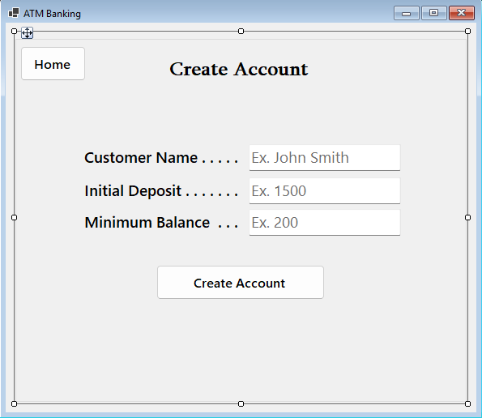

Create Account screen: Customer Name, Initial Deposit and Minimum Balance inputs.

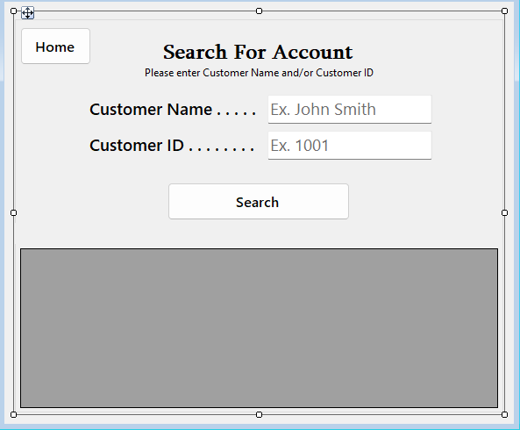
6.4 Interface mockup — Search Account/

Search Account screen: search by Customer Name and/or Customer ID; results appear in the grid.

6.5 Interface mockup – View All Accounts
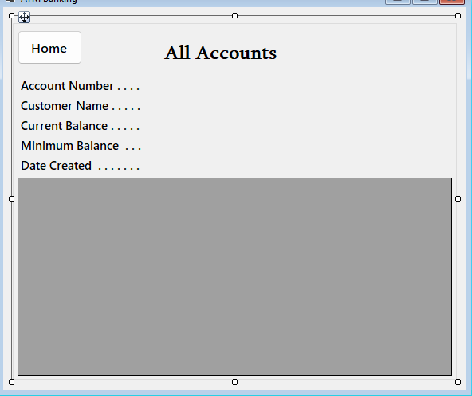

6.6 Module connections and integration workflow
View All Accounts screen: account details shown in a grid.
6.5 Module connections and integration workflow

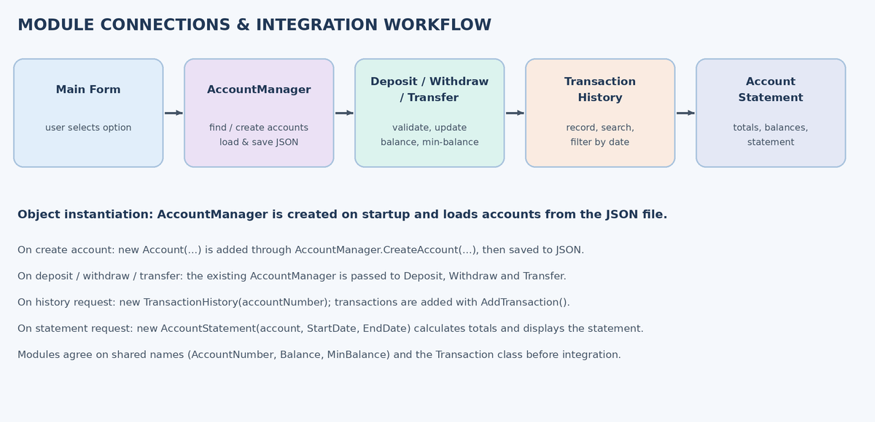

Proposed creation sequence and integration responsibilities.

7. Student ownership and integration checklist

Checkpoint 1 evidence: class diagram; object diagram; interface mockups; ownership table; data storage approach; integration plan; object instantiation plan; completed review form.

