Grant Toepfer

TCSS 342

Assignment 1 – Burger Baron

Analysis

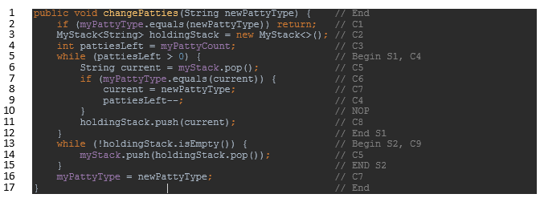

In the code above the comments show the line-by-line analysis of the costs. Line 2 checks to see if the new patty type is the same as the previous patty type and returns if it is. This transforms the cost of the function to a short O(1) for that case. For the rest of the analysis, however, we will pretend this if always evaluates to false and therefore will always have a cost of C1.

C2, C3, and C7 will always be ran once and therefore be combined into C10.

$$C_{10}= C_{2}+C_{3}+C_{7}$$

S1 will be run until the last patty is changed to the new patty type.

Inside S1: C5, C6 and C8 will be run on every iteration and C7 and C4 will be run when we find a patty. Lets pretend they are ran on every iteration as it will not effect our final answer. n is the number of ingredients between the top of the stack and the final patty, but for simplicity we’ll consider n to be the size of the entire stack since it won’t affect our final answer.

$$S_{1}=\sum_{i=0}^{n-1}{C_{4}+C_{4}+C_{5}+C_{6}+C_{7}+C_{8}}$$

$$S_{1}={(C}_{4}+C_{4}+C_{5}+C_{6}+C_{7}+C_{8})\sum_{i=0}^{n-1}{1}$$

$$S_{1}=C_{11}n$$

Inside S2: C5 and C9 will be ran on every iteration. The loop will end once all the ingredients are moved back to the other stack. This means that n on this loop is the same n from the S1, which again we will pretend to be the size of the entire stack.

$$S_{2}=\sum_{i=0}^{n-1}{C_{5}+C_{9}}$$

$$S_{2}=(C_{5}+C_{9})\sum_{i=0}^{n-1}{1}$$

$$S_{2}=C_{12}n$$

We can get the runtime of the method by adding up all our sums and constants.

$$runtime\left(changePatties\right)= C_{10}+S_{1}+S_{2}$$

$$= C_{10}+C_{11}n+C_{12}n$$

$$= C_{10}+{(C}_{11}+C_{12})n$$

$$= O(1)+O(n)$$

$$∈O(n)$$